Architecture Design Proposal
Retail Media Intelligence Platform
Prepared by: Bhuvnesh Dixit

Table of Contents
1. Executive Summary
2. Business Context
3. Requirements Engineering
4. Capacity Planning
5. Architecture Principles
6. Solution Overview
7. End-to-End Data Flow
8. Deployment Architecture
9. Security Architecture
10. Data Architecture
11. Observability & Reliability
12. Technology Decisions
13. Future Roadmap
14. Challenges and Trade-offs
15. Conclusion

1. Executive Summary
This document presents the proposed architecture for a Retail Media Intelligence Platform that enables retailers to collect customer interaction events, process them in near real time, and provide campaign performance insights to advertisers.
The solution is designed as a cloud-native, multi-tenant platform on Google Cloud Platform (GCP) using .NET, SQL Server, Redis, and BigQuery. It combines synchronous APIs with asynchronous event processing to achieve scalability, resilience, and operational simplicity.

Key Objectives
Objective | Description
Scalability | Handle high-volume event ingestion through horizontal scaling.
Security | Protect platform and customer data.
Multi-Tenancy | Support multiple retailers on a shared platform.
Reliability | Ensure continuous processing with fault tolerance.
Extensibility | Support future business growth with minimal redesign.

Technology Stack
Layer | Technology
Cloud | Google Cloud Platform
Backend | .NET / C#
Database | SQL Server
Cache | Redis
Analytics | BigQuery
Messaging | Google Pub/Sub
Container Platform | Google Kubernetes Engine

High-Level Solution
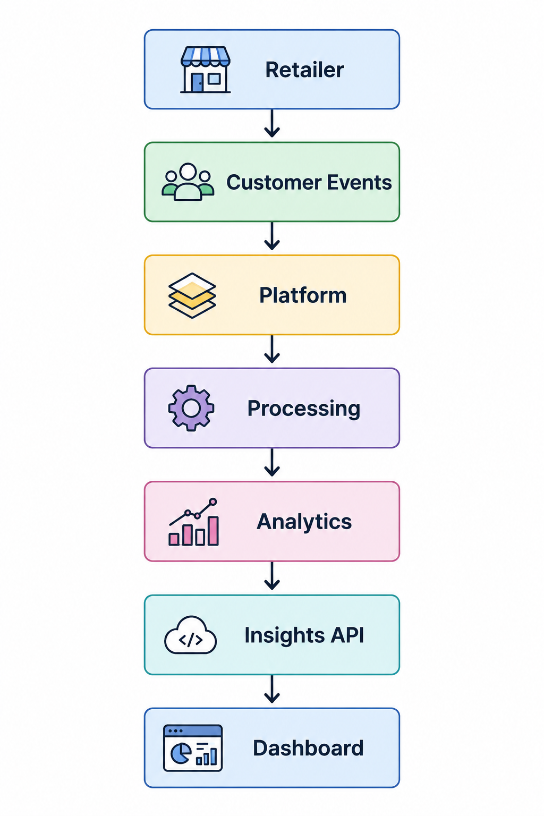

2. Business Context

Problem Statement
Retailers generate a large volume of customer interaction events through their digital channels. Processing these events efficiently is essential to provide advertisers with timely campaign insights and performance metrics.
The proposed platform addresses this need by collecting, processing, and exposing campaign analytics through secure APIs while supporting multiple retailers on a shared platform.

Business Scope

In Scope
- Customer event collection
- Event processing
- Campaign analytics
- Secure APIs
- Multi-tenant architecture
- Cloud deployment

Out of Scope
- AI recommendations
- Fraud detection
- Real-time bidding
- Multi-region deployment

3. Requirements Engineering

Functional Requirements
# | Requirement
1 | Capture customer interaction events.
2 | Process events in near real time.
3 | Aggregate campaign metrics.
4 | Expose campaign insights through secure REST APIs.
5 | Support multiple retailers (multi-tenant).
6 | Store operational and analytical data separately.

Non-Functional Requirements
Category | Requirement
Scalability | Independently scale ingestion, processing and API layers.
Availability | Highly available platform with no single point of failure.
Performance | Low latency for event ingestion and dashboard APIs.
Security | Authentication, authorization and encryption.
Observability | Centralized logging, monitoring and tracing.
Maintainability | Modular architecture with clear service responsibilities.

Assumptions
- Retailers integrate using REST APIs or SDKs.
- Customer events are immutable.
- Every request contains tenant information.
- Near real-time processing is sufficient for business reporting.

4. Capacity Planning
The following engineering assumptions are used to guide the architecture and infrastructure design.

Capacity Assumptions
Metric | Value
Daily Active Users | ~50 Million
Events per User | 40
Daily Events | ~2 Billion
Average Throughput | ~23K events/sec
Peak Throughput | ~230K events/sec
Average Event Size | 1 KB
Read / Write Ratio | 90 : 10

Workload Characteristics
Although the platform ingests a large volume of customer interaction events, the overall workload is predominantly read-heavy.
Each customer interaction generates a single write operation, while campaign dashboards, retailer portals, and advertiser reports repeatedly query aggregated metrics throughout the day. As a result, the same dataset is read significantly more often than it is written. This workload profile directly influences the architectural design.

Design Impact
Assumption | Architecture Decision
High Event Volume | Asynchronous event processing using Google Pub/Sub
Peak Traffic | Horizontal auto scaling
Read-Heavy Workload | Redis used as the primary read cache
Historical Reporting | BigQuery stores analytical data
Independent Scaling | Command and query workloads are scaled independently

Capacity Overview
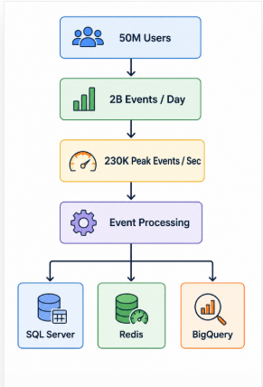

5. Architecture Principles
The proposed solution is designed using a small set of architectural principles that guide technology selection and system evolution.
Principle | Description
Cloud Native | Leverage managed cloud services and containerized workloads.
Event-Driven | Process high-volume events asynchronously.
Multi-Tenant | Support multiple retailers on a shared platform with tenant isolation.
Security by Design | Apply authentication, authorization and encryption across all layers.
Scalability | Independently scale platform components based on workload.
Observability | Enable centralized monitoring, logging and tracing.

6. Solution Overview
The platform follows a hybrid architecture where synchronous APIs are used for client interactions, while asynchronous messaging is used for event processing. This separation improves scalability, resilience and operational flexibility.

Core Components
Component | Responsibility
API Gateway | Secure entry point and request routing
Event Collector | Validate event schema, resolve tenant, generate correlation ID, validate authentication context, normalize payloads, enforce idempotency, publish events
Pub/Sub | Reliable event transport
Event Processor | Process and enrich events
Metrics Aggregator | Calculate campaign metrics
SQL Server | Operational data
Redis | Read cache
BigQuery | Historical analytics
Insights API | Provides campaign insights by serving real-time metrics from Redis and historical analytics from BigQuery through CQRS-based query handlers.

Key Design Decisions
Decision | Reason
API Gateway | Centralized security and routing.
Event Collector | Keep ingestion lightweight and validate requests.
Pub/Sub | Decouple ingestion from processing.
SQL Server | Transactional system of record.
Redis | Low-latency dashboard responses.
BigQuery | Dedicated analytical processing.

Solution Overview Diagram
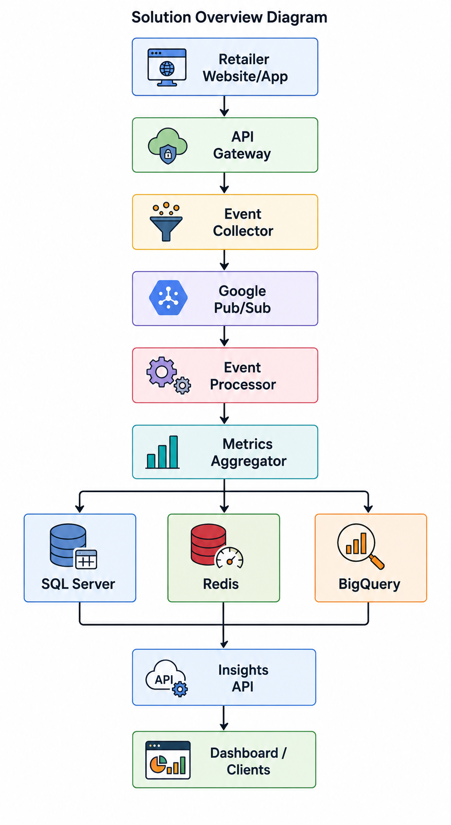

7. End-to-End Data Flow
The platform captures customer interactions from retailer applications, validates each request, processes events asynchronously, and generates campaign insights that are exposed through secure APIs.

Processing Flow
The Event Processor enriches each event with session context. The retailer SDK generates a SessionId when a user lands on the page and passes it with every subsequent event during that visit. The Processor links events sharing the same SessionId into a session window, considered complete after 30 minutes of inactivity. ClickToBasket conversion is calculated at the session level, as the percentage of sessions containing a click event that also contain a basket event, rather than as a raw ratio of total clicks to total impressions.

End-to-End Flow Diagram
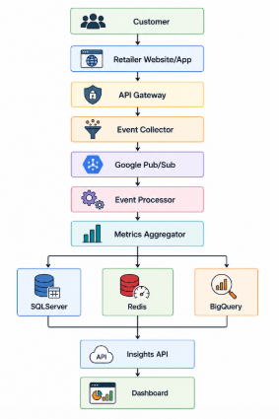

8. Deployment Architecture
The solution is deployed on Google Cloud Platform (GCP) using managed services to simplify operations, improve scalability, and reduce infrastructure management.

Deployment Components
Layer | Technology
Global Load Balancer | Google Cloud Load Balancer
Container Platform | Google Kubernetes Engine (GKE)
Messaging | Google Pub/Sub
Database | SQL Server
Cache | Redis
Analytics | BigQuery
Secrets | Secret Manager
Monitoring | Cloud Monitoring & Cloud Logging

Scaling Strategy
Each service scales independently based on its own workload instead of scaling the entire platform. This minimizes infrastructure cost while preventing bottlenecks caused by unrelated workloads.
Service | Scaling Trigger
API Gateway | HTTP request rate
Event Collector | Incoming ingestion requests
Event Processor | Pub/Sub subscription backlog
Metrics Aggregator | Aggregation queue depth
Insights API | Dashboard/API requests

Event Stream Partitioning
Google Pub/Sub subscriptions for the Processing and Aggregation consumers are configured with message ordering enabled, using CampaignId as the ordering key. This guarantees all events for a given campaign are delivered sequentially to the same consumer instance, preserving order for accurate aggregation. At the ingest side, the Event Collector publishes using TenantId as the ordering key, distributing load evenly across partitions while keeping each tenant's events on a consistent partition.

Deployment Diagram
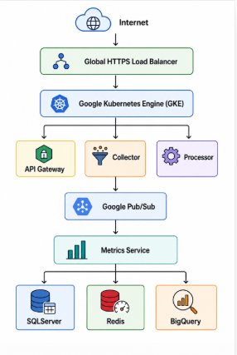

Deployment Decisions
Decision | Reason
GKE | Run scalable containerized services.
Load Balancer | Distribute external traffic.
Pub/Sub | Decouple producers and consumers.
Secret Manager | Secure application secrets.
Cloud Monitoring | Centralized monitoring and alerting.

9. Security Architecture
Security is implemented across every layer of the platform to protect customer data, tenant information, and platform resources. The solution follows a defense-in-depth approach using industry-standard authentication, authorization, encryption, and secret management.

Security Controls
Area | Implementation
Authentication | OAuth 2.0 + JWT
Authorization | Role-Based Access Control (RBAC)
Tenant Isolation | Tenant ID validation for every request
Rate Limiting | Per-tenant sliding window counter in Redis. Default 10,000 events/minute per tenant, configurable per tenant.
Encryption in Transit | HTTPS (TLS 1.3)
Encryption at Rest | Cloud-managed encryption
Secrets | Google Secret Manager
Audit Logging | Centralized audit logs

Key Security Decisions
Decision | Reason
JWT Authentication | Stateless and scalable authentication
RBAC | Fine-grained access control
Secret Manager | Secure credential management
HTTPS | Secure communication
Audit Logs | Traceability and compliance

Security Flow
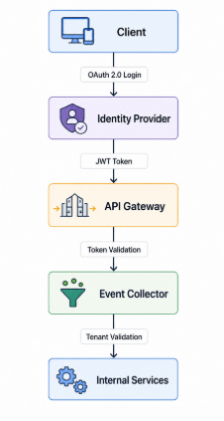

10. Data Architecture
The platform separates operational, caching, and analytical workloads to improve scalability, maintainability, and reporting performance.

Data Stores
Data Store | Purpose
SQL Server | Operational system of record
Redis | Low-latency cache for dashboards
BigQuery | Historical analytics and reporting
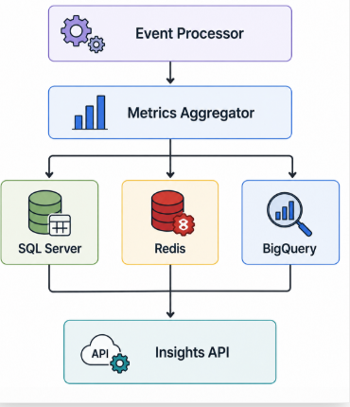

Data Strategy
Area | Approach
Operational Data | SQL Server
Cached Data | Redis
Historical Analytics | BigQuery
Read Optimization | Redis-first strategy
Analytics Updates | Asynchronous processing

CQRS Approach
The platform follows a logical Command Query Responsibility Segregation (CQRS) pattern.
Customer events are processed through the command path, where operational data is persisted and domain events are published.
Analytical queries are served through dedicated read models backed by Redis and BigQuery, ensuring that reporting workloads never impact transactional processing.
This separation enables independent scaling of write-intensive ingestion and read-intensive analytical APIs while maintaining clear ownership of operational and analytical data.

Session Read Model
The Aggregator maintains a CustomerSession read model alongside CampaignMetrics, accumulating event types per SessionId and finalizing the record once the inactivity window expires. Campaign-level conversion metrics are derived from finalized session records.

Cache Recovery
Redis counters are the live source of truth for real-time metrics, not a disposable cache, so a Redis restart would otherwise lose all in-flight campaign counts. A recovery process runs at Aggregator startup: if the cache is found empty, counters are re-seeded from the last durable snapshot in the analytics store before any live event processing resumes. Live event subscription is deliberately withheld until recovery completes, preventing a race between seeded values and concurrently-arriving events.

Key Data Decisions
Decision | Reason
SQL Server | Strong transactional consistency
Redis | Improve API response time
BigQuery | Isolate analytical workloads
Separate Data Stores | Independent scaling of workloads

Data Retention
Store | Retention Period | Action on Expiry
SQL Server (raw events) | 90 days | Archive to cold storage or delete
Redis (live counters) | No expiry | Persist for the life of the campaign; reset only by an explicit recovery-seed at startup, never by time
BigQuery (analytics) | 3 years | Move to long-term BigQuery storage tier (lower cost)

Customer interaction events contain a CustomerId, which may be considered personal data depending on jurisdiction. A soft-delete flag on CustomerEvent allows the system to mark events for erasure without immediate deletion. A scheduled job permanently removes flagged records after 30 days, satisfying most right-to-erasure timelines.

11. Observability & Reliability
The platform is designed to provide operational visibility and resilience through centralized monitoring, distributed tracing, health checks, and automated recovery mechanisms.

Observability Components
Area | Implementation
Logging | Cloud Logging
Monitoring | Cloud Monitoring
Distributed Tracing | Open Telemetry
Health Checks | Liveness & Readiness Probes
Alerting | Cloud Monitoring Alerts

Reliability Features
Feature | Purpose
Retry Policy | Handle transient failures
Dead Letter Queue | Capture failed events
Auto Scaling | Handle traffic spikes
Health Checks | Automatic service recovery
Correlation ID | End-to-end request tracing

Failure Handling
Failure Scenario | Platform Behavior
Event processing failure | Automatic retry
Retry limit exceeded | Event moved to Dead Letter Queue
Redis restarted or flushed | Recovery service detects an empty cache at startup and re-seeds all counters from the last durable snapshot before resuming live event processing; queries fall back to the last snapshot in the interim
Event Processor unavailable | Events remain in Pub/Sub until consumers recover
Metrics Aggregator unavailable | Event processing continues; aggregation resumes after recovery

Observability Flow
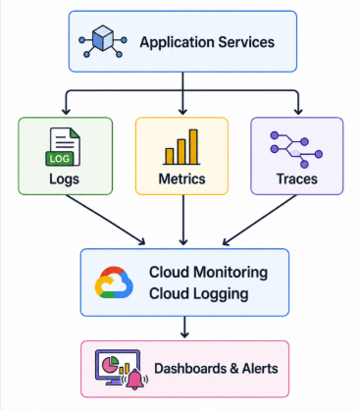

Key Metrics
The following metrics form the operational alerting baseline for the platform.
Metric | Alert Threshold | Why
Event ingestion rate | Drop > 20% from baseline | Retailer SDK or upstream outage
Processing latency P99 | > 2 seconds | Near-real-time SLA breach
Pub/Sub subscription backlog | > 10,000 messages | Consumer falling behind
Redis cache hit ratio | < 70% | Insights API over-hitting BigQuery
Dead letter queue depth | > 0 | Events being permanently lost
5xx error rate per service | > 1% | Service degradation

Cost Monitoring
Cost monitoring runs as a background concern across all services. Cloud Billing Export sends daily cost data to BigQuery, surfaced as a dashboard by service, tenant, and resource type, with alerts on per-tenant spend thresholds.
All analytical queries target tables partitioned by date and TenantId to minimize scan cost. Since Redis counters are updated on every event rather than re-fetched on a timer, the cost lever here is write volume to the durable analytics store rather than cache re-fetch frequency; batching or debouncing analytics-store writes is a natural future optimization if per-event write cost becomes significant at higher scale.

Reliability Features — Summary
Decision | Reason
Centralized Logging | Simplify troubleshooting
Distributed Tracing | Track end-to-end requests
Health Checks | Improve service availability
Auto Scaling | Handle peak workloads
Dead Letter Queue | Prevent message loss

12. Technology Decisions
The following technologies have been selected based on the functional and non-functional requirements of the proposed solution.

Technology Selection
Layer | Technology | Purpose
Cloud Platform | Google Cloud Platform | Managed cloud infrastructure
Backend | .NET 9 / C# | Backend services
API | REST | External communication
Container Platform | Google Kubernetes Engine | Container orchestration
API Gateway | API Gateway | Secure API entry point
Messaging | Google Pub/Sub | Event-driven communication
Operational Database | SQL Server | Transactional data
Cache | Redis | Low-latency reads
Analytics | BigQuery | Historical reporting
Authentication | OAuth 2.0 + JWT | Identity and access management
Secrets | Secret Manager | Secure secret storage
Monitoring | Cloud Monitoring | Metrics and alerting
Logging | Cloud Logging | Centralized logging
Tracing | Open Telemetry | Distributed tracing
Infrastructure | Terraform | Infrastructure as Code

Architecture Trade-offs
Decision | Alternative | Why Selected | Trade-off
Google Pub/Sub | Kafka | Fully managed GCP service | Less control over broker configuration
SQL Server | Cassandra | Strong consistency and relational queries | Lower write scalability
Redis | Direct SQL reads | Low-latency dashboard responses | Live counters require a recovery mechanism on restart, not just a simple re-fetch
BigQuery | SQL reporting | Optimized for analytics | Eventual consistency
Event-Driven | Synchronous APIs | Better scalability | More operational complexity

Technology Stack Overview
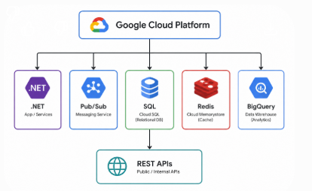

Design Summary
Area | Design Choice
Architecture | Hybrid (REST + Event-Driven)
Deployment | Cloud-Native
Scalability | Horizontal Scaling
Security | OAuth 2.0 + JWT
Data Strategy | Operational + Analytical Separation
Observability | Centralized Monitoring & Tracing

13. Future Roadmap
The proposed architecture has been designed to support future enhancements without requiring significant changes to the core platform. The modular and event-driven approach enables new capabilities to be introduced incrementally as business needs evolve.

Planned Evolution
Phase | Enhancement
Phase 1 | Retail Media Intelligence Platform
Phase 2 | AI-powered campaign recommendations
Phase 3 | Fraud detection and anomaly monitoring
Phase 4 | Multi-region deployment
Phase 5 | Multi-cloud readiness

Future Architecture
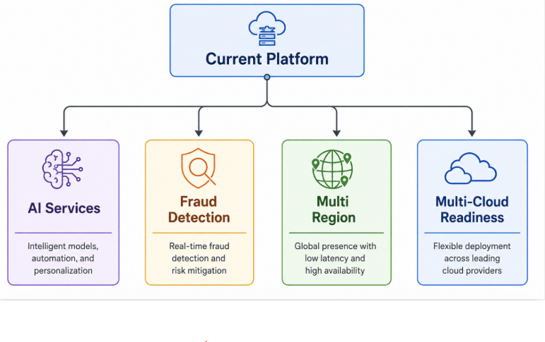

Future Design Goals
Goal | Benefit
AI Integration | Improve campaign optimization
Multi-Region Deployment | Improve availability and disaster recovery
Multi-Cloud Readiness | Reduce cloud provider dependency
Advanced Analytics | Deliver richer business insights

14. Challenges and Trade-offs
This chapter anticipates potential challenges in the platform and explains the trade-offs consciously made between real-time performance, data accuracy, operational complexity, and cost.

14.1 Real-Time Performance vs. Data Accuracy
Pub/Sub delivers events at-least-once, not exactly-once. Under network failures or consumer restarts, the same event can be delivered twice. Processing it twice would double-count a click.
- Chosen resolution: Idempotent event handlers using CorrelationId as a deduplication key. This adds a Redis lookup per event but eliminates double-counting.
- Alternative rejected: Exactly-once processing via distributed transactions. This guarantees accuracy but adds significant latency (two-phase commit across SQL Server and Pub/Sub acknowledgement) and reduces throughput under load.

14.2 SQL Server vs. NoSQL for Raw Event Storage
SQL Server provides ACID transactions and a familiar operational model, but its write throughput is lower than purpose-built event stores like Cassandra or DynamoDB at extreme scale.
- Chosen resolution: SQL Server with horizontal sharding by TenantId for the first phase. The IRawEventStore interface isolates this decision, so migrating to Cassandra later is an infrastructure change, not a business logic change.
- Trigger to revisit: when single SQL Server instance write throughput exceeds 80% capacity at peak load.

14.3 Eventual Consistency in the Analytics Pipeline
The path from event ingestion to a readable metric involves four steps: Collector persists, Pub/Sub delivers, Processor enriches, Aggregator writes. Each step adds latency. A marketer querying immediately after an event fires may not see it reflected for several seconds.
- Chosen resolution: Near-real-time is sufficient for campaign reporting. Metrics dashboards do not need sub-second accuracy. This allows each component to be independently scaled and deployed without synchronisation.
- Not appropriate for: billing or financial reporting, which would require stronger consistency guarantees.

14.4 Shared Platform vs. Dedicated Infrastructure per Tenant
A shared platform (one Pub/Sub topic, one GKE cluster) reduces cost but introduces the noisy neighbour problem, where one high-volume tenant degrades processing for others.
- Chosen resolution: Rate limiting per tenant at the Collector layer controls event volume. Pub/Sub partitioning by TenantId ensures fair scheduling. Resource quotas at the GKE namespace level isolate compute.

14.6 Live Cache Counters vs. Disposable Cache with TTL
Campaign metrics could be served from a disposable cache that is periodically re-fetched from the analytics store on a timer, or from Redis counters that are updated atomically on every event and treated as the live source of truth for real-time queries.
- Chosen resolution: Atomic Redis counters as the live source of truth, incremented directly by the Aggregator on every event, backed by a startup recovery process that re-seeds counters from the last durable snapshot if the cache is found empty. This removes read staleness entirely under normal operation and removes TTL tuning as an ongoing cost lever.
- Alternative rejected: A disposable cache re-fetched on a fixed TTL. Simpler to reason about and requires no recovery mechanism, but bounds freshness to an arbitrary time window rather than being genuinely live, and does not remove the underlying risk of a lost read-modify-write race the way an atomic counter does.
- Trade-off accepted: live counters require an explicit recovery mechanism to survive a cache restart, which is more moving parts than a simple TTL re-fetch. The recovery service exists specifically to carry this cost.

15. Conclusion
The proposed architecture is designed to balance scalability, maintainability, and operational simplicity while supporting billions of customer interaction events per day. By combining asynchronous event processing, multi-tenant isolation, CQRS-inspired data separation, and managed cloud services, the platform provides a scalable foundation that can evolve incrementally as business requirements grow. The architecture leverages managed Google Cloud Platform services together with .NET, SQL Server, Redis, and BigQuery to deliver a maintainable and extensible solution aligned with current business requirements and future growth.

Solution Summary
Area | Proposed Solution
Architecture | Hybrid (REST + Event-Driven)
Cloud Platform | Google Cloud Platform
Backend | .NET / C#
Messaging | Google Pub/Sub
Operational Database | SQL Server
Cache | Redis
Analytics | BigQuery
Deployment | Google Kubernetes Engine
Security | OAuth 2.0, JWT, RBAC
Observability | Cloud Monitoring, Cloud Logging, Open Telemetry

Key Outcomes
- Cloud-native and scalable architecture.
- Secure multi-tenant platform.
- Near real-time event processing.
- Operational and analytical workload separation.
- Production-ready deployment model.
- Extensible foundation for future capabilities.

