Macintosh HD:Users:volker_belli:Desktop:back.png

Titel

**2014**

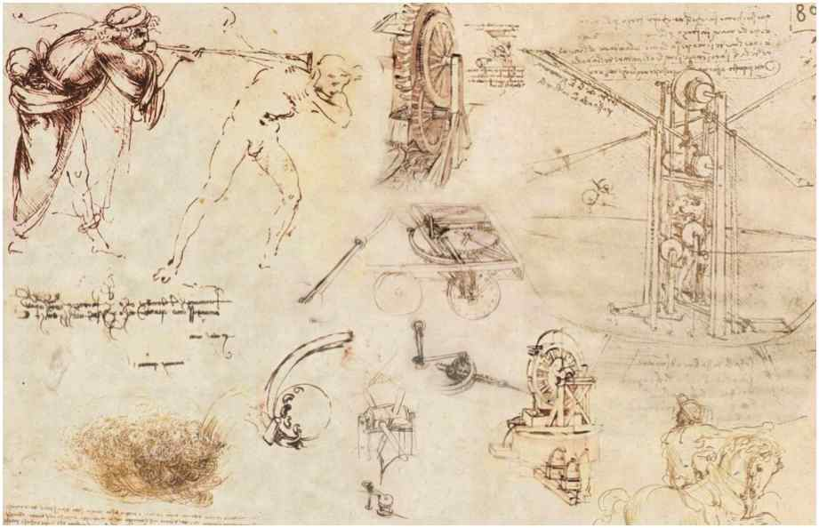

Autor: Volker Belli

Geändert: 2014-02-10

Version: 29

Example Page – will be deleted

# Heading 1

## Heading 2

### Heading 3

#### Heading 4

##### Heading 5

###### Heading 6

Heading 7

Heading 8

Heading 9

Text Body

Unordered List

* dfsdsdf
  + sadsd
    - fsdfdsf

Ordered List

1. Ordered List 1
   1. Ordered List 2
      1. Ordered List 3

Little piece of preformatted

code block

|  |  |
| --- | --- |
| TableHeader |  |
| TableBody |  |



Caption