How large is your network?
Estimating Network Size of Residents in the Netherlands

Authors

Abstract

Keywords

INTRODUCTION

Since the beginning of network research, scholars tried to measure the size of a person’s social network, that is, basically, the total number of people one knows personally (REF). The quantity of connections within people’s social networks reflects the level of social interconnectedness and, ultimately, the social cohesion of that society. The larger personal networks are on average in a given population, the greater the chances of network overlap and hence the probability that people could reach each other via a small number of links. These considerations were, a.o., the point of departure of the famous small world studies (Milgram 1967, Dodds, Muhamad, Watts 2003), who showed, however, that societies are segregated, and many networks do not intersect.

At the micro level, social network size is linked to a diverse set of outcomes. Larger networks are associated with increased access to social capital, such as being connected to influential persons (Van Tubergen and Völker 2015). People with larger networks are also more likely to receive support in case of need (REF).
Furthermore, evidence suggests that network size is positively linked to individual’s mental health and well-being (e.g., Stokes 1983, Penninx et al. 1999, Wang 2016, Bidart 2020). Studies show, for example, that people with smaller networks related face enhanced mortality risks (Schutter et al. 2022, Laugesen et al 2018, Domènech-Abella et al 2019 cf Berkman and Syme 1979). In addition, in larger networks, just by chance more types of ties and persons are represented, implying that heterogeneity is larger. In the famous common cold study (Cohen et al. 1997) the greater number of different types of ties in a personal network boosted the resistance to respiratory illness.
More in general, network size has consequences for the micro-level of the individual as well as for the macro-level such as neighbourhoods, regions, or countries. As to the individual consequences of network size, it has been shown that

larger networks are associated with more political knowledge, tolerance, as well as civic and political participation (REF). In addition and due the fact that the number of very close contacts is usually tight, larger networks are composed of more weak ties than smaller ones (Gil de Zúñiga & Valenzuela, 2011,cited in Eveland et al 2013). As to the social consequences on the macro level, network size is the mechanism behind the small world effect and responsible for diffusion of innovation (REF).

Given its importance at the micro and macro level, scholars have attempted to describe and explain variation in personal network size -across social groups, space and place (REF).

Most of these studies, however, were directed to the stronger part of a person’s network. In particular, scholars have examined the ‘core discussion networks’ of individuals, which captures the number of alters to whom people turn to discuss important matters (REF). Relatedly, research has been done on people’s ‘sympathy’ and ‘affinity’ network, which reflects people’s strong tie network beyond the inner core (REF). Prior work studied how the size of these strong-tie networks changed over time (REF), and how the size of the strong-tie networks varies across social groups, such as gender, age, race and ethnicity (REF).

While research on the quantity of strong ties is relatively well-established, much less attention has been paid to the ‘extended’ social network, which is made of acquaintances. Such weaker ties are more difficult to measure and often explicitly excluded from network delineation. A seminal study is Gurevitch (1967), who analyzed diaries of the encounters of 27 persons from relatively different social strata, who also differed in age and gender, during a period of 100 days. He showed the large dissimilarities in the social universe for people at the lower as opposed to the higher rungs on the social ladder. In particular, people from higher social strata not only meet more others during their day, but they also meet more distinctive people in every setting they enter. All in all, the range in network size was very large. During the research period, some persons met - roughly - 100 other persons, while others encountered more than 5000 unique others. (CHECK NOG EENS).

In the footsteps of Gurevitsch, a variety of methods have been used to estimate people’s extended network (REF), such as contact diaries (REF), the number of Christmas cards people send (REF), and connections on social media (REF), and surveys (REF). To date, however, most studies have relied on convenience samples, which could introduce biases in the estimate of the volume of acquaintanceship networks, and its correlates. An exception is the study of Lubbers et al. (2019), who relied on a nationally representative survey of the population of Spain.

In this paper, we contribute to the dearth of research on the volume and determinants of extended social networks. First, like Lubbers et al. (2019), we use large-scale, nationally representative survey data. We draw on evidence from the Netherlands, and compare our findings to that of Lubbers et al. Second, we provide improved measures of the scale-up method.. XX Bas.. kan jij dit uitwerken.. kunnen we bijv. laten zien wat er gebeurt als je netwerkomvang met 5X, 10X, 25X meet -veranderen resultaten dan? an unusually large number of ‘Xs’ for the estimation has been implemented in the questionnaire. XX

THEORY

Determinants of network size

Given the lack of a systematic theory of the determinants of extended network sizes (Kadushin, 2012)
, we rely on the literature on core networks to derive hypotheses on individual and structural determinants of network size, using Fischers’ choice-constraint approach (Fischer et al., 1977), which assumes that social relations are the results of individual choices (“demand”) made under social constrains (“supply”). This is in line with Lubbers et al (2019) who also assumed that the structure and composition of an individual extended or acquaintance network follows that of core discussion networks and depend on the same factors. In particular, and following Hofstra et al. (2021), we build on the notions of opportunity structures for the supply side, and homophily and cognitive ability for the demand side.

First, the literature on core discussion networks highlights that social contexts shape social networks by creating opportunities to meet (Blau, 1977). Feld (1981:1016) coined the term foci to describe such contexts: “social, psychological, legal, or physical entity around which joint activities are organized”. Key examples of such contexts include workplaces (Zheng et al., 2006), associations (Mollenhorst et al., 2008a), neighborhoods (Fischer et al., 1977; Mollenhorst et al., 2008b), and educational settings (Hofstra et al., 2017; Wimmer & Lewis, 2010). Second, in addition to this “supply side” of social relations, we assume that homophily preferences play a key role in the “demand side”. Here, “homophily” refers to the individual tendency (rather than to the resulting pattern of relationships) to associate with similar individuals, which in turn is the result of various psychological mechanisms (McPherson et al., 2001). Third, also on the demand side, we assume that systematic differences in cognitive abilities between social groups when it comes to handling social relationships contribute to variation in network size (Brashears et al., 2016).

Building on these mechanisms, we derive a number of hypotheses on how key demographic and socioeconomic factors are associated with extended network size. First, relying primarily on the mechanism of meeting opportunities, we expect that respondents who are employed have larger networks than those who do not work, as the workplace provides them with more opportunities to establish relationships. Similarly, we expect respondents who live in larger households to have larger networks, because 1) a partner provides access to additional contacts (Hofstra et al., 2021; Van Tubergen et al., 2016), and 2) children provide additional meeting opportunities (e.g., daycare, schools, children’s friends’ parents, etc.).

We expect furthermore that network size is positively correlated with income as an indicator of occupational prestige, as individuals who are in higher positions in organizations are expected to interact with more different people. In addition, we follow the studies that have demonstrated that network size declines with age (Wruz 2013, Cornwall et al. 2014). Older people are less mobile and meet others before all in their neighborhood and not beyond, while illness and mortality are higher in networks of older people. Finally, crucial life events and transitions clearly influence network size, such as getting married, divorced, unemployed, widowed or becoming a parent.

Second, we combine the mechanisms of opportunity and homophily to derive a hypothesis on the relation between ethnic background and extended network size, following Hofstra et al. (2021). They argue that, while individuals in general have a tendency to associate with others of the same ethnicity, the opportunities to do so are more constrained for members of ethnic minorities, simply because (by definition) there are fewer individuals of the same ethnicity available in the population. Even when social contexts are segregated by ethnicity, which implies that individuals of the same ethnicity are disproportionately represented in social contexts, extended networks, being larger, are less affected by this. Indeed, for adolescents in high schools, Hofstra et al. (2021) find that extended networks tend to be smaller for members of ethnic minorities (also see Hofstra (2017), who shows that while core ties tend to be segregated, extended networks of adolescents of minority backgrounds are more diverse than those of majority backgrounds, which is consistent with the mechanism). Thus, we expect respondents with migration backgrounds to have smaller social networks.

Finally, we assume that there are systematic differences between social groups when it comes to managing social relationships, which could be partially caused by cognitive differences and also to differing social roles. Following the literature, we expect women to have larger networks than men (Lubbers et al. 2019, Brashears et al., 2016), and we expect higher educated individuals to have larger networks than lower educated individuals.

Table 1 summarizes our expectations.

METHODS

Data

The Dutch Network Size Survey (hereafter: DNSS) were collected by a professional field work agency that employed a continuous representative panel all over the Netherlands. Respondents answered the questions online. They did not receive any incentive.
People were invited to participate in a survey on their networks and signed a consent form. The survey was to be completed online and lasted about 10-15 minutes. The response rate was 90%. Appendix 1 provides the questionnaire.

The Network Scale-up Method

Although not being able to solve all these issues, the scale-up method is considered as a more appropriate method to measure general network size, independent of type or content of relationships. In this method respondents recall their network members from a presented list of names or occupations. Since the prevalence of these “Xs” in the population is known, the network size of the respondent can be ‘scaled up’ (Freeman and Thompson 1989). The method has usually been applied for the estimates of hidden or unknown populations, such as the number or victims in an earthquake (Bernard et al. 1991), or the number of heroin users (Kadushin et al. 2006). But the method also offers the possibility to estimate network size in more general populations. Unlike to other network estimators, the method does not rely on the delineation of individual network members but collects the numbers of people known with a specific characteristic, so called aggregated relational data. Respondents answer questions of the type ‘How many individuals do you know who are called Jim?’ These questions constitute the estimators or the Xs in the analysis. For example, a respondent is asked how many twins she knows. If she knows 3 twin-couples, from a total number of 10 million twins in a population of 330.000.000, it would be estimated that she knows about 3/10 million of the population which is

(3/10000000) x 330000000=99

This is often called the “basic scale-up estimator”. This calculation becomes more precise if more questions of this type are added and responses can be averaged. McCormick, Salganik and Zhen (2010) applied the method in an adult sample of 1370 US residents, while presenting them a list of male and female given names. The estimated median network size was 610, but method of estimation mattered, next to respondent characteristics.

Also, DiPrete et al. (2011) applied the technique using the 2006 GSS data and showed that networks of US residents are heavily segregated along political attitudes, religion and social behaviors, divides that are almost as strong as the divides along races.

More recently, Hofstra, Corten and Van Tubergen (2021) showed variation in youth network sizes, while applying the scale up method in a sample of 5,921 adolescents in the Netherlands. Amongst others, they found that network size was predicted by gender and ethnicity, but that engaging in many social foci also enhances the size of the network. (…)

This paper builds upon this work, while using a representative adult sample (n=1300) from the population in the Netherlands and employing relatively many Xs (see Appendix 1 for the questionnaire).

Network Scale-up Instrument in the DNS
In the DNSS survey, respondents read the following NSUM-prompt:

In the following, we ask you a number of question about persons you know. With “know” we mean persons in the Netherlands you know personally by name and with whom you would have a chat if you met them. For all questions: if you know a person with that feature, report how many person in your network have that feature.

We survey respondents about three different batteries of X’s. The first battery are six X’s about knowing someone whom “in the last 12 months” graduated from university, university of applied science, tertiairy vocational education, had a son/daughter, gave birth to twins, or was infected with the COVID-19 virus. The second battery are three X’s on knowing someone who “drives an electric vehicle,” “drives a scooter,” and “is vegan.” The third 34 X’s are about whether and how many others they know carrying a specific name (e.g., “Sophie,” “Daan,” “Noor,” and so forth). We selected these names and categories on the basis of… [?Rense & Beate?]. Respondents in all three batteries indicated first whether they know someone with that feature (yes/no) and then reported the number of persons that they know carrying that feature. See Appendix A for our list of NSUM-categories and their population sizes during the time of the survey.

Network Size Estimation Strategy
NSUMs assume that a person’s social network represents the population, which is not without problems. In general, three problems may bias NSUM estimates (McCormick, Salganik and Zheng 2010): transmission errors, barrier effects and recall errors. Transmission errors simply occur if a respondent does not know whether a person she knows belongs to a certain group (e.g., not knowing whether someone gave birth). Barrier effects occur since networks are not random or no perfect reflection of the population. People know many people who are alike themselves but much fewer who are different. Finally, recall errors are made in very large or very small populations: numbers in smaller populations are overestimated, while numbers in larger populations are underestimated (Zheng, Salganik, and Gelman 2006).

By carefully curating a selection of Xs, we already ameloriate some of these issues. For instance, our Xs crosscut social groups by age, social class, and ethnic background (reducing barrier effects), consist mostly of names (likely reducing transmission errors), and consist of large number of Xs (likely reducing or avering out recall error). Yet, to err on the side of caution, we follow Maltiel et al. (2015) who propose Baysian methods using Markov Chain Monte Carlo algorithms so as to further reduce barrier effects and transmission errors in the network size estimations. In short, this procedure includes a random effect to regularize degree estimates, allows probabilities that a person knows someone on a given group vary randomly across individuals, and adds a multiplier to the binomial proportion of persons known in a category. We use the NSUM R package (Maltiel and Baraff 2015), and refer to Maltiel et al. (2015) for details on the estimation procedure. We extract starting values from the basic scale-up estimator, run 40,000 estimations of the algorithm (burnin = 1,000), and retain 4,000 chains from which we extract an average network size per respondent.

Finally, as NSUM network sizes vary substantially depending on the selected X-categories, we take an additional step as an attempt to account for this. We run each estimation of network size and hold out an X-category to find out if network sizes vary under different X-category selections. We coin this the “brute-force” approach. In our paper, we estimated individual network size 43 times and each time hold out a different X-category. We then repeated this with different TauK regimes (the assumed transmission errors in the model, here: low, medium, high, very high). Essentially, this implies we estimated 172 (= 43 X-categories*4 TauK regimes) network sizes per individual. Note that the point-estimates of network size might vary. Yet, one of the key endeavors of this paper is to model variation between individuals rather than to arrive a fixed number. If intra-person correlations between different estimands are high, we can assume that the network size variation is highly consistent between individuals and independent from held out X-categories. This is the measure we use for our inferential analyses.

We also select a number of X-categories and calculate network sizes for descriptive analyses and comparisons on the basis of the naïve estimator (e.g., Hofstra et al. [2021], Equation 2). We report which X-categories we use when we discuss those comparisons.

Independent variables
We construct a vector of independent variables that we then relate to our estimated network sizes.

Respondents were asked to report their current employment status (e.g., self-employed, retired, working for government, currently a student, working in industry, and so forth). We construct a binary variable that indicates whether respondents work (yes/no).
We also measure how many persons live in the household that the respondent lives in (household size).
Respondents reported their income in seven intervals in the survey (e.g., minimum income [<€14,100], more than twice modal income [>€87,100], and so forth). We created a categorical variable income that indicated whether respondents earn up to modal income (1), earn a modal income or more (2), or whether respondents do not want to report or do not know their income, or are missing altogether (3). We include this last category so as to not further decrease our case count. We
also measure an integer variable denoting age divided by ten (age/10).

We consider a variable that labels respondents’ migrant background (none, Western, non-Western) on the basis of their parental birth countries. If one or both of the parents are not born in the Netherlands, we assign a migration background to the respondent that is either Western (Europe, North-America, and Oceania) or non-Western (Africa, Latin-America, Asia [excluding Indonesia and Japan], and Turkey). Mothers’ birth countries take precedent if parental birth countries do not overlap, with the exception of a non-Dutch father and a Dutch mother. This measure is standard practice in research on migration background in the Netherlands (Castles et al. 2013).
We construct indicator for biological sex where respondents reported to be a women (yes/no, biological sex) and with indicators for whether

respondents completed primary or secondary education (yes/no, Dutch “Basisschool/VMBO/Onderbouw Havo/VWO”), lower tertiary education (yes/no, Dutch “MBO), or (preparatory) higher tertiary eduction (yes/no, Dutch “Bovenbouw Havo/VWO/HBO/University”) (educational level).

Control variables

We measure respondents’ neighborhood characteristics by considering the zipcodes indicating where they live. To do so, we merge neighborhood information of Statistics Netherlands (Statistics Netherlands 2021) to respondents’ four-digit zipcodes available in the survey data. Those data contain neighborhood information on housing (house values based on tax records) and its population. We control for respondents’ neighborhood density divided by 1,000 and mean neighborhood house values based on tax records divided by 100,000 (Dutch “WOZ-waarde”).

Handling of missing values
Within the estimated network size set of N = 1,263 respondents, biological sex, age/10, and educational level do not contain any missing values. The birth country of respondents’ fathers and mothers contain six and four missing values, respectively. The four missing values of mothers’ birth countries are entirely contained in fathers’ birth countries, thus resulting in four missing values on migration background – i.e., if one of the parents has a nonmissing birth country, we label a migration background according to that parent. Current employment situation and household size have two and one missing values, respectively. Income and political left/right have 37 and 135 missing values, though these are binned into the “Other” category as we describe above. Matching neighborhood information from Statistics Netherlands to respondents’ zipcodes results in eight missings on house tax values and four missing values on population density (these four are entirely contained within the eight missing values of house tax value). By deleting missing values listwise we have an effective sample of N = 1,249 respondents, or 1.1 percent missing data in our independent variables. Table 1 depicts the descriptive statistics of our independent variables and Table 2 shows the correlations between the binary, ordinal, and continuous variables.

Table 1. Descriptive statistics of independent and control variables in the analyses
 |  | N |  | Mean/Proportion |  | SD |  | Min. |  | Max.
Working |  | 1249 |  | 0.53 |  |  |  | 0 |  | 1
Household size |  | 1249 |  | 2.13 |  | 1.12 |  | 1 |  | 8
Income
< modal |  | 627 |  | 0.50 |  |  |  | 0 |  | 1
> modal |  | 440 |  | 0.35 |  |  |  | 0 |  | 1
Unknown |  | 182 |  | 0.15 |  |  |  | 0 |  | 1
Age/10 |  | 1249 |  | 5.18 |  | 1.69 |  | 1.8 |  | 88
Migation backgroumd
Dutch |  | 1131 |  | 0.91 |  |  |  | 0 |  | 1
Western |  | 62 |  | 0.05 |  |  |  | 0 |  | 1
Non-Western |  | 56 |  | 0.04 |  |  |  | 0 |  | 1
Woman |  | 1249 |  | 0.51 |  |  |  | 0 |  | 1
Education
Primary/Secundary |  | 313 |  | 0.25 |  |  |  | 0 |  | 1
Tertiary low |  | 292 |  | 0.24 |  |  |  | 0 |  | 1
Tertiary high |  | 644 |  | 0.52 |  |  |  | 0 |  | 1
Neigborhood density |  | 1249 |  | 1.88 |  | 1.62 |  | 0.01 |  | 10.69
WOZ-values |  | 1249 |  | 2.67 |  | 0.89 |  | 0.95 |  | 9.96

Table 2. Correlations between variables (binary, ordinal, or continuous)
 | Household size | Age /10 | Woman | Education | Neighborhood Density |  | WOZ-values
Work | 0.14 | -0.39 | -0.06 | 0.26 | 0.08 |  | 0.11
 | 0.00 | 0.00 | 0.03 | 0.00 | 0.00 |  | 0.00
Household size |  | -0.26 | 0.04 | 0.08 | -0.11 |  | 0.06
 |  | 0.00 | 0.16 | 0.00 | 0.00 |  | 0.05
Age/10 |  |  | 0.00 | -0.32 | -0.27 |  | 0.04
 |  |  | 0.93 | 0.00 | 0.00 |  | 0.13
Woman |  |  |  | -0.05 | -0.01 |  | 0.06
 |  |  |  | 0.07 | 0.64 |  | 0.03
Education |  |  |  |  | 0.17 |  | 0.14
 |  |  |  |  | 0.00 |  | 0.00
Neighb. dens. |  |  |  |  |  |  | 0.03
 |  |  |  |  |  |  | 0.32
Note: P-values are presented in italics below the Pearson correlations

RESULTS
Network Size Estimates
One of the questions of this paper concerns how many (different types of) X’s one needs to get at comparable network size estimates. Figure 1 provides an answer to that question and calculates network sizes using the naïve NSUM estimator with different X-categories. The X-axis provides network size estimates, the Y-axis densities, and the legend shows which X-categories were used for plotting specific density lines. The first battery (education, births, etc) and the second battery (electric vehicle, scooter, vegan) both result in considerably more right-skewed yet lower network sizes compared to all X-categories (black line). Both correlate low with one another (r = 0.19) yet higher with the size estimate using all X-categories (battery 1 r = 0.47; battery 2 r = 0.42). If we include only names in the naïve estimator, the densoity line closely follows the line using all categories, and these two correlate highly (r = 0.94). This latter finding shows how the naïve estimator is mostly driven by the 34 names as X-categories. Logically so, as they take up the large majority of X-categories. Using only a small subsets of four names lead to lower correlations (from Figure 1, names 1 r = 0.53; names 2 r = 0.62, names 3 r = 0.65), though increases again if we use more names (names 1+2+3 r = 0.78). In sum, the combination of X-categories do make the estimand more precise, though the number of names take the largest role in this process given our selection of X-categories.

Perhaps most interesting is how the naïve estimator corresponds with those network size estimates generated by the Bayesian method. As we show below, most estimations using the Baeysian methods correlate very highly, but if we take a random sample of 5 Bayesian estimations they only correlate between .45 and .50. This implies that the Bayesian method ameloriates biases that render the study of variation between groups (next sections) more valid.

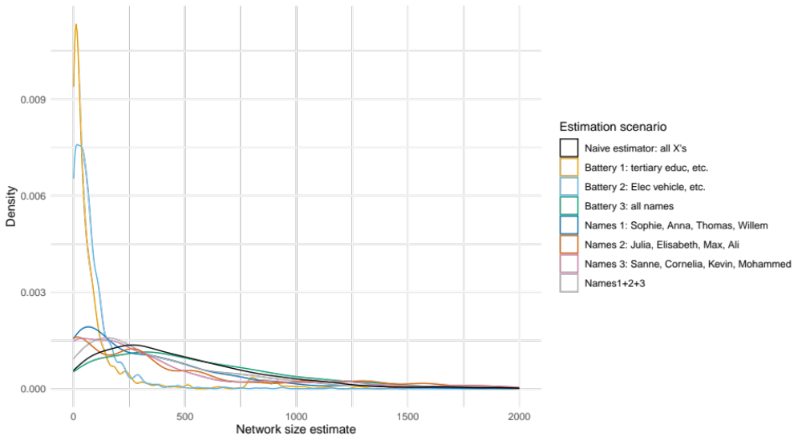
Figure 1. Network size estimators using different subsets of X-categories.

Figure 2 depicts the results of all of our 172 network size estimations. In Panel A, we observe the density distribution of all correlations between all the 172 different scenarios. In short, correlations are very high and more than 98% of the correlations is even higher than .95. This is also reflected in the density distributions of network size itself in Panel B, where we observe that distributions are alike – i.e., carrying a long tail, where many respondents have a medium number of estimated acquaintances, and only few respondents have very many. The median and mean network size over all of these scenarios is about 379 and 540 acquaintances, respectively.

Figure 2. Panel A depicts the correlations between network sizes in different scenarios. 98.5 percent of all these correlations are higher than .95. Panel B depicts the density distributions of the network sizes in the different scenarios, suggesting highly similar distributions. Median network size is about 379, and the average is about 540.

Determinants of Network Size
We run a series of different regression models of acquaintanceship network size on our independent variables. These regression models take the form of linear regression models with the log of acquaintanceship network size as dependent variables. For the sake of space, we present the results of linear regression models in the paper, though the main effect findings are robust to negative binomial regression model specifications.

Figure X depicts how our independent variables relate to logged acquaintanceship network size. The hollow black dots are coefficients and the grey whiskers are confidence intervals of 172 negative binomial regressions – i.e., regression models of all our network size scenarios. Coefficients do not significantly deviate from zero if confidence intervals cross the vertical zero line.

Five results merit attention in these regression results. First, younger individuals seem to have larger networks, or, vice versa: as individuals grow older, their number of acquaintanceship ties decrease. Second, those who live in households with more persons have significantly larger acquaintanceship networks. Third, those who are currently in some way (self-)employed have larger networks than those respondents who are not employed. Fourth, it seems that those who choose not to vote, vote “blanco,” or who have missing values there, have significantly smaller networks compared to politically right-leaning individuals. Fifth and most interestingly, those in the highest education track have significantly larger networks compared to those in the other two education tracks, though the contrast between the lowest and middle track is not statistically significant (not shown). To give some semblance of the effect size, we draw on the results of linear regression models without logged dependent variables. The linear regression coefficients across all network size scenario results indicate that the lowest and middle education tracks have about 110 and 90 acquaintanceship ties less, respectively, compared to the highest education track. Note that all these education results are incredibly robust across the regression results of all network size scenarios.

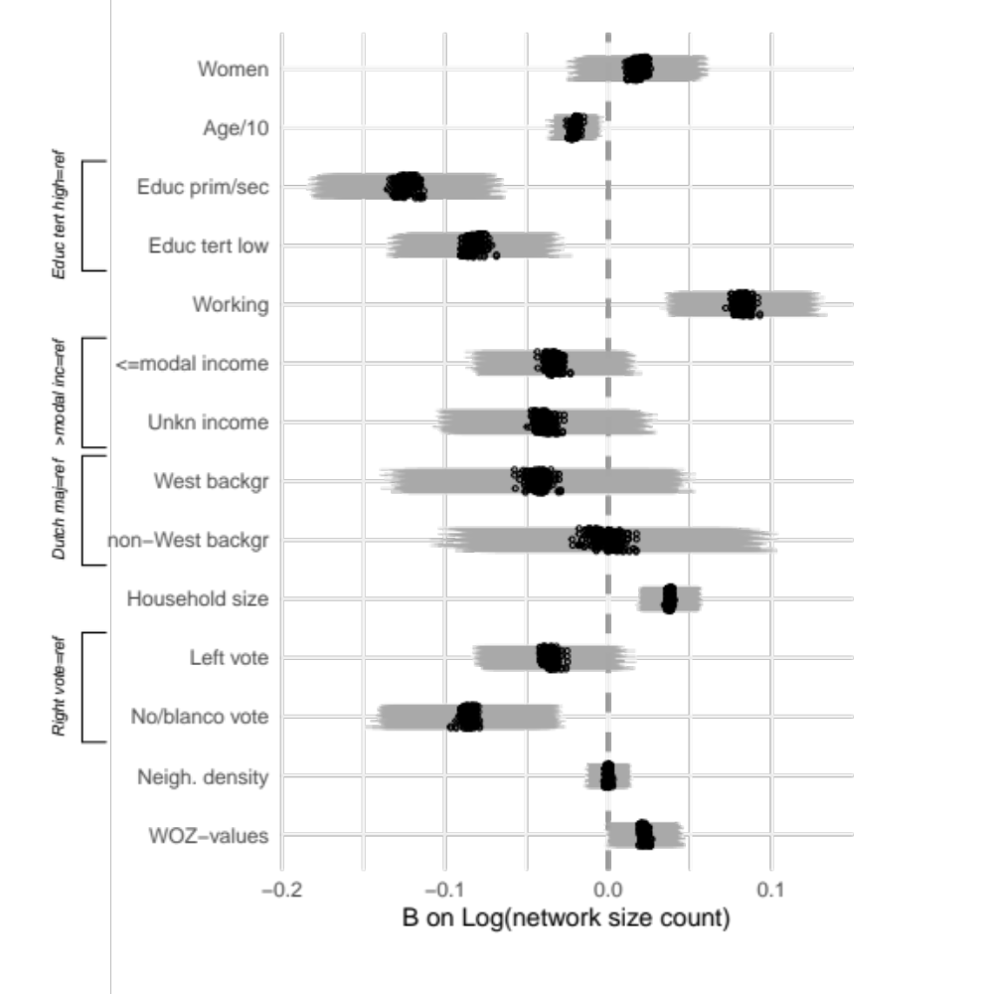

Figure X. Regressions of logged acquaintanceship network size (all scenarios) on covariates.

CONCLUSIONS AND DISCUSSION
- Reflect: large number of Xs, carefully curated
- Reflect: brute-force approach checking for sensitivity
- Reflect: comparison blocks of X’s

REFERENCES

Bernard, H. R., Johnsen, E. C., Killworth, P., and Robinson, S. (1991). Estimating the Size of an Average Personal Network and of an Event Subpopulation: Some Empirical Results. Social Science Research, 20, 109–121.

Berkman, L. F., & Syme, S. L. (1979). Social networks, host resistance, and mortality: a nine-year follow-up study of Alameda County residents. American journal of Epidemiology, 109(2), 186-204.

Bickart, K. C., Wright, C. I., Dautoff, R. J., Dickerson, B. C., & Barrett, L. F. (2011). Amygdala volume and social network size in humans. Nature neuroscience, 14(2), 163-164.

Bickart, K. C., Hollenbeck, M. C., Barrett, L. F., & Dickerson, B. C. (2012). Intrinsic amygdala–cortical functional connectivity predicts social network size in humans. Journal of neuroscience, 32(42), 14729-14741.

Bidart, C. (2020) Living in Networks. The Dynamics of Social Relationships. Cambridge University Press. Cambridge, UK.

Bernard, R. H., Johnsen, E., Killworth, P., & Robinson, S. (1991). Estimating the size of an average personal network and of an event subpopulation: Some empirical results. Social Science Research, 20(2), 109–121.

Castles Stephen, de Haas Hein, Miller & Mark J. (2013). The Age of Migration: International Population Movements in the Modern World, 5th ed. New York: The Guilford Press.

Cohen, S., Doyle, W. J., Skoner, D. P., Rabin, B. S., & Gwaltney, J. M. (1997). Social ties and susceptibility to the common cold. Jama, 277(24), 1940-1944.

Cornwell, B., Schumm, L. P., Laumann, E. O., Kim, J., & Kim, Y. J. (2014). Assessment of social network change in a national longitudinal survey. Journals of Gerontology Series B: Psychological Sciences and Social Sciences, 69(Suppl_2), S75-S82.

de Sola Pool, I., & Kochen, M. (1978). Contacts and influence. Social networks, 1(1), 5-51.

de Sola Pool, I., & Kochen, M. (2011). Contacts and influence. In The structure and dynamics of networks (pp. 83-129). Princeton University Press.

DiPrete, T. A., Gelman, A., McCormick, T., Teitler, J., & Zheng, T. (2011). Segregation in social networks based on acquaintanceship and trust. American journal of sociology, 116(4), 1234-83.

Dodds P. S., Muhamad R., Watts D. J. (2003). An experimental Study of search in global networks. Science 301, 827-879.

Domènech-Abella, J., Mundó, J., Haro, J. M., & Rubio-Valera, M. (2019). Anxiety, depression, loneliness and social network in the elderly: Longitudinal associations from The Irish Longitudinal Study on Ageing (TILDA). Journal of affective disorders, 246, 82-88.

Freeman, L. & C. Thompson (1989) Estimating acquaintanceship volume. Pp1470158 in M. Kochen (ed) The Small World. Norwood, NJ:Ablex.

Gurevitch, M. (1961). The social structure of acquaintanceship networks (Doctoral dissertation, Massachusetts Institute of Technology).

Hill, R. A., & Dunbar, R. I. (2003). Social network size in humans. Human nature, 14(1), 53-72.

Hofstra, B., Corten, R., & van Tubergen, F. (2021). Beyond the core: who has larger social networks? Social Forces, 99(3), 1274-1305.

Kadushin, C., Killworth, P., Bernard, H., & Beveridge, A. (2006). Scale-up methods as applied to estimates of heroin use. Journal of Drug Issues, 36(2), 417.

Killworth, P. D., Johnsen, E. C., Bernard, H. R., Shelley, G. A., & McCarty, C. (1990). Estimating the size of personal networks. Social Networks, 12(4), 289-312.

*Kochen, M. (Ed.). (1989). The small world. New York, NY, USA: Ablex Pub.

Laugesen, K., Baggesen, L. M., Schmidt, S. A. J., Glymour, M. M., Lasgaard, M., Milstein, A., ... & Ehrenstein, V. (2018). Social isolation and all-cause mortality: a population-based cohort study in Denmark. Scientific reports, 8(1), 4731.

Lubbers, M. J., Molina, J. L., & Valenzuela-García, H. (2019). When networks speak volumes: Variation in the size of broader acquaintanceship networks. Social Networks, 56, 55-69.

Maltiel, R., Raftery, A. E., McCormick, T. H., & Baraff, A. J. (2015). Estimating population size using the network scale up method. The annals of applied statistics, 9(3), 1247.

Maltiel, Rachael, and Aaron J. Baraff. "NSUM: Network Scale Up Method." R package version 1 (2015).

Marsden, P. V. (1987). Core discussion networks of Americans. American sociological review, 122-131.

Marsden, P. V. (2003). Interviewer effects in measuring network size using a single name generator. Social networks, 25(1), 1-16.

McCormick, T. H., Salganik, M. J., & Zheng, T. (2010). How many people do you know?: Efficiently estimating personal network size. Journal of the American Statistical Association, 105(489), 59-70.

McLaughlin, D., Vagenas, D., Pachana, N. A., Begum, N., & Dobson, A. (2010). Gender differences in social network size and satisfaction in adults in their 70s. Journal of Health Psychology, 15(5), 671-679.

Milgram, S. (1967) The small world problem. Psychology Today, 22:61-67.

Paik, A., & Sanchagrin, K. (2013). Social isolation in America: An artifact. American Sociological Review, 78(3), 339-360.

Penninx, B. W., Van Tilburg, T., Kriegsman, D. M., Boeke, A. J. P., Deeg, D. J., & Van Eijk, J. T. M. (1999). Social network, social support, and loneliness in older persons with different chronic diseases. Journal of aging and health, 11(2), 151-168.

Pollet, T. V., Roberts, S. G., & Dunbar, R. I. (2011). Extraverts have larger social network layers: But do not feel emotionally closer to individuals at any layer. Journal of Individual Differences, 32(3), 161.

Roberts, S. G., Wilson, R., Fedurek, P., & Dunbar, R. I. (2008). Individual differences and personal social network size and structure. Personality and individual differences, 44(4), 954-964.

Schutter, N., Holwerda, T. J., Comijs, H. C., Stek, M. L., Peen, J., & Dekker, J. J. (2022). Loneliness, social network size and mortality in older adults: a meta-analysis. European journal of ageing, 19(4), 1057-1076.

Stokes, J. P. (1983). Predicting satisfaction with social support from social network structure. American Journal of Community Psychology, 11(2), 141.

Tulin…. Paper over personality en social capital 2019

Van Tilburg, T. G. (1995). Delineation of the social network and differences in network size. Living arrangements and social networks of older adults, 83-96.

Van Tubergen & Volker 2015, Inequality in access to social capital in the Netherlands

Wang, X. (2016). Subjective well-being associated with size of social network and social support of elderly. Journal of health psychology, 21(6), 1037-1042.

Wrzus, C., Hänel, M., Wagner, J., & Neyer, F. J. (2013). Social network changes and life events across the life span: a meta-analysis. Psychological bulletin, 139(1), 53.

Zheng, T., Salganik, M. J., and Gelman, A. (2006). How Many People Do You Know in Prison? Using Overdispersion in Count Data to Estimate Social Structure in Networks. Journal of the American Statistical Association, 101, 409–423. [60,61,63-66]

Appendix A. X-categories and their population sizes.

Table X. X-categories and their associated population sizes in the Netherlands, 2021.
X-category | Population | X-category | Population
1 University | 84957 | 23 Wilhelmina | 98208
2 Uni. of Applied Science | 75214 | 24 Amira | 1386
3Tertiary Vocational | 145600 | 25 Samira | 2186
4 Daughter/Son | 168066 | 26 Sara | 11640
5 Twins | 2500 | 27 Daan | 22704
6 COVID-19 Infection | 1558549 | 28 Sem | 13276
7 Electric car | 273259 | 29 Thomas | 40543
8 Scooter | 460618 | 30 Max | 17024
9 Vegan | 261000 | 31 Kevin | 23167
10 Sophie | 15276 | 32 Johannes | 307032
11 Julia | 16350 | 33 Dennis | 36411
12 Sanne | 27394 | 34 Jeroen | 49182
13 Lisa | 21200 | 35 Jan | 186746
14 Laura | 25681 | 36 Marcel | 35973
15 Maria | 334502 | 37 Cornelis | 134956
16 Linda | 29955 | 38 Hendrik | 118610
17 Johanna | 266522 | 39 Petrus | 86500
18 Monique | 39481 | 40 Willem | 102296
19 Ester | 2692 | 41 Ali | 4213
20 Anna | 136296 | 42 Mohammed | 5003
21 Elisabeth | 110231 | 43 Noor | 4517
22 Cornelia | 112807

Appendix 1
Questionnaire: How large is your network?

Hartelijk dank dat u meedoet aan dit onderzoek dat I&O in samenwerking met het wetenschapsmagazine QUEST en de Universiteit Utrecht uitvoert. U krijgt een aantal vragen over posities en voornamen. Wij gebruiken uw antwoorden om de omvang van uw netwerk in te schatten.
Ook vragen wij u om enkele basale gegevens over uw herkomst en gezondheid te geven. Deze gegevens worden alleen gebruikt om uw netwerk te schatten. Ze worden alleen voor dit onderzoek gebruikt en volledig geanonimiseerd verwerkt. Gegevens die gebruikt kunnen worden om u identiteit te herleiden worden door I&O niet vrijgegeven, ook niet aan de onderzoekers.

Hieronder kunt u invullen dat u akkoord gaat met de verwerking van deze gegevens.

□ Ik ga akkoord met de verwerking van deze gegevens.
In het volgende stellen wij een aantal vragen over mensen die u kent. Met ‘kennen’ bedoelen we mensen die in Nederland wonen, die uw persoonlijk kent, met naam en waarmee u een praatje zou kunnen maken als u elkaar tegenkomt. Voor alle vragen geldt: indien u een persoon kent met het betreffende kenmerk, geef dan aan hoeveel mensen in uw netwerk dit kenmerk hebben.

Vraag 1: Kent u iemand die in de laatste in het jaar 2020….. (uzelf aub niet meetellen)
Met ‘kennen’ bedoelen we mensen die in Nederland wonen, die uw persoonlijk kent, met naam en waarmee u een praatje zou kunnen maken als u elkaar tegenkomt.
 |  | Ja/nee/geen antwoord | aantal
1 | Is afgestudeerd aan een universiteit (bachelor/master)?
2 | Een HBO diploma geeft behaald
3 | Een MBO diploma heeft behaald
4 | Bevallen is van een dochter/zoon
5 | Bevallen is van een tweeling
6 | Een huis in één van de vier grote steden heeft gekocht (Amsterdam, Rotterdam, Den Haag, Utrecht)
7 | Positief is getest op het corona-virus

Vraag 2: Kent u iemand die…..(uzelf aub niet mee tellen)
Met ‘kennen’ bedoelen we mensen die in Nederland wonen, die uw persoonlijk kent, met naam en waarmee u een praatje zou kunnen maken als u elkaar tegenkomt.
 |  | Ja/nee/geen antwoord | aantal
1 | In een elektrische auto rijdt
2 | Op een scooter rijdt
3 | Veganistisch eet (dus geen vlees, vis, zuivel, eieren)

Vraag 3: Kent u iemand met de volgende naam? (uw eigen naam telt niet mee)
Met ‘kennen’ bedoelen we mensen die in Nederland wonen, die uw persoonlijk kent, met naam en waarmee u een praatje zou kunnen maken als u elkaar tegenkomt.
Naam | Ja/nee/geen antwoord | aantal | Naam | Ja/nee/geen antwoord | aantal
Sophie |  |  | Daan
Julia |  |  | Sem
Sanne |  |  | Thomas
Lisa |  |  | Max
Laura |  |  | Kevin
Maria |  |  | Johannes
Linda |  |  | Dennis
Johanna |  |  | Jeroen
Monique |  |  | Jan
Ester |  |  | Marcel
Anna |  |  | Cornelis
Elisabeth |  |  | Hendrik
Cornelia |  |  | Petrus
Wilhelmina |  |  | Willem
Amira |  |  | Ali
Samira |  |  | Mohammed
Sara |  |  | Noor

Tot slot:
Vraag 4
Bent u sinds het begin van de pandemie positief getest op het corona virus? ja/nee/geen antwoord

Vraag 5:
In welk land zijn uw ouders geboren?
Vader: Nederland
Elders, namelijk:
geen antwoord

Moeder: Nederland,
Elders, namelijk:____
geen antwoord

Vraag 5:
Rijdt u in een elektrische auto?

Vraag 6:
Heeft u een scooter, die u als vervoermiddel kunt gebruiken?

Vraag 7:
Eet u veganistisch (geen vlees, vis, kaas, eieren)?

Overal: ja/nee/geen antwoord

Dit was de laatste vraag, heel veel dank voor uw medewerking!

