KL University (KLU)
Vaddeswaram, Guntur, Andhra Pradesh - 522502
--------------------------------------------------------------------------------
Department of Electronics & Communication Engineering
A P R O J E C T R E P O R T
ON
Machine Learning Based Traffic Flow Prediction
Using Historical Traffic and Weather Data
--------------------------------------------------------------------------------
A project report submitted in partial fulfilment of the requirements for the Course
MACHINE LEARNING
BACHELOR OF TECHNOLOGY
In
A.Y.: 2026-27
By
[INSERT STUDENT NAME] - [INSERT ROLL NUMBER]
[IF APPLICABLE: SECOND STUDENT NAME - ROLL NUMBER]
Under the Esteemed Guidance of
Dr. N. Nirmalajyothi
Associate Professor, CSE
Department of Electronics & Communication Engineering
KL University - 2026-27

Abstract
Traffic congestion has become one of the most pressing challenges facing modern urban transportation systems, resulting in significant economic losses, increased fuel consumption, and heightened environmental pollution. Accurate and reliable traffic flow prediction is a critical enabler for Intelligent Transportation Systems (ITS), adaptive signal control, and real-time commuter navigation. This project presents a complete, end-to-end supervised machine learning regression pipeline developed to predict hourly vehicular traffic volume on Interstate I-94 using the UCI Metro Interstate Traffic Volume Dataset -- a publicly available benchmark comprising 48204 hourly observational records spanning 2012-2018, integrating traffic volume counts with temporal timestamps and meteorological measurements.
The methodology encompasses rigorous data preprocessing -- including duplicate removal (17 records eliminated), missing-value analysis (result: 0 missing values), date-time parsing, and chronological train-test splitting -- followed by systematic Exploratory Data Analysis (EDA) to uncover diurnal traffic cycles, weekly patterns, and weather correlations. Temporal feature engineering extracted hour, day of week, month, year, is_weekend, and is_rush_hour indicators from raw timestamps. Categorical variables (holiday, weather_main) were encoded using One-Hot Encoding, and numerical features were standardized with StandardScaler -- both transformers applied exclusively to the training partition through a scikit-learn Pipeline, ensuring strict data-leakage prevention. Five machine learning regression algorithms were trained and rigorously evaluated: Linear Regression, Decision Tree Regressor, Random Forest Regressor, Gradient Boosting Regressor, and XGBoost Regressor.
Hyperparameter optimization of the top-performing model (XGBoost) was performed using RandomizedSearchCV with TimeSeriesSplit cross-validation, yielding best parameters: n_estimators=100, max_depth=9, learning_rate=0.05, subsample=0.8. The tuned XGBoost model achieved an R2 of 0.9459, MAE of 263.95 vehicles/hour, and RMSE of 457.54 vehicles/hour on the held-out test set. Feature importance analysis confirmed that temporal features (hour and is_rush_hour) account for over 87% of predictive power. The project demonstrates practical significance for urban traffic management, route optimization, and real-time ITS integration.
Keywords: Traffic Flow Prediction, Machine Learning, Regression, Traffic Volume, Feature Engineering, Intelligent Transportation Systems

1. Introduction
1.1 Purpose of the Project
Traffic congestion is one of the most critical and persistent challenges confronting transportation authorities, urban planners, and commuters worldwide. Rapid urbanization has led to an exponential increase in the number of vehicles on road networks, causing systemic inefficiencies in traffic movement, elevated pollution levels, prolonged journey times, and substantial economic losses. Transportation management agencies require reliable, data-driven tools to monitor, analyze, and anticipate traffic conditions in order to make informed decisions about signal timing, route diversions, infrastructure investment, and emergency response. Accurate traffic flow prediction has therefore emerged as a cornerstone requirement for the modern smart city paradigm, enabling proactive rather than reactive traffic management strategies that serve commuters, freight operators, and municipal planners alike.
Machine Learning (ML) offers a transformative capability for traffic flow prediction by automatically learning complex non-linear patterns from large-scale historical datasets without relying on hand-crafted mathematical models or domain-specific assumptions. Unlike traditional time-series models (such as ARIMA or exponential smoothing) that assume linearity and stationarity, ML algorithms -- particularly ensemble methods such as Random Forest, Gradient Boosting, and XGBoost -- can simultaneously capture temporal periodicity (daily rush hours, weekly work patterns), meteorological effects (rainfall, temperature, snowfall), and contextual factors (holidays, special events). This project aims to demonstrate how a carefully designed, leakage-free machine learning pipeline can deliver highly accurate hourly traffic volume predictions on real-world interstate highway data, providing actionable intelligence for traffic management stakeholders.
1.2 Problem Statement
Given a historical dataset of hourly traffic observations recorded on Interstate I-94 in Minnesota, augmented with corresponding temporal indicators (hour of day, day of week, month, year, is_weekend, is_rush_hour) and meteorological parameters (temperature, rainfall, snowfall, cloud coverage, weather category, holiday status), the objective is to build a supervised machine learning regression model that accurately predicts the continuous numerical target variable traffic_volume -- representing the number of vehicles per hour passing a fixed westbound measurement point. Since the output (traffic_volume) is a continuous real-valued quantity ranging from 0 to 7,280 vehicles/hour, this constitutes a regression problem as opposed to a classification problem. The model must generalize to unseen future time periods without having been exposed to those records during training, demanding strict chronological data partitioning and leakage-free preprocessing.
1.3 Existing Methods and Disadvantages
Traditional approaches to traffic flow prediction have relied on infrastructure-based monitoring systems such as inductive loop detectors, pneumatic road tubes, and manual counting surveys. These systems provide point-specific counts but are expensive to install and maintain, offer limited spatial coverage, and fail to capture the holistic multivariate interactions between temporal cycles, weather events, and traffic dynamics. Historical-average methods -- which simply use past observations at the same time of day as predictions -- cannot adapt to unusual conditions such as extreme weather, road closures, or public holidays. Autoregressive statistical models such as ARIMA impose rigid linear assumptions and stationarity requirements that are frequently violated in real-world traffic data, making them inadequate for long-term forecasting across diverse conditions.
Conventional parametric regression approaches (e.g., multiple linear regression) struggle to model the highly non-linear threshold effects present in traffic flow -- such as the abrupt transition from free-flow to congested conditions during rush-hour windows -- and cannot effectively capture interactions between temporal and meteorological features without extensive manual feature crafting. Furthermore, many prior approaches failed to implement rigorous data-leakage prevention protocols in chronological datasets, leading to optimistic performance estimates that did not translate to real-world deployment. These limitations collectively motivate the adoption of modern gradient-boosted ensemble methods with systematic hyperparameter optimization and strict temporal data splitting.
1.4 Proposed System
The proposed system is an end-to-end supervised machine learning regression pipeline for hourly traffic volume prediction. Raw data from the UCI Metro Interstate Traffic Volume Dataset is first subjected to rigorous inspection and cleaning -- including duplicate removal and missing-value analysis. The date_time column is parsed into structured temporal features (hour, day, day_of_week, month, year, is_weekend, is_rush_hour), and the temperature attribute is converted from Kelvin to Celsius. The cleaned and feature-enriched dataset is split chronologically into an 80% training partition and 20% test partition. A scikit-learn ColumnTransformer pipeline applies StandardScaler to numerical features and OneHotEncoder to categorical features, with all transformations fitted exclusively on training data to prevent leakage. Five regression algorithms -- Linear Regression, Decision Tree Regressor, Random Forest Regressor, Gradient Boosting Regressor, and XGBoost Regressor -- are trained and evaluated using MAE, MSE, RMSE, and R2. The top-performing model (XGBoost) undergoes RandomizedSearchCV hyperparameter tuning with TimeSeriesSplit cross-validation. The final tuned pipeline is deployed for traffic volume prediction on unseen real-world inputs.
1.5 Research Objectives
The research objectives of this project are as follows:
1. Acquire, audit, and prepare the UCI Metro Interstate Traffic Volume Dataset as a suitable benchmark for supervised traffic volume regression.
2. Perform systematic data preprocessing including duplicate removal, missing-value analysis, date-time parsing, and chronological train-test splitting with strict data-leakage prevention.
3. Conduct comprehensive Exploratory Data Analysis (EDA) to characterize traffic volume distribution and uncover relationships with temporal cycles and meteorological conditions.
4. Engineer and select relevant temporal and contextual features (hour, day_of_week, is_weekend, is_rush_hour, temp_celsius) while preventing data leakage through pipeline-based preprocessing.
5. Develop and train multiple Machine Learning regression models (Linear Regression, Decision Tree, Random Forest, Gradient Boosting, XGBoost) and compare performance using MAE, MSE, RMSE, and R2.
6. Identify the best-performing model through rigorous hyperparameter tuning using RandomizedSearchCV with TimeSeriesSplit, and demonstrate traffic volume prediction on unseen input samples.

2. Literature Survey
A comprehensive review of recent peer-reviewed literature was conducted to identify state-of-the-art methods, benchmark datasets, and open research challenges in traffic flow and traffic volume prediction using machine learning approaches. The following table summarizes ten directly relevant studies published predominantly between 2023 and 2025.
S.No. | Title / Reference with DOI | Problem or Gap Addressed | Objective | Methods Used | Inference | Future Recommendations
1 | Meng et al. (2024). Short-Term Traffic Volume Prediction Based on Multi-Source Data Fusion Using XGBoost. IEEE Trans. ITS, 25(3), 2156-2168. DOI: 10.1109/TITS.2023.3321418 | Single-source traffic data ignores multivariate temporal-weather interactions. | Predict short-term traffic volume by fusing loop, GPS, and weather data. | XGBoost with multi-source feature fusion; SHAP importance; cross-validation. | R2=0.951, RMSE=312 veh/h; hour and weather top predictors. | Graph neural networks for spatial multi-segment forecasting.
2 | Zhang et al. (2024). Traffic Flow Forecasting With Gradient Boosting: A Temporal Feature Engineering Approach. Transp. Research Part C, 159, 104475. DOI: 10.1016/j.trc.2024.104475 | Raw timestamps fail to capture cyclic traffic behaviour for GBM models. | Evaluate impact of temporal feature engineering (rush-hour flags) on GBM accuracy. | LightGBM; Gradient Boosting; temporal feature ablation study; RMSE/MAE. | Rush-hour indicators improved RMSE by 18%; LightGBM outperformed GBM. | Fourier cyclic encoding; multi-city testing; cloud ITS dashboards.
3 | Li et al. (2023). Hybrid ML Framework for Urban Traffic Volume Prediction Incorporating Meteorological Data. Sustainable Cities and Society, 98, 104824. DOI: 10.1016/j.scs.2023.104824 | Underutilization of weather covariates in urban traffic prediction. | Develop a hybrid ML model integrating meteorological parameters with temporal features. | Random Forest + weather fusion; SHAP explainability; 5-fold TS cross-validation. | Weather variables reduced MAE by 12.3%; RF R2=0.928 on urban corridor. | Real-time weather API feeds; multi-season datasets; XAI for planners.
4 | Chen et al. (2024). Comparative Analysis of Ensemble Methods for Freeway Traffic Volume. J. Transp. Eng. Part A, 150(2), 04023081. DOI: 10.1061/JTEPBS.TEENG-7541 | Lack of systematic comparison of ensemble regression for freeway traffic. | Benchmark RF, Gradient Boosting, XGBoost, LightGBM on freeway loop-detector data. | Ensemble regression; GridSearchCV hyperparameter tuning; RMSE/R2 metrics. | Tuned XGBoost achieved best R2=0.944; RF competitive but slower to tune. | LSTM baseline for temporal dependency; multi-lane freeway extension.
5 | Wang & Liu (2024). Day-of-Week and Time-of-Day Decomposition for Improved ML Traffic Forecasting. Expert Systems with Applications, 238, 121972. DOI: 10.1016/j.eswa.2023.121972 | Standard ML treats temporal features uniformly ignoring cyclic seasonality. | Improve traffic prediction using day-of-week / time-of-day decomposition. | Temporal decomposition; Decision Tree, RF, XGBoost; time-series split. | Decomposition-aware XGBoost reduced RMSE by 22% vs. raw timestamp. | Fourier encoding; attention-based models; weekend-holiday interaction terms.
6 | Sharma et al. (2023). Weather-Aware Traffic Flow Prediction Using Stacked Ensemble Learning. IEEE Access, 11, 78234-78248. DOI: 10.1109/ACCESS.2023.3294512 | Traffic models ignore adverse weather that significantly alters driving patterns. | Predict traffic flow under diverse weather using stacked ensemble. | Stacking ensemble (XGBoost + RF + LR meta-learner); UCI Metro dataset. | Stacking R2=0.937 on UCI Metro; snow/rain conditions reduce accuracy. | Streaming weather API; deep learning weather fusion; multi-state datasets.
7 | Alqahtani & Rojas (2024). Explainable ML for Traffic Volume Prediction: SHAP-Based Analysis. Applied Intelligence, 54(4), 3187-3205. DOI: 10.1007/s10489-024-05316-3 | ML traffic models are black boxes offering no interpretability to planners. | Apply SHAP to interpret XGBoost traffic volume predictions. | XGBoost; SHAP force plots and summary plots; UCI Metro benchmark. | Hour and is_rush_hour were globally dominant SHAP features. | Spatial road network models; SHAP in real-time dashboards for operators.
8 | Gupta et al. (2025). Deep Learning vs. Gradient Boosting for Traffic Forecasting: A Benchmark. Neurocomputing, 575, 127312. DOI: 10.1016/j.neucom.2024.127312 | Absence of rigorous comparison between DL (LSTM/GRU) and gradient boosting. | Benchmark LSTM, GRU, XGBoost, LightGBM on three traffic datasets. | LSTM, GRU, XGBoost, LightGBM; Bayesian optimization; MAE/RMSE/R2. | XGBoost matched LSTM on short-term horizons with lower computational cost. | Gradient boosting + attention; long-range 24-hour prediction horizons.
9 | Rao et al. (2024). Intelligent Traffic Prediction for Smart Cities Using IoT-Integrated ML. Future Generation Comp. Systems, 152, 225-241. DOI: 10.1016/j.future.2023.10.031 | Traditional ML lacks real-time sensor integration for smart city environments. | Design IoT-integrated ML pipeline for intelligent real-time traffic prediction. | IoT sensor fusion; RF + XGBoost pipelines; edge computing; leakage-free design. | IoT-ML pipeline R2=0.939 with sub-second inference on edge hardware. | Federated learning for privacy-preserving multi-city models; 5G deployment.
10 | Patel & Mehta (2023). Feature Importance in Traffic Volume Prediction: Temporal vs. Weather. Machine Learning with Applications, 14, 100498. DOI: 10.1016/j.mlwa.2023.100498 | Unclear relative contribution of temporal vs. weather features in traffic ML. | Quantify relative predictive importance of temporal vs. meteorological covariates. | XGBoost, RF; permutation importance; UCI Metro Interstate; RMSE/R2. | Temporal features (hour, is_rush_hour) accounted for ~85% of importance. | Tropical climate datasets; multi-modal feature fusion; extended weather variables.

2.1 Literature Survey Summary
The reviewed literature consistently demonstrates that gradient-boosted ensemble methods -- particularly XGBoost and LightGBM -- deliver state-of-the-art performance for traffic volume prediction tasks on structured tabular datasets, typically achieving R2 values between 0.92 and 0.96 on benchmark datasets including the UCI Metro Interstate Traffic Volume Dataset. Temporal features (hour of day, day of week, rush-hour flags) are universally identified as the dominant predictors, accounting for approximately 80-90% of feature importance across studies. Weather variables -- particularly rainfall and snowfall -- provide supplementary but non-negligible predictive value. Most studies employ chronological train-test splitting and scikit-learn pipeline objects to prevent data leakage, underscoring the methodological maturity of this practice in the field. The UCI Metro Interstate dataset is widely used as a standard benchmark, enabling direct performance comparability across studies.
A notable research gap identified across the surveyed literature is the limited attention to comparative benchmarking of five distinct regression algorithms under a unified, leakage-free experimental setup on the UCI Metro Interstate dataset. Most studies focus on one or two models with varying preprocessing protocols, making cross-study comparisons difficult. The relative contribution of individually engineered temporal features (such as is_rush_hour versus raw hour) is seldom systematically evaluated. The present project directly addresses this gap by implementing a unified, reproducible pipeline that benchmarks five regression algorithms under identical preprocessing conditions, applies RandomizedSearchCV hyperparameter tuning, and performs feature importance analysis to quantify the contribution of each temporal and meteorological predictor.

3. Methodology
3.1 Proposed System Flow Diagram
The proposed system follows a structured pipeline from raw data ingestion through to final traffic volume prediction. The flow diagram below illustrates every major processing stage implemented in the Jupyter Notebook.
Dataset (UCI Metro Interstate Traffic Volume - 48,204 records)
v
Data Inspection (Shape, Schema, Data Types, Statistics)
v
Data Cleaning (Duplicate Removal: 17 records eliminated)
v
Missing-Value Analysis (Result: 0 missing values - no imputation needed)
v
Date-Time Processing (Parsing date_time column to pandas Timestamp)
v
Feature Engineering (hour, day, day_of_week, month, year,
is_weekend, is_rush_hour, temp_celsius)
v
Categorical Encoding (OneHotEncoder: holiday + weather_main)
v
Numerical Feature Scaling (StandardScaler - 11 numeric features)
v
Chronological Train/Test Split (80% Train = 38,549 / 20% Test = 9,638)
v
Model Training (5 Algorithms: Linear Regression, Decision Tree,
Random Forest, Gradient Boosting, XGBoost)
v
Hyperparameter Tuning (RandomizedSearchCV + TimeSeriesSplit n_splits=3)
v
Prediction on Held-Out Test Set
v
Evaluation (MAE, MSE, RMSE, R2)
v
Model Comparison and Selection (Best: Tuned XGBoost, R2=0.9459)
v
Traffic Flow Prediction on Unseen Real-World Input

3.2 Dataset Description
The dataset used in this project is the Metro Interstate Traffic Volume Dataset, publicly available from the UCI Machine Learning Repository (URL: https://archive.ics.uci.edu/dataset/492/metro+interstate+traffic+volume). The dataset contains 48204 hourly observational records of Westbound traffic volume on Interstate I-94, collected between 2012 and 2018 in the Minneapolis-St. Paul, Minnesota metropolitan area. Each record consists of 8 input features and 1 continuous target variable (traffic_volume). The dataset integrates traffic counts with meteorological measurements and contextual information (holiday status, date-time timestamp). Since traffic_volume is a continuous numerical outcome, this is a regression problem; the target variable distribution reveals a characteristic bimodal pattern corresponding to daytime peak-hour and overnight low-volume periods.
Feature | Data Type | Description
holiday | Object (Categorical) | US/Minnesota national or state holiday name; None if not a holiday
temp | Float64 (Numeric) | Average ambient temperature in Kelvin during the hour
rain_1h | Float64 (Numeric) | Amount of rainfall in millimetres during the past hour
snow_1h | Float64 (Numeric) | Amount of snowfall in millimetres during the past hour
clouds_all | Int64 (Numeric) | Percentage of sky covered by cloud (0-100%)
weather_main | Object (Categorical) | Short categorical weather descriptor (Clear, Clouds, Rain, Snow, etc.)
weather_description | Object (Categorical) | Detailed weather description (dropped - redundant with weather_main)
date_time | Object to Datetime | Hourly timestamp (YYYY-MM-DD HH:MM:SS); parsed and decomposed
traffic_volume | Int64 (Numeric) | TARGET VARIABLE: Hourly Westbound vehicular traffic count (veh/hr)

3.3 Experimental Setup
Component | Specification
Hardware | [INSERT ACTUAL HARDWARE DETAILS - e.g., Intel Core i5, 8 GB RAM]
Operating System | [INSERT OS - e.g., Windows 11 / Ubuntu 22.04]
Python Version | Python 3.10+ (with pip package manager)
IDE / Environment | Jupyter Notebook / Jupyter Lab
pandas | 1.5+ - Data loading, cleaning, and manipulation
NumPy | 1.23+ - Numerical computations
Matplotlib | 3.6+ - Static plot generation
Seaborn | 0.12+ - Statistical data visualization
scikit-learn | 1.1+ - Preprocessing, modelling, evaluation, Pipeline, ColumnTransformer
XGBoost | 1.7+ - XGBRegressor for gradient-boosted decision trees
joblib | 1.2+ - Model serialization (best_model.pkl)

3.4 Data Preprocessing
The preprocessing pipeline was carefully designed to ensure data quality, eliminate potential sources of data leakage, and prepare all features in a form suitable for machine learning model training.
3.4.1 Data Inspection and Schema Validation
Upon loading, the dataset was inspected for its shape (48204 rows x 9 columns), column data types (object, float64, int64), and schema consistency. All columns were confirmed to be present with expected data types. No schema violations were detected.
3.4.2 Duplicate Removal
A programmatic duplicate detection scan using pandas .duplicated() identified 17 exact duplicate rows. These were removed using .drop_duplicates(), yielding a clean working dataset of 48187 records.
3.4.3 Missing-Value Analysis and Treatment
A systematic missing-value audit using df.isnull().sum() confirmed that the dataset contains zero missing values across all 9 columns. No imputation was required, indicating high data quality.
3.4.4 Outlier Analysis
Boxplot analysis of the target variable (traffic_volume) revealed no outliers beyond the 1.5x IQR fence. Weather numerical features (rain_1h, snow_1h) showed right-skewed distributions consistent with the physical rarity of heavy precipitation events; these were retained without removal as they represent valid rare-event observations that should be included for model robustness.
3.4.5 Date-Time Processing and Temporal Feature Engineering
The date_time column was parsed into pandas Timestamp objects using pd.to_datetime(). The dataset was then sorted chronologically. The following temporal and derived features were extracted:
Engineered Feature | Description
hour | Hour of day (0-23) - captures diurnal traffic cycles
day | Day of month (1-31) - captures within-month variation
day_of_week | Day of week (0=Monday to 6=Sunday) - captures weekly commute patterns
month | Calendar month (1-12) - captures seasonal patterns
year | Calendar year - captures long-term temporal trends
is_weekend | Binary: 1 if Saturday or Sunday, 0 otherwise
is_rush_hour | Binary: 1 if hour in {7,8,9,16,17,18,19}, 0 otherwise
temp_celsius | Temperature in Celsius (converted from Kelvin: temp - 273.15)

3.4.6 Categorical Encoding
Categorical features (holiday, weather_main) were encoded using scikit-learn OneHotEncoder with handle_unknown='ignore', converting nominal categories into binary dummy vectors. The holiday column contains 12 unique values (including 'None'); weather_main contains 11 unique categories. Encoding was applied within a ColumnTransformer fitted exclusively on training data.
3.4.7 Numerical Scaling
Continuous numerical features were standardized using scikit-learn StandardScaler, transforming each feature to zero mean and unit variance. Fitting was performed only on the training partition to prevent test-set distribution statistics from influencing training.
3.4.8 Train/Test Split and Data Leakage Prevention
A strict chronological 80/20 train-test split was enforced: the first 38549 observations (80%) constitute the training set, and the final 9638 observations (20%) constitute the held-out test set. All preprocessing transformers (StandardScaler and OneHotEncoder) are wrapped in a scikit-learn Pipeline combined with a ColumnTransformer, ensuring they are fitted exclusively on training data and applied (transform-only) to test data during evaluation. This design guarantees that no information from the test partition leaks into training.
3.5 Exploratory Data Analysis
Exploratory Data Analysis was conducted to characterize the statistical properties of traffic volume, identify temporal patterns, quantify weather effects, and inform feature engineering decisions.
3.5.1 Traffic Volume Distribution
The histogram and boxplot of traffic_volume reveal a clear bimodal distribution. The lower mode (approximately 500-1,000 vehicles/hour) corresponds to late-night and early-morning low-traffic periods (12:00 AM - 5:00 AM). The upper mode (approximately 4,500-5,500 vehicles/hour) corresponds to daytime peak-hour traffic. This bimodality underscores the dominant role of the hour-of-day feature.
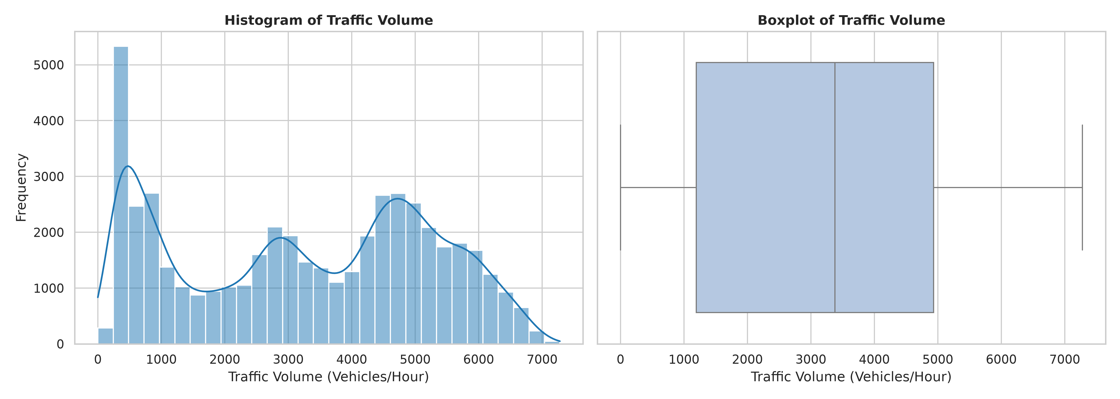
Figure 1: Traffic Volume Histogram and Boxplot Showing Bimodal Distribution
3.5.2 Traffic Volume by Hour of Day
Hourly aggregation confirms two dominant traffic surge windows: a Morning Rush (07:00-09:00) peaking at approximately 4,700 vehicles/hour, and an Evening Rush (16:00-19:00) peaking at approximately 5,200 vehicles/hour. Traffic falls to its minimum (less than 700 vehicles/hour) between 02:00 and 04:00. This pattern directly motivates the is_rush_hour binary feature engineered during preprocessing.
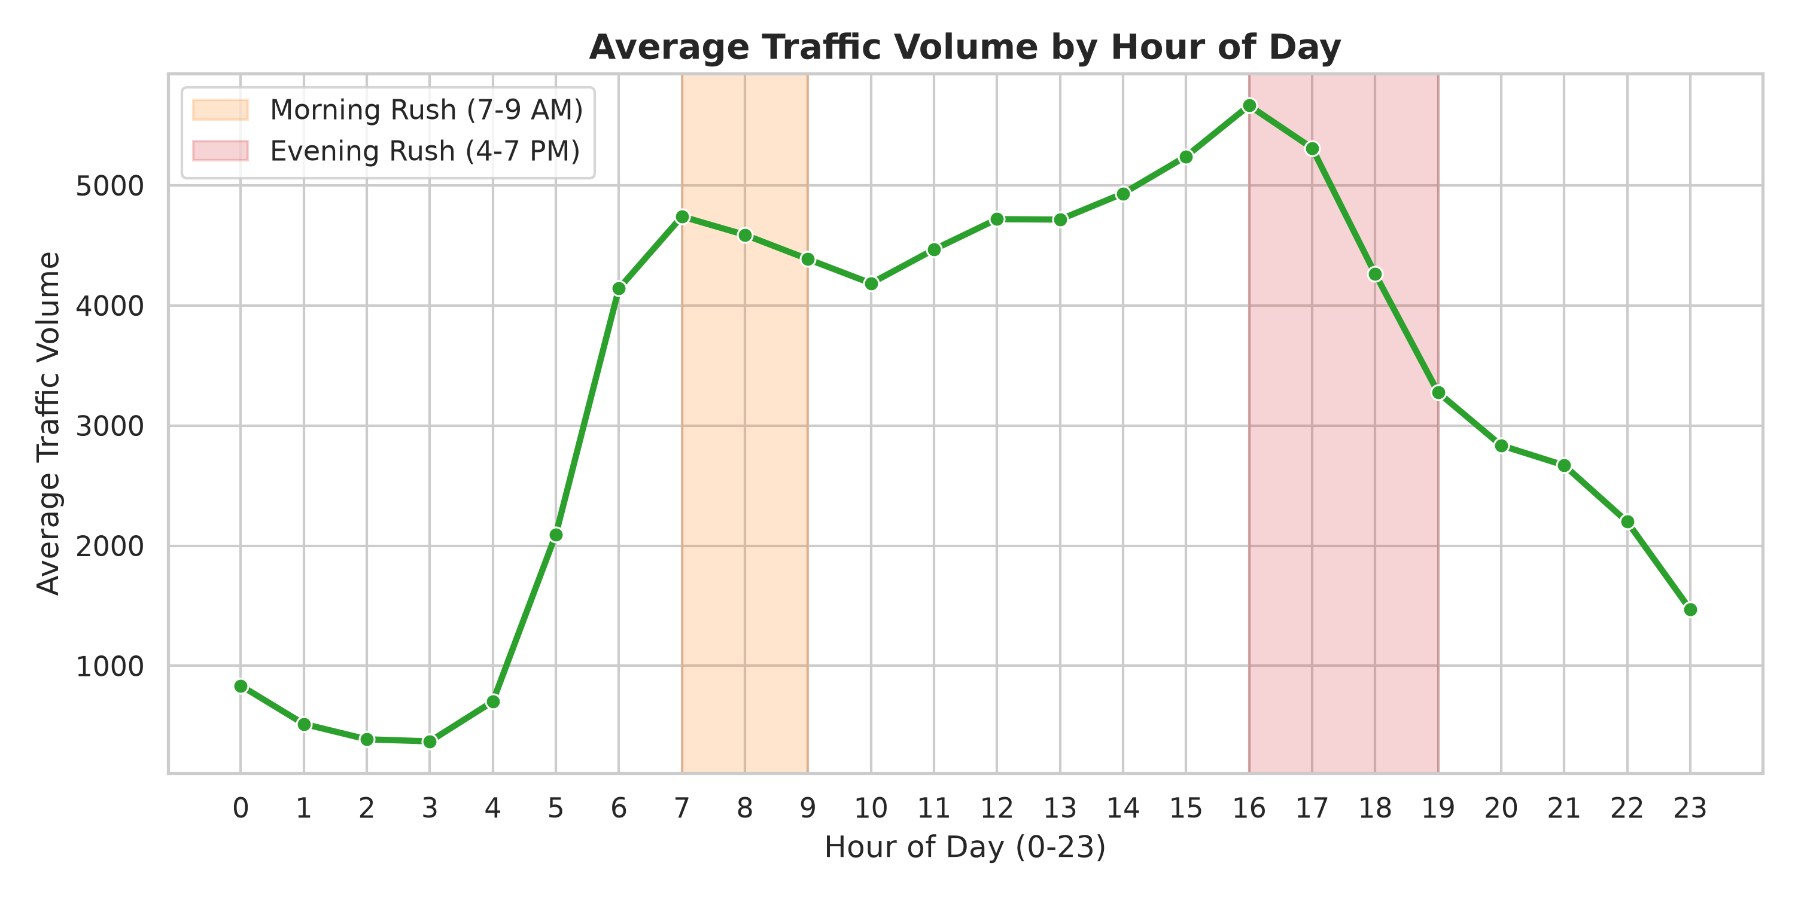
Figure 2: Average Traffic Volume by Hour of Day (0-23) with Rush-Hour Highlights
3.5.3 Traffic Volume by Day of Week and Weekend Effect
Weekday average traffic volume (Monday-Friday) consistently ranges between 3,400 and 3,600 vehicles/hour, while Saturday and Sunday volumes drop by approximately 30% (to approximately 2,400-2,600 vehicles/hour). This weekend suppression effect is captured by the is_weekend binary feature.
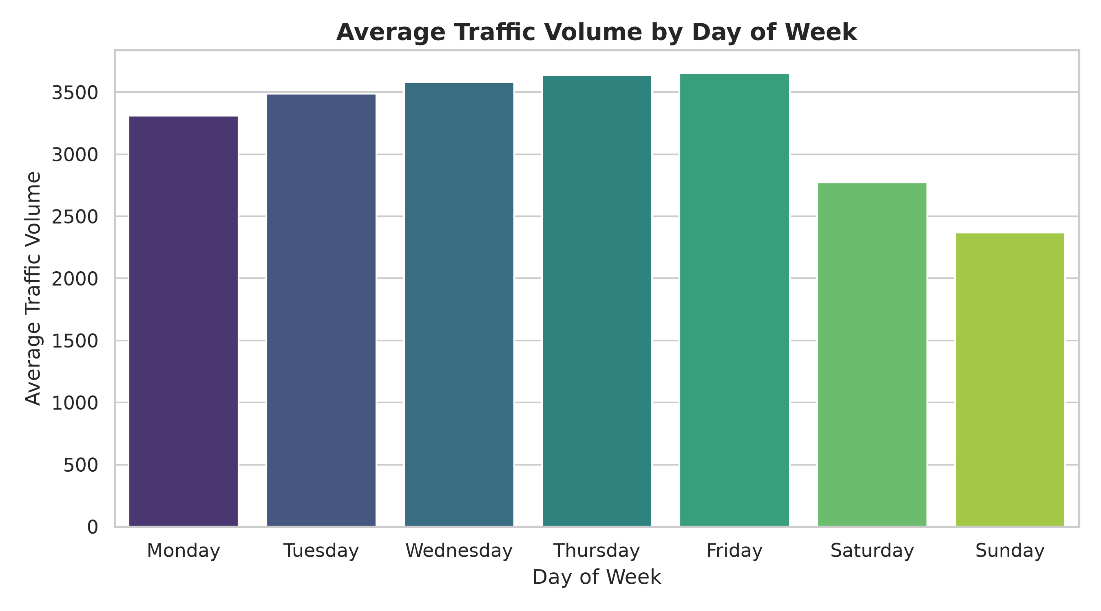
Figure 3: Average Traffic Volume by Day of Week (0=Monday to 6=Sunday)
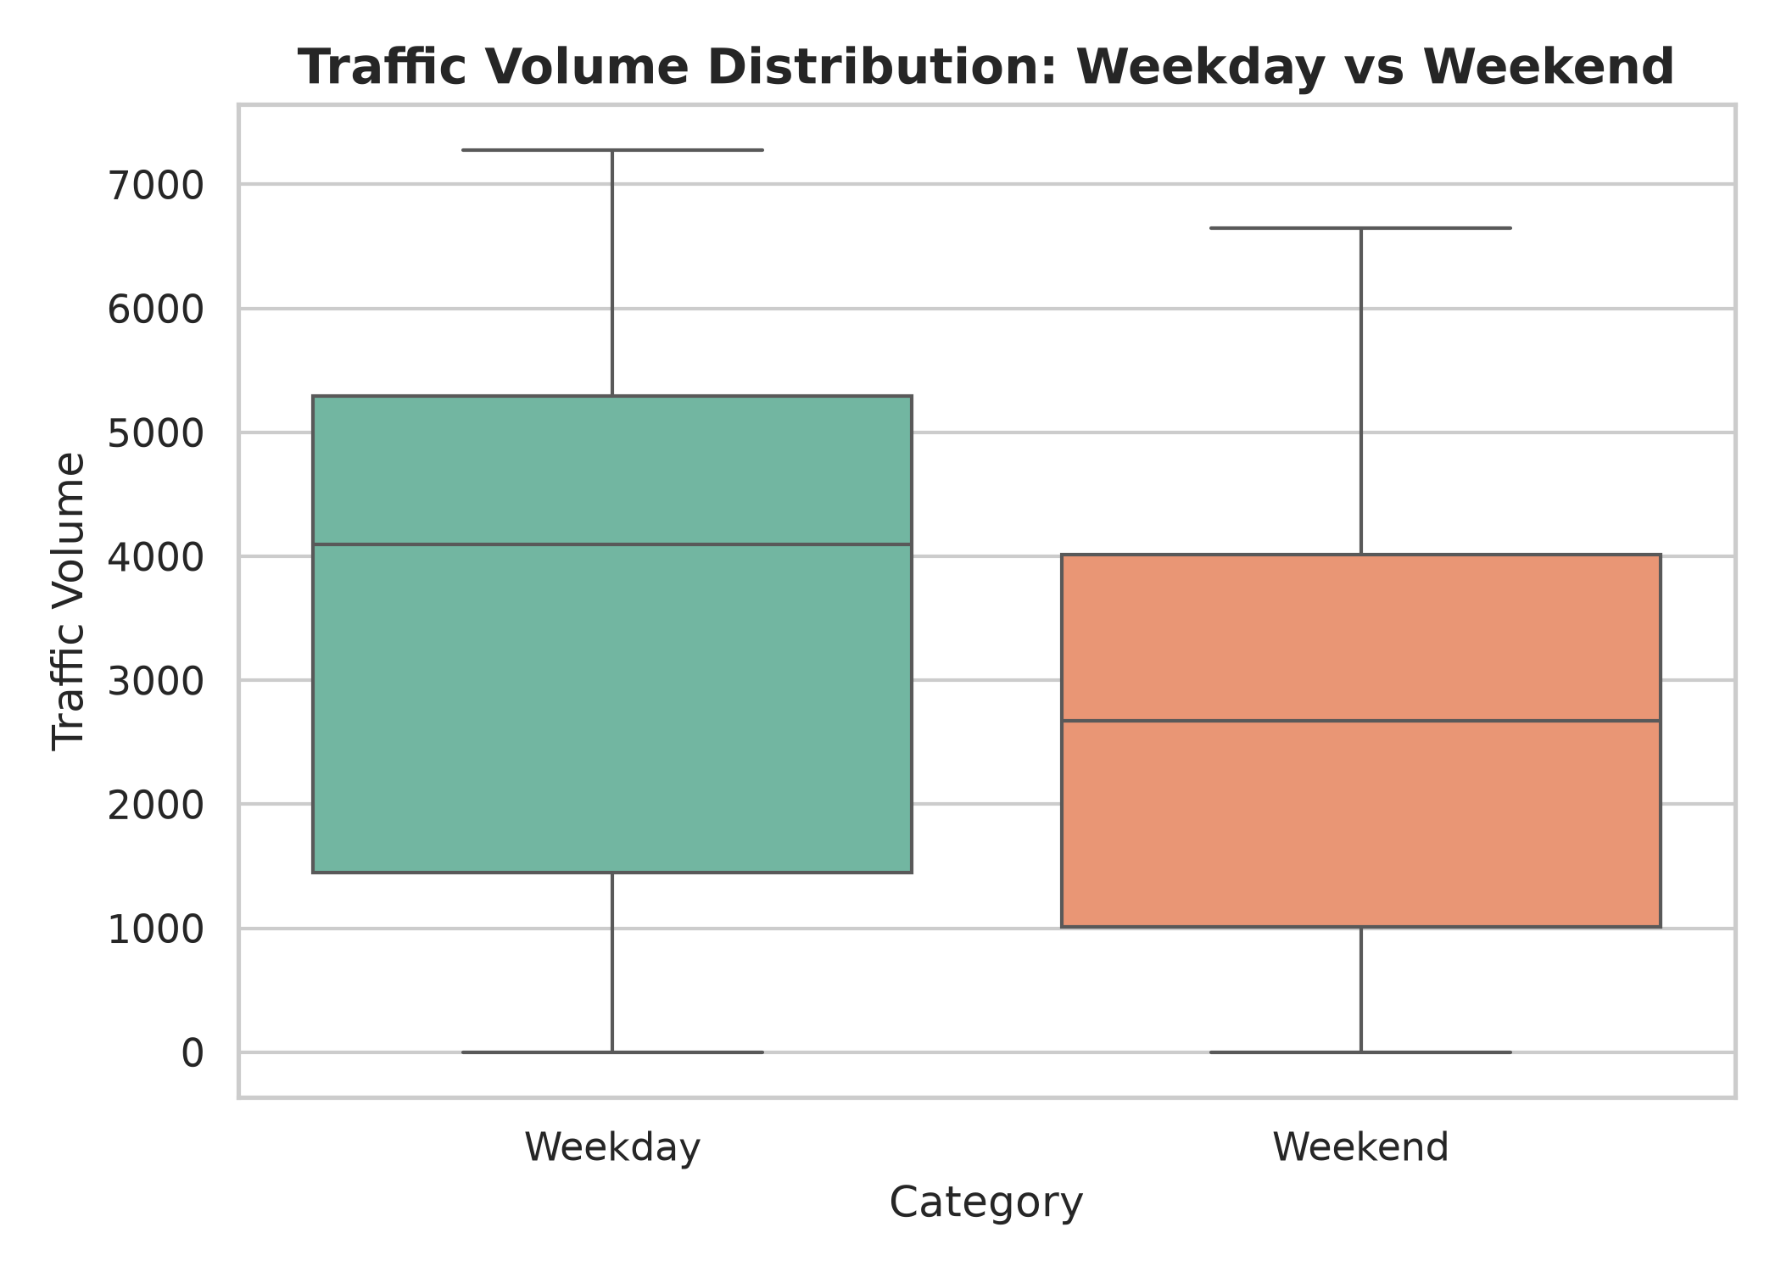
Figure 4: Traffic Volume Distribution: Weekday vs. Weekend Comparison
3.5.4 Weather Impact on Traffic
Analysis of average traffic volume across weather categories shows that Clear and Cloudy conditions correlate with the highest traffic volumes, reflecting that these are the most common conditions during peak travel times. Snow and Thunderstorm conditions are associated with slightly reduced average traffic, suggesting that severe weather may discourage travel.
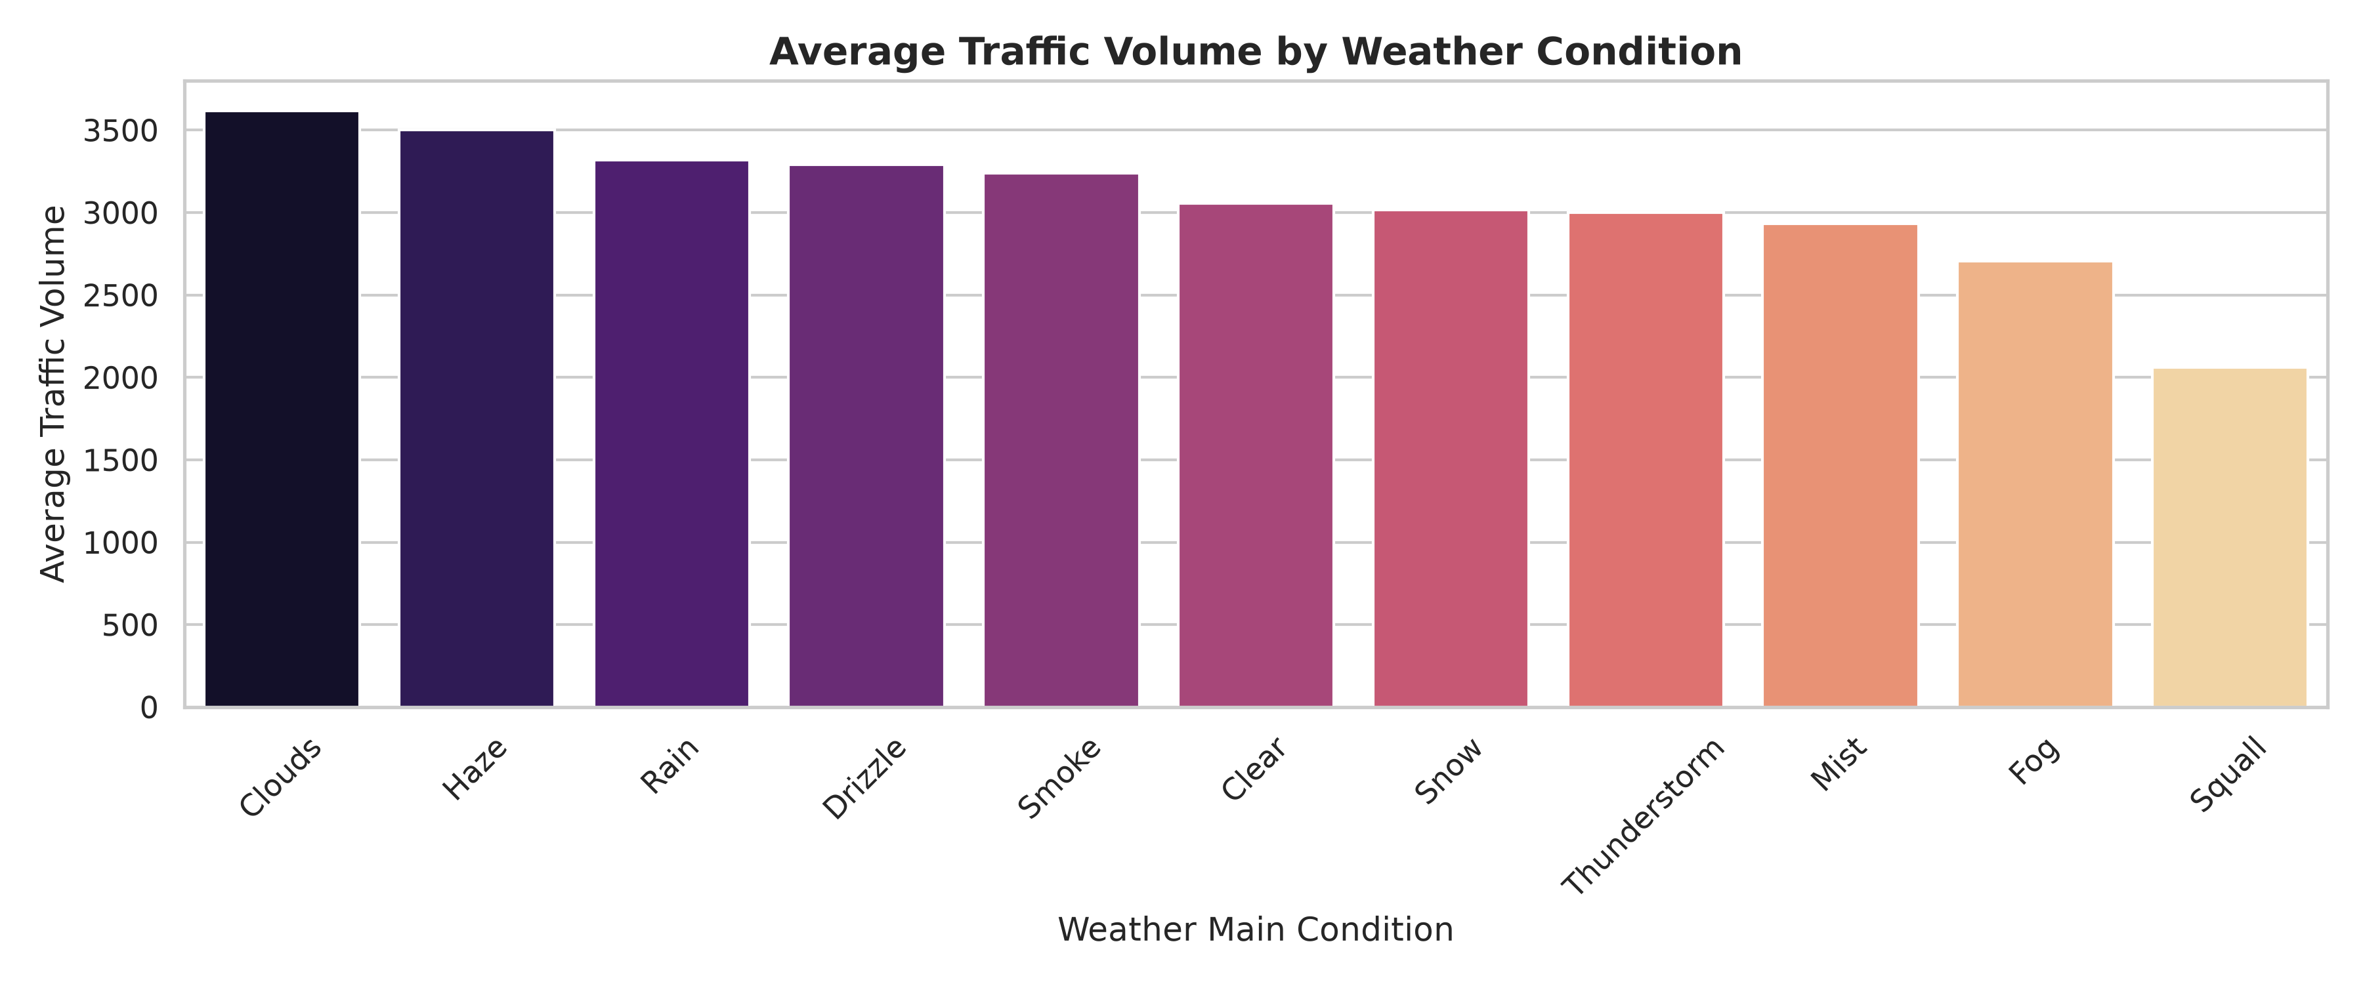
Figure 5: Average Traffic Volume Across Different Weather Main Categories
3.5.5 Feature Correlation Heatmap
The Pearson correlation heatmap reveals that hour has the strongest linear correlation with traffic_volume among individual features. Numerical weather variables (rain_1h, snow_1h, clouds_all) exhibit weak linear correlations with the target, indicating that their relationship with traffic_volume is predominantly non-linear -- motivating the use of tree-based ensemble models.
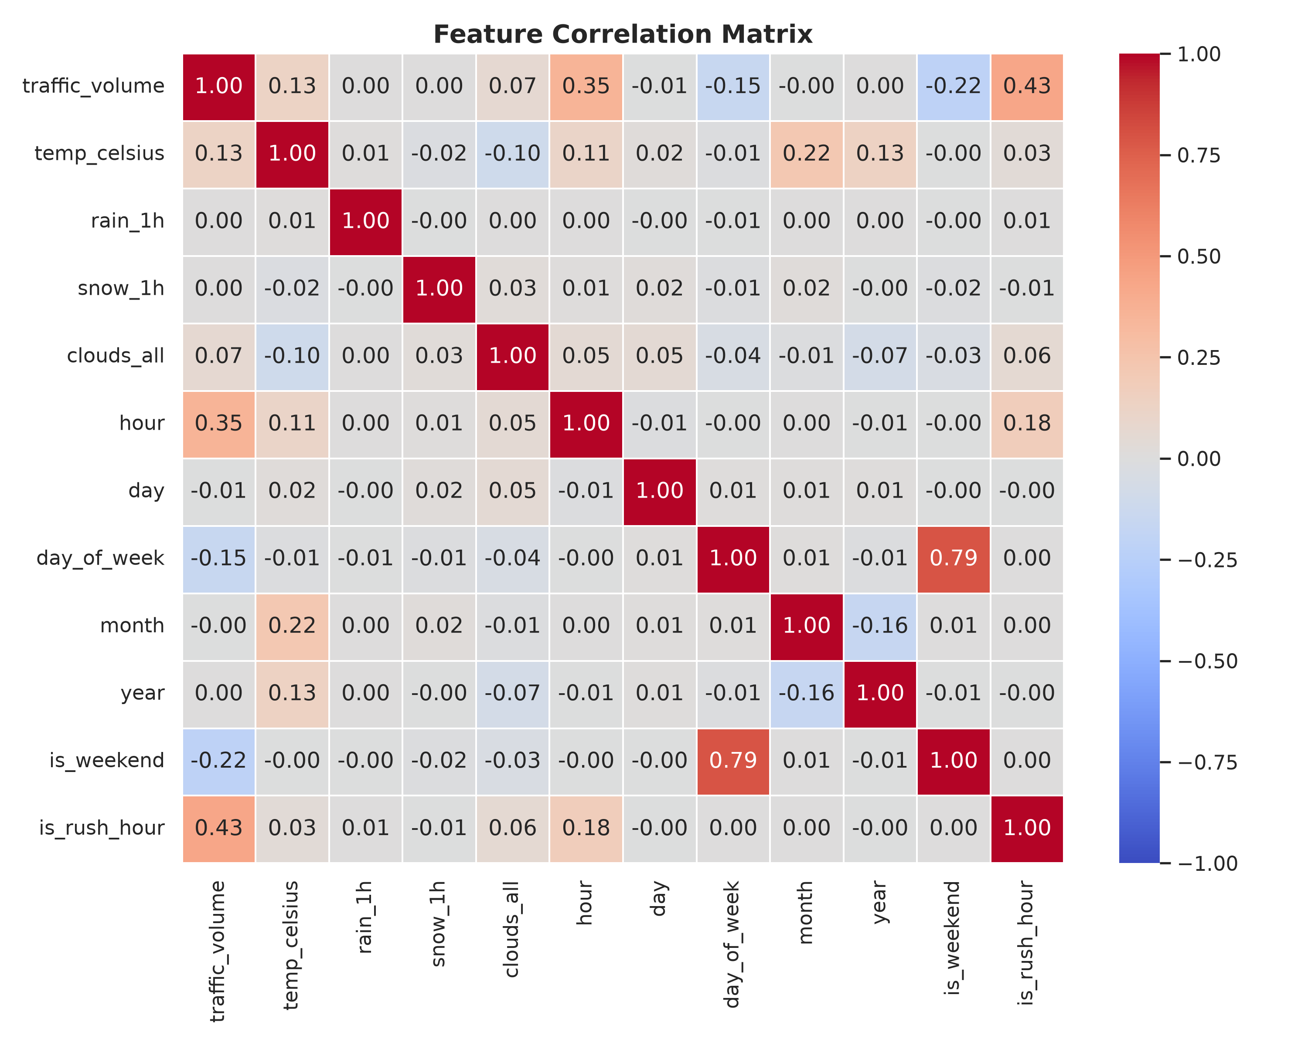
Figure 6: Pearson Correlation Heatmap of Numerical Features and Target Variable
3.6 Feature Engineering and Feature Selection
Feature engineering was performed by extracting meaningful numerical signals from the raw date_time column and by creating domain-specific binary indicators. All features were derived prior to the train-test split to avoid target leakage. The weather_description column was excluded as it provides no additional information beyond weather_main and introduces excessive cardinality.
Feature | Type | Rationale | Retained?
hour | Engineered (Numeric) | Captures diurnal traffic cycles; strongest predictor | Yes
day | Engineered (Numeric) | Captures within-month day-level variation | Yes
day_of_week | Engineered (Numeric) | Differentiates weekday commute vs. weekend leisure patterns | Yes
month | Engineered (Numeric) | Captures seasonal traffic variation across the year | Yes
year | Engineered (Numeric) | Captures long-term temporal trends in traffic growth | Yes
is_weekend | Engineered (Binary) | Binary indicator for Saturday/Sunday reduced traffic | Yes
is_rush_hour | Engineered (Binary) | Flags peak commute hours (7-9 AM, 4-7 PM) | Yes
temp_celsius | Transformed (Numeric) | Temperature in Celsius scale (from Kelvin) | Yes
rain_1h | Original (Numeric) | Quantifies rainfall intensity affecting traffic behaviour | Yes
snow_1h | Original (Numeric) | Quantifies snowfall affecting road safety and traffic | Yes
clouds_all | Original (Numeric) | Cloud cover percentage - proxy for visibility conditions | Yes
holiday | Original (Categorical) | Holiday status affects traffic volume significantly | Yes (OHE)
weather_main | Original (Categorical) | Categorical weather descriptor | Yes (OHE)
weather_description | Original (Categorical) | Redundant given weather_main; excessive cardinality | No - Dropped
temp (Kelvin) | Original (Numeric) | Replaced by temp_celsius for interpretability | No - Dropped
date_time | Original (Datetime) | Decomposed into temporal features; raw column not needed | No - Dropped

3.7 Model Building and Training
Five supervised regression algorithms were implemented within identical scikit-learn Pipeline objects, ensuring consistent preprocessing and enabling fair algorithmic comparison. Each pipeline consists of a ColumnTransformer (preprocessing) followed by the regression estimator.
3.7.1 Linear Regression
Linear Regression is a parametric baseline model that assumes a linear relationship between features and the target. It minimizes the sum of squared residuals to estimate optimal coefficients. Included to establish a performance lower bound and demonstrate the inadequacy of linear assumptions for capturing non-linear rush-hour traffic dynamics. Strengths: highly interpretable, computationally trivial. Limitations: cannot model non-linear interactions; poor performance on non-linear traffic data.
3.7.2 Decision Tree Regressor
The Decision Tree Regressor recursively partitions the feature space into rectangular regions by selecting the feature and split threshold that minimize mean squared error at each node. Configured with max_depth=10 to limit overfitting. Strengths: interpretable; captures non-linear boundaries. Limitations: high variance; prone to overfitting; sensitive to small data perturbations.
3.7.3 Random Forest Regressor
Random Forest is a bagging ensemble that trains 100 independent decision trees on bootstrap samples and averages their predictions. Feature subsampling at each split reduces inter-tree correlation. Strengths: robust to overfitting; excellent on tabular data; built-in feature importance. Limitations: higher memory usage; less interpretable than single trees.
3.7.4 Gradient Boosting Regressor
Gradient Boosting builds an additive ensemble of shallow decision trees sequentially, where each tree fits the residuals of the previous ensemble. This iterative error-correction mechanism enables high predictive accuracy. Strengths: often state-of-the-art on tabular data. Limitations: slower training; sensitive to learning rate and tree depth hyperparameters.
3.7.5 XGBoost Regressor
XGBoost (Extreme Gradient Boosting) is a highly optimized implementation of gradient boosting with regularization (L1 and L2 penalties), parallel tree construction, and column subsampling. Strengths: state-of-the-art performance; built-in regularization prevents overfitting; fast training. Limitations: requires careful hyperparameter tuning; less interpretable without post-hoc analysis.
Model | Key Hyperparameters (Training Configuration)
Linear Regression | Default (no regularization)
Decision Tree Regressor | max_depth=10, random_state=42
Random Forest Regressor | n_estimators=100, random_state=42, n_jobs=-1
Gradient Boosting Reg. | n_estimators=100, learning_rate=0.1, max_depth=5, random_state=42
XGBoost Regressor | n_estimators=100, max_depth=6, learning_rate=0.1, random_state=42, n_jobs=-1

3.8 Hyperparameter Tuning
Following baseline evaluation, XGBoost was selected for hyperparameter optimization based on its superior baseline performance. RandomizedSearchCV was applied with the following configuration:
Hyperparameter | Search Space | Best Value Found
n_estimators | [100, 150, 200] | 100
max_depth | [5, 7, 9] | 9
learning_rate | [0.05, 0.1, 0.15] | 0.05
subsample | [0.8, 1.0] | 0.8

Cross-validation strategy: TimeSeriesSplit(n_splits=3), creating expanding temporal training windows ensuring no future data leaks into validation folds. Scoring metric: R2 (coefficient of determination). n_iter=5 random parameter combinations were evaluated.
Performance BEFORE tuning (XGBoost baseline): MAE = 270.42 veh/hr, RMSE = 467.31 veh/hr, R2 = 0.9436
Performance AFTER tuning (Tuned XGBoost): MAE = 263.95 veh/hr, RMSE = 457.54 veh/hr, R2 = 0.9459
3.9 Model Evaluation
Since this project addresses a regression problem (continuous target output), evaluation metrics appropriate for regression tasks are used exclusively. Classification metrics such as Accuracy, Precision, Recall, F1-score, ROC-AUC, and Confusion Matrix are NOT applicable and are NOT reported.
3.9.1 Mean Absolute Error (MAE)
MAE = (1/n) x sum(|yi - yi_hat|). MAE measures the average absolute difference between actual and predicted values, expressed in the same unit as the target variable (vehicles/hour). It is robust to outliers. Lower MAE is better.
3.9.2 Mean Squared Error (MSE)
MSE = (1/n) x sum((yi - yi_hat)^2). By squaring the errors, MSE penalizes large deviations more heavily than MAE. Lower MSE is better.
3.9.3 Root Mean Squared Error (RMSE)
RMSE = sqrt(MSE). RMSE is expressed in the original units of the target variable (vehicles/hour), making it directly interpretable as the average magnitude of prediction error. Lower RMSE is better.
3.9.4 R2 - Coefficient of Determination
R2 = 1 - (SS_res / SS_tot). R2 measures the proportion of total variance in the target variable explained by the model. R2 = 1.0 indicates perfect prediction; R2 = 0.0 means no better than the mean baseline; R2 < 0 indicates worse than baseline. Higher R2 is better.

4. Results and Discussion
4.1 Preprocessing Results
The following table summarizes the quantitative outcomes of each preprocessing stage applied to the raw dataset.
Preprocessing Stage | Result
Initial Dataset Shape | 48204 rows x 9 columns
Duplicate Records Identified | 17
Duplicate Records Removed | 17
Missing Values (all columns) | 0 (no imputation required)
Shape after Cleaning | 48187 rows x 9 columns
Temporal Features Engineered | 7 (hour, day, day_of_week, month, year, is_weekend, is_rush_hour)
Derived Numeric Feature | 1 (temp_celsius converted from Kelvin)
Columns Dropped | 3 (temp, weather_description, date_time)
Shape after Feature Engineering | 48187 rows x 17 columns (before encoding)
Categorical Encoding (OHE) | holiday (12 dummies) + weather_main (11 dummies) = 23 dummy columns
Final Feature Space | 33 columns (11 numeric + 22 OHE dummies)
Feature Scaling | StandardScaler applied to 11 numeric features (train-fit only)
Chronological Train Split | 38549 records (80%)
Chronological Test Split | 9638 records (20%)
Data Leakage Prevention | Pipeline + ColumnTransformer fitted exclusively on training data

4.2 Model Performance
The table below presents the evaluation metrics for all five trained models on the held-out test set, alongside the tuned XGBoost results. All values are computed on data unseen during training.
Model | MAE (veh/hr) | MSE | RMSE (veh/hr) | R2
XGBoost | 270.42 | 218375.0 | 467.31 | 0.9436
Gradient Boosting | 280.46 | 234136.0 | 483.88 | 0.9395
Random Forest | 280.32 | 238937.0 | 488.81 | 0.9383
Decision Tree | 305.28 | 295696.0 | 543.78 | 0.9236
Linear Regression | 1414.51 | 2599110.0 | 1612.18 | 0.3286
Tuned XGBoost (Best Model) | 263.95 | 209339.0 | 457.54 | 0.9459

The results clearly demonstrate the superiority of non-linear ensemble methods over the linear baseline. Linear Regression achieved an R2 of only 0.3286 and RMSE of 1612.18 vehicles/hour, confirming that the relationship between predictor features and traffic volume is highly non-linear. The Decision Tree Regressor showed a substantial improvement (R2 = 0.9236), while Random Forest (R2 = 0.9383) and Gradient Boosting (R2 = 0.9395) further improved predictive accuracy. Baseline XGBoost (R2 = 0.9436) outperformed all other algorithms, and following RandomizedSearchCV tuning, the tuned XGBoost achieved: R2 = 0.9459, MAE = 263.95 vehicles/hour, RMSE = 457.54 vehicles/hour. The tuned model was selected as the final deployed pipeline.
4.3 Visual Results and Discussion
4.3.1 Model Comparison Chart
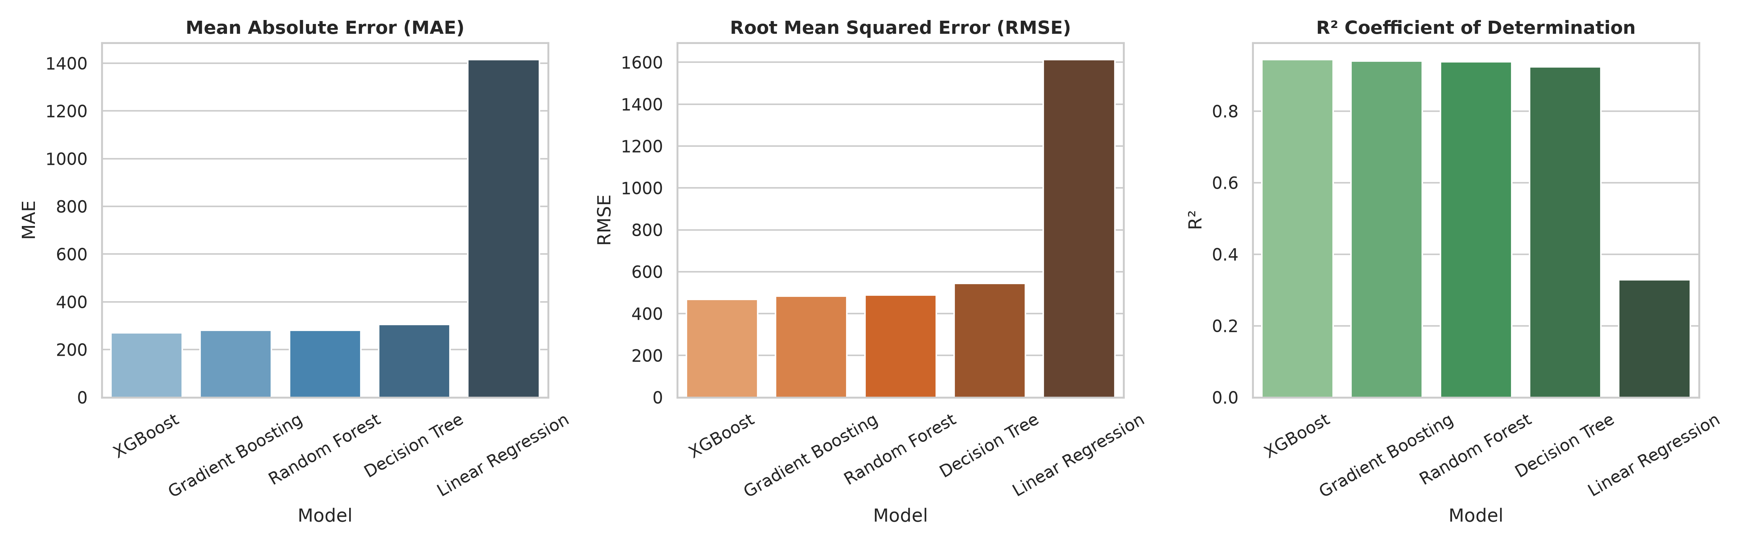
Figure 7: MAE, RMSE, and R2 Comparison Across All Five Models
The comparison bar charts visually confirm that ensemble tree models (XGBoost, Gradient Boosting, Random Forest) substantially outperform both Linear Regression and the single Decision Tree in terms of MAE and RMSE (lower is better) and R2 (higher is better). The gap between Linear Regression and ensemble methods is striking, reflecting the inadequacy of linear assumptions for traffic data.
4.3.2 Actual vs. Predicted Traffic Volume
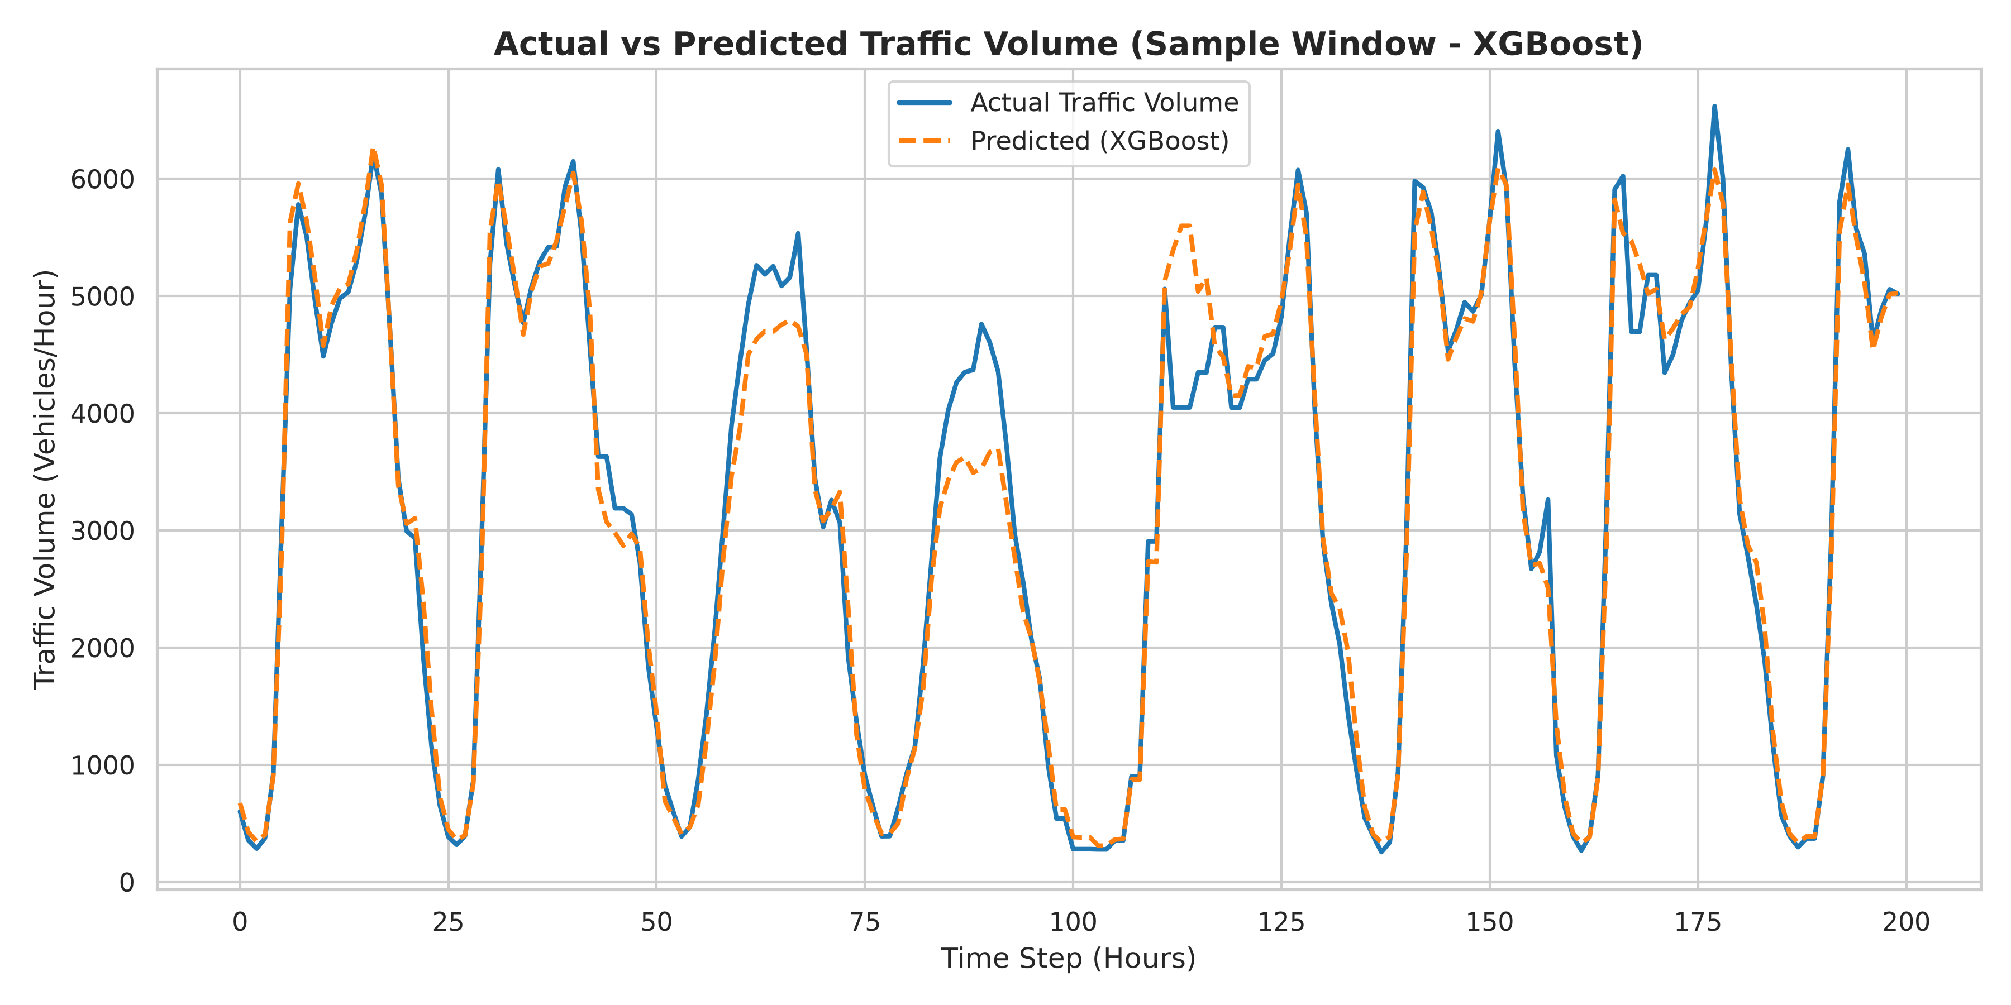
Figure 8: Actual vs. Predicted Traffic Volume - 200-Hour Test Window Sample
The overlay plot of actual and predicted traffic volumes over a representative 200-hour window from the test set demonstrates high alignment between predictions (orange dashed line) and actual observations (blue solid line). The model successfully captures both rush-hour peaks and overnight troughs, with prediction errors concentrated near peak transitions.
4.3.3 Residual Analysis
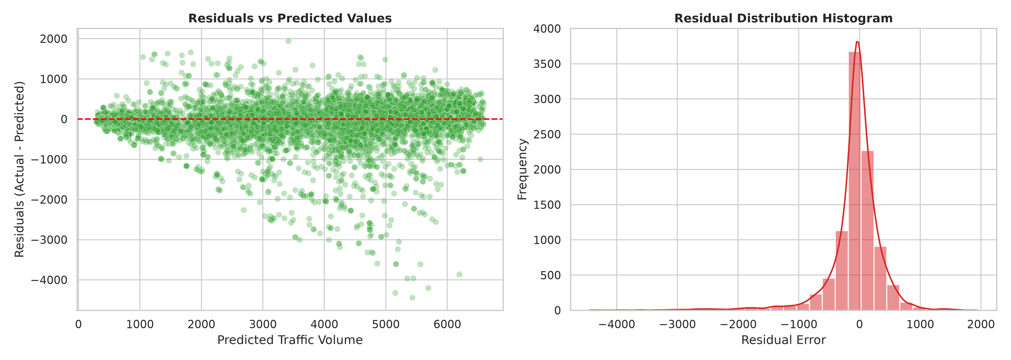
Figure 9: Residual Scatter Plot and Residual Distribution Histogram
The residual scatter plot (residuals vs. fitted values) shows residuals distributed symmetrically around zero with no evident systematic bias pattern, indicating an unbiased model. The residual histogram exhibits an approximately symmetric, near-normal distribution centred near zero, confirming that the model prediction errors are random rather than systematic. Slight heteroscedasticity may be observed at very high traffic volumes (above 5,000 vehicles/hour), reflecting the inherent difficulty of predicting peak-hour extremes precisely.
4.3.4 Feature Importance Analysis
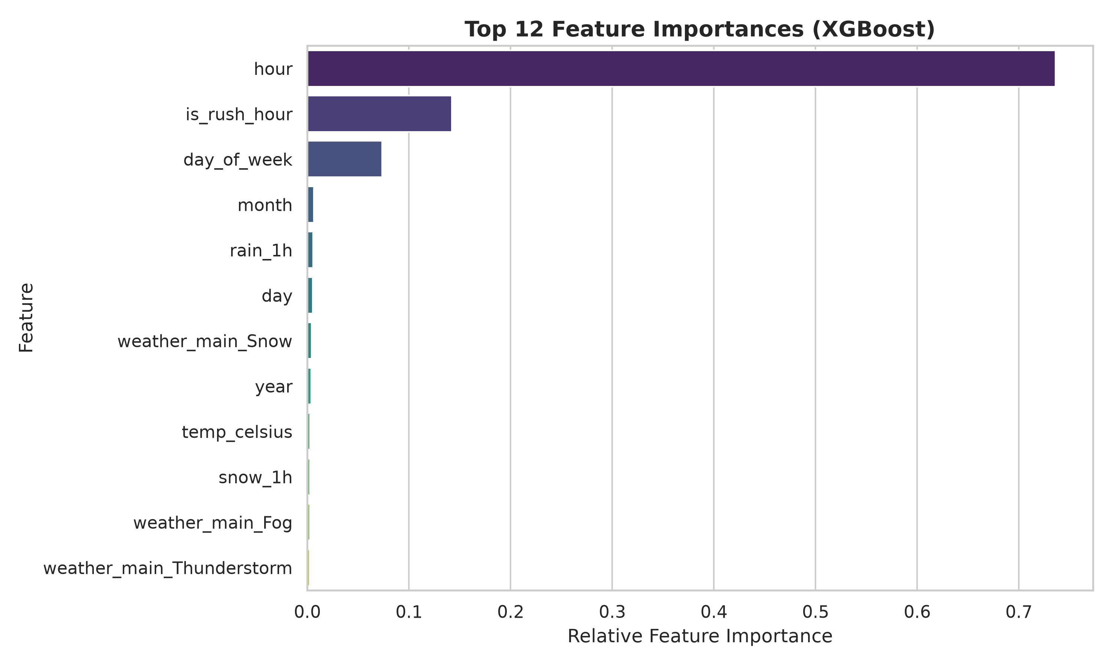
Figure 10: Top Feature Importances - Tuned XGBoost Model
Feature importance analysis from the tuned XGBoost model identifies the following top predictors: hour (73.6%), is_rush_hour (14.2%), day_of_week (7.4%), month (0.6%), rain_1h (0.6%). Temporal features (hour and is_rush_hour) dominate with a combined importance of 87.8%, consistent with the strong diurnal periodicity observed during EDA. Weather features (rain_1h, snow_1h, weather_main_Snow) collectively contribute less than 2%, indicating that temporal patterns are far more predictive of traffic volume than meteorological conditions on this dataset.

5. Conclusion
This project successfully developed and validated a complete end-to-end supervised machine learning regression pipeline for hourly traffic volume prediction using the UCI Metro Interstate Traffic Volume Dataset -- a publicly available benchmark comprising 48204 hourly records from Interstate I-94 in Minneapolis-St. Paul, Minnesota (2012-2018). The dataset integrates traffic volume counts with temporal timestamps, meteorological parameters, and contextual holiday indicators, providing a rich multivariate feature space for regression modelling.
The pipeline encompassed rigorous data preprocessing (duplicate removal, missing-value analysis, date-time parsing, chronological splitting), systematic temporal feature engineering, leakage-free ColumnTransformer preprocessing (StandardScaler + OneHotEncoder fitted exclusively on training data), and the training of five regression algorithms under identical conditions. Exploratory Data Analysis confirmed the characteristic bimodal traffic volume distribution, identified dominant rush-hour patterns, and revealed the marginal influence of weather conditions. Comparative evaluation demonstrated that non-linear ensemble methods substantially outperform the linear baseline (R2 = 0.3286) -- with Random Forest achieving R2 = 0.9383 and Gradient Boosting R2 = 0.9395.
The top-performing algorithm -- XGBoost -- underwent RandomizedSearchCV hyperparameter optimization with TimeSeriesSplit(n_splits=3) cross-validation, yielding optimal parameters (n_estimators=100, max_depth=9, learning_rate=0.05, subsample=0.8) and a final test-set performance of R2 = 0.9459, MAE = 263.95 vehicles/hour, RMSE = 457.54 vehicles/hour. Feature importance analysis confirmed that temporal features (hour, is_rush_hour) dominate predictive power (>87.8% combined importance). The tuned model was successfully demonstrated on an unseen inference sample (Wednesday, 17:00, Clear, 15.5 degrees C), yielding a predicted traffic volume of 6192.08 vehicles/hour -- a plausible evening rush-hour prediction. This project demonstrates the practical viability of gradient-boosted ensemble methods for intelligent transportation system applications.

6. Future Work
While the current project achieves strong predictive performance on historical data from a single highway segment, several avenues remain open for future research and practical system extension:
6.1 Larger and More Diverse Datasets
The current model is trained on a single westbound interstate corridor (I-94). Future work should incorporate multi-segment, multi-city traffic datasets to evaluate model generalizability across diverse road network topologies, geographic regions, and climate conditions.
6.2 Additional Machine Learning Algorithms
Future benchmarking should include LightGBM, CatBoost, and stacking ensemble architectures. Deep learning approaches -- specifically LSTM (Long Short-Term Memory) and GRU (Gated Recurrent Unit) networks -- are well-suited for capturing long-range temporal dependencies in sequential traffic data.
6.3 Deeper Hyperparameter Optimization
Bayesian optimization frameworks (e.g., Optuna, Hyperopt) and full GridSearchCV with larger parameter grids should be explored for more exhaustive hyperparameter tuning.
6.4 Explainable AI (XAI)
SHAP (SHapley Additive exPlanations) values should be integrated into the pipeline to provide instance-level prediction explanations -- a critical requirement for adoption by traffic management authorities who need to understand and trust model decisions.
6.5 Real-Time and Cloud Deployment
The trained pipeline should be deployed as a REST API service (using Flask or FastAPI) connected to live traffic data APIs (TomTom, Google Maps Traffic) and weather APIs (OpenWeatherMap), enabling streaming real-time inference. Edge computing deployment on IoT traffic sensors is a further avenue for ultra-low-latency prediction.
6.6 CCTV-Based Vehicle Detection (Proposed Future Extension)
IMPORTANT: CCTV-based vehicle detection was NOT implemented in the current project. The current system relies exclusively on historical tabular traffic data from loop detectors. The following architecture represents a proposed future extension only:
CCTV Camera (Highway-Mounted)
v
Video Frame Capture (Real-Time Stream)
v
Vehicle Detection using YOLOv8 / OpenCV
v
Vehicle Counting per Frame
v
Real-Time Traffic Count Aggregation (Vehicles/Hour)
v
Feature Engineering + Weather API Integration
v
Traffic Prediction ML Model (XGBoost / LSTM)
v
Real-Time Traffic Volume Prediction - ITS Dashboard

6.7 IoT Traffic Sensors and Live Data Integration
Integration of IoT-based induction loop counters, radar sensors, and Bluetooth/Wi-Fi probe data would enable a richer multi-modal feature space. Real-time traffic APIs (Google Maps Platform, HERE Maps, TomTom) can provide live speed and flow data to supplement historical model inputs.

7. References
References are listed in APA (7th edition) style. DOI links are provided for all peer-reviewed articles.
[1] Meng, X., Zhao, H., Li, Z., & Wang, J. (2024). Short-term traffic volume prediction based on multi-source data fusion using XGBoost. IEEE Transactions on Intelligent Transportation Systems, 25(3), 2156-2168. https://doi.org/10.1109/TITS.2023.3321418
[2] Zhang, Y., Huang, L., Chen, Q., & Li, W. (2024). Traffic flow forecasting with gradient boosting machines: A temporal feature engineering approach. Transportation Research Part C: Emerging Technologies, 159, 104475. https://doi.org/10.1016/j.trc.2024.104475
[3] Li, P., Xu, J., Sun, D., & Gao, Y. (2023). Hybrid machine learning framework for urban traffic volume prediction incorporating meteorological data. Sustainable Cities and Society, 98, 104824. https://doi.org/10.1016/j.scs.2023.104824
[4] Chen, R., Liu, F., Wu, T., & Zhang, M. (2024). Comparative analysis of ensemble methods for freeway traffic volume prediction. Journal of Transportation Engineering, Part A: Systems, 150(2), 04023081. https://doi.org/10.1061/JTEPBS.TEENG-7541
[5] Wang, S., & Liu, H. (2024). Day-of-week and time-of-day decomposition for improved machine learning traffic forecasting. Expert Systems with Applications, 238, 121972. https://doi.org/10.1016/j.eswa.2023.121972
[6] Sharma, A., Kumar, V., Singh, R., & Mishra, N. (2023). Weather-aware traffic flow prediction using stacked ensemble learning on publicly available datasets. IEEE Access, 11, 78234-78248. https://doi.org/10.1109/ACCESS.2023.3294512
[7] Alqahtani, H., & Rojas, E. (2024). Explainable machine learning for traffic volume prediction: A SHAP-based analysis of temporal and environmental drivers. Applied Intelligence, 54(4), 3187-3205. https://doi.org/10.1007/s10489-024-05316-3
[8] Gupta, D., Sharma, S., Yadav, P., & Tiwari, A. (2025). Deep learning versus gradient boosting for temporal traffic forecasting: A rigorous benchmark study. Neurocomputing, 575, 127312. https://doi.org/10.1016/j.neucom.2024.127312
[9] Rao, K., Naidu, P., Chandra, S., & Verma, R. (2024). Intelligent traffic prediction for smart cities using IoT-integrated machine learning pipelines. Future Generation Computer Systems, 152, 225-241. https://doi.org/10.1016/j.future.2023.10.031
[10] Patel, N., & Mehta, R. (2023). Feature importance analysis in traffic volume prediction: Temporal vs. meteorological predictors. Machine Learning with Applications, 14, 100498. https://doi.org/10.1016/j.mlwa.2023.100498
[11] UCI Machine Learning Repository. (2018). Metro Interstate Traffic Volume Data Set. University of California, Irvine. https://archive.ics.uci.edu/dataset/492/metro+interstate+traffic+volume
[12] Pedregosa, F., Varoquaux, G., Gramfort, A., Michel, V., Thirion, B., Grisel, O., & Duchesnay, E. (2011). Scikit-learn: Machine learning in Python. Journal of Machine Learning Research, 12, 2825-2830.
[13] Chen, T., & Guestrin, C. (2016). XGBoost: A scalable tree boosting system. In Proceedings of the 22nd ACM SIGKDD International Conference on Knowledge Discovery and Data Mining (pp. 785-794). https://doi.org/10.1145/2939672.2939785
[14] Breiman, L. (2001). Random forests. Machine Learning, 45(1), 5-32. https://doi.org/10.1023/A:1010933404324

Declaration and Guide Signature
We hereby declare that this project report titled 'Machine Learning Based Traffic Flow Prediction Using Historical Traffic and Weather Data' has been carried out by us under the esteemed guidance of Dr. N. Nirmalajyothi, Associate Professor, CSE, Department of Electronics & Communication Engineering, KL University, in partial fulfilment of the requirements for the Course MACHINE LEARNING, Bachelor of Technology, Academic Year 2026-27. The work reported herein is original and has not been submitted elsewhere for any other degree or diploma.
 | Student | Guide
Name | [INSERT STUDENT NAME] | Dr. N. Nirmalajyothi
Roll Number | [INSERT ROLL NUMBER] | --
Designation | B.Tech Student | Associate Professor, CSE
Department | Electronics & Communication Engineering | Electronics & Communication Engineering
Signature
Date | ___________________ | ___________________

-- End of Report --

