**Student Name: Suyog Ashok Bhole.**

**PRN No. 200944281024**

**CCPP ID: PD0752**

**Email:** [**bhole.suyog@gmail.com**](mailto:bhole.suyog@gmail.com)

**Phone: 9403375364, 9890249990**

**Subject:- Documentation to use Search box to search an artist Application**

**Technology Used:- React Js.**

Tried with following api.

https://itunes.apple.com/search

is https://itunes.apple.com/search?term=#searchTerm

**Coding Exercise**

Q. Write an application using react that connects to the iTunes connect API to

retrieve songs for a search term.

Step-1 🡪 Follow following are the steps to use Search box to search an artist Application please follow step by step.

Step-2 🡪 First extract the given file you can download it from given google drive link.

Step-3 🡪After that React Application Steps:- Start VS Code and click on File then click on open folder and then select path where you extracted the given file.

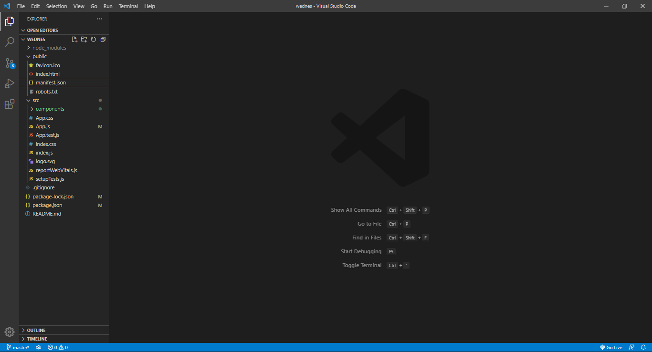

Then see Above Hierarchy for reference.

* Right click on left free space and open integrated terminal and check path of terminal.
* 🡪npm i
* Put above command to install dependencies.

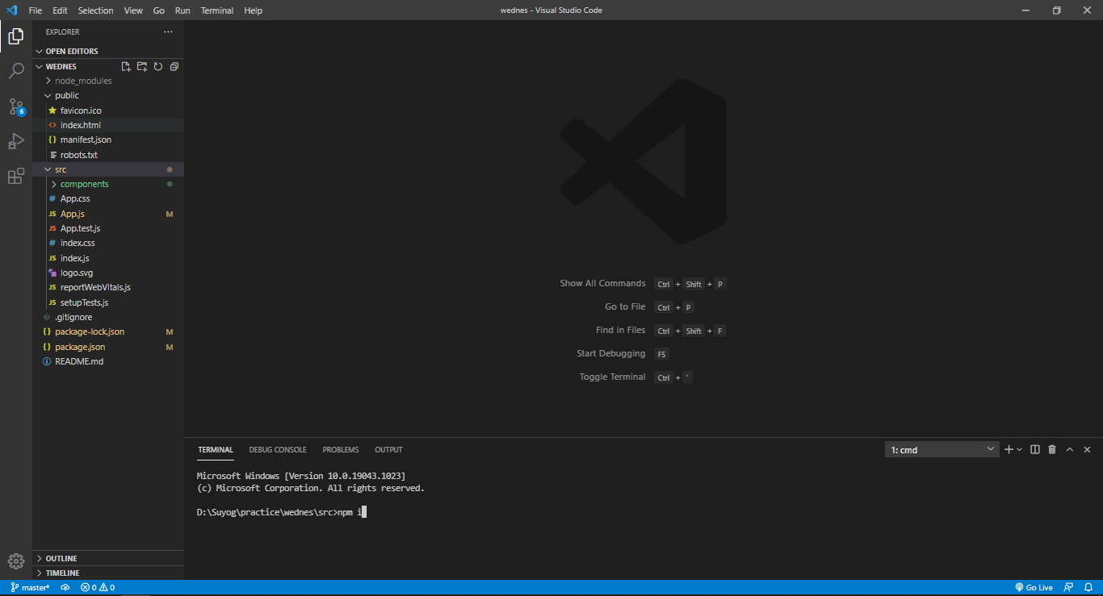

Step- 8 🡪 npm start (to run the react application)

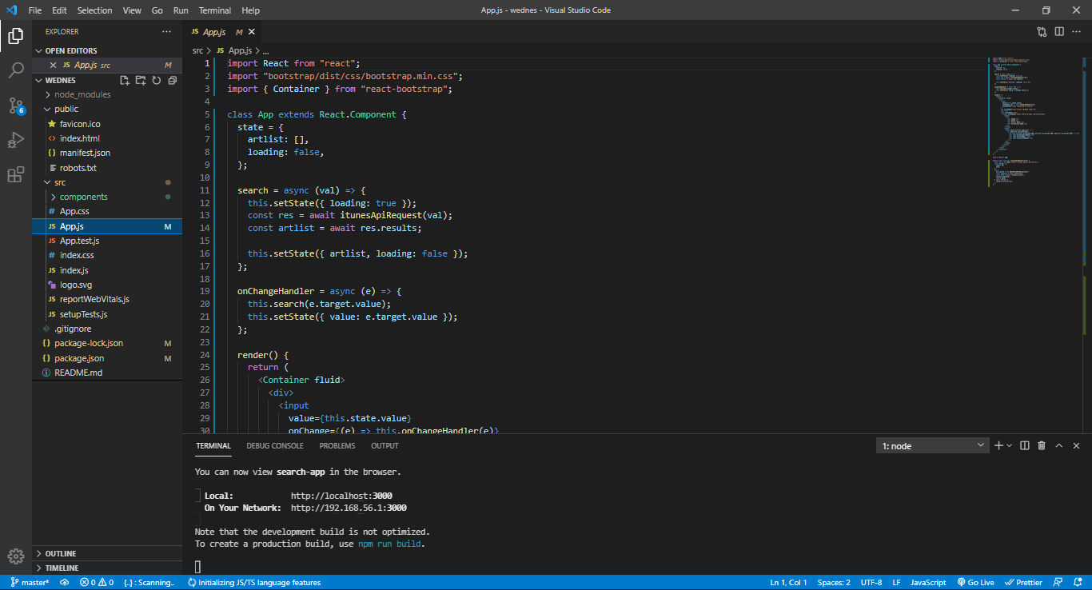

Step- 9 🡪 By using the given url you can open it on chrome browser

(http://localhost:3000)



**Screens on UI**

1. User can Search here.

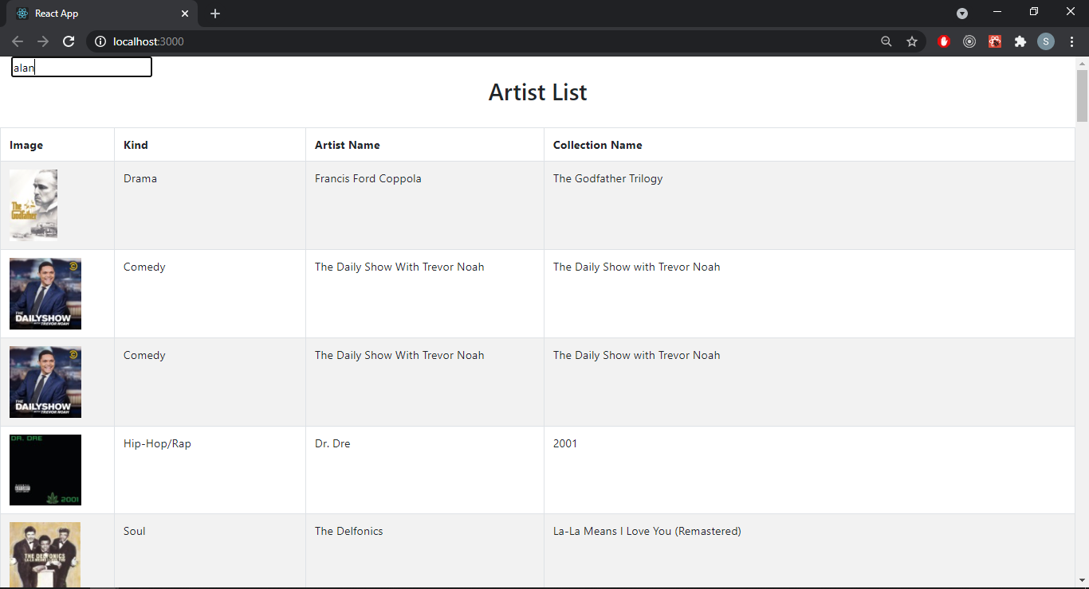

**Thank You…**