Example of Transition Screen:

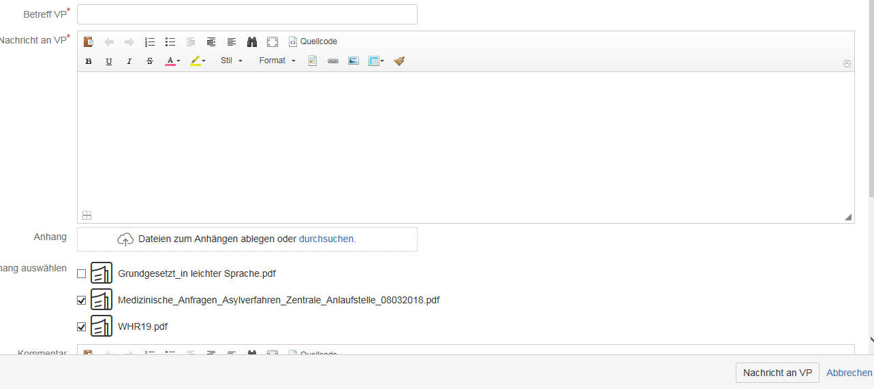

We want to retrieve this documents in postfuntion

Log snippet on Postfuntion:

2019-08-02 11:44:17,256 http-nio-8080-exec-15 DEBUG SU27 704x26678x1 9xkf4p 172.20.17.43,127.0.0.1 /secure/CommentAssignIssue.jspa [d.b.b.scts.workflow.AppendAttachmentsPostFunction] \*\*\* de.bund.bamf.scts.workflow.AppendAttachmentsPostFunction.execute.[285](): evaluating attachments for mail body. \*\*\*

// Here we are looking for changeItems and logging all available fields but “Attachment” Field is missing in major transitions

2019-08-02 11:44:17,256 http-nio-8080-exec-15 DEBUG SU27 704x26678x1 9xkf4p 172.20.17.43,127.0.0.1 /secure/CommentAssignIssue.jspa [d.b.b.scts.workflow.AppendAttachmentsPostFunction] [AppendAttach-mentsPostFunction] ChangeItem -> status

2019-08-02 11:44:17,256 http-nio-8080-exec-15 DEBUG SU27 704x26678x1 9xkf4p 172.20.17.43,127.0.0.1 /secure/CommentAssignIssue.jspa [d.b.b.scts.workflow.AppendAttachmentsPostFunction] [AppendAttach-mentsPostFunction] ChangeItem -> Mail (parallel)

2019-08-02 11:44:17,256 http-nio-8080-exec-15 DEBUG SU27 704x26678x1 9xkf4p 172.20.17.43,127.0.0.1 /secure/CommentAssignIssue.jspa [d.b.b.scts.workflow.AppendAttachmentsPostFunction] [AppendAttach-mentsPostFunction] ChangeItems is not null

2019-08-02 11:44:17,256 http-nio-8080-exec-15 DEBUG SU27 704x26678x1 9xkf4p 172.20.17.43,127.0.0.1 /secure/CommentAssignIssue.jspa [d.b.b.scts.workflow.AppendAttachmentsPostFunction] [AppendAttach-mentsPostFunction] Checking uploaded attachments

2019-08-02 11:44:17,256 http-nio-8080-exec-15 DEBUG SU27 704x26678x1 9xkf4p 172.20.17.43,127.0.0.1 /secure/CommentAssignIssue.jspa [d.b.b.scts.workflow.AppendAttachmentsPostFunction] [AppendAttach-mentsPostFunction] Upload Attachments

2019-08-02 11:44:17,256 http-nio-8080-exec-15 DEBUG SU27 704x26678x1 9xkf4p 172.20.17.43,127.0.0.1 /secure/CommentAssignIssue.jspa [d.b.b.scts.workflow.AppendAttachmentsPostFunction] [AppendAttach-mentsPostFunction] Selectd Attachment added 1 Total : 1

2019-08-02 11:44:17,256 http-nio-8080-exec-15 DEBUG SU27 704x26678x1 9xkf4p 172.20.17.43,127.0.0.1 /secure/CommentAssignIssue.jspa [d.b.b.scts.workflow.AppendAttachmentsPostFunction] [AppendAttach-mentsPostFunction] Selectd Attachment true

2019-08-02 11:44:17,251 http-nio-8080-exec-15 DEBUG SU27 704x26678x1 9xkf4p 172.20.17.43,127.0.0.1 /secure/CommentAssignIssue.jspa [d.b.b.scts.workflow.AppendAttachmentsPostFunction] [AppendAttach-mentsPostFunction] START - ISSUE IVS-1112

de.bund.bamf.scts.workflow.AppendAttachmentsPostFunction.execute.[376](): evaluating attachments for issue comment. \*\*\*

2019-08-02 11:44:17,243 http-nio-8080-exec-15 DEBUG SU27 704x26678x1 9xkf4p 172.20.17.43,127.0.0.1 /secure/CommentAssignIssue.jspa [d.b.b.scts.workflow.AppendAttachmentsPostFunction] [AppendAttach-mentsPostFunction] Item : [ Mail (parallel) TO ] [ status TO 10502 ]

2019-08-02 11:44:17,243 http-nio-8080-exec-15 DEBUG SU27 704x26678x1 9xkf4p 172.20.17.43,127.0.0.1 /secure/CommentAssignIssue.jspa [d.b.b.scts.workflow.AppendAttachmentsPostFunction] [AppendAttach-mentsPostFunction] List of ChangeItems :

2019-08-02 11:44:17,242 http-nio-8080-exec-15 DEBUG SU27 704x26678x1 9xkf4p 172.20.17.43,127.0.0.1 /secure/CommentAssignIssue.jspa [d.b.b.scts.workflow.AppendAttachmentsPostFunction] \*\*\* de.bund.bamf.scts.workflow.AppendAttachmentsPostFunction.execute.[317](): 'no attachments uploaded. \*\*\*

2019-08-02 11:44:17,242 http-nio-8080-exec-15 DEBUG SU27 704x26678x1 9xkf4p 172.20.17.43,127.0.0.1 /secure/CommentAssignIssue.jspa [d.b.b.scts.workflow.AppendAttachmentsPostFunction] \*\*\* de.bund.bamf.scts.workflow.AppendAttachmentsPostFunction.execute.[285](): evaluating attachments for mail body. \*\*\*

// Here we are looking for changeItems and logging all available fields but “Attachment” Field is missing in major transitions

2019-08-02 11:44:17,241 http-nio-8080-exec-15 DEBUG SU27 704x26678x1 9xkf4p 172.20.17.43,127.0.0.1 /secure/CommentAssignIssue.jspa [d.b.b.scts.workflow.AppendAttachmentsPostFunction] [AppendAttach-mentsPostFunction] ChangeItem -> status

2019-08-02 11:44:17,241 http-nio-8080-exec-15 DEBUG SU27 704x26678x1 9xkf4p 172.20.17.43,127.0.0.1 /secure/CommentAssignIssue.jspa [d.b.b.scts.workflow.AppendAttachmentsPostFunction] [AppendAttach-mentsPostFunction] ChangeItem -> Mail (parallel)

2019-08-02 11:44:17,241 http-nio-8080-exec-15 DEBUG SU27 704x26678x1 9xkf4p 172.20.17.43,127.0.0.1 /secure/CommentAssignIssue.jspa [d.b.b.scts.workflow.AppendAttachmentsPostFunction] [AppendAttach-mentsPostFunction] ChangeItems is not null

2019-08-02 11:44:17,241 http-nio-8080-exec-15 DEBUG SU27 704x26678x1 9xkf4p 172.20.17.43,127.0.0.1 /secure/CommentAssignIssue.jspa [d.b.b.scts.workflow.AppendAttachmentsPostFunction] [AppendAttach-mentsPostFunction] Checking uploaded attachments

2019-08-02 11:44:17,241 http-nio-8080-exec-15 DEBUG SU27 704x26678x1 9xkf4p 172.20.17.43,127.0.0.1 /secure/CommentAssignIssue.jspa [d.b.b.scts.workflow.AppendAttachmentsPostFunction] [AppendAttach-mentsPostFunction] Upload Attachments

2019-08-02 11:44:17,241 http-nio-8080-exec-15 DEBUG SU27 704x26678x1 9xkf4p 172.20.17.43,127.0.0.1 /secure/CommentAssignIssue.jspa [d.b.b.scts.workflow.AppendAttachmentsPostFunction] [AppendAttach-mentsPostFunction] Selectd Attachment added 1 Total : 1

2019-08-02 11:44:17,241 http-nio-8080-exec-15 DEBUG SU27 704x26678x1 9xkf4p 172.20.17.43,127.0.0.1 /secure/CommentAssignIssue.jspa [d.b.b.scts.workflow.AppendAttachmentsPostFunction] [AppendAttach-mentsPostFunction] Selectd Attachment true

2019-08-02 11:44:17,241 http-nio-8080-exec-15 DEBUG SU27 704x26678x1 9xkf4p 172.20.17.43,127.0.0.1 /secure/CommentAssignIssue.jspa [d.b.b.scts.workflow.AppendAttachmentsPostFunction] [AppendAttach-mentsPostFunction] SelectAttachment