UNIVERSITY OF COMPUTER STUDIES, YANGON 2025-2026 ACADEMIC YEAR



Project Report On
Telco Customer Churn Analysis and Prediction System

Semester IX
DATA AND KNOWLEDGE MINING (IS-212) PROJECT

Submitted By
YKPT-22522 Mg Bhone Min Khant

September, 2026 B.C.Sc.(SE)

Contents

ACKNOWLEDGEMENT 4
CHAPTER 1 5
INTRODUCTION 5
1.1Project Background 5
1.2 Objectives of the Project 5
1.3 Scope of the Project 6
1.4 Methodology overview 6
1.5 Benefits of the Project 7
CHAPTER 2 8
DATA PREPARATION & PREPROCESSING 8
2.1 Dataset and Data Statistics 8
Dataset Attributes 8
2.2 Data Preprocessing 9
2.2.1 Handling Missing Values 9
2.2.2 Data Transformation 9
2.2.3 Feature Selection 9
2.2.4 Removing Noises 10
2.2.5 Preparation for Customer Clustering 10
2.3 Data Visualization 10
2.4 Chapter 2 Summary 12
CHAPTER 3 13
APPLIED METHODOLOGIES & MINING 13
3.1 Descri ptive mining 13
3.1.1 Distribution Analysis 13
3.1.2 Group-by Analysis 13
3.1.3 Association Mining 14
3.1.4 Association Interpretation 14
3.2 Modeling 15
3.2.1 Applied Methodoligies / Algorithms 15
3.2.2 Model Setup 15
3.2.3 Baseline Model 15
3.2.4 Proposed Model and Data Insights 16
3.2.5 Class Imbalance Experiment 16
3.3 System Implementation 16
3.4 Chapter 3 Summary 17
CHAPTER 4 18
EVALUATION 18
4.1 Performance Metrics 18
4.2 Model Comparison 18
4.2.1 Evaluation Analysis 19
4.2.2 Feature Scaling 20
4.2.3 Findings 20
4.3 Chapter 4 Summary 21
CHAPTER 5 22
CONCLUSION 22
5.1 Advantages of using this project 22
5.2 Disadvantages & Limitations 23
5.3 Future Work 23
REFERENCES 24

List Of Tables
Table 2. 1 Dataset 8
Table 2. 2 Dataset Attributes 9
Table 3. 1 Distribution Description 13
Table 3.2 Dataset Description 14
Table 3.3 Association Interpretation 14
Table 3.4 Class Imbalance Experiment 16
Table 4. 1Model Comparison 18
Table 4.2 Evaluation Analysis 19
Table 4.3 Feature Scaling 20

List of Figures
Figure 2.1: Overall Churn Distribution………………………………………………………......11
Figure 2.2: Selected Churn Rates………………………………………………………………...11
Figure 4.1: Classification Model Performance Comparison 19
Figure 4.2: Classification Model Performance Comparison 20

ACKNOWLEDGEMENT

Firstly, I am grateful to my teacher Dr Hsu Myat Mo for her guidance and support given during this Data and Knowledge Mining project. Her explanations and feedback helped me to understand the data mining process and improve the project step by step. I aslo luck to find out publicly available IBM Telco Customer Churn dataset from Kaggle. The dataset enable the study customers churn, helpful patterns discovery, and build a classification model development.

CHAPTER 1

INTRODUCTION

1.1Project Background

Customer churn is an important problem for a telecommunications company. When a customer stops using the service, the company can lose regular income and may also need to spend more money to find a new customer.
Telecom companies store large volume of data containing information about their customers, including contract type, service, payment method, monthly and total charges, and customer tenure. This data can contain valuable patterns related to churn.
In this project, I applied descriptive mining to the IBM Telco Customer Churn dataset to explore these patterns. The objective was to determine which customer characteristics were associated with churn, and whether those characteristics could be used to predict churn.
To address this problem, the data is first prepared and explored. Descriptive mining is then used to compare churn rates across customer groups. Apriori association mining finds common combinations of customer characteristics associated with churn. Finally classification is used to predict churn. The project also involves a simple Streamlit system that can be used to view churn information and enter customer details to obtain a churn prediction..

1.2 Objectives of the Project

- To understand the Telco Customer Churn dataset and its main attributes.
- To clean and prepare the customer data for data mining.
- To find customer groups with higher or lower observed churn rates.
- To find common combinations of customer characteristics related to churn using Apriori.
- To build classification models for churn prediction.
- To compare Logistic Regression, Decision Tree, and Random Forest.
- To test whether StandardScaler improves Logistic Regression.
- To evaluate the models using suitable performance measures

1.3 Scope of the Project

The project addresses the customer churn in a telecommunications dataset which contains 7,043 customer records and 21 columns. It involves data preparation, descriptive mining, association rule mining, predictive mining, model evaluation, model interpretation, and system implementation. The target variable is Churn, which has two classes: Yes and No.
- Data loading and inspection.
- Missing value and data type handling.
- Conversion of TotalCharges to numeric values.
- One-hot encoding of categorical variables.
- Descriptive mining and visualization.
- Apriori association rule mining.
- Classification using Logistic Regression, Decision Tree, and Random Forest.
- Feature scaling experiment using StandardScaler.
- Model evaluation and interpretation.
- Streamlit dashboard and prediction system..

1.4 Methodology overview

I followed the standard data mining process, beginning with loading and inspecting the dataset. Data preprocessing was performed, then descriptive mining was used to explore churn patterns. Apriori was used to find associated customer characteristics. For predictive mining, the data was split into training and testing sets, and three classification models were tested. Models were evaluated using appropriate metrics, and the selected model was integrated with a Streamlit system.

- Business Understanding
- Data Collection
- Data Understanding
- Data Preparation and Preprocessing
- Descriptive Mining
- Association / Pattern Mining
- Predictive Mining
- Model Evaluation
- Model Interpretation
- System Implementation

1.5 Benefits of the Project

This project helps telecom company understand customer churn in a simple way. Instead of analyzing records for every customer, this approach can group customers with higher observed churn rates. The prediction model can also give an estimate of churn risk for an individual customer. This may enable the company to focus on customers who need more retention effort.

CHAPTER 2

DATA PREPARATION & PREPROCESSING

In this chapter, data preparation is performed before applying any data mining methods. The data size, columns, data types, target variable, missing records, duplicate rows, and model features were examined

2.1 Dataset and Data Statistics

The The dataset used in this project is the IBM Telco Customer Churn dataset from the kaggle . It contains customer information and the final churn status of each customer.
Item | Value
Number of records | 7,043
Number of attributes | 21
Target attribute | Churn
No Churn | 5,174
Churn | 1,869
Overall churn rate | 26.54%
Duplicate rows | 0
Blank TotalCharges records | 11

Table 2. 1 Dataset

Dataset Attributes

Attri bute | Meaning
customerID | Unique customer identifier
gender | Customer gender
SeniorCitizen | Senior citizen indicator
Partner | Whether customer has a partner
Dependents | Whether customer has dependents
tenure | Number of months customer stayed
InternetService | Type of internet service
TechSupport | Technical support service
Contract | Contract type
PaymentMethod | Payment method
MonthlyCharges | Monthly charge
TotalCharges | Total amount charged
Churn | Target variable

Table 2. 2 Dataset Attributes

2.2 Data Preprocessing

Before mining and modeling, I checked the data for any missing values,data types issues, duplicate rows, and attributes that should not be used as model inputs.

2.2.1 Handling Missing Values

TotalCharges was stored as an object because some records contained blank strings. After converting into numeric, 11 missing values were found. All 11 records had tenure equal to 0. These values were filled with 0 because there was no accumulated total charge recorded for these new customers.

2.2.2 Data Transformation

TotalCharges was converted from text into numeric data. Churn was made into a binary value where No = 0 and Yes = 1. Categorical attributes were converted using One-Hot Encoding when the classification models were trained.
For descriptive analysis, tenure was divided into 0-6, 7-12, 13-24, 25-48, and 49-72 months. In the classification pipeline, tenure_group was treated as a categorical feature.

2.2.3 Feature Selection
CustomerID was removed as it is simply an identifier. Churn was used as the target and was not included as an input feature. ChurnFlag was removed when present because it could leak information about the target....

2.2.4 Removing Noises

There were no duplicate rows. The main data quality issue was the blank format in TotalCharges. I also avoid treating categories such as contract type as normal numbers because that would create an incorrect order between the categories.

2.2.5 Preparation for Customer Clustering

For customer segmentation, a combination of four features were selected, including tenure, MonthlyCharges, TotalCharges and SeniorCitizen. Since a set of variables are in different scales, StandardScaler() was applied when using K-Means clustering. For determining the optimal number of clusters, K values from 2 to 6 were tested based on the average of Silhouette scores. Specifically, scores were 0.4040, 0.4613, 0.4281, 0.4473 and 0.4706, respectively. K=6was selected as the most optimal number since it has the highest score.

2.3 Data Visualization

Visualization was used to understand the distribution of churn and compare churn rates between different customer groups. The key charts focus on contract type, tenure, internet service, technical support, payment method, monthly charges, and customer demographics.
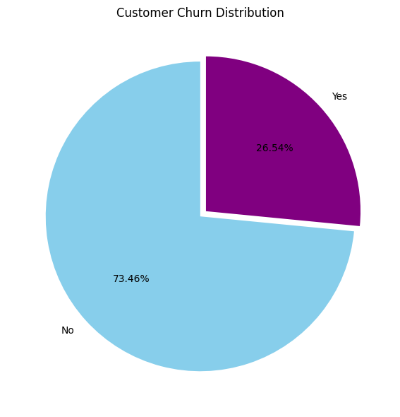

Figure 2.1: Overall Churn Distribution

There were 1,869 churned customers out of 7,043 customers, giving an overall churn rate of 26.54%
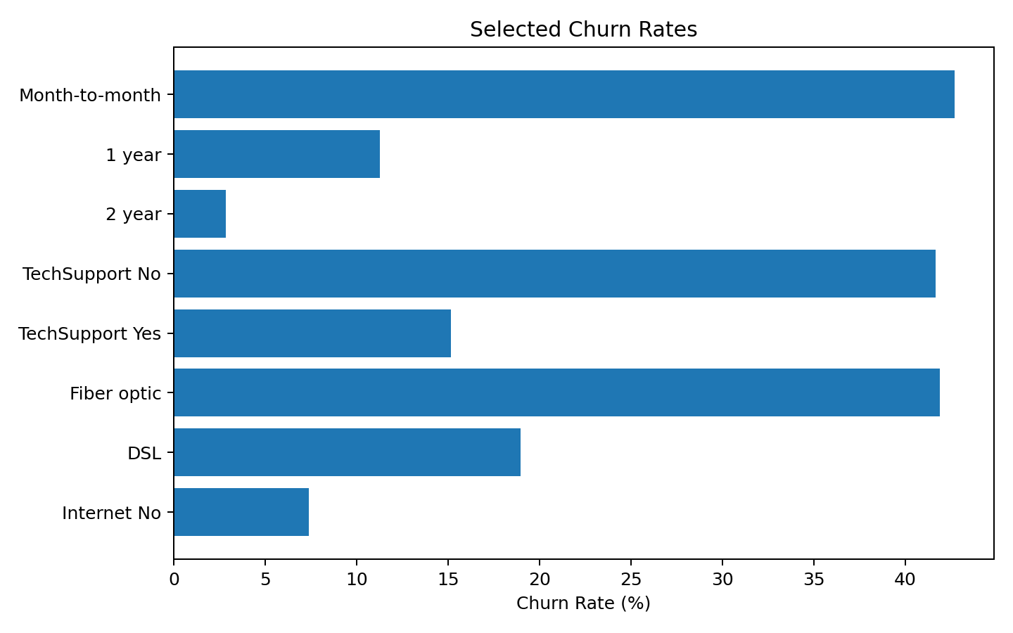Figure 2.2: Selected Churn Rates
Month-to-month customers have 42.71% churn, while two-year contract customers have 2.83%. Customers without TechSupport have 41.64% churn, while customers with TechSupport have 15.17%.

2.4 Chapter 2 Summary

This chapter prepared the 7,043 record Telco Customer Churn dataset for mining and modeling. The data was examined for structure, missing values, duplicates and data types. TotalCharges was converted to numeric and the 11 blank records filled with 0 since they were zero-tenure customers. customerID was excluded from modeling and ChurnFlag excluded as a predictor to prevent target leakage. Categorical variables were prepared for one-hot encoding. This chapter also prepared standardized data for K-Means customer segmentation and presented the main visualizations used to understand churn.
- 7,043 records and 21 attributes were analyzed.
- 11 blank TotalCharges values were handled after checking their zero-tenure context.
- Identifier and target-leakage columns were excluded from the model predictors.
- Clustering features were standardized before K-Means.
- Visualization was used to identify important observed churn patterns.

CHAPTER 3

APPLIED METHODOLOGIES & MINING

3.1 Descri ptive mining

Descriptive mining describe what is present in the data. In this project, the focus is mainly on the churn rate of different customer groups.

3.1.1 Distribution Analysis

The overall churn rate is 26.54% ( 73.46% did not churn) .
This means the Churn = Yes class is smaller than the Churn = No class

Tenure Group | Customers | Churn Rate
0-6 months | 1,481 | 52.94%
7-12 months | 705 | 35.89%
13-24 months | 1,024 | 28.71%
25-48 months | 1,594 | 20.39%
49-72 months | 2,239 | 9.51%

Table 3. 2 Distribution Description

The results of tenure show a clear pattern. Customers who have been with the company for the first 6 months have a significantly higher observed churn rate than those who have stayed longer.

3.1.2 Group-by Analysis

Attribute | Group | Churn Rate
Contract | Month-to-month | 42.71%
Contract | One year | 11.27%
Contract | Two year | 2.83%
TechSupport | No | 41.64%
TechSupport | Yes | 15.17%
InternetService | Fiber optic | 41.89%
InternetService | DSL | 18.96%
InternetService | No internet service | 7.40%
PaymentMethod | Electronic check | 45.29%
PaymentMethod | Mailed check | 19.11%
PaymentMethod | Bank transfer | 16.71%
PaymentMethod | Credit card | 15.24%

Table 3.2 Dataset Description

3.1.3 Association Mining

Apriori association rule mining was used to find customer characteristics that were commonly associated with churn. Selected categorical values were converted into transaction items such as Contract_Month-to-month, TechSupport_No, Internet_Fiber optic, Payment_Electronic check, and Churn_Yes.
Support indicates how common a combination is in the entire dataset. Confidence indicates how often the consequent appears when the antecedent appears. Lift compares the observed association with what would be expected if items were independent.

3.1.4 Association Interpretation

Example rule:
TechSupport_No + Internet_Fiber optic + Contract_Month-to-month → Churn_Yes
Measure | Value
Support | 10.17%
Confidence | 62.92%
Lift | 2.37

Table 3.3 Association Interpretation

This rule indicates that the combination is often found together with Churn_Yes in the dataset. The lift of 2.37 indicates a positive association with churn.
Association rules help find patterns in data, but they are not prediction results and do not prove causation. For instance, the rule does not prove that having no TechSupport causes churn.

3.2 Modeling
Predictive mining is different from descriptive mining. The model is learned from customer records where the actual Churn value is known and is then tested on records that were not used during training.

3.2.1 Applied Methodoligies / Algorithms
- Logistic Regression: used as the primary baseline classification method. It estimates the probability of churn.
- Decision Tree: makes a series of feature-based decisions to classify customers bases on the feature.
- Random Forest: combines many decision trees and uses their combined result

3.2.2 Model Setup
The data was split into 80% training data and 20% testing data. This resulted in 5,634 training records and 1,409 testing records. Stratified splitting was used to maintain similar churn/no-churn proportions.
Categorical attributes were processed with One-Hot Encoding. The preprocessing steps and classifier was placed in a scikit-learn Pipeline..

3.2.3 Baseline Model
A Three baseline models were trained using the same training and testing data. Logistic Regression performed the best overall baseline result. It had the highest Accuracy, Precision, F1-score, and ROC-AUC. Decision Tree had a slightly higher Recall, but its the other scores were lower.

3.2.4 Proposed Model and Data Insights
Based on the baseline comparison, Logistic Regression was selected as the main final model. Its highest positive coefficients were for InternetService_Fiber optic, Contract_Month-to-month, and tenure_group_0-6.
These findings were similar to the descriptive findings, but coefficients in a model describe how the model makes predictions based on the features. They should not be interpreted as proof that those features cause churn.

3.2.5 Class Imbalance Experiment

The target variable is imbalanced since 5,174 customers (73.46%) did not churn and 1,869 customers (26.54%) churned. Two approaches were tested: class_weight='balanced' and SMOTE. The latter was applied only to the training set while the test set was kept as is.
Experiment | Accuracy | Precision | Recall | F1 | ROC-AUC
Baseline Logistic Regression | 80.06% | 65.87% | 51.60% | 57.87% | 84.47%
LR + class_weight balanced | 73.88% | 50.51% | 80.21% | 61.98% | 84.49%
LR + SMOTE | 74.10% | 50.77% | 79.41% | 61.94% | 84.28%

Table 3.4 Class Imbalance Experiment
The experiments performed demonstrate that the application of class weighting and the SMOTE technique leads to an increase in the model’s Recall but a decrease in Accuracy and Precision as compared to the baseline.

3.3 System Implementation
The project was implemented as a simple Streamlit web application. The system combines the analysis and prediction parts in one place.
- Dashboard: displays total customers, churn rate, average monthly charges, average tenure, and churn charts.
- Churn Prediction: allows the user to enter customer information and receive a churn prediction and probability.
- Model Evaluation: displays the model comparison results.
- Business Insights: displays the main findings and potential business actions.
The Logistic Regression Pipeline was saved as logistic_regression_model.pkl. The preprocessing is part of the pipeline so that the same process is applied when new customer information is entered.

3.4 Chapter 3 Summary

Descriptive data mining, association, clustering analysis, and predictive modeling were performed in chapter 3. Analysis of variations in the churn rate across different groups of customers was performed using group-by analysis. The association rules were discovered using the Apriori algorithm. Customer segmentation was done using the K-Means algorithm, which resulted in six customer segments. Predictive modeling was done using Logistic Regression, Decision Tree, and Random Forest algorithms. Experiments performed to address the class imbalance problem included application of class weights and the use of the SMOTE technique. Both led to an increase in Recall but a decrease in Accuracy and Precision as compared to the baseline model.
- Descriptive mining summarized churn patterns across customer groups.
- Apriori found recurring combinations associated with churn.
- K-Means created six customer segments using selected customer characteristics.
- Three classification algorithms were compared.
- Class weighting and SMOTE were tested for the imbalanced target.

CHAPTER 4

EVALUATION

The evaluation stage examines how well the classification models perform on unseen test data. The same test set was used for the three baseline models to compare their results.

4.1 Performance Metrics

- Accuracy: percentage of all predictions that are correct.
- Precision: among customers predicted as churners, how many actually churned.
- Recall: among customers who actually churned, how many were correctly found.
- F1-score: balance between Precision and Recall.
- ROC-AUC: indicates how well the model separates churn and no-churn customers.
Recall is important in churn analysis because a False Negative means an actual churner was missed. At the same time, Precision is important because the company may not want to spend retention resources on too many customers who would not churn.

4.2 Model Comparison

Model | Accuracy | Precision | Recall | F1 Score | ROC-AUC
Logistic Regression | 80.41% | 65.31% | 55.88% | 60.23% | 84.26%
Decision Tree | 73.03% | 49.24% | 51.87% | 50.52% | 66.25%
Random Forest | 77.79% | 60.27% | 47.86% | 53.35% | 81.84%

Table 4. 3Model Comparison

Logistic Regression achieved the highest overall result among the three baseline models.
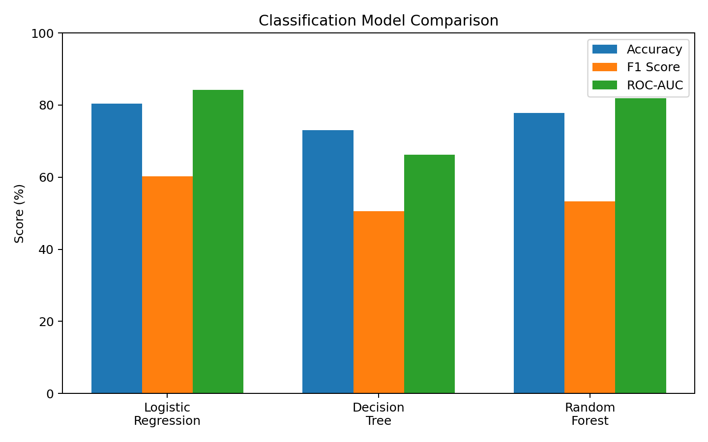

Figure 4.1: Classification Model Performance Comparison

4.2.1 Evaluation Analysis

Logistic Regression obtained 80.41% Accuracy, 65.31% Precision, 55.88% Recall, 60.23% F1-score, and 84.26% ROC-AUC.
Decision Tree had the highest Recall at 51.87%, but the other metrics were lower. Random Forest was superior to Decision Tree in Accuracy, Precision, F1-score, and ROC-AUC, but had the lowest Recall.
The Logistic Regression confusion matrix was [[924, 111], [165, 209]]. This indicates 924 non-churn customers and 209 churn customers were correctly classified. There were 111 False Positives and 165 False Negatives.
Model | TN | FP | FN | TP
Logistic Regression | 924 | 111 | 165 | 209
Decision Tree | 835 | 200 | 180 | 194
Random Forest | 917 | 118 | 195 | 179

Table 4.2 Evaluation Analysis

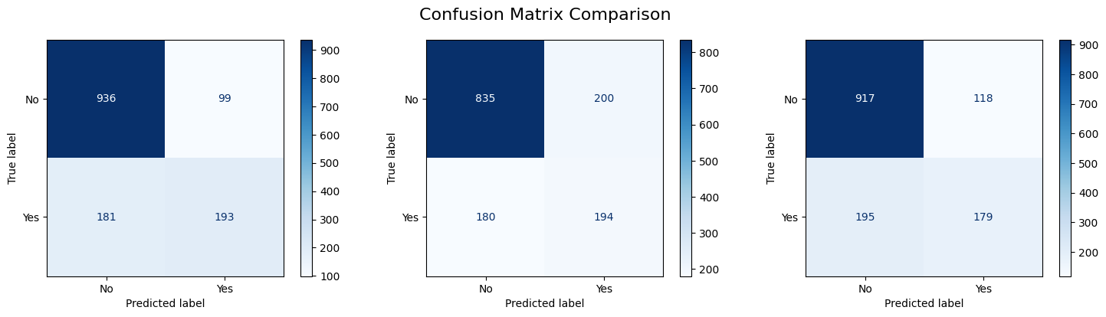

Figure 4.2: Classification Model Performance Comparison

4.2.2 Feature Scaling
I then tested whether feature scaling would improve Logistic Regression. Two versions were compared: Logistic Regression with no scaling and Logistic Regression using StandardScaler on numerical features.
Model | Accuracy | Precision | Recall | F1 Score | ROC-AUC
No Scaling | 80.41% | 65.31% | 55.88% | 60.23% | 84.26%
StandardScaler | 80.55% | 65.72% | 55.88% | 60.40% | 84.21%

Table 4.3 Feature Scaling

StandardScaler slightly improved Accuracy, Precision, and F1-score, but Recall remained the same. ROC-AUC decreased slightly from 84.26% to 84.21%.
Since the changes were very small and the no-scaling model had the slightly higher ROC-AUC, I selected Logistic Regression without scaling as the final model. This experiment shows that feature scaling should be based on the model/data rather than applied automatically

4.2.3 Findings
- Logistic Regression was the strongest model in the main baseline comparison.
- It achieved 80.41% Accuracy and 84.26% ROC-AUC.
- Customers with 0-6 months tenure had the highest observed churn rate among the tenure groups.
- Month-to-month customers had much higher observed churn than one-year and two-year contract customers.
- Customers without TechSupport had a higher observed churn rate than customers with TechSupport.
- Fiber optic customers and electronic-check users also showed higher observed churn rates.
- Apriori found combinations of these characteristics associated with Churn_Yes.
- StandardScaler produced only small changes in the Logistic Regression results.
- The no-scaling Logistic Regression model was selected as the final model.
- The results describe associations and model behavior. But they do not prove direct cause and effect.

4.3 Chapter 4 Summary

Chapter 4 used Accuracy, Precision, Recall, F1-score, ROC-AUC, and confusion matrices to evaluate experiments. I performed experiments with class-imbalance, which demonstrated that using class weighting and SMOTE techniques allowed to identify more churn cases, which decreased Precision and Accuracy. The results of the experiment with scaling demonstrated only minor differences between the outcomes. For this reason, I decided to consider multiple factors when evaluating performance besides using Accuracy as a metric.
- Multiple performance metrics were used.
- Class weighting produced the highest Recall in the imbalance experiment.
- SMOTE also substantially increased Recall.
- Higher Recall came with a Precision/Accuracy trade-off.
- Feature scaling produced only small performance changes.

CHAPTER 5

CONCLUSION

This project studied customer churn using the IBM Telco Customer Churn dataset. The main objective was to understand which customer characteristics were associated with churn, and to develop a model that could predict customer churn.
During descriptive mining, there were clear differences between several customer groups. New customers, month-to-month contract customers, customers without TechSupport, fiber optic customers, and electronic-check users showed higher observed churn rates in the dataset.
Apriori association rule mining was used to examine combinations of customer characteristics. The rules indicated that combinations such as month-to-month contract, no TechSupport, and fiber optic service often appeared with Churn_Yes. These are associations, not proof of causation.
For predictive mining, Logistic Regression, Decision Tree, and Random Forest were compared. Logistic Regression achieved the strongest overall result in the baseline comparison. An experiment was also performed to test whether feature scaling would improve performance. StandardScaler produced only very small changes, and the no-scaling Logistic Regression model was selected as the final model.
Finally, the project was implemented as a Streamlit system. The system connects the analysis, model evaluation, business insights, and churn prediction parts in one application

5.1 Advantages of using this project

- It provides simple insight into customer churn patterns.
- It combines descriptive mining, association mining, and predictive mining.
- It compares more than one classification algorithm.
- It uses several evaluation metrics ,not just Accuracy.
- It provides model information through Logistic Regression coefficients.
- It includes a feature scaling experiment.
- It provides a simple Streamlit interface for analysis and prediction.
- It can support customer retention planning.

5.2 Disadvantages & Limitations

- The dataset may not represent every telecom company or customer type.
- Model performance is dependent on the available training and testing data.
- The model still misses some customers who actually churn, indicated by the False Negatives.
- Association rules cannot prove that one customer attribute causes churn.
- The dataset does not contain every possible cause of churn, such as detailed complaints, service quality, or competitor offers.
- The current model is a baseline solution, and more experiments and new data could improve it.
- Business actions should be tested before assuming that a particular action will reduce churn.

5.3 Future Work
- Try more classification algorithms and tuning methods.
- Use cross-validation in a future experiment to examine model stability.
- Test different prediction thresholds based on business cost.
- Add customer service and complaint information if available.
- Enhance the Streamlit system with a database and user access control.
- Monitor the model using new customer data after deployment.

REFERENCES

[1] Kaggle, IBM Telco Customer Churn Dataset, blastchar. https://www.kaggle.com/datasets/blastchar/telco-customer-churn
[2] Streamlit Documentation, Streamlit Python framework.

