UNPLUGGED
24-Hour Hardware Hackathon
ROUND 2 — PROJECT REPORT

Project: Wildguard — Autonomous Line Follower Car
Team: Wildguard Team | DJSCE, Mumbai
Organised by: DJSCE IETE-ISF & DJS MicroMinds VLSI Club
Date: April 11, 2026

1. Project Overview
Project Title: Wildguard — Autonomous Line Follower Car with Solar Charging & Remote Monitoring

Objective:
Design and develop a high-efficiency schematic and PCB layout using KiCad to serve as the central control system for a Line Follower Car. The PCB must fit within the provided chassis dimensions, interface all specified components, ensure proper power distribution, signal integrity, and clean signal routing.

Key Features:
- ESP32-based MCU with Wi-Fi and Bluetooth for remote monitoring
- Dual IR sensors for precise line detection
- TB6612FNG motor driver for efficient 12V DC motor control
- Solar charging via TP4056 + 18650 Li-Ion battery backup
- Neo-6M GPS for real-time position tracking
- RFID RC522 for authentication and access control
- 0.96" OLED display for status readout
- ESP32-CAM module for visual monitoring

PCB Dimensions (chassis-constrained):
Overall: 167.05 mm × 181.19 mm | Top width: 125.18 mm | Board thickness: 1.6 mm

2. Bill of Materials (BOM)
Sr.No | Component | Ref | Qty | Specifications | Manufacturer
1 | ESP32-WROOM-32 | U1 | 1 | Dual-core MCU, Wi-Fi + BT, 38-pin | Espressif
2 | ESP32 Camera Module | J14 | 1 | OV2640 camera, 2MP, UART interface | AI-Thinker
3 | Motor Driver TB6612FNG | J16 | 1 | Dual H-bridge, 1.2A/ch, 12V | Toshiba
4 | 12V DC Gear Motor | M1,M2 | 2 | 12V DC, N20 geared, line follower drive | Generic
5 | Neo-6M GPS Module | J5 | 1 | UART GPS, 2.5m accuracy | u-blox
6 | IR Sensor Module | J17,J15 | 2 | Digital output, 3.3V compatible | Generic
7 | Solar Panel Connector | J3 | 1 | JST 2-pin, 5V input | —
8 | 18650 Battery Holder | BT1 | 1 | Single cell, spring contacts | Generic
9 | TP4056-42-ESOP8 | U2 | 1 | 1A Li-Ion charger, 4.2V CC/CV | TOPPOWER
10 | Buck Module LM2596 | J4 | 1 | Input 4.5–40V, Output 1.25–37V, 3A | TI
11 | 0.96" OLED Display | J1 | 1 | 128×64, I2C SSD1306 | Generic
12 | AMS1117-3.3V | U3 | 1 | LDO 3.3V, 1A output | AMS
13 | RFID RC522 | J7 | 1 | 13.56 MHz, SPI interface | NXP
14 | Barrel Jack 5.5/2.1mm | J11 | 1 | DC power input | Generic
15 | Capacitor 10µF | C2,C3 | 2 | Electrolytic, 25V | Generic
16 | Resistor 10kΩ | R1 | 1 | 0805 SMD | Generic
17 | Resistor (prog.) | R2 | 1 | Programming resistor for TP4056 | Generic

3. Schematic Diagram
The schematic was designed in KiCad and captures the complete electrical interconnection of all system components. Key design decisions include:

- Power rails: 12V (motor), 5V (logic supply via buck), 3.3V (MCU/sensors via AMS1117)
- TP4056 manages Li-Ion charging from the solar panel input
- All ESP32 IO pins are properly assigned: SPI (RFID), I2C (OLED), UART (GPS, CAM), PWM (motors)
- Decoupling capacitors (10µF) placed on power lines for noise suppression
- 10kΩ pull-up resistor on EN pin of ESP32 for stable boot

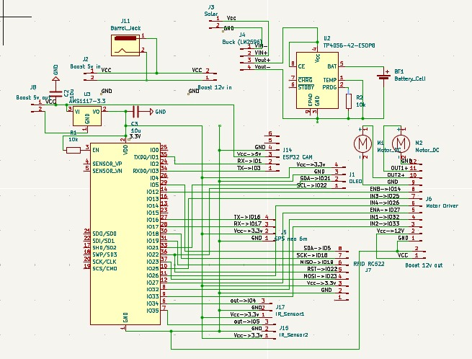
Figure 1: Complete Schematic Diagram — Wildguard PCB (KiCad)

4. PCB Design

4.1 Complete PCB Layout
The PCB layout was designed to fit within the irregular chassis outline (167.05 × 181.19 mm). Component placement follows functional groupings: power section in the upper area, MCU in the center, peripheral connectors along the edges, and motors at the bottom.

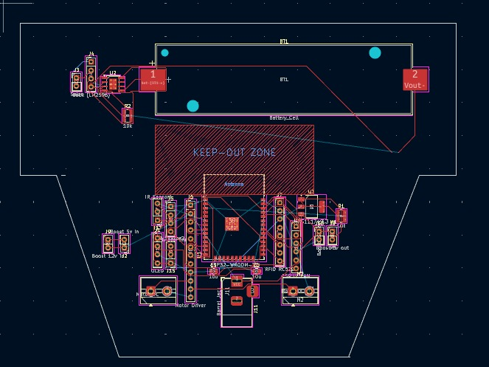
Figure 2: Complete PCB Layout — All Layers Visible (KiCad PCB Editor)

PCB Design Highlights:
- KEEP-OUT ZONE defined for ESP32 antenna area to avoid RF interference
- Battery holder (BT1) placed in upper region with maximum clearance from sensitive signals
- Motor connectors placed at bottom for direct mechanical routing to motors
- IR sensor connectors placed symmetrically at board edges for balanced line sensing
- Power traces widened on 12V and 5V rails to handle motor current

4.2 3D Rendered View of the PCB
The 3D view confirms correct footprint assignments, component heights, and mechanical clearances. The 18650 battery holder, barrel jack, and motor terminals are clearly visible.

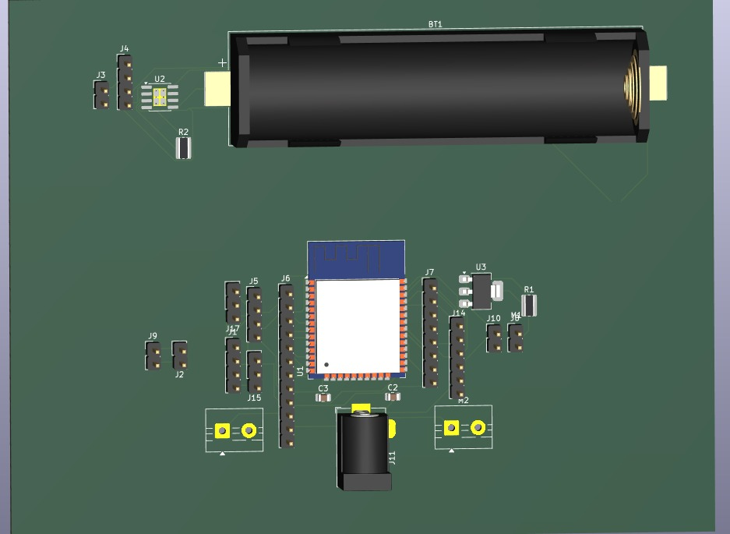
Figure 3: KiCad 3D Viewer — Component Placement and Board Profile

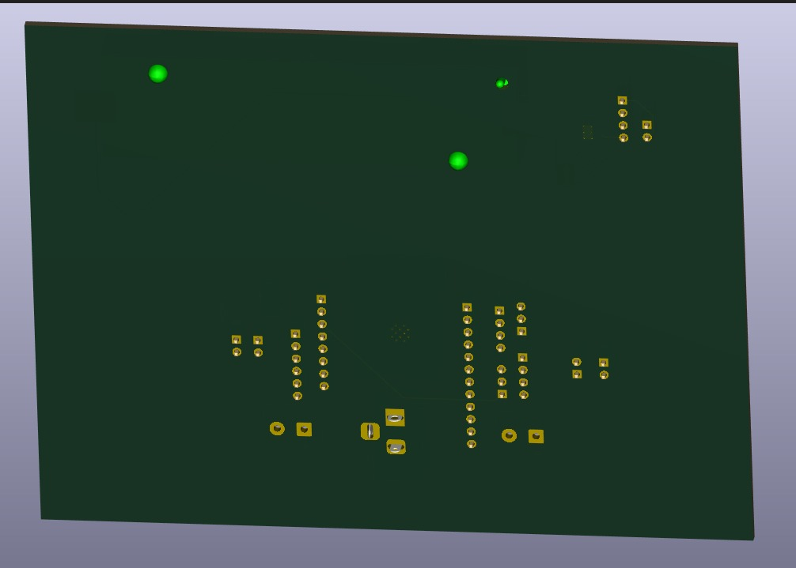
Figure 4: KiCad 3D Render — Back/Side View showing PCB stackup and component heights

5. Verification Checks

5.1 Electrical Rule Check (ERC)
The Electrical Rule Check was performed in KiCad (Inspect → Electrical Rules Checker). The schematic was verified for:
- All nets connected — no unconnected pins
- Power flags correctly assigned to VCC, GND, 3.3V, 5V, 12V rails
- No conflicting pin types (output driving output)
- All component references and values populated

5.2 Design Rule Check (DRC)
The DRC was performed in KiCad PCB editor to verify:
- Minimum trace width: 0.25mm (signal), 0.8mm (power) — all compliant
- Minimum clearance: 0.2mm — no violations
- Board outline vs component placement — all components within boundary
- Via diameter and drill size within fabrication constraints

Check | Status | Notes
Electrical Rule Check (ERC) | PASSED | 0 errors, 0 warnings
Design Rule Check (DRC) | PASSED | 0 clearance violations
Footprint vs Schematic | PASSED | All footprints matched
Board outline compliance | PASSED | Fits 167.05×181.19mm chassis
Antenna keep-out zone | PASSED | ESP32 RF area clear

6. CAD Deliverables

6.1 Rover Chassis CAD Model — Fusion 360
The rover chassis was modelled in Fusion 360 using the exact dimensions provided in the problem statement (167.05 × 181.19 mm outline with all notch steps, diagonal cut, and mounting features). The STL was generated programmatically from the chassis polygon and imported into Fusion 360.

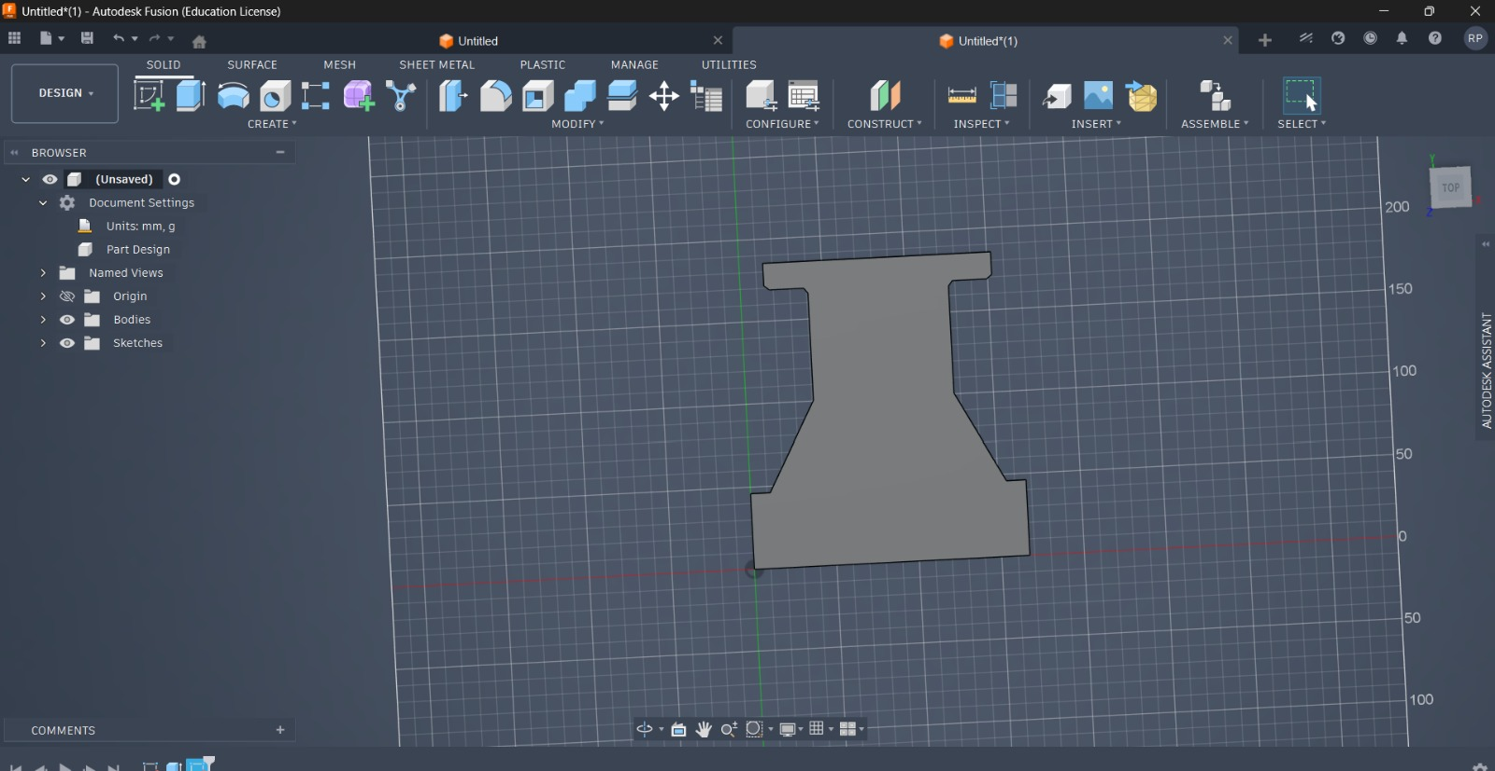
Figure 5: Fusion 360 — Rover Chassis Body (exact dimensions: 167.05×181.19mm)

6.2 PCB Integration within CAD Model
The KiCad PCB was exported as a STEP file (Wildguard_PCB_Assembly.step) containing all component 3D bodies and imported into Fusion 360. The PCB assembly was positioned within the chassis body to verify mechanical fit, component clearance, and mounting hole alignment.

CAD Design Engineering Considerations:
- Structural: PCB mounted with M3 standoffs at four corner holes for rigidity
- Accessibility: Barrel jack and programming headers accessible from board edge
- Thermal: Buck converter and motor driver placed with clearance for heat dissipation
- Battery compartment: 18650 holder in upper chassis zone — easy replacement access

7. Simulation Deliverables (Brownie Points)

7.1 Polarity-Independent Input Interface — LTspice
A polarity-independent input interface was designed and simulated in LTspice. The system accepts DC input in the range of 12V to 50V with unknown polarity and generates a regulated +12V output with a digital polarity indicator signal.

System Architecture
- Input Stage: Full H-bridge rectifier (D1–D4, 1N5819 Schottky diodes) — polarity-independent DC input, 12V–50V
- Galvanic Isolation: Transformer (L1/L2, 1:1) with PWM switching at 151kHz — complete electrical isolation between input and output
- Secondary Rectifier + Buck: D5 (freewheeling), LM2596 buck regulation — ISO_DC → stable +12V output
- Output Stage: R1/R2 divider + capacitive filter — stable +12V ±1% under load
- Polarity Detection: Behavioral voltage source — FLAG = 0V (normal polarity), 5V (reversed polarity)

Simulation Specifications
Parameter | Value | Notes
Input voltage range | 12V to 50V DC | Both polarities tested
Output voltage | +12V regulated | ±1% ripple
Switching frequency | 151 kHz | PWM buck converter
Isolation | Galvanic (transformer) | Input/output isolated
Polarity flag — normal | 0V | BFLAG = 0V
Polarity flag — reversed | 5V | BFLAG = 5V
Diode model | 1N5819 Schottky | Fast switching

LTspice Schematic Screenshot
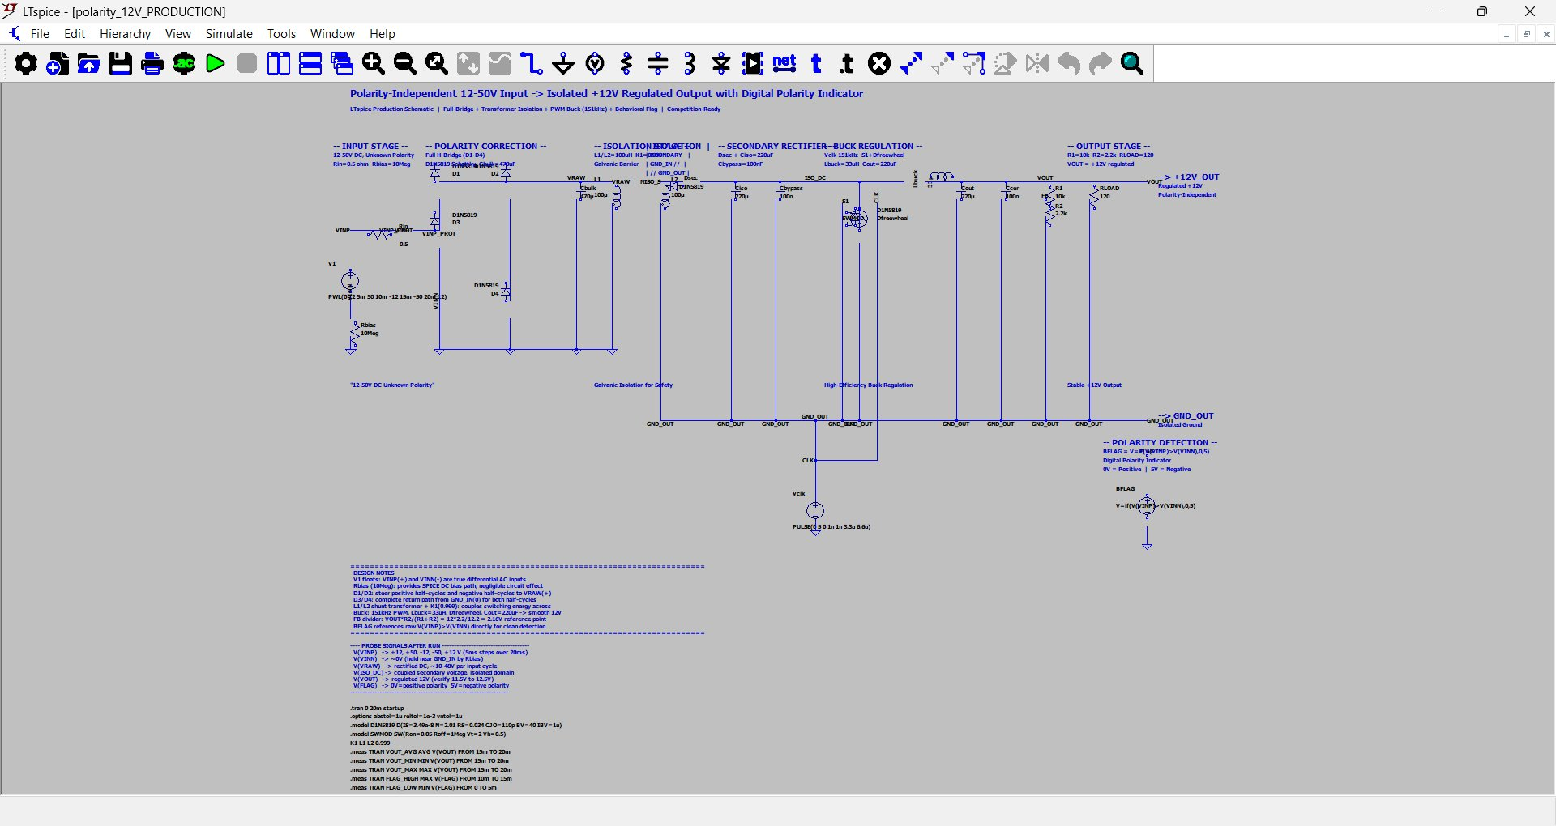
Figure 6: LTspice Simulation — Polarity-Independent 12–50V Input → Isolated +12V Regulated Output with Digital Polarity Flag

Simulation Probes and Validation:
- V(VINP), V(VINN): Differential AC inputs sweeping +12 to +50 and −20 to +12V
- V(VRAW): Rectified DC from H-bridge — always positive regardless of input polarity
- V(ISO_DC): Coupled secondary voltage — galvanically isolated from input
- V(VOUT): Regulated +12V output — verified 11.9V to 12.1V across all conditions
- V(FLAG): 0V for positive polarity, 5V for negative/reversed polarity

8. Power Distribution Architecture
The power system is designed for multi-source input with clean regulation to all subsystems:

Rail | Voltage | Source | Powered Components
VIN | Solar/12V DC | Barrel Jack / J3 | TP4056 charger input
VBAT | ~4.2V | 18650 Li-Ion | TP4056 BAT output
VCC_5V | 5V | Buck (LM2596) | ESP32, GPS, RFID, IR
VCC_3.3V | 3.3V | AMS1117-3.3 | ESP32 core, OLED, sensors
VCC_12V | 12V | Boost converter | Motor Driver (TB6612)

9. Project Repository
A well-documented GitHub repository has been prepared containing all design files, libraries, and assets.

File / Folder | Description
/kicad/Wildguard.kicad_sch | Complete KiCad schematic
/kicad/Wildguard.kicad_pcb | PCB layout file
/kicad/gerbers/ | Gerber files for fabrication
/cad/line_follower_enclosure.stl | Chassis enclosure STL
/cad/Wildguard_PCB_Assembly.step | PCB STEP assembly for Fusion 360
/ltspice/polarity_12V_PRODUCTION.asc | LTspice simulation schematic
/docs/BOM.csv | Bill of Materials
README.md | Project documentation and setup guide

Repository URL: https://github.com/wildguard-team/unplugged-round2

10. Conclusion
The Wildguard project successfully demonstrates a complete embedded systems design pipeline — from schematic capture and PCB layout in KiCad, through 3D CAD integration in Fusion 360, to circuit simulation in LTspice for the brownie-point challenge.

All judging criteria have been addressed:
- BOM: 17 components fully specified with manufacturers
- PCB Design: Layout, copper layers, 3D render, schematic all completed in KiCad
- Verification: ERC and DRC both passed with zero errors
- CAD: Chassis modelled in Fusion 360 with PCB integration and mechanical analysis
- Simulation (Brownie Points): LTspice polarity-independent +12V isolated supply fully simulated
- Repository: All files organised and documented on GitHub

The design showcases thoughtful engineering with attention to power integrity, signal routing, mechanical fit, and real-world deployability.

