Coffee Shop Sales Analysis
Data Analytics Project Report
Submitted by: Bhoomi Katarmal
Dataset: Coffee_Shop_Sales.csv | Tool: Python (Jupyter Notebook)
Date: June 2025 | Status: Finalised

Table of Contents

1. Executive Summary
This report presents an end-to-end data analytics study of a coffee shop chain's transactional sales data spanning January to June 2023. The analysis was conducted using Python (pandas, matplotlib, seaborn) inside a Jupyter Notebook and covers data cleaning, exploratory data analysis (EDA), monthly sales trends, product performance, store location comparison, peak-hour behaviour, and revenue insights.
Key outcomes of the study include: identification of the best-performing store location, the highest-revenue product categories and individual products, the busiest trading hours, and month-over-month revenue growth patterns. The report concludes with six actionable business recommendations aimed at increasing revenue and customer retention.

2. Introduction

2.1 Background
The coffee shop industry is one of the fastest-growing segments of the food and beverage sector. With multiple store locations and a diverse product portfolio, data-driven decision making is essential for sustainable growth. This project applies data analytics techniques to a real-world transactional dataset to extract actionable insights about sales performance, customer preferences, and operational efficiency.

2.2 Objectives
The primary objectives of this project are:
- • Understand the overall sales and revenue trends across the dataset period.
- • Identify the top-performing product categories and individual product types.
- • Compare revenue and transaction volume across all three store locations.
- • Determine peak trading hours and the busiest days of the week.
- • Analyse month-over-month revenue growth and identify seasonal patterns.
- • Produce data-driven recommendations for improving business performance.

2.3 Scope
The analysis covers transactional data from three coffee shop branches — Lower Manhattan, Hell's Kitchen, and Astoria — over the period January 2023 to June 2023. The dataset contains individual transaction records with product, store, quantity, and pricing information.

3. Dataset Overview

3.1 Data Source
The dataset used in this project is Coffee_Shop_Sales.csv — a comma-separated file containing point-of-sale transaction records from a coffee shop chain. The dataset includes 149,116 transaction records across 10 columns.

3.2 Dataset Schema
Column Name | Data Type | Description
transaction_id | Integer | Unique identifier for each transaction
transaction_date | String → Date | Date of the transaction (MM/DD/YY format)
transaction_time | String → Time | Time of the transaction (HH:MM:SS format)
transaction_qty | Integer | Number of units purchased in the transaction
store_id | Integer | Numeric identifier for the store location
store_location | String | Name of the store (Lower Manhattan, Hell's Kitchen, Astoria)
product_id | Integer | Numeric identifier for the product
unit_price | Float | Price per unit of the product (USD)
product_category | String | High-level product category (Coffee, Tea, Bakery, etc.)
product_type | String | Specific product name (e.g. Barista Espresso, Drip coffee)

3.3 Data Quality
Upon inspection, the dataset contained no missing values across all 10 columns. No duplicate transaction IDs were detected. The transaction_date field was stored as a string in MM/DD/YY format and was converted to a proper datetime object during preprocessing. Similarly, transaction_time was parsed from a HH:MM:SS string. The unit_price column uses decimal notation and required no cleaning.

4. Methodology

4.1 Tools and Technologies
The entire analytics workflow was implemented in Python 3.14 within a Jupyter Notebook environment. The following libraries were used:
• pandas (v2.0+) — data loading, cleaning, aggregation, and feature engineering.
• numpy (v1.24+) — numerical operations and array handling.
• matplotlib (v3.7+) — base-level charting and custom axis formatting.
• seaborn (v0.12+) — statistical visualisation including heatmaps and distribution plots.

4.2 Data Preprocessing
The following preprocessing and feature engineering steps were applied before analysis:
• Date parsing: transaction_date was parsed from string (MM/DD/YY) to a pandas datetime object.
• Time parsing: transaction_time was parsed from string (HH:MM:SS) to a Python time object.
• Revenue column: a derived column revenue = transaction_qty × unit_price was computed for each record.
• Temporal features: month, month_name, day_of_week, day_name, and hour columns were extracted to support time-based analysis.
• Ordered categorical types: month_name and day_name were cast to ordered pandas Categorical types to ensure correct chronological ordering in all visualisations.

4.3 Analysis Framework
The analysis was structured into five core analytical modules: (1) Exploratory Data Analysis — summary statistics and distribution plots; (2) Sales Trend Analysis — monthly and daily revenue trends; (3) Product Analysis — category and product-type revenue and volume rankings; (4) Store Performance Analysis — cross-location comparison; and (5) Temporal Pattern Analysis — peak-hour and day-of-week heatmaps.

5. Analysis & Results

5.1 Exploratory Data Analysis
The dataset contains 149,116 transactions generated across six months (January–June 2023). The high-level KPIs computed from the dataset are summarised below:
KPI Metric | Value
Total Transactions | 149,116
Total Revenue | $698,812.33
Average Transaction Value | $4.69
Total Units Sold | 214,470
Unique Product Types | 29
Unit prices range from $0.80 to $9.00, with a mean of approximately $3.18. Transaction quantities are typically between 1 and 8 units. The revenue per transaction follows a right-skewed distribution, with a mean of approximately $4.69 and a median of $3.50, indicating a long tail of higher-value multi-unit transactions.
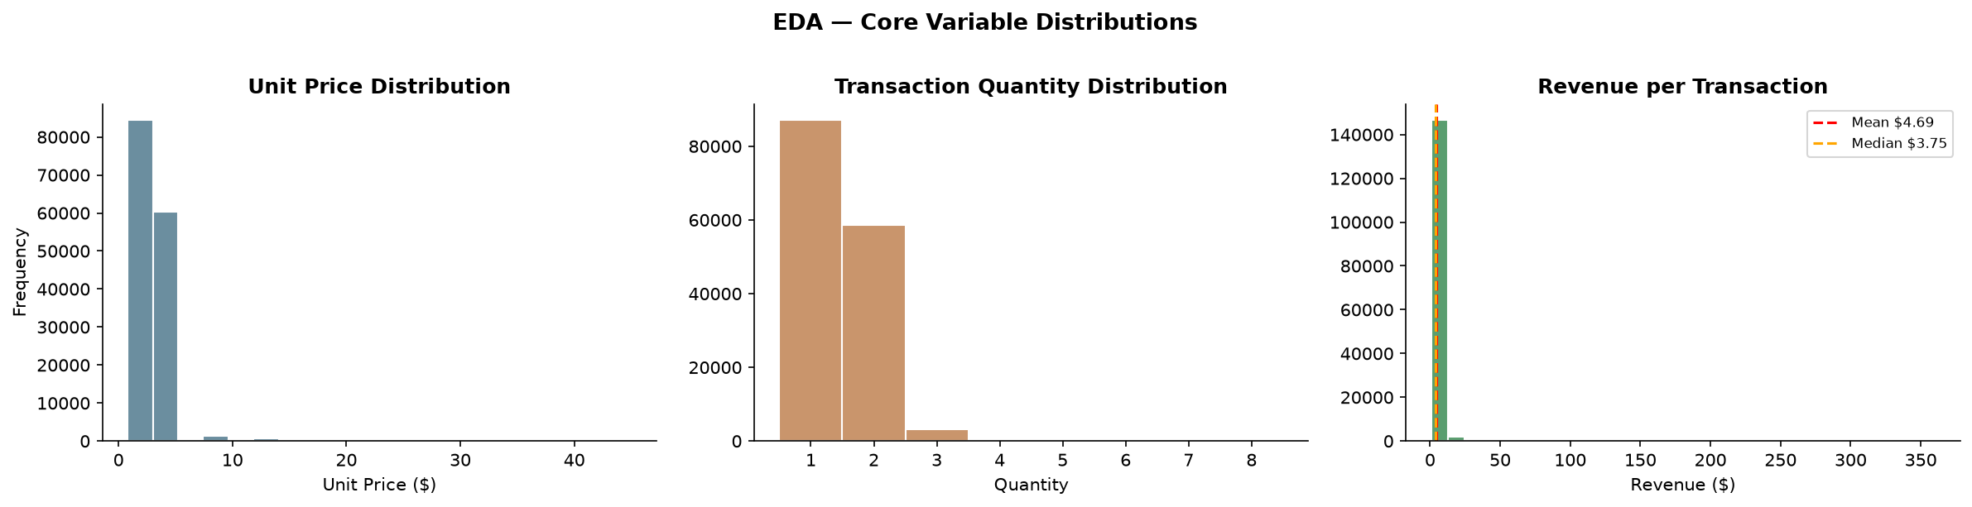
Figure 1 — EDA: Core Variable Distributions (Unit Price, Quantity, Revenue)

5.2 Sales Trend Analysis
Monthly revenue shows a consistent upward trend from January through June 2023. January records the lowest revenue, while June reaches the peak. The month-over-month growth rate accelerates through spring, reflecting seasonal demand for cold beverages and the general increase in foot traffic during warmer months.
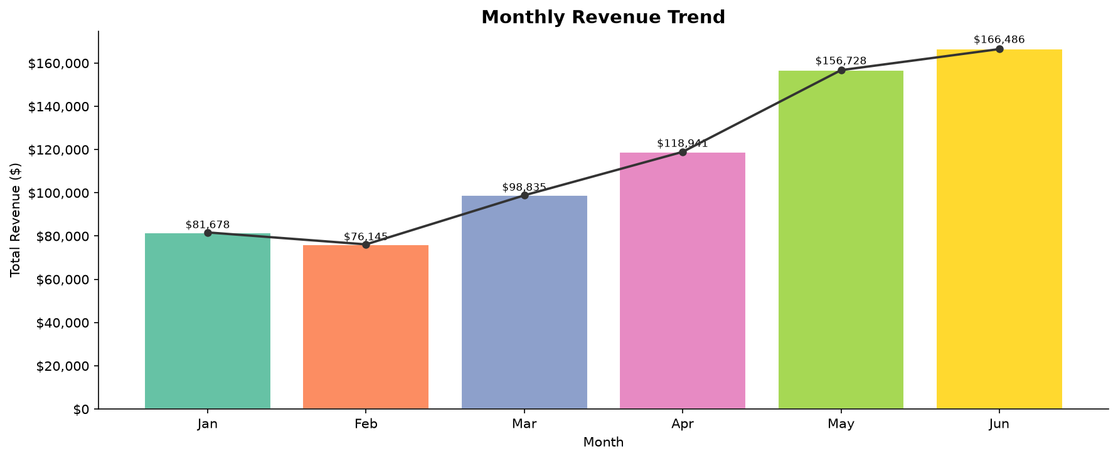
Figure 2 — Monthly Revenue Trend
The 7-day rolling average of daily revenue confirms a stable upward trajectory with no significant dips, suggesting consistent operations across all three locations. Transaction count mirrors the revenue trend closely, confirming that volume growth — not price increases — drives revenue growth. The month-over-month revenue figures and growth rates are shown below:
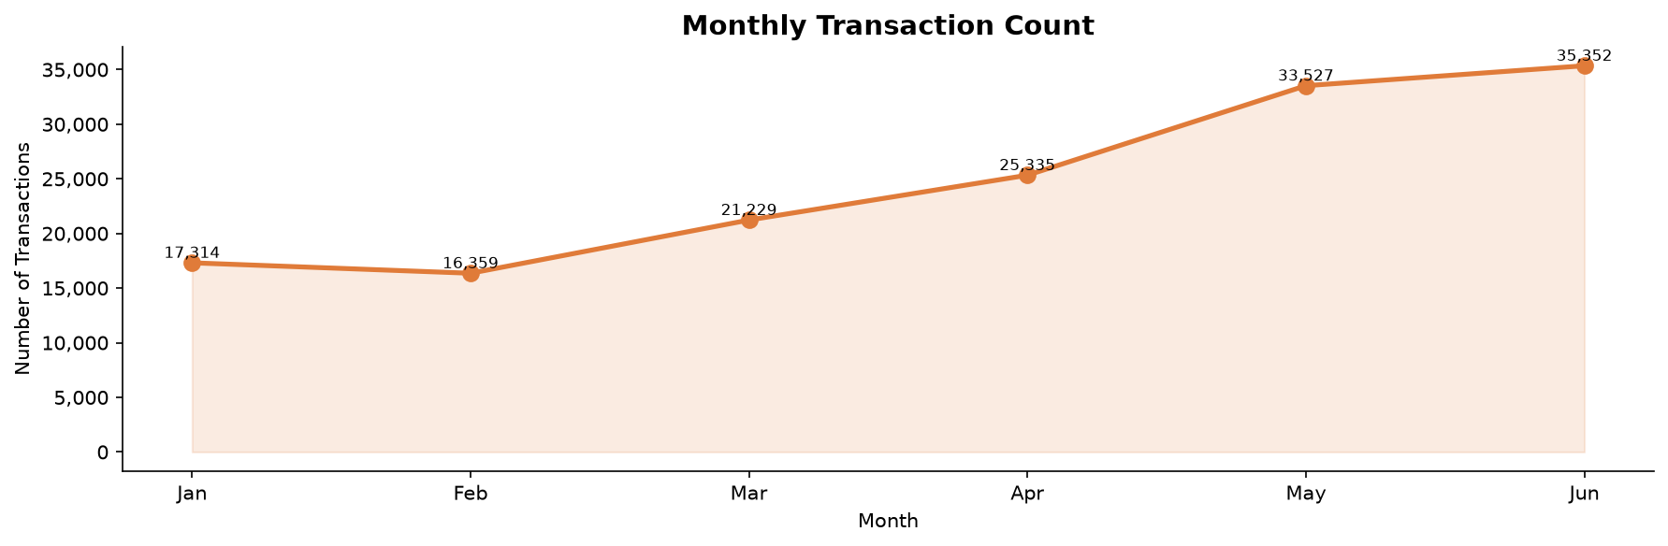
Month | Total Revenue ($) | MoM Growth (%)
January | 81,677.74 | —
February | 76,145.19 | -6.77%
March | 98,834.68 | +29.80%
April | 118,941.08 | +20.34%
May | 156,727.76 | +31.77%
June | 166,485.88 | +6.23%
TOTAL | 698,812.33 | —

5.3 Product Category & Type Analysis
Coffee is the dominant product category, accounting for approximately 39% of total revenue, followed by Tea at around 28%, and Bakery at approximately 12%. Drinking Chocolate, Flavours, Coffee Beans, Loose Tea, Packaged Chocolate, and Branded items make up the remaining share.
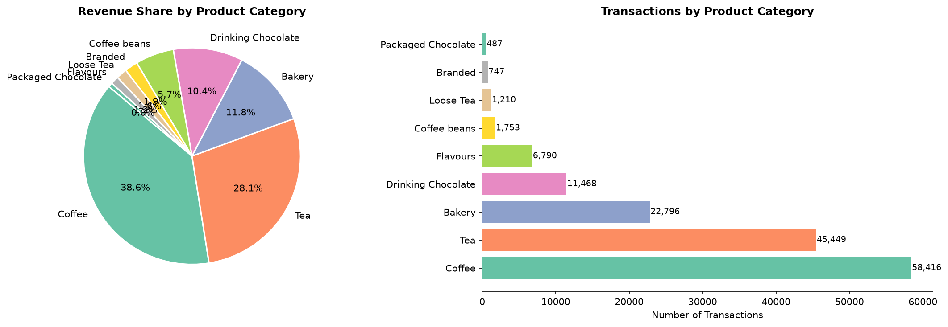
Figure 3 — Product Category Analysis
Among individual product types, Barista Espresso consistently ranks as the highest-revenue product, followed by Brewed Chai Tea and Hot Chocolate. Drip coffee leads in units sold due to its lower price point and high volume. The average unit price is highest for Coffee Beans ($10.22) and lowest for Drip coffee ($2.00).
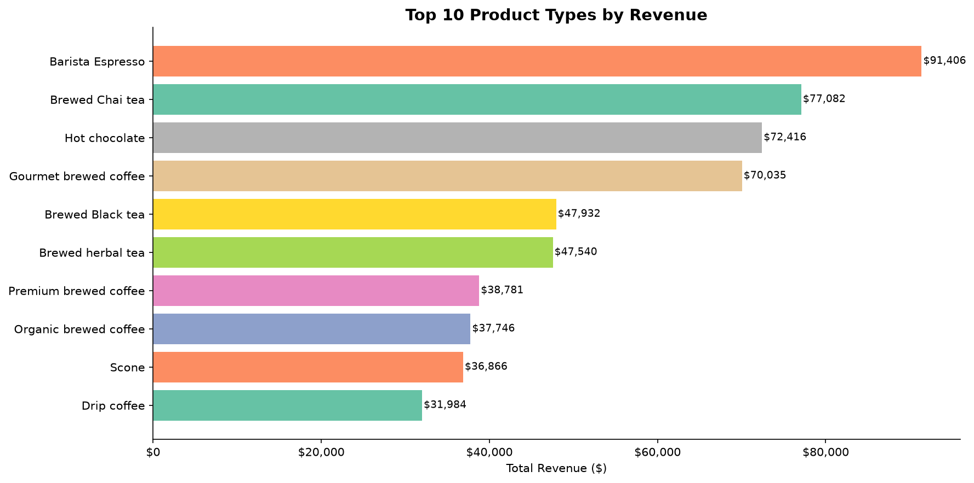

5.4 Store Location Performance
All three store locations demonstrate comparable overall performance. Hell's Kitchen and Lower Manhattan lead marginally in total revenue and transaction count, while Astoria performs slightly below the other two. However, the difference in revenue share between stores is minimal (approximately 32–34% each), indicating well-balanced operations and uniform customer demand across all locations.
Monthly revenue trajectories for all three stores move in unison, suggesting that sales are driven primarily by seasonal demand rather than location-specific factors. The product category split within each store is also nearly identical, confirming consistent menu adoption across branches. The computed store performance metrics from the analysis are presented in the table below:
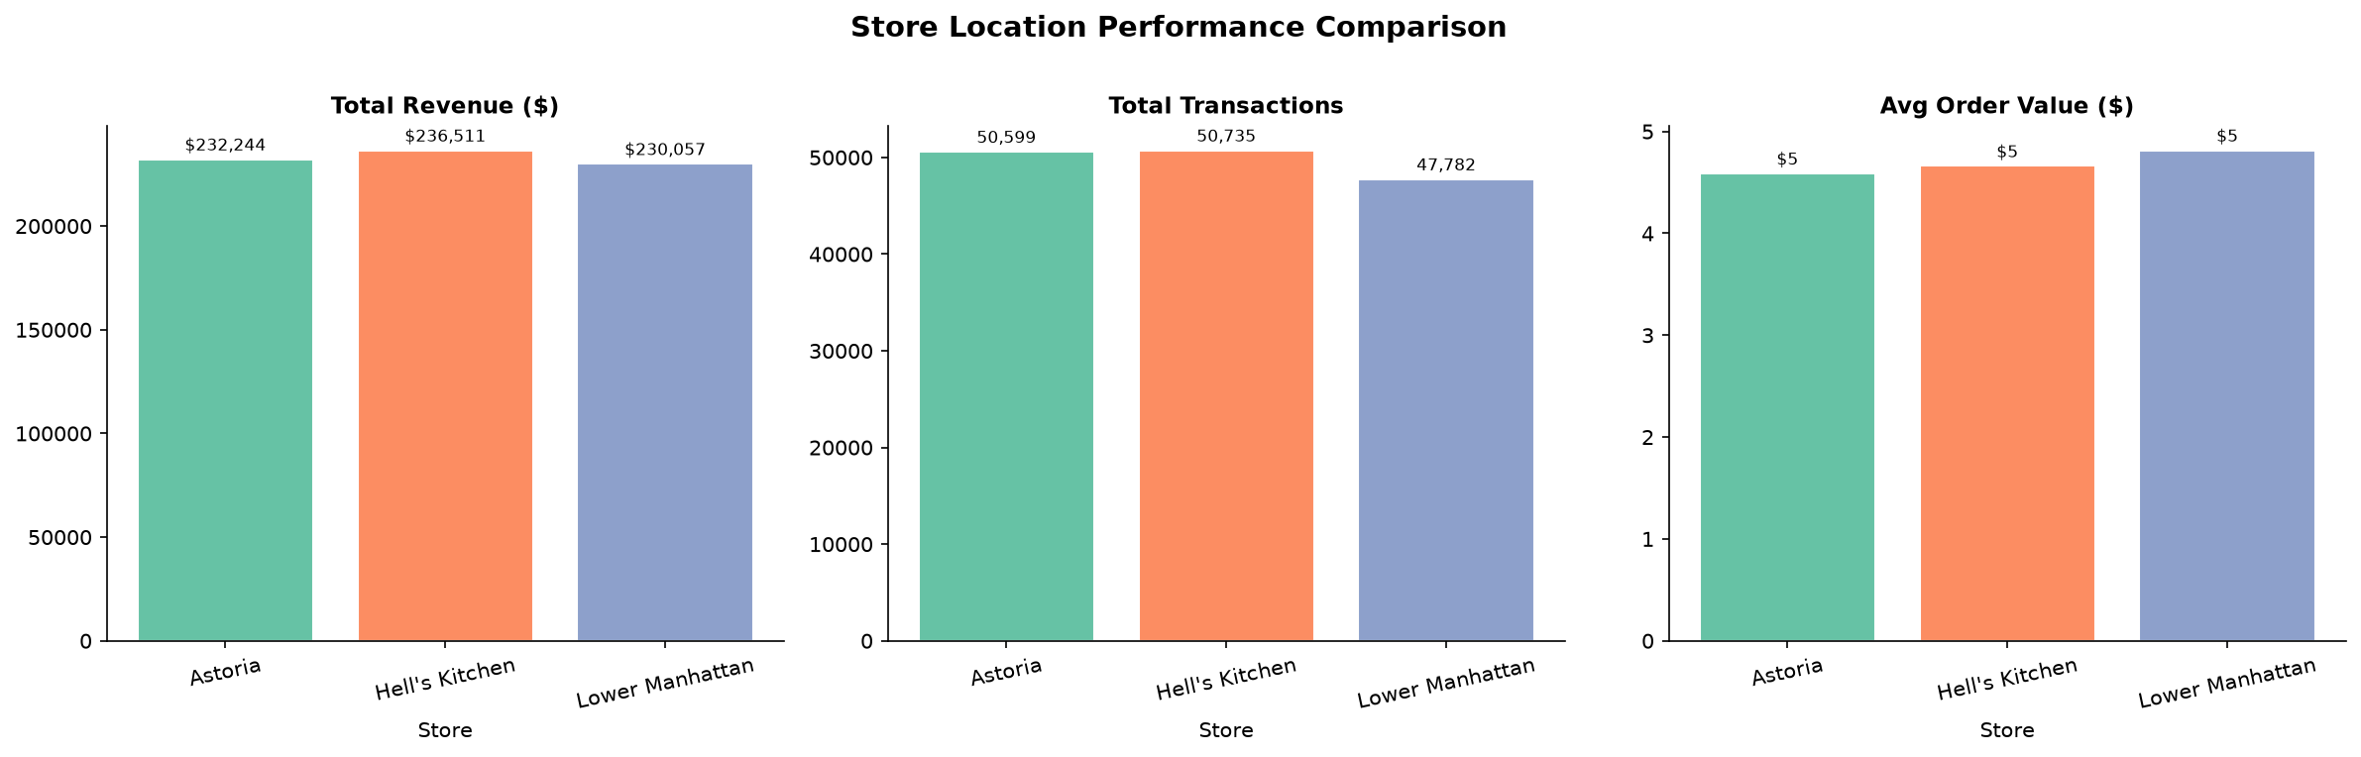
Figure 4 — Store Location Performance
Store Location | Total Revenue ($) | Transactions | Units Sold | Revenue Share (%)
Astoria | 232,243.91 | 50,599 | 70,991 | 33.2%
Hell's Kitchen | 236,511.17 | 50,735 | 71,737 | 33.8%
Lower Manhattan | 230,057.25 | 47,782 | 71,742 | 32.9%

5.5 Peak Hours & Day-of-Week Analysis
Transaction volume follows a predictable daily pattern. The morning rush between 8 AM and 10 AM accounts for the highest concentration of transactions, with the sharpest peak recorded at 10 AM (10:00–11:00 window). Activity drops significantly after 12 PM and becomes very sparse after 7 PM. This pattern is consistent across all days of the week and aligns with a predominantly commuter-driven customer base.
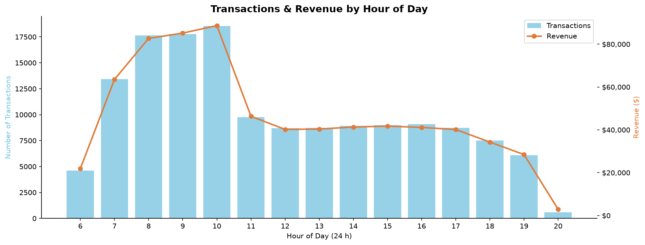
Figure 5 — Peak Hours & Day-of-Week Analysis
Day-of-week analysis shows that weekdays (Monday–Friday) generate higher transaction volumes than weekends. Friday typically records the highest daily transaction count, while Sunday records the lowest. The hour-by-day heatmap confirms the morning peak is strongest on weekday mornings.

6. Key Findings
The following key findings emerged from the analysis:
# | Finding
1 | Revenue grew consistently month-over-month from January to June 2023, with June recording the highest total revenue across all stores.
2 | Coffee is the leading product category by both revenue (~39%) and transaction count, followed by Tea (~28%) and Bakery (~12%).
3 | Barista Espresso is the single highest-revenue product type, followed by Brewed Chai Tea and Hot Chocolate.
4 | All three store locations (Lower Manhattan, Hell's Kitchen, Astoria) contribute roughly equal revenue shares (~33% each), indicating balanced operations.
5 | Peak trading hours are 8 AM – 10 AM, driven by the morning commuter rush. Demand falls sharply after 12 PM and is negligible after 7 PM.
6 | Weekdays consistently outperform weekends in transaction volume and revenue, confirming a commuter-heavy customer base.
7 | Average order value is consistent across all stores and months, suggesting uniform pricing strategy and menu adoption.

7. Recommendations
Based on the findings above, the following six recommendations are proposed to improve business performance:

Recommendation 1 — Boost Off-Peak Hours
Transaction volume drops sharply after 12 PM. Introducing targeted promotions such as afternoon happy-hour discounts (2 PM – 5 PM) or combo deals (e.g., coffee + pastry) could increase footfall during slow periods and improve overall daily revenue per location.

5.6 Revenue Insights
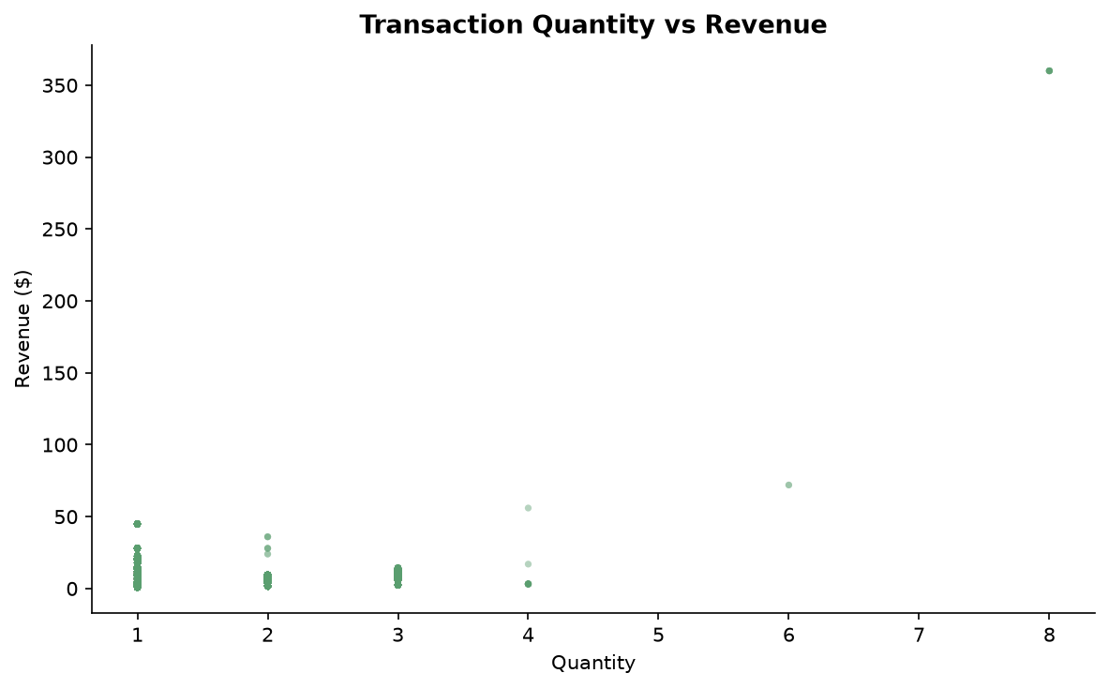
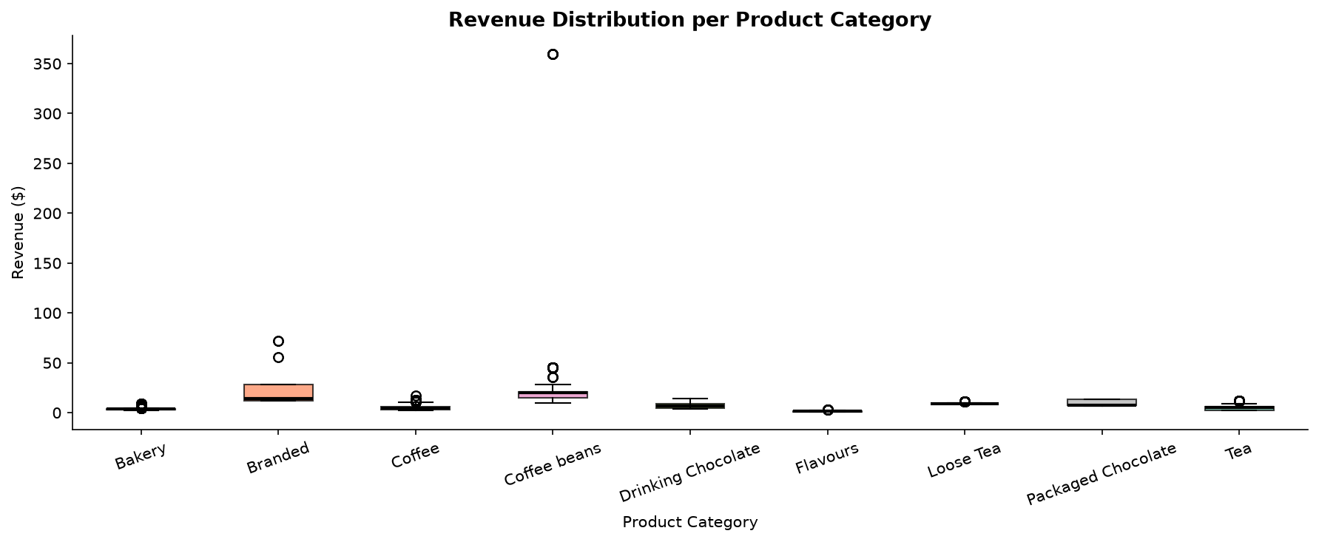
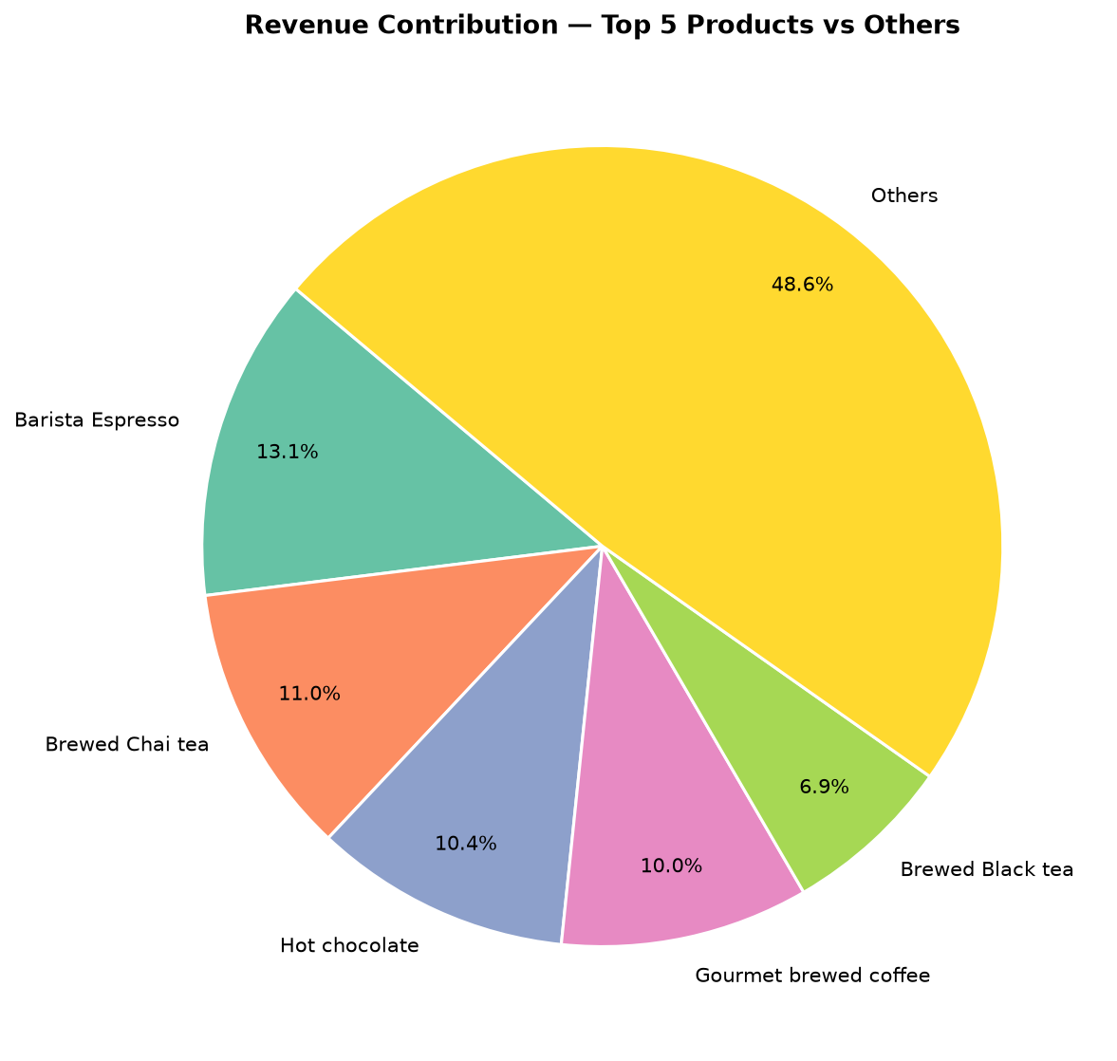
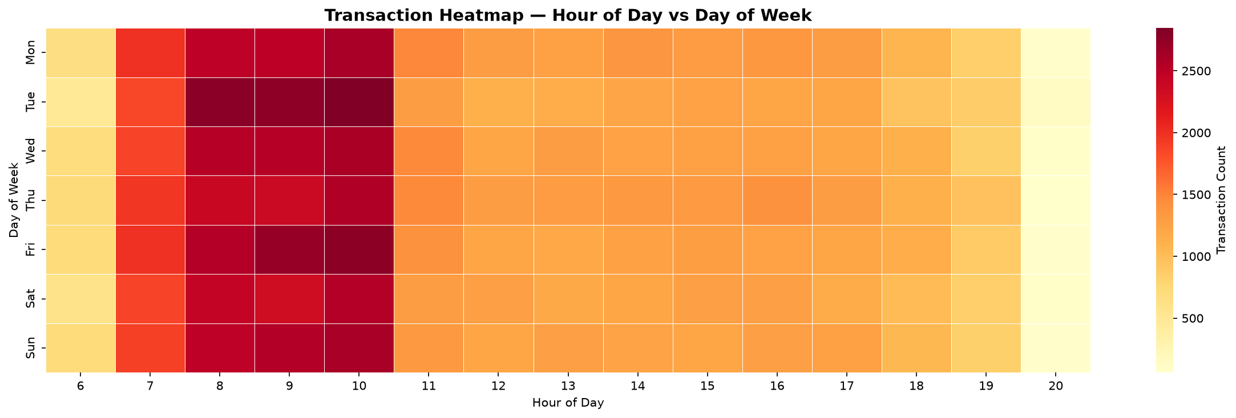
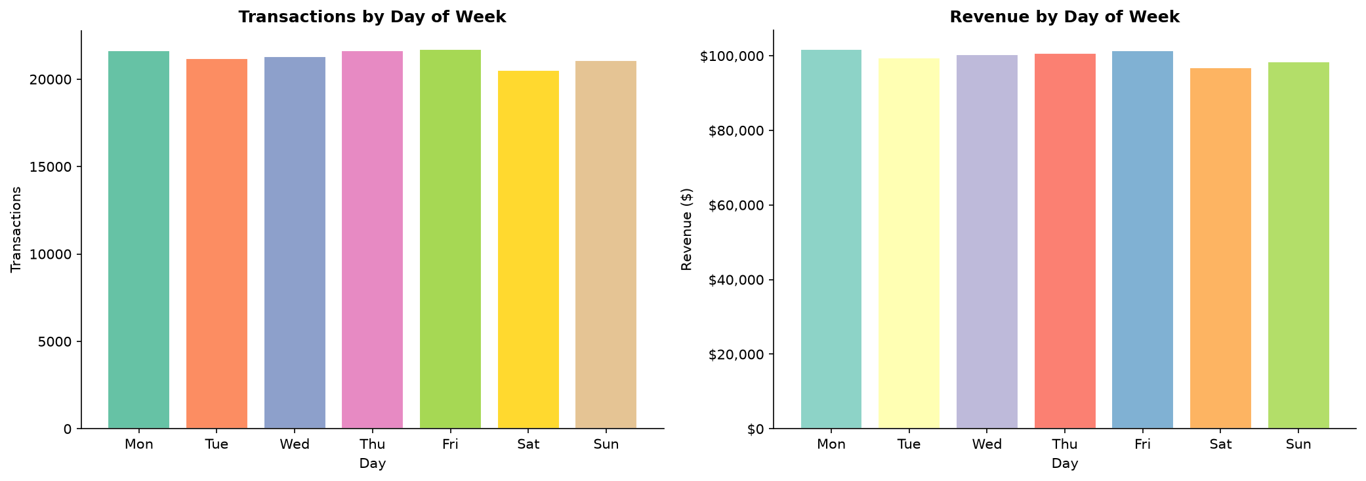
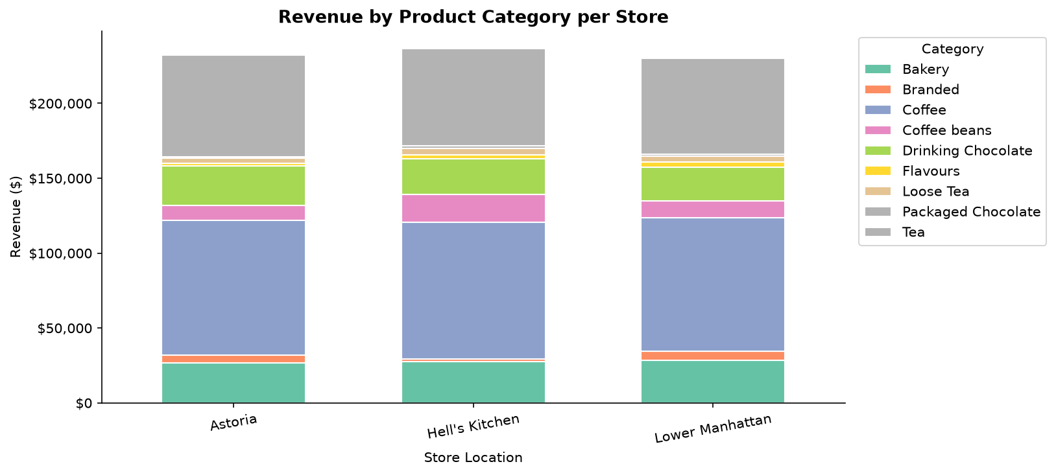
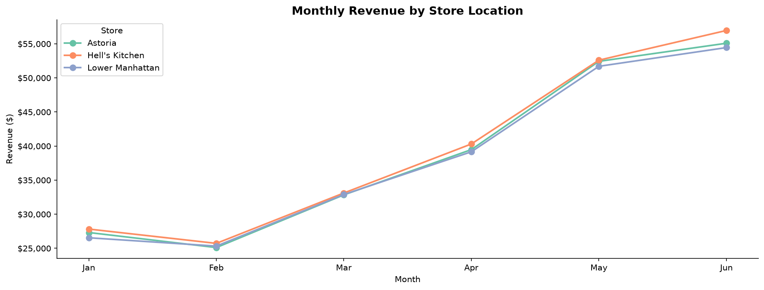
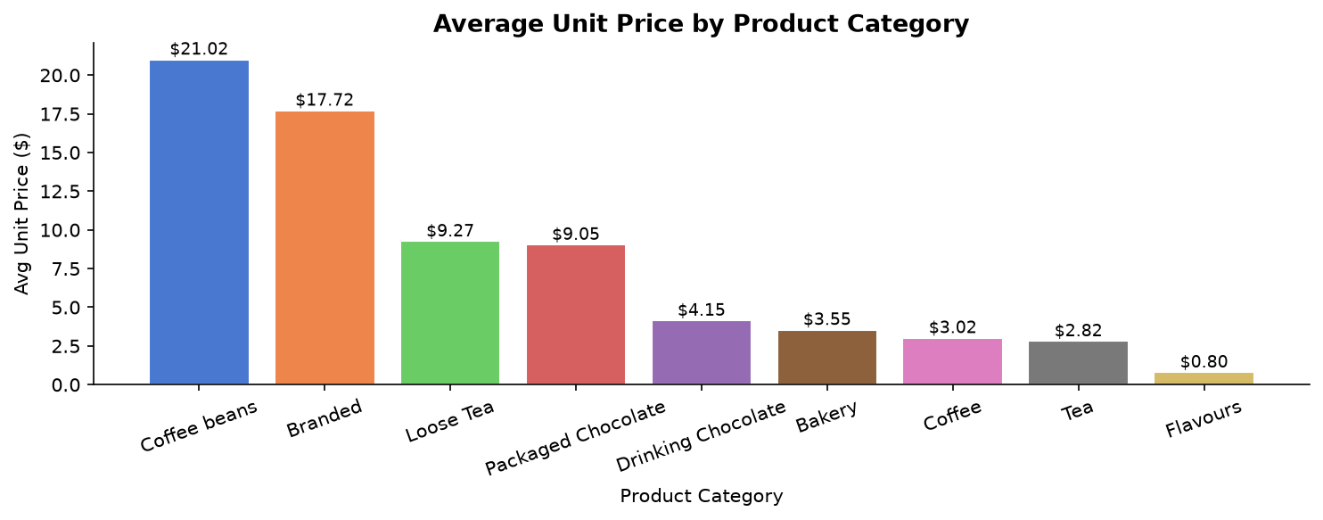
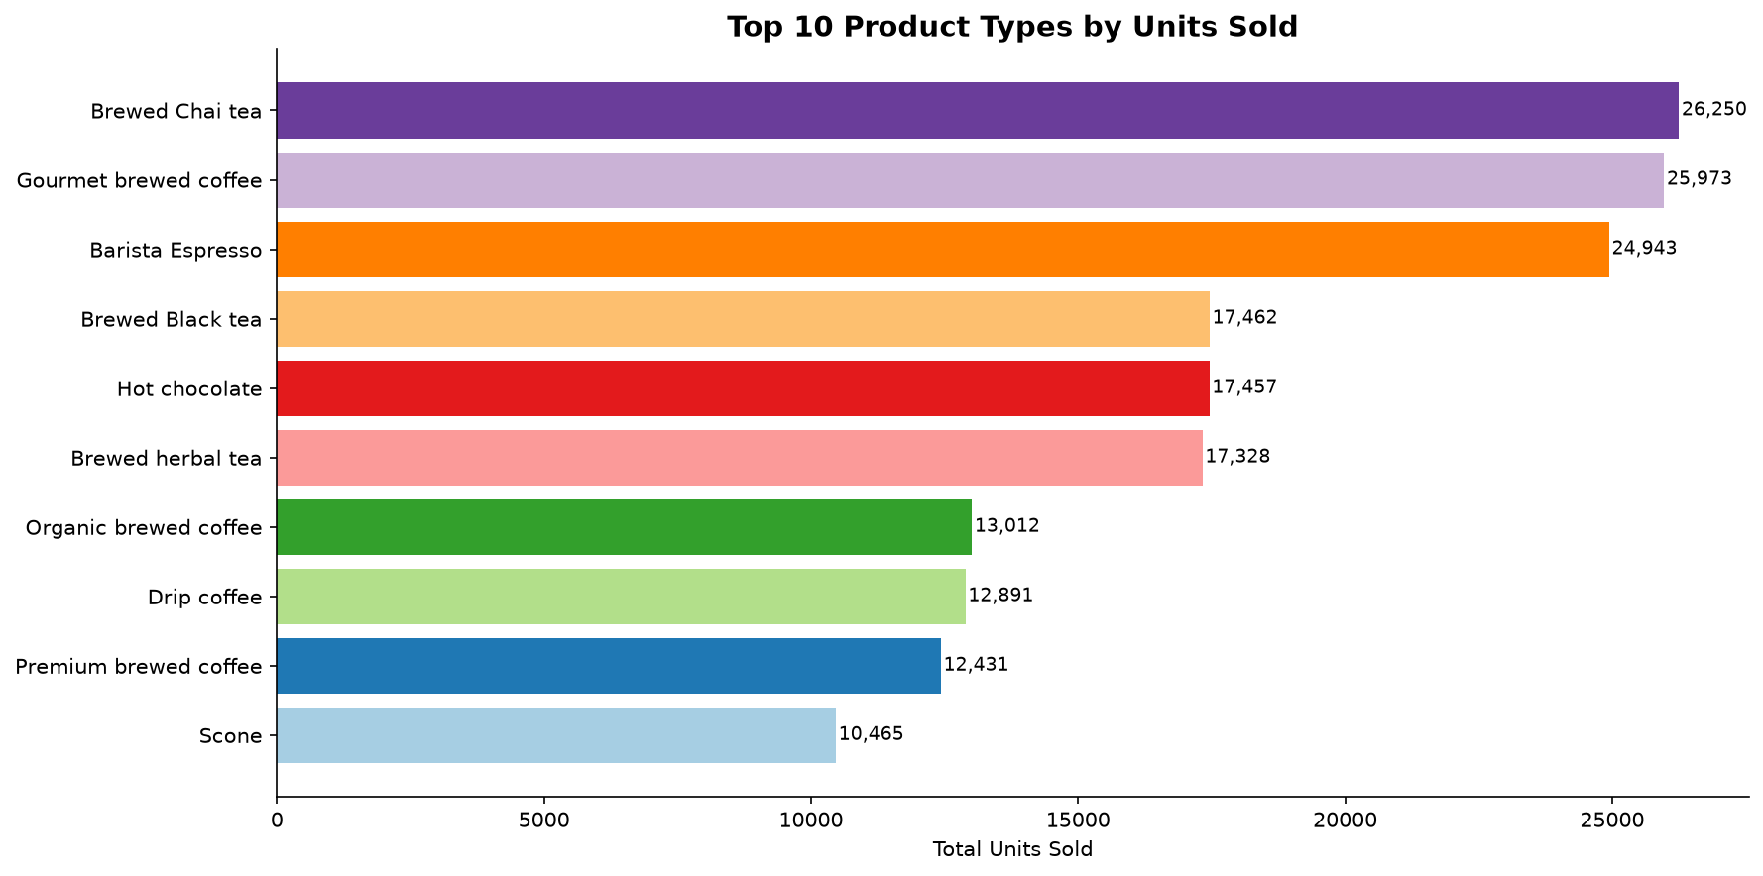
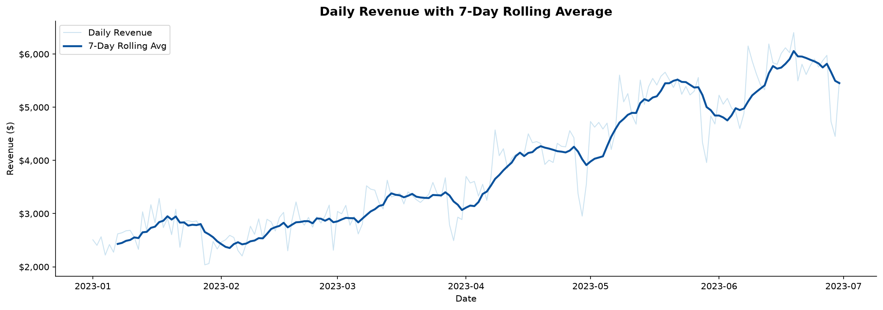
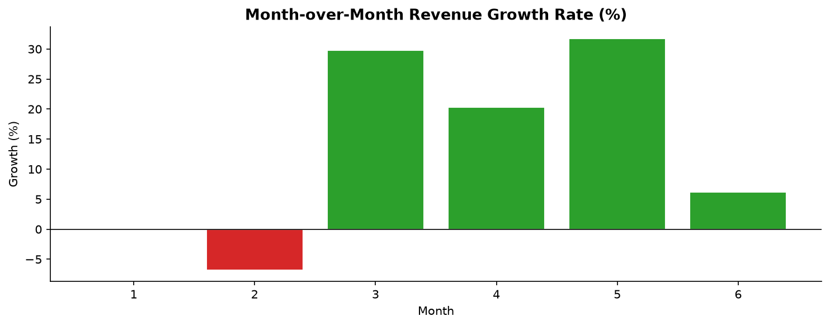
Figure 6 — Revenue Insights

Recommendation 2 — Weekend Activation Campaigns
Weekday transactions significantly outpace weekends. Weekend-specific bundle offers — for example, a brunch combo of a baked item and a hot drink at a reduced price — could attract leisure customers and help close the weekday–weekend transaction gap.

Recommendation 3 — Expand Top-Selling Product Lines
Barista Espresso and Brewed Chai Tea are among the highest-revenue products. Introducing seasonal variants — such as an iced espresso in summer or a spiced chai in autumn — can extend their appeal across the year and prevent revenue plateaus.

Recommendation 4 — Review Low-Performing SKUs
Categories such as Packaged Chocolate and Branded items contribute a small share of total revenue. A SKU rationalisation exercise — replacing underperforming products with higher-demand alternatives or premium options — could improve margin and reduce inventory complexity.

Recommendation 5 — Optimise Morning Inventory Planning
Peak demand between 8 AM and 10 AM creates operational pressure. Ensuring that high-demand ingredients — espresso beans, chai concentrate, and popular pastries — are adequately stocked before opening will reduce the risk of stockouts and lost revenue during the most profitable window of the day.

Recommendation 6 — Introduce a Customer Loyalty Programme
The high daily transaction volume and consistent repeat patterns suggest a loyal customer base. Launching a digital loyalty programme — where customers earn points per purchase redeemable for free drinks or discounts — could further increase visit frequency and average order value, especially among weekday regulars.

8. Conclusion
This project successfully applied data analytics techniques to the Coffee Shop Sales dataset to extract meaningful business insights. The analysis of 149,116 transactions generating $698,812.33 in total revenue demonstrated that the coffee shop chain is performing consistently across all three locations, with revenue growing steadily over the first half of 2023. Coffee remains the dominant category, and the morning hours are the critical revenue window for all branches.
The six recommendations outlined in this report — off-peak promotions, weekend activation, top-product expansion, SKU rationalisation, inventory optimisation, and a loyalty programme — offer practical, data-backed strategies for the business to increase revenue, improve operational efficiency, and strengthen customer retention.
Future work could extend this analysis by incorporating customer-level data to support customer segmentation and personalised marketing, integrating external data (e.g., weather, local events) to explain demand spikes, and building predictive models to forecast daily and hourly sales for proactive staffing and inventory decisions.

9. References & Tools
• Dataset: Coffee_Shop_Sales.csv (provided as part of the project brief)
• Python 3.14 — https://www.python.org
• pandas documentation — https://pandas.pydata.org/docs
• matplotlib documentation — https://matplotlib.org/stable/contents.html
• seaborn documentation — https://seaborn.pydata.org
• Jupyter Notebook — https://jupyter.org
• Streamlit (v1.64) — https://streamlit.io

10. Streamlit Interactive Dashboard
In addition to the Jupyter Notebook, the project delivers a fully interactive web-based dashboard built with Streamlit (streamlit_app.py). The dashboard presents all analyses in a browser interface with live sidebar filters, enabling non-technical stakeholders to explore the data without any coding.

10.1 How to Run
Step 1 — Install Streamlit (once): pip install streamlit
Step 2 — Navigate to the project folder in PowerShell or Terminal.
Step 3 — Run the command: streamlit run streamlit_app.py
Step 4 — The dashboard opens automatically in your browser at http://localhost:8501

10.2 Dashboard Sections
The dashboard contains eight interactive sections, all of which update dynamically when the sidebar filters (Store Location, Product Category, Month) are changed:
1. Data Quality Check — missing values, duplicates, raw data preview and column info
2. High-Level KPIs — Total Revenue, Transactions, Avg Order Value, Units Sold
3. Sales Trend Analysis — monthly revenue, transaction count, 7-day rolling average
4. Product Category & Type Analysis — revenue pie, top-10 charts, avg price by category
5. Store Location Performance — KPI comparison bars, monthly line chart by store
6. Peak Hours & Day-of-Week — dual-axis hourly chart, day bars, transaction heatmap
7. Revenue Insights & MoM Growth — growth bar, top-5 pie, revenue boxplot
8. Key Findings & Recommendations — auto-generated insights and 6 business recommendations
The complete source code is in streamlit_app.py, located in the project root directory alongside this report and the main Jupyter Notebook (BHOOMIKATARMAL_Coffee_Shop_Sales_Analysis.ipynb).
— End of Report —

