Assignment – 2 (Module – 2)

1) What is Exploratory Testing?
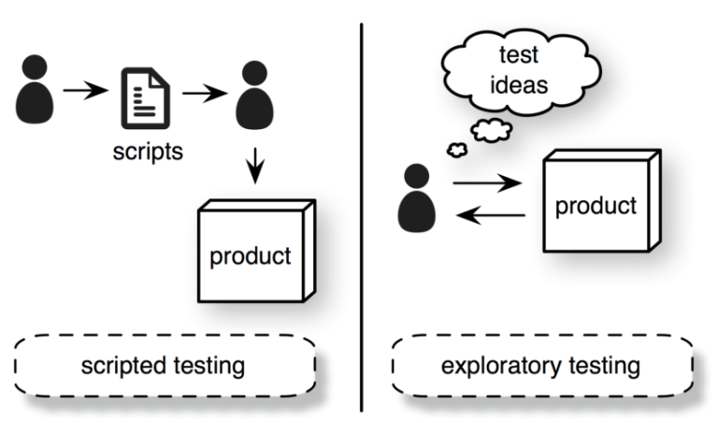
Ans.
- Exploratory testing is a concurrent process where Test design, execution and logging happen simultaneously, and it’s carried out in time boxed intervals and more structured than Error guessing.

2) What is traceability matrix?
Ans.
- Test conditions should be able to be linked back to their sources in the test basis, this is known as traceability.
- It’s all about to trace back from every system component to the original requirement that caused its presence.
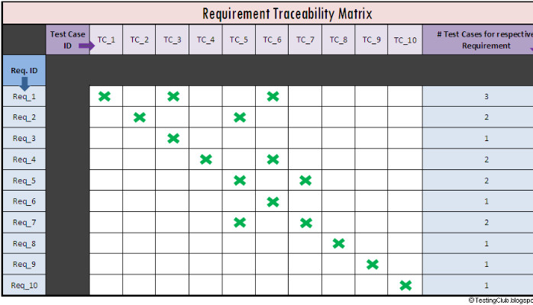

3) What is Boundary value testing?
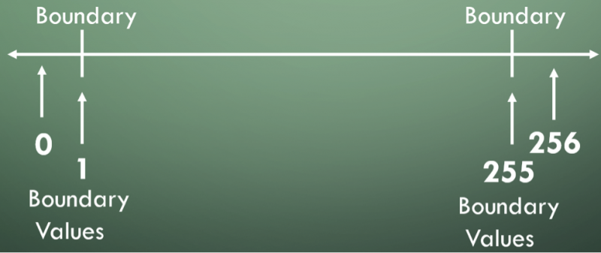
Ans.
- Boundary value analysis is a methodology for designing test cases that concentrates software testing effort on cases near the limits of valid ranges.

4) What is Equivalence partitioning testing?
Ans.
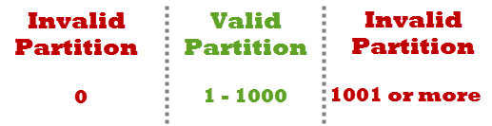
- Equivalence partitioning testing means to treat groups of inputs as equivalent and to select one representative input to test
them all.

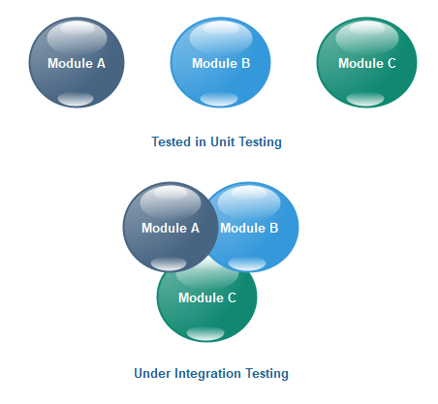
5) What is Integration testing?
Ans.
- Integration Testing is a level of the software testing process where individual units are combined and tested as a group.

6) What determines the level of risk?
Ans.
- Risk means a factor that could result in future negative consequences and usually expressed as impact and likelihood.
- Project risk and product risk are types of Risk.

7) What is Alpha testing?
Ans.
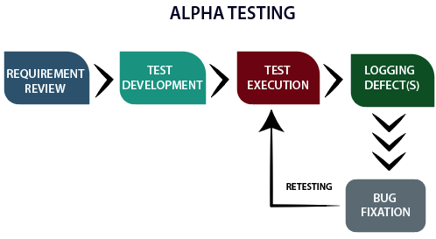
- Alpha testing is a part of Acceptance Testing which is always performed by the developers at the software development site. Sometimes it is also performed by Independent Testing Team.
- Alpha testing always performed in Virtual Environment.

8) What is beta testing?
Ans.
- Beta Testing is a part of Acceptance Testing which is always performed
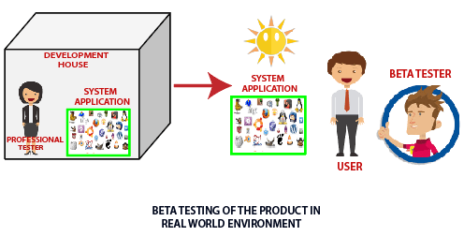
by the customers at their own site. It’s not performed by Independent Testing Team.
- Beta Testing is performed in Real Time Environment.

9) What is component testing?
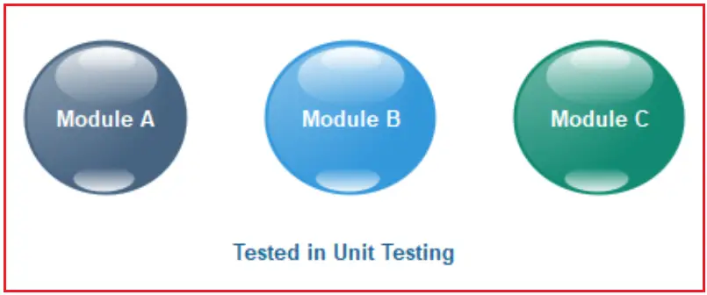
Ans.
- Unit Testing is a level of the software testing process where individual units/components of a software/system are tested.
- The purpose is to validate that each unit of the software performs as designed.

10) What is functional system testing?
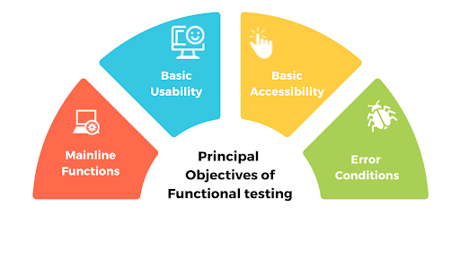
Ans.
- A requirement that specifies a function that a system or system component must perform.
- Functional testing verifies that each function of the software application operates in conformance with the requirement specification.
- This testing mainly involves black box testing.

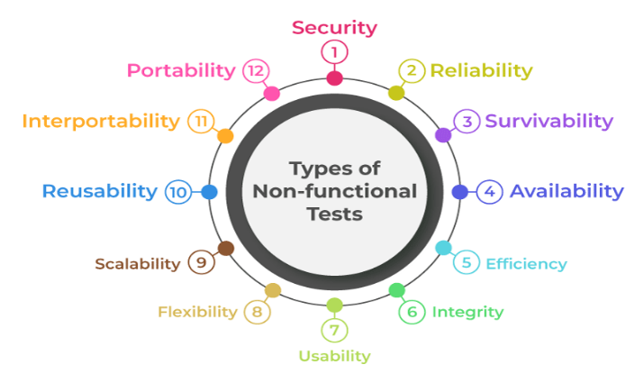
11) What is Non-Functional Testing?
Ans.
- Testing the attributes of a component or system that do not relate to functionality.
- e.g. portability,
efficiency,
usability etc.
12) What is GUI Testing?
Ans.
- Graphical User Interface (GUI) testing is the process of testing the system’s GUI of the System under Test.
- GUI testing involves checking the screens with the controls like menus, buttons, icons etc.
- It’s about to check GUI elements for size, position, width, length and acceptance of characters or numbers.
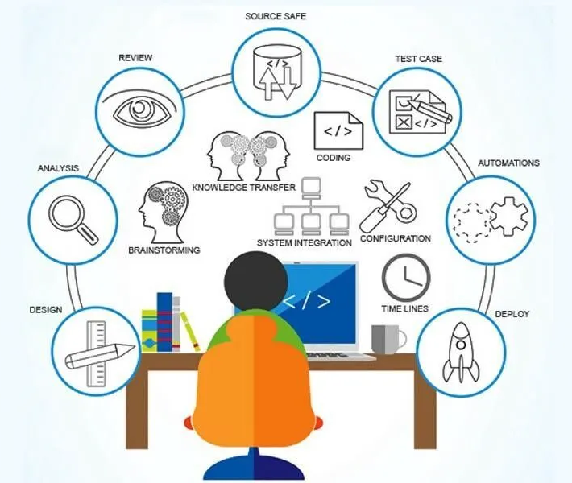

13) What is Ad hoc testing?
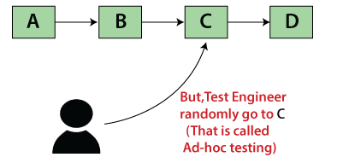
Ans.
- Ad hoc testing is an informal testing type with an aim to break the system.
- This testing is primarily performed if the
knowledge of testers in the system under test is very high.
- Ad hoc testing can be achieved with the testing technique called Error Guessing.

14) What is load testing?
Ans.
- Load testing means to check the stability of the application by applying load (designed no. of users) within response time.
- e.g. app will handle 5000 users at every 3 sec.
so, you have to check 5000 or <=5000 users with your application.

15) What is stress Testing?
Ans.
- Stress testing means to check the stability of the application by applying load (app will withstand with designed no. of users) within response time.
- e.g. app will handle 5000 users at every 3 sec.
so, you have to check 5000 or >=5000 users with your application.

16) What is white box testing and list the types of white box
Testing?
Ans.
- White Box Testing is a Testing based on an analysis of the internal structure of the component or system.
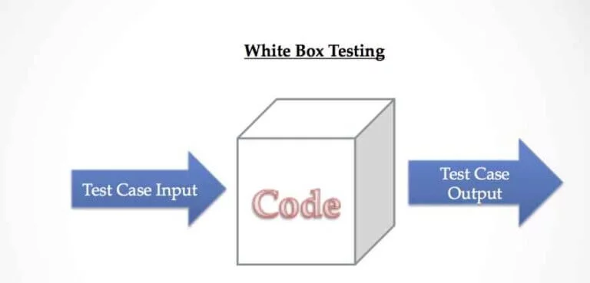
- White box testing is the detailed investigation of internal logic and structure of the code.
- Types of white box testing :
- Statement coverage
- Decision/Branch coverage
- Condition coverage

17) What is black box testing? What are the different black
box testing techniques?
Ans.
- Black-box testing is a Testing, either functional or non-functional, without reference to the internal structure of the component or system.

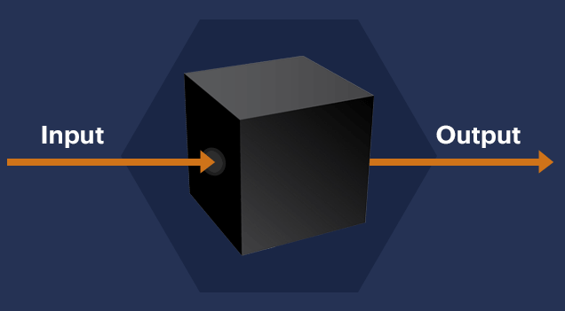
- Types of black box testing :

- Equivalence partitioning
- Boundary value analysis
- Decision tables
- State transition testing

18) Mention what big bang testing is?
Ans.
- In Big Bang integration testing all components or modules is integrated simultaneously , after which everything is tested as a whole.

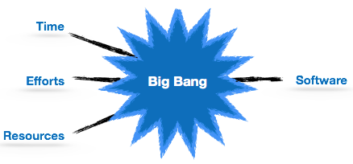
- Big Bang testing has the advantage that everything is finished before integration testing starts.

19) What is the purpose of exit criteria?
Ans.
- the purpose of exit criteria is Doing successful testing of integrated application.
- All High prioritized bugs fixed and closed.
- Executed Test Cases are documented.
- Technical documents to be submitted followed by release Notes.

20) When should "Regression Testing" be performed?
Ans.
Regression testing should be performed :
- When testing bug-fix releases as part of the maintenance phase.
- When the system is stable and the system or the environment changes.
- When it undergoes a code change to ensure that the new code has not affected other parts of the software.

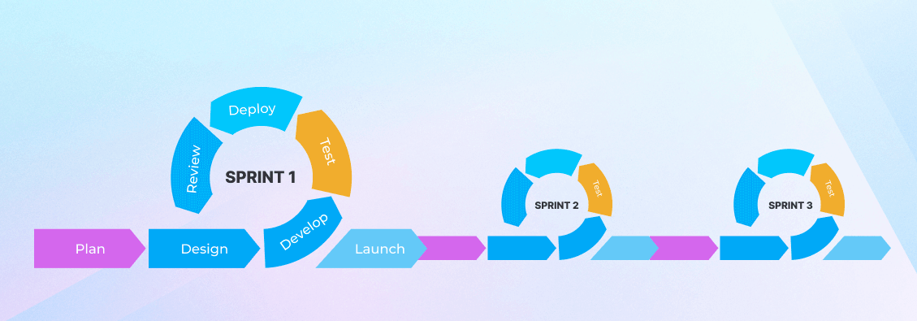

.

.
21) What is 7 key principles? Explain in detail?
Ans.
1.Testing shows presence of Defects :-

- Testing can show that the defects are present in the software but it can not prove that there are no defects .
- Testing reduces the probability of undiscovered defects in software even if no defects are found , it’s not a proof of correctness.

2. Exhaustive Testing is Impossible :-

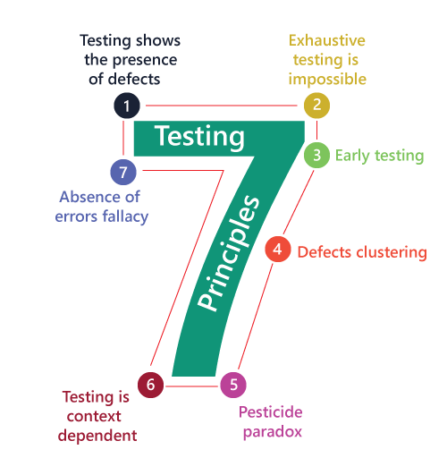
- Testing everything like all combinations of inputs and preconditions is not possible.
- So instead of doing the exhaustive testing we can use risks and priorities to focus testing.
- That is we must prioritise our testing using a risk based approach.

3. Early Testing :-

- Testing activities should start as early as possible in the software / development life cycle.
- Testing doesn’t start if the code has been written .
- These activities should be focused on defined objectives – outlined in the Test Strategy.
4. Defect Clustering :-

- Defects are not evenly spread in a system. They are clustered.
- In other words , most defects found during testing are usually small number of modules.
- And this small number of modules contain most of the defects and responsible for the most operational failures.

5. Pesticide Paradox :-

- If the same tests are repeated over and over again , test cases will no longer find any new defect.
- To overcome this pesticide paradox , the test cases need to be regularly reviewed and revised and new and different tests need to be written to find more defects.
- Testing identifies bugs and programmers respond to fix them.

6. Testing is Context Dependent :-

- Testing is basically context dependent. Testing is done differently in different contexts.
- Different kind of sites are tested differently.
- Ex. Safety-critical software is tested differently from an E-commerce site.

7. Absence of Errors Fallacy :-

- If the system does not fulfil the user’s needs and expectations then finding and fixing defects doesn’t help.
- If we build a system , find and fix bugs , it doesn’t make it a good system.
- Even after defect have been resolved if the user’s needs and expectations doesn’t fulfil it will unusable.
22) Difference between QA v/s QC v/s Tester.
Ans.
Quality Assurance | Quality Control | Testing
Activities which ensure the implementation of processes, procedures and standards in context to verification of developed software and intended requirements. | Activities which ensure the verification of developed software with respect to documented requirements. | Activities which ensure the identification of bugs or error or defects in the Software.
It’s a Preventive activities. | It’s a corrective process. | It’s a preventive process.
QA is about to Focuses on processes and procedures rather than conducting actual testing on the system. | QC is about to Focuses on actual testing by executing Software with intend to identify bug/defect through implementation of procedures and process. | Testing is about to Focuses on actual testing.
It’s a Process oriented activities. | It’s a Product oriented activities. | It’s a Product oriented activities.
QA is a subset of Software Test Life Cycle (STLC). | QC can be considered as the subset of Quality Assurance. | Testing is the subset of Quality Control.

.

.
23) Difference between Smoke and Sanity.
Ans.

Smoke Testing | Sanity Testing
performed to ascertain that the critical functionalities of the program is working fine. | Performed to check new functionality / bugs have been fixed
Smoke testing is performed by the developers or testers. | Sanity testing is usually performed by testers
Smoke testing is a subset of Regression testing | Sanity testing is a subset of Acceptance testing
The objective of this testing is to verify "stability" of the system in order to with more rigorous testing. | The objective of the testing is to verify the "rationality" of the system in order to proceed with more rigorous testing.
Smoke testing exercises the entire system from end to end. | Sanity testing exercises only the particular component of the entire system.
Smoke testing is usually documented  or scripted. | Sanity testing is usually not documented and is unscripted.
Smoke testing is like General Health Check Up | Sanity Testing is like specialized health  check up

.

.
24) Difference between verification and Validation.
Ans.

Verification | Validation
Verification is Performed at development level. | Validation is Performed at testing level.
Verification phases :  - Business requirement  - System requirement  - Technical specification  - Program specification | Validation phases :  - Unit testing  - Integration testing  - System testing  - Acceptance testing
Verification can be achieved by asking ,“Are you building a product right?” | Validation can be achieved by asking , “Are you building a right product?”
Verification activities are reviews and inspections. | Validation activity is about to testing.
The evolution of verification can be achieved by planning, requirement specification, designing, code specification and test cases. | The evolution of validation can be achieved as an actual product.
Verification is about to check whether the specified requirements meet or not. | Validation is about to check whether it satisfied business requirements or not.

.

25) Explain types of Performance testing.
Ans. Types of Performance Testing :
- Load Testing
- Stress Testing
- Scalability Testing
- Volume Testing (Flood Testing)
- Endurance Testing (Soak Testing)
- Spike Testing

- Load Testing :
- To check the stability of the application by applying load (designed number of users) within response time.
- e.g. app will handle 5000 user at every 10 sec.
so, you have to check 5000 or <=5000 users with your application.

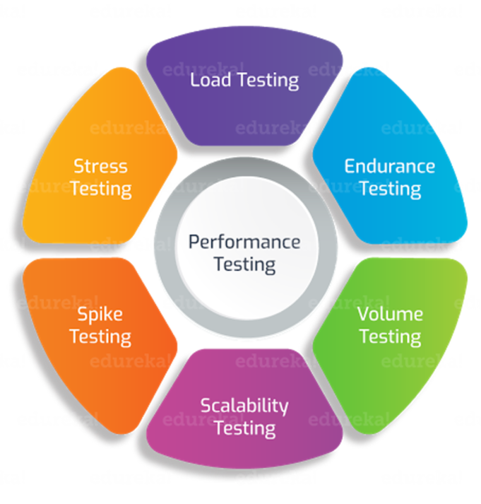
- Stress Testing :
- To check the stability of the application by applying load (designed number of users) within response time.
- e.g. app will handle 5000 user at every
10 sec.
so, you have to check 5000 or
>=5000 users with your
application.

3) Scalability Testing :
- To check the stability of the application by applying load (designed number of users) within response time.
- you are checking the performance of the application continue with load until your system will be crashed.
- e.g. app. Will handle 5000 users at every 10 sec.
5500 users : 15 sec
6000 users : 25 sec
………
1,00,000 users : Crashed

4) Volume Testing (Flood Testing) :
- To check the stability of the application by applying load (designed number of users) within response time.
- To check the capacity or volume of database.

5) Endurance Testing (Soak Testing) :
- To check the stability of the application by applying load (designed number of users) within response time.
- e.g. To check how the system will run continuously.

6) Spike Testing :
- To check the stability of the application by applying load (designed number of users) within response time.
- e.g. To check extreme increment or decrement of load according to the response time.

26) What is Error, Defect, Bug and failure?
Ans.
- Error :- A mistake in coding.

- Defect :- Error found by tester.

- Bug :- Defect accepted by the Developer.

- Failure :- Build does not meet the requirements.
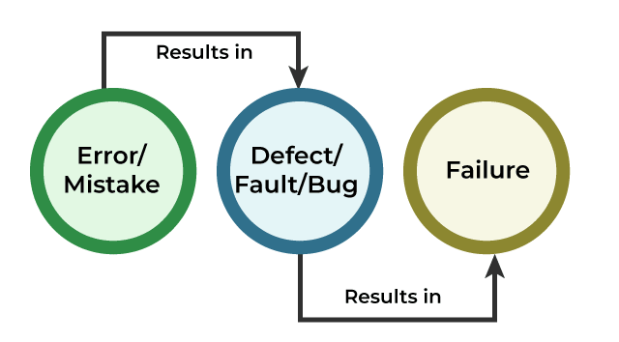

27) Explain the difference between Functional testing and
Non Functional testing.
Ans.

Functional Testing | Non-Functional Testing
Performed using the functional specification provided by the client and verifies the system against the functional requirements. | Checks the Performance, reliability, scalability and other non-functional aspects of the software system.
Manual testing or automation tools can be used for functional testing. | Using tools will be effective for this testing.
Business requirements are the inputs to functional testing. | Performance parameters like speed , scalability are inputs to non-functional testing.
Functional testing is executed first. | Non functional testing should be performed after functional testing.
Easy to do manual testing. | Tough to do manual testing.
Functional testing describes what the product does. | Nonfunctional testing describes how good the product works.
Types of Functional testing are -  ∙ Unit Testing  ∙ Smoke Testing  ∙ Sanity Testing  ∙ Regression Testing  ∙ White box testing  ∙ Black Box testing  ∙ Smoke Testing  ∙ User Acceptance testing  ∙ Integration Testing | Types of Nonfunctional testing are -  ∙ Performance Testing  ∙ Load Testing  ∙ Stress Testing  ∙ Installation Testing  ∙ Compatibility Testing  ∙ Migration Testing  ∙ Volume Testing  ∙ Penetration Testing  ∙ Security Testing
28) To create HLR & Test Case of (Instagram , Facebook) only
first page.
Ans.
HLR & Test Case of Instagram | Click here
HLR & Test Case of Facebook | Click here

29) What is the difference between the STLC (Software-
Testing Life Cycle) and SDLC (Software Development Life-
Cycle)?
Ans.

STLC  (Software Testing Life Cycle) | SDLC  (Software Development Life Cycle)
STLC is mainly related to software testing. | SDLC is mainly related to software testing.
In STLC, less number of members are needed. | In SDLC , more number of members are required.
It focus only on testing the software. | Besides development other phases like testing is also included.
In STLC, testing team makes the plans and designs. | In SDLC ,development team makes the plans and design based on the requirements.
It helps in developing good quality software. | It helps in making the software defects free.
Goal of STLC is to complete successful testing of software. | Goal of SDLC is to complete successful development of software.
STLC phases are performed after SDLC phases. | SDLC phases are completed before the STLC phases.
A tested software system is the end result of STLC. | Creation of reusable software systems is the end result of SDLC.
Post deployment support, enhancement and update are to be included if necessary. | Regression tests are run by QA team to check deployed maintenance code and maintains test cases and automated scripts.

30) What is the difference between test scenarios, testcases,
and test script?
Ans.

Test scenario | Test case | Test script
It’s derived from software requirement specification.(SRS) | It’s mostly derived from test scenarios. | It’s derived from test cases
Test scenario means any functionality that can be tested | Test case is a set of executed to verify particular functionality | Test script is a set of instructions to test an app automatically.
It’s more focused on what to test. | It’s focused on what to test and how to test . | It’s focused on the expected result.
Taked less time and fewer resources to create. | Requires more resources and time. | Requires less time for testing but more resources for scripts creating and updating.
Includes an end-to-end functionality to be tested. | Includes test steps, data, expected results for testing. | Includes different commands to develop a script.
The main task is to check the full functionality of a software application | The main task is to verify compliance with the applicable standards, guidelines and customer requirements . | The main task is to verify that nothing is skipped and the results are true as the desired testing plan.

31) Explain what Test Plan is? What is the information that
should be covered.
Ans.
- Test planning means a document describing the scope, approach, resources and schedule of intended test activities.

- Defining the overall approach of testing, including the definition of the test levels and entry and exit criteria.
- Test Planning in STLC is a phase in which a Senior QA manager determines the test plan strategy along with efforts and cost estimates for the project.
- Where the test environment, test limitation and test schedule are also determined.
- Test plan /strategy document and Effort estimation document should be covered in Test plan.

32) What are the different Methodologies in Agile
Development Model?
Ans.
Methodologies in Agile Development Model :
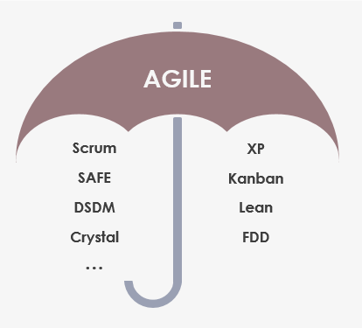
- Scrum
- Kanban
- XP
- Lean
- Crystal etc.

33) Explain the difference between Authorization and
Authentication in Web testing. What are the common
problems faced in Web testing?
Ans.
Authorization | Authentication
While in Authorization process, the user’s authorities are checked for accessing the resources. | In the authentication process, the identify of users are checked for providing the access to the system.
While in this process, users are validated. | In the authentication process, users are verified.
In the Authorization process, it needs the user’s privilege or security levels. | In the authentication process, it needs usually the user’s login details.
Authorization process is done after the authentication process | Authentication process is done before the Authorization process
While it determines what permission does the user have ? | Authentication determines whether the person is user or not.
The user authorization is carried out through the access rights the resources by using roles that have been pre-defined. | The user authentication is identified with username, password, face recognition, retina scan, fingerprints etc.
The authorization permissions cannot be changes by user as these are granted by the owner of the system and only he/she has the access to change it. | The authentication credentials can be changed in part as and when required by the user.
Generally, transmit information through an access token. | Generally, transmit information through an ID token.
The user authorization is not visible at the user end. | The user authentication is visible at user end.
Popular authorization techniques.  - SAML authorization  - OpenID authorization  - Role based access controls (RBAC)  - JSON web token (JWT) authorization | Popular authentication techniques.  - Password less authentication  - Password based authentication  - Social authentication  - Single sign-on (SSO)
Most common problems faced during web Testing :
- Dealing with dynamic content
- Security testing
- Communication and collaboration
- Ensuring cross browser compatibility
- Performance and scalability testing
- Test data management
- Debugging and reporting
- Responsiveness
- Entry and exit points
- Firewalls
- Project deadlines
- Web service requests
- User input validation
- Continuous evaluation
- Usability bugs

34) To create HLR & Test Case of Web Based
(WhatsApp Web , Instagram)
Ans.
HLR & Test Case of Web Based WhatsApp | Click here
HLR & Test Case of Web Based Instagram | Click here

35) To create HLR and Test Case on this Link.
https://artoftesting.com/
Ans.
HLR & Test Case of link  https://artoftesting.com/ | Click here
36) Write a scenario of only WhatsApp chat messages.
Ans.
scenario of WhatsApp chat messages. | Click here

37) Write a Scenario of Pen.
Ans.
Scenario of Pen | Click here

38) Write a Scenario of Pen Stand.
Ans.
Scenario of Pen Stand | Click here

39) Write a Scenario of Door.
Ans.
Scenario of Door | Click here

40) Write a Scenario of ATM.
Ans.
Scenario of ATM | Click here
41) When to used Usability Testing?
Ans.
- Usability Testing identifies usability errors in the system early in development cycle and can save a product from failure.
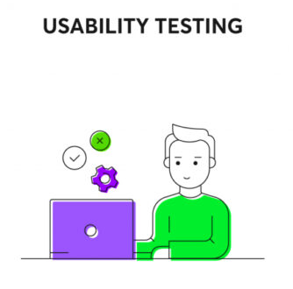
- When you have a new feature or design to test at that time usability testing done.
- When quantitative analytics flag an issues at that time usability testing done.
- Aesthetics and design are important. How well a product looks usually determines how well it works. So for this purpose usability testing done.
- Usability testing is generally done during the Discovery phase of a project.

42) What is the procedure for GUI Testing?
Ans.
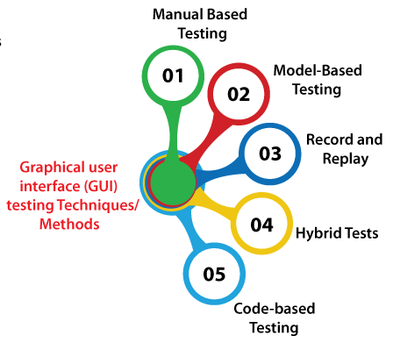
Procedure of GUI testing :

- Manual Based Testing
- Model Based Testing
- Record and Replay
- Hybrid Testing
- Code-based testing

43) Write a scenario of Microwave Owen.
Ans.
scenario of Microwave Owen | Click here

44) Write a scenario of Coffee vending Machine.
Ans.
Scenario of Coffee vending Machine | Click here

45) Write a scenario of chair.
Ans.
Scenario of Chair | Click here

46) To Create Scenario (Positive & Negative)
Scenario of Gmail (receiving mail) | Click here
Scenario of-  Online shopping to buy product-  (Flipkart) | Click here

47) Write a Scenario of Wrist Watch.
Ans.
Scenario of Wrist Watch | Click here

48) Write a Scenario of Lift(Elevator)
Ans.
Scenario of Lift (Elevator) | Click here

49) Write a Scenario of WhatsApp Group (generate group)
Ans.
Scenario of WhatsApp Group  (generate group) | Click here

50) Write a Scenario of WhatsApp payment.
Ans.
Scenario of WhatsApp payment | Click here

