Assignment – 3 ( Module – 3 )

- What is RDBMS?
Ans.
- The software used to store,manage,query and retrieve data stored in a relational database is called a relational database management system (RDBMS).
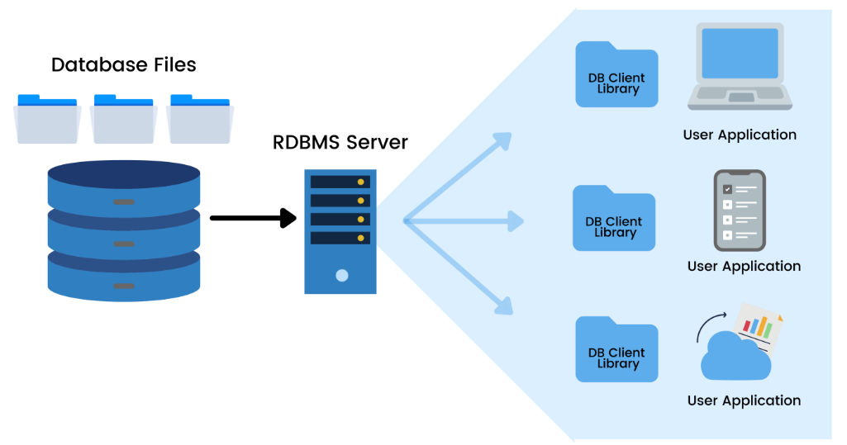

- What is SQL?
Ans.
- SQL stands for Structured Query Language.
- SQL is a standard language for storing, manipulating and retrieving data in databases.
- SQL allows you to access and manipulate the databases. To use SQL in: MySQL, SQL Server, MS Access, Oracle, Sybase, Informix, Postgres, and other database systems.

- Write SQL Commands.
Ans.
- DDL : Data Definition Language
- DQL : Data Query Language
- DML : Data Manipulation Language
- DCL : Data Control Language
- TCL : Transaction Control Language

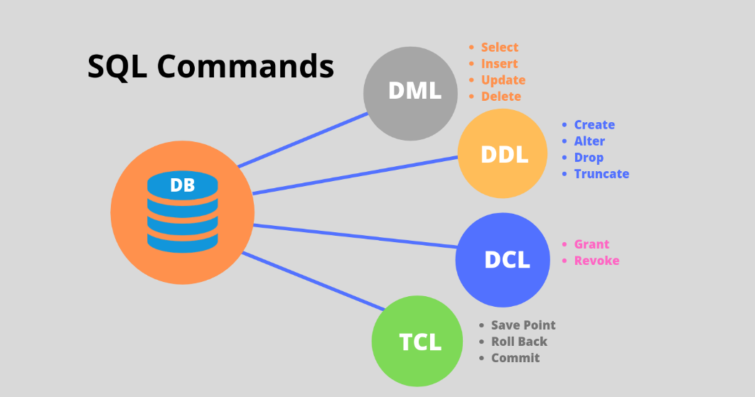

- What is join?
Ans.
- A Join clause is used to combine rows from two or more tables, based on a related column between them.
- The join keyword merges two or more tables and creates a temporary image of the merged table. Then according to the conditions provided, it extracts the required data from the image table, and once data is fetched, the temporary image of the merged tables is dumped.

- Write type of joins.
Ans.
- Inner Join
- Outer Join 1. Left Outer Join
2. Right Outer Join
3. Full Outer Join
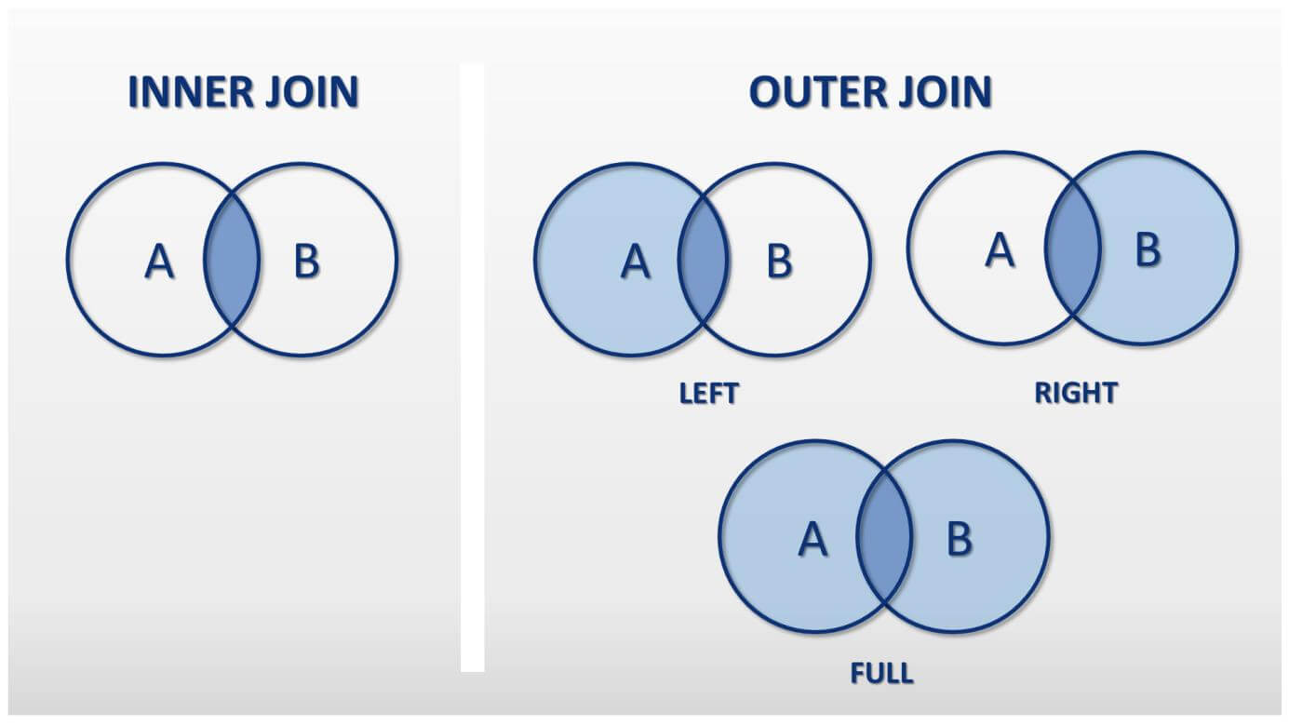

- How Many constraints and describes itself.
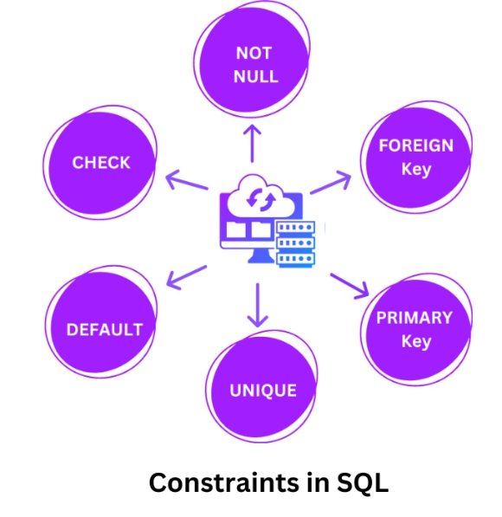
Ans.
- There are six types of constraints.
1. Not Null constraint
2. Unique constraint
3. Primary Key constraint
4. Foreign Key constraint
5. Check constraint
6. Default constraint

1. Not Null constraint :
- Ensures that a column cannot have a NULL value.
- By default, a column can hold NULL values.
- The NOT NULL constraint enforces a column to NOT accept NULL
values.
- This enforces a field to always contain a value, which means that you cannot insert a new record, or update a record without adding a value to this field.
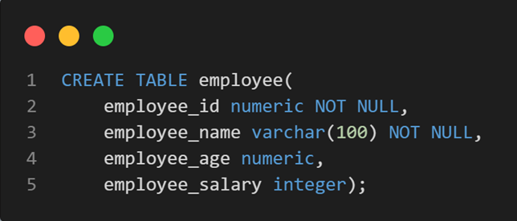

2. UNIQUE Constraint :
- Ensures that all values in a column are different.
- The UNIQUE constraint ensures that all values in a column are different.
- Both the UNIQUE and PRIMARY KEY constraints provide a guarantee for uniqueness for a column or set of columns.

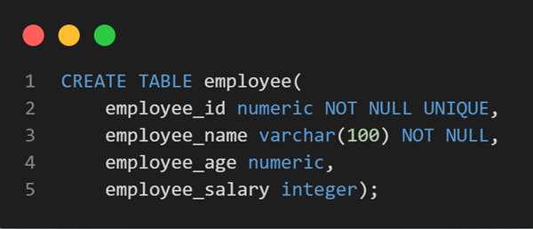

3. Primary Key constraint :
- A combination of a NOT NULL and UNIQUE. Uniquely identifies each row in a table
- The PRIMARY KEY constraint uniquely identifies each record in a table.
- Primary keys must contain UNIQUE values, and cannot contain NULL values.
- A table can have only ONE primary key; and in the table, this primary key can consist of single or multiple columns (fields).
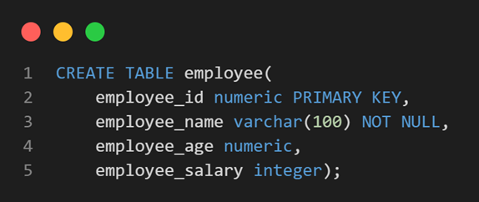

4. Foreign Key constraint :
- Prevents actions that would destroy links between tables
- The Foreign Key constraint is used to prevent actions that would destroylinks between tables.
- A Foreign Key is a field (or collection of fields) in one table, that refers to the Primary Key in another table.
- The table with the foreign key is called the child table, and the table with the primary key is called the referenced or parent table.
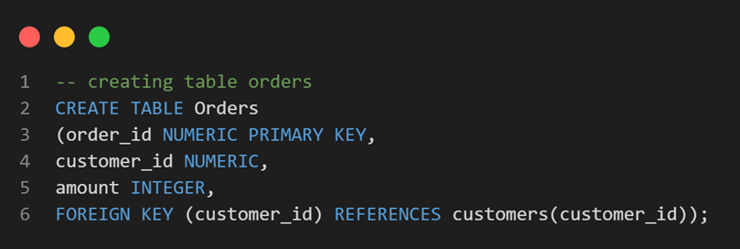

5. Check constraint :
- Ensures that the values in a column satisfies a specific condition
- The CHECK constraint is used to limit the value range that can be placed in a column.
- If you define a CHECK constraint on a column it will allow only certain values for this column.
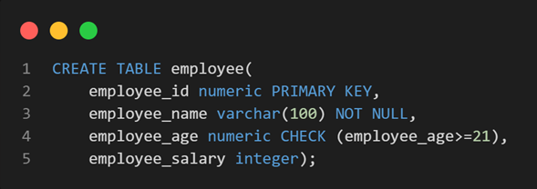
- If you define a CHECK constraint on a table it can limit the values in certain columns based on values in other columns in the row.

6. Default constraint :
- Sets a default value for a column if no value is specified
- The DEFAULT constraint is used to set a default value for a column.
- The default value will be added to all new records, if no other value is specified.
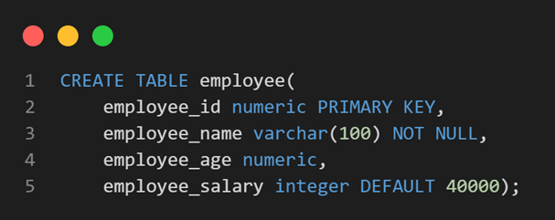

- Difference between RDBMS vs DBMS.
Ans.
RDBMS | DBMS
In RDBMS, Data stored is in table format. | In DBMS, Data stored is in the file format.
In RDBMS, Data in the form of a table are linked together. | In DBMS, No connection between data.
In RDBMS, Multiple data elements are accessible together. | In DBMS, Individual access of data elements.
In RDBMS, Support distributed database. | In DBMS, No support for distributed database.
In RDBMS, Data is stored in a large amount. | In DBMS, Data is stored in a small amount.
RDBMS supports multiple users. | DBMS supports a single user.
In RDBMS, the software and hardware requirements are higher. | In DBMS, the software and hardware requirements are low.
Ex. – Oracle, SQL server. | Ex. – XML, Microsoft Access.

- What is API Testing.
Ans.
- API Testing means Application Programming Interface Testing.
- API is the mediator which helps to applications to communicate with each other. It is kind of logic written by developers using any programming language to perform something.
- Testing the business logic of any application is called API. QA will test the same logic and called API testing.
- API testing is a part of back-end testing like database.
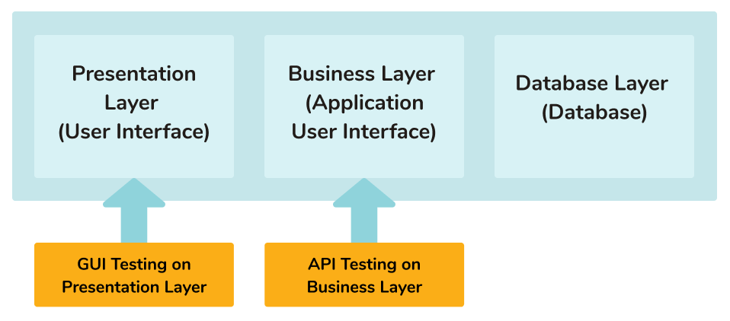

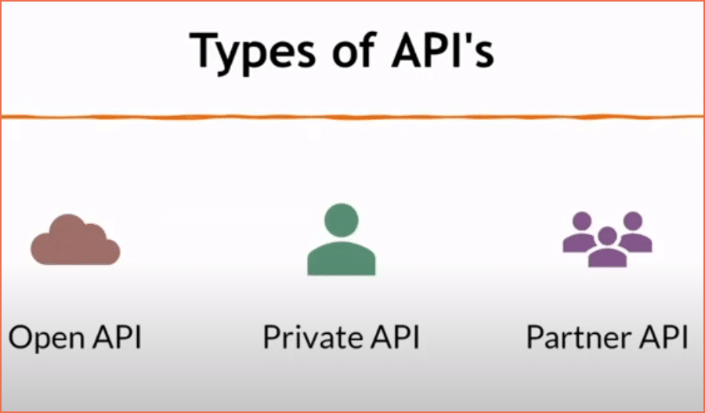
- Types of API Testing.
Ans.
- Mainly there are three types of API Testing.
1. Open APIs
2. Partner APIs
3. Private/Internal APIs

- Open APIs: These types of APIs are publicly available to use like OAuth APIs from Google. It has also not given any restriction to use them. So, they are also known as Public APIs.

- Partner APIs: Specific rights or licenses to access this type of API because they are not available to the public.

- Internal APIs: Internal or private. These APIs are developed by companies to use in their internal systems. It helps you to enhance the productivity of your teams.

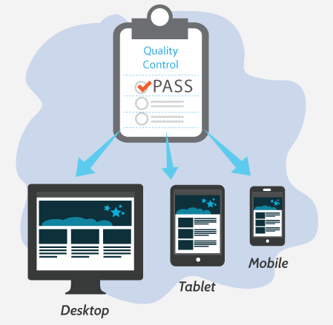
10) What is Responsive Testing?
Ans.
- Responsive testing involves how a website or web application looks and behaves on different devices, screen sizes, and resolutions.
- The goal of responsive testing is to ensure that the website or web application can be used effectively on various devices, including desktops, laptops, tablets, and smartphones.

11) Which types of tools are available for Responsive
Testing.
Ans. Responsive Testing Tools :
- LT Browser
- Lambda Testing
- Google Resizer
- am I responsive
- Pixel tuner

12) What is the full form of .ipa, .apk
Ans.
- .ipa – iOS package App, international phonetic alphabet
- .apk – Android Application Package

13) How to create step for to open the developer option
mode ON?
Ans.
- Step 1 : Go to Settings >my Phone.

- Step 2 : Tap Software Info > Build Number.

- Step 3 : Tap Build Number seven times. After the first few taps, you should see the steps counting down until you unlock the developer options. You may also have to tap in your PIN for verification.

- Step 4 : Once developer options are activated, you will see a message that reads, you are now a developer.

- Step 5 : Go back to the Settings pane, where you will now find Developer options as an entry.

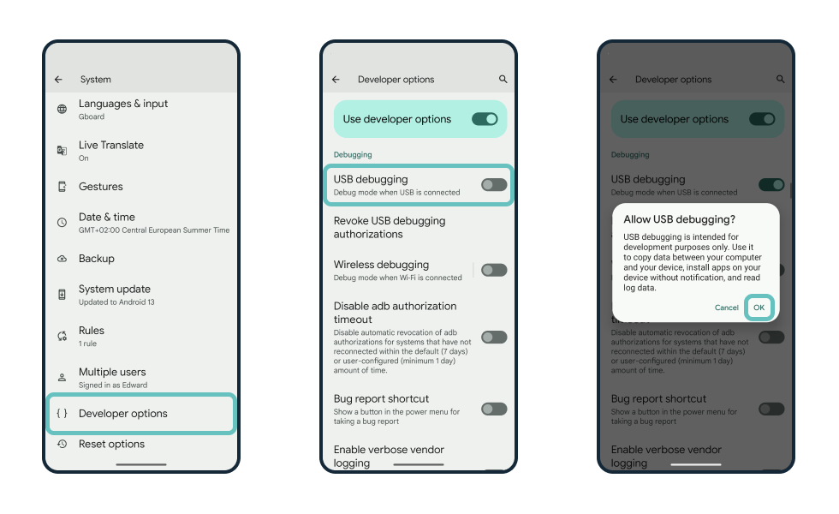
- Step 6 : Tap it and toggle (USB debugging) the switch on if it is not already, and from there, you can proceed to make adjustments to your phone.

