Assignment - 4
Module – 4
(Automation Core Testing)

Que-1 ) Which components have you used in Load Runner?
Ans.
- Virtual user generator (vugen.exe)
- Load controller (wlrun.exe)
- Load Generator (mdrv.exe)
- Agent processor (magentproc.exe)
- Analysis (analysisui.exe)

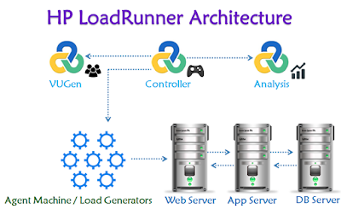

Que-2 ) How can you set the number of Vusers in Load
Runner ?
Ans.
- Go to LoadRunner installation folder C:\Program Files(x86)\HP\LoadRunner\dat\protocols
- Find .lrp file that is corresponding to the protocol you use to create VuGen Script.
- Edit it: paste MaxThreadPerProcess=10 after [Vugen]. Or edit this variable if it already exists.
- HP LoadRunner Controller should be restarted so that changes could take effect.

Que-3 ) What is Correlation?
Ans.
- Correlation in performance testing is a technique used to account for dynamic values.
- Many web applications have dynamic data that changes every time the user runs that web application.
- Web applications often need to track user’s interactions as they navigate through the website while preserving their state between navigations.
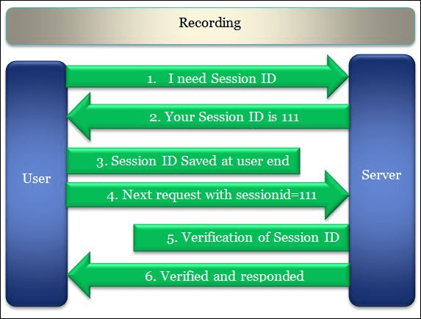
- Session ids for example are used by server engines such as ASP, ASP.NET, JSP and PHP to manage sessions. These session ids will change each time the page is loaded.

Que-4 ) What is the process for developing a Vuser Script?
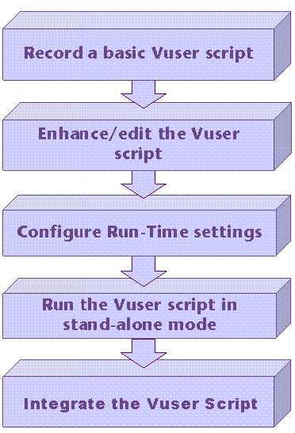
Ans.
- Recording the vuser script .
- edit the vuser script.
- Runtime setting .
- Run the vuser script in stand-alone mode.
- Incorporate the vuser script into a load runner scenario.

Que-5 ) How Load Runner interacts with the application?
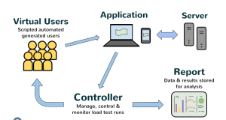
Ans.
- LoadRunner simulates user activity by generating messages between application components or by simulating interactions with the user interface.


- The messages and interactions to be generated are stored in scripts. LoadRunner has several key components, including Load Generator, VuGen (Virtual User Generator), Controller, and Agent process.
- Load Generator generates the load against the application by following scripts, VuGen is used for generating and editing scripts, Controller controls, launches and sequence instances of Load Generator, and Agent process manages connection between Controller and Load Generator instances.

Que-6 ) How many VUsers are required for load testing?
Ans.
- The number of virtual users required for load testing depends on various factors such as the software being tested, the number of users expected to use the software, and the budget available for testing. Ideally, you could test with as many virtual users as you need. In practice, this may be too expensive because load testing software is priced on the number of concurrent virtual users.
- It’s important to note that the number of concurrent virtual users is one of the most important factors affecting the accuracy of load testing. However, the number of virtual users required for load testing can vary depending on the software being tested and the testing environment.
- To calculate the number of concurrent virtual users required for a load test, you can use the following formula:

(concurrent users) x (requests per user per minute) = total requests per minute

- For example, if we run a load test with 10,000 virtual users, each making a request every 20 seconds (3 requests per minute), then we are making 30,000 requests per minute, which equals 500 requests per second.

Que-7 ) What is the relationship between Response Time
and Throughput?
Ans.
- Response time is typically treated as the elapsed time from the moment that a user enters a command or activates a function until the time that the application indicates that the command or function has completed.

- Throughput measures the overall performance of the system. For transaction processing systems, throughput is typically measured in transactions per second (TPS) or transactions per minute (TPM).
- Response time and throughput are related. The response time for an average transaction tends to decrease as you increase overall throughput.
- However, you can decrease the response time for a specific query, at the expense of overall throughput, by allocating a disproportionate amount of resources to that query. Conversely, you can maintain overall throughput by restricting the resources that the database allocates
to a large query.
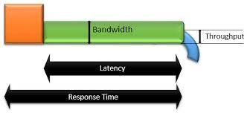

Assignmnet – 5
Module – 5
(Selenium IDE)

Que-1 ) What is Automation Testing?
Ans.
- Automation Testing :- Automated testing is the application of software tools to automate a human-driven manual process of reviewing and validating a software product.

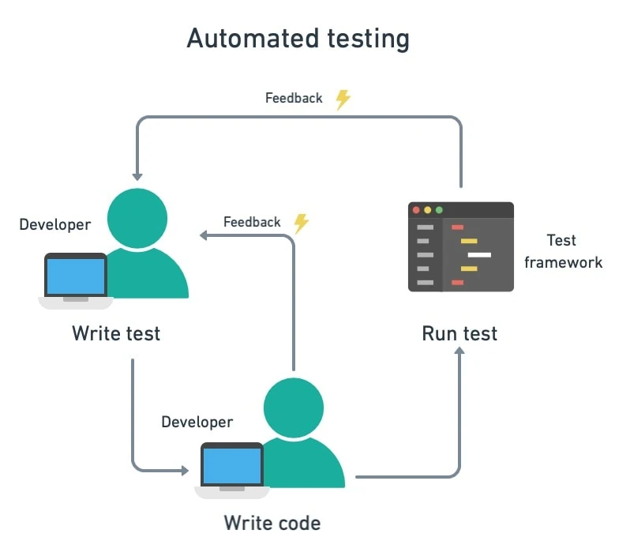

Que-2 ) Which Are The Browsers Supported By Selenium
Ide?
Ans.
- Browsers supported by Selenium IDE :- Firefox
Chrome Browsers.
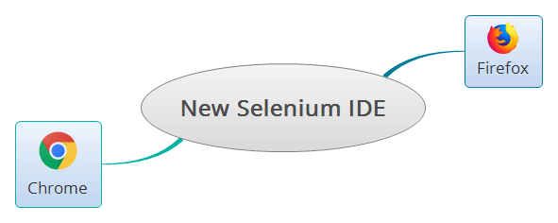

Que-3) What are the benefits of Automation Testing?
Ans.
- Test at Scale.
- Faster Feedback Loop.
- Better Allocation of Resources.
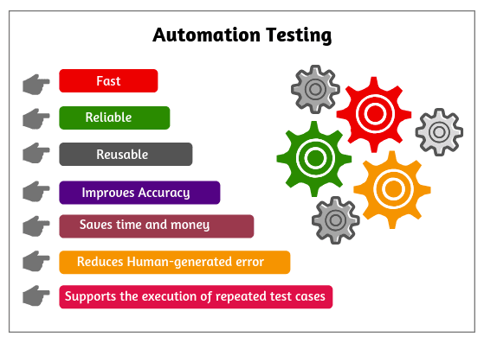
- Guarantees Higher Accuracy.
- Saving Costs.
- Increased Test Coverage.
- Increasing Employee Satisfaction and Retention.
- Detects bugs earlier.

Que-4 ) What are the advantages of Selenium?
Ans.
- Open Source Availability
- Parallel test execution and faster market launch
- Less Hardware Usage
- Language and Framework Support
- Multi-Browser Support
- Support Across Various Operations
- Reusability and Integrations
- Flexibility
- Easy to Learn and Use
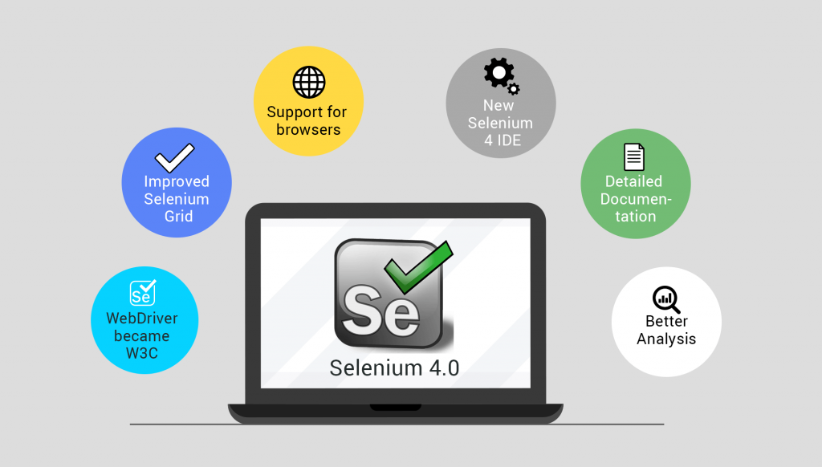
- Ease of Implementation

Que-5 ) Why testers should opt for Selenium and not QTP?
Ans.
For beginners in automation testing, Selenium is generally recommended over QTP/UFT because it is free, open-source, and supports multiple programming languages. This makes it easier to learn and use Selenium, and it gives testers more flexibility in their choice of programming language.

