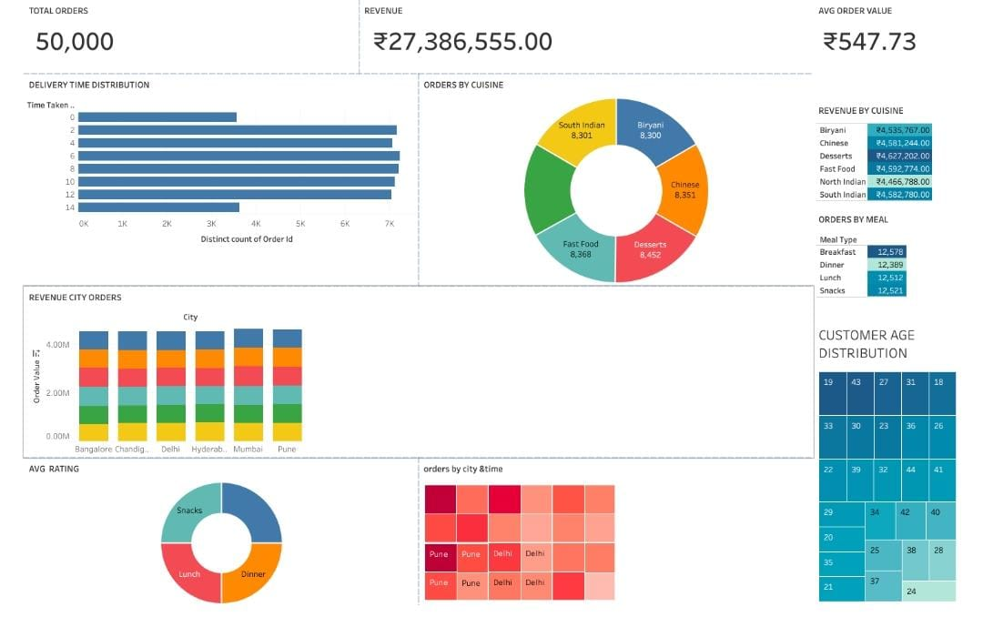
Food Ordering Analytics Dashboard

Project Overview

This project analyzes food ordering behavior using Tableau.

This project focuses on uncovering the key factors that influence housing prices and sales trends by analyzing a comprehensive dataset of food ordering behavior.

Dashboard KPIs

- Total Orders
- Total Revenue

- Average Order Value

- Average Delivery Time
Visualizations
- Orders by City
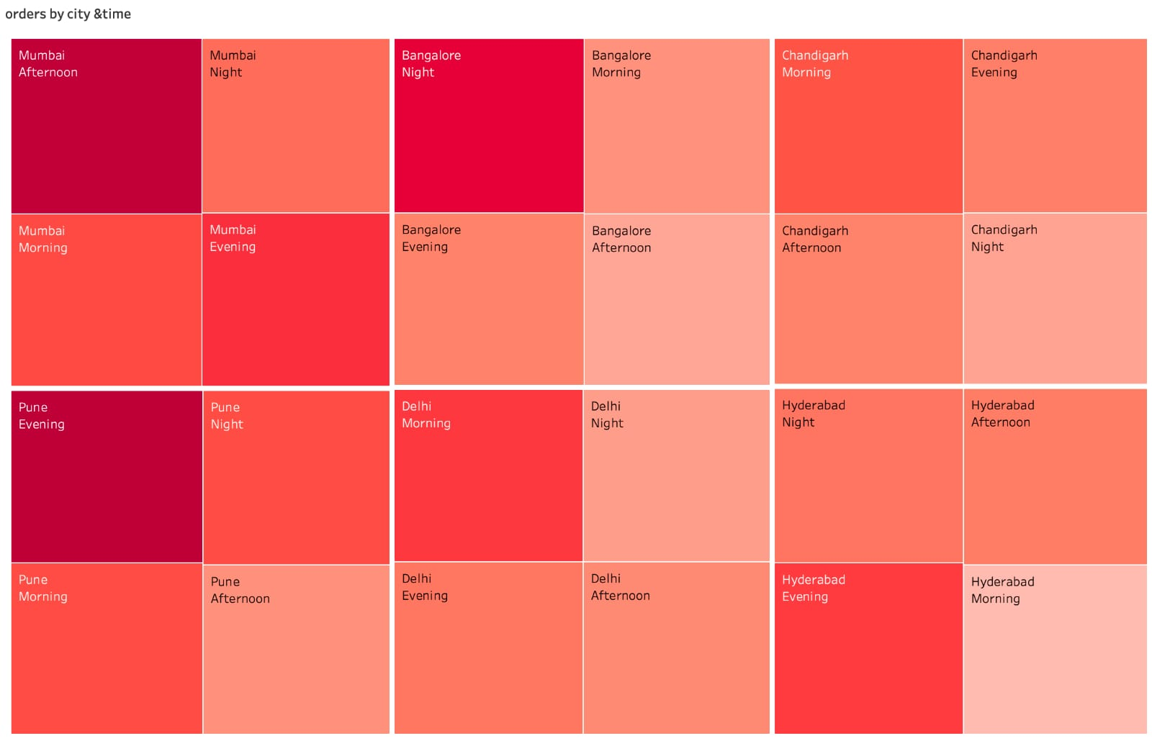
Revenue By City
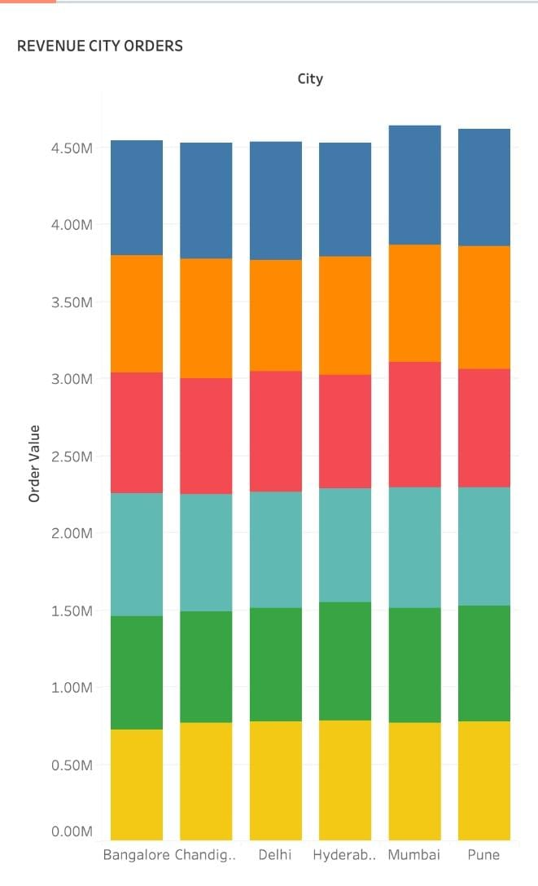
Orders By Cuisine
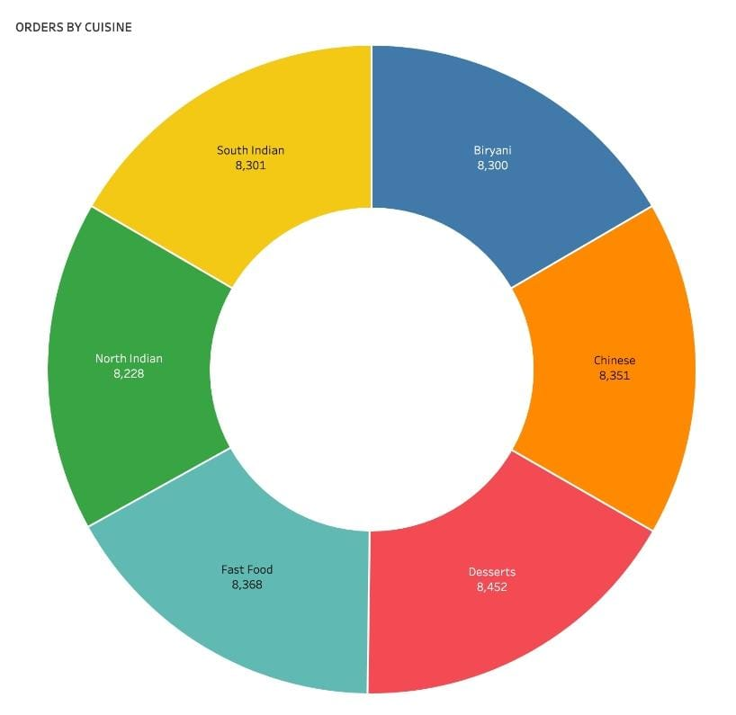
Revenue by Cuisine
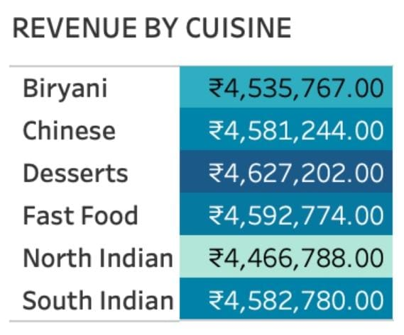
Order by meal type

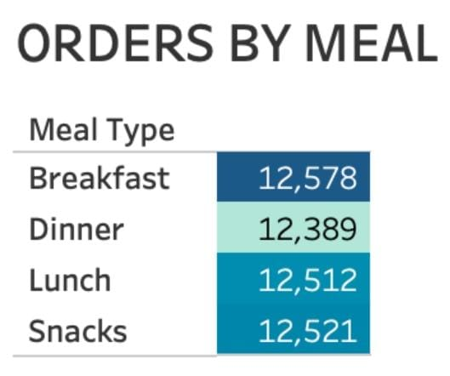

Customer Age Distribution

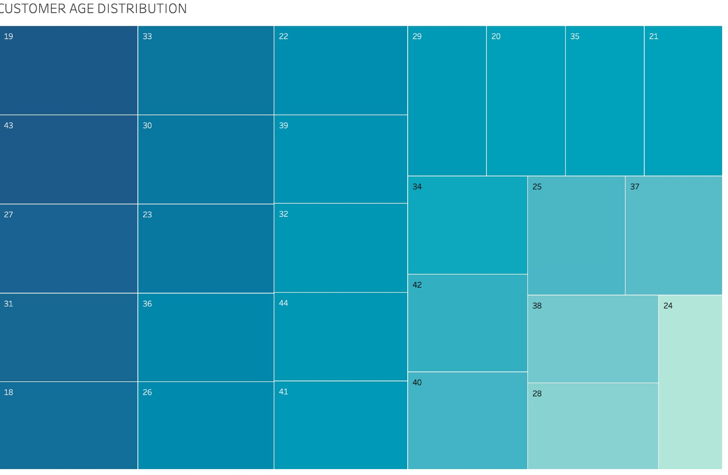

Tools used
- Tableau Public
- GitHub

Dataset
- Food ordering behaviour data set
Dashboard Preview



Demo video link

https://drive.google.com/file/d/14ljlklm5UwyMWEXpKwCLKVXNxxgwvtHI/view?usp=drivesdk

Author
Bhoomi Jain

