Assignment - 2

2)Take one Domain and draw the graph (Normal distribution) (Empirical rule)
What is Normal Distribution?
- A normal distribution is a continuous probability distribution that is:
- Symmetrical about the mean (average).
- Bell-shaped, with one single peak at the center.
- The mean, median, and mode are equal.
- The total area under the curve is always equal to 1 (or 100%).
- The curve extends infinitely in both directions but never touches the horizontal axis.
In our example, suppose:
- Mean (μ) = 60 marks
- Standard Deviation (σ) = 10 marks
This means most students score around 60 marks, and the spread of marks depends on the standard deviation.

Empirical Rule (68–95–99.7 Rule)
The Empirical Rule explains how data is distributed in a normal distribution.
1️⃣ 68% Rule (Within 1 Standard Deviation)
- About 68% of students score between:
- μ − 1σ = 60 − 10 = 50
- μ + 1σ = 60 + 10 = 70
So, approximately 68% of students score between 50 and 70 marks.

2️⃣ 95% Rule (Within 2 Standard Deviations)
- About 95% of students score between:
- μ − 2σ = 60 − 20 = 40
- μ + 2σ = 60 + 20 = 80
So, approximately 95% of students score between 40 and 80 marks.

3️⃣ 99.7% Rule (Within 3 Standard Deviations)
- About 99.7% of students score between:
- μ − 3σ = 60 − 30 = 30
- μ + 3σ = 60 + 30 = 90
So, nearly all students score between 30 and 90 marks.
Only 0.3% of students score extremely low (below 30) or extremely high (above 90).

Graph of Normal Distribution (Exam Marks)
Below is the representation of the normal distribution curve for exam marks:

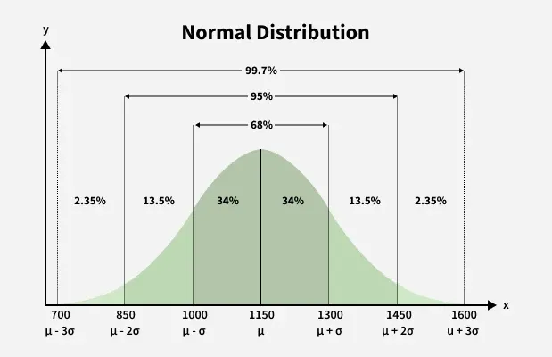

Explanation of the Graph:
- The horizontal axis represents the exam marks.
- The vertical axis represents the frequency or number of students.
- The highest point of the curve is at the mean (60 marks).
- The curve decreases symmetrically on both sides.
- Most students are concentrated around the center.
- Very few students are at the extreme ends.

Important Characteristics in This Domain
- The distribution is symmetrical, meaning the left and right sides are mirror images.
- The mean = median = mode = 60.
- The spread of marks depends on the standard deviation (10).
- Higher standard deviation means more spread-out marks.
- Lower standard deviation means marks are closely clustered around the mean.
- The empirical rule helps teachers understand student performance distribution.
- It also helps identify outliers, such as students scoring extremely low or high.

Real-Life Importance
- Schools use normal distribution to analyze overall performance.
- It helps in grading systems such as grading on a curve.
- It helps identify average, below-average, and above-average students.
- It is widely used in statistics, machine learning, and data science.
- It helps in decision-making and performance evaluation.

Advantages of Using Normal Distribution
- Easy to analyze.
- Predictable pattern.
- Helps in probability calculation.
- Useful in hypothesis testing.
- Forms the base of many statistical techniques.

Limitations
- Not all real-world data is perfectly normal.
- Extreme outliers may distort results.
- Some data may be skewed instead of symmetric.

