LAB05 TASKS
Task 1:
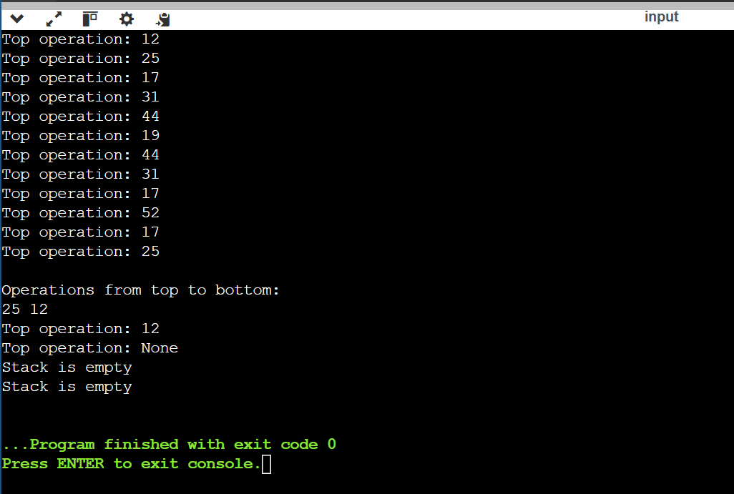

Task 2:
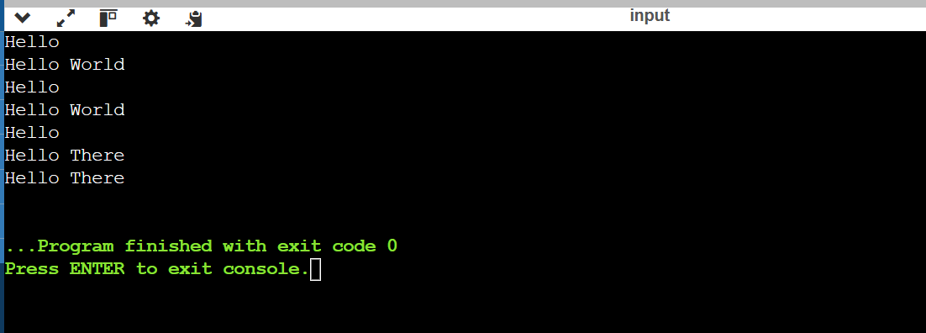

Task 3:
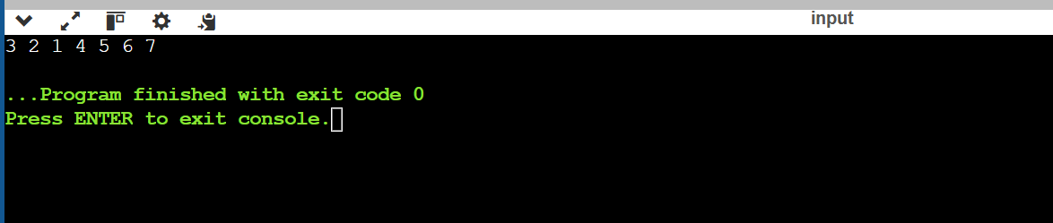

Task 4:
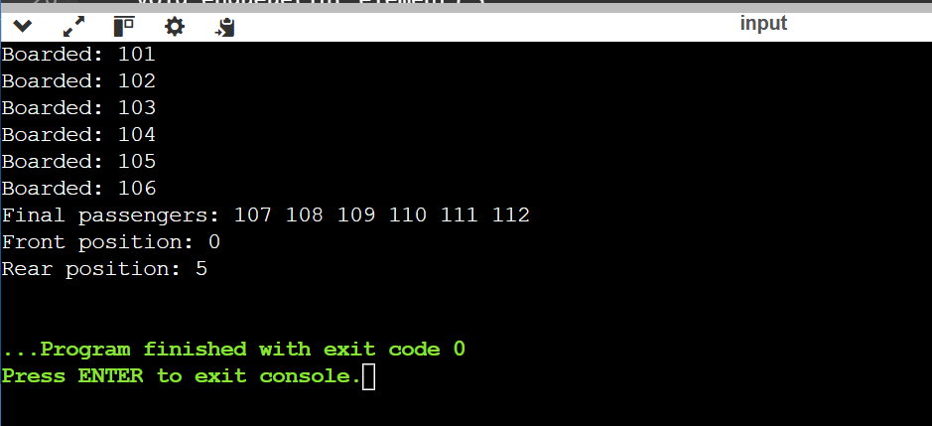

Task 5:


