**DEPARTMENT OF INFORMATION TECHNOLOGY**

**COURSE CODE: DJ19ITL602 DATE: 29-03-2022**

**COURSE NAME: Software Engineering CLASS: TY B.TECH**

**LAB EXPERIMENT NO. 3**

**CO/LO:** Understanding and drawing the data flow diagram

**AIM / OBJECTIVE:** Understanding and drawing the data flow diagram of our project.

**DESCRIPTION OF EXPERIMENT:**

1. Learn the concept of Data Flow Diagram (DFD) and building blocks/notations used to draw DFD.

A data flow diagram (DFD) is a graphical or visual representation using a standardized set of symbols and notations to describe a business's operations through data movement. They are often elements of a formal methodology such as Structured Systems Analysis and Design Method (SSADM). Superficially, DFDs can resemble flow charts or Unified Modeling Language (UML), but they are not meant to represent details of software logic.

#### Components of DFD:

The Data Flow Diagram has 4 components:

* Process  
  Input to output transformation in a system takes place because of process function. The symbols of a process are rectangular with rounded corners, oval, rectangle or a circle. The process is named a short sentence, in one word or a phrase to express its essence
* Data Flow  
  Data flow describes the information transferring between different parts of the systems. The arrow symbol is the symbol of data flow. A relatable name should be given to the flow to determine the information which is being moved. Data flow also represents material along with information that is being moved. Material shifts are modeled in systems that are not merely informative. A given flow should only transfer a single type of information. The direction of flow is represented by the arrow which can also be bi-directional.
* Warehouse  
  The data is stored in the warehouse for later use. Two horizontal lines represent the symbol of the store. The warehouse is simply not restricted to being a data file rather it can be anything like a folder with documents, an optical disc, a filing cabinet. The data warehouse can be viewed independent of its implementation. When the data flow from the warehouse it is considered as data reading and when data flows to the warehouse it is called data entry or data updation.
* Terminator  
  The Terminator is an external entity that stands outside of the system and communicates with the system. It can be, for example, organizations like banks, groups of people like customers or different departments of the same organization, which is not a part of the model system and is an external entity. Modeled systems also communicate with terminators.

Levels or layers are used in DFDs to represent progressive degrees of detail about the system or process. These levels include:

* Level 0: Also known as a "context diagram," this is the highest level and represents a very simple, top-level view of the system being represented.
* Level 1: Still a relatively broad view of the system, but incorporates subprocesses and more detail.
* Level 2: Provides even more detail and continues to break down sub processes as needed.

2. Draw a DFD for your entire proposed system up-to level 2 using online drawing tools viz. Lucidchart, draw io etc.

**DFD Level 0**

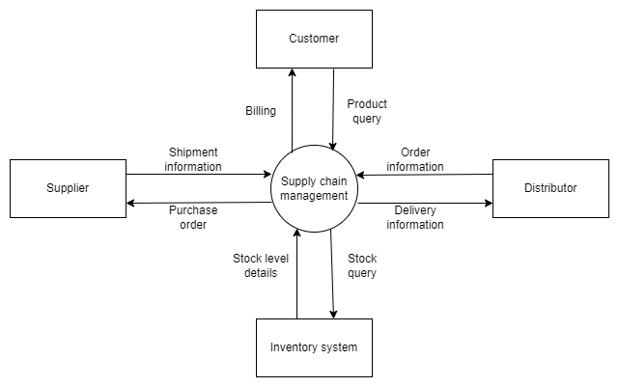

**DFD Level 1** 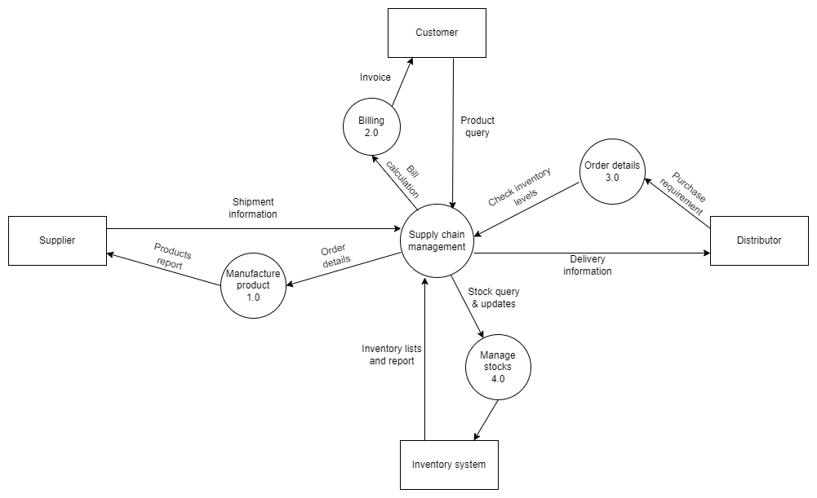

**DFD Level 2**

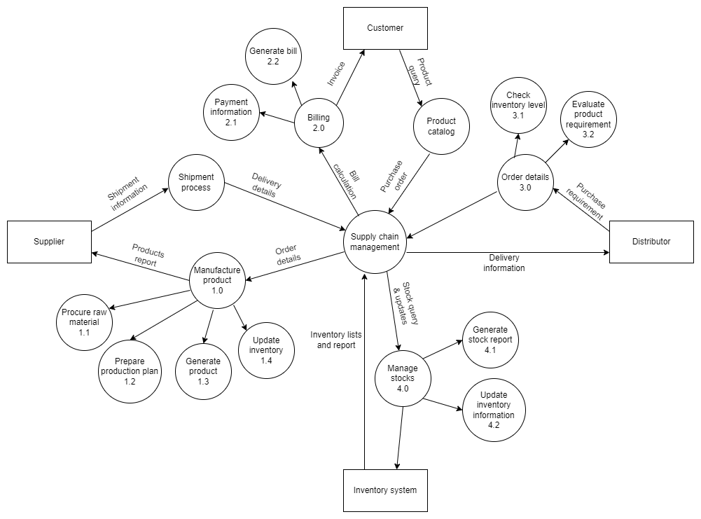

**REFERENCES:**

**​Website References:​**

[1] “What is DFD” from GFG by

<https://www.geeksforgeeks.org/what-is-dfddata-flow-diagram/>

[2] “Data flow diagram” from LucidChart by

<https://www.lucidchart.com/pages/data-flow-diagram>