444

**Informatica Intelligent Data Management Cloud**

**Course Project on**

**Local Mail Delivery System**

**Bachelor of Engineering**

**in**

**COMPUTER SCIENCE AND ENGINEERING**

***Submitted By***

***Disha Kalyanshettar 01FE22BCI016***

***Drakshayani Chalageri 01FE22BCI028***

***Bhoomika Marigoudar 01FE22BCI035***

**Team No:**

**Faculty In charges**

**Mr. Channabasappa M**

**Ms.Neha.T**

**DEPARTMENT OF COMPUTER SCIENCE**

**(ARTIFICIAL INTELLIGENCE)& ENGINEERING**

**HUBLI–580 031 (India).**

**Academic year 2024-25**

|  |  |
| --- | --- |
| **Table of Content** |  |
| **Chapters** | **Page**  **No** |
| **1. Introduction**  1.1 Preamble  1.2 Problem Definition  1.3 Objectives | **3** |
| **2. ER diagram** | **5** |
| **3. Data set description** | **6** |
| **4. Transformations**  **(screenshots) with explanation** | **7** |
| **5. Conclusion (insights from data – Business Intelligence)**  Appendix  Roles and responsibility | **10** |

## 

## 1. Introduction

### 1.1 Preamble

In today’s fast-paced logistics and service-driven economy, mail and parcel delivery systems require robust data integration and transformation capabilities to ensure timely operations, transparent billing, and high-quality customer service. Our project focused on designing and executing a solution using **Informatica Intelligent Cloud Services (IICS)** to efficiently process and transform data within a **Mail Delivery System** that comprises entities such as **Service**, **Billing_Information**, **Customer Data**, and **Delivery Transactions**.

The objective was to ingest and transform data from these interrelated tables to generate actionable insights such as delivery performance metrics, revenue analysis, customer service usage patterns, and branch-wise operational efficiency. By utilizing the powerful features of **IICS**, we ensured high data quality, integrity, and readiness for reporting and business intelligence.

This transformation pipeline supports strategic decision-making in areas like **cost optimization**, **service personalization**, **branch-level performance tracking**, and **workflow automation**, ultimately enhancing the operational agility and customer satisfaction of the mail delivery ecosystem.

### 1.2 Problem Definition

In a typical small town, the local mail delivery system efficiently handles various types of mail, including letters, couriers, and parcels. Customers drop off their mail at designated mailboxes around town, where each item is later collected by postal employees. These items are automatically scanned at the central branch to identify their type, and the system prompts for additional service options like delivery speed and insurance for couriers and parcels, while letters are usually mailed free of charge.

Charges are applied accordingly, and receipts, including tracking numbers for paid items, are issued based on the selected services. The sorted mail is then organized at the branch according to type and delivery specifications, and stored in designated bins. To ensure efficient delivery, the branch manager plans the delivery routes based on the volume of mail and its destinations and assigns vehicles and drivers for the routes.

As deliveries are made, drivers use handheld devices to update the delivery status in real-time, providing customers with the ability to track their mailed items. This streamlined process not only simplifies initial mail drop-off but also optimizes the sequence from collection and sorting to final delivery, enhancing both operational efficiency and customer service.

### 1.3 Objectives

### 1. To centralize mail delivery information by building a unified database that stores sender and receiver details, tracking numbers, and timestamps.

### 2. To implement real-time tracking of mail items, enabling transparency and allowing customers to monitor delivery status continuously.

### 3. To automate the generation of invoices and receipts for paid mail services, streamlining administrative tasks.

### 4. To automatically classify mail by type and service options, enabling efficient sorting and storage using predefined bins.

### 5. To support the branch manager in planning optimal delivery routes by analyzing mail volume and destinations, thereby improving operational efficiency.

### 6. To enhance customer experience by providing secure, fast, and trackable mail delivery services.

### 7. To leverage delivery and operational data for business intelligence.

### 8. To implement data transformation techniques such as ranking, aggregation, and expression evaluation to enable effective reporting and system design.

## 

## 

## 2. ER Diagram

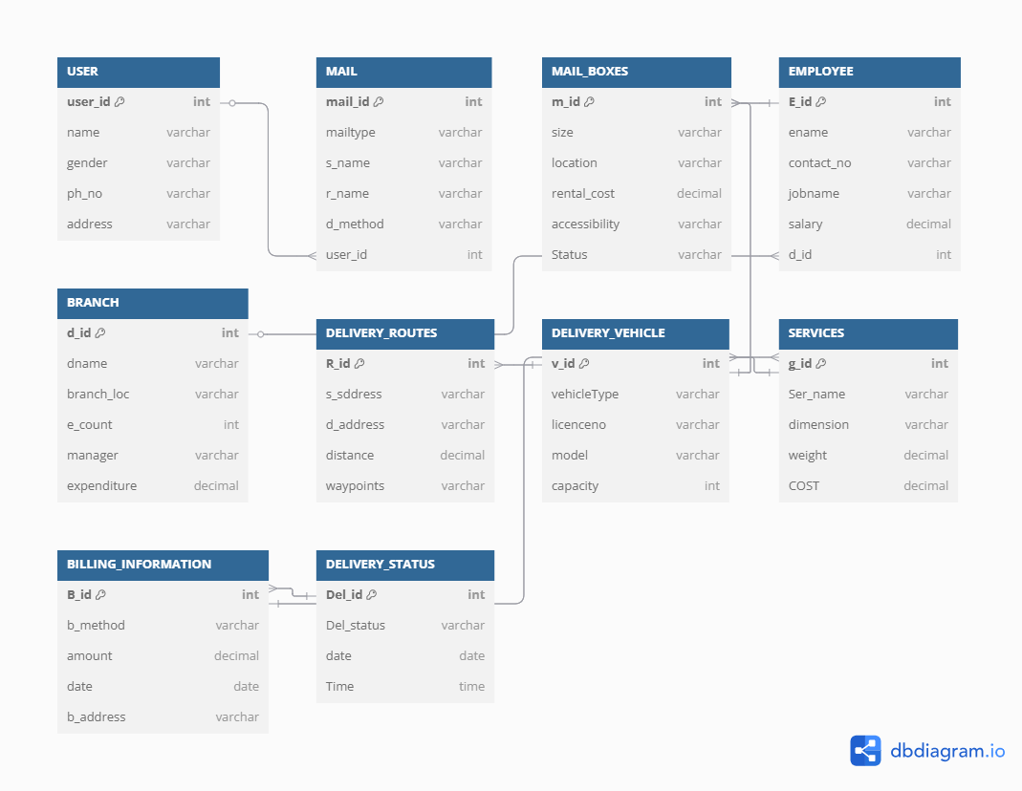

## 

## 3. Database Description **Mail Delivery Database**

|  |  |
| --- | --- |
| **Table Name** | **Description** |
| **User** | Contains user details including User_id, User_name, gender, phoneno and address. |
| **Mail** | Stores mail details such as Mail_id, Mail_type, Sender_name, Receiver_name, Delivery_method, time, date, User_id, Mailbox_id, destination, weight. |
| **Mail_Boxes** | Contains Mail_Box details linked to tables Employee, Branvh and Services including Mailbox_id, Mailbox_size, Mb_status, location, Rental_cost, and accessibility with foreign keys Emp_id, Branch_id and Service_id. |
| **Employee** | Records Employee details with Emp_id, Emp_name, Contact_no, Job_name, salary, Branch_id, Emp_age, and Joining_year. |
| **Branch** | Line items for each order, including Branch_id, Brach_loc, Branch_name, Manager_name, and Expenditure_month |
| **Delivery_Routes** | Contains DRoute_id, Dest_add, Source_add, waypoints, distance, Branch_id, and Amount_km. |
| **Delivery_Vehicle** | Stores Vehicle_id, Vehicle_type, Licence_no, Vehicle_model, and Vehicle_capacity. And foreign keys Emp_id and DRoute_id |
| **Services** | Contains Service_id, Service_charge, Weight_charge_gm, and foreign key Branch_id |
| **Billing_Information** | Includes Billing_id, Billing_method, Billing_address, amount, Billing_date and Billing_time. And foreign keys Service_id and Branch_id |
| **Delivery_Status** | Delivery_id, Delivery_date, Delivery_status, Delivery_time, and Branch_id |

The database consists of several interconnected tables supporting a mail delivery system. The User table stores user details, while the Mail table records information about each mail item including sender, receiver, and delivery method. Mail_Boxes hold data on mailbox specifications and are linked to employees, branches, and services. Employee and Branch tables capture staff and branch-level information such as job roles, salaries, locations, and expenditures.

The Delivery_Routes table outlines delivery paths with distances and costs, and Delivery_Vehicle stores vehicle information linked to employees and routes. Services defines service charges per branch, and Billing_Information logs transaction details like billing amount and method. Finally, Delivery_Status tracks delivery outcomes, enabling performance monitoring across branches.

## 4. Transformations (with Screenshots and Explanation)

**Use Case 1: Calculate Total Billing Amount per Branch**

It enables financial performance tracking, supports budgeting decisions, identifies high performing locations, and aids in resource allocation.

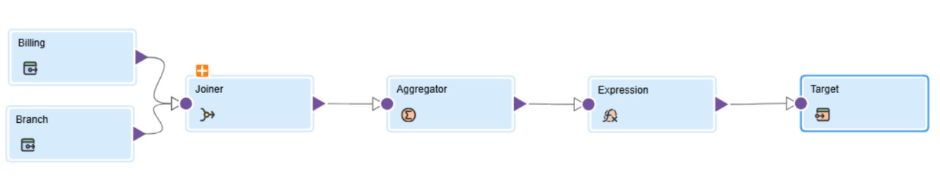

**Use Case 2: Track Failed Deliveries and Responsible Branch**

It supports delivery performance audits, helps identify operational inefficiencies, enables accountability tracking, and guides service improvement strategies.

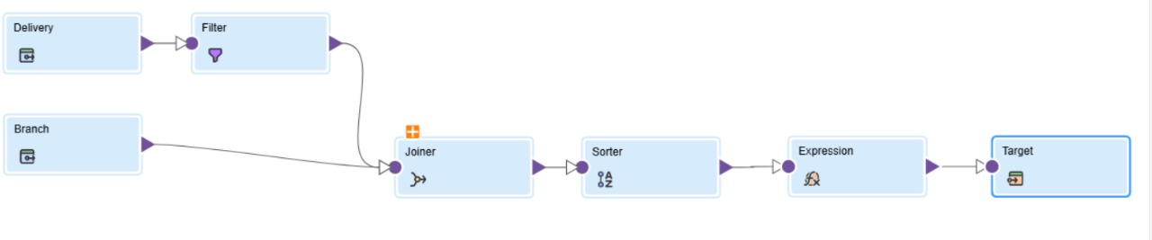

**Use Case 3:** **Calculate Route Delivery Cost**

It enables identification of high-cost routes, supports delivery path optimization, aids in cost reduction strategies, and enhances logistics planning.

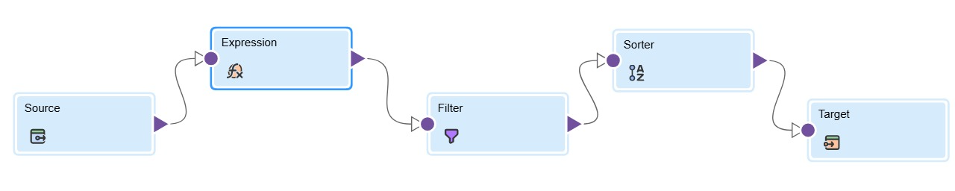

**Use case 4:** **Sort Senior Employees by Branch Expenditure**

It helps identify experienced employees in high-spending branches, supports workforce planning, enables targeted managerial oversight, and assists in strategic resource deployment.

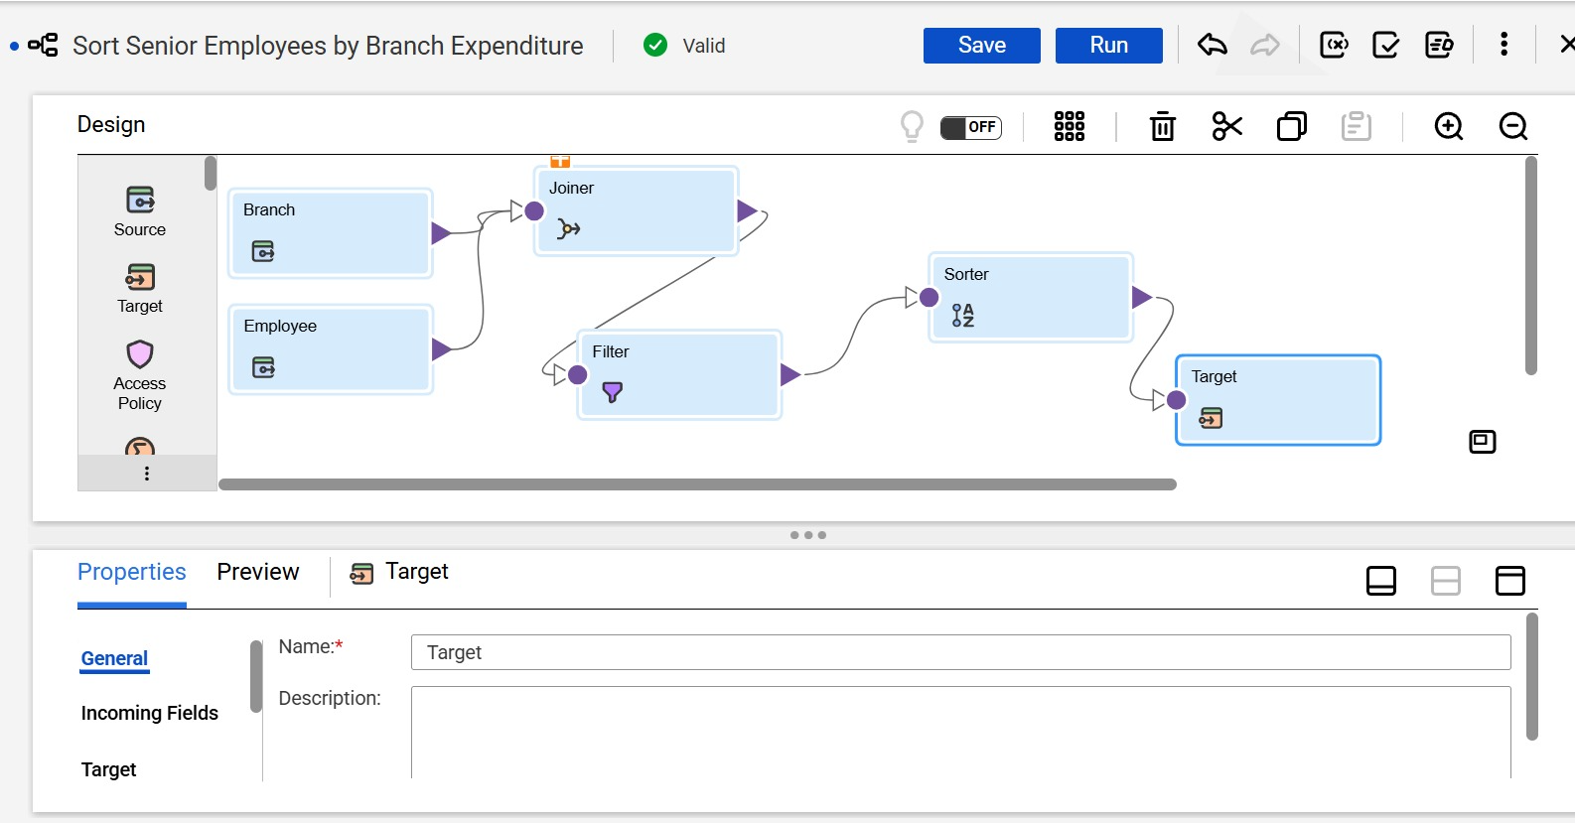

**Use case 5:** **Filtered Mails for Express Delivery**

It facilitates prioritization of urgent deliveries, enables performance tracking of express services, supports timely handling, and aids in analyzing express delivery trends.

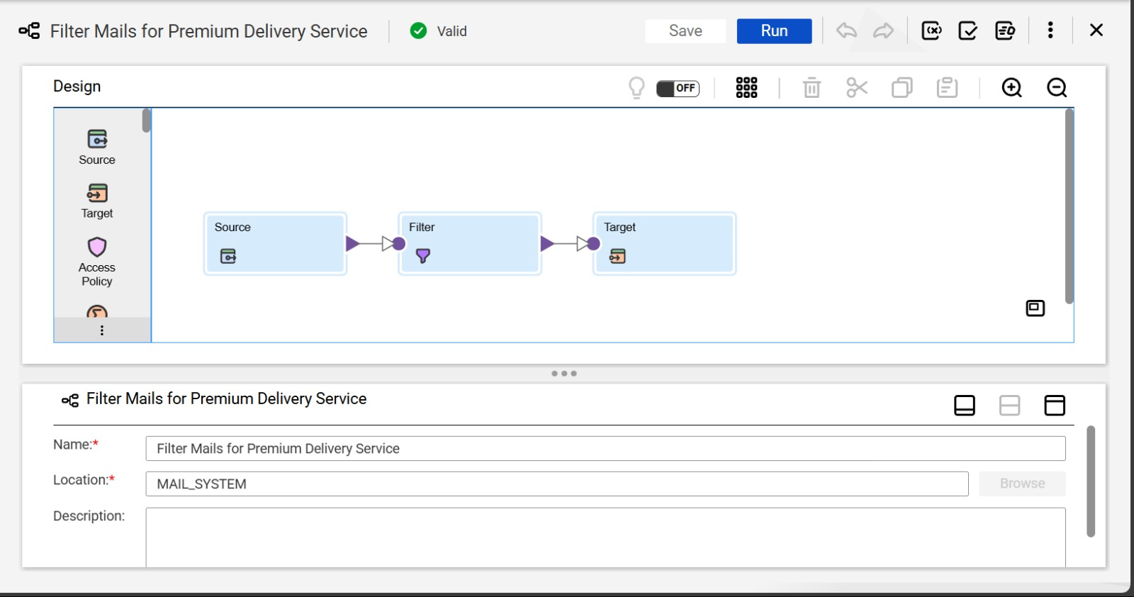

**Use case 6: Generate Unique Mail Tracking**

Generate Unique Mail Tracking Numbers using Sequence, Expression ensures automated assignment of unique tracking IDs, maintains consistency with business standards, eliminates manual errors, and streamlines mail tracking processes.

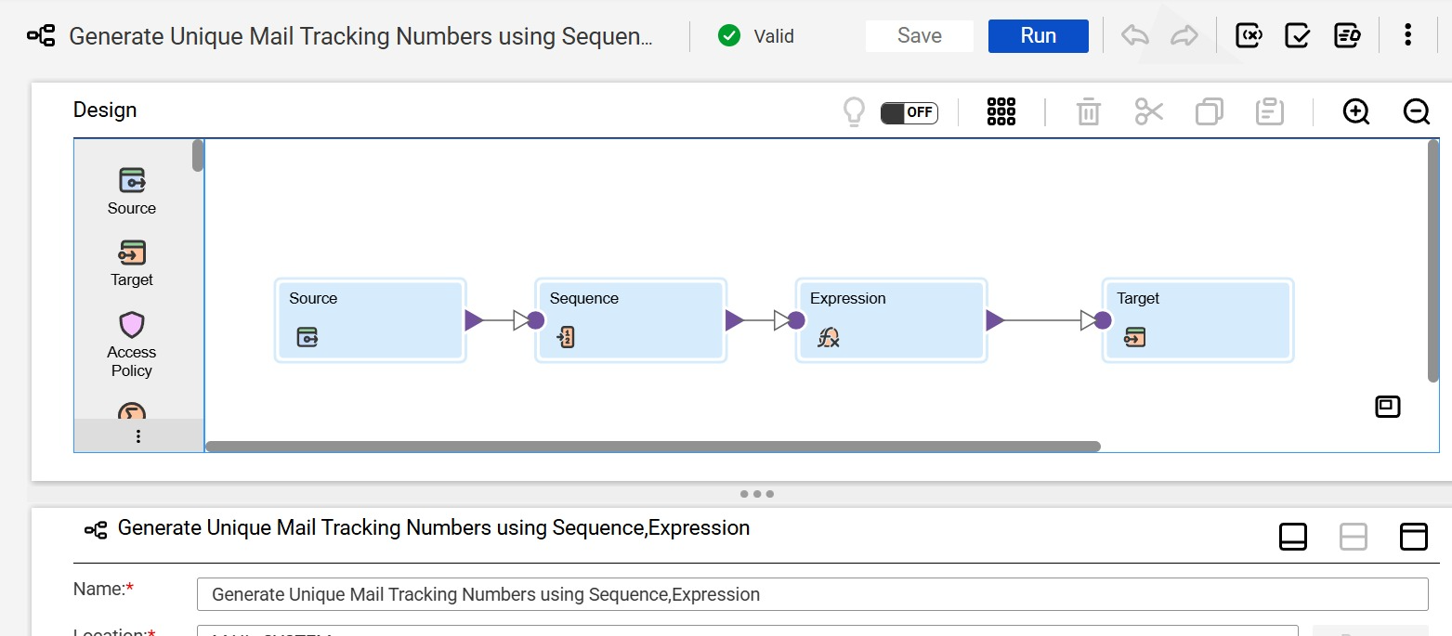

**Use case 7:** **Filter by gender Female**

It enables targeted communication, supports gender based marketing strategies, assists in demographic analysis, and enhances customer segmentation efforts.

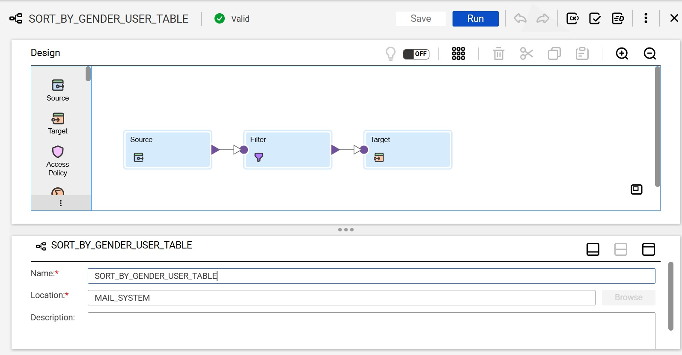

**Use case 8:** Branch Wise Revenue Analysis through Service and Billing supports financial reporting, enables monitoring of service performance per branch, aids in revenue trend analysis, and facilitates data-driven decision-making through visual dashboards.

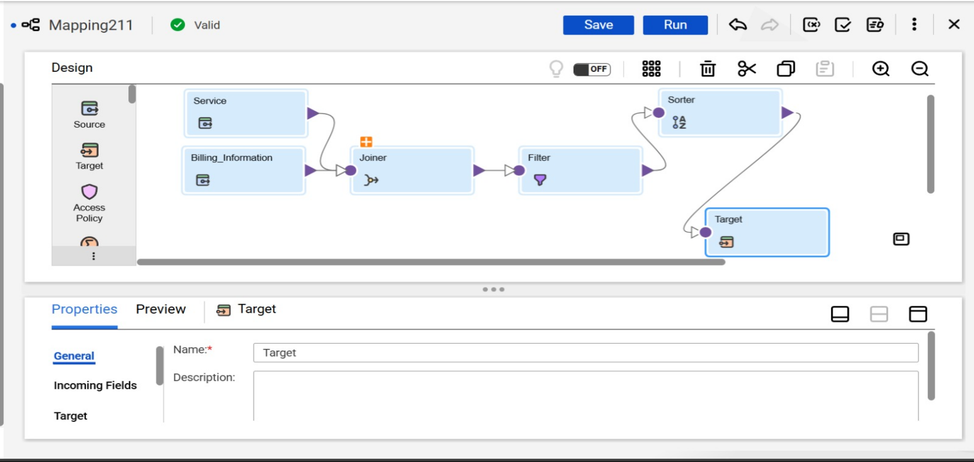

**5. Conclusion**

The Mail Delivery System project successfully demonstrated how Informatica IICS can be leveraged to transform raw postal data into meaningful business insights. By integrating delivery, billing, customer, and routing data, we enabled real-time visibility across operations. Automated workflows such as tracking ID generation, express mail filtering, and revenue analysis improve both efficiency and user experience. The system empowers decision-makers with actionable intelligence for operational optimization, cost reduction, and strategic planning.

**Key insights** derived from our analysis include:

1. Branch-Wise Revenue Analysis: Aggregating billing and service data revealed high-performing branches and helped in strategic financial planning.
2. Failed Delivery Monitoring: Tracking delivery failures by branch highlighted underperforming zones, aiding in quality control and audit readiness.
3. Route Cost Efficiency: Distance-based cost calculations exposed the most expensive delivery routes, guiding route restructuring.
4. Employee Impact Analysis: Correlating senior employees with branch expenditures offered insights into resource allocation and leadership efficiency.
5. Express Delivery Prioritization: Isolating express deliveries ensured better service tracking and faster delivery performance metrics.
6. Automated Tracking IDs: Use of Sequence and Expression transformations ensured unique, error-free tracking numbers.
7. Gender-Based User Insights: Filtering female users supported personalized communication and targeted service strategies.
8. Integrated View of Service and Revenue: Joining service charges and billing data provided a comprehensive revenue dashboard for executive-level reporting.