Department of Collegiate and Technical Education
Shivasharane Akkamahadevi
Government Women’s Polytechnic, Shiralakoppa
Department Of Computer Science And Engineering

Mini-Project Report on
“Rainfall Prediction Mini Project”
Submitted in partial fulfillment of the requirement for the award of the

Diploma Course in Computer Science and Engineering – 2023-24

Submitted by
Name | Reg No
Priya C.K | 143CS21028
Shruthana J | 143CS21040
Under the Guidance Of
Mr. Umesha D.K BE,M.Tech
Lecturer, Dept of CS&E


BOARD OF TECHNICAL EXAMINATION
PALACE ROAD, BANGLORE-1, Karnataka-590018
June -2023

DEPARTMENT OF COLLEGIATE AND TECHNICAL EDUCATION SHIVASHARANE AKKAMAHADEVI
GOVERNMENT WOMEN’S POLYTECHNIC
SHIRALKOPPA-577428

Department of Computer Science & Engineering

CERTIFICATE
This is to certify that the project work entitled “Rainfall Prediction Mini Project” is a work carried out by Priya c k(143CS21028), Shruthana J (143CS21040) in partial fulfillment for the award of Diploma Course in Computer Science and Engineering , Board of Technical Examination, Bangalore during the year 2023-24. It is certified that all correction/suggestions indicated for Internal Assessment have been incorporated in the report deposited in the departmental library. The project report has been approved as it satisfies the academic requirements in respect of Project work prescribed for the said diploma course.

Signature of Guide Signature of HOD Signature of Principal
Mr.Umesha D K Mr.Umesha D K Mr. D S Ravishankar
Lecturer, Dept of CS&E, HOD, Dept of CS&E Principal
SAGWPT, Shiralakoppa SAGWPT, Shiralakoppa SAGWPT, Shiralakoppa

Signature with Date

CANDIDATE’S DECLARATION

We, undersigned, the students of Diploma in Computer Science and Engineering Department of Shivasharane Akkamahadevi Government Women’s Polytechnic, Shiralakoppa, hereby declare that, we own full responsibility for the information, results and conclusions provided in this project work titled “Rainfall Prediction Mini Project” submitted to Board of Technical Examinations, Government of Karnataka for the award of Diploma in Computer Science and Engineering.
To the best of our knowledge, this project work has been not been submitted in part or full elsewhere in any other institution/ organization for the award of any certificate/diploma/degree. We have completely taken care in acknowledging the contribution of others in this academic work. We further declare that in case of any violation of intellectual property rights and particulars declared, found at any stage, we, as the candidates will be solely responsible for the same.

Sl. No | Student Name | Student Register No | Student Signature
1 | Priya c k | 143CS21028
2 | Shruthana J | 143CS21040

Date:
Place: Shiralakoppa

ACKNOWLEDGEMENT

We would like to express our sincere gratitude to all those who contributed to the successful completion of the Rainfall Prediction ML Project. This project would not have been possible without the support, guidance, and dedication of numerous individuals and organizations.
First and foremost, we extend our heartfelt thanks to our team members for their tireless efforts and unwavering commitment to this project. Their collective expertise, cooperation, and teamwork were instrumental in turning our ideas into a working machine learning model.
We would also like to express our profound appreciation to our project supervisor, Umesha.D.K , for their invaluable guidance and mentorship throughout the project. Their knowledge and insights were critical in shaping the project's direction and ensuring its quality.
We are grateful to our institution, Shivasharane Akkamahadevi Govt. Women’s Polytechnic,Shiralakoppa , for providing us with the necessary resources, infrastructure, and access to datasets that were essential for the research and development phase of this project.
Our appreciation extends to the online communities and forums that provided insightful discussions and solutions to challenges encountered during the project. Your shared knowledge greatly contributed to our project's success.
Last but not least, we want to acknowledge the participants who volunteered their time and data, as well as anyone who supported us in any way during this project.
In conclusion, we are thankful to everyone who played a role, big or small, in making this Rainfall Prediction ML Project a reality. Your contributions have been invaluable, and this project stands as a testament to the power of collaboration and dedication in the field of machine learning.

ABSTRACT

India is an agricultural country and its economy is largely based upon crop productivity and rainfall. For analyzing the crop productivity, rainfall prediction is required and necessary to all farmers. Rainfall Prediction is the application of science and technology to predict the state of the atmosphere. It is important to exactly determine the rainfall for effective use of water resources, crop productivity and pre planning of water structures. Using different data mining techniques, it can predict rainfall. Data mining techniques are used to estimate the rainfall numerically. This paper focuses some of the popular data mining algorithms for rainfall prediction. Logistic Regression, Support Vector Classifier, Decision Tree Classifier and Random Forest Classifier are some of the algorithms compared in this paper. From that comparison, it can analyze which method gives better accuracy for rainfall prediction.

TABLE
CHAPTER NO | TITLE
1 | INTRODUCTION
2 | METHODOLOGY
3 | RESULT AND DISCUSSION
4 | CONCLUSION

CHAPTER 1
INTRODUCTION
1.1 BACKGROUND AND BASICS
Rainfall Prediction is one of the most challenging tasks. Though already many algorithms have been proposed but still accurate prediction of rainfall is very difficult. In an agricultural country like India, the success or failure of the crops and water scarcity in any year is always viewed with greatest concern. A small fluctuation in the seasonal rainfall can have devastating impacts on agriculture sector. Accurate rainfall prediction has a potential benefit of preventing causalities and damages caused by natural disasters. Under certain circumstances such as flood and drought, highly accurate rainfall prediction is useful for agriculture management and disaster prevention. In this paper, various algorithms have been analyzed. Data mining techniques are efficiently used in rainfall prediction.
1.2 EXISTING SYSTEM
Agriculture is the strength of our Indian economy. Farmer only depends upon monsoon to be their cultivation. The good crop productivity needs good soil, fertilizer and also good climate. Weather forecasting is the very important requirement of the each farmer. Due to the sudden changes in climate/weather, The people are suffered economically and physically. Weather prediction is one of the challenging problems in current state. The main motivation of this paper to predict the weather using various data mining techniques. Such as classification, clustering, decision tree and also neural networks. Weather related information is also called the meteorological data. In this paper the most commonly used weather parameters are rainfall, wind speed, temperature and cold.
1.3 PROPOSED SYSTEM
Rainfall is important for food production plan, water resource management and all activity
plans in the nature. The occurrence of prolonged dry period or heavy rain at the critical stages
of the crop growth and development may lead to significantly reduce crop yield. India is an
agricultural country and its economy are largely based upon crop productivity. Thus rainfall
prediction becomes a significant factor in agricultural countries like India. Rainfall forecasting
has been one of the most scientifically and technologically challenging problems around the
world in the last century.

CHAPTER 2
METHODOLOGY
2.1 SYSTEM REQUIREMENT SPECIFICATION
2.1.1 Hardware Requirements:

- Speed - 2.4GHZ
- Hard disk - 40GB
- Monitor - 15VGA Color
- RAM - 4GB

2.1.2 Software Requirements:
- Coding Language - Python
- IDE – Jupyter Notebook
- System - Windows7/10
- Framework-Flask


2.1.3 PROPOSED METHODOLOGY
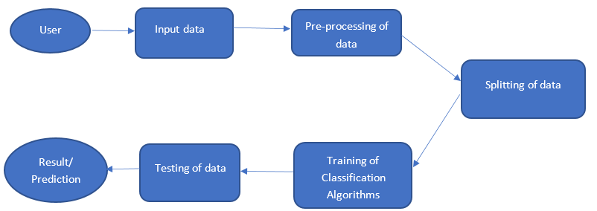
A. Data Exploration and Analysis
Data analysis is done to achieve certainty of future result to be close so that prediction is valid and correctly interpreted. This certainty can be gained only after raw data is verified and checked for abnormality thus ensuring that the data was gathered without any errors. It also helps in finding the data which contains irrelevant features for prediction model.

B. Data Pre-processing
Data pre-processing is a data mining technique that converts raw and inconsistent data into useful understandable format for the model. Raw data is inconsistent and incomplete and contains missing features along with many errors. As per data exploration and analysis we have learned that raw data for our model contains many null values which must be replaced with their mean value. We can also handle the missing values either by deleting irrelevant column or row. Feature selection is also the part of pre-processing in which we select only those features which contributes to our rainfall prediction model thus helps in reducing training time and increases accuracy of the model. Feature scaling is the final stage in pre-processing in independent variables are brought into specific range so that no any variable dominates the other variable.

C. Modelling
Initially in the proposed model, redeemed weather data is cleaned, then it is pre-processed and then arranged. Finally, rainfall data is designated into various categories as per Indian Meteorological Department guidelines. In this paper we have come up with an approach for the prediction of rainfall using Machine Learning classification algorithms. The pre-processed data is segregated into 80% training and 20% for testing. Four different Machine Learning Algorithms are applied on the portioned data and after that each result is analyzed and final accurate result is displayed. The working of the individual classifiers is explained in the proceeding section.
Modeling is the process of choosing and using appropriate mathematics and statistics to analyze empirical situations. The pre-processed data is segregated into 80% training and 20% for testing. Four different Machine Learning Algorithms are applied on the portioned data and after that each result is analyzed and final accurate result is displayed. The working of the individual classifiers is explained in the proceeding section.
- Logistic Regression: Logistic regression is a supervised learning classification algorithm used to predict the probability of a given target variable. The nature of target or dependent variable is branched, there would be only two possibility of classes 0 for failure and 1 for success.
- Random Forest: Random Forest is a supervised learning algorithm which is used for both classification as well as regression thus by creating decision trees on the data samples.
- Decision Tree: A decision tree is a type of supervised machine learning used to categorize or make predictions. This classification algorithm that works on categorical as well as numerical data is a Decision tree algorithm. This algorithm has higher accuracy in comparison to other algorithms as it analyses the dataset in the tree-like graph.
- Support Vector Machine: Support Vector Machine (SVM) is a supervised machine learning algorithm for classification and regression. It finds the best hyperplane to separate classes, using support vectors for robustness. It works well in high dimensions and can handle binary and multi-class problems. SVM can also handle non-linear data through kernel functions like polynomial and RBF kernels.
Evaluation:
1.Accuracy: It is the ratio of number of correct outputs to the total number of input samples.
2.Precision: It is the number of correct positive correct results divided by the number of positive results predicted by the classifiers.

CHAPTER 3
RESULT AND DISCUSSION

The focus of this research paper is to design a model and analyze the performance of various Machine Learning algorithms and predict the most accurate algorithm for the predicting of rainfall. This research was done using techniques of Logistic Regression, Random Forest, Decision Tree, on the dataset. For the experimental purpose we have given the actual real time values of maximum and minimum temperature, relative humidity, wind speed etc. Dataset was segregated into training and testing data and after those models were trained and the accuracy score was noted and analyzed before final prediction. A comparison of the performance of the algorithms are represented below and their accuracy scores are shown in the table.

Method | Classification Accuracy | Precision
Random Forest | 72% | 77%
Logistic Regression | 76% | 79%
Decision Tree | 68% | 78%
Support Vector | 73% | 78%
Table: Classification Accuracy and Model Precision
ADVANTAGES
- Water resources can be managed efficiently by using rainfall prediction system.
- Regions can be evacuated if flood are expected.
- It helps in taking appropriate measures to efficiently manage water resources, crop productivity and no wastage of any resources.
Output: Deployed Rainfall Prediction project in Web Browser using Flask Framework.
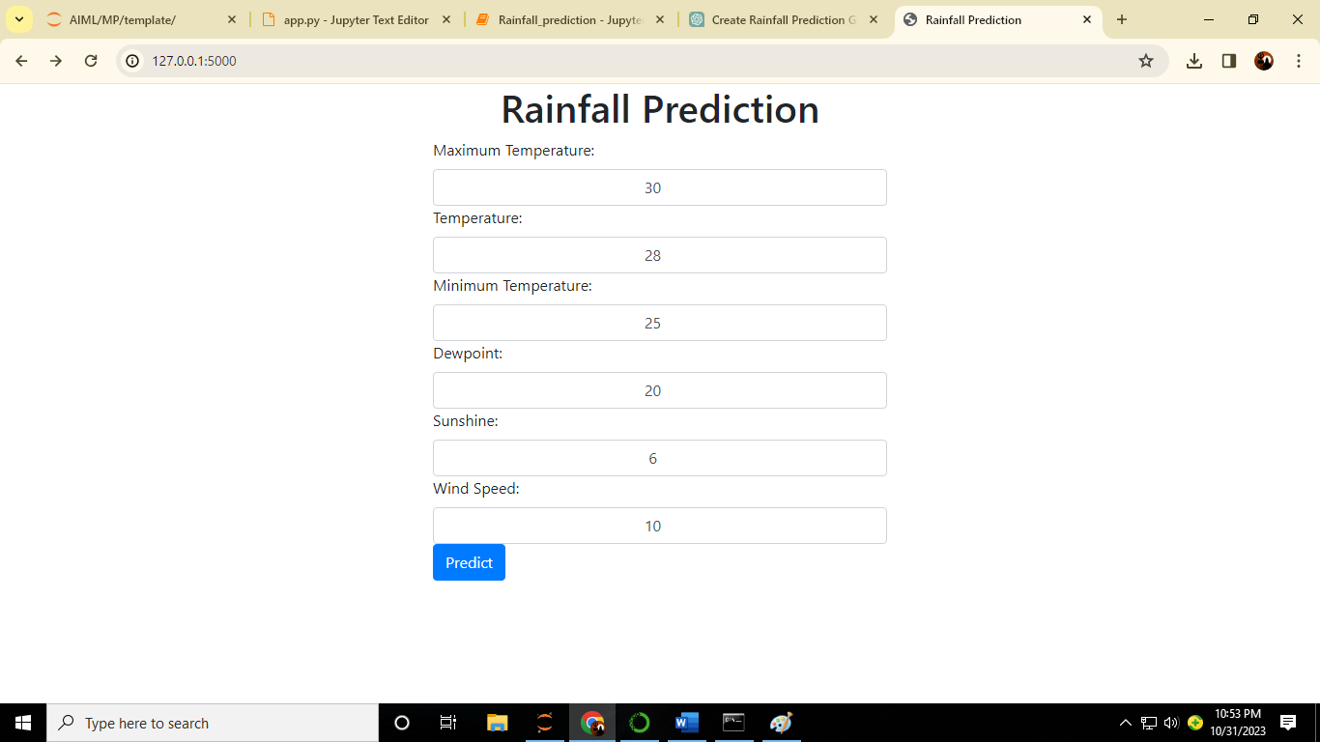


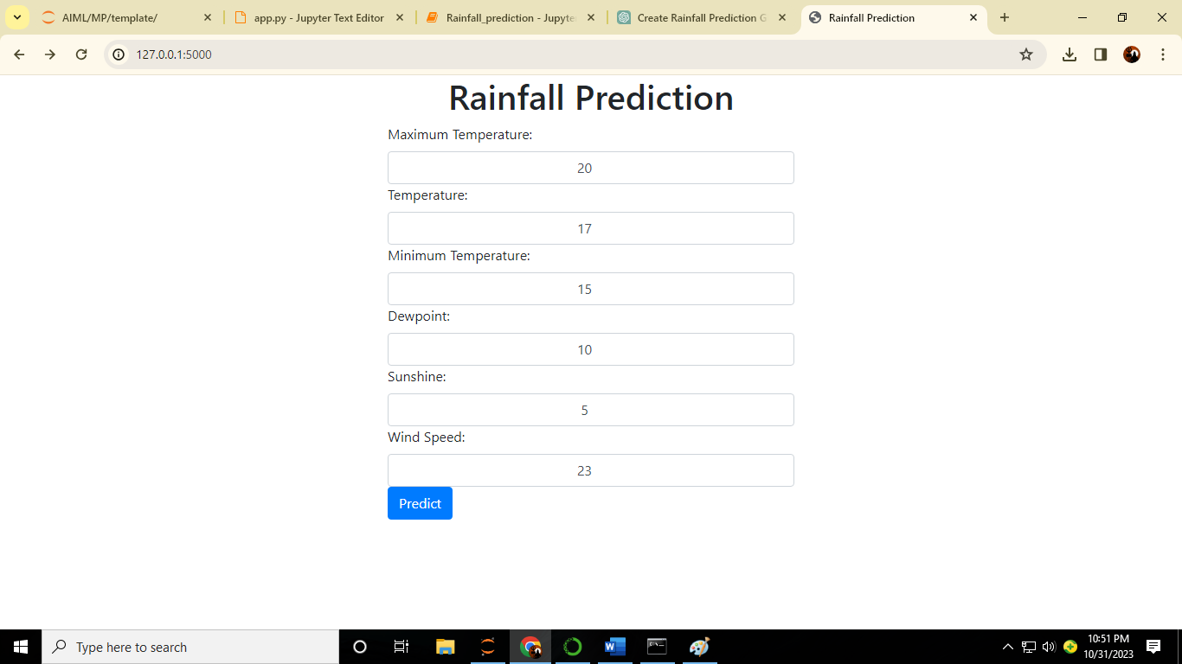


CHAPTER 4
CONCLUSION
The overall aim is to define various ML techniques that are useful in predicting rainfall. The goal of this research is to design accurate and efficient model by applying lesser number of attributes and tests. Firstly, the data is pre-processed and then it is used in the model. Logistic Regression with 76% , Random Forest classifier with approximately 72% and Support Vector Classifier with 72% are the most efficient classification algorithms. However, Decision Tree gives the least accuracy with 68%. We can further expand this research covering other ML techniques such as time series, clustering and association rules and other ensemble techniques. Taking into consideration the limitations of this study, there is a need to build more complex and combination of models to get higher accuracy for rainfall prediction system. Study can also be formulated using greater articulate monitoring for particular area and create this kind of model for enormous dataset so that calculation rate can be increased with better precision and with more accuracy.

‘

BIBLOGRAPHY
- Geeks_for_Geeks
- Chat_GPT
- Bard_AI
- International Jounal for Reasearch in Applied Science and Engg. Technology
- Flask Framework User Guidance
- GitHub

