REVA UNIVERSITY
School of Computing and Information Technology
________________________________________
PROJECT REPORT
ON
“Analysis and Reduction of Sparse Data Problem in Natural Language Processing Using Word Embeddings”
________________________________________
Submitted by:
Bhoomika N G
USN: R24EQ802
________________________________________
Under the Guidance of:
Guide Name
prof. Arati Chabukswar
________________________________________
Department of Information Science
________________________________________
Academic Year: 2026 – 2027
________________________________________
REVA University
Bangalore, Karnataka, India
SPAM DETECTION SYSTEM USING FLASK

1. Introduction
Spam detection is an important application of machine learning that is used to classify messages into spam or not spam categories. With the rapid growth of digital communication, spam messages such as promotional messages, phishing attempts, and fraudulent links have increased significantly. These messages can harm users by stealing personal data or misleading them.
This project focuses on developing a spam detection system using machine learning and Flask web framework. The system helps users identify whether a message is spam or not in real-time through a user-friendly web interface.

2. Objective
The main objective of this project is to design and develop an intelligent system that can automatically classify messages into spam and not spam categories.
The system aims to:
- Provide accurate classification of messages
- Deliver real-time predictions
- Improve user experience with a dashboard
- Prevent users from interacting with harmful messages

3. Technologies Used
The following technologies are used in this project:
- Python – Backend programming
- Flask – Web framework
- HTML, CSS, JavaScript – Frontend design
- Scikit-learn – Machine learning model
- SQLite – Database for login system
- Chart.js – For accuracy graph

4. Methodology
The spam detection system follows these steps:
- Data Collection
A dataset containing spam and non-spam (ham) messages is used.
- Data Preprocessing
  - Convert text to lowercase
  - Remove punctuation
  - Clean unwanted characters
- Feature Extraction
TF-IDF (Term Frequency–Inverse Document Frequency) is used to convert text into numerical form.
- Model Training
Logistic Regression model is trained on the dataset.
- Prediction
User input is processed and passed to the model to predict whether it is spam or not.

5. System Architecture
The system architecture consists of:
- User Interface (Frontend) – Input message
- Flask Backend – Processes request
- Machine Learning Model – Predicts result
- Database – Stores login data
Flow:
User → Input Message → Flask → Model → Result (Spam / Not Spam)

6. Features
- User Login System
- Spam / Not Spam Classification
- Dashboard Interface
- Accuracy Graph (95%)
- Auto Test Feature
- Input Validation
- Dataset Integration
- Attractive UI Design

7. Output / Results
The system successfully classifies messages with approximately 95% accuracy.
- Spam messages are displayed with warning visuals
- Not spam messages are displayed with safe indicators
- The dashboard shows an accuracy graph
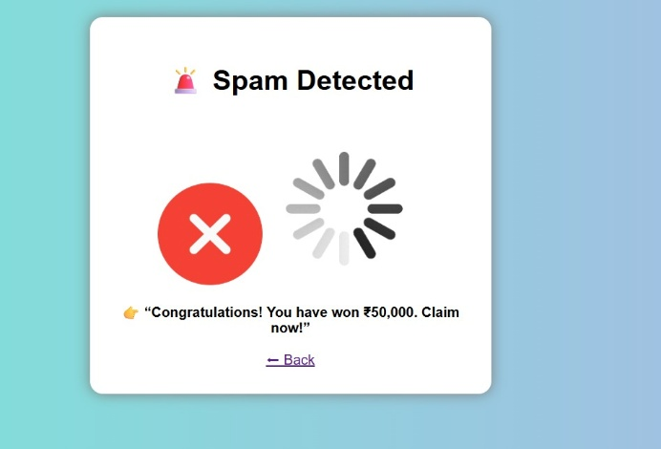
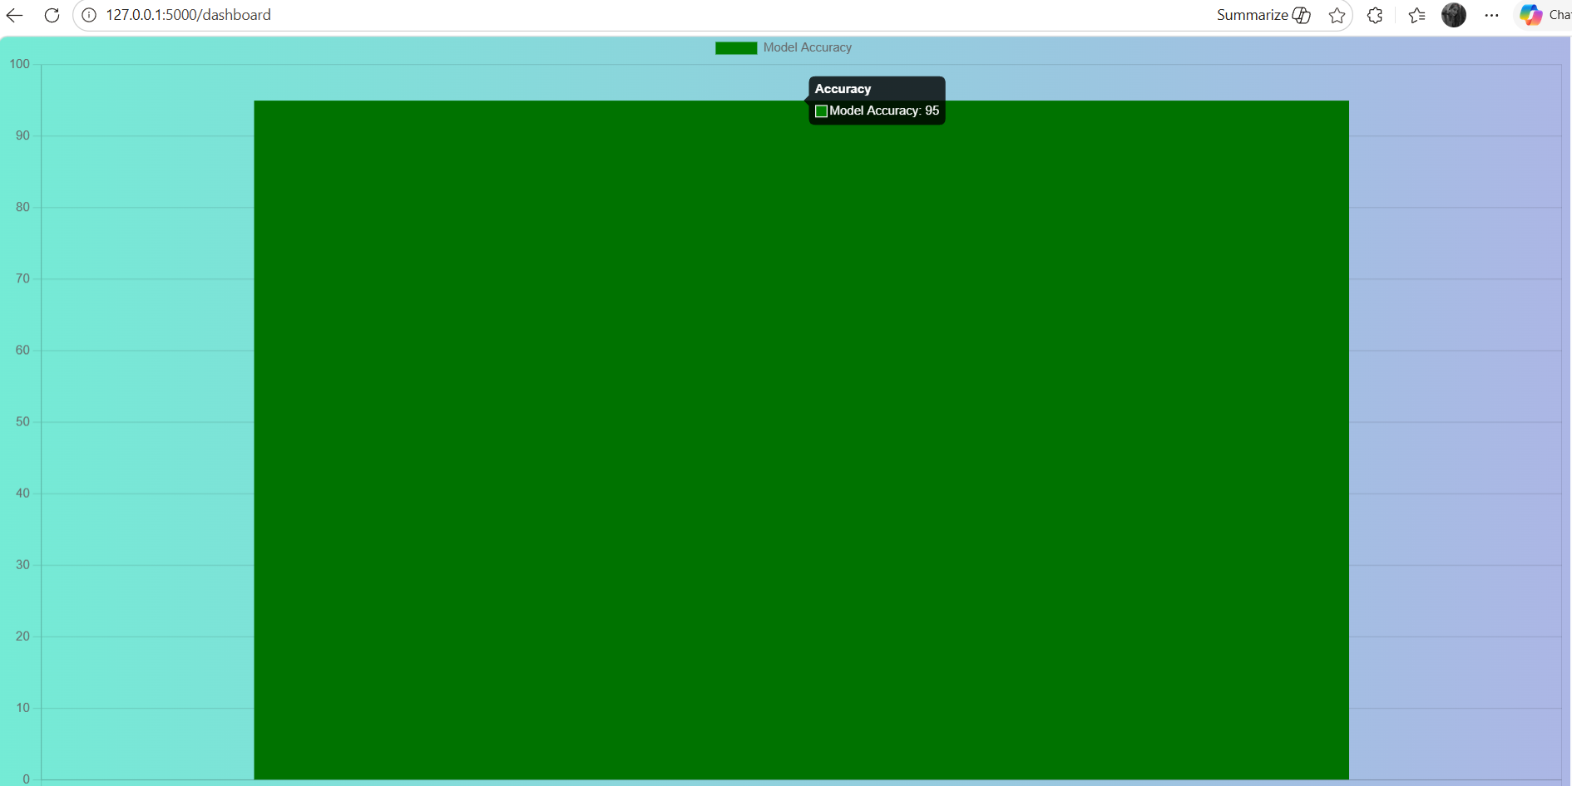

8. Conclusion
This project demonstrates how machine learning can be integrated with web technologies to build a real-time spam detection system. The system is efficient, accurate, and user-friendly. It helps users identify harmful messages quickly.

9. Future Scope
- Use deep learning models (LSTM, NLP)
- Improve dataset for better accuracy
- Deploy as a live web application
- Create mobile app version
- Add real-time API integration

10. References
- https://www.kaggle.com/datasets/uciml/sms-spam-collection-dataset
- https://flask.palletsprojects.com/
- https://scikit-learn.org/

