LINEAR REGRESSION
Concept of linear relationship between input and output

If there is a relationship exist between input and output .It means if there is any change in input then automatically output changes and this relationship represented by a straight line the model aims to find the best fit line that minimizes the differnce between actual values and predicted values.bestfit line nothing but finding the line which is best represents the data.

Example:predicting exam scores based on study hours.

Equation of a line, cost function, mean squared error :

Equation of line in linear regression is y=mx+c
Here x is the input variable m is the slope and c is constant y is the traget/output variable.

Cost function:The cost function tells how wrong our model is how far our predictions are from the actual values.
We commonly used cost function is:
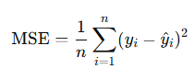

Here y is the actual value,y cap is the predicted value and n is the no of datapoints.

Gradient descent optimization for regression
It is an optimization algorithm used to minimize the cost function.it helps us to find the best values for weights w and bias b to get accurate predictions In y=wx+b .
first it randomly assigns and then caluculate the loss and update the weights until the loss is very small.

Interpretation of coefficients and intercept:

Interpretation is nothing but what it means?
Coeffecient:How much does the output changes when input increases by 1 nothing but it expresses the relation between an input variable and output variable.

Intercept: What is the output when all input variables are 1

Subtasks :
Manually implement linear regression using numpy

import numpy as np
import matplotlib.pyplot as plt

x = np.array([1, 2, 3, 4, 5])
y = np.array([2, 4, 6, 8, 10])

w = 0.0
b = 0.0
learning_rate = 0.01
epochs = 1000
n = len(x)
for i in range(epochs):
y_pred = w * x + b
error = y - y_pred

# Gradients
dw = (-2/n) * np.sum(x * error)
db = (-2/n) * np.sum(error)

# Update parameters
w -= learning_rate * dw
b -= learning_rate * db
# Optionally print every 100 steps
if i % 100 == 0:
mse = np.mean(error ** 2)
print(f"Epoch {i}: w = {w:.4f}, b = {b:.4f}, MSE = {mse:.4f}")
# 5. Final model
print("\nFinal model: y = {:.2f}x + {:.2f}".format(w, b))
# 6. Plot
plt.scatter(x, y, color='red', label='Actual')
plt.plot(x, w * x + b, label='Predicted line')
plt.legend()
plt.xlabel("x")
plt.ylabel("y")
plt.title("Manual Linear Regression")
plt.grid(True)
plt.show()

OUTPUT
Epoch 0: w = 0.4400, b = 0.1200, MSE = 44.0000
Epoch 100: w = 1.8988, b = 0.3655, MSE = 0.0245
Epoch 200: w = 1.9279, b = 0.2605, MSE = 0.0124
Epoch 300: w = 1.9486, b = 0.1856, MSE = 0.0063
Epoch 400: w = 1.9634, b = 0.1323, MSE = 0.0032
Epoch 500: w = 1.9739, b = 0.0943, MSE = 0.0016
Epoch 600: w = 1.9814, b = 0.0672, MSE = 0.0008
Epoch 700: w = 1.9867, b = 0.0479, MSE = 0.0004
Epoch 800: w = 1.9905, b = 0.0341, MSE = 0.0002
Epoch 900: w = 1.9933, b = 0.0243, MSE = 0.0001
Final model: y = 2.00x + 0.02

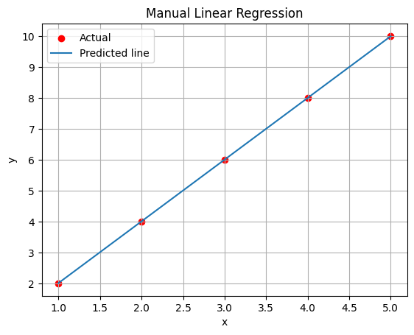
Train using sklearn’s LinearRegression :

import numpy as np
import matplotlib.pyplot as plt
from sklearn.linear_model import LinearRegression

# 1. Create data (simple linear relation y = 2x + 1)
x = np.array([1, 2, 3, 4, 5]).reshape(-1, 1) # 2D array for sklearn
y = np.array([3, 5, 7, 9, 11]) # Actual output

# 2. Create and train the model
model = LinearRegression()
model.fit(x, y)

# 3. Get the parameters
w = model.coef_[0] # slope
b = model.intercept_ # intercept

print(f"Learned model: y = {w:.2f}x + {b:.2f}")
# 4. Predict using the model
y_pred = model.predict(x)
# 5. Plot the data and regression line
plt.scatter(x, y, color='red', label='Actual Data')
plt.plot(x, y_pred, color='blue', label='Regression Line')
plt.xlabel('x')
plt.ylabel('y')
plt.title('Linear Regression using scikit-learn')
plt.legend()
plt.grid(True)
plt.show()

Visualize line fit and residuals :
import numpy as np
import matplotlib.pyplot as plt
from sklearn.linear_model import LinearRegression

# 1. Create data
x = np.array([1, 2, 3, 4, 5]).reshape(-1, 1)
y = np.array([3, 5, 7, 10, 11]) # Slightly noisy data (not perfect)

# 2. Train model
model = LinearRegression()
model.fit(x, y)
y_pred = model.predict(x)

# 3. Plot data and regression line
plt.figure(figsize=(10, 6))
plt.scatter(x, y, color='red', label='Actual data')
plt.plot(x, y_pred, color='blue', label='Regression Line')

# 4. Plot residuals (vertical lines from actual points to the line)
for i in range(len(x)):
plt.vlines(x[i], y[i], y_pred[i], color='gray', linestyle='dashed')

# 5. Labels and title
plt.xlabel('x')
plt.ylabel('y')
plt.title('Linear Regression with Residuals')
plt.legend()
plt.grid(True)
plt.show()
residuals = y - y_pred
for i, r in enumerate(residuals):
print(f"Point {i+1}: Residual = {r:.2f}")

OUTPUT:
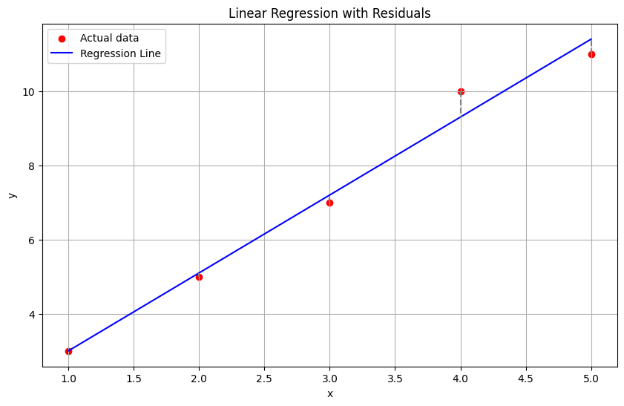
Point 1: Residual = 0.00
Point 2: Residual = -0.10
Point 3: Residual = -0.20
Point 4: Residual = 0.70
Point 5: Residual = -0.40

Logistic Regression
Logistic regression is mainly used for classification problems.mainly used for binary classification problems where the output is possible for one of two categories like yes/no etc.It uses sigmoid function to convert inputs into probability value between 0 and 1.

Logistic function and sigmoid output
Logistic function is also known as sigmoid function it takes any real number as input and outputs a value between 0 and 1.In logistic regression the sigmoid function acts like a link function it takes output of linear model and transforms into a probability.

Binary classification usecases
In Binaryclassification output will be one of two categories .

- Spam Detection
- >No
- >Yes
- Fraud Detection
- >fraudulent
- >legitimate
- Loan approval
- >Not Approved
- >Approved
- Face Recognition
- >Un Authorized
- >Authorized
- Student admission
- >Rejected
- >Admitted

Cross Entropy Loss
Cross Entropy loss is a mteric used to measure the performance of a classification model.so it measures difference between predicted probabilty and true probability.

Decision Boundary
A decision boundary is a line or surface that divides different groups in a classification task.It decides which data point belong which category.

Build logistic regression using sklearn

import pandas as pd
from sklearn.model_selection import train_test_split
from sklearn.linear_model import LogisticRegression
from sklearn.metrics import accuracy_score, confusion_matrix, classification_report

from sklearn.datasets import load_diabetes

df = pd.read_csv("/content/diabetes.csv")
print(df.columns)
X = df.drop("Outcome", axis=1)
y = df["Outcome"]
X_train, X_test, y_train, y_test = train_test_split(X, y, test_size=0.2, random_state=42)

model = LogisticRegression(max_iter=1000)
model.fit(X_train, y_train)

y_pred = model.predict(X_test)
y_prob = model.predict_proba(X_test)[:, 1]

print("Accuracy:", accuracy_score(y_test, y_pred))
print("Confusion Matrix:\n", confusion_matrix(y_test, y_pred))
print("Classification Report:\n", classification_report(y_test, y_pred))

# Optional: Show some predicted probabilities
for i in range(5):
print(f"Predicted prob = {y_prob[i]:.2f}, Actual = {y_test.iloc[i]}")

Index(['Pregnancies', 'Glucose', 'BloodPressure', 'SkinThickness', 'Insulin',
'BMI', 'DiabetesPedigreeFunction', 'Age', 'Outcome'],
dtype='object')
Accuracy: 0.7467532467532467
Confusion Matrix:
[[78 21]
[18 37]]
Classification Report:
precision recall f1-score support

0 0.81 0.79 0.80 99
1 0.64 0.67 0.65 55

accuracy 0.75 154
macro avg 0.73 0.73 0.73 154
weighted avg 0.75 0.75 0.75 154

Predicted prob = 0.28, Actual = 0
Predicted prob = 0.19, Actual = 0
Predicted prob = 0.11, Actual = 0
Predicted prob = 0.16, Actual = 0
Predicted prob = 0.47, Actual = 0
Visualize sigmoid and decision threshold
import numpy as np
import matplotlib.pyplot as plt

z = np.linspace(-10, 10, 200)
sigmoid = 1 / (1 + np.exp(-z))

plt.figure(figsize=(8, 5))
plt.plot(z, sigmoid, label="Sigmoid Function", color='blue')

plt.axhline(0.5, color='red', linestyle='--', label='Decision Threshold = 0.5')
plt.axvline(0, color='green', linestyle='--', label='z = 0 (Boundary)')

plt.title("Sigmoid Function and Decision Threshold")
plt.xlabel("z = wᵀx + b")
plt.ylabel("Predicted Probability")
plt.legend()
plt.grid(True)
plt.show()
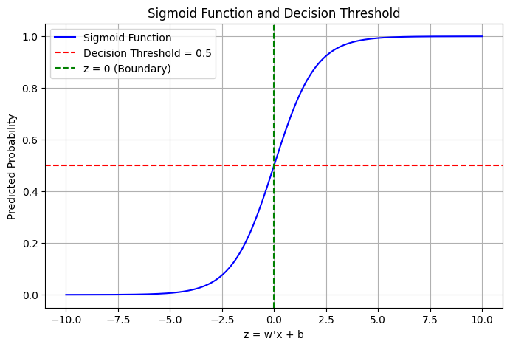

Confusion Matrix
It is used evaluate the performance of a binary classifier by comparing actual vs predicted classes.

Support Vector Machines SVM
It is supervised machine learning algorithm mainly used classification and regression tasks.It tries to find the best boundary (hyperplane) that seperates the different classes in data.

Margin:The distance between hyperplane and nearest datapoints(support vectors) of each class.
Support vectors: The datapoints closest to hyperplane,which are crucial for margin and decision boundary.
Hyperplane:A decision boundary that seprates datapoints into different classes.

Linear vs nonlinear SVM

Linear SVM: When the data is linearly seperable nothing but it can be seperated by straight line.

Non Linear SVM: When the data is not linearly seperable,so it uses a kernal trick to map data to higher dimensional space where it becomes linearly seperable.

Kernal Trick
The Kernal Trick is used to enable linear models to classify non linear data by transforming data into higher dimensional data.
It Works by caluculating the dot product of data points in the higher dimensional space using the kernal function.

Types:
Linear Kernal:No mapping is required it used for linearly seperable data
It is used in text classification,sentiment analysis.
Polynomial Kernal:It useful for non linearly seperable data it is used in image recognition where the features are non linear.

RBF(Radial Basis Function): It maps data into infinate dimensional space making it highly effective for complex classifucation problems.
It measures similarity between two data points in infinate dimensional space.it is used in face recognition,hand written digit recognition.

Use sklearn to train linear and RBF SVM
import numpy as np
import matplotlib.pyplot as plt
from sklearn.svm import SVC
from sklearn.datasets import make_classification, make_circles
from sklearn.model_selection import train_test_split
from sklearn.metrics import accuracy_score
# Linearly separable data
X1, y1 = make_classification(n_samples=100, n_features=2, n_redundant=0,
n_informative=2, n_clusters_per_class=1, random_state=42)
X1_train, X1_test, y1_train, y1_test = train_test_split(X1, y1, test_size=0.2, random_state=42)
# Circular (non-linear) data
X2, y2 = make_circles(n_samples=200, factor=0.5, noise=0.1, random_state=42)
X2_train, X2_test, y2_train, y2_test = train_test_split(X2, y2, test_size=0.2, random_state=42)
# Train Linear SVM on linear data
linear_svm = SVC(kernel='linear', C=1)
linear_svm.fit(X1_train, y1_train)

# Train RBF SVM on circular data
rbf_svm = SVC(kernel='rbf', C=1, gamma=1)
rbf_svm.fit(X2_train, y2_train)
print("Linear SVM Accuracy:", accuracy_score(y1_test, linear_svm.predict(X1_test)))
print("RBF SVM Accuracy:", accuracy_score(y2_test, rbf_svm.predict(X2_test)))
def plot_decision_boundary(model, X, y, title):
h = 0.02
x_min, x_max = X[:, 0].min() - 1, X[:, 0].max() + 1
y_min, y_max = X[:, 1].min() - 1, X[:, 1].max() + 1
xx, yy = np.meshgrid(np.arange(x_min, x_max, h),
np.arange(y_min, y_max, h))

Z = model.predict(np.c_[xx.ravel(), yy.ravel()])
Z = Z.reshape(xx.shape)

plt.contourf(xx, yy, Z, cmap='coolwarm', alpha=0.8)
plt.scatter(X[:, 0], X[:, 1], c=y, cmap='coolwarm', edgecolors='k')
plt.title(title)
plt.show()

# Plot both
plot_decision_boundary(linear_svm, X1, y1, "Linear SVM on Linearly Separable Data")
plot_decision_boundary(rbf_svm, X2, y2, "RBF SVM on Non-Linear Circular Data")

Linear SVM Accuracy: 1.0
RBF SVM Accuracy: 1.0
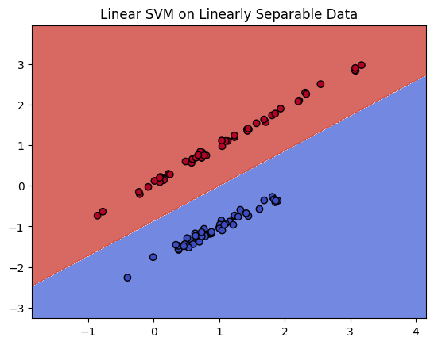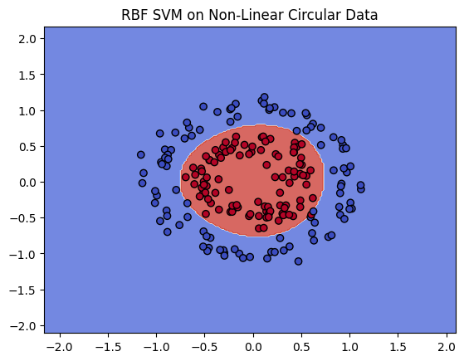
Plot decision boundaries on 2D data
import numpy as np
import matplotlib.pyplot as plt
from sklearn.datasets import make_classification
from sklearn.svm import SVC

# 1. Generate 2D data (linearly separable for simplicity)
X, y = make_classification(n_samples=100, n_features=2,
n_redundant=0, n_informative=2,
n_clusters_per_class=1, random_state=42)

# 2. Train SVM (you can switch between 'linear' and 'rbf')
model = SVC(kernel='rbf', C=1, gamma=0.5)
model.fit(X, y)

# 3. Create mesh grid for plotting
x_min, x_max = X[:, 0].min() - 1, X[:, 0].max() + 1
y_min, y_max = X[:, 1].min() - 1, X[:, 1].max() + 1
xx, yy = np.meshgrid(np.linspace(x_min, x_max, 500),
np.linspace(y_min, y_max, 500))

# 4. Predict on mesh grid
Z = model.predict(np.c_[xx.ravel(), yy.ravel()])
Z = Z.reshape(xx.shape)

# 5. Plot decision boundary
plt.figure(figsize=(8, 6))
plt.contourf(xx, yy, Z, alpha=0.3, cmap='coolwarm')
plt.scatter(X[:, 0], X[:, 1], c=y, cmap='coolwarm', edgecolors='k')
plt.title("Decision Boundary with SVM")
plt.xlabel("Feature 1")
plt.ylabel("Feature 2")
plt.grid(True)
plt.show()

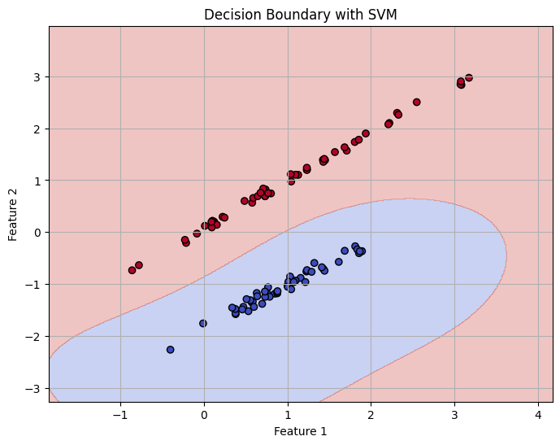

Experiment with kernel and C parameter
import numpy as np
import matplotlib.pyplot as plt
from sklearn.datasets import make_classification
from sklearn.svm import SVC

# Generate simple 2D dataset
X, y = make_classification(n_samples=100, n_features=2, n_redundant=0,
n_informative=2, n_clusters_per_class=1, random_state=42)

# Kernels and C values to try
kernels = ['linear', 'rbf', 'poly']
C_values = [0.1, 1, 100]

# Create subplots
fig, axes = plt.subplots(len(kernels), len(C_values), figsize=(15, 9))
plt.subplots_adjust(hspace=0.4, wspace=0.3)

# Loop through kernels and C values
for i, kernel in enumerate(kernels):
for j, C in enumerate(C_values):
model = SVC(kernel=kernel, C=C, gamma='scale', degree=3) # degree is for poly
model.fit(X, y)

# Create meshgrid
x_min, x_max = X[:, 0].min() - 1, X[:, 0].max() + 1
y_min, y_max = X[:, 1].min() - 1, X[:, 1].max() + 1
xx, yy = np.meshgrid(np.linspace(x_min, x_max, 300),
np.linspace(y_min, y_max, 300))
Z = model.predict(np.c_[xx.ravel(), yy.ravel()])
Z = Z.reshape(xx.shape)

# Plot
ax = axes[i][j]
ax.contourf(xx, yy, Z, cmap='coolwarm', alpha=0.3)
ax.scatter(X[:, 0], X[:, 1], c=y, cmap='coolwarm', edgecolors='k')
ax.set_title(f'Kernel: {kernel}, C: {C}')
ax.set_xticks([]); ax.set_yticks([])

plt.suptitle("SVM Decision Boundaries - Varying Kernel and C", fontsize=16)
plt.show()

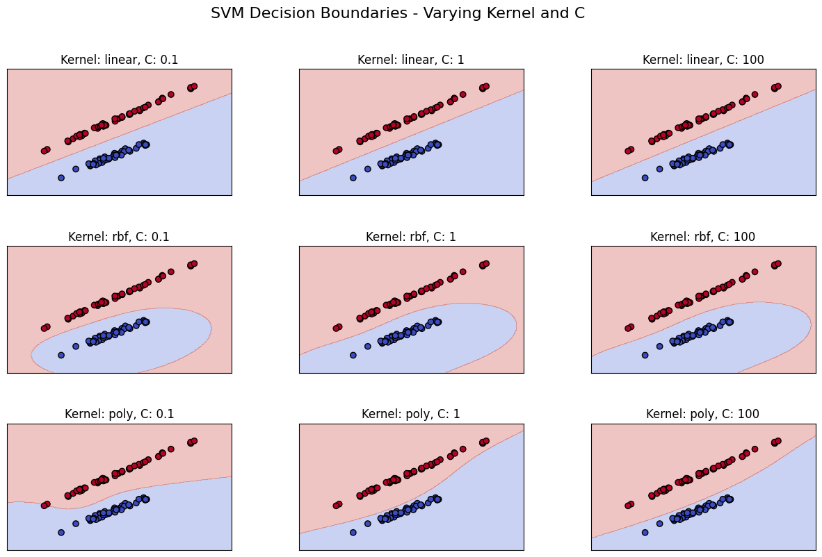

Decision Trees
A decision tree is supervised learning algorithm used for classification and regression tasks it works by splitting the data into branches like a tree based on feature values to make a decision or prediction.

Structure of decision tree:
Root Node:Starting point of the tree,represents the first/Intial decision.
Internal Node:It represent the further decisions based on input features.
Leaf Node:It was the terminal nodes represents the final prediction or classification.
Branches:It represents possible outcomes of the decisions.

Overfitting in trees:
- Overfitting happens when decision tree grows too deep
- Captures noise or small fluctuations in training data
- Performs well on training data
- Performs poor on test data

Pruning:This is the process to remove uneccesary nodes,improve generalization ,prevent overfitting

Decision trees are interpretable due to their simple and heirarichical structure

Build and visualize a decision tree
import pandas as pd
import matplotlib.pyplot as plt
from sklearn.datasets import load_iris
from sklearn.tree import DecisionTreeClassifier, plot_tree
iris = load_iris()
X = iris.data
y = iris.target
feature_names = iris.feature_names
class_names = iris.target_names
model = DecisionTreeClassifier(max_depth=3, random_state=42)
model.fit(X, y)
plt.figure(figsize=(12, 8))
plot_tree(model,
feature_names=feature_names,
class_names=class_names,
filled=True,
rounded=True)
plt.title("Decision Tree on Iris Dataset")
plt.show()

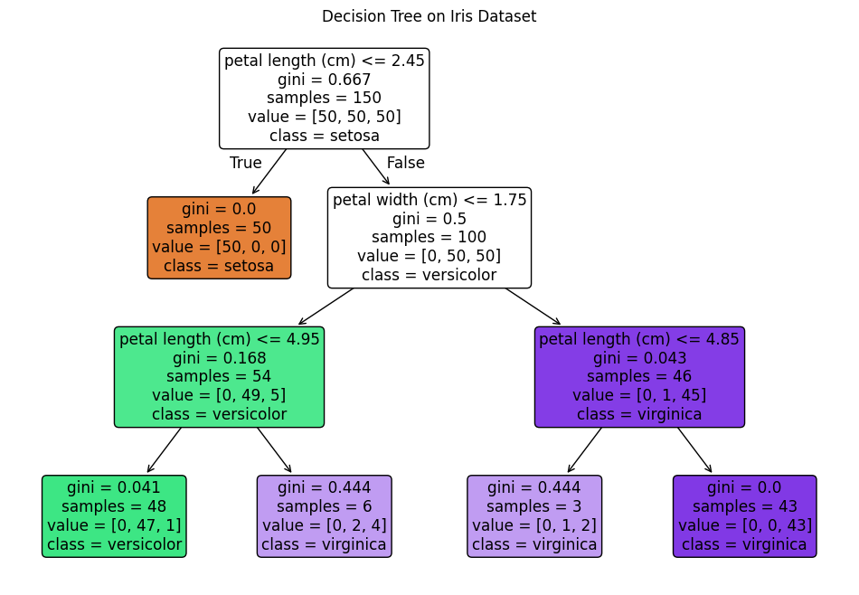
Analyze tree depth and leaf nodes

Tree depth:It means no of levels from root to leaf node
Leaf node:Leaf node is the terminal node to end the tree
from sklearn.datasets import load_iris
from sklearn.tree import DecisionTreeClassifier

# Load data
iris = load_iris()
X, y = iris.data, iris.target

# Train tree
model = DecisionTreeClassifier(max_depth=4, random_state=42)
model.fit(X, y)

# Analyze
depth = model.get_depth()
leaves = model.get_n_leaves()

print("Tree Depth:", depth)
print("Number of Leaf Nodes:", leaves)

Tree Depth: 4
Number of Leaf Nodes: 8

Use feature importance from the tree

import pandas as pd
import matplotlib.pyplot as plt
from sklearn.datasets import load_iris
from sklearn.tree import DecisionTreeClassifier

# Load data
iris = load_iris()
X = iris.data
y = iris.target
feature_names = iris.feature_names

# Train model
model = DecisionTreeClassifier(max_depth=3, random_state=42)
model.fit(X, y)

# Get feature importances
importances = model.feature_importances_

# Create a DataFrame for visualization
fi_df = pd.DataFrame({
'Feature': feature_names,
'Importance': importances
}).sort_values(by='Importance', ascending=True)
plt.figure(figsize=(8, 5))
plt.barh(fi_df['Feature'], fi_df['Importance'], color='forestgreen')
plt.xlabel("Importance Score")
plt.title("Feature Importances from Decision Tree")
plt.grid(True, axis='x', linestyle='--', alpha=0.6)
plt.show()

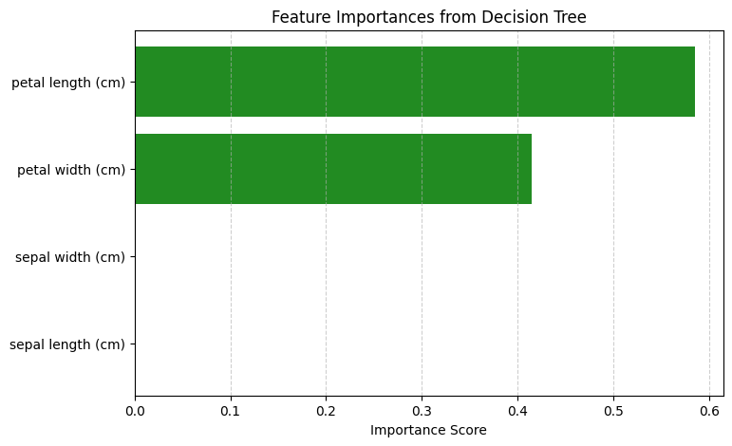

Random Forests
Random forest is an ensemble of many decision trees.combined to make accurate and stable predictions.It works by creating many decision trees and combining their outputs.For classification based on majority vote and for regression based on average.

Ensemble of decision trees
An Ensemble is group of models that work together to make better predictions than individual models.So it is more accurate than one tree , handles missing/noise data and works for both classification and regression.

Bagging and bootstrap sampling
Bagging:Bagging is machine learning ensemble technique aimed to improve accuracy.It involves in generating multiple subsets of training data using random sampling with replacement.finally aggregating their predictions/outputs if it is a classification applies majority voting if it is regression average is done.

Bootstrap Sampling:Bootstraping is machine learning ensemble technique aimed to improve the accuracy.It combines multiple weak learns into a single strong learner.Here weak learner correct their mistakes based on predecessor gradually enhaces models performances.

Feature importance and OOB score
Feature Importance:It Indicates how much each input feature contribute to models prediction accuracy.
OOB Score:OOB score is used to evaluate the performance of machine learning model specially like random forest.it is caluculated using the samples that are not used in training of the model called out of bag samples(un seen data)

Reducing overfitting with randomness :
You can reduce overfitting with randomness by averaging.if tree 1 was overfitted in one way and tree2 overfitted in anotherway by averaging the trees overfitting can be reduced.
max_features='sqrt', using this we can reduce overfitting selecting sqrt of no of features.

Train a Random Forest and compare with single tree

from sklearn.datasets import load_iris
from sklearn.tree import DecisionTreeClassifier
from sklearn.ensemble import RandomForestClassifier
from sklearn.model_selection import train_test_split
from sklearn.metrics import accuracy_score, classification_report

# Load dataset
iris = load_iris()
X = iris.data
y = iris.target

# Split into train/test sets
X_train, X_test, y_train, y_test = train_test_split(X, y, test_size=0.3, random_state=42)

# 1️⃣ Train a Single Decision Tree
tree = DecisionTreeClassifier(random_state=42)
tree.fit(X_train, y_train)
y_pred_tree = tree.predict(X_test)
acc_tree = accuracy_score(y_test, y_pred_tree)

# 2️⃣ Train a Random Forest
forest = RandomForestClassifier(n_estimators=100, max_features='sqrt', random_state=42)
forest.fit(X_train, y_train)
y_pred_forest = forest.predict(X_test)
acc_forest = accuracy_score(y_test, y_pred_forest)
print("Single Decision Tree Accuracy:", acc_tree)
print(" Random Forest Accuracy:", acc_forest)

Single Decision Tree Accuracy: 1.0
Random Forest Accuracy: 1.0

Extract feature importances:
from sklearn.ensemble import RandomForestClassifier
from sklearn.datasets import load_iris
import pandas as pd
import matplotlib.pyplot as plt

# Load dataset
iris = load_iris()
X, y = iris.data, iris.target
feature_names = iris.feature_names

# Train a Random Forest
model = RandomForestClassifier(n_estimators=100, random_state=42)
model.fit(X, y)

# Get feature importances
importances = model.feature_importances_

# Put into a DataFrame for easy plotting
fi_df = pd.DataFrame({
'Feature': feature_names,
'Importance': importances
}).sort_values(by="Importance", ascending=True)
plt.figure(figsize=(8, 5))
plt.barh(fi_df['Feature'], fi_df['Importance'], color='teal')
plt.title("Feature Importances from Random Forest")
plt.xlabel("Importance Score")
plt.grid(True, axis='x', linestyle='--', alpha=0.6)
plt.show()

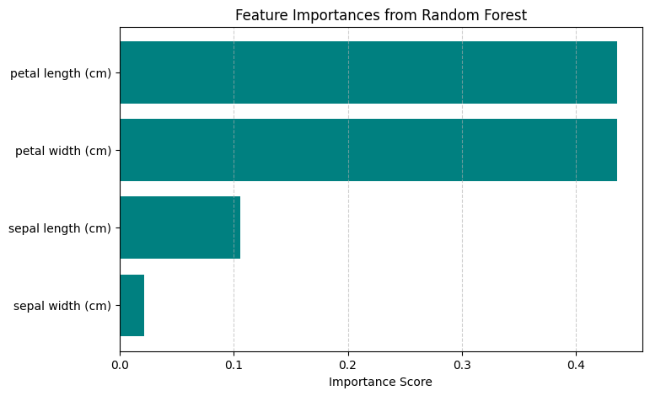

K-Nearest Neighbors KNN

It is a machine learning algorithm used for both classificaton and reggression tasks.it works by finding k nearest neighbours to new or unseen data point. For classification is assigna data point which is most frequent among k neighbours.for regression it predicts the new value for data point by averging the values of k neighbours.

K is the most important parameter a small k can overfit large k can underfit.distance is caluculated using metrics like euclidean,manhattan.

Normalization and scaling requirement :
Feature scaling nothing but ensuring all features contribute equally to the model.
- Normalization(min max scaling):
It scales all feature values to a fixed range.
- Standarization(Z score scaling):
It transforms features to have mean=0 and standard deviation=1

Implement KNN from scratch
import numpy as np
from collections import Counter

# Step 1: Define Euclidean Distance
def euclidean_distance(x1, x2):
return np.sqrt(np.sum((x1 - x2) ** 2))

# Step 2: Create KNN Class
class KNN:
def __init__(self, k=3):
self.k = k

def fit(self, X, y):
self.X_train = X
self.y_train = y

def predict(self, X):
predictions = [self._predict(x) for x in X]
return np.array(predictions)

def _predict(self, x):
# Compute distances to all training points
distances = [euclidean_distance(x, x_train) for x_train in self.X_train]

# Get the k nearest points
k_indices = np.argsort(distances)[:self.k]
k_nearest_labels = [self.y_train[i] for i in k_indices]

# Majority vote
most_common = Counter(k_nearest_labels).most_common(1)
return most_common[0][0]

def score(self, X, y):
y_pred = self.predict(X)
return np.mean(y_pred == y)

