UNSUPERVISED LEARNING

KMEANS
WHAT IS KMEANS?
It is an unsupervised learning algorithm used to group data into k clusters based on similarity

HOW WILL IT WORK?
First choose no of clusters.randomly intialize k centroid assign each data point to nearest centroid and update the centroid by computing mean of all points.

WHEN WILL YOU USE?
- When you have unlabelled data and need natural groupings.
- When you want to reduce complexity
- Suppose if you want to divide customers in 3 segements based on purchasing behaviour.

WHERE WILL YOU USE?

- Ecommerce-cluster similar products based on price,category.
- Music--grouping listeners based on similar taste
- Healthcare--group patients

REAL WORLD SCENERIOS

- Ecommerce websites--group customers based on behaviour like age,income,purchase frequency

- Edtech platforms--like byjus,coursera group students based on study hours,attendence,marks

PRACTICAL TASK
import pandas as pd
import matplotlib.pyplot as plt
from sklearn.preprocessing import StandardScaler
from sklearn.cluster import KMeans

df = pd.read_csv("/content/Mall_Customers (2).csv")

# Step 3: Select features
X = df[['Annual Income (k$)', 'Spending Score (1-100)']]

# Step 4: Feature scaling
scaler = StandardScaler()
X_scaled = scaler.fit_transform(X)

# Step 5: Apply KMeans
kmeans = KMeans(n_clusters=5, random_state=0)
kmeans.fit(X_scaled)

# Add the cluster labels to the original data
df['Cluster'] = kmeans.labels_

# Step 6: Visualize the clusters
plt.figure(figsize=(8, 5))
plt.scatter(df['Annual Income (k$)'], df['Spending Score (1-100)'],
c=df['Cluster'], cmap='rainbow', s=100)
plt.xlabel('Annual Income (k$)')
plt.ylabel('Spending Score (1–100)')
plt.title('Mall Customer Segments using K-Means')
plt.grid(True)
plt.show()
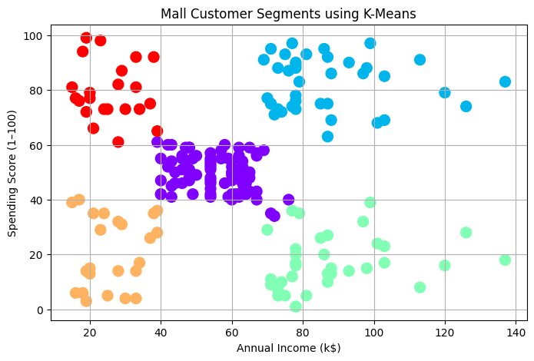

HEIRARCHICAL CLUSTERING
WHAT IT IS?
It builds a heirarchy of clusters nothing but tree structure if you don’t know how many number of clusters you can use heirarchical clustering.

HOW IT WORKS?

Actually there are two types of heirarchical clusterings
- Agglomerative--starts each point as a cluster and then merges with the closest one it merges until all the points belong same cluster.
- Divisive--start with one cluster and splits recursively.

WHEN WILL YOU USE?
- When you don’t know how many clusters you need
- When you want see cluster relationships as tree
- When you working with small-medium datsets

REAL WORLD

- Spotify--group users by listening behaviour.
- Myntra--group clothing products by style,cloth.

DBSCAN CLUSTERING

WHAT IT IS?
It is an unsupervised algorithm used for clustering datapoints into groups based denisty.here high density and low density areas are seperated.It is used when you don’t want to specify how many no of clusters .It effectively ientifies and noise.

HOW IT WORKS?
First it will start as a unvisited point and caluculates the distance using eps(it is used check the distance of neighbourhood points).if the cluster has greater the min_samples mark it as a core point and form a cluster and then moves to other.

WHEN TO USE?

- when you don’t know how many no of clusters
- When there is noise or outliers
- When there is different cluster sizes

REAL WORLD SCENERIOS

- UBER,OLA--identify pickup spots in a city
- Police departments--Analyze crime reports
- Astronomy--Identify clusters of stars,galaxies

PRACTICAL TASK

import numpy as np
import pandas as pd
import matplotlib.pyplot as plt
from sklearn.cluster import DBSCAN
from geopy.distance import great_circle
from sklearn.preprocessing import StandardScaler

np.random.seed(0)
pickup_points = np.concatenate([
np.random.normal(loc=[37.7749, -122.4194], scale=0.001, size=(50, 2)), # Downtown SF
np.random.normal(loc=[37.8044, -122.2711], scale=0.001, size=(50, 2)), # Oakland
np.random.normal(loc=[37.6213, -122.3790], scale=0.001, size=(30, 2)), # SFO Airport
np.random.uniform(low=[37.6, -122.5], high=[37.9, -122.2], size=(10, 2)) # Random noise
])

df = pd.DataFrame(pickup_points, columns=['lat', 'lon'])
scaler = StandardScaler()
coords_scaled = scaler.fit_transform(df[['lat', 'lon']])
db = DBSCAN(eps=0.3, min_samples=5
labels = db.fit_predict(coords_scaled)
df['cluster'] = labels
plt.figure(figsize=(10, 6))
for label in set(labels):
cluster_data = df[df['cluster'] == label]
plt.scatter(cluster_data['lon'], cluster_data['lat'], label=f"Cluster {label}", s=30)
plt.title("DBSCAN Clustering of Ride Pickups")
plt.xlabel("Longitude")
plt.ylabel("Latitude")
plt.legend()
plt.grid(True)
plt.show()

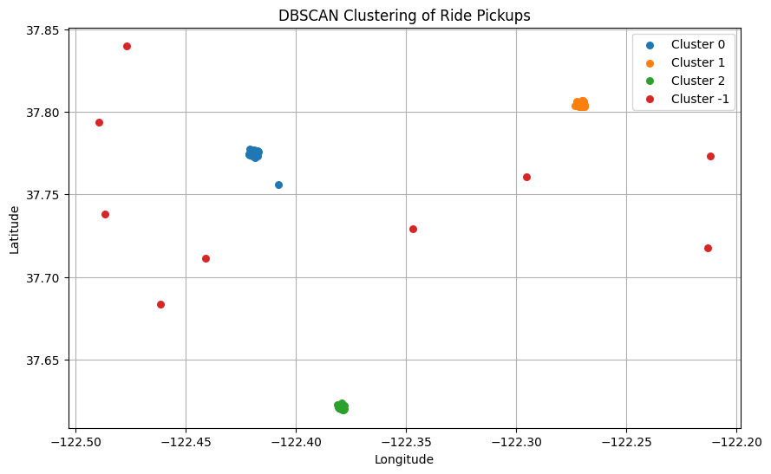

PCA

WHAT IT IS?

PCA is the dimensionality reduction technique used to simplify complex datasets by transforming them into new set of uncorrelated variables called principal components.

HOW IT WORKS?

First need to standarize the data and then compute covariance matriix(used to measure the relationship between features) and caluculates eigen values and eigen vectors finally it transforms the data into low dimensionnal data with uncorrelated variables.

WHEN WILL USE?
- When data set has too many features.
- Features are correlated.
- When you want to visualize the data in 2d,3d.

WHERE IT IS USED?
- BIO INFORMATICS-Here u will have thousands of features.
- Computer vision--Image compression and preprocessing.

REAL WORLD SCENERIOS

- Healthcare -pca reduces dimensions of ecg data.
- Credit scoring models--pca summarize the financial behaviour.

PRACTICAL TASK
from sklearn.decomposition import PCA
from sklearn.datasets import load_iris
import matplotlib.pyplot as plt

# Load sample dataset
iris = load_iris()
X = iris.data

# Apply PCA to reduce to 2 dimensions
pca = PCA(n_components=2)
X_pca = pca.fit_transform(X)

# Plot the result
plt.scatter(X_pca[:, 0], X_pca[:, 1], c=iris.target)
plt.xlabel("First Principal Component")
plt.ylabel("Second Principal Component")
plt.title("PCA of Iris Dataset")
plt.show()

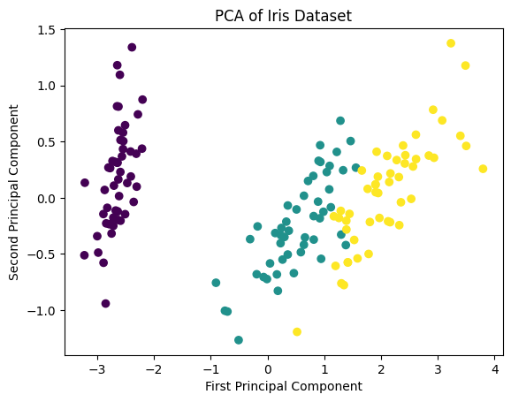

TSNE-(t-distrubuted stochastic neighbour embedding)
WHAT IS THIS?
It is a dimensionality reduction technique mainly used for visualizing higher dimensional data in lower dimensions

HOW IT WORKS?
First it finds the similarities between the data points in high dimensional data .and then minimizing the difference blw thos distrubutions like wise it transforms higher dimensional to lower dimensional preserving linear structure same

WHEN WILL WE USE t-SNE?
- When you want visualize high dimensional data
- When you want to detect clusters or groupings in data visually

WHERE IT IS USED?

- Image processing-visualizing high dimensional image features
- NLP-visualizing word embeddings to understand relationships between words

REAL WORLD SCENERIOS

- Medical diagnosis-to identifies patterns in medical images and patient data.
- Facial recognition

PRACTICAL TASK

from sklearn.datasets import load_digits
from sklearn.manifold import TSNE
import matplotlib.pyplot as plt
import seaborn as sns

digits = load_digits()
X = digits.data
y = digits.target

tsne = TSNE(n_components=2, perplexity=30, random_state=42)
X_tsne = tsne.fit_transform(X)

# Plot the result
plt.figure(figsize=(10, 6))
sns.scatterplot(x=X_tsne[:, 0], y=X_tsne[:, 1], hue=y, palette='tab10', s=60)
plt.title("t-SNE Visualization of Digits Dataset")
plt.xlabel("Component 1")
plt.ylabel("Component 2")
plt.legend(title='Digit')
plt.grid(True)
plt.show()

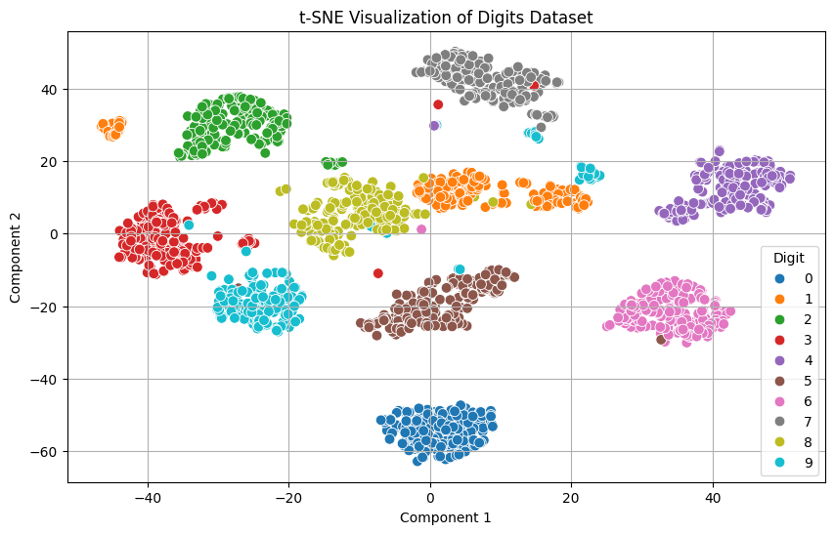

ANOMOLY DETECTION
WHAT IT IS?
It is also known as outlier detection.it identifies the unexpected or unusual data points in the datasets.this anomalies represents errors,frauds etc.

HOW IT WORKS?
It compares with the past data or historical data to learn the patterns it could be network traffic,sensor readings. And then compare the data and detects the anamolies.

WHEN IT IS USED?

- When you want to detect early signs of failure.
- When you are working on real time data.
- When you are monitoring behaviour patterns.

WHERE IT IS USED?
- Financial fraud-unusual purchases
- Ecommerce-fake reviews
- Manufacturing-damage products

REAL WORLD SCENEROIS
- Paypal-fraud detection
- Amazon-detecting fake reviews
- Uber ola-unusual path detection

ASSOCIATION RULE MINING

WHAT IT IS?
Association rule mining is a technique used for discovering relationships,frequent patterns,associations,correlations between variables in larget datasets.

HOW IT WORKS?
It works by caluculating the metrics like support,lift,confidence.

WHEN TO USE?
- When you want to discover patterns.
- When you don’t have labels.
- When you are analyzing transactions,clicks.
- When you want to improve recommendation system.

REAL WORLD SCENERIOS

- Amazon-customers who bought x also bought y
- Netflix-suggesting shows commonly watched together

