Manually implement a single-layer perceptron in NumPy

import numpy as np

# Step function (activation)
def step(x):
return 1 if x >= 0 else 0

# Training data (AND)
X = np.array([
[0, 0],
[0, 1],
[1, 0],
[1, 1]
])
y = np.array([0, 0, 0, 1]) # AND outputs

# Initialize weights and bias
weights = np.zeros(2)
bias = 0
learning_rate = 0.1

# Training loop
for epoch in range(10):
print(f"\nEpoch {epoch+1}")
for i in range(len(X)):
x_i = X[i]
target = y[i]

# Compute linear output
z = np.dot(x_i, weights) + bias
pred = step(z)

# Update rule
error = target - pred
weights += learning_rate * error * x_i
bias += learning_rate * error

print(f"Input: {x_i}, Target: {target}, Pred: {pred}, Error: {error}")
print(f"Weights: {weights}, Bias: {bias}")

Epoch 10 Input: [0 0], Target: 0, Pred: 0, Error: 0 Weights: [0.2 0.1], Bias: -0.20000000000000004 Input: [0 1], Target: 0, Pred: 0, Error: 0 Weights: [0.2 0.1], Bias: -0.20000000000000004 Input: [1 0], Target: 0, Pred: 0, Error: 0 Weights: [0.2 0.1], Bias: -0.20000000000000004 Input: [1 1], Target: 1, Pred: 1, Error: 0 Weights: [0.2 0.1], Bias: -0.20000000000000004

Use PyTorch or TensorFlow to build a basic MLP
import numpy as np
from tensorflow.keras.models import Sequential
from tensorflow.keras.layers import Dense

# Dataset (AND logic)
X = np.array([[0,0],[0,1],[1,0],[1,1]])
y = np.array([0,0,0,1])

# Build MLP model
model = Sequential([
Dense(4, input_dim=2, activation='relu'),
Dense(1, activation='sigmoid')
])

model.compile(optimizer='sgd', loss='binary_crossentropy', metrics=['accuracy'])

# Train
model.fit(X, y, epochs=100, verbose=0)

# Predict
preds = model.predict(X).round()
print("Predictions:", preds.squeeze())

Predictions: [0. 0. 0. 0.]

Train an MLP on a binary classification problem

import numpy as np
from sklearn.datasets import make_moons
from sklearn.model_selection import train_test_split
from sklearn.preprocessing import StandardScaler
from tensorflow.keras.models import Sequential
from tensorflow.keras.layers import Dense

# 1. Generate synthetic dataset (moons)
X, y = make_moons(n_samples=1000, noise=0.2, random_state=42)

# 2. Split dataset into train and test
X_train, X_test, y_train, y_test = train_test_split(X, y, test_size=0.2, random_state=42)

# 3. Scale features
scaler = StandardScaler()
X_train = scaler.fit_transform(X_train)
X_test = scaler.transform(X_test)

# 4. Build MLP model
model = Sequential([
Dense(16, input_dim=2, activation='relu'),
Dense(8, activation='relu'),
Dense(1, activation='sigmoid') # Output layer for binary classification
])

# 5. Compile model
model.compile(optimizer='adam', loss='binary_crossentropy', metrics=['accuracy'])

# 6. Train model
history = model.fit(X_train, y_train, epochs=50, batch_size=32, validation_split=0.2)

# 7. Evaluate model on test set
loss, accuracy = model.evaluate(X_test, y_test)
print(f"Test Accuracy: {accuracy:.4f}")

# 8. Make predictions on test data
preds = model.predict(X_test).round()
print("Sample predictions:", preds[:10].flatten())

Sample predictions: [1. 0. 1. 0. 1. 1. 1. 1. 1. 0.]

Visualize network architecture using graph tools
from tensorflow.keras.models import Sequential
from tensorflow.keras.layers import Dense
from tensorflow.keras.utils import plot_model

# Build a simple MLP model
model = Sequential([
Dense(16, input_dim=2, activation='relu'),
Dense(8, activation='relu'),
Dense(1, activation='sigmoid')
])

# Visualize and save model architecture to PNG
plot_model(model, to_file='model_architecture.png', show_shapes=True, show_layer_names=True)

print("Model architecture saved as 'model_architecture.png'")

Plot and compare activation functions
import numpy as np
import matplotlib.pyplot as plt

# Define x range
x = np.linspace(-10, 10, 1000)

# Activation functions
def sigmoid(x):
return 1 / (1 + np.exp(-x))

def tanh(x):
return np.tanh(x)

def relu(x):
return np.maximum(0, x)

def leaky_relu(x, alpha=0.1):
return np.where(x > 0, x, alpha * x)

def softmax(x):
exps = np.exp(x - np.max(x)) # for numerical stability
return exps / np.sum(exps)

# Plotting
plt.figure(figsize=(12, 8))

# Sigmoid
plt.subplot(2, 2, 1)
plt.plot(x, sigmoid(x), label='Sigmoid', color='blue')
plt.title("Sigmoid")
plt.grid(True)

# Tanh
plt.subplot(2, 2, 2)
plt.plot(x, tanh(x), label='Tanh', color='green')
plt.title("Tanh")
plt.grid(True)

# ReLU and Leaky ReLU
plt.subplot(2, 2, 3)
plt.plot(x, relu(x), label='ReLU', color='red')
plt.plot(x, leaky_relu(x), label='Leaky ReLU', color='orange', linestyle='--')
plt.title("ReLU vs Leaky ReLU")
plt.legend()
plt.grid(True)

# Softmax on a small vector of logits
plt.subplot(2, 2, 4)
sample = np.array([1.0, 2.0, 3.0])
softmax_out = softmax(sample)
plt.bar(range(len(sample)), softmax_out, color='purple')
plt.title("Softmax Output (on [1, 2, 3])")
plt.xticks(range(len(sample)), ['Class 0', 'Class 1', 'Class 2'])
plt.grid(True)

plt.tight_layout()
plt.show()

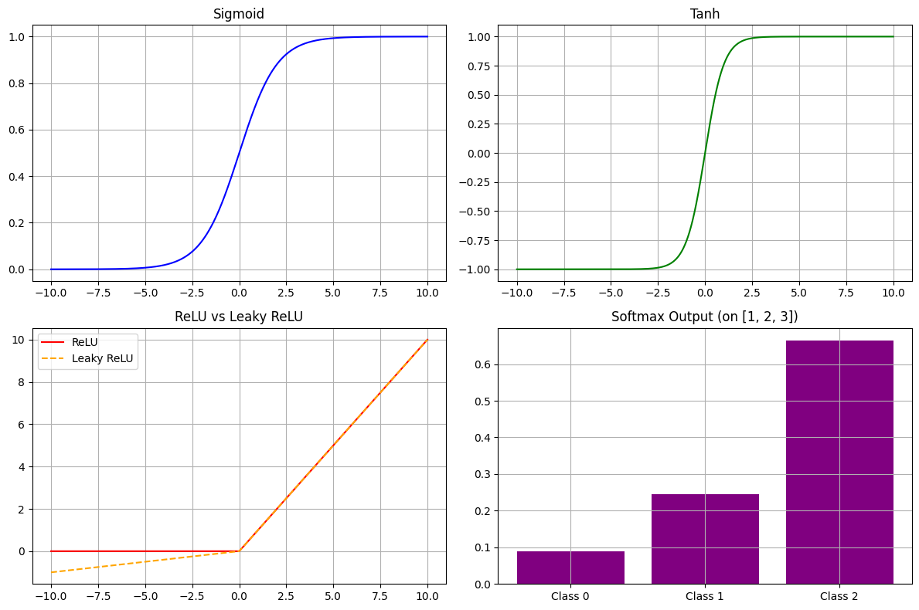

Visualize outputs and gradients
import numpy as np
import matplotlib.pyplot as plt

# Input values
x = np.linspace(-10, 10, 1000)

# Activation functions and their derivatives
def sigmoid(x):
return 1 / (1 + np.exp(-x))

def d_sigmoid(x):
s = sigmoid(x)
return s * (1 - s)

def tanh(x):
return np.tanh(x)

def d_tanh(x):
return 1 - np.tanh(x) ** 2

def relu(x):
return np.maximum(0, x)

def d_relu(x):
return np.where(x > 0, 1, 0)

def leaky_relu(x, alpha=0.1):
return np.where(x > 0, x, alpha * x)

def d_leaky_relu(x, alpha=0.1):
return np.where(x > 0, 1, alpha)

# Plotting
fig, axes = plt.subplots(4, 2, figsize=(12, 12))
fig.suptitle("Activation Functions and Their Derivatives", fontsize=16)

# Sigmoid
axes[0, 0].plot(x, sigmoid(x), label="Sigmoid", color='blue')
axes[0, 0].set_title("Sigmoid Output")
axes[0, 0].grid(True)

axes[0, 1].plot(x, d_sigmoid(x), label="d(Sigmoid)", color='blue')
axes[0, 1].set_title("Sigmoid Gradient")
axes[0, 1].grid(True)

# Tanh
axes[1, 0].plot(x, tanh(x), label="Tanh", color='green')
axes[1, 0].set_title("Tanh Output")
axes[1, 0].grid(True)

axes[1, 1].plot(x, d_tanh(x), label="d(Tanh)", color='green')
axes[1, 1].set_title("Tanh Gradient")
axes[1, 1].grid(True)

# ReLU
axes[2, 0].plot(x, relu(x), label="ReLU", color='red')
axes[2, 0].set_title("ReLU Output")
axes[2, 0].grid(True)

axes[2, 1].plot(x, d_relu(x), label="d(ReLU)", color='red')
axes[2, 1].set_title("ReLU Gradient")
axes[2, 1].grid(True)

# Leaky ReLU
axes[3, 0].plot(x, leaky_relu(x), label="Leaky ReLU", color='orange')
axes[3, 0].set_title("Leaky ReLU Output")
axes[3, 0].grid(True)

axes[3, 1].plot(x, d_leaky_relu(x), label="d(Leaky ReLU)", color='orange')
axes[3, 1].set_title("Leaky ReLU Gradient")
axes[3, 1].grid(True)

plt.tight_layout(rect=[0, 0, 1, 0.96])
plt.show()

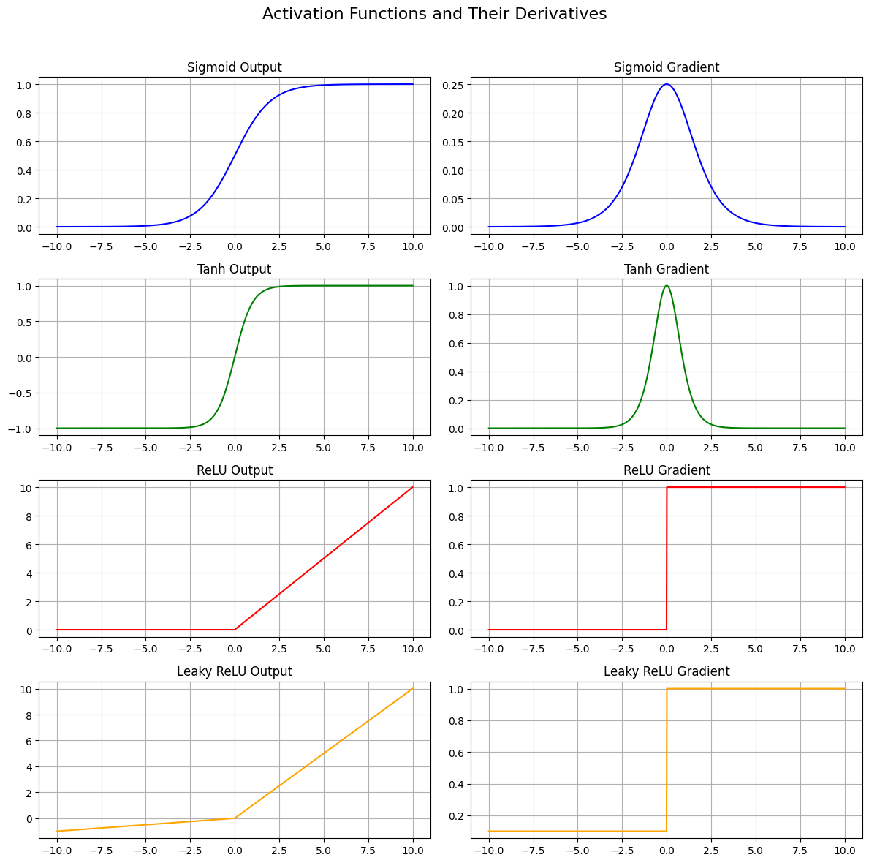

Apply different activations in MLP and observe performance differences

import numpy as np
import matplotlib.pyplot as plt
from sklearn.datasets import make_moons
from sklearn.model_selection import train_test_split
from sklearn.preprocessing import StandardScaler
from tensorflow.keras.models import Sequential
from tensorflow.keras.layers import Dense
from tensorflow.keras.optimizers import Adam
from tensorflow.keras.utils import set_random_seed

# Set seed for reproducibility
set_random_seed(42)

# 1. Generate dataset
X, y = make_moons(n_samples=1000, noise=0.2, random_state=42)
X = StandardScaler().fit_transform(X)
X_train, X_test, y_train, y_test = train_test_split(X, y, test_size=0.2, random_state=42)

# 2. Helper: Build model with given activation
def build_model(activation):
model = Sequential([
Dense(16, input_dim=2, activation=activation),
Dense(8, activation=activation),
Dense(1, activation='sigmoid') # Binary classification
])
model.compile(optimizer=Adam(learning_rate=0.01),
loss='binary_crossentropy',
metrics=['accuracy'])
return model

# 3. Train with different activations
activations = ['relu', 'tanh', 'sigmoid']
histories = {}
results = {}

for act in activations:
print(f"\nTraining with activation: {act}")
model = build_model(act)
history = model.fit(X_train, y_train, validation_split=0.2,
epochs=50, batch_size=32, verbose=0)
loss, acc = model.evaluate(X_test, y_test, verbose=0)
results[act] = acc
histories[act] = history

# 4. Plot accuracy curves
plt.figure(figsize=(10, 6))
for act in activations:
plt.plot(histories[act].history['val_accuracy'], label=f'{act} val_acc')
plt.title("Validation Accuracy by Activation Function")
plt.xlabel("Epochs")
plt.ylabel("Accuracy")
plt.legend()
plt.grid(True)
plt.show()

# 5. Print final test accuracies
print("\n🔍 Final Test Accuracies:")
for act in activations:
print(f"{act.upper():<7}: {results[act]*100:.2f}%")
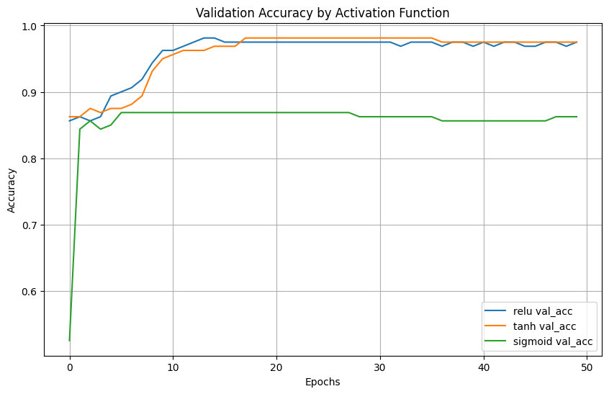
Implement MSE and Binary Cross Entropy from scratch
import numpy as np

def mse(predictions, targets):
"""
Calculates the Mean Squared Error (MSE) loss.

Args:
predictions (numpy.ndarray): Predicted values.
targets (numpy.ndarray): Actual target values.

Returns:
float: The MSE loss.
"""
return np.mean((predictions - targets) ** 2)

def binary_cross_entropy(predictions, targets):
"""
Calculates the Binary Cross-Entropy (BCE) loss.

Args:
predictions (numpy.ndarray): Predicted probabilities (values between 0 and 1).
targets (numpy.ndarray): Actual binary target values (0 or 1).

Returns:
float: The BCE loss.
"""
# Clip predictions to avoid numerical instability (log(0) or log(1))
predictions = np.clip(predictions, 1e-15, 1 - 1e-15)
return -np.mean(targets * np.log(predictions) + (1 - targets) * np.log(1 - predictions))

# Example Usage
if __name__ == '__main__':
# Generate some dummy data
y_true = np.array([0, 1, 0, 1, 1])
y_pred_regression = np.array([0.1, 0.9, 0.2, 0.8, 0.7])
y_pred_classification = np.array([0.2, 0.8, 0.3, 0.7, 0.9])

# Calculate MSE
mse_loss = mse(y_pred_regression, y_true)
print(f"MSE Loss: {mse_loss}")

# Calculate BCE
bce_loss = binary_cross_entropy(y_pred_classification, y_true)
print(f"Binary Cross-Entropy Loss: {bce_loss}")
MSE Loss: 0.038
Binary Cross-Entropy Loss: 0.2529995012327421

Use appropriate loss in PyTorch for regression and classification

import numpy as np
import matplotlib.pyplot as plt

# 1. Simple synthetic dataset (y = 2x + 1)
X = np.linspace(-1, 1, 20)
y_true = 2 * X + 1

# 2. Grid of w and b values
w_vals = np.linspace(0, 4, 100)
b_vals = np.linspace(-1, 3, 100)

W, B = np.meshgrid(w_vals, b_vals)
Loss = np.zeros_like(W)

# 3. Compute MSE loss for each (w, b)
for i in range(W.shape[0]):
for j in range(W.shape[1]):
y_pred = W[i, j] * X + B[i, j]
Loss[i, j] = np.mean((y_true - y_pred) ** 2)

# 4. Plot 3D loss landscape
fig = plt.figure(figsize=(14, 6))

# 3D surface plot
ax = fig.add_subplot(1, 2, 1, projection='3d')
ax.plot_surface(W, B, Loss, cmap='viridis')
ax.set_title("MSE Loss Surface")
ax.set_xlabel("Weight (w)")
ax.set_ylabel("Bias (b)")
ax.set_zlabel("Loss")

# Contour plot
ax2 = fig.add_subplot(1, 2, 2)
cp = ax2.contourf(W, B, Loss, levels=50, cmap='viridis')
plt.colorbar(cp, ax=ax2)
ax2.set_title("Loss Contour")
ax2.set_xlabel("Weight (w)")
ax2.set_ylabel("Bias (b)")

plt.tight_layout()
plt.show()

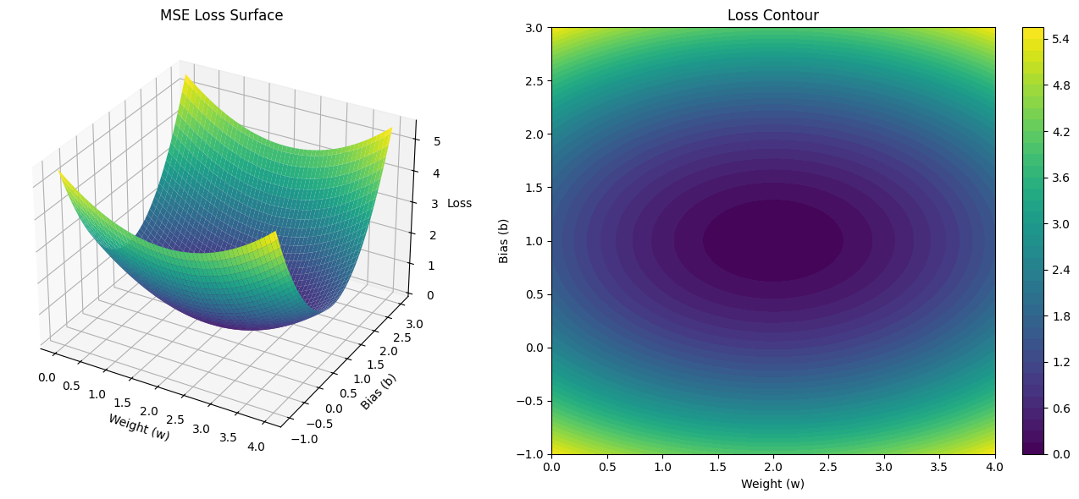

Manually implement backpropagation in NumPy for a 2-layer neural net

import numpy as np

# 1. Input data (XOR)
X = np.array([[0,0], [0,1], [1,0], [1,1]]) # shape: (4, 2)
y = np.array([[0], [1], [1], [0]]) # shape: (4, 1)

# 2. Initialize weights and biases
np.random.seed(42)
W1 = np.random.randn(2, 2) # 2 input → 2 hidden
b1 = np.zeros((1, 2))
W2 = np.random.randn(2, 1) # 2 hidden → 1 output
b2 = np.zeros((1, 1))

# 3. Activation functions
def sigmoid(z):
return 1 / (1 + np.exp(-z))

def sigmoid_deriv(a):
return a * (1 - a)

def relu(z):
return np.maximum(0, z)

def relu_deriv(z):
return (z > 0).astype(float)

# 4. Training loop
lr = 0.1
for epoch in range(10000):
# --- Forward pass ---
z1 = X @ W1 + b1
a1 = relu(z1)

z2 = a1 @ W2 + b2
a2 = sigmoid(z2) # prediction

# --- Loss (binary cross-entropy) ---
loss = -np.mean(y * np.log(a2 + 1e-9) + (1 - y) * np.log(1 - a2 + 1e-9))

# --- Backward pass ---
dz2 = a2 - y # dL/da2 * da2/dz2
dW2 = a1.T @ dz2 # shape (2, 1)
db2 = np.sum(dz2, axis=0, keepdims=True)

da1 = dz2 @ W2.T # backprop to hidden layer
dz1 = da1 * relu_deriv(z1)
dW1 = X.T @ dz1 # shape (2, 2)
db1 = np.sum(dz1, axis=0, keepdims=True)

# --- Update weights ---
W1 -= lr * dW1
b1 -= lr * db1
W2 -= lr * dW2
b2 -= lr * db2

# Print every 1000 epochs
if epoch % 10 == 0:
print(f"Epoch {epoch}, Loss: {loss:.4f}")

# Final predictions
print("\nFinal predictions:")
print(a2.round())

Final predictions: [[1.] [1.] [1.] [0.]]

Use .backward() and track gradient shapes

import torch
import torch.nn as nn
import torch.nn.functional as F

# 1. Input and target (XOR problem)
X = torch.tensor([[0.0, 0.0],
[0.0, 1.0],
[1.0, 0.0],
[1.0, 1.0]])

y = torch.tensor([[0.0], [1.0], [1.0], [0.0]])

# 2. Define a simple 2-layer network
class SimpleNet(nn.Module):
def __init__(self):
super().__init__()
self.fc1 = nn.Linear(2, 2) # input → hidden
self.fc2 = nn.Linear(2, 1) # hidden → output

def forward(self, x):
x = F.relu(self.fc1(x))
x = torch.sigmoid(self.fc2(x))
return x

model = SimpleNet()

# 3. Loss function and optimizer
criterion = nn.BCELoss()
optimizer = torch.optim.SGD(model.parameters(), lr=0.1)

# 4. Forward pass
y_pred = model(X)
loss = criterion(y_pred, y)

# 5. Backward pass
loss.backward()

# 6. Print gradient shapes and values
print("\n=== Gradient Shapes and Values ===\n")
for name, param in model.named_parameters():
if param.requires_grad:
print(f"{name}: {param.grad.shape}")
print(param.grad, "\n")

=== Gradient Shapes and Values ===
fc1.weight: torch.Size([2, 2]) tensor([[0.0000, 0.0000], [0.0285, 0.0255]]) fc1.bias: torch.Size([2]) tensor([0.0000, 0.0538])
fc2.weight: torch.Size([1, 2]) tensor([[ 0.0000, -0.0559]]) fc2.bias: torch.Size([1]) tensor([-0.1440])

Plot learning curves of different optimizers

import numpy as np
import matplotlib.pyplot as plt
import torch
import torch.nn as nn
import torch.nn.functional as F
from torch.optim import SGD, Adam, RMSprop

# XOR dataset
X = torch.tensor([[0., 0.], [0., 1.], [1., 0.], [1., 1.]])
y = torch.tensor([[0.], [1.], [1.], [0.]])

# Define MLP
class MLP(nn.Module):
def __init__(self):
super().__init__()
self.fc1 = nn.Linear(2, 4)
self.fc2 = nn.Linear(4, 1)

def forward(self, x):
x = F.relu(self.fc1(x))
return torch.sigmoid(self.fc2(x))

# Training function
def train_model(optimizer_class, name, epochs=2000, lr=0.01):
model = MLP()
optimizer = optimizer_class(model.parameters(), lr=lr)
criterion = nn.BCELoss()
losses = []
for epoch in range(epochs):
optimizer.zero_grad()
y_pred = model(X)
loss = criterion(y_pred, y)
loss.backward()
optimizer.step()
losses.append(loss.item())
return losses

# Run training for all optimizers
optimizers = {
"SGD": SGD,
"SGD + Momentum": lambda params, lr: SGD(params, lr=lr, momentum=0.9),
"RMSProp": RMSprop,
"Adam": Adam
}

loss_curves = {name: train_model(opt, name) for name, opt in optimizers.items()}

# Plot curves
plt.figure(figsize=(10, 6))
for name, losses in loss_curves.items():
plt.plot(losses, label=name)
plt.title("Learning Curves of Different Optimizers on XOR Task")
plt.xlabel("Epoch")
plt.ylabel("Binary Cross-Entropy Loss")
plt.legend()
plt.grid(True)
plt.tight_layout()
plt.show()

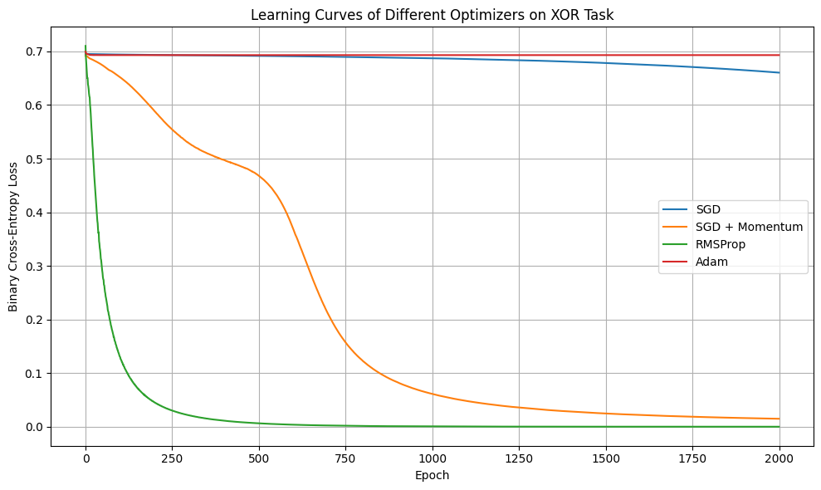

Try different learning rates and analyze convergence
import torch
import torch.nn as nn
import torch.nn.functional as F
import matplotlib.pyplot as plt

# XOR dataset
X = torch.tensor([[0., 0.], [0., 1.], [1., 0.], [1., 1.]])
y = torch.tensor([[0.], [1.], [1.], [0.]])

# Define simple MLP
class MLP(nn.Module):
def __init__(self):
super().__init__()
self.fc1 = nn.Linear(2, 4)
self.fc2 = nn.Linear(4, 1)

def forward(self, x):
x = F.relu(self.fc1(x))
return torch.sigmoid(self.fc2(x))

def train_with_lr(lr, epochs=1000):
model = MLP()
optimizer = torch.optim.Adam(model.parameters(), lr=lr)
criterion = nn.BCELoss()
losses = []
for epoch in range(epochs):
optimizer.zero_grad()
y_pred = model(X)
loss = criterion(y_pred, y)
loss.backward()
optimizer.step()
losses.append(loss.item())
return losses

learning_rates = [0.0001, 0.001, 0.01, 0.1]

plt.figure(figsize=(10, 6))
for lr in learning_rates:
losses = train_with_lr(lr)
plt.plot(losses, label=f"lr={lr}")

plt.title("Training Loss Curves with Different Learning Rates (Adam)")
plt.xlabel("Epoch")
plt.ylabel("Binary Cross-Entropy Loss")
plt.legend()
plt.grid(True)
plt.show()

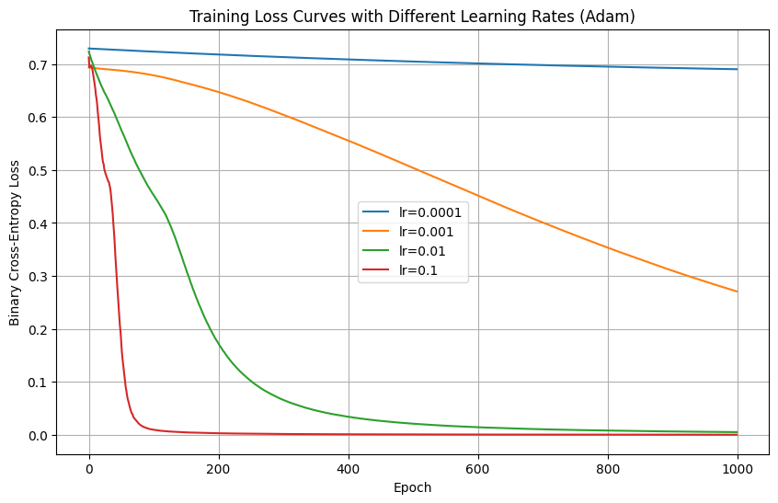
Use schedulers to decay learning rate
import torch
import torch.nn as nn
import torch.nn.functional as F
import matplotlib.pyplot as plt

# XOR dataset
X = torch.tensor([[0., 0.], [0., 1.], [1., 0.], [1., 1.]])
y = torch.tensor([[0.], [1.], [1.], [0.]])

# Simple MLP
class MLP(nn.Module):
def __init__(self):
super().__init__()
self.fc1 = nn.Linear(2, 4)
self.fc2 = nn.Linear(4, 1)

def forward(self, x):
x = F.relu(self.fc1(x))
return torch.sigmoid(self.fc2(x))

# Train function with StepLR scheduler
def train_with_scheduler(lr=0.01, epochs=1000, step_size=200, gamma=0.5):
model = MLP()
optimizer = torch.optim.Adam(model.parameters(), lr=lr)
scheduler = torch.optim.lr_scheduler.StepLR(optimizer, step_size=step_size, gamma=gamma)
criterion = nn.BCELoss()
losses = []
lrs = []

for epoch in range(epochs):
optimizer.zero_grad()
y_pred = model(X)
loss = criterion(y_pred, y)
loss.backward()
optimizer.step()
scheduler.step() # Update learning rate

losses.append(loss.item())
lrs.append(optimizer.param_groups[0]['lr'])

return losses, lrs

losses, lrs = train_with_scheduler()

# Plot Loss and Learning Rate
fig, ax1 = plt.subplots(figsize=(10, 6))

color = 'tab:blue'
ax1.set_xlabel('Epoch')
ax1.set_ylabel('Loss', color=color)
ax1.plot(losses, color=color)
ax1.tick_params(axis='y', labelcolor=color)

ax2 = ax1.twinx()
color = 'tab:red'
ax2.set_ylabel('Learning Rate', color=color)
ax2.plot(lrs, color=color)
ax2.tick_params(axis='y', labelcolor=color)

plt.title("Training Loss and Learning Rate with StepLR Scheduler")
plt.show()

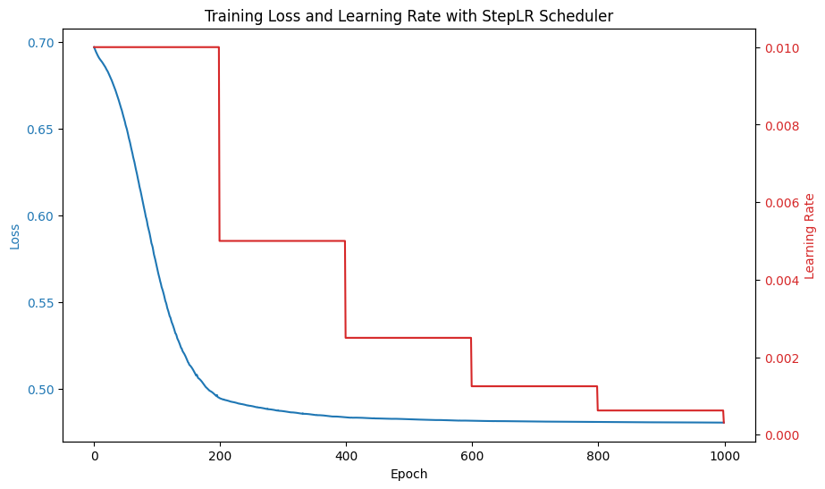
Implement and compare random, Xavier, He initializations

import torch
import torch.nn as nn
import torch.nn.functional as F
import matplotlib.pyplot as plt

# XOR dataset
X = torch.tensor([[0., 0.], [0., 1.], [1., 0.], [1., 1.]])
y = torch.tensor([[0.], [1.], [1.], [0.]])

# Simple MLP
class MLP(nn.Module):
def __init__(self):
super().__init__()
self.fc1 = nn.Linear(2, 4)
self.fc2 = nn.Linear(4, 1)

def forward(self, x):
x = F.relu(self.fc1(x))
return torch.sigmoid(self.fc2(x))

# Custom weight initializer
def initialize_weights(model, method='random'):
if method == 'xavier':
nn.init.xavier_uniform_(model.fc1.weight)
nn.init.xavier_uniform_(model.fc2.weight)
elif method == 'he':
nn.init.kaiming_uniform_(model.fc1.weight, nonlinearity='relu')
nn.init.kaiming_uniform_(model.fc2.weight, nonlinearity='relu')
elif method == 'random':
# Leave PyTorch defaults
pass

# Training function
def train_model(init_method, epochs=1000, lr=0.01):
model = MLP()
initialize_weights(model, init_method)
optimizer = torch.optim.Adam(model.parameters(), lr=lr)
criterion = nn.BCELoss()
losses = []

for epoch in range(epochs):
optimizer.zero_grad()
y_pred = model(X)
loss = criterion(y_pred, y)
loss.backward()
optimizer.step()
losses.append(loss.item())

return losses

# Train and plot
methods = ['random', 'xavier', 'he']
losses = {m: train_model(m) for m in methods}

plt.figure(figsize=(10, 6))
for m, l in losses.items():
plt.plot(l, label=f"{m.capitalize()} Init")
plt.title("Loss Comparison: Random vs Xavier vs He Initialization")
plt.xlabel("Epochs")
plt.ylabel("Loss")
plt.grid(True)
plt.legend()
plt.tight_layout()
plt.show()

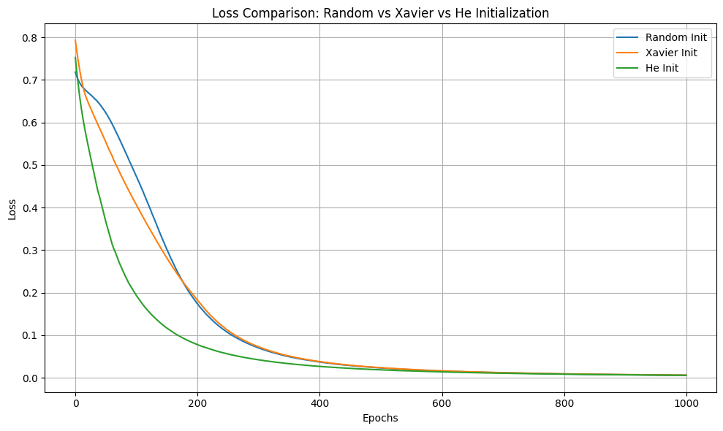
Visualize activation variances layer-wise
import numpy as np
import matplotlib.pyplot as plt

def relu(x):
return np.maximum(0, x)

def simulate_activation_variance(n_layers=10, n_neurons=1000, init='random'):
var_activations = []
x = np.random.randn(n_neurons) # Input with variance ~1
var_activations.append(np.var(x))

for layer in range(n_layers):
if init == 'random':
# small random weights ~U(-0.1, 0.1)
W = np.random.uniform(-0.1, 0.1, size=(n_neurons, n_neurons))
elif init == 'xavier':
limit = np.sqrt(6 / (n_neurons + n_neurons))
W = np.random.uniform(-limit, limit, size=(n_neurons, n_neurons))
elif init == 'he':
std = np.sqrt(2 / n_neurons)
W = np.random.normal(0, std, size=(n_neurons, n_neurons))
else:
raise ValueError("Unknown init")

# Forward pass: x = ReLU(Wx)
x = relu(np.dot(W, x))
var_activations.append(np.var(x))

return var_activations

# Run simulation for each init type
layers = 11 # input + 10 hidden layers
random_var = simulate_activation_variance(init='random', n_layers=layers-1)
xavier_var = simulate_activation_variance(init='xavier', n_layers=layers-1)
he_var = simulate_activation_variance(init='he', n_layers=layers-1)

# Plot
plt.figure(figsize=(10,6))
plt.plot(range(layers), random_var, label="Random Init")
plt.plot(range(layers), xavier_var, label="Xavier Init")
plt.plot(range(layers), he_var, label="He Init")
plt.xlabel("Layer")
plt.ylabel("Activation Variance")
plt.title("Layer-wise Activation Variance for Different Initializations")
plt.legend()
plt.grid(True)
plt.show()

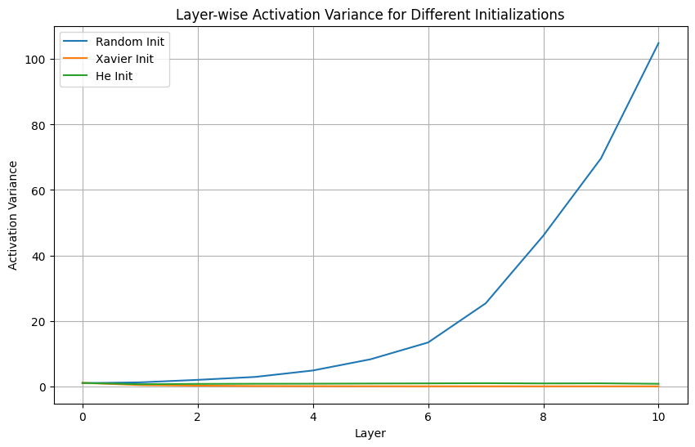
Track convergence speed for different initializations
import torch
import torch.nn as nn
import torch.nn.functional as F
import matplotlib.pyplot as plt

# XOR dataset
X = torch.tensor([[0., 0.], [0., 1.], [1., 0.], [1., 1.]])
y = torch.tensor([[0.], [1.], [1.], [0.]])

# Simple MLP
class MLP(nn.Module):
def __init__(self):
super().__init__()
self.fc1 = nn.Linear(2, 8)
self.fc2 = nn.Linear(8, 1)

def forward(self, x):
x = F.relu(self.fc1(x))
return torch.sigmoid(self.fc2(x))

# Weight initialization function
def init_weights(model, method='random'):
if method == 'xavier':
nn.init.xavier_uniform_(model.fc1.weight)
nn.init.xavier_uniform_(model.fc2.weight)
elif method == 'he':
nn.init.kaiming_uniform_(model.fc1.weight, nonlinearity='relu')
nn.init.kaiming_uniform_(model.fc2.weight, nonlinearity='relu')
elif method == 'random':
# default PyTorch initialization
pass

# Train function returns loss curve
def train_model(init_method, epochs=500, lr=0.01):
model = MLP()
init_weights(model, method=init_method)
optimizer = torch.optim.Adam(model.parameters(), lr=lr)
criterion = nn.BCELoss()
losses = []

for epoch in range(epochs):
optimizer.zero_grad()
y_pred = model(X)
loss = criterion(y_pred, y)
loss.backward()
optimizer.step()
losses.append(loss.item())
return losses

# Compare all initializations
init_methods = ['random', 'xavier', 'he']
loss_curves = {m: train_model(m) for m in init_methods}

# Plot losses
plt.figure(figsize=(10, 6))
for method, losses in loss_curves.items():
plt.plot(losses, label=f"{method.capitalize()} Init")
plt.xlabel("Epoch")
plt.ylabel("Binary Cross-Entropy Loss")
plt.title("Convergence Speed with Different Weight Initializations")
plt.legend()
plt.grid(True)
plt.show()

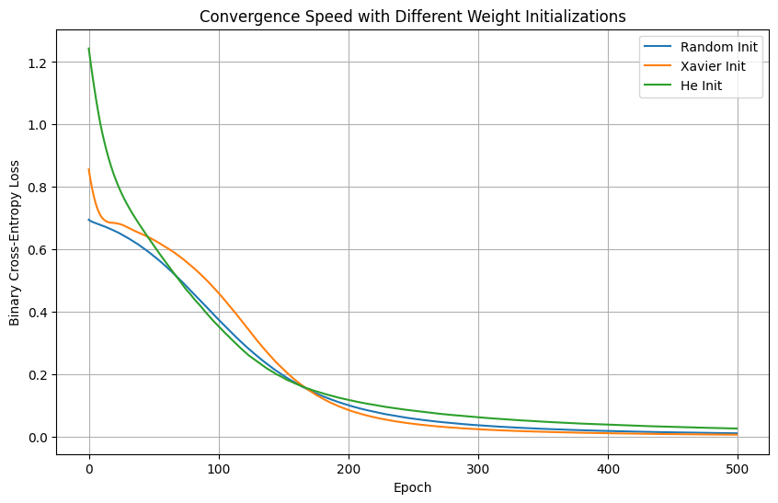
Apply L2 regularization via weight decay
from tensorflow.keras.models import Sequential
from tensorflow.keras.layers import Dense
from tensorflow.keras.regularizers import l2
from tensorflow.keras.optimizers import Adam

# Define a model with L2 regularization
model = Sequential([
Dense(128, activation='relu', input_shape=(20,), kernel_regularizer=l2(0.01)),
Dense(64, activation='relu', kernel_regularizer=l2(0.01)),
Dense(1, activation='sigmoid') # Binary classification
])

# Compile the model
model.compile(optimizer=Adam(), loss='binary_crossentropy', metrics=['accuracy'])

# Summary
model.summary()

Total params: 11,009 (43.00 KB)
Trainable params: 11,009 (43.00 KB)
Non-trainable params: 0 (0.00 B)

Compare validation loss with and without regularization
import numpy as np
import tensorflow as tf
from tensorflow.keras.models import Sequential
from tensorflow.keras.layers import Dense
from tensorflow.keras.regularizers import l2
from sklearn.datasets import load_iris
from sklearn.model_selection import train_test_split
from sklearn.preprocessing import StandardScaler
import matplotlib.pyplot as plt

# Load and preprocess
iris = load_iris()
X, y = iris.data, iris.target
y = (y == 0).astype(int) # Convert to binary classification

X_train, X_val, y_train, y_val = train_test_split(X, y, test_size=0.2, random_state=42)
scaler = StandardScaler()
X_train = scaler.fit_transform(X_train)
X_val = scaler.transform(X_val)
def build_model_no_reg():
model = Sequential([
Dense(64, activation='relu', input_shape=(X_train.shape[1],)),
Dense(32, activation='relu'),
Dense(1, activation='sigmoid')
])
model.compile(optimizer='adam', loss='binary_crossentropy', metrics=['accuracy'])
return model

def build_model_l2():
model = Sequential([
Dense(64, activation='relu', input_shape=(X_train.shape[1],), kernel_regularizer=l2(0.01)),
Dense(32, activation='relu', kernel_regularizer=l2(0.01)),
Dense(1, activation='sigmoid')
])
model.compile(optimizer='adam', loss='binary_crossentropy', metrics=['accuracy'])
return model
history_no_reg = build_model_no_reg().fit(
X_train, y_train, validation_data=(X_val, y_val),
epochs=50, batch_size=8, verbose=0
)

history_l2 = build_model_l2().fit(
X_train, y_train, validation_data=(X_val, y_val),
epochs=50, batch_size=8, verbose=0
)
plt.plot(history_no_reg.history['val_loss'], label='❌ No Regularization')
plt.plot(history_l2.history['val_loss'], label='✅ L2 Regularization')
plt.title("Validation Loss Comparison")
plt.xlabel("Epochs")
plt.ylabel("Loss")
plt.legend()
plt.grid(True)
plt.show()

