Python Programming:
It is a high level programming language. It will execute line by line(Interpreter) and Indentation follows.

Syntax:
print(“Hello World”)
In Python Indentation Must Be Follwed. Where Indentation Represents Block of code

Variables:
Variables are containers for storing data values.
Eg: x=10

DataTypes:

To get to know the type of an object you can use type() function

Numeric Types:
- int: Represents whole numbers (e. g. , 10, -5, 0).
- float: Represents real numbers with decimal points (e. g. , 3. 14, -2. 5).
- complex: Represents complex numbers (e. g. , 2 + 3j).

Sequence Types:
- str: Represents a sequence of characters (e. g. , "hello", 'world').
- list: Represents an ordered, mutable sequence of items (e. g. , \[1, 2, "apple"]).
- tuple: Represents an ordered, immutable sequence of items (e. g. , (1, 2, "apple")).
- dict: Represents a collection of key-value pairs (e. g. , {"name": "John", "age": 30}).
- bool: Represents either True or False.
- NoneType: Represents the absence of a value (None).

Operators

- Multiplication, division, modulo *, /, %
- Addition and subtraction +, -
- Bitwise shifts <<, >>
- Bitwise AND &
- Bitwise OR and XOR |, ^
- Comparison operators ==, !=, >, <, >=, <=
- Identity operators is, is not
- Membership operators in, not in
- Logical operators not, and, or

Contro Flow
Control flow refers to the order in which statements within a program execute.

if-else Statements:
statements allow a program to execute different blocks of code depending on whether a condition is true or false.

Loops:
Loops allow you to repeat a block of code multiple times, either a specific number of times or until a condition is met.
for loop: Iterates over a sequence. (No of Iterations knows)
While Loop: Repeats a block of code as long as the condition is true

Functions
A function is a block of reusable code that performs a specific task when called.

*args allows a function to accept any number of positional arguments. It is used when you don’t know how many no of arguments need to pass
**kwargs(Keyword arguments) allows to pass a variable number of keyword arguments to a function. ---It passes dictonary keys with values

Recursion: the Function calling itself

File handling
File handling in Python involves interacting with files on your computer to read data from them or write data to them. Python provides built-in functions and methods for creating, opening, reading, writing, and closing files.

"r": Read mode (default). Opens a file for reading.
"w": Write mode. Opens a file for writing; creates the file if it doesn't exist, overwrites it if it does.
"a": Append mode. Opens a file for appending; creates the file if it doesn't exist.
"x": Create mode. Creates a new file; returns an error if the file exists.
"b": Binary mode. Used for non-text files (e. g. , images).
"t": Text mode (default). Used for text files.
Delete--os. remove(file name)

open() Function:
The open() function is used to open a file, taking the filename and mode as arguments:

f = open("filename. txt", "r")
with Statement: It is recommended to use the with statement for file operations, as it automatically closes the file when the block is exited:
with open("filename. txt", "r") as f:

Exception Handling
An Exception is an error occurs during Program execution
To Handle the errors Here we use Try-Except block

try:
#code
Except error name:

Try-here we write the code
Except-handles specific exceptions
Else-Runs only if no exception occurred
Finally--It will runs always

OOPS:Used to structure the code using classes and objects
Class:It is blueprint of object---it holds methods and properties of an object

Class classname:

Object:It is Instance of class --a real world entity

S=classname()
When object is called constructor is created and the constructor is represented by __init__()
def __init__(self):
Self parameter is the refernce variable of object

Inheritance:
Inheritance allows us to define a class that inherits all the methods and properties from another class.

class Animal:
def __init__(self, name):
self. name = name
print(f"Animal Constructor: {self. name}")

class Dog(Animal):
def __init__(self, name, breed):
super(). __init__(name) # Call parent constructor
self. breed = breed
print(f"Dog Constructor: {self. breed}")

d = Dog("Tommy", "Labrador")

Parent constructor is not called until super() is called

Abstraction:means hiding internal details and showing only the essential features of an object.

from abc import ABC, abstractmethod

# Abstract class
class Animal(ABC):

@abstractmethod
def make_sound(self):
pass

class Dog(Animal):
def make_sound(self):
print("Bark")

class Cat(Animal):
def make_sound(self):
print("Meow")

dog = Dog()
cat = Cat()

dog. make_sound()
cat. make_sound()

Encapsulation:

Encapsulation is the OOP principle of binding data (attributes) and methods that operate on that data into a single unit

class BankAccount:
def __init__(self, balance):
self. __balance = balance

def get_balance(self):
return self. __balance
def deposit(self, amount):
if amount > 0:
self. __balance += amount

def withdraw(self, amount):
if 0 < amount <= self. __balance:
self. __balance -= amount
else:
print("Insufficient balance")

account = BankAccount(1000)
print("Balance: ", account. get_balance())
account. deposit(500)
print("After deposit: ", account. get_balance()) account. withdraw(200)
print("After withdrawal: ", account. get_balance())

Polymorphism

Polymorphism means "many forms". In Object-Oriented Programming, it refers to the ability of different classes to respond to the same method name in different ways.

class Dog:
def speak(self):
print("Bark")

class Cat:
def speak(self):
print("Meow")

def animal_sound(animal):
animal. speak()

d = Dog()
c = Cat()

animal_sound(d)
animal_sound(c)

Modules:

Modules are . py files with functions classes etc
You can use this module by importing
Eg import math
Packages: A package is a folder that contains one or more modules and an __init__. py file (can be empty). It allows hierarchical organization of modules.
Eg: from package import module

TASKS:
Write Python scripts for math operations
a=int(input())
b=int(input())
print("1. add, 2. sub, 3. mul, 4. div")
ch=int(input("enter your choice"))
if ch==1:
print(a+b)
elif(ch==2):
print(a-b)
elif ch==3:
print(a*b)
else:
print(a//b)

Implement custom classes

class Bank:
def __init__(self, balance):
self. balance=balance
def getbal(self):
return self. balance
def deposit(self, amt):
self. balance+=amt
def withdraw(self, amt):
if 0<amt<=self. balance:
self. balance-=amt
else:
print("insufficient balance")
a=Bank(1000)
print("current Blance is", a. getbal())
a. deposit(100)
print("after deposit", a. getbal())
a. withdraw(100)
print("withdrawn successfully now current balance: ", a. getbal())

reading/writing files:

with open("sample. txt", "w") as f:

f. write("heyy hello")
with open("sample. txt", "r") as f:
a= f. read()
print(a)
Build reusable utility modules
Main. py

import maths
x = 10
y = 5
print("Addition: ", maths. add(x, y))
print("Subtraction: ", maths. subtract(x, y))
print("Multiplication: ", maths. multiply(x, y))
print("Division: ", maths. divide(x, y))

Maths. py
def add(a, b):
return a + b

def subtract(a, b):
return a - b
def multiply(a, b):
return a * b
def divide(a, b):
if b == 0:
return "Error: Cannot divide by zero"
return a / b

NUMPY
Numpy is used for numerical caluculations

ARRAYS VS LISTS
Arrays stores only same datatypes, where lists stores different datatypes both are mutable

Lists=[1, ”jaya”, x]
. append, insert, remove, pop(position)

Import numpy as np

A=np. array([1, 2, 2])
A=np. append(a, 5)

Arange()

import numpy as np
arr1 = np. arange(0, 10) # [0 1 2 3 4 5 6 7 8 9]
arr2 = np. arange(1, 10, 2) # [1 3 5 7 9]

Linspace: -evenly spaced values blw 0 and 1
arr3 = np. linspace(0, 1, 5) # [0. 0. 25 0. 5 0. 75 1. ]

Zeros:
arr4 = np. zeros(5)
arr5 = np. zeros((2, 3))

Ones:
arr6 = np. ones(4)
arr7 = np. ones((3, 2))

Eye:
arr9 = np. eye(3)
Np. empty()-creates empty matrix
Indexing
import numpy as np

arr = np. array([10, 20, 30, 40, 50])
print(arr[0])
print(arr[-1])

Slicing:
arr = np. array([10, 20, 30, 40, 50])

print(arr[1: 4])

Reshaping:
arr = np. array([1, 2, 3, 4, 5, 6])

reshaped = arr. reshape((2, 3))
print(reshaped)
# [[1 2 3]
# [4 5 6]]

Broadcasting

Broadcasting in NumPy allows us to perform arithmetic operations on arrays of different shapes without reshaping them.

import numpy as np

array_2d = np. array([[1, 2, 3], [4, 5, 6]])
scalar = 10

result = array_2d + scalar
print(result)

Mathematical operations
import numpy as np

a = np. array([1, 2, 3])

b = np. array([4, 5, 6])

print(a + b)
print(a - b)
print(a * b)
print(b / a)
print(a ** 2)

Aggregation
arr = np. array([[1, 2, 3], [4, 5, 6]])

print(np. sum(arr)) # 21
print(np. mean(arr)) # 3. 5
print(np. min(arr)) # 1
print(np. max(arr)) # 6
print(np. std(arr)) # Standard deviation
print(np. var(arr)) # Variance

Linear algebra functions (dot, transpose, inv, etc)

Dot Product:
import numpy as np

A = np. array([[1, 2],
[3, 4]])

B = np. array([[5, 6],
[7, 8]])

result = np. dot(A, B)
# OR simply: result = A @ B

print(result)
# [[19 22]
# [43 50]]

Transpose (. T):
A = np. array([[1, 2],
[3, 4]])

print(A. T)

Inverse:
A = np. array([[1, 2],
[3, 4]])

inv_A = np. linalg. inv(A)
print(inv_A)

Determinant:
A = np. array([[1, 2], [3, 4]])
det = np. linalg. det(A)
print(det)

PANDAS:
Pandas is a Python library used for data manipulation and analysis. It provides data structures like Series (1D) and DataFrames (2D) to easily clean, transform, and analyze datasets.

A Pandas Series is a one-dimensional array-like object that can hold data of any type (integer, float, string, etc. ).

data = [1, 2, 3, 4, 5]
series_from_list = pd. Series(data)
print(series_from_list)
output
0 1 1 2 2 3 3 4 4 5

A Pandas DataFrame is a two-dimensional, tabular data structure with rows and columns. It is similar to a spreadsheet or a table in a relational database.

Reading/writing csv, excel files:

import pandas as pd

df = pd. read_csv('data. csv')

print(df. head())

df. to_csv('output. csv', index=False)

If it is excel file use read_excel method to read and to_excel to write

INDEXING

df['Name']
df[['Name', 'Age']]

ACCESSING
df. loc[2]
df. iloc[2]

If you want to access by name/label use loc otherwise use iloc it will based on position

SLICING
df[1: 4]
df. iloc[: 3]

FILTERING
df[df['Age'] > 25]

Aggregation means reducing data by performing operations like:
Sum(), mean(), count(), min(), std()
import pandas as pd

data = {
'Department': ['HR', 'IT', 'IT', 'HR', 'Finance'],
'Employee': ['Alice', 'Bob', 'Charlie', 'David', 'Eva'],
'Salary': [50000, 60000, 65000, 52000, 70000]
}

df = pd. DataFrame(data)

# Aggregate the Salary column
print(df['Salary']. sum())
print(df['Salary']. mean())
print(df['Salary']. max())

groupby() groups rows based on one or more columns and allows you to run aggregation functions per group.

Detecting missing data:
df. isnull()
df. isnull(). sum()
df. notnull()

Removing null values
df_clean = df. dropna()

Filling missed values
df['Age'] = df['Age']. fillna(df['Age']. mean())

df. fillna(method='ffill')
inner = pd. merge(df1, df2, on='EmpID', how='inner')

df_row = pd. concat([df1, df2], axis=0)

df3 = df1. set_index('EmpID')
df4 = df2. set_index('EmpID')

joined = df3. join(df4, how='inner')

Load real datasets (e. g. , Iris, Titanic)

Using sklearn

from sklearn. datasets import load_iris
import pandas as pd
iris_data = load_iris()

Using Seaborn

import seaborn as sns

iris = sns. load_dataset('iris')
print(iris. head())

Or you can load data using load_csv using pandas library

Perform data cleaning

import pandas as pd
import seaborn as sns

df = sns. load_dataset('titanic')

df['age'] = df['age']. fillna(df['age']. median())

df = df. drop_duplicates()
df = df[(df['age'] >= 0) & (df['age'] <= 100)]
Print(df)

pandas. pivot_table() function allows us to create a pivot table to summarize and aggregate data.
import pandas as pd
df = pd. DataFrame({
'A': ['John', 'Boby', 'Mina', 'Peter', 'Nicky'],
'B': ['Masters', 'Graduate', 'Graduate', 'Masters', 'Graduate'],
'C': [27, 23, 21, 23, 24]
})

df
table = pd. pivot_table(df, index=['A', 'B'])
Table

Here the output is it will aggregate their values by caluculating their mean

Summary Statistics

print(df. describe())---this gives count, mean, std, min, max
When you used include=”all” it combines both numeric and categorical columns

print(df. info())

Column names,datatypes,not null constants

MATPLOTLIB AND SEABORN:

This two libraries are used for data visualizations

Matplotlib for customised detailed visualizations

import matplotlib. pyplot as plt

x = [1, 2, 3]

y = [4, 1, 8]

plt. plot(x, y)
plt. title("Line Chart")
plt. xlabel("X")
plt. ylabel("Y")
plt. show()

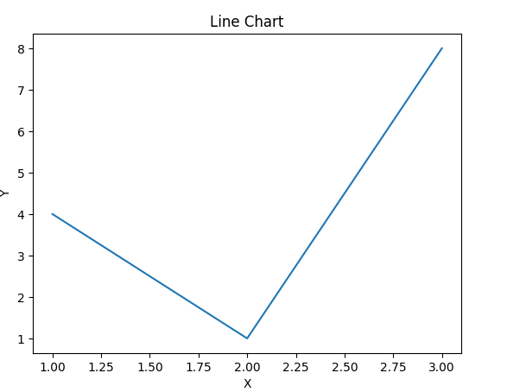

Seaborn is used for quick and beautiful visualizations with less code

BARCHART:

plt. bar(x, y, color='green')
sns. barplot(data=df, x='Category', y='Value')

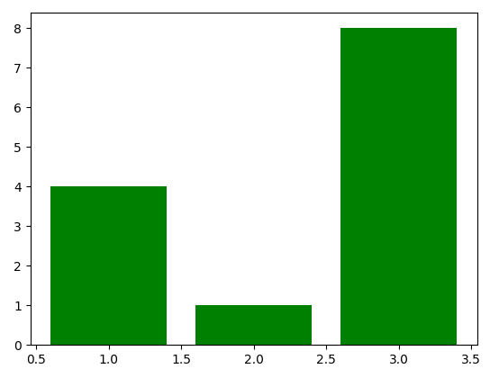

HISTOGRAM

plt. hist(data, bins=5, color='orange')
sns. histplot(data, bins=5, color='orange')

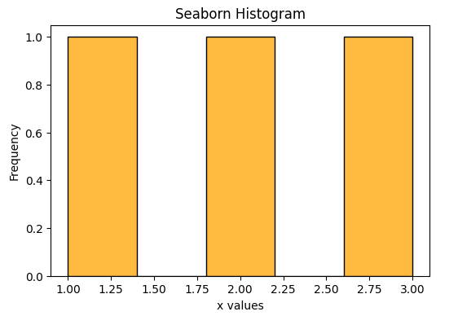

SCATTERPLOT

plt. scatter(x, y, color='red')
sns. scatterplot(data=df, x='x', y='y', color='red')
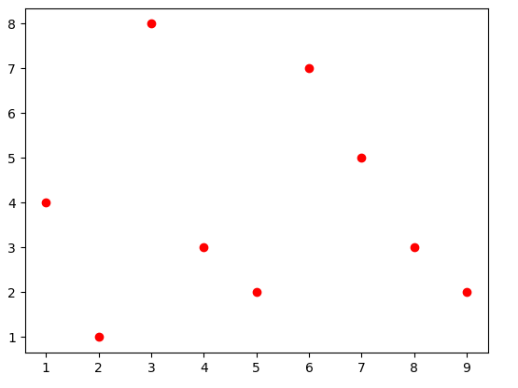

SUBPLOT:

Subplots are used to plot multiples plots in one figure
import matplotlib. pyplot as plt

x = [1, 2, 3, 4]
y1 = [10, 20, 25, 30]
y2 = [5, 15, 20, 22]

plt. figure(figsize=(10, 4))

plt. subplot(1, 2, 1)
plt. plot(x, y1, color='blue')
plt. title("Plot 1")
plt. xlabel("X1")
plt. ylabel("Y1")

plt. subplot(1, 2, 2)
plt. plot(x, y2, color='green')
plt. title("Plot 2")
plt. xlabel("X2")
plt. ylabel("Y2")

plt. tight_layout()
plt. show()

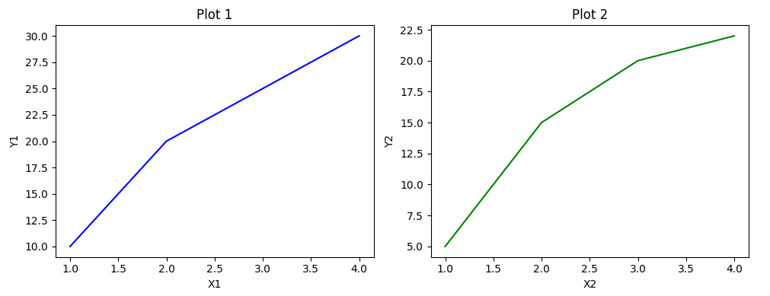

DISTPLOT

The distplot() function in Seaborn was used to visualize the distribution of a single variable, combining a histogram and a density curve (KDE).

A heatmap represents numerical values in a grid, like matrix

Savingfig
plt. savefig("plot. png")

Correlation matrix heatmaps

import seaborn as sns
import matplotlib. pyplot as plt
df = sns. load_dataset("iris")
corr_matrix = df. corr(numeric_only=True)

plt. figure(figsize=(8, 6))
sns. heatmap(corr_matrix, annot=True, cmap="coolwarm", linewidths=0.5)
plt. title("Correlation Matrix Heatmap - Iris Dataset")
Plt.show()

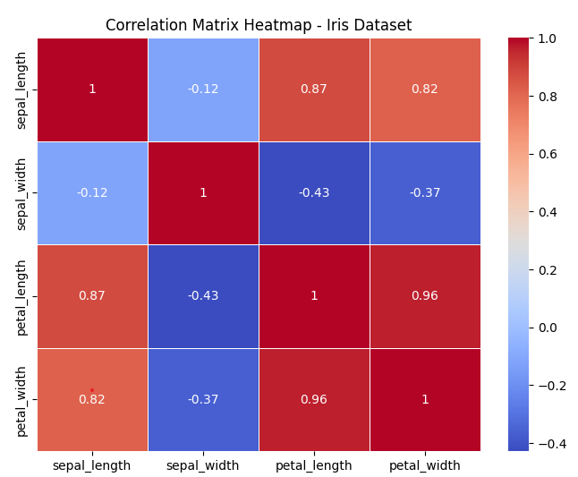

Scikit-learn:It provide tools for classification, regression, clustering, dimensionality reduction, preprocessing
Loading datasets (Iris, Digits, etc)
from sklearn. datasets import load_iris

data = load_iris()
X = data. data
y = data. target

Preprocessing:This is essential step in ml it will clean and transform the raw data

StandardScaler:standardize numeric features

from sklearn. preprocessing import StandardScaler
import numpy as np

X = np. array([[10. 0, 100. 0],
[20. 0, 300. 0],
[15. 0, 250. 0]])

scaler = StandardScaler()
X_scaled = scaler. fit_transform(X)

print("Scaled Data: \n", X_scaled)

It transfroms to mean=0, std=1

LabelEncoder:It converts categorical to numeric data

from sklearn. preprocessing import LabelEncoder

y = ['cat', 'dog', 'dog', 'fish', 'cat']

encoder = LabelEncoder()
print(encoder)

O/p: [0 1 1 2 0]

Onehot encoder :converts the categorical data to binary values

TRAIN/TEST

from sklearn. model_selection import train_test_split

X_train, X_test, y_train, y_test = train_test_split(X, y, test_size=0. 2, random_state=42)

Fitting basic models

LinearRegression for regression tasks

from sklearn. linear_model import LinearRegression
model = LinearRegression()
model. fit(X_train, y_train)
y_pred = model. predict(X_test)

KNN is used for classifications tasks

from sklearn. neighbors import KNeighborsClassifier
knn = KNeighborsClassifier(n_neighbors=3)
knn. fit(X_train, y_train)
y_pred = knn. predict(X_test)

MODEL EVALUATION: It is used to evaluate the performance of traiined model using accuracy , precision, recall, f1score

print("Accuracy: ", accuracy_score(y_test, y_pred))
print("\nConfusion Matrix: \n", confusion_matrix(y_test, y_pred))

Git Commands
git init---initializes repository

Git add main. py ---it will add to repository

Git add . ---adds all the files

Git comit “message”---saves

Git push origin main

Git pull orin main

Git Branch---it is like a separate work space you can make changes without affecting the main code

Git Merge----It means combining changes from one branch to another

Git log---gives all the history of the repository like author date commit message

git diff---it shows the differnce of changes made

git diff commit1 commit2--- changes made between two commits

git stash---without commit you can save your work temporarily

RESOLVE CONFLICT

First need to edit the file manually

git add file. txt

And then commit
Git commit “…. ”
And then check for conficts using the command git status

Linear Algebra

Scalar-single number
Vector-1d array
Matrix-2d array
Tensor-nd array

Matrix operations

- Addition
A = np. array([[1, 2], [3, 4]])
B = np. array([[5, 6], [7, 8]])

C = A + B
Print c

- Multiplication
C = A @ B or c=np. dot(a, b)

- Transpose
A=A. T

DOT PRODUCT AND CROSS PRODUCT

Dot product is used for 1d, 2d, 3d
Np. dot(a, b)
Here the result is scalar

Cross product is used only for 3d
Np. cross(a, b)
Here the result is vector

Determinant
det = np. linalg. det(A)

Inverse
inv = np. linalg. inv(A)

Eigen values and eigen vectors
eigenvalues, eigenvectors = np. linalg. eig(A)

print("Eigenvalues: \n", eigenvalues)
print("Eigenvectors: \n", eigenvectors)

Matrix decomposition

LU--Lower upper Triangle decomposition
import numpy as np
from scipy. linalg import lu

A = np. array([[2, 3],
[5, 4]])

P, L, U = lu(A)

print("L: \n", L)
print("U: \n", U)

QR--Orthogonal , Upper traingle decomposition

A = np. array([[1, 2],
[3, 4]])

Q, R = np. linalg. qr(A)

print("Q: \n", Q)
print("R: \n", R)

SVD--Singular value decomposition
U, S, Vt = np. linalg. svd(A)

Solving

X = np. linalg. solve(A, B)

PROBABILITY:

Random Variable:
It is numerical outcome of random process example tossing a coin X=1--heads
X=2--tail where X is a random variable

CONDITIONAL PROBABILITY

The probability of an event A happening given that event B has already occurred.

P(A∣B)=P(A∩B)/P(B)

BAYES THEORM

is used to determine the conditional probability of event A when event B has already occurred.
· P(A∣B)=P(B∣A)P(A)/P(B )

Mean (Expected Value)

Average outcome of an random variable
Mean (E[X])=∑xi P(xi)

Variance
Var(X)=∑P(xi)(xi−μ)2

STATISTICS

A Confidence Interval (CI) is a range of values that contains the true value of something we are trying to measure like the average height of students or average income of a population

HYPOTHESIS TESTING-

a statistical method used to make decisions or inferences about a population based on sample data

Null Hypothesis (H0):
This is a statement of no effect or no difference. it dissaprove the statement

Alternative Hypothesis (Ha or H1):
This is the statement that contradicts the null hypothesis.

Sampling is the process of selecting a subset (sample) from a larger population to estimate characteristics of the whole group.

Simple Random Sampling: Every member has an equal chance.

Stratified Sampling:

Population is divided into strata (groups), and samples are taken from each group.

Systematic Sampling :

Choose every kth item from a list.

Cluster Sampling :

Divide population into clusters, randomly select some clusters, and survey all members in them

