Supervised Learning

Defination
It is a type of machine learning where a model is trained on labeled data—meaning each input is paired with the correct output.that is, data that includes both the input features (X) and the correct output (Y).The goal of supervised learning is to make accurate predictions when given new, unseen data.

INTUTION:
Think of it like teaching a child. You show them examples of labeled objects (e.g., a picture of an apple with the label "apple"). The child learns to associate the visual characteristics of the apple with the label "apple". Later, when presented with a new, unseen apple, the child can correctly identify it as an apple.

Types
1.Classification:Where the output is a categorical variable (e.g., spam vs. non-spam emails, yes vs. no).

- Regression:Where the output is a continuous variable (e.g., predicting house prices, stock prices).

Labelled Data

Labeled data is data that contains both input features (X) and the corresponding output or target labels (Y). It is essential for supervised learning, where the goal is to train models to predict outputs based on inputs.

Importance:
- Algorithms learn patterns by mapping inputs to known outputs.
Without Labels models cannot learn.
- Used to train models.
- used to evaluate model performance (accuracy, precision, etc.).
- It also gives high accuracy predictions and supports for real world applications.

How models learn from data

Machine learning models learn from data by identifying patterns and relationships between inputs (features) and outputs (labels) so they can make accurate predictions on new, unseen data.

First it will feed the labelled data like 0 is not spam and 1 is spam and then it calucate the error and then learn from it so it will give accurate predictions.

features and labels
from sklearn.datasets import load_iris

data = load_iris()
X = data.data
Y = data.target
print("Features shape:", X.shape)
print("Labels shape:", Y.shape)

Simple Linear Regression
Simple Linear Regression is a supervised machine learning algorithm used to predict a continuous numeric value based on a single input feature. It assumes a linear relationship between the input (X) and the output (y).

from sklearn.linear_model import LinearRegression
from sklearn.model_selection import train_test_split
import numpy as np

x = np.array([[1], [2], [3], [4], [5]])

y=np.array([40,50,60,65,70)]

X_train, X_test, y_train, y_test = train_test_split(X, y, test_size=0.2, random_state=42)

model = LinearRegression()
model.fit(X_train, y_train)

predictions = model.predict(X_test)
print("Predicted Marks:", predictions)

Logistic Regression
Logistic Regression is a classification algorithm used to predict binary outcomes (e.g., yes/no, pass/fail, spam/not spam).--mainly used for classification tasks.

from sklearn.linear_model import LogisticRegression
from sklearn.model_selection import train_test_split
import numpy as np

X = np.array([[1], [2], [3], [4], [5]])
y=np.array([0,0,1,1,1])

X_train, X_test, y_train, y_test = train_test_split(X, y, test_size=0.2, random_state=42)

model = LogisticRegression()
model.fit(X_train, y_train)

predictions = model.predict(X_test)
print("Predicted Outcome (Pass=1, Fail=0):", predictions)

Unsupervised Learning
Unsupervised learning is a branch of machine learning that deals with unlabeled data. It works by analyzing unlabeled data to identify patterns and relationships.It has only input no outputs.

Importance of unlabeled data

Unlabeled data (e.g., images, text, logs) is easily available in large volumes from the real world.
Used in NLP, medical imaging.

Clustering
Clustering is an unsupervised learning technique that groups similar data points together without labels. Each group is called a cluster.

TYPES
KMeans: Partitions data into k groups by minimizing intra cluster distance .
DBSCAN: GroupsPoints Close Together,Identifies noise/outliers.
Hierarchical:Builds a tree of clusters.

Dimensionality Reduction :
Dimensionality reduction is the process of reducing the number of input features while preserving the important/relevant information as much as possible.It is mainly useful for reducing noise,speeding up the algorithms.

Techniques:

Principal component analysis: PCA aims to reduce the number of variables in a dataset while preserving the most important information. This is achieved by transforming the original variables into a new set of variables (principal components).it finds by caluculating eigen vectors and eigen values.---it is used to solve unsupervised classification problems

PCA is commonly used for data preprocessing for use with machine learning algorithms. It helps to remove redundancy, improve computational efficiency and make data easier to visualize and analyze especially when dealing with high-dimensional data.

Linear Discriminant Analysis :It helps to separate two or more classes by converting higher dimensional data to lower dimensional data.
It is used to solve supervised classification problems

import pandas as pd
import matplotlib.pyplot as plt
from sklearn.cluster import KMeans
from sklearn.preprocessing import StandardScaler

df = pd.read_csv("/content/Mall_Customers (1).csv")
X = df[['Annual Income (k$)', 'Spending Score (1-100)']]
scaler = StandardScaler()
X_scaled = scaler.fit_transform(X)
kmeans = KMeans(n_clusters=5, random_state=42)
df['Cluster'] = kmeans.fit_predict(X_scaled)
plt.figure(figsize=(8, 6))
plt.scatter(df['Annual Income (k$)'], df['Spending Score (1-100)'],
c=df['Cluster'], cmap='viridis', s=60, edgecolor='k')

plt.title('Customer Segmentation using KMeans')
plt.xlabel('Annual Income (k$)')
plt.ylabel('Spending Score (1–100)')
plt.grid(True)
plt.show()

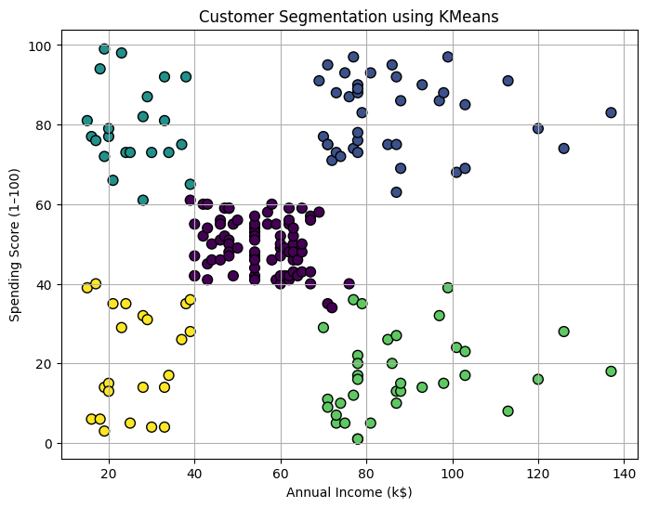
The graph here generated is based on customers spending and their income like high income low spenders,low income high spenders.

Visualize clusters using PCA or t-SNE

PCA:

import pandas as pd
import matplotlib.pyplot as plt
from sklearn.preprocessing import StandardScaler
from sklearn.decomposition import PCA

df = pd.read_csv("Mall_Customers.csv")

X = df[['Annual Income (k₹)', 'Spending Score (1-100)']]

scaler = StandardScaler()
X_scaled = scaler.fit_transform(X)
pca = PCA(n_components=2)
X_pca = pca.fit_transform(X_scaled)
plt.figure(figsize=(6, 5))
plt.scatter(X_pca[:, 0], X_pca[:, 1], color='orange', edgecolor='k')
plt.title("PCA Visualization of Customers")
plt.xlabel("PCA Component 1")
plt.ylabel("PCA Component 2")
plt.grid(True)
plt.show()

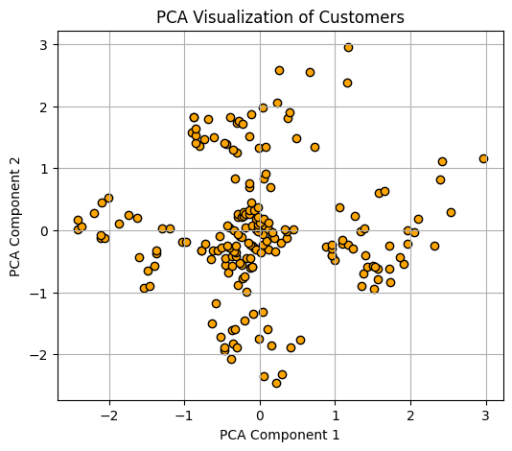

t-SNE:
t-distributed Stochastic Neighbor Embedding.It is non linearity dimension reduction technique mainly used for visualizing high dimension data in 2 or 3 dimensions.

import pandas as pd
import matplotlib.pyplot as plt
from sklearn.preprocessing import StandardScaler
from sklearn.manifold import TSNE

df = pd.read_csv("Mall_Customers.csv")
X = df[['Annual Income (k₹)', 'Spending Score (1-100)']]

scaler = StandardScaler()
X_scaled = scaler.fit_transform(X)

tsne = TSNE(n_components=2, perplexity=30, n_iter=300, random_state=42)
X_tsne = tsne.fit_transform(X_scaled)

plt.figure(figsize=(6, 5))
plt.scatter(X_tsne[:, 0], X_tsne[:, 1], color='teal', edgecolor='k')
plt.title("t-SNE Visualization of Customers")
plt.xlabel("t-SNE Dimension 1")
plt.ylabel("t-SNE Dimension 2")
plt.grid(True)
plt.show()

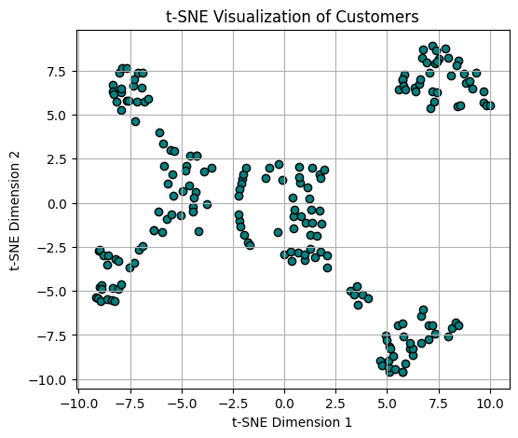
---------------------------------------------------------------------

Heirarchical Clustering:
It Builds a heirarchy of clusters tree like structure .you doesnot require to specify the number of clusters like k means,It will merge the clusters until all the points in big clusters.

import pandas as pd
import matplotlib.pyplot as plt
from sklearn.preprocessing import StandardScaler
from scipy.cluster.hierarchy import dendrogram, linkage, fcluster
df = pd.read_csv("/content/Mall_Customers (1).csv")
X = df[['Annual Income (k$)', 'Spending Score (1-100)']]

scaler = StandardScaler()
X_scaled = scaler.fit_transform(X)
linked = linkage(X_scaled, method='ward')

plt.figure(figsize=(10, 5))
dendrogram(linked, orientation='top', distance_sort='descending', show_leaf_counts=False)
plt.title("Hierarchical Clustering Dendrogram")
plt.xlabel("Samples")
plt.ylabel("Euclidean Distance")
plt.grid(True)
plt.show()

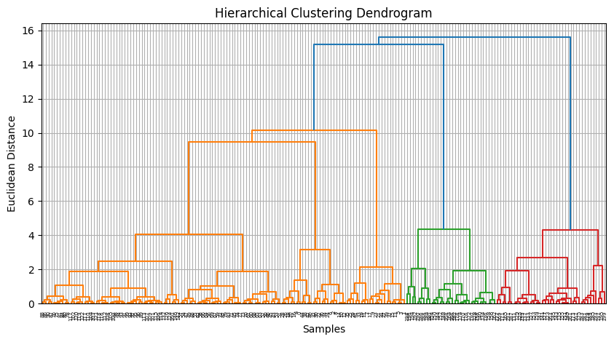

DBSCAN Clustering:
Density based spatial clustering Applications with Noise,It Is a powerful algorithm it groups datapoints based on density,it identifies clusters of varying shapes and effectivly handle noise.

from sklearn.cluster import DBSCAN

dbscan = DBSCAN(eps=0.5, min_samples=5)
df['DBSCAN_Cluster'] = dbscan.fit_predict(X_scaled)

plt.figure(figsize=(6, 5))
plt.scatter(df['Annual Income (k$)'], df['Spending Score (1-100)'],
c=df['DBSCAN_Cluster'], cmap='rainbow', edgecolor='k')
plt.title("DBSCAN Clustering Results")
plt.xlabel("Annual Income (k₹)")
plt.ylabel("Spending Score (1-100)")
plt.grid(True)
plt.show()

Reinforcement Learning
It is a type of machine learning where an agent learns to make descisions by interacting with an environment to achieve a goal.Here the agent learn based on actions,receiving penalities and rewards and from the experience.

Agent:The decision maker that performs actions.
Environment:The system where the agent works.
Reward:The feedback or the result based from the environment based agents action.
State: The situation or condition where the agent currently in.

RL VS SL VS USL
RL:It will learns from the action By interacting with environment.it is like trail and error.
SL:Learns from labelled data .The main goal is to predict the output.
USL:Learns from unlabelled data.The main goal is to find hidden patterns or grouping from data.

QLearning:
It is an reinforcement learning algorithm aims to find an best action given current state.It finds the best action by caluculating the q values.

Policy based Method:
it directly learn a policy (the strategy for choosing actions) without relying on estimating the value of states or action.policy is nothing but
A mapping from states to actions, determining what action an agent should take in a given state.

Classification vs Regression

Both classification and regression comes under supervised learning tasks where classification predicts discrete values and regression predicts continous values.

Classification--It categorize data points into categories like spam,not spam.
Regression--It predicts a continous numeric value.

Discrete Vs Continous
Discrete has distinct,separate values and also has gap between them.
It can be integers or categories.like no of students,categories like colors.

Continous has continous values,It includes fractions decimals like Temeprature,Height,time.

Discrete is measurable,continous is countable.

When to apply regression or classification:

Choosing between classification or regression depends on type of the output if it is category apply classification,if it is a number apply regression.

Classification use cases:
Email---spam,not spam
Fraud detection
Object recognition
Education-pass,fail

Regression usecases:
Real estate--house price prediction
Call centers --customer wait time
Education--Predict exam score

Linear regression vs Logistic regression:

Linear regression predicts a contionus output,like predicting house price based on size,location etc.

Logistic regression predicts a categorical variable,Like yes/no ,true/false.

Visualize prediction boundaries and curves:
import matplotlib.pyplot as plt
import numpy as np
from sklearn.linear_model import LogisticRegression
from sklearn.datasets import load_iris
from sklearn.model_selection import train_test_split
X = X[:, :2] # only first two features

# Train-test split
X_train, X_test, y_train, y_test = train_test_split(X, y, test_size=0.3, random_state=42)

# Train model
model = LogisticRegression()
model.fit(X_train, y_train)

# Plotting
h = 0.02
x_min, x_max = X[:, 0].min() - 1, X[:, 0].max() + 1
y_min, y_max = X[:, 1].min() - 1, X[:, 1].max() + 1
xx, yy = np.meshgrid(np.arange(x_min, x_max, h), np.arange(y_min, y_max, h))
Z = model.predict(np.c_[xx.ravel(), yy.ravel()])
Z = Z.reshape(xx.shape)

plt.figure(figsize=(8, 6))
plt.contourf(xx, yy, Z, alpha=0.4, cmap=plt.cm.Paired)
plt.scatter(X[:, 0], X[:, 1], c=y, edgecolors='k', cmap=plt.cm.Paired)
plt.xlabel("Feature 1")
plt.ylabel("Feature 2")
plt.title("Classification Decision Boundary")
plt.show()

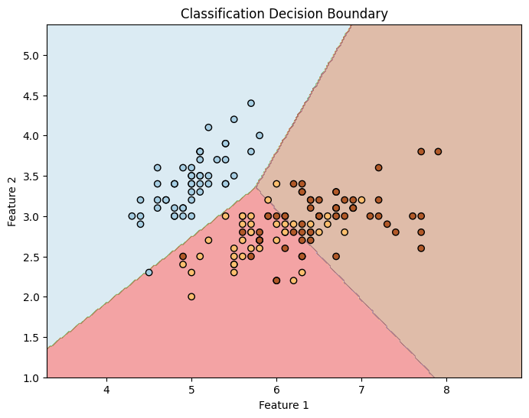

Clustering

Clustering in unsupervised learning technique used to group similar data points based on similarity or distance measures like euclidean,manhattan
Similar points falls into same cluster,dissimilar points falls on different clusters. It is useful when you don’t have labelled data.

KMeans:
Kmeans is a entroid based algorithm.It divides the data into kgroups such that points in the same group are similar.

It first chooses k number of clusters,and then randomly chooses k centroids assign each point to nearest centroid.

Agglomerative Clustering:

It is also known as heirarchical clustering(groups data into tree of nested clusters).each point starts as an its own cluster and pairs of clusters are merged step by step based on distance.

First it start as an n individual clusters ,computes distances between all clusters and then merges the closest clusters repeat until the big cluster forms.

Perform Kmeans on different datasets
from sklearn.datasets import load_iris
from sklearn.cluster import KMeans
import pandas as pd
import seaborn as sns
import matplotlib.pyplot as plt

# Load dataset
iris = load_iris()
df = pd.DataFrame(iris.data, columns=iris.feature_names)

# Apply KMeans
kmeans = KMeans(n_clusters=3, random_state=0)
df['cluster'] = kmeans.fit_predict(df)

# Visualize (2 features only)
sns.scatterplot(data=df, x='sepal length (cm)', y='sepal width (cm)', hue='cluster', palette='Set2')
plt.title("KMeans on Iris Dataset")
plt.show()

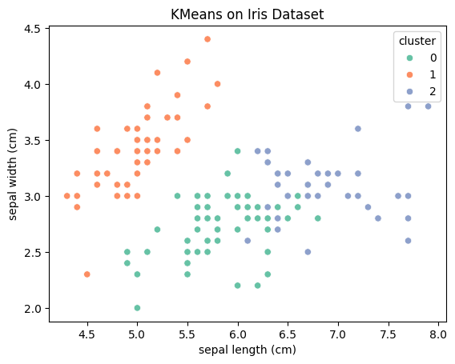

df = pd.read_csv("/content/Mall_Customers (1).csv") # Must contain 'Annual Income (k₹)' and 'Spending Score (1-100)'

# Select relevant features
X = df[['Annual Income (k$)', 'Spending Score (1-100)']]
# Apply KMeans
kmeans = KMeans(n_clusters=5, random_state=0)
df['cluster'] = kmeans.fit_predict(X)
# Visualize clusters
sns.scatterplot(data=df, x='Annual Income (k$)', y='Spending Score (1-100)', hue='cluster', palette='tab10')
plt.title("KMeans Clustering on Mall Customers")
plt.show()
# Must contain 'Annual Income (k₹)' and 'Spending Score (1-100)'
# Select relevant features
X = df[['Annual Income (k$)', 'Spending Score (1-100)']]
# Apply KMeans
kmeans = KMeans(n_clusters=5, random_state=0)
df['cluster'] = kmeans.fit_predict(X)
# Visualize clusters
sns.scatterplot(data=df, x='Annual Income (k$)', y='Spending Score (1-100)', hue='cluster', palette='tab10')
plt.title("KMeans Clustering on Mall Customers")
plt.show()

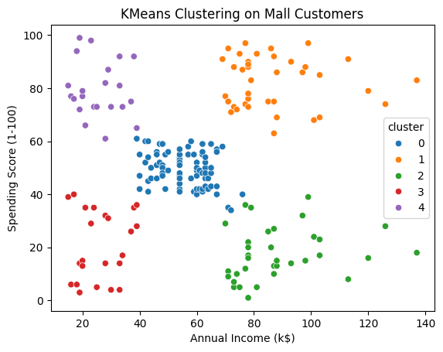

Evaluation of Clusters:
Evaluation is nothing but assessing the quality of grouping and understanding the characterstics of each cluster.

Evaluation is done based on silhoutte score,Davies Bouldin index
If score is 1 indicates perfect clustering,0 indicates overlapping clustering -1 indicates misclassified data points.

Bias-Variance Tradeoff :
Bias:When a model makes incorrect assumptions then bias occurs.
It is the difference between actual value and predicted value.It leads to underfitting.

Variance:Variance is an error caused by an algorithm that is too sensitive to fluctuations in data.

Bias-variance tradeoff--It is used to find the balance between error introduced by bias and error introduced by variance. If you increase model complexity bias increases variance decreases.if you decrease model complexity bias decreases variance increases so we need balance between bias and variance .Mainly bias variance tradeoff is used for minimizing the errors caused by oversimplification.

Impact on model:
Using variance and bias it helps to understand how well ml model is performing and how well it will perform on unseen data.

import numpy as np
import matplotlib.pyplot as plt
from sklearn.preprocessing import PolynomialFeatures
from sklearn.linear_model import LinearRegression
from sklearn.metrics import mean_squared_error
from sklearn.model_selection import train_test_split

# 1. Generate synthetic non-linear data
np.random.seed(0)
X=np.sort(5*np.random.rand(80,1),axis=0)
y = np.sin(X).ravel() + np.random.normal(0, 0.2, X.shape[0])
# 2. Split into training and test sets
X_train, X_test, y_train, y_test = train_test_split(X, y, test_size=0.3, random_state=42)
# 3. Initialize error lists
train_errors = []
test_errors = []
degrees = range(1, 15) # increasing model complexity
# 4. Train and evaluate models of increasing complexity
for degree in degrees:
poly = PolynomialFeatures(degree)
X_train_poly = poly.fit_transform(X_train)
X_test_poly = poly.transform(X_test)
model = LinearRegression()
model.fit(X_train_poly, y_train)
y_train_pred = model.predict(X_train_poly)
y_test_pred = model.predict(X_test_poly)
train_errors.append(mean_squared_error(y_train, y_train_pred))
test_errors.append(mean_squared_error(y_test, y_test_pred))

# 5. Plot training vs test error
plt.figure(figsize=(10, 6))
plt.plot(degrees, train_errors, label='Training Error', marker='o')
plt.plot(degrees, test_errors, label='Test Error', marker='s')
plt.title('Training vs Test Error with Increasing Model Complexity')
plt.xlabel('Model Complexity (Polynomial Degree)')
plt.ylabel('Mean Squared Error')
plt.legend()
plt.grid(True)
plt.tight_layout()
plt.show()
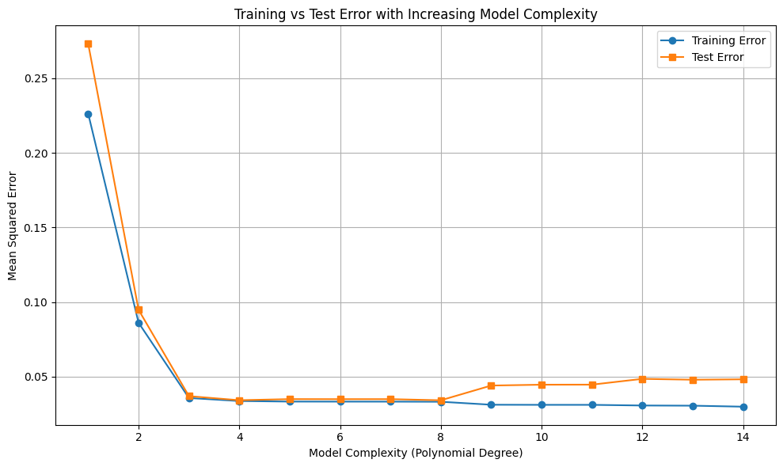

Use polynomial regression to show underfitting and overfitting
import numpy as np
import matplotlib.pyplot as plt
from sklearn.preprocessing import PolynomialFeatures
from sklearn.linear_model import LinearRegression
from sklearn.model_selection import train_test_split

# 1. Generate synthetic dataset
np.random.seed(0)
X = np.sort(5 * np.random.rand(80, 1), axis=0)
y = np.sin(X).ravel() + np.random.normal(0, 0.2, X.shape[0])

# 2. Split into training and testing data
X_train, X_test, y_train, y_test = train_test_split(X, y, test_size=0.3, random_state=42)

# 3. Choose degrees to demonstrate underfitting, good fit, and overfitting
degrees_to_plot = [1, 4, 12] # Low, medium, high complexity

# 4. Plot predictions for each degree
plt.figure(figsize=(18, 5))

for i, degree in enumerate(degrees_to_plot, 1):
poly = PolynomialFeatures(degree)
X_poly = poly.fit_transform(X)

model = LinearRegression()
model.fit(poly.fit_transform(X_train), y_train)
y_pred = model.predict(X_poly)
# Plot results
plt.subplot(1, 3, i)
plt.scatter(X, y, color='gray', label='Original Data')
plt.plot(X, y_pred, color='red', label=f'Polynomial Degree = {degree}')
plt.title(f'Degree {degree}: Model Complexity')
plt.xlabel('X')
plt.ylabel('y')
plt.legend()
plt.grid(True)
plt.suptitle('Underfitting vs Good Fit vs Overfitting (Polynomial Regression)', fontsize=16)
plt.tight_layout()
plt.show()

how regularization reduces variance:

Regulariazation reduces variance by preventing a machine from becoming overly complex and fitting the noise in training data.This was done by adding penality to loss function it discourage the model from assigning large weights to any feature.

Underfitting vs Overfitting
Over Fitting: overfitting occurs when a model learns too much from the training data including noise,outliers.it leads to excellent performance on training data,But poor performance on new unseen data(test data).

Underfitting:Underfitting occurs when model is too simple to capture the underlying patterns in data.results in poor performance in both training and test data.it has limited training data.

How to detect and mitigate underfitting and overfitting:
You can detect by looking how well it performs on new data.
You can mitigate by using simple/complex model ,adding/ removing features reducing/applying regularizations.
Pruning:
Pruning is the technique used to simplify models by removing unecessary components like branches in decision trees or reduntant weights in neural network

Cross-Validation:
Cross validation is the technique used to evaluate the performance of models on unseen data by splitting data multiple times in training and testing data. The main purpose of cross validation is to prevent overfitting.

KFold Cross-Validation:
It splits the data into k equal folds and runs k iterations each time uses a different fold as test set remaining k-1 folds as training set.

Stratified cross validation:
Same like k fold cross validation but it is useful when class labels are not evenly distributed.i.e data is imbalanced.

LOOCV:
Same like k fold cross validation here no of folds is equal to no of datapoints(1row=1 data point).

Implement k-fold CV on multiple ML models

from sklearn.datasets import load_iris
from sklearn.model_selection import KFold, cross_val_score
from sklearn.linear_model import LogisticRegression
from sklearn.tree import DecisionTreeClassifier
from sklearn.svm import SVC
from sklearn.naive_bayes import GaussianNB
import numpy as np

# Load the Iris dataset
X, y = load_iris(return_X_y=True)

# Define multiple models to evaluate
models = {
"Logistic Regression": LogisticRegression(max_iter=1000),
"Decision Tree": DecisionTreeClassifier(),
"SVM": SVC(),
"Naive Bayes": GaussianNB()
}

# Initialize 5-Fold cross-validation
kfold = KFold(n_splits=5, shuffle=True, random_state=42)

# Evaluate each model
results = {}
for name, model in models.items():
scores = cross_val_score(model, X, y, cv=kfold, scoring='accuracy')
results[name] = (np.round(scores, 3), scores.mean())

# Print the results
for name, (fold_scores, avg_score) in results.items():
print(f"{name}:\n Fold Accuracies: {fold_scores}\n Mean Accuracy: {avg_score:.3f}\n")

OUTPUT:
Logistic Regression: Fold Accuracies: [1. 1. 0.933 0.967 0.967]
Mean Accuracy: 0.973
Decision Tree: Fold Accuracies: [1. 0.967 0.933 0.933 0.933]
Mean Accuracy: 0.953
SVM: Fold Accuracies: [1. 1. 0.933 0.933 0.967]
Mean Accuracy: 0.967
Naive Bayes: Fold Accuracies: [1. 0.967 0.933 0.967 0.933]
Mean Accuracy: 0.960

Train/Test Split:
we split data into training and testing sets to evaluate the how well a model perform on new unseen data.

Training set:used to teach the model-helps to learn the relationship between input features and output labels.
Testing set:used to evaluate the model.

When we use validation set?

If you want to tune the model then we use validation set.

Experiment with different ratios (70-30, 80-20):
from sklearn.datasets import load_iris
from sklearn.linear_model import LogisticRegression
from sklearn.model_selection import train_test_split
from sklearn.metrics import accuracy_score

# Load dataset
X, y = load_iris(return_X_y=True)

# Try different splits
for ratio in [0.3, 0.2]:
X_train, X_test, y_train, y_test = train_test_split(X, y, test_size=ratio, random_state=42, stratify=y)

model = LogisticRegression(max_iter=1000)
model.fit(X_train, y_train)

y_pred = model.predict(X_test)
accuracy = accuracy_score(y_test, y_pred)

print(f"\n📊 Classification (Test size: {int(ratio*100)}%):")
print(f"Train samples: {len(X_train)}, Test samples: {len(X_test)}")
print(f"Accuracy: {accuracy:.2f}"
)

OUTPUT:
Classification (Test size: 30%):
Train samples: 105, Test samples: 45 Accuracy: 0.93
Classification (Test size: 20%):
Train samples: 120, Test samples: 30 Accuracy: 0.97

Random state:

Random_state is used to control the randomness in algorithms like splitting data,intializing weights so that it produces same results every tme you run the code.

Supervised Learning

Defination
It is a type of machine learning where a model is trained on labeled data—meaning each input is paired with the correct output.that is, data that includes both the input features (X) and the correct output (Y).The goal of supervised learning is to make accurate predictions when given new, unseen data.

INTUTION:
Think of it like teaching a child. You show them examples of labeled objects (e.g., a picture of an apple with the label "apple"). The child learns to associate the visual characteristics of the apple with the label "apple". Later, when presented with a new, unseen apple, the child can correctly identify it as an apple.

Types
1.Classification:Where the output is a categorical variable (e.g., spam vs. non-spam emails, yes vs. no).

- Regression:Where the output is a continuous variable (e.g., predicting house prices, stock prices).

Labelled Data

Labeled data is data that contains both input features (X) and the corresponding output or target labels (Y). It is essential for supervised learning, where the goal is to train models to predict outputs based on inputs.

Importance:
- Algorithms learn patterns by mapping inputs to known outputs.
Without Labels models cannot learn.
- Used to train models.
- used to evaluate model performance (accuracy, precision, etc.).
- It also gives high accuracy predictions and supports for real world applications.

How models learn from data

Machine learning models learn from data by identifying patterns and relationships between inputs (features) and outputs (labels) so they can make accurate predictions on new, unseen data.

First it will feed the labelled data like 0 is not spam and 1 is spam and then it calucate the error and then learn from it so it will give accurate predictions.

features and labels
from sklearn.datasets import load_iris

data = load_iris()
X = data.data
Y = data.target
print("Features shape:", X.shape)
print("Labels shape:", Y.shape)

Simple Linear Regression
Simple Linear Regression is a supervised machine learning algorithm used to predict a continuous numeric value based on a single input feature. It assumes a linear relationship between the input (X) and the output (y).

from sklearn.linear_model import LinearRegression
from sklearn.model_selection import train_test_split
import numpy as np

x = np.array([[1], [2], [3], [4], [5]])

y=np.array([40,50,60,65,70)]

X_train, X_test, y_train, y_test = train_test_split(X, y, test_size=0.2, random_state=42)

model = LinearRegression()
model.fit(X_train, y_train)

predictions = model.predict(X_test)
print("Predicted Marks:", predictions)

Logistic Regression
Logistic Regression is a classification algorithm used to predict binary outcomes (e.g., yes/no, pass/fail, spam/not spam).--mainly used for classification tasks.

from sklearn.linear_model import LogisticRegression
from sklearn.model_selection import train_test_split
import numpy as np

X = np.array([[1], [2], [3], [4], [5]])
y=np.array([0,0,1,1,1])

X_train, X_test, y_train, y_test = train_test_split(X, y, test_size=0.2, random_state=42)

model = LogisticRegression()
model.fit(X_train, y_train)

predictions = model.predict(X_test)
print("Predicted Outcome (Pass=1, Fail=0):", predictions)

Unsupervised Learning
Unsupervised learning is a branch of machine learning that deals with unlabeled data. It works by analyzing unlabeled data to identify patterns and relationships.It has only input no outputs.

Importance of unlabeled data

Unlabeled data (e.g., images, text, logs) is easily available in large volumes from the real world.
Used in NLP, medical imaging.

Clustering
Clustering is an unsupervised learning technique that groups similar data points together without labels. Each group is called a cluster.

TYPES
KMeans: Partitions data into k groups by minimizing intra cluster distance .
DBSCAN: GroupsPoints Close Together,Identifies noise/outliers.
Hierarchical:Builds a tree of clusters.

Dimensionality Reduction :
Dimensionality reduction is the process of reducing the number of input features while preserving the important/relevant information as much as possible.It is mainly useful for reducing noise,speeding up the algorithms.

Techniques:

Principal component analysis: PCA aims to reduce the number of variables in a dataset while preserving the most important information. This is achieved by transforming the original variables into a new set of variables (principal components).it finds by caluculating eigen vectors and eigen values.---it is used to solve unsupervised classification problems

PCA is commonly used for data preprocessing for use with machine learning algorithms. It helps to remove redundancy, improve computational efficiency and make data easier to visualize and analyze especially when dealing with high-dimensional data.

Linear Discriminant Analysis :It helps to separate two or more classes by converting higher dimensional data to lower dimensional data.
It is used to solve supervised classification problems

import pandas as pd
import matplotlib.pyplot as plt
from sklearn.cluster import KMeans
from sklearn.preprocessing import StandardScaler

df = pd.read_csv("/content/Mall_Customers (1).csv")
X = df[['Annual Income (k$)', 'Spending Score (1-100)']]
scaler = StandardScaler()
X_scaled = scaler.fit_transform(X)
kmeans = KMeans(n_clusters=5, random_state=42)
df['Cluster'] = kmeans.fit_predict(X_scaled)
plt.figure(figsize=(8, 6))
plt.scatter(df['Annual Income (k$)'], df['Spending Score (1-100)'],
c=df['Cluster'], cmap='viridis', s=60, edgecolor='k')

plt.title('Customer Segmentation using KMeans')
plt.xlabel('Annual Income (k$)')
plt.ylabel('Spending Score (1–100)')
plt.grid(True)
plt.show()


The graph here generated is based on customers spending and their income like high income low spenders,low income high spenders.

Visualize clusters using PCA or t-SNE

PCA:

import pandas as pd
import matplotlib.pyplot as plt
from sklearn.preprocessing import StandardScaler
from sklearn.decomposition import PCA

df = pd.read_csv("Mall_Customers.csv")

X = df[['Annual Income (k₹)', 'Spending Score (1-100)']]

scaler = StandardScaler()
X_scaled = scaler.fit_transform(X)
pca = PCA(n_components=2)
X_pca = pca.fit_transform(X_scaled)
plt.figure(figsize=(6, 5))
plt.scatter(X_pca[:, 0], X_pca[:, 1], color='orange', edgecolor='k')
plt.title("PCA Visualization of Customers")
plt.xlabel("PCA Component 1")
plt.ylabel("PCA Component 2")
plt.grid(True)
plt.show()



t-SNE:
t-distributed Stochastic Neighbor Embedding.It is non linearity dimension reduction technique mainly used for visualizing high dimension data in 2 or 3 dimensions.

import pandas as pd
import matplotlib.pyplot as plt
from sklearn.preprocessing import StandardScaler
from sklearn.manifold import TSNE

df = pd.read_csv("Mall_Customers.csv")
X = df[['Annual Income (k₹)', 'Spending Score (1-100)']]

scaler = StandardScaler()
X_scaled = scaler.fit_transform(X)

tsne = TSNE(n_components=2, perplexity=30, n_iter=300, random_state=42)
X_tsne = tsne.fit_transform(X_scaled)

plt.figure(figsize=(6, 5))
plt.scatter(X_tsne[:, 0], X_tsne[:, 1], color='teal', edgecolor='k')
plt.title("t-SNE Visualization of Customers")
plt.xlabel("t-SNE Dimension 1")
plt.ylabel("t-SNE Dimension 2")
plt.grid(True)
plt.show()


---------------------------------------------------------------------

Heirarchical Clustering:
It Builds a heirarchy of clusters tree like structure .you doesnot require to specify the number of clusters like k means,It will merge the clusters until all the points in big clusters.

import pandas as pd
import matplotlib.pyplot as plt
from sklearn.preprocessing import StandardScaler
from scipy.cluster.hierarchy import dendrogram, linkage, fcluster
df = pd.read_csv("/content/Mall_Customers (1).csv")
X = df[['Annual Income (k$)', 'Spending Score (1-100)']]

scaler = StandardScaler()
X_scaled = scaler.fit_transform(X)
linked = linkage(X_scaled, method='ward')

plt.figure(figsize=(10, 5))
dendrogram(linked, orientation='top', distance_sort='descending', show_leaf_counts=False)
plt.title("Hierarchical Clustering Dendrogram")
plt.xlabel("Samples")
plt.ylabel("Euclidean Distance")
plt.grid(True)
plt.show()



DBSCAN Clustering:
Density based spatial clustering Applications with Noise,It Is a powerful algorithm it groups datapoints based on density,it identifies clusters of varying shapes and effectivly handle noise.

from sklearn.cluster import DBSCAN

dbscan = DBSCAN(eps=0.5, min_samples=5)
df['DBSCAN_Cluster'] = dbscan.fit_predict(X_scaled)

plt.figure(figsize=(6, 5))
plt.scatter(df['Annual Income (k$)'], df['Spending Score (1-100)'],
c=df['DBSCAN_Cluster'], cmap='rainbow', edgecolor='k')
plt.title("DBSCAN Clustering Results")
plt.xlabel("Annual Income (k₹)")
plt.ylabel("Spending Score (1-100)")
plt.grid(True)
plt.show()

Reinforcement Learning
It is a type of machine learning where an agent learns to make descisions by interacting with an environment to achieve a goal.Here the agent learn based on actions,receiving penalities and rewards and from the experience.

Agent:The decision maker that performs actions.
Environment:The system where the agent works.
Reward:The feedback or the result based from the environment based agents action.
State: The situation or condition where the agent currently in.

RL VS SL VS USL
RL:It will learns from the action By interacting with environment.it is like trail and error.
SL:Learns from labelled data .The main goal is to predict the output.
USL:Learns from unlabelled data.The main goal is to find hidden patterns or grouping from data.

QLearning:
It is an reinforcement learning algorithm aims to find an best action given current state.It finds the best action by caluculating the q values.

Policy based Method:
it directly learn a policy (the strategy for choosing actions) without relying on estimating the value of states or action.policy is nothing but
A mapping from states to actions, determining what action an agent should take in a given state.

Classification vs Regression

Both classification and regression comes under supervised learning tasks where classification predicts discrete values and regression predicts continous values.

Classification--It categorize data points into categories like spam,not spam.
Regression--It predicts a continous numeric value.

Discrete Vs Continous
Discrete has distinct,separate values and also has gap between them.
It can be integers or categories.like no of students,categories like colors.

Continous has continous values,It includes fractions decimals like Temeprature,Height,time.

Discrete is measurable,continous is countable.

When to apply regression or classification:

Choosing between classification or regression depends on type of the output if it is category apply classification,if it is a number apply regression.

Classification use cases:
Email---spam,not spam
Fraud detection
Object recognition
Education-pass,fail

Regression usecases:
Real estate--house price prediction
Call centers --customer wait time
Education--Predict exam score

Linear regression vs Logistic regression:

Linear regression predicts a contionus output,like predicting house price based on size,location etc.

Logistic regression predicts a categorical variable,Like yes/no ,true/false.

Visualize prediction boundaries and curves:
import matplotlib.pyplot as plt
import numpy as np
from sklearn.linear_model import LogisticRegression
from sklearn.datasets import load_iris
from sklearn.model_selection import train_test_split
X = X[:, :2] # only first two features

# Train-test split
X_train, X_test, y_train, y_test = train_test_split(X, y, test_size=0.3, random_state=42)

# Train model
model = LogisticRegression()
model.fit(X_train, y_train)

# Plotting
h = 0.02
x_min, x_max = X[:, 0].min() - 1, X[:, 0].max() + 1
y_min, y_max = X[:, 1].min() - 1, X[:, 1].max() + 1
xx, yy = np.meshgrid(np.arange(x_min, x_max, h), np.arange(y_min, y_max, h))
Z = model.predict(np.c_[xx.ravel(), yy.ravel()])
Z = Z.reshape(xx.shape)

plt.figure(figsize=(8, 6))
plt.contourf(xx, yy, Z, alpha=0.4, cmap=plt.cm.Paired)
plt.scatter(X[:, 0], X[:, 1], c=y, edgecolors='k', cmap=plt.cm.Paired)
plt.xlabel("Feature 1")
plt.ylabel("Feature 2")
plt.title("Classification Decision Boundary")
plt.show()



Clustering

Clustering in unsupervised learning technique used to group similar data points based on similarity or distance measures like euclidean,manhattan
Similar points falls into same cluster,dissimilar points falls on different clusters. It is useful when you don’t have labelled data.

KMeans:
Kmeans is a entroid based algorithm.It divides the data into kgroups such that points in the same group are similar.

It first chooses k number of clusters,and then randomly chooses k centroids assign each point to nearest centroid.

Agglomerative Clustering:

It is also known as heirarchical clustering(groups data into tree of nested clusters).each point starts as an its own cluster and pairs of clusters are merged step by step based on distance.

First it start as an n individual clusters ,computes distances between all clusters and then merges the closest clusters repeat until the big cluster forms.

Perform Kmeans on different datasets
from sklearn.datasets import load_iris
from sklearn.cluster import KMeans
import pandas as pd
import seaborn as sns
import matplotlib.pyplot as plt

# Load dataset
iris = load_iris()
df = pd.DataFrame(iris.data, columns=iris.feature_names)

# Apply KMeans
kmeans = KMeans(n_clusters=3, random_state=0)
df['cluster'] = kmeans.fit_predict(df)

# Visualize (2 features only)
sns.scatterplot(data=df, x='sepal length (cm)', y='sepal width (cm)', hue='cluster', palette='Set2')
plt.title("KMeans on Iris Dataset")
plt.show()



df = pd.read_csv("/content/Mall_Customers (1).csv") # Must contain 'Annual Income (k₹)' and 'Spending Score (1-100)'

# Select relevant features
X = df[['Annual Income (k$)', 'Spending Score (1-100)']]
# Apply KMeans
kmeans = KMeans(n_clusters=5, random_state=0)
df['cluster'] = kmeans.fit_predict(X)
# Visualize clusters
sns.scatterplot(data=df, x='Annual Income (k$)', y='Spending Score (1-100)', hue='cluster', palette='tab10')
plt.title("KMeans Clustering on Mall Customers")
plt.show()
# Must contain 'Annual Income (k₹)' and 'Spending Score (1-100)'
# Select relevant features
X = df[['Annual Income (k$)', 'Spending Score (1-100)']]
# Apply KMeans
kmeans = KMeans(n_clusters=5, random_state=0)
df['cluster'] = kmeans.fit_predict(X)
# Visualize clusters
sns.scatterplot(data=df, x='Annual Income (k$)', y='Spending Score (1-100)', hue='cluster', palette='tab10')
plt.title("KMeans Clustering on Mall Customers")
plt.show()



Evaluation of Clusters:
Evaluation is nothing but assessing the quality of grouping and understanding the characterstics of each cluster.

Evaluation is done based on silhoutte score,Davies Bouldin index
If score is 1 indicates perfect clustering,0 indicates overlapping clustering -1 indicates misclassified data points.

Bias-Variance Tradeoff :
Bias:When a model makes incorrect assumptions then bias occurs.
It is the difference between actual value and predicted value.It leads to underfitting.

Variance:Variance is an error caused by an algorithm that is too sensitive to fluctuations in data.

Bias-variance tradeoff--It is used to find the balance between error introduced by bias and error introduced by variance. If you increase model complexity bias increases variance decreases.if you decrease model complexity bias decreases variance increases so we need balance between bias and variance .Mainly bias variance tradeoff is used for minimizing the errors caused by oversimplification.

Impact on model:
Using variance and bias it helps to understand how well ml model is performing and how well it will perform on unseen data.

import numpy as np
import matplotlib.pyplot as plt
from sklearn.preprocessing import PolynomialFeatures
from sklearn.linear_model import LinearRegression
from sklearn.metrics import mean_squared_error
from sklearn.model_selection import train_test_split

# 1. Generate synthetic non-linear data
np.random.seed(0)
X=np.sort(5*np.random.rand(80,1),axis=0)
y = np.sin(X).ravel() + np.random.normal(0, 0.2, X.shape[0])
# 2. Split into training and test sets
X_train, X_test, y_train, y_test = train_test_split(X, y, test_size=0.3, random_state=42)
# 3. Initialize error lists
train_errors = []
test_errors = []
degrees = range(1, 15) # increasing model complexity
# 4. Train and evaluate models of increasing complexity
for degree in degrees:
poly = PolynomialFeatures(degree)
X_train_poly = poly.fit_transform(X_train)
X_test_poly = poly.transform(X_test)
model = LinearRegression()
model.fit(X_train_poly, y_train)
y_train_pred = model.predict(X_train_poly)
y_test_pred = model.predict(X_test_poly)
train_errors.append(mean_squared_error(y_train, y_train_pred))
test_errors.append(mean_squared_error(y_test, y_test_pred))

# 5. Plot training vs test error
plt.figure(figsize=(10, 6))
plt.plot(degrees, train_errors, label='Training Error', marker='o')
plt.plot(degrees, test_errors, label='Test Error', marker='s')
plt.title('Training vs Test Error with Increasing Model Complexity')
plt.xlabel('Model Complexity (Polynomial Degree)')
plt.ylabel('Mean Squared Error')
plt.legend()
plt.grid(True)
plt.tight_layout()
plt.show()


Use polynomial regression to show underfitting and overfitting
import numpy as np
import matplotlib.pyplot as plt
from sklearn.preprocessing import PolynomialFeatures
from sklearn.linear_model import LinearRegression
from sklearn.model_selection import train_test_split

# 1. Generate synthetic dataset
np.random.seed(0)
X = np.sort(5 * np.random.rand(80, 1), axis=0)
y = np.sin(X).ravel() + np.random.normal(0, 0.2, X.shape[0])

# 2. Split into training and testing data
X_train, X_test, y_train, y_test = train_test_split(X, y, test_size=0.3, random_state=42)

# 3. Choose degrees to demonstrate underfitting, good fit, and overfitting
degrees_to_plot = [1, 4, 12] # Low, medium, high complexity

# 4. Plot predictions for each degree
plt.figure(figsize=(18, 5))

for i, degree in enumerate(degrees_to_plot, 1):
poly = PolynomialFeatures(degree)
X_poly = poly.fit_transform(X)

model = LinearRegression()
model.fit(poly.fit_transform(X_train), y_train)
y_pred = model.predict(X_poly)
# Plot results
plt.subplot(1, 3, i)
plt.scatter(X, y, color='gray', label='Original Data')
plt.plot(X, y_pred, color='red', label=f'Polynomial Degree = {degree}')
plt.title(f'Degree {degree}: Model Complexity')
plt.xlabel('X')
plt.ylabel('y')
plt.legend()
plt.grid(True)
plt.suptitle('Underfitting vs Good Fit vs Overfitting (Polynomial Regression)', fontsize=16)
plt.tight_layout()
plt.show()

how regularization reduces variance:

Regulariazation reduces variance by preventing a machine from becoming overly complex and fitting the noise in training data.This was done by adding penality to loss function it discourage the model from assigning large weights to any feature.

Underfitting vs Overfitting
Over Fitting: overfitting occurs when a model learns too much from the training data including noise,outliers.it leads to excellent performance on training data,But poor performance on new unseen data(test data).

Underfitting:Underfitting occurs when model is too simple to capture the underlying patterns in data.results in poor performance in both training and test data.it has limited training data.

How to detect and mitigate underfitting and overfitting:
You can detect by looking how well it performs on new data.
You can mitigate by using simple/complex model ,adding/ removing features reducing/applying regularizations.
Pruning:
Pruning is the technique used to simplify models by removing unecessary components like branches in decision trees or reduntant weights in neural network

Cross-Validation:
Cross validation is the technique used to evaluate the performance of models on unseen data by splitting data multiple times in training and testing data. The main purpose of cross validation is to prevent overfitting.

KFold Cross-Validation:
It splits the data into k equal folds and runs k iterations each time uses a different fold as test set remaining k-1 folds as training set.

Stratified cross validation:
Same like k fold cross validation but it is useful when class labels are not evenly distributed.i.e data is imbalanced.

LOOCV:
Same like k fold cross validation here no of folds is equal to no of datapoints(1row=1 data point).

Implement k-fold CV on multiple ML models

from sklearn.datasets import load_iris
from sklearn.model_selection import KFold, cross_val_score
from sklearn.linear_model import LogisticRegression
from sklearn.tree import DecisionTreeClassifier
from sklearn.svm import SVC
from sklearn.naive_bayes import GaussianNB
import numpy as np

# Load the Iris dataset
X, y = load_iris(return_X_y=True)

# Define multiple models to evaluate
models = {
"Logistic Regression": LogisticRegression(max_iter=1000),
"Decision Tree": DecisionTreeClassifier(),
"SVM": SVC(),
"Naive Bayes": GaussianNB()
}

# Initialize 5-Fold cross-validation
kfold = KFold(n_splits=5, shuffle=True, random_state=42)

# Evaluate each model
results = {}
for name, model in models.items():
scores = cross_val_score(model, X, y, cv=kfold, scoring='accuracy')
results[name] = (np.round(scores, 3), scores.mean())

# Print the results
for name, (fold_scores, avg_score) in results.items():
print(f"{name}:\n Fold Accuracies: {fold_scores}\n Mean Accuracy: {avg_score:.3f}\n")

OUTPUT:
Logistic Regression: Fold Accuracies: [1. 1. 0.933 0.967 0.967]
Mean Accuracy: 0.973
Decision Tree: Fold Accuracies: [1. 0.967 0.933 0.933 0.933]
Mean Accuracy: 0.953
SVM: Fold Accuracies: [1. 1. 0.933 0.933 0.967]
Mean Accuracy: 0.967
Naive Bayes: Fold Accuracies: [1. 0.967 0.933 0.967 0.933]
Mean Accuracy: 0.960

Train/Test Split:
we split data into training and testing sets to evaluate the how well a model perform on new unseen data.

Training set:used to teach the model-helps to learn the relationship between input features and output labels.
Testing set:used to evaluate the model.

When we use validation set?

If you want to tune the model then we use validation set.

Experiment with different ratios (70-30, 80-20):
from sklearn.datasets import load_iris
from sklearn.linear_model import LogisticRegression
from sklearn.model_selection import train_test_split
from sklearn.metrics import accuracy_score

# Load dataset
X, y = load_iris(return_X_y=True)

# Try different splits
for ratio in [0.3, 0.2]:
X_train, X_test, y_train, y_test = train_test_split(X, y, test_size=ratio, random_state=42, stratify=y)

model = LogisticRegression(max_iter=1000)
model.fit(X_train, y_train)

y_pred = model.predict(X_test)
accuracy = accuracy_score(y_test, y_pred)

print(f"\n📊 Classification (Test size: {int(ratio*100)}%):")
print(f"Train samples: {len(X_train)}, Test samples: {len(X_test)}")
print(f"Accuracy: {accuracy:.2f}"
)

OUTPUT:
Classification (Test size: 30%):
Train samples: 105, Test samples: 45 Accuracy: 0.93
Classification (Test size: 20%):
Train samples: 120, Test samples: 30 Accuracy: 0.97

Random state:

Random_state is used to control the randomness in algorithms like splitting data,intializing weights so that it produces same results every tme you run the code.

