Use NLTK and SpaCy for preprocessing pipelines

import nltk
import string
from nltk.tokenize import word_tokenize
from nltk.corpus import stopwords
from nltk.stem import WordNetLemmatizer

# Download required NLTK data
nltk.download('punkt')
nltk.download('stopwords')
nltk.download('wordnet')
nltk.download('omw-1.4')
# nltk.download('punkt_tab') # Remove this line as it seems to be causing the issue

text = "Cats are running quickly across the garden."

# 1. Lowercase
text = text.lower()

# 2. Tokenize
tokens = word_tokenize(text)

# 3. Remove punctuation
tokens = [word for word in tokens if word not in string.punctuation]

# 4. Remove stopwords
stop_words = set(stopwords.words('english'))
tokens = [word for word in tokens if word not in stop_words]

# 5. Lemmatize
lemmatizer = WordNetLemmatizer()
tokens = [lemmatizer.lemmatize(word) for word in tokens]

print("Processed tokens:", tokens)

Processed tokens: ['cat', 'running', 'quickly', 'across', 'garden']

Tokenize sentences using word_tokenize and SentencePiece

import nltk
from nltk.tokenize import word_tokenize

nltk.download('punkt')

text = "Hello! I'm learning NLP with NLTK and SentencePiece."
tokens = word_tokenize(text)

print(tokens)

['Hello', '!', 'I', "'m", 'learning', 'NLP', 'with', 'NLTK', 'and', 'SentencePiece', '.']

import sentencepiece as spm

# 1. Train a SentencePiece model
with open("sample.txt", "w") as f:
f.write("Hello! I'm learning NLP with NLTK and SentencePiece.")

spm.SentencePieceTrainer.train(input='sample.txt', model_prefix='m', vocab_size=100, model_type='bpe')

# 2. Load the tokenizer
sp = spm.SentencePieceProcessor()
sp.load("m.model")

# 3. Tokenize the sentence
tokens = sp.encode("Hello! I'm learning NLP with NLTK and SentencePiece.", out_type=str)
print(tokens)

['▁Hello', '!', '▁I', "'", 'm', '▁learning', '▁NLP', '▁with', '▁NLTK', '▁and', '▁SentencePiece', '.']

Compare effects of stemming and lemmatization on dataset

import nltk
from nltk.stem import PorterStemmer, WordNetLemmatizer
from nltk.tokenize import word_tokenize
nltk.download('punkt')
nltk.download('wordnet')

text = "He was running and runners were running in a race. They run every day."
tokens = word_tokenize(text)

stemmer = PorterStemmer()
lemmatizer = WordNetLemmatizer()

print("Original:", tokens)
print("Stemming :", [stemmer.stem(word) for word in tokens])
print("Lemmatize:", [lemmatizer.lemmatize(word) for word in tokens])

Original: ['He', 'was', 'running', 'and', 'runners', 'were', 'running', 'in', 'a', 'race', '.', 'They', 'run', 'every', 'day', '.'] Stemming : ['he', 'wa', 'run', 'and', 'runner', 'were', 'run', 'in', 'a', 'race', '.', 'they', 'run', 'everi', 'day', '.'] Lemmatize: ['He', 'wa', 'running', 'and', 'runner', 'were', 'running', 'in', 'a', 'race', '.', 'They', 'run', 'every', 'day', '.']

Convert text data into BoW and TF-IDF representations using Scikit-learn

from sklearn.feature_extraction.text import CountVectorizer

# Initialize CountVectorizer
bow_vectorizer = CountVectorizer()

# Fit and transform the documents
bow_matrix = bow_vectorizer.fit_transform(documents)

# Get feature names (words)
print("Feature names:", bow_vectorizer.get_feature_names_out())

# Convert sparse matrix to array and display
print("BoW Matrix:\n", bow_matrix.toarray())

Feature names: ['and' 'fascinating' 'is' 'language' 'learning' 'love' 'machine' 'natural' 'nlp' 'of' 'part' 'processing']
BoW Matrix: [[1 0 0 0 1 1 1 0 1 0 0 0] [0 1 1 0 1 0 1 0 0 0 0 0] [0 0 1 1 0 0 0 1 1 1 1 1]]

Visualize TF-IDF scores of most important words
import matplotlib.pyplot as plt
from sklearn.feature_extraction.text import TfidfVectorizer
import numpy as np

documents = [
"I love machine learning and NLP.",
"Machine learning is fascinating.",
"Natural language processing is a part of NLP.",
"I love coding in Python and learning new things."
]

# Initialize TF-IDF Vectorizer
vectorizer = TfidfVectorizer(stop_words='english')
tfidf_matrix = vectorizer.fit_transform(documents)

# Sum TF-IDF scores for each word over all documents
tfidf_sum = np.asarray(tfidf_matrix.sum(axis=0)).flatten()

# Get feature (word) names
feature_names = vectorizer.get_feature_names_out()

# Get indices of top N words
N = 10
top_n_indices = tfidf_sum.argsort()[::-1][:N]

top_features = feature_names[top_n_indices]
top_scores = tfidf_sum[top_n_indices]

# Plotting
plt.figure(figsize=(10,6))
plt.barh(top_features[::-1], top_scores[::-1], color='skyblue')
plt.xlabel("TF-IDF Score")
plt.title(f"Top {N} Important Words by TF-IDF")
plt.show()

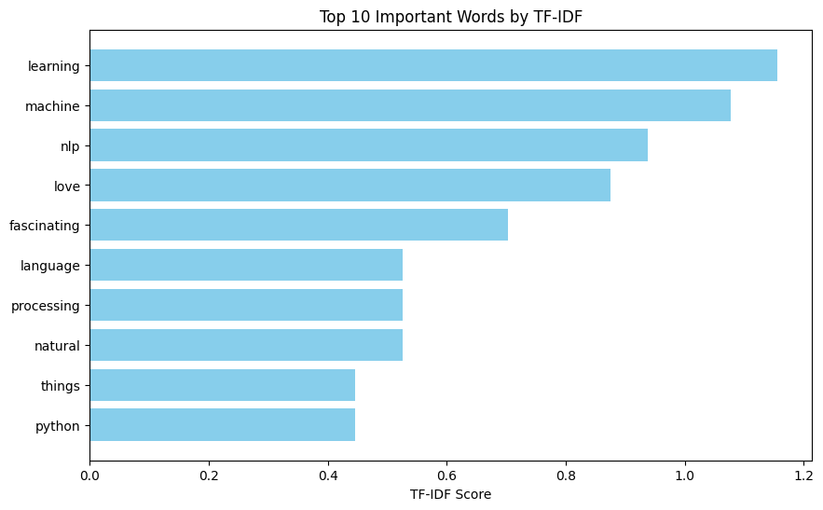
Visualize word vectors using t-SNE
import matplotlib.pyplot as plt
from sklearn.manifold import TSNE
from gensim.models import Word2Vec
import numpy as np

# Define the documents here to ensure they are available
documents = [
"I love machine learning and NLP.",
"Machine learning is fascinating.",
"Natural language processing is a part of NLP.",
"I love coding in Python and learning new things."
]

# Add training of a simple Word2Vec model using the 'documents' variable
# First, tokenize the documents for Word2Vec training
tokenized_documents = [doc.split() for doc in documents]

# Train the Word2Vec model
model = Word2Vec(sentences=tokenized_documents, vector_size=100, window=5, min_count=1, workers=4)

# Step 1: Choose top N words to visualize
N = 50
# Ensure N does not exceed the number of words in the vocabulary
N = min(N, len(model.wv.index_to_key))
words = list(model.wv.index_to_key)[:N]

# Check if there are enough words for t-SNE
if N < 2:
print("Not enough words to perform t-SNE visualization (need at least 2).")
else:
word_vectors = [model.wv[word] for word in words]

# Convert word_vectors to a NumPy array
word_vectors = np.array(word_vectors)

# Step 2: Reduce dimensionality with t-SNE
tsne = TSNE(n_components=2, random_state=42, perplexity=min(30, N-1), n_iter=1000) # Adjust perplexity based on N
word_vecs_2d = tsne.fit_transform(word_vectors)

# Step 3: Plotting
plt.figure(figsize=(14, 10))
plt.scatter(word_vecs_2d[:, 0], word_vecs_2d[:, 1], color='blue')

# Annotate points with the words
for i, word in enumerate(words):
plt.annotate(word, xy=(word_vecs_2d[i, 0], word_vecs_2d[i, 1]))

plt.title("t-SNE visualization of Word2Vec embeddings")
plt.xlabel("Dimension 1")
plt.ylabel("Dimension 2")
plt.show()
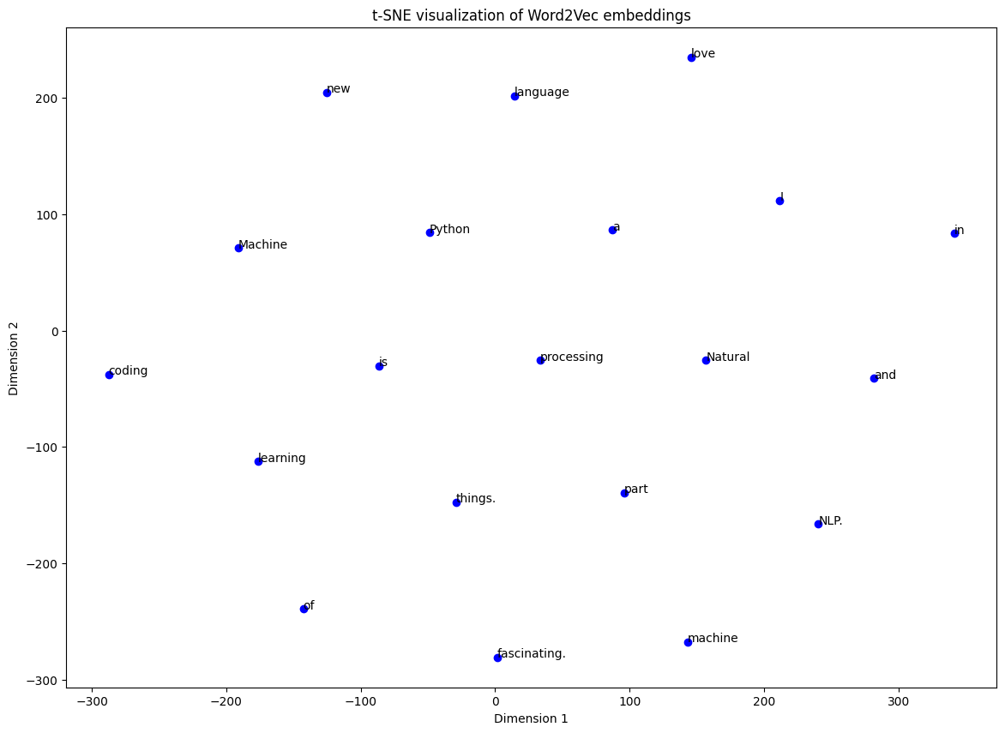
Generate text using GPT-2
from transformers import GPT2Tokenizer, GPT2LMHeadModel
import torch

# Load pre-trained GPT-2 tokenizer and model
tokenizer = GPT2Tokenizer.from_pretrained("gpt2")
model = GPT2LMHeadModel.from_pretrained("gpt2")
model.eval() # Set model to evaluation mode

# Move to GPU if available
device = torch.device("cuda" if torch.cuda.is_available() else "cpu")
model.to(device)

# Prompt text
prompt = "In the future, artificial intelligence will"

# Encode input and generate output
input_ids = tokenizer.encode(prompt, return_tensors="pt").to(device)

# Generate text
output = model.generate(
input_ids,
max_length=100,
num_return_sequences=1,
no_repeat_ngram_size=2,
do_sample=True,
top_k=50,
top_p=0.95,
temperature=0.9,
pad_token_id=tokenizer.eos_token_id,
)

# Decode and print
generated_text = tokenizer.decode(output[0], skip_special_tokens=True)
print("📝 Generated Text:\n")
print(generated_text)

In the future, artificial intelligence will play a major role in creating products and services that support the services we provide. It will be interesting to see how many jobs artificial intelligences create in the long-term.

A big challenge is to address these challenges by increasing our understanding of the technology that's needed to make life on Earth possible and allowing humanity to have access to what we have today. We've been very much on the right track as a country for artificial intelligent design.

Use SpaCy and Hugging Face for NER tagging
import spacy

# Load SpaCy English model
nlp = spacy.load("en_core_web_sm")

text = "Barack Obama was born in Hawaii and served as the president of the United States."

# Process the text
doc = nlp(text)

# Extract named entities
for ent in doc.ents:
print(f"{ent.text} -> {ent.label_}")

Barack Obama -> PERSON
Hawaii -> GPE
the United States -> GPE geopolitical entity

Tag POS using NLTK and SpaCy
import nltk
nltk.download('punkt')
nltk.download('averaged_perceptron_tagger')

sentence = "Apple is looking at buying U.K. startup for $1 billion"

# Tokenize the sentence into words
tokens = nltk.word_tokenize(sentence)

# POS tagging
pos_tags = nltk.pos_tag(tokens)

print(pos_tags)
]
[('Apple', 'NNP'), ('is', 'VBZ'), ('looking', 'VBG'), ('at', 'IN'), ('buying', 'VBG'), ('U.K.', 'NNP'), ('startup', 'NN'), ('for', 'IN'), ('$', '$'), ('1', 'CD'), ('billion', 'CD')]

Visualize POS tag distribution
import spacy
import matplotlib.pyplot as plt
from collections import Counter

# Load SpaCy model
nlp = spacy.load("en_core_web_sm")

text = """Apple is looking at buying U.K. startup for $1 billion.
The quick brown fox jumps over the lazy dog."""

# Process text
doc = nlp(text)

# Extract POS tags (using Universal POS tag set)
pos_tags = [token.pos_ for token in doc]

# Count frequency of each POS tag
pos_counts = Counter(pos_tags)

# Separate keys and values
tags = list(pos_counts.keys())
counts = list(pos_counts.values())

# Plot bar chart
plt.figure(figsize=(10, 6))
plt.bar(tags, counts, color='skyblue')
plt.title('POS Tag Distribution')
plt.xlabel('POS Tag')
plt.ylabel('Frequency')
plt.show()
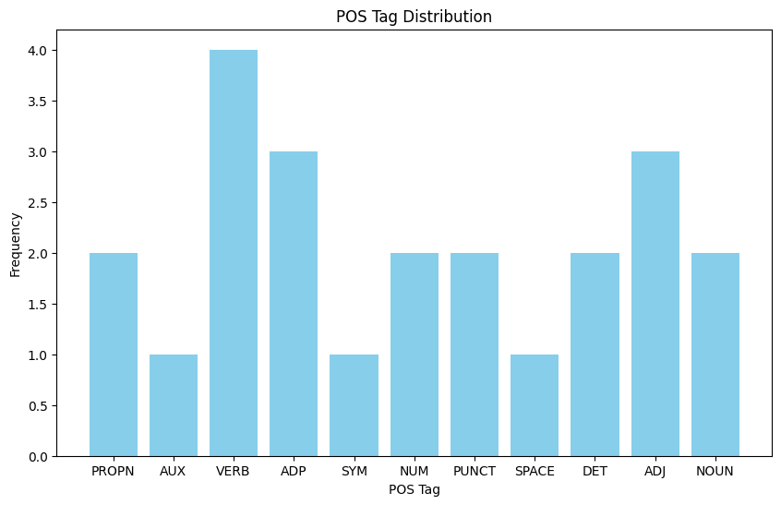
Generate text from trained language model

def generate_text(model, start_text, length=50):
model.eval()
input_seq = [char2idx[ch] for ch in start_text]
input_seq = torch.tensor(input_seq).unsqueeze(0) # batch size 1

generated = start_text

hidden = None
for _ in range(length):
with torch.no_grad():
output, hidden = model.lstm(model.embed(input_seq), hidden)
logits = model.fc(output[:, -1, :]) # last time step
probs = torch.softmax(logits, dim=-1)
next_char_idx = torch.multinomial(probs, num_samples=1).item()

generated += idx2char[next_char_idx]
input_seq = torch.cat([input_seq[:, 1:], torch.tensor([[next_char_idx]])], dim=1)

return generated
start = "hell"
generated_text = generate_text(model, start_text=start, length=50)
print("Generated text:")
print(generated_text)
Generated text: hello oorllelo worlllowworllo worolollllo worlellorldl

