VISVESVARAYA TECHNOLOGICAL UNIVERSITY
“JnanaSangama”, Belgaum -590014, Karnataka.


LAB REPORT
on
Artificial Intelligence (23CS5PCAIN)

Submitted by
Bhoomika B G (1BM23CS067)

in partial fulfillment for the award of the degree of
BACHELOR OF ENGINEERING
in
COMPUTER SCIENCE AND ENGINEERING


B.M.S. COLLEGE OF ENGINEERING
(Autonomous Institution under VTU)
BENGALURU-560019
Aug 2025 to Dec 2025
B.M.S. College of Engineering,
Bull Temple Road, Bangalore 560019
(Affiliated To Visvesvaraya Technological University, Belgaum)

Department of Computer Science and Engineering



CERTIFICATE

This is to certify that the Lab work entitled “Artificial Intelligence (23CS5PCAIN)” carried out by Bhoomika B G (1BM23CS067), who is bonafide student of B.M.S. College of Engineering. It is in partial fulfillment for the award of Bachelor of Engineering in Computer Science and Engineering of the Visvesvaraya Technological University, Belgaum. The Lab report has been approved as it satisfies the academic requirements in respect of an Artificial Intelligence (23CS5PCAIN) work prescribed for the said degree.

Prof.Swathi Sridharan  Assistant Professor  Department of CSE, BMSCE | Dr. Kavitha Sooda  Professor & HOD  Department of CSE, BMSCE

Index

Sl.  No. | Date | Experiment Title | Page No.
1 | 21-08-2025 | Implement Tic –Tac –Toe Game Implement vacuum cleaner agent | 5
2 | 28-08-2025 | Implement 8 puzzle problems using Depth First  Search (DFS)  Implement Iterative deepening search algorithm | 14
3 | 11-09-2025 | Implement A* search algorithm | 20
4 | 09-10-2025 | Implement Hill Climbing search algorithm to solve N-Queens problem | 24
5 | 09-10-2025 | Simulated Annealing to Solve 8-Queens problem | 27
6 | 16-10-2025 | Create a knowledge base using propositional logic and show that the given query entails the knowledge base or not | 30
7 | 30-10-2025 | Implement unification in first order logic | 33
8 | 06-11-2025 | Create a knowledge base consisting of first order logic statements and prove the given query using forward reasoning | 35
9 | 06-11-2025 | Create a knowledge base consisting of first order logic statements and prove the given query using Resolution | 37
10 | 13-11-2025 | Implement Alpha-Beta Pruning | 45
11 | 13-11-2025 | Conversion to CNF | 47

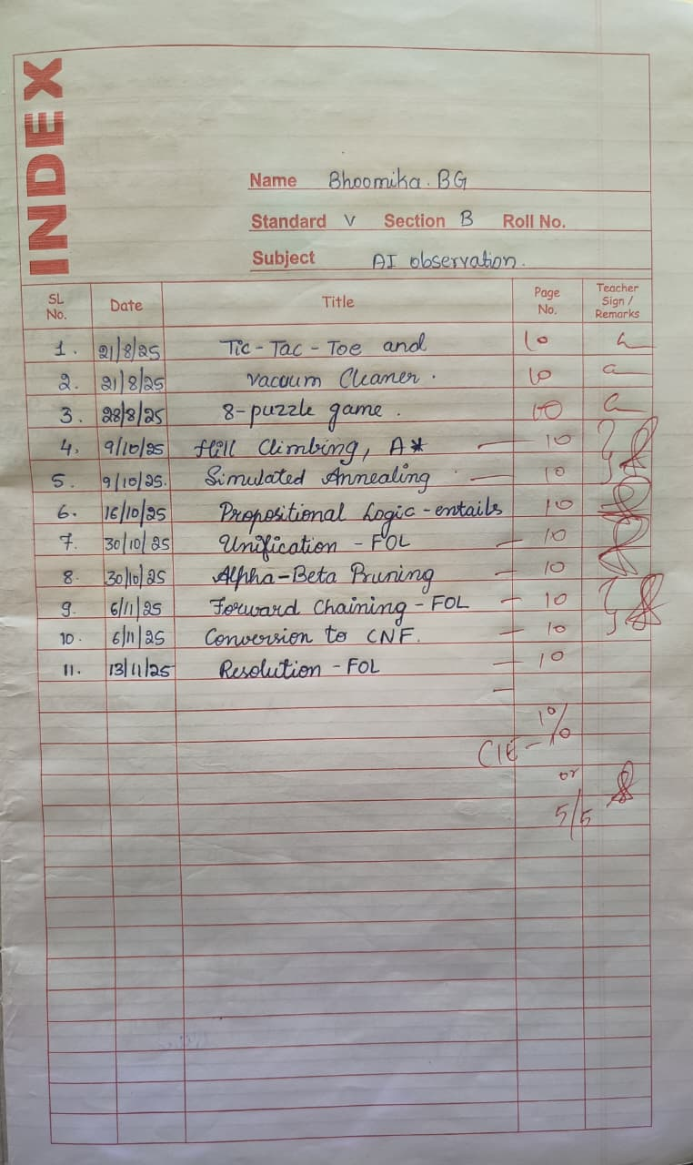
Github Link: https://github.com/bhoomikabg/AI
Program 1
Implement Tic –Tac –Toe Game Algorithm:
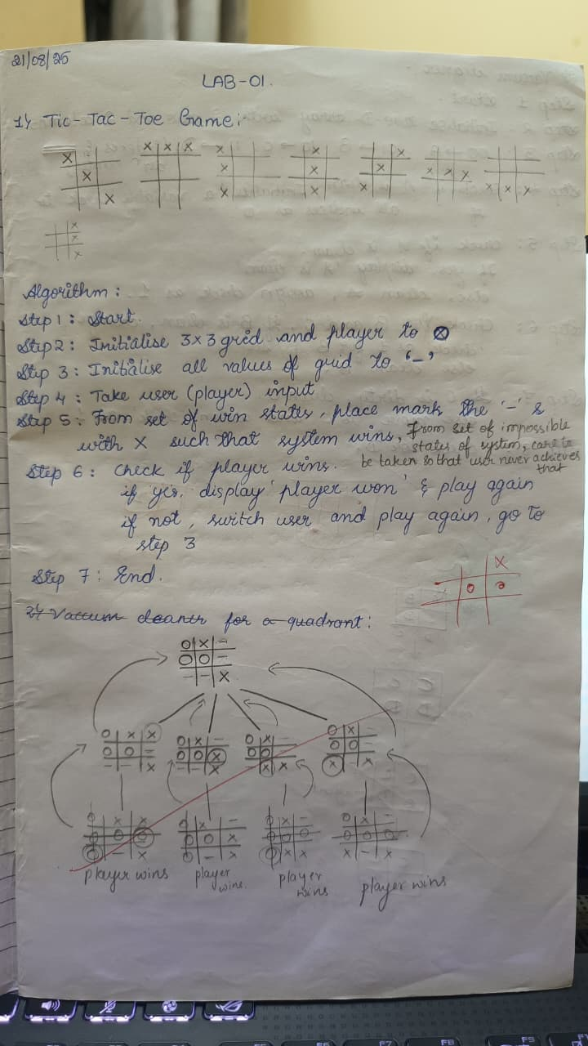
Code: def print_board(board): for row in board: print(" ".join(row))
print()

def check_winner(board, player): for i in range(3): if all(board[i][j] == player for j in range(3)):
return True if all(board[j][i] == player for j in range(3)):
return True if all(board[i][i] == player for i in range(3)):
return True if all(board[i][2 - i] == player for i in range(3)):
return True
return False

def is_draw(board):
return all(board[i][j] != '-' for i in range(3) for j in range(3))

cost_counter = 0

def minimax(board, is_ai_turn):
global cost_counter
cost_counter += 1

if check_winner(board, 'O'): return 1 if check_winner(board, 'X'):
return -1 if is_draw(board):
return 0

if is_ai_turn:
best_score = -float('inf') for i in range(3): for j in range(3): if board[i][j] == '-': board[i][j] = 'O' score = minimax(board, False) board[i][j] = '-' best_score = max(score, best_score) return best_score else:
best_score = float('inf') for i in range(3): for j in range(3):
if board[i][j] == '-': board[i][j] = 'X' score = minimax(board, True) board[i][j] = '-' best_score = min(score, best_score) return best_score

def manual_game():
board = [['-' for _ in range(3)] for _ in range(3)] print("Initial Board:")
print_board(board)

while True:

while True: try:
x_row = int(input("Enter X row (1-3): ")) - 1 x_col = int(input("Enter X col (1-3): ")) - 1 if board[x_row][x_col] == '-': board[x_row][x_col] = 'X'
break else: print("Cell occupied!") except:
print("Invalid input!")

print("Board after X move:")
print_board(board)

if check_winner(board, 'X'):
print("X wins!") break if is_draw(board): print("Draw!")
break

while True: try:
o_row = int(input("Enter O row (1-3): ")) - 1 o_col = int(input("Enter O col (1-3): ")) - 1 if board[o_row][o_col] == '-': board[o_row][o_col] = 'O'
break else: print("Cell occupied!") except:
print("Invalid input!")

print("Board after O move:") print_board(board)

if check_winner(board, 'O'):
print("O wins!") break if is_draw(board): print("Draw!")
break

global cost_counter cost_counter = 0 cost = minimax(board, True) print(f"AI evaluation cost from this position: {cost_counter} states examined") print(f"AI evaluation score from this position: {cost}")

manual_game()

Implement vacuum cleaner agent.
Algorithm:
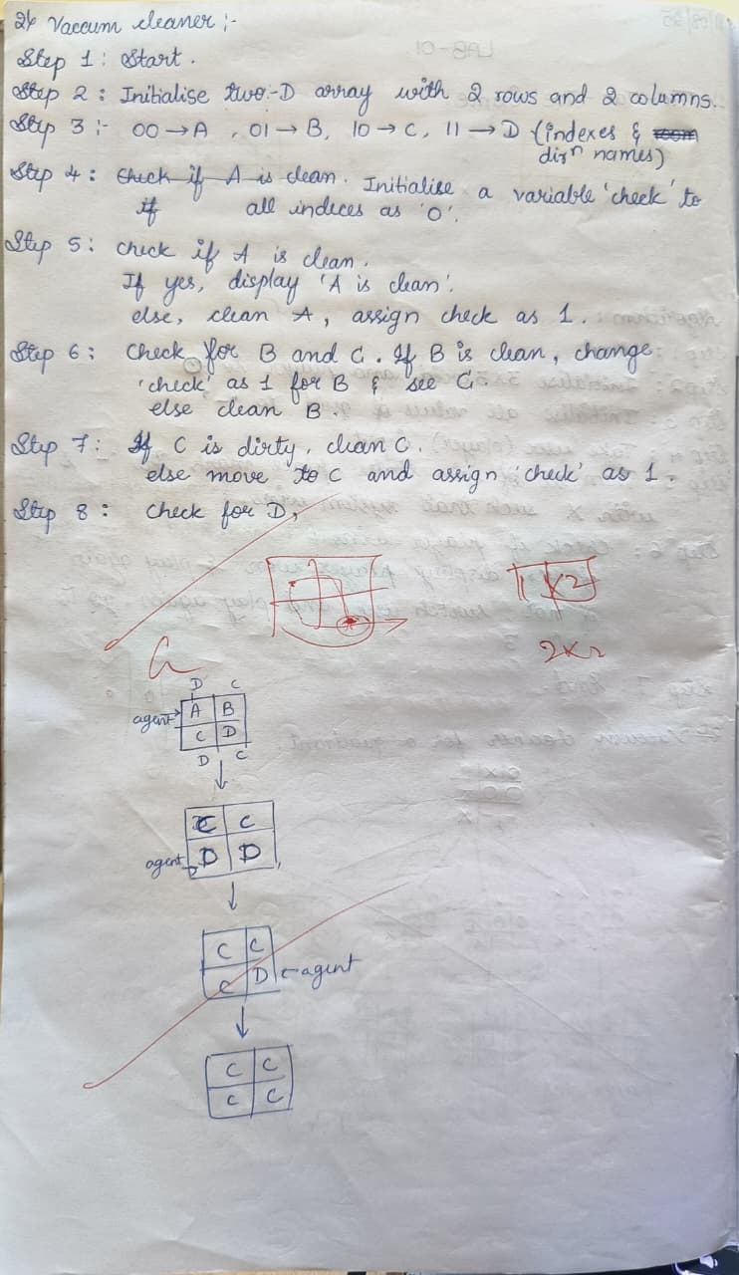

Code: rooms = {
'A': True,
'B': True,
'C': True,
'D': True
}
# The agent's current location current_room = 'A' def vacuum_cleaner_agent(): global current_room print("---Starting Vacuum Cleaner Agent---") print("Initial state:", rooms) print("Agent starts in room A.") # A set to track visited rooms to avoid loops visited = set()
# While there's any dirty room left while any(rooms.values()):
# Clean the current room if dirty if rooms[current_room]:
print(f"\nSucking dust in room {current_room}...") rooms[current_room] = False
print(f"Room {current_room} is now clean.") visited.add(current_room)
# Decide where to go next based on current location and available dirty rooms next_room = None if current_room == 'A':
options = [room for room in ['B', 'C'] if rooms[room] and room not in visited]
if options: while True:
user_choice = input(f"Do you want to go to room {options[0]} or room {options[-1]}?
(Type '{options[0]}' or '{options[-1]}'): ").upper() if user_choice in options: next_room = user_choice
break else:
print("Invalid input. Please choose a valid dirty room.")
else:
# Default to B or C if no input needed for room in ['B', 'C']: if rooms[room] and room not in visited:
next_room = room break
elif current_room == 'B': if rooms['D'] and 'D' not in visited:
print("Moving to room D.") next_room = 'D'
elif rooms['A'] and 'A' not in visited:
next_room = 'A' elif current_room == 'C': if rooms['D'] and 'D' not in visited: print("Moving to room D.") next_room = 'D' elif rooms['A'] and 'A' not in visited:
next_room = 'A' elif current_room == 'D': if rooms['C'] and 'C' not in visited: print("Moving to room C.") next_room = 'C' elif rooms['B'] and 'B' not in visited:
next_room = 'B'
# Fallback: find any remaining dirty room not visited yet if not next_room:
for room in ['A', 'B', 'C', 'D']: if rooms[room] and room not in visited:
next_room = room break if next_room:
print(f"Moving to room {next_room}.") current_room = next_room else:
# No dirty unvisited rooms left break print("\n---Goal State Achieved---") print("All rooms are clean:", rooms) print("---Agent is done---") vacuum_cleaner_agent()

Outputs:
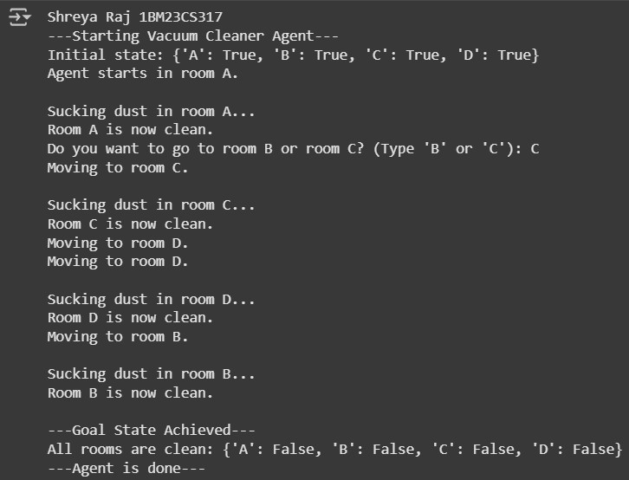

Program 2
Using BFS solve 8 puzzle without heuristic approach.
Algorithm:

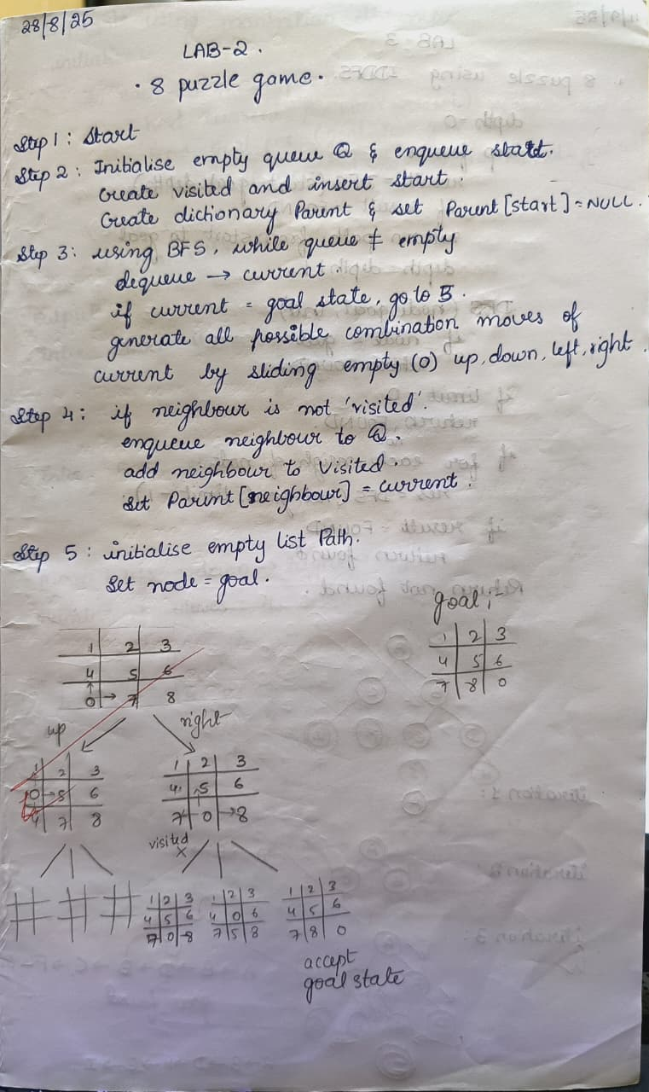

Code:

from collections import deque

def print_state(state): for i in range(0, 9, 3): print(state[i:i+3]) print()

def bfs(start, goal): queue = deque([(start, [])]) visited = set([start]) while queue:
state, path = queue.popleft() if state == goal:
return path + [state] zero = state.index(0) moves = [] if zero % 3 > 0:
moves.append(zero - 1) if zero % 3 < 2:
moves.append(zero + 1) if zero // 3 > 0:
moves.append(zero - 3) if zero // 3 < 2:
moves.append(zero + 3) for move in moves:
new_state = list(state) new_state[zero], new_state[move] = new_state[move], new_state[zero] new_state = tuple(new_state) if new_state not in visited: visited.add(new_state) queue.append((new_state, path + [state])) return None

def input_state(prompt): s = input(prompt).strip().split()
return tuple(map(int, s))

start = input_state("Enter initial state (9 numbers with 0 for blank): ") goal = input_state("Enter goal state (9 numbers with 0 for blank): ")

result = bfs(start, goal) if result: for step in result: print_state(step) else:
print("No solution found")
Output:

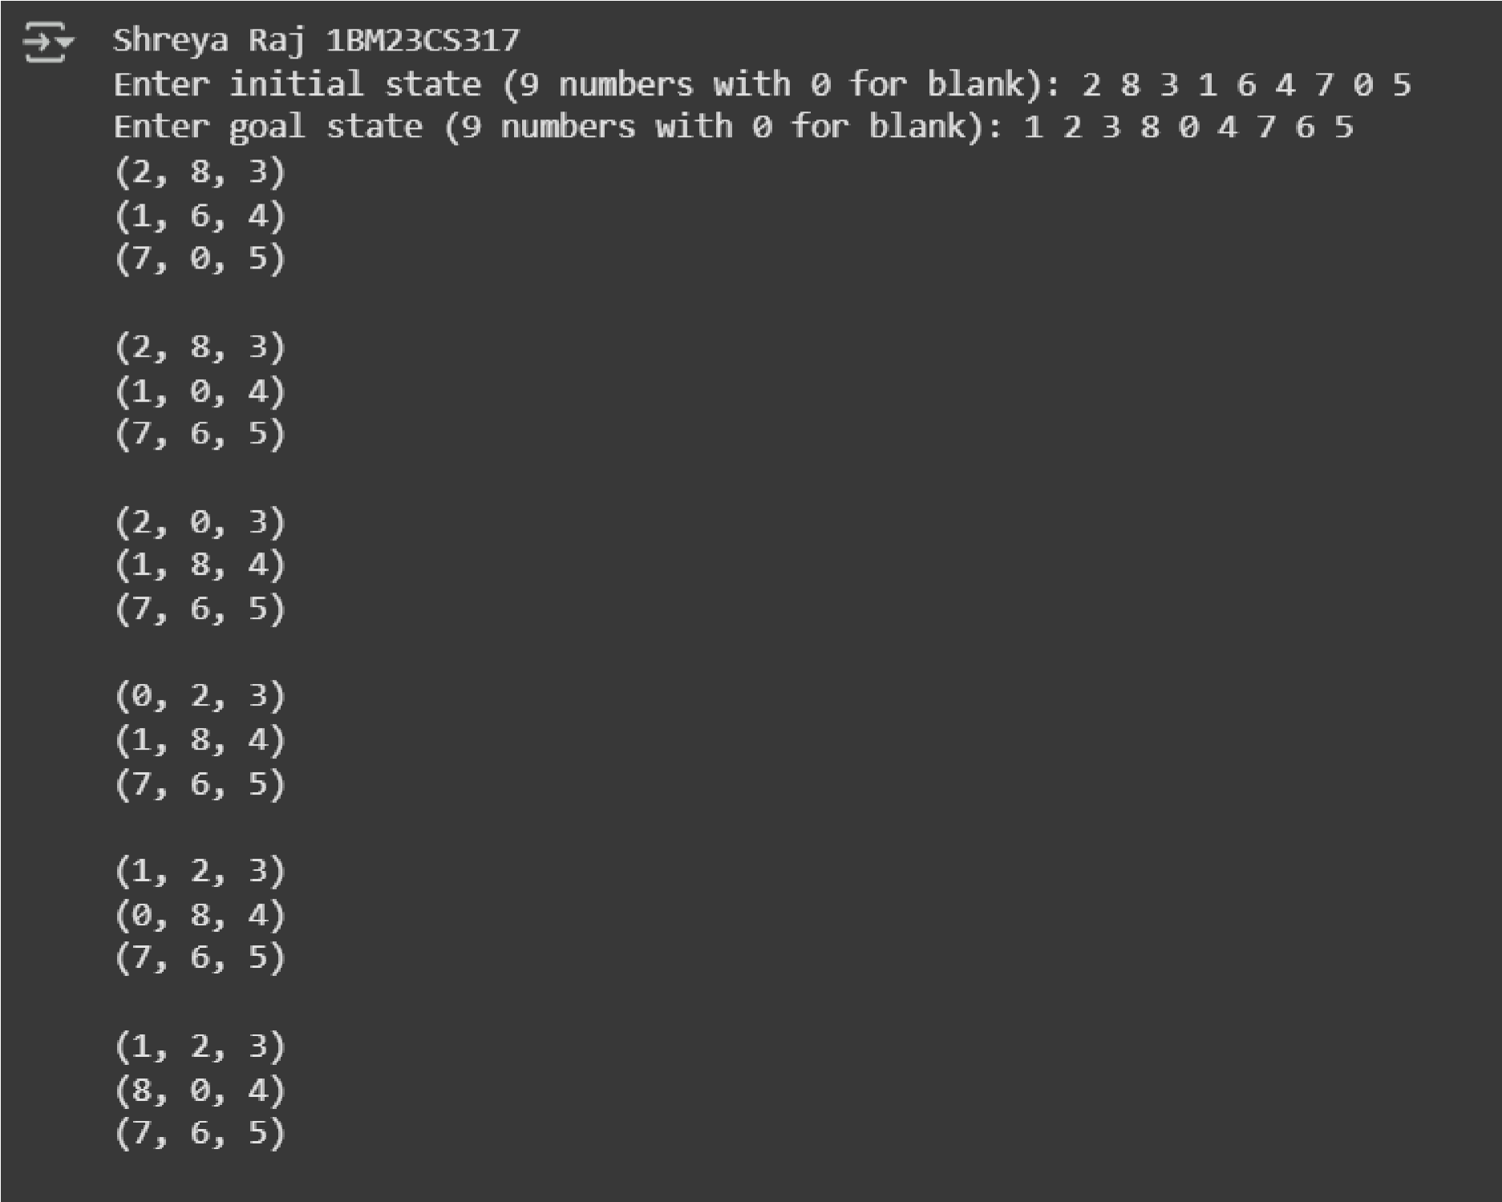

Using Iterative Deepening DFS solve 8 puzzle without heuristic approach. 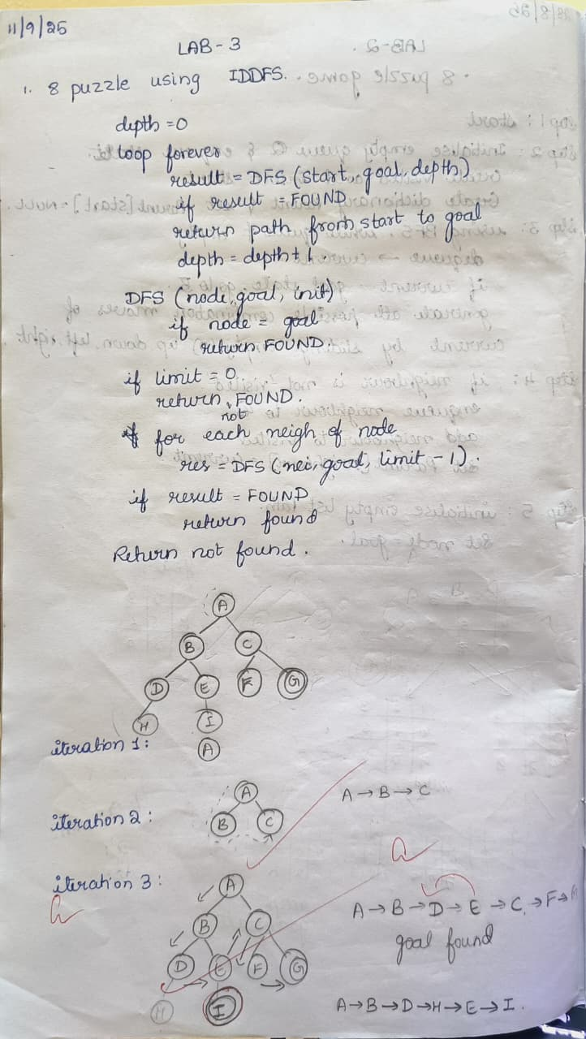 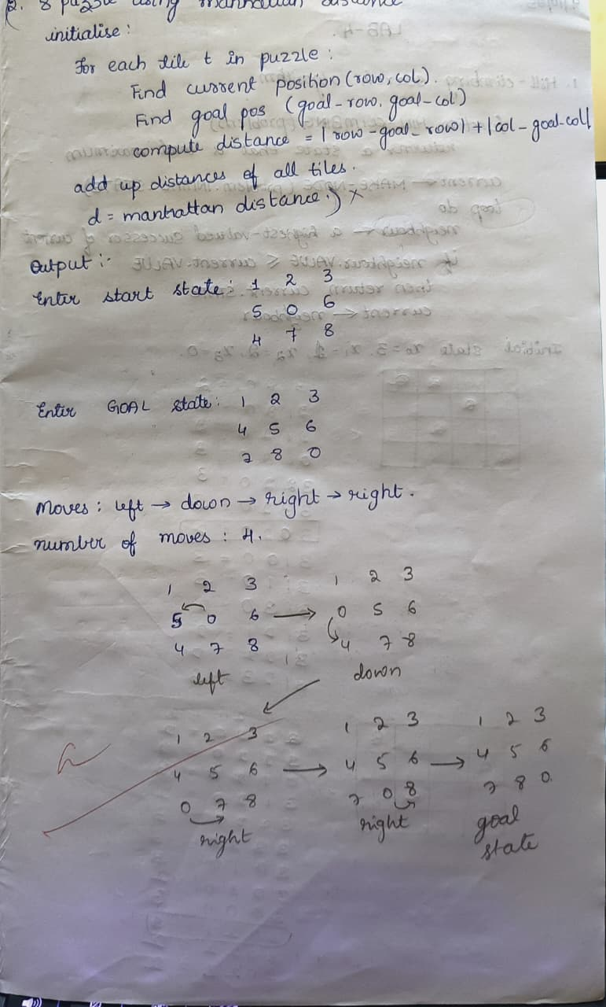

Code: class PuzzleState: def __init__(self, board, empty_pos, moves=0, path=None):
self.board = board self.empty_pos = empty_pos self.moves = moves
self.path = path or [board]

def is_goal(self, goal):
return self.board == goal

def get_neighbors(self): neighbors = [] x, y = self.empty_pos directions = [(-1,0),(1,0),(0,-1),(0,1)] # Up, Down, Left, Right for dx, dy in directions: nx, ny = x + dx, y + dy if 0 <= nx < 3 and 0 <= ny < 3: new_board = [list(row) for row in self.board]
# swap empty_pos with target
new_board[x][y], new_board[nx][ny] = new_board[nx][ny], new_board[x][y] new_board = tuple(tuple(row) for row in new_board) neighbors.append(PuzzleState(new_board, (nx, ny), self.moves + 1, self.path + [new_board])) return neighbors

def dls(state, goal, limit, visited): if state.is_goal(goal): return state.path if limit == 0: return None visited.add(state.board) for neighbor in state.get_neighbors(): if neighbor.board not in visited:
result = dls(neighbor, goal, limit - 1, visited) if result is not None: return result visited.remove(state.board) return None

def iddfs(start, goal):
depth = 0 while True:
visited = set() result = dls(start, goal, depth, visited) if result is not None:
return result depth += 1

def print_path(path):
print(f"Solution Found in {len(path)-1} moves") for state in path: for row in state:
print(" ".join(str(x) if x != 0 else "-" for x in row)) print()

def get_user_board(prompt):
print(prompt) board = [] for i in range(3):
row = list(map(int, input(f"Row {i+1} (space separated, use 0 for empty): ").strip().split())) board.append(tuple(row)) return tuple(board)

start_board = get_user_board("Enter the initial state:") goal_board = get_user_board("Enter the goal state:")

# Locate empty in start state empty_pos = None for i in range(3): for j in range(3): if start_board[i][j] == 0:
empty_pos = (i, j) break if empty_pos is not None: break

start_state = PuzzleState(start_board, empty_pos) path = iddfs(start_state, goal_board) if path:
print_path(path) else:
print("No solution found.")

Output:
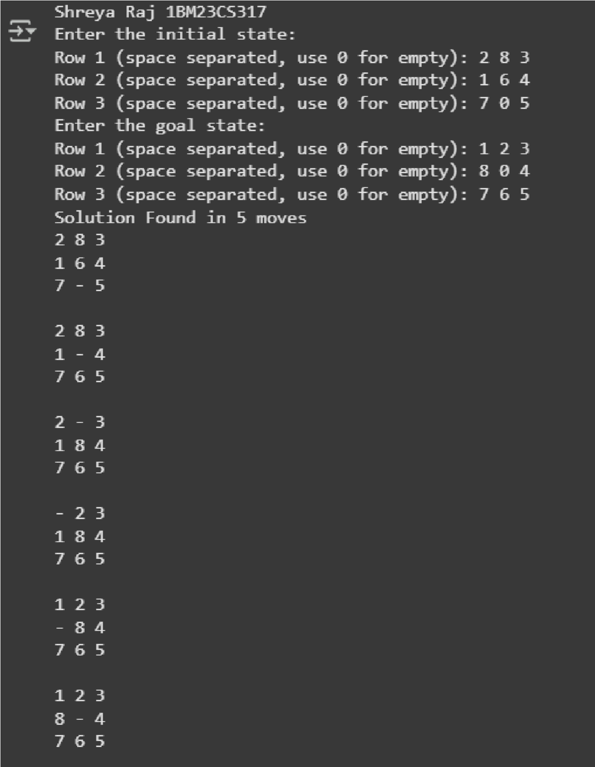

Program 3
Apply A* algorithm for misplaced tiles.
Algorithm:
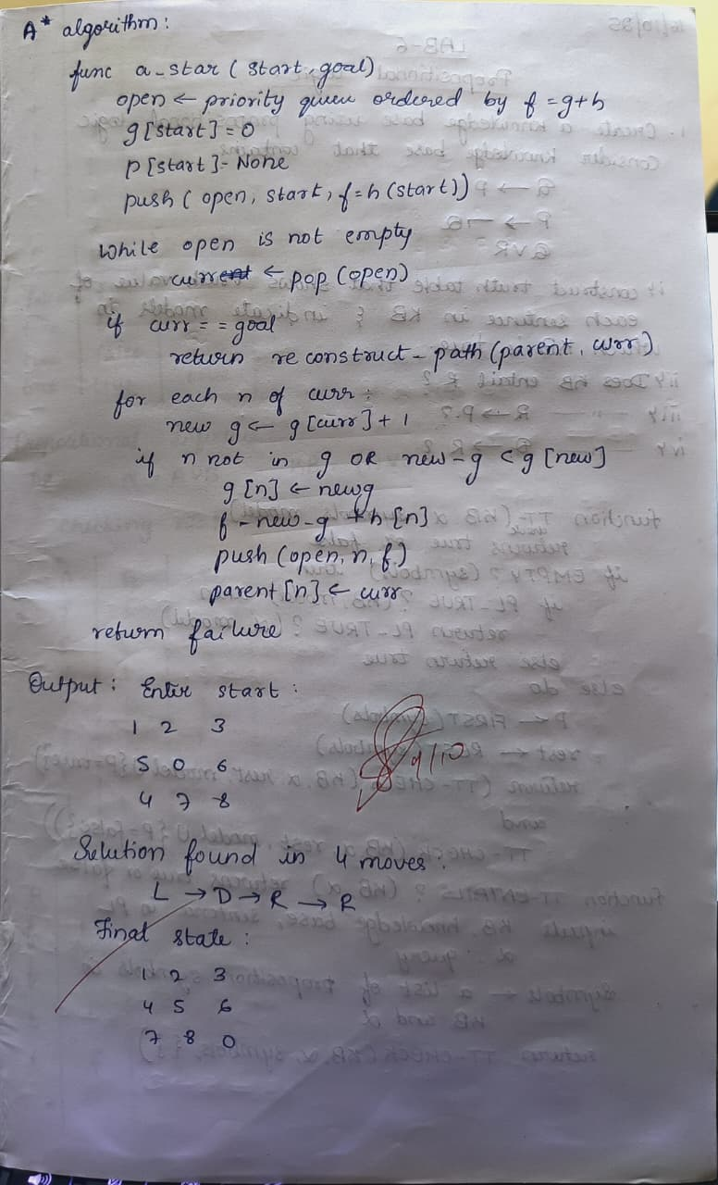

Code: import heapq

class PuzzleState: def __init__(self, board, goal, parent=None, g=0):
self.board = board self.goal = goal self.parent = parent
self.g = g self.h = self.misplaced_tiles() self.f = self.g + self.h

def misplaced_tiles(self):
"""Count misplaced tiles (excluding 0)."""
return sum(1 for i in range(9) if self.board[i] != 0 and self.board[i] != self.goal[i])

def get_neighbors(self):
"""Generate possible moves by sliding the blank (0).""" neighbors = [] idx = self.board.index(0) x, y = divmod(idx, 3) # row, col moves = [(-1,0),(1,0),(0,-1),(0,1)] # up, down, left, right

for dx, dy in moves: nx, ny = x+dx, y+dy if 0 <= nx < 3 and 0 <= ny < 3: new_idx = nx*3 + ny new_board = self.board[:] new_board[idx], new_board[new_idx] = new_board[new_idx], new_board[idx] neighbors.append(PuzzleState(new_board, self.goal, self, self.g+1)) return neighbors

def __lt__(self, other):
return self.f < other.f # priority queue uses f value

def reconstruct_path(state):
path = [] while state:
path.append(state.board) state = state.parent
return path[::-1]

def astar(start, goal):
start_state = PuzzleState(start, goal) open_list = [] heapq.heappush(open_list, start_state) closed_set = set()

while open_list:
current = heapq.heappop(open_list)

if current.board == goal:
return reconstruct_path(current)

closed_set.add(tuple(current.board))

for neighbor in current.get_neighbors(): if tuple(neighbor.board) in closed_set: continue heapq.heappush(open_list, neighbor) return None

print("Enter the 8-puzzle START state (use 0 for blank).") start_input = list(map(int, input("Enter 9 numbers separated by spaces: ").split()))

print("\nEnter the GOAL state (use 0 for blank).") goal_input = list(map(int, input("Enter 9 numbers separated by spaces: ").split()))

if len(start_input) != 9 or len(goal_input) != 9:
print("Invalid input! Please enter exactly 9 numbers for each state.") else:
solution = astar(start_input, goal_input)

if solution:
print("\n Steps to solve:") for step in solution: for i in range(0,9,3): print(step[i:i+3]) print("------") else:
print(" No solution found!")

Output:

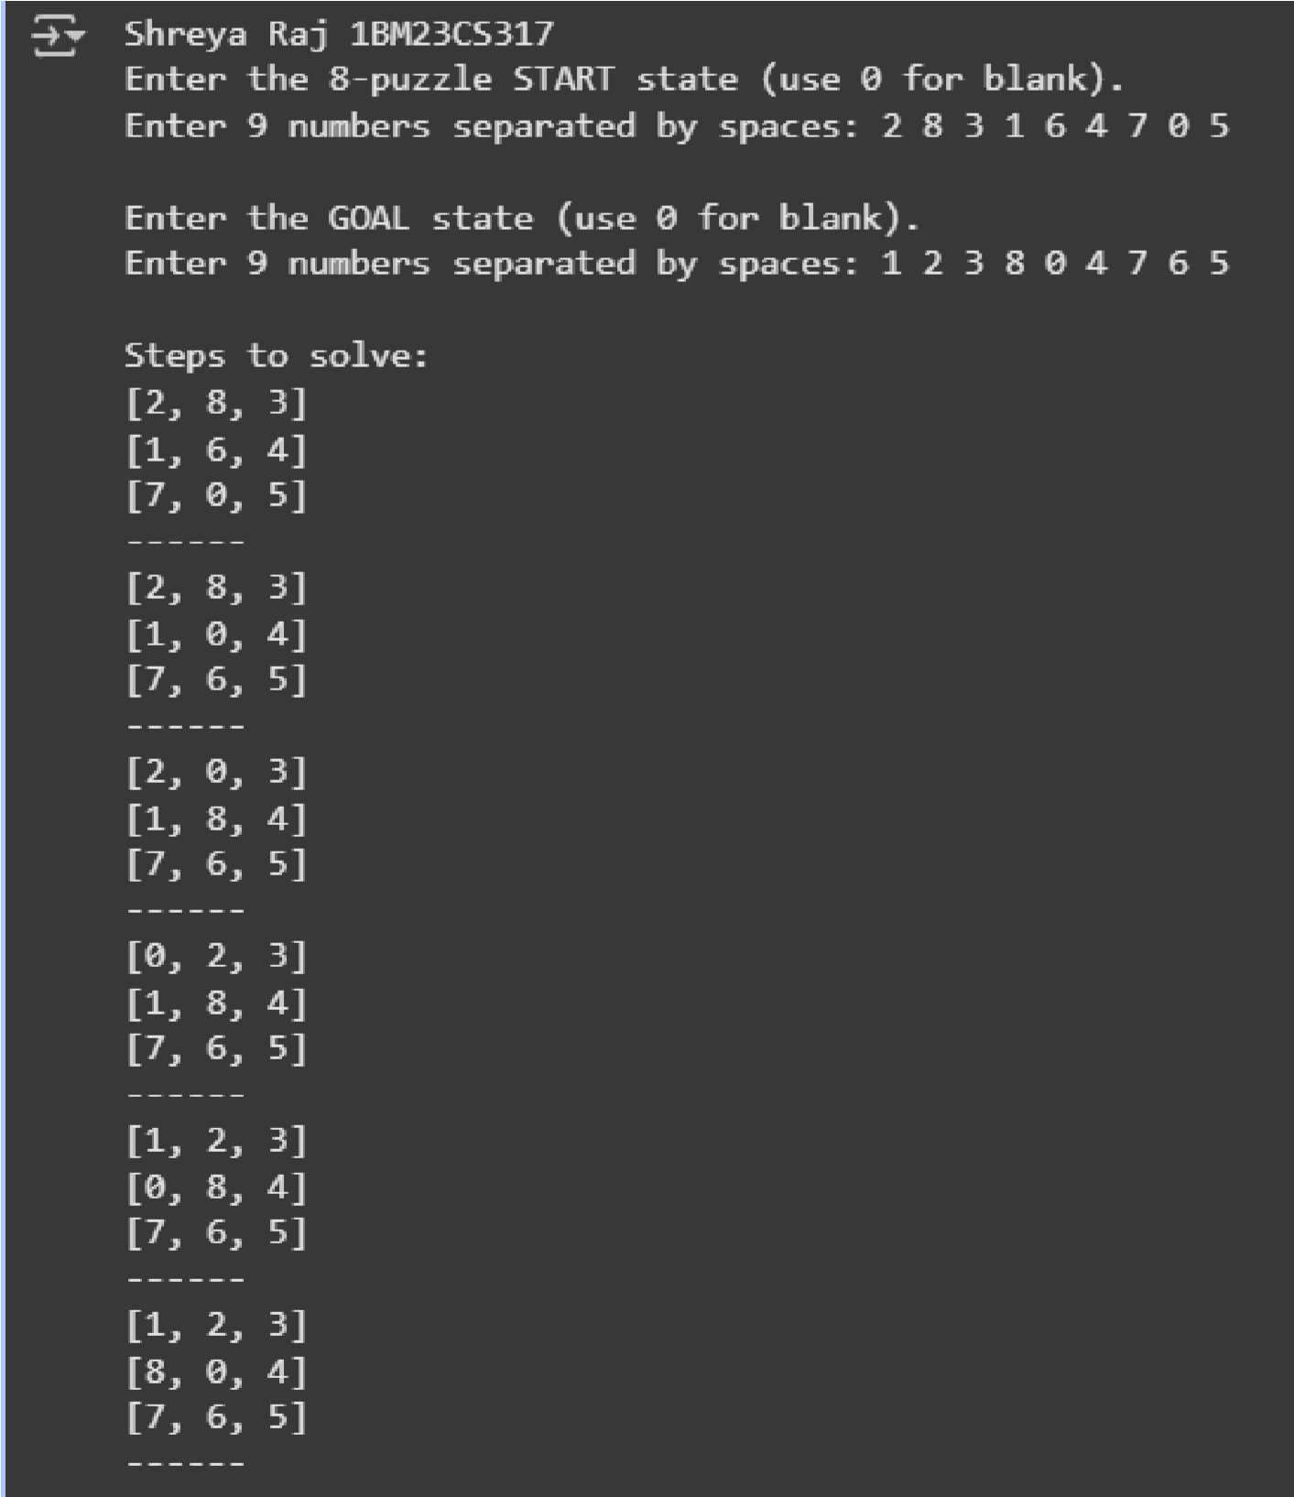

Program 4

Implement hill climbing search algorithm to solve N-Queens problem.
Algorithm:

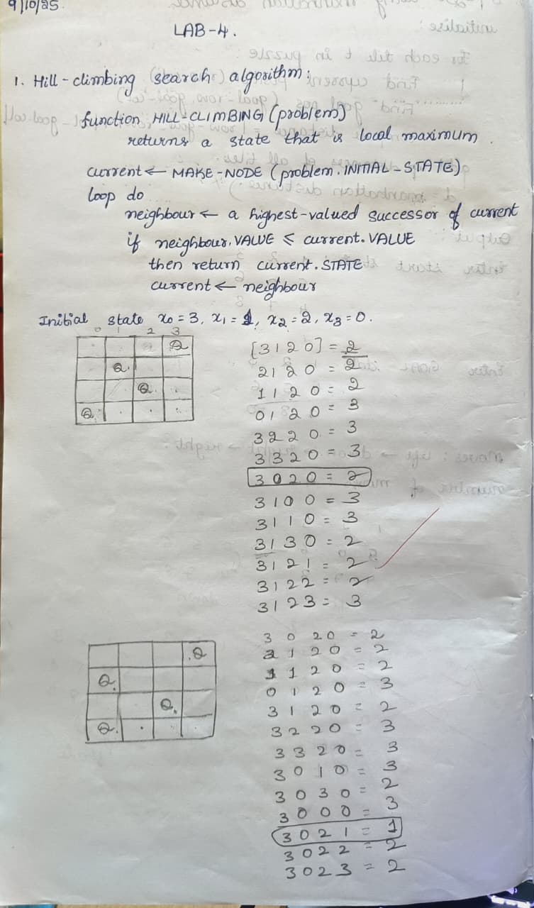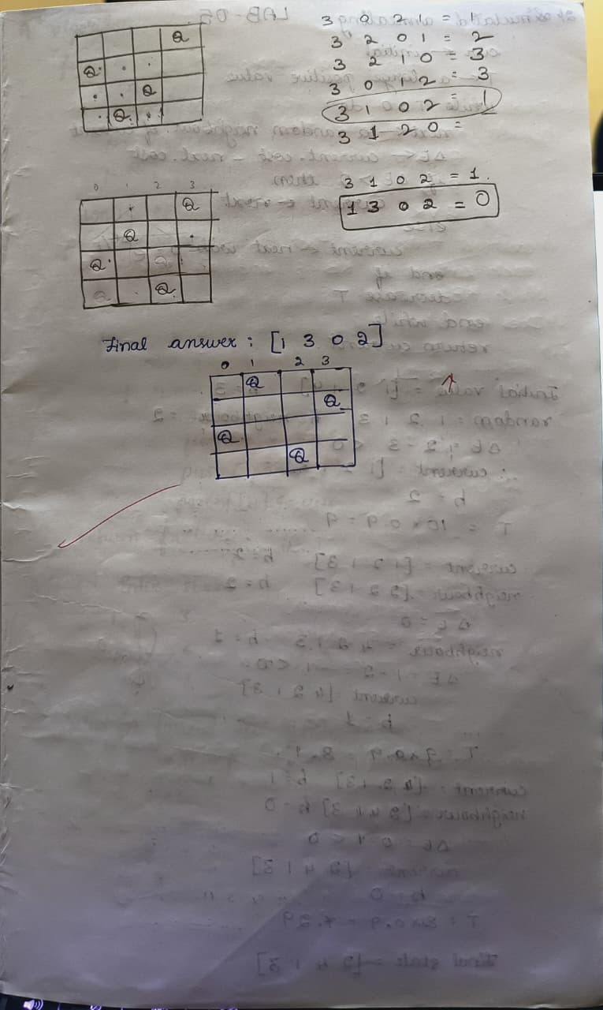

Code:

def print_board(state):
n = len(state) for row in range(n): line = "" for col in range(n):
line += "Q " if state[col] == row else ". "
print(line)
print()

def heuristic(state): attacks = 0 n = len(state) for i in range(n): for j in range(i + 1, n):
if state[i] == state[j]: # same row
attacks += 1 if abs(state[i] - state[j]) == abs(i - j): # same diagonal attacks += 1
return attacks

def get_neighbors(state):
neighbors = [] n = len(state) for col in range(n): for row in range(n): if state[col] != row: new_state = list(state) new_state[col] = row neighbors.append(new_state) return neighbors

def hill_climbing(start_state):
current = copy.deepcopy(start_state) while True:
current_h = heuristic(current) if current_h == 0: return current, 0

neighbors = get_neighbors(current)
neighbor_h = [heuristic(neigh) for neigh in neighbors]

min_h = min(neighbor_h) if min_h >= current_h: # No improvement possible return current, current_h

current = neighbors[neighbor_h.index(min_h)]

def generate_all_states(n):

states = [] def backtrack(col=0, state=[]): if col == n: states.append(state.copy())
return for row in range(n): state.append(row) backtrack(col+1, state)
state.pop() backtrack()
return states

if __name__ == "__main__":
n = 4 all_states = generate_all_states(n)

print(f"Total initial states for {n} queens: {len(all_states)}\n")

for i, start in enumerate(all_states, start=1): final_state, cost = hill_climbing(start) print(f"Initial state {i}: {start}") print(f"Final state after hill climbing:") print_board(final_state) print(f"Cost (heuristic): {cost}") print("="*30)

Output:

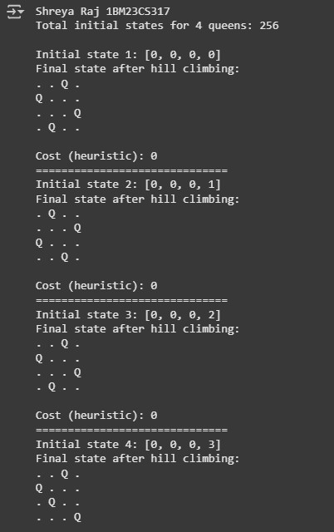
Program 5
8 Queens Problem using Simulated Annealing Algorithm:

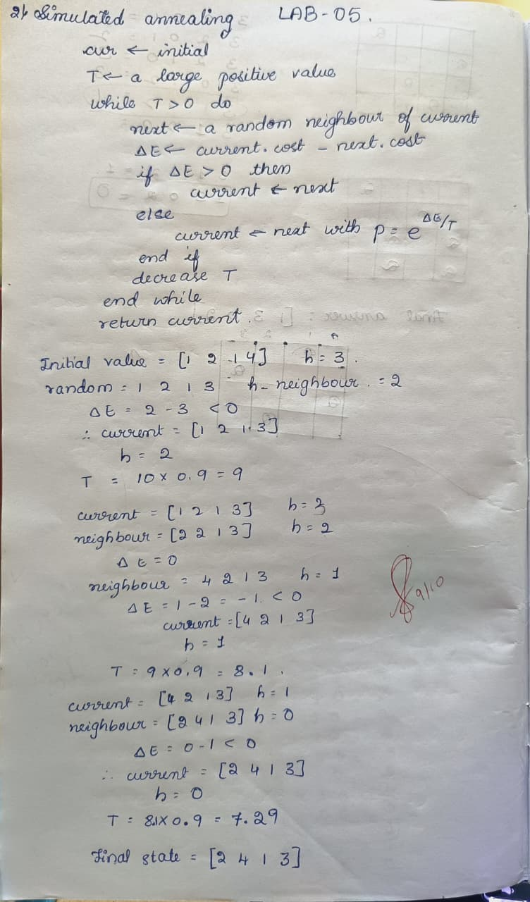

Code: import random
import math
def cost(state): attacks = 0 n = len(state) for i in range(n): for j in range(i + 1, n): if state[i] == state[j] or abs(state[i] - state[j]) == abs(i - j):
attacks += 1
return attacks

def get_neighbor(state): neighbor = state[:] i, j = random.sample(range(len(state)), 2) neighbor[i], neighbor[j] = neighbor[j], neighbor[i] return neighbor

def simulated_annealing(n=8, max_iter=10000):
current = list(range(n)) random.shuffle(current)
current_cost = cost(current)

temperature = 100.0
cooling_rate = 0.95

best = current[:]
best_cost = current_cost

for _ in range(max_iter):
if temperature <= 0 or best_cost == 0: break

neighbor = get_neighbor(current) neighbor_cost = cost(neighbor)
delta = current_cost - neighbor_cost
if delta > 0:
current, current_cost = neighbor, neighbor_cost if neighbor_cost < best_cost:
best, best_cost = neighbor, neighbor_cost else:
probability = math.exp(delta / temperature) if random.random() < probability:
current, current_cost = neighbor, neighbor_cost

temperature *= cooling_rate

return best, best_cost

def print_board(state):
n = len(state) for row in range(n): line = "" for col in range(n): if state[col] == row:
line += " Q " else: line += " . " print(line)
print()

if __name__ == "__main__":
n = 8 solution, cost_val = simulated_annealing(n)

print("Best position found:", solution) print(f"Number of non-attacking pairs: {n*(n-1)//2 - cost_val}") print("\nBoard:")
print_board(solution)

Output:

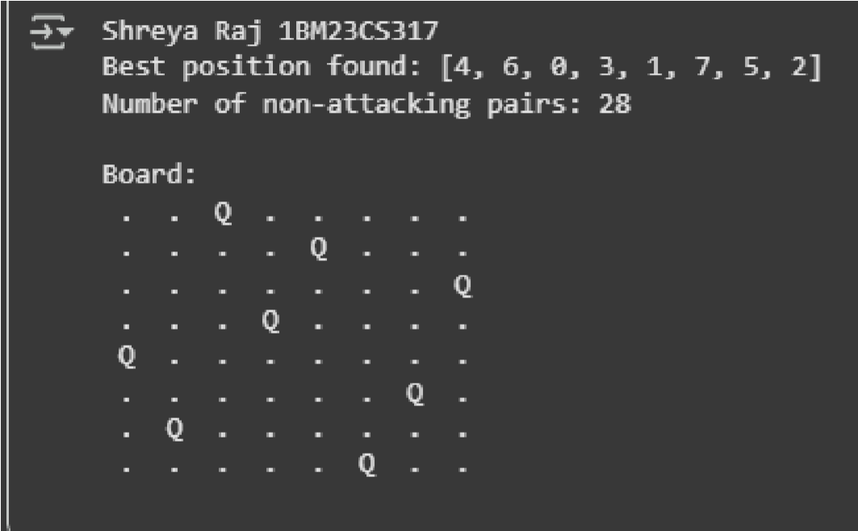

Program 6
Implement truth table enumeration algorithm for deciding propositional entailment.
Algorithm:
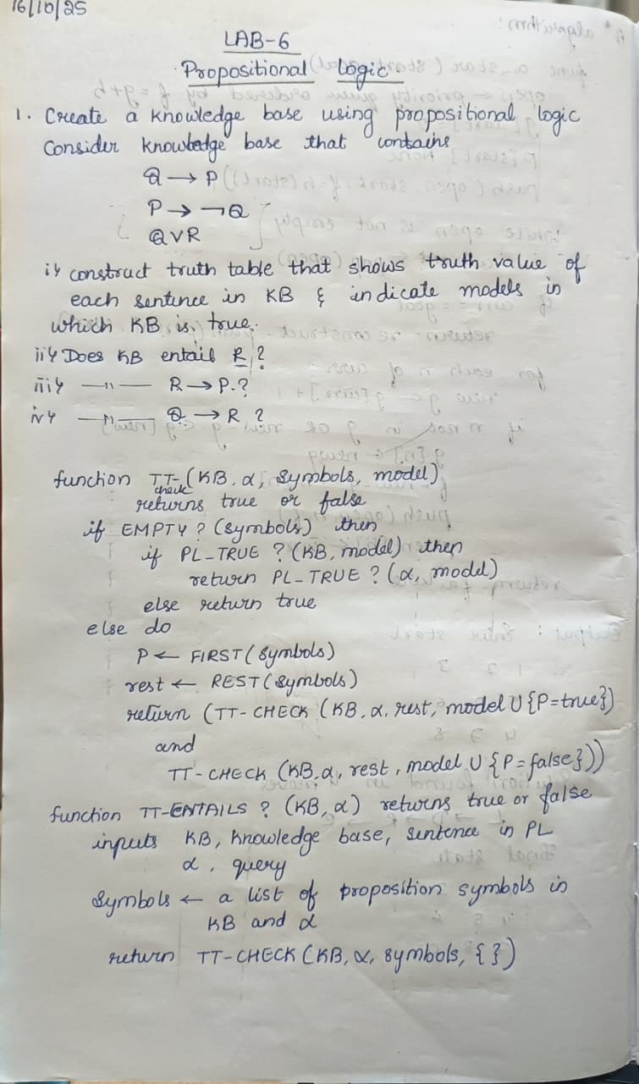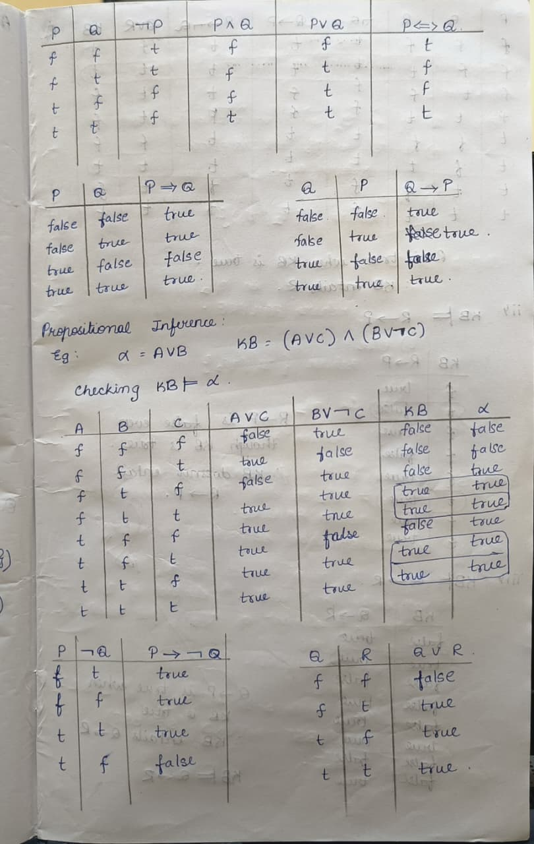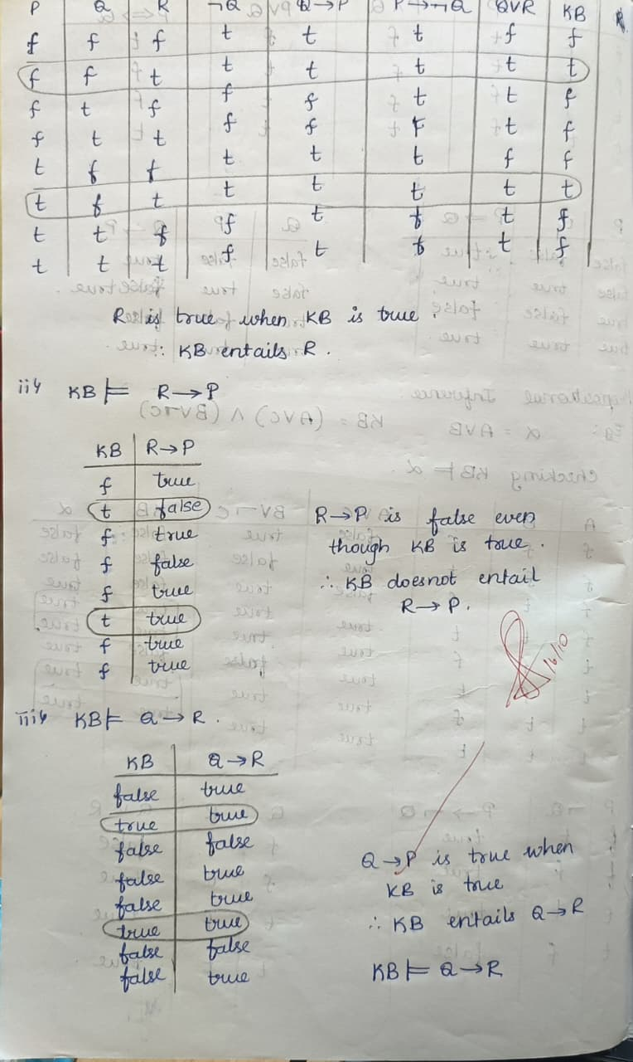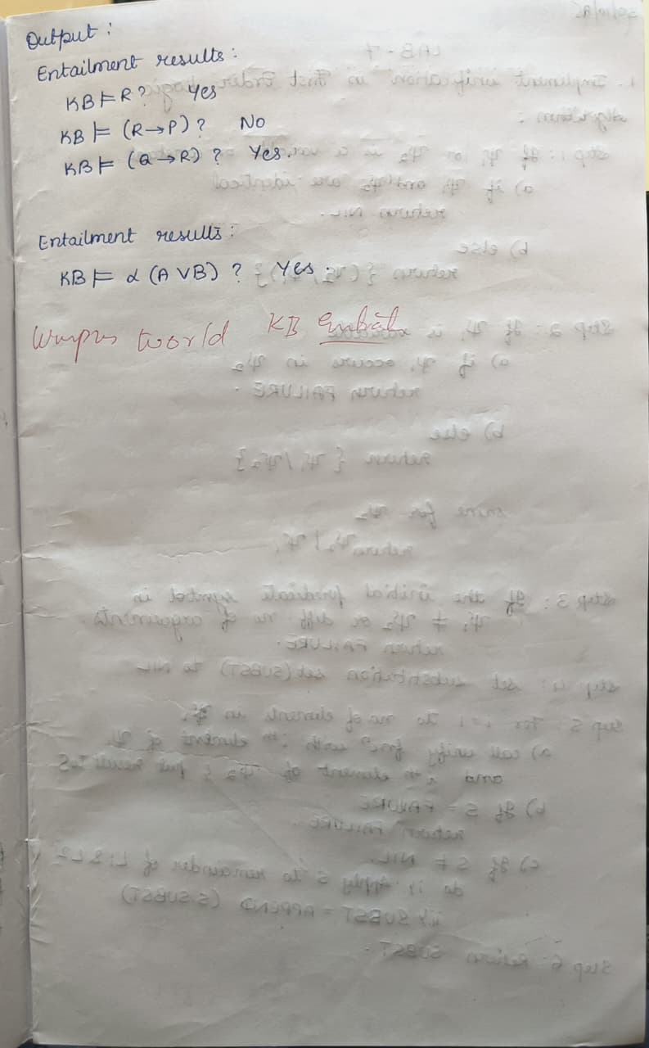

Code:
import pandas as pd from itertools import product import re
def tokenize(sentence):
# Now also tokenize symbols like (logical OR) # Added ∨, ∧, ¬ in the regex to separate them as tokens token_pattern = r'\w+|[()∨∧¬]' return re.findall(token_pattern, sentence)
def pl_true(sentence, model): tokens = tokenize(sentence) logical_ops = {'and', 'or', 'not', '∨', '∧', '¬'}
evaluated_tokens = [] for token in tokens: if token == '':
evaluated_tokens.append('or') # replace symbol with python 'or' elif token == '':
evaluated_tokens.append('and') # replace symbol with python 'and' elif token == '¬':
evaluated_tokens.append('not') # replace symbol with python 'not' elif token.lower() in logical_ops:
evaluated_tokens.append(token.lower()) elif token in model:
evaluated_tokens.append(str(model[token])) else:
evaluated_tokens.append(token) eval_sentence = ' '.join(evaluated_tokens) try:
return eval(eval_sentence) except Exception as e:
print(f"Error evaluating sentence: {eval_sentence}") raise e
def tt_entails(kb, alpha, symbols):
truth_table = [] for model in product([False, True], repeat=len(symbols)):
model_dict = dict(zip(symbols, model)) kb_value = pl_true(kb, model_dict) alpha_value = pl_true(alpha, model_dict) row = {
'A': model_dict.get('A', False),
'B': model_dict.get('B', False),
'C': model_dict.get('C', False),
'A C': model_dict.get('A', False) or model_dict.get('C', False),
'B ¬C': model_dict.get('B', False) or not model_dict.get('C', False), 'KB': kb_value,
'α': alpha_value
}
truth_table.append(row) if kb_value and not alpha_value:
return False, pd.DataFrame(truth_table)
return True, pd.DataFrame(truth_table)
def get_symbols(kb, alpha):
return sorted(set(re.findall(r'[A-Z]', kb + alpha)))
alpha = "A B"
symbols = get_symbols(kb, alpha) result, truth_table = tt_entails(kb, alpha, symbols)
def highlight_kb_alpha(row): if row['KB'] and row['α']:
return ['background-color: lightgreen' if col in ['KB', 'α'] else '' for col in row.index] else:
return ['' for _ in row.index]
print("Shreya Raj 1BM23CS317") styled_table = truth_table.style.apply(highlight_kb_alpha, axis=1) display(styled_table)

if result:
print("\nKB entails α") else:
print("\nKB does not entail α")

Output:

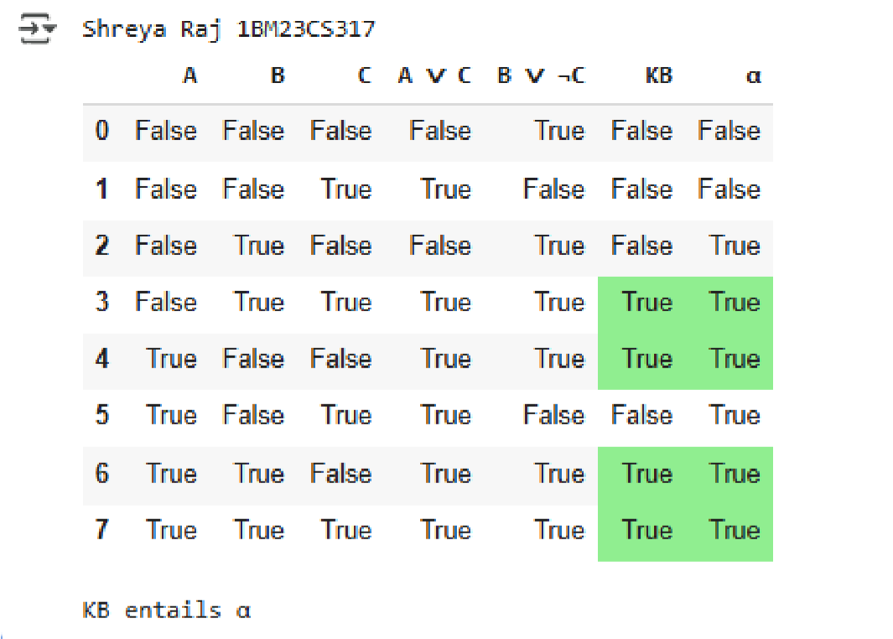

Program 7
Implement unification in first order logic.
Algorithm:
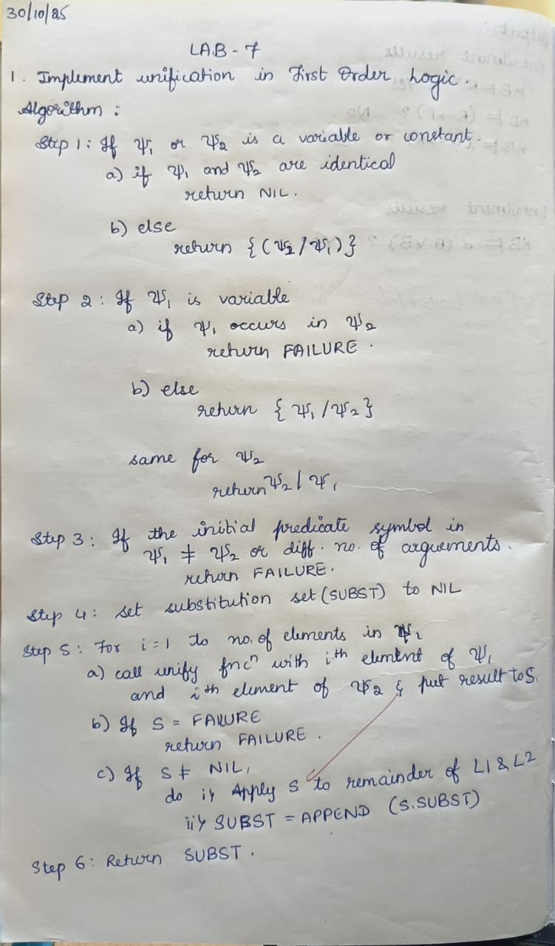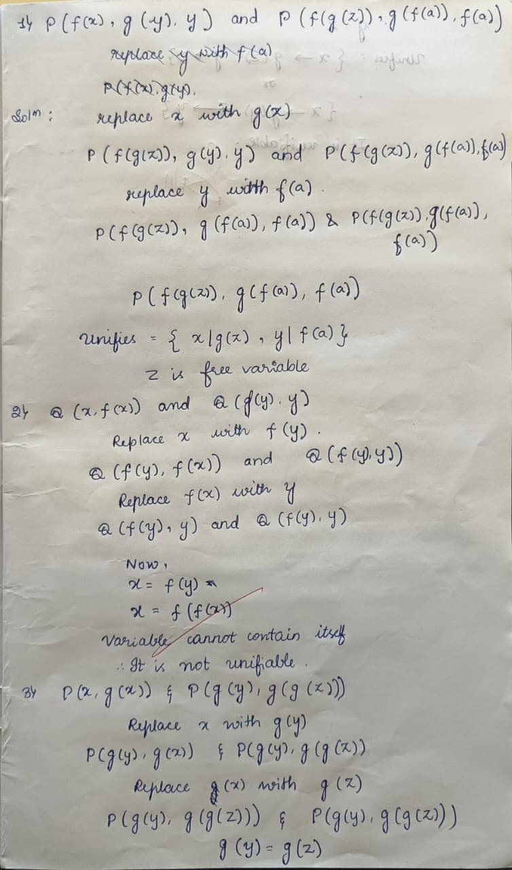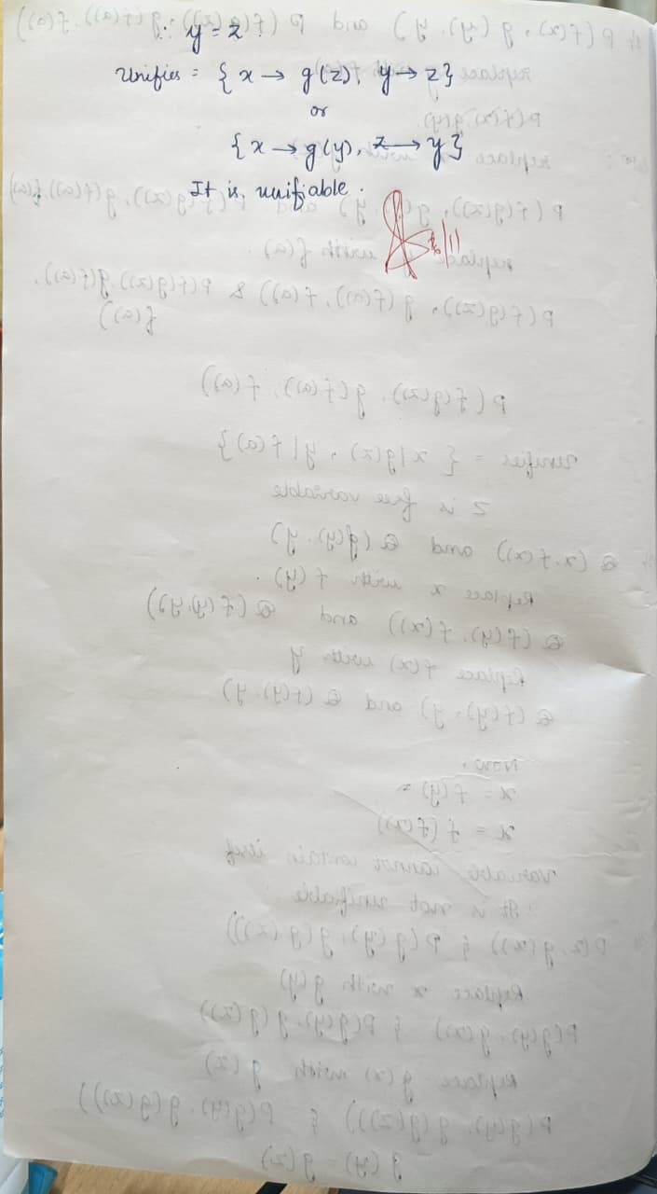

Code: def unify(x, y, subst=None): if subst is None:
subst = {}

# If x or y is a variable or constant if is_variable(x) or is_constant(x): if x == y:
return subst elif is_variable(x):
return unify_var(x, y, subst) elif is_variable(y):
return unify_var(y, x, subst) else:
return None

# If both x and y are compound expressions if is_compound(x) and is_compound(y): if x[0] != y[0] or len(x[1]) != len(y[1]):
return None for xi, yi in zip(x[1], y[1]): subst = unify(xi, yi, subst) if subst is None: return None return subst
return None

def is_variable(x):
return isinstance(x, str) and x.islower() and x.isalpha()

def is_constant(x):
return isinstance(x, str) and x.isupper() and x.isalpha()

def is_compound(x): return isinstance(x, tuple) and len(x) == 2 and isinstance(x[0], str) and isinstance(x[1], list)

def unify_var(var, x, subst): if var in subst:
return unify(subst[var], x, subst) elif x in subst:
return unify(var, subst[x], subst) elif occurs_check(var, x, subst):
return None else:
subst[var] = x
return subst

def occurs_check(var, x, subst): if var == x: return True elif is_variable(x) and x in subst:
return occurs_check(var, subst[x], subst) elif is_compound(x):
return any(occurs_check(var, arg, subst) for arg in x[1]) else:
return False
x = ("P", ["x", "A"])
y = ("P", ["B", "y"])

result = unify(x, y) if result is not None:
print("Unification succeeded with substitution:", result) else:
print("Unification failed.")

Output:
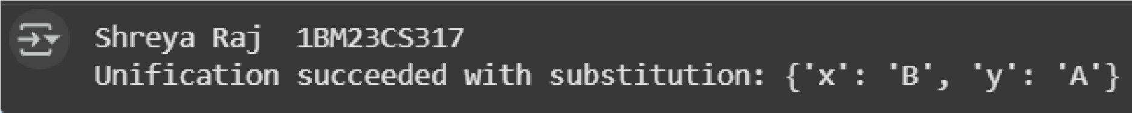

Program 8
Create a knowledge base consisting of first order logic statements and prove the given query using forward reasoning. Algorithm:
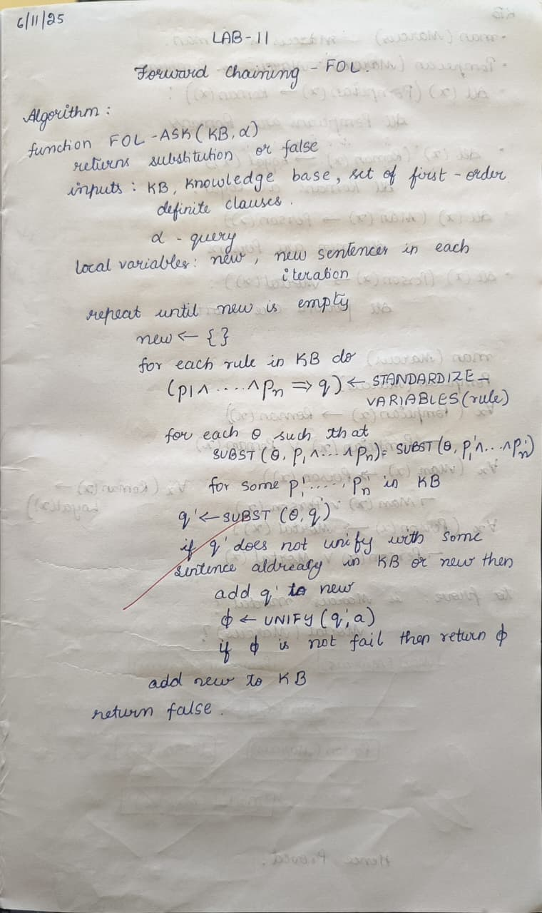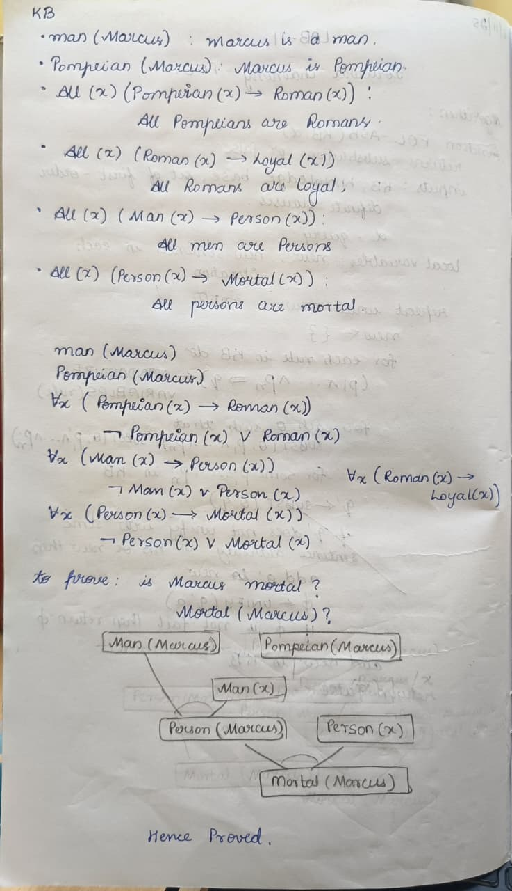

Code: facts = {
'American(West)': True,
'Hostile(Nono)': True,
'Missiles(Nono)': True,
} def rule1(facts): if facts.get('American(West)', False) and facts.get('Hostile(Nono)', False):
return 'Criminal(West)'
return None

def rule2(facts): if facts.get('Missiles(Nono)', False) and facts.get('Hostile(Nono)', False):
return 'SoldWeapons(West, Nono)'

def forward_chaining(facts, rules):
new_facts = facts.copy() inferred = True while inferred: inferred = False for rule in rules:
result = rule(new_facts) if result and result not in new_facts:
new_facts[result] = True inferred = True print(f"New fact inferred: {result}")
return new_facts
rules = [rule1, rule2]

inferred_facts = forward_chaining(facts, rules)

print("\nFinal facts:") for fact in inferred_facts:
print(fact)

Output:

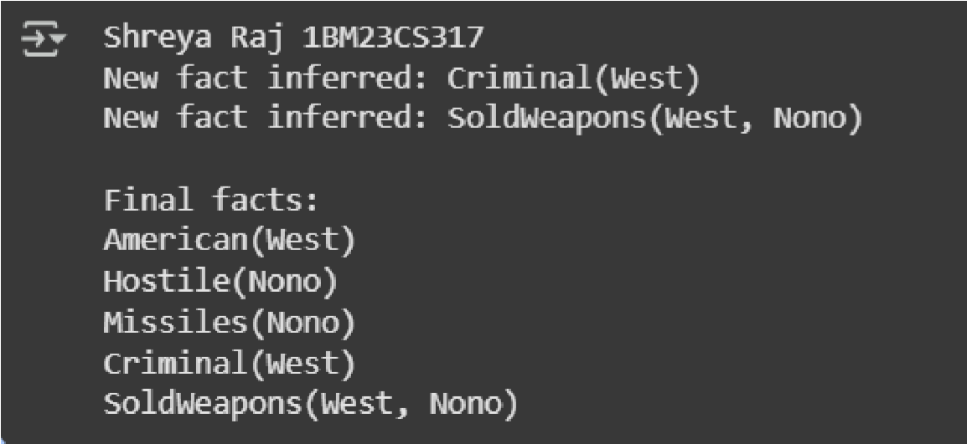

Program 9
Create a knowledge base consisting of first order logic statements and prove the given query using Resolution Algorithm:

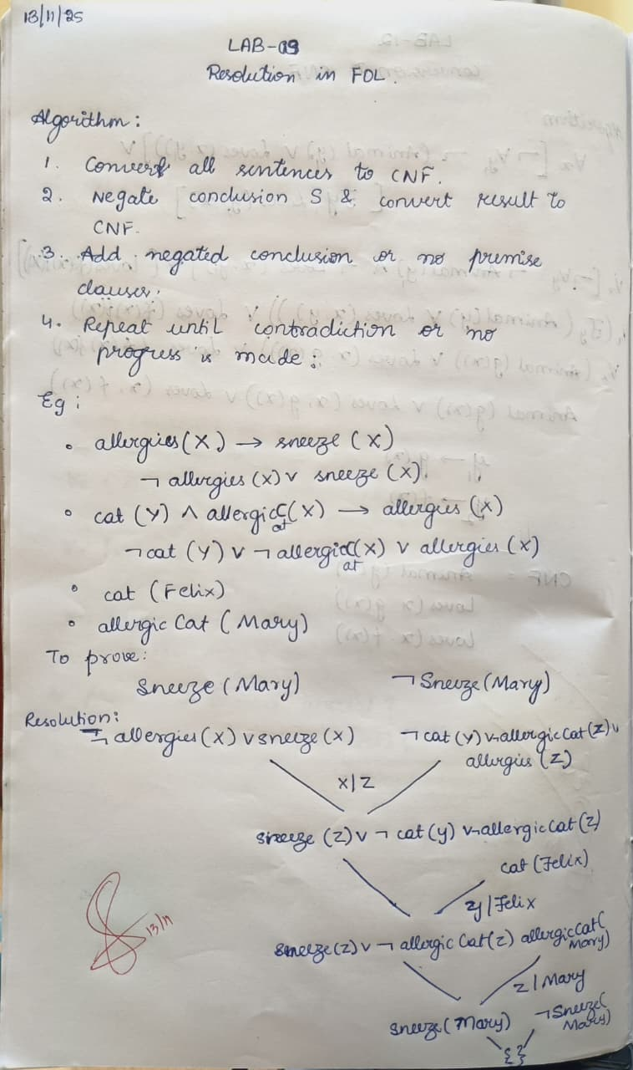

Code: from collections import deque
import itertools import copy import pprint
# ----- Data structures ----- class Var: def __init__(self, name):
self.name = name def __repr__(self):
return f"Var({self.name})" def __eq__(self, other):
return isinstance(other, Var) and self.name == other.name def __hash__(self):
return hash(('Var', self.name))

class Const: def __init__(self, name):
self.name = name def __repr__(self):
return f"Const({self.name})" def __eq__(self, other):
return isinstance(other, Const) and self.name == other.name def __hash__(self):
return hash(('Const', self.name))

class Func: def __init__(self, name, args):
self.name = name self.args = args def __repr__(self):
return f"Func({self.name}, {self.args})" def __eq__(self, other):
return isinstance(other, Func) and self.name == other.name and self.args == other.args def __hash__(self):
return hash(('Func', self.name, tuple(self.args)))

class Literal:
# predicate_name: str, args: list of Terms, negated: bool def __init__(self, predicate, args, negated=False):
self.predicate = predicate self.args = tuple(args) self.negated = negated def negate(self):
return Literal(self.predicate, list(self.args), not self.negated) def __repr__(self):
sign = "~" if self.negated else ""
args = ",".join(map(term_to_str, self.args)) return f"{sign}{self.predicate}({args})" def __eq__(self, other):
return (self.predicate, self.args, self.negated) == (other.predicate, other.args, other.negated) def __hash__(self):
return hash((self.predicate, self.args, self.negated))

# Clause is frozenset of Literal def clause_to_str(cl):
return " OR ".join(map(str, cl)) if cl else "EMPTY"

def term_to_str(t): if isinstance(t, Var):
return t.name if isinstance(t, Const):
return t.name if isinstance(t, Func):
return f"{t.name}({','.join(term_to_str(a) for a in t.args)})" return str(t)

# ----- Substitution utilities ----- def apply_subst_term(term, subst): if isinstance(term, Var): if term in subst:
return apply_subst_term(subst[term], subst) else:
return term elif isinstance(term, Const):
return term elif isinstance(term, Func):
return Func(term.name, [apply_subst_term(a, subst) for a in term.args]) else:
return term

def apply_subst_literal(lit, subst):
return Literal(lit.predicate, [apply_subst_term(a, subst) for a in lit.args], lit.negated)

def apply_subst_clause(clause, subst):
return frozenset(apply_subst_literal(l, subst) for l in clause)

# ----- Unification (Robust, with occurs-check) ----- def occurs_check(var, term, subst):
term = apply_subst_term(term, subst) if term == var: return True if isinstance(term, Func):
return any(occurs_check(var, arg, subst) for arg in term.args) return False

def unify_terms(x, y, subst):
# returns updated subst or None on failure x = apply_subst_term(x, subst) y = apply_subst_term(y, subst)

if isinstance(x, Var): if x == y:
return subst if occurs_check(x, y, subst):
return None new = subst.copy() new[x] = y return new if isinstance(y, Var):
return unify_terms(y, x, subst) if isinstance(x, Const) and isinstance(y, Const): return subst if x.name == y.name else None if isinstance(x, Func) and isinstance(y, Func) and x.name == y.name and len(x.args) == len(y.args): for a, b in zip(x.args, y.args):
subst = unify_terms(a, b, subst) if subst is None: return None return subst
return None

def unify_literals(l1, l2):
# l1 and l2 must have same predicate and opposite polarity for resolution if l1.predicate != l2.predicate or l1.negated == l2.negated or len(l1.args) != len(l2.args):
return None subst = {} for a, b in zip(l1.args, l2.args):
subst = unify_terms(a, b, subst) if subst is None: return None
return subst

# ----- Standardize apart variables (to avoid name clashes) -----
_var_count = 0 def standardize_apart(clause):
global _var_count varmap = {} new_literals = [] for lit in clause: new_args = [] for t in lit.args:
new_args.append(_rename_term_vars(t, varmap)) new_literals.append(Literal(lit.predicate, new_args, lit.negated)) return frozenset(new_literals)

def _rename_term_vars(term, varmap):
global _var_count if isinstance(term, Var): if term.name not in varmap: _var_count += 1
varmap[term.name] = Var(f"{term.name}_{_var_count}") return varmap[term.name] if isinstance(term, Const):
return term if isinstance(term, Func):
return Func(term.name, [_rename_term_vars(a, varmap) for a in term.args]) return term

# ----- Resolution operation between two clauses ----- def resolve(ci, cj):
# returns set of resolvent clauses (frozenset of literals) resolvents = set() ci = standardize_apart(ci) cj = standardize_apart(cj) for li in ci: for lj in cj: if li.predicate == lj.predicate and li.negated != lj.negated and len(li.args) == len(lj.args):
subst = unify_literals(li, lj) if subst is not None:
# build resolvent: (Ci - {li}) U (Cj - {lj}) with subst applied
new_clause = set(apply_subst_literal(l, subst) for l in (ci - {li}) | (cj - {lj}))
# remove tautologies: a clause containing P and ~P after subst preds = {} taut = False for l in new_clause:
key = (l.predicate, tuple(map(term_to_str, l.args))) if key in preds and preds[key] != l.negated:
taut = True break preds[key] = l.negated if not taut:
resolvents.add(frozenset(new_clause)) return resolvents

# ----- Main resolution loop ----- def fol_resolution(kb_clauses, query_clause, max_iterations=20000):
"""
kb_clauses: set/list of clauses (each clause is frozenset of Literal) query_clause: single Literal (to be proved), will be negated and added to KB Returns True if contradiction (empty clause) is derived.
"""
# Negate the query and add its literals as separate clauses (each literal is a clause) negated_query = [query_clause.negate()] clauses = set(kb_clauses) for l in negated_query:
clauses.add(frozenset([l]))

new = set() processed_pairs = set()
queue = list(clauses)

iterations = 0 while True: pairs = [] clause_list = list(clauses) n = len(clause_list)
# iterate over all unordered pairs for i in range(n): for j in range(i+1, n):
pairs.append((clause_list[i], clause_list[j]))

something_added = False for (ci, cj) in pairs: pair_key = (ci, cj) if pair_key in processed_pairs: continue
processed_pairs.add(pair_key) resolvents = resolve(ci, cj) iterations += 1 if iterations > max_iterations:
return False, "max_iterations_exceeded" for r in resolvents: if len(r) == 0:
return True, "Derived empty clause (success)" if r not in clauses and r not in new:
new.add(r) something_added = True if not something_added: return False, "No new clauses — failure (KB does not entail query)" clauses.update(new) new = set()

# ----- Helper to create easy constants/vars ----- def C(name): return Const(name) def V(name): return Var(name)
def F(name, *args): return Func(name, list(args)) def L(pred, args, neg=False): return Literal(pred, args, neg)

# Build clauses (using variables V('x'), constants C('Anil'), etc.)
x = V('x') y = V('y')
kb = set()
# 1. ¬Food(x) Likes(John,x)
kb.add(frozenset([L('Food', [x], neg=True), L('Likes', [C('John'), x], neg=False)]))

# 2a. Food(Apple)
kb.add(frozenset([L('Food', [C('apple')], neg=False)]))
# 2b. Food(vegetable)
kb.add(frozenset([L('Food', [C('vegetable')], neg=False)]))

# 3. ¬Eats(x,y) Killed(y) Food(y)
kb.add(frozenset([L('Eats', [x,y], neg=True), L('Killed', [y], neg=False), L('Food', [y], neg=False)]))

# 4a. Eats(Anil,peanuts)
kb.add(frozenset([L('Eats', [C('Anil'), C('peanuts')], neg=False)]))
# 4b. Alive(Anil)
kb.add(frozenset([L('Alive', [C('Anil')], neg=False)]))

# 5. ¬Eats(Anil,x) Eats(Harry,x)
kb.add(frozenset([L('Eats', [C('Anil'), x], neg=True), L('Eats', [C('Harry'), x], neg=False)]))

# 6. ¬Alive(x) ¬Killed(x)
kb.add(frozenset([L('Alive', [x], neg=True), L('Killed', [x], neg=True)]))

# 7. Killed(x) Alive(x)
kb.add(frozenset([L('Killed', [x], neg=True), L('Alive', [x], neg=False)]))
# Query
query = L('Likes', [C('John'), C('peanuts')], neg=False)

def show_kb(kb):
print("Knowledge base clauses:") for c in kb:
print(" ", clause_to_str(c))
print()

if __name__ == "__main__":
print("FOL resolution prover (basic example)\n") show_kb(kb) print("Query:", query) print("Negated query clause will be added to KB and resolution attempted.\n") success, info = fol_resolution(kb, query, max_iterations=20000) print("Result:", success, "|", info)

Output:

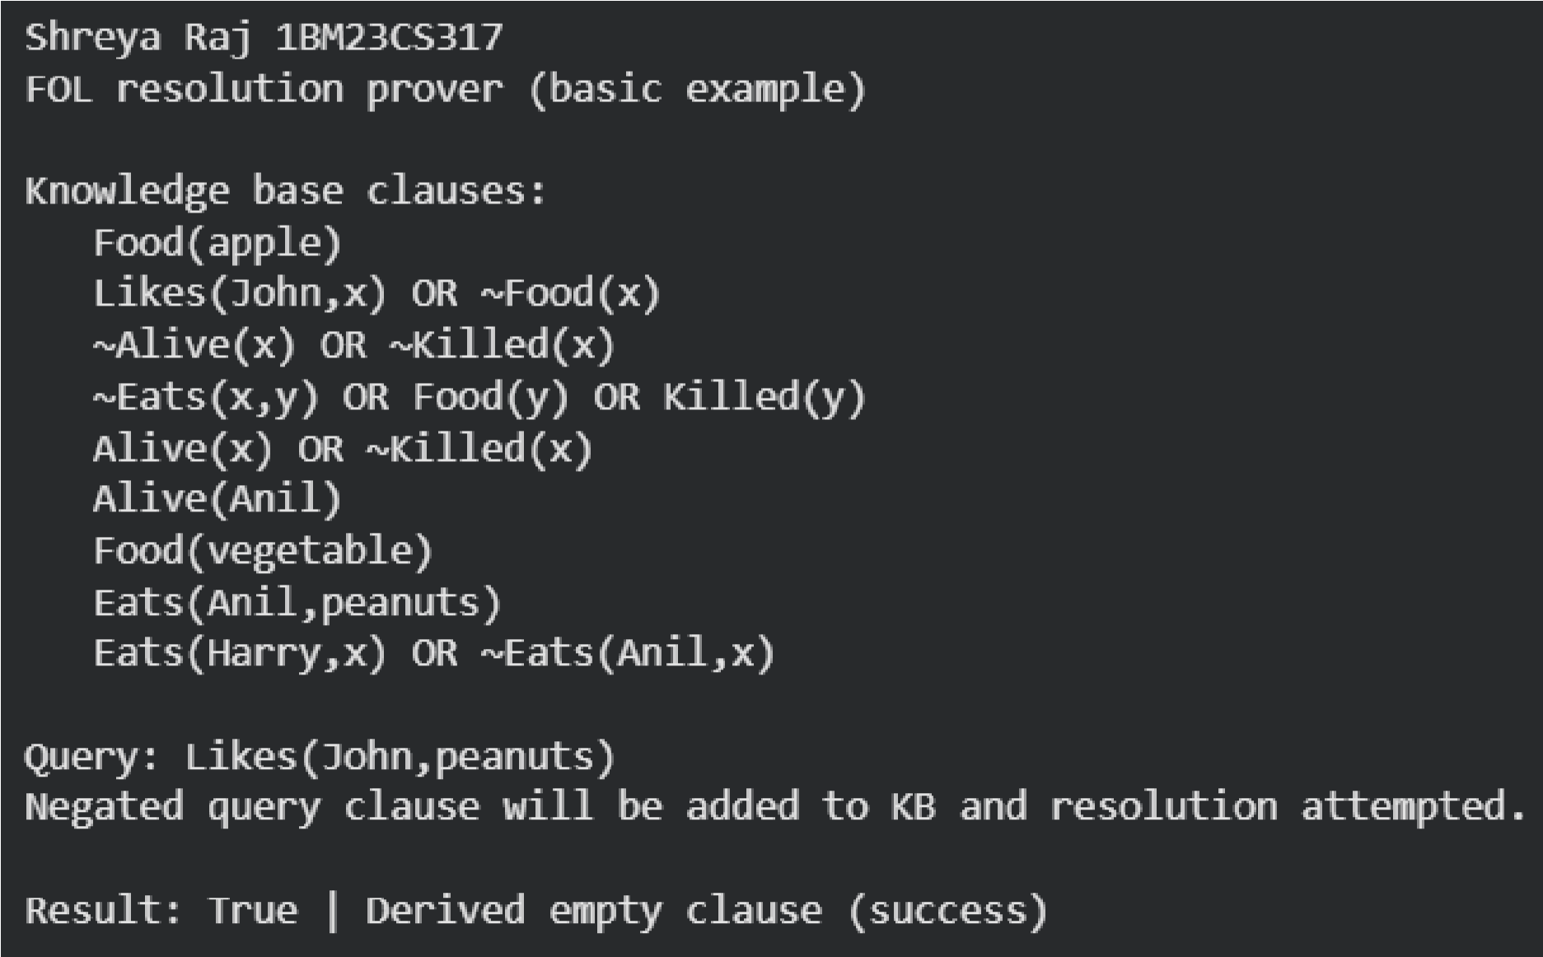

Program 10
Implement Alpha-Beta Pruning Algorithm:

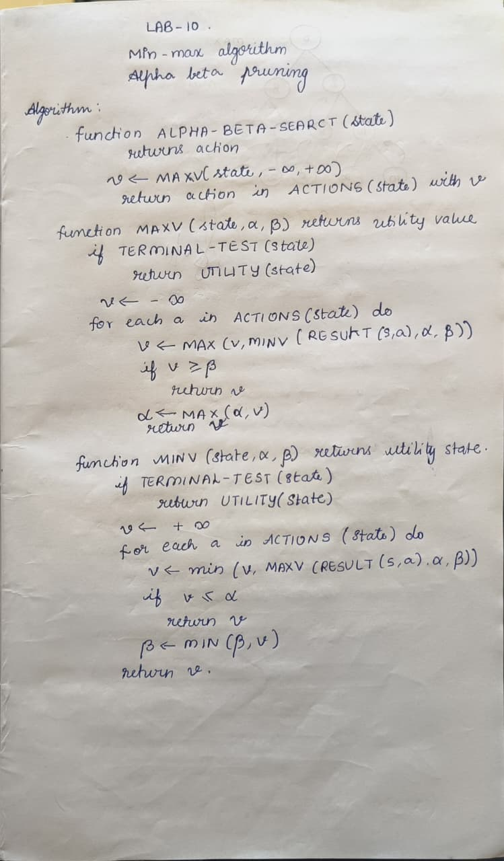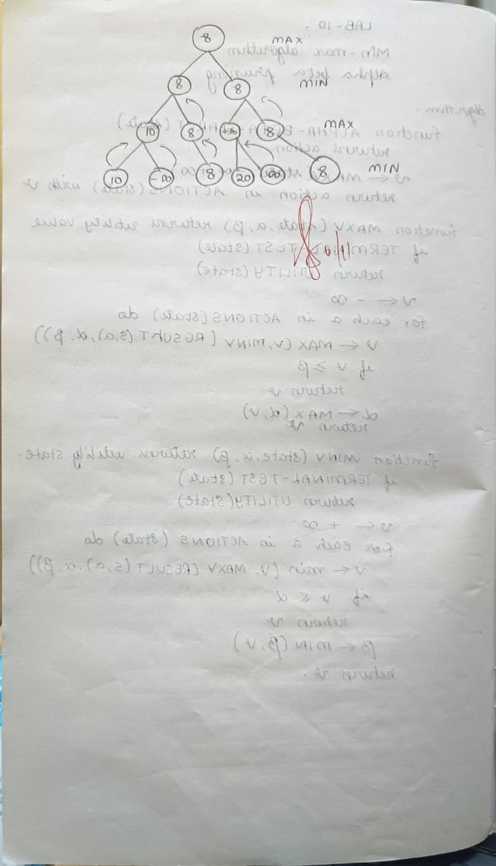
Code: def alpha_beta(node_index, depth, max_depth, alpha, beta, is_max, values, explored, pruned, path):
node_index : index of current node in conceptual tree
depth : current depth (0 = root) max_depth : total depth of tree values : list of leaf node values
total_leaves = len(values)
if depth == max_depth:
leaf_index = node_index - (2 ** max_depth - 1) if 0 <= leaf_index < total_leaves: val = values[leaf_index] explored.append((list(path), val)) return val else: return 0 # Safety fallback if is_max:
value = float('-inf') for i in range(2): # left & right children child_index = node_index * 2 + i + 1 path.append(child_index) value = max(value, alpha_beta(child_index, depth + 1, max_depth, alpha, beta, False, values, explored, pruned, path)) path.pop() alpha = max(alpha, value) if beta <= alpha:
pruned.append((node_index, child_index, 'Beta cutoff')) break return value else:
value = float('inf') for i in range(2):
child_index = node_index * 2 + i + 1 path.append(child_index) value = min(value, alpha_beta(child_index, depth + 1, max_depth, alpha, beta, True, values, explored, pruned, path)) path.pop() beta = min(beta, value) if beta <= alpha:
pruned.append((node_index, child_index, 'Alpha cutoff')) break return value
__name__ == "__main__":
values = [3, 5, 6, 9, 1, 2, 0, -1] # leaf node values max_depth = 3 # since 2^3 = 8 leaves explored, pruned = [], [] print("Leaf node values:", values) result = alpha_beta(0, 0, max_depth, float('-inf'), float('inf'),
True, values, explored, pruned, [0])
print("\nValue of root node (MAX mode):", result)
print("\nExplored leaf paths:") for p, val in explored:
print(f"Path {p} -> Value {val}")
print("\nPruned branches:") for item in pruned:
print(item)

Output:

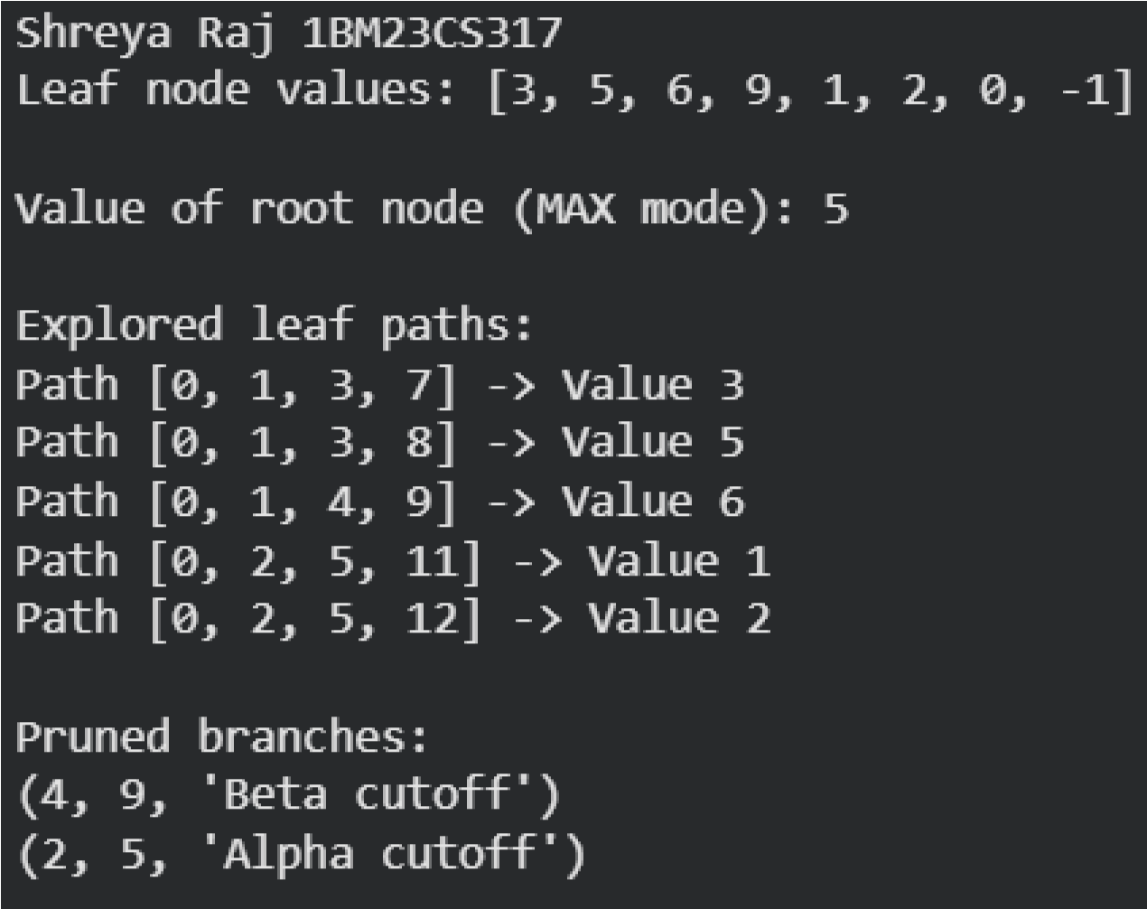
Program 11:
Convert a given first order logic statement into Conjunctive Normal Form (CNF).
Algorithm:
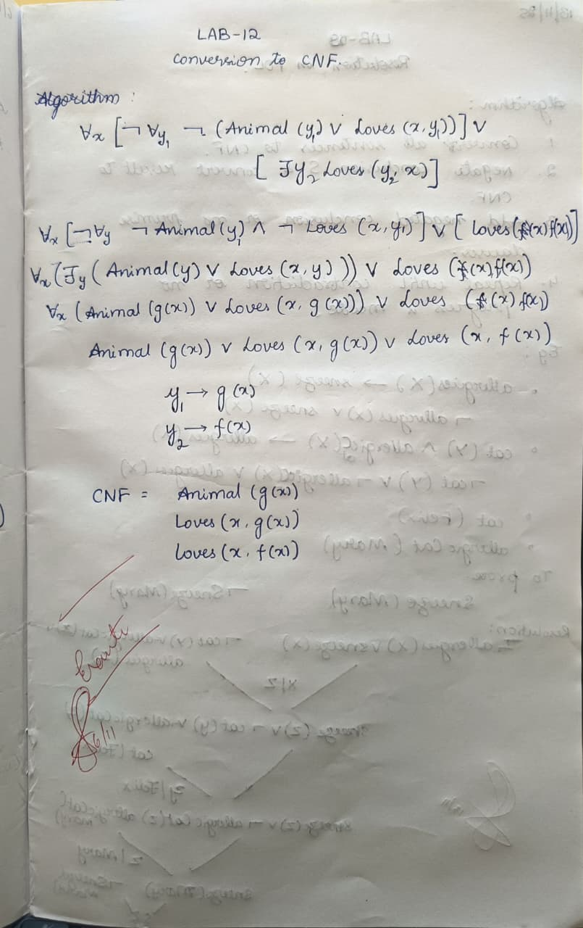
Code:
import re
def getAttributes(string):
expr = r'\([^)]+\)'
matches = re.findall(expr, string)
return [m for m in str(matches) if m.isalpha()]

def getPredicates(string):
expr = r'[A-Za-z~]+\([A-Za-z,]+\)'
return re.findall(expr, string)
def DeMorgan(sentence):
string = ''.join(list(sentence).copy())
string = string.replace('~~', '')
flag = '[' in string
string = string.replace('~[', '')
string = string.strip(']')
for predicate in getPredicates(string):
string = string.replace(predicate, f'~{predicate}')
s = list(string)
for i, c in enumerate(s):
if c == 'V':
s[i] = '^'
elif c == '^':
s[i] = 'V'
string = ''.join(s)
string = string.replace('~~', '')
return f'[{string}]' if flag else string
def Skolemization(sentence):
SKOLEM_CONSTANTS = [f'{chr(c)}' for c in range(ord('A'), ord('Z')+1)]
statement = ''.join(list(sentence).copy())
matches = re.findall('[∀∃].', statement)
for match in matches[::-1]:
statement = statement.replace(match, '')
statements = re.findall(r'\[\[[^]]+\]\]', statement)
for s in statements:
statement = statement.replace(s, s[1:-1])
for predicate in getPredicates(statement):
attributes = getAttributes(predicate)
if ''.join(attributes).islower():
statement = statement.replace(predicate, predicate)
else:
aL = [a for a in attributes if a.islower()]
aU = [a for a in attributes if not a.islower()][0] if attributes else ''
if aU:
statement = statement.replace(aU, f'{SKOLEM_CONSTANTS.pop(0)}({aL[0] if len(aL) else match[1]})')
return statement
def clean_output(expr):
# Remove multiple brackets and redundant negations
expr = expr.replace('~~', '')
while '[[' in expr or ']]' in expr:
expr = expr.replace('[[', '[').replace(']]', ']')
expr = expr.strip('[] ')
# Remove redundant outer brackets like [(p | q)] -> p | q
if expr.startswith('(') and expr.endswith(')'):
expr = expr[1:-1]
# Replace internal redundant patterns
expr = re.sub(r'\s+', ' ', expr)
return expr
def fol_to_cnf(fol):
statement = fol.replace("<=>", "_")
while '_' in statement:
i = statement.index('_')
new_statement = '[' + statement[:i] + '=>' + statement[i+1:] + ']^[' + statement[i+1:] + '=>' + statement[:i] + ']'
statement = new_statement
statement = statement.replace("=>", "-")
expr = r'\[([^]]+)\]'
statements = re.findall(expr, statement)
for i, s in enumerate(statements):
if '[' in s and ']' not in s:
statements[i] += ']'
for s in statements:
statement = statement.replace(s, fol_to_cnf(s))
while '-' in statement:
i = statement.index('-')
br = statement.index('[') if '[' in statement else 0
new_statement = '~' + statement[br:i] + 'V' + statement[i+1:]
statement = statement[:br] + new_statement if br > 0 else new_statement

while '~∀' in statement:
i = statement.index('~∀')
statement = list(statement)
statement[i], statement[i+1], statement[i+2] = '∃', statement[i+2], '~'
statement = ''.join(statement)

while '~∃' in statement:
i = statement.index('~∃')
s = list(statement)
s[i], s[i+1], s[i+2] = '∀', s[i+2], '~'
statement = ''.join(s)
statement = statement.replace('~[∀', '[~∀')
statement = statement.replace('~[∃', '[~∃')

expr = r'(~[∀V∃].)'
statements = re.findall(expr, statement)
for s in statements:
statement = statement.replace(s, fol_to_cnf(s))

expr = r'~\[[^]]+\]'
statements = re.findall(expr, statement)
for s in statements:
statement = statement.replace(s, DeMorgan(s))
return statement

def main():
print("=== FOL to CNF Converter (Simplified Output) ===")
print("Supports ∀, ∃, ~, &, |, >>, <=>, brackets [] () {}")
print("Example 1: ∀x[~∀y~(Animal(y) | Loves(x,y)) | ∃y Loves(y,x)]")
print("Example 2: ~(p >> q) | (r & s)")
print("------------------------------------------------------------")

fol = input("Enter FOL formula: ").strip()
try:
result = Skolemization(fol_to_cnf(fol))
print("\nSimplified CNF form:")
print(clean_output(result))
except Exception as e:
print("\nError: Could not parse the formula.")
print("Details:", e)
if __name__ == "__main__":
main()

Output: