B.M.S. COLLEGE OF ENGINEERING BENGALURU
Autonomous Institute, Affiliated to VTU



Lab Record

Computer Networks – 23CS5PCCON

Submitted in partial fulfillment for the 5th Semester Laboratory

Bachelor of Engineering
in
Computer Science and Engineering

Submitted by:

Bhoomika B G

(1BM23CS067)

Department of Computer Science and Engineering
B.M.S. College of Engineering
Bull Temple Road, Basavanagudi, Bangalore 560 019
August 2025-December 2025

B.M.S. College of EngineerinG
DEPARTMENT OF COMPUTER SCIENCE AND ENGINEERING



CERTIFICATE

This is to certify that the Computer Networks (23CS5PCCON) laboratory has been carried out by Bhoomika B G (1BM23CS067) during the 5th Semester August 2025-December 2025

Signature of the Faculty Incharge:

Spoorthi D M
Assistant Professor
Department of Computer Science and Engineering
B.M.S. College of Engineering, Bangalore

Table of Contents

PART - A
Serial No. | Name of Experiment
1. | Create a topology and simulate sending a simple PDU from source to destination using hub and switch as connecting devices and demonstrate ping message.
2. | Configure DHCP within a LAN and outside LAN.
3. | Configure Web Server, DNS within a LAN.
4. | Configure IP address to routers in packet tracer. Explore the following messages: ping responses, destination unreachable, request timed out, reply.
5. | Configure default route, static route to the Router.
6. | Configure RIP routing Protocol in Routers.
7. | Configure OSPF routing protocol.
8. | To construct a VLAN and make the PC’s communicate among a VLAN.
9. | To construct a WLAN and make the nodes communicate wirelessly.
10. | Demonstrate the TTL/ Life of a Packet.
11. | To understand the operation of TELNET by accessing the router in server room from a PC in IT office.
12. | To construct simple LAN and understand the concept and operation of Address Resolution Protocol (ARP).

PART – B
Serial No. | Name of Experiment
1. | Write a program for congestion control using Leaky bucket algorithm.
2. | Using TCP/IP sockets, write a client-server program to make client sending the file name and the server to send back the contents of the requested file if present.
3. | Using UDP sockets, write a client-server program to make client sending the file name and the server to send back the contents of the requested file if present.
4. | Write a program for error detecting code using CRC-CCITT (16-bits).

PART - A
Program 1: Create a topology and simulate sending a simple PDU from source to destination using hub and switch as connecting devices and demonstrate ping message.
Network diagram:
Bus
Hub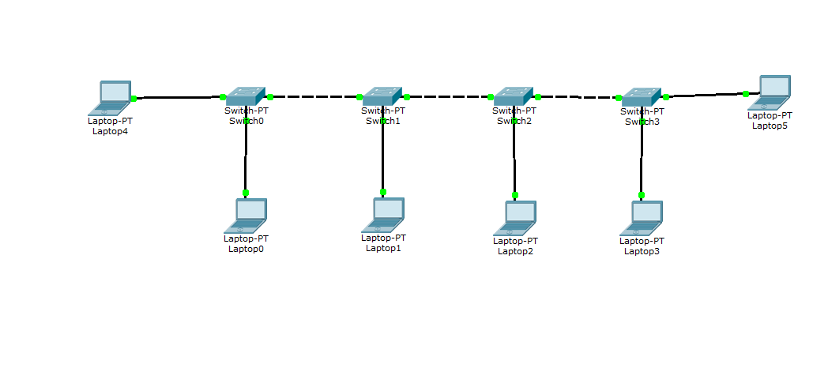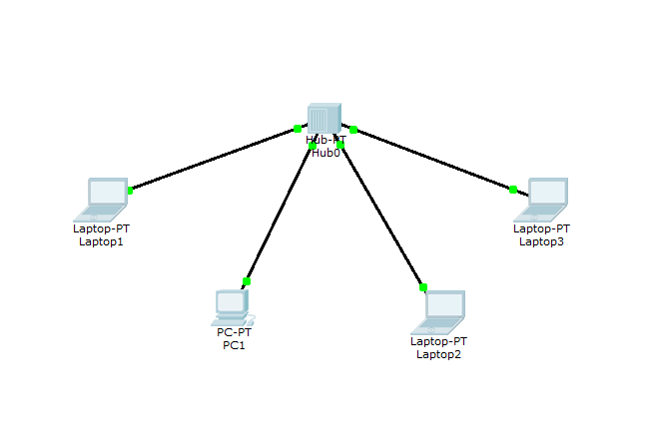

Switch
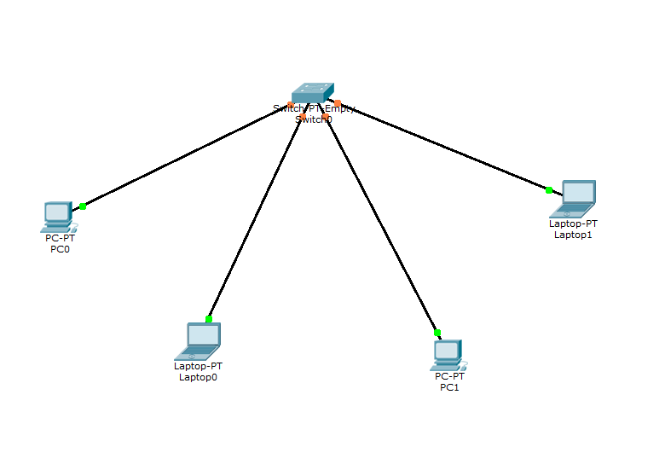

Mesh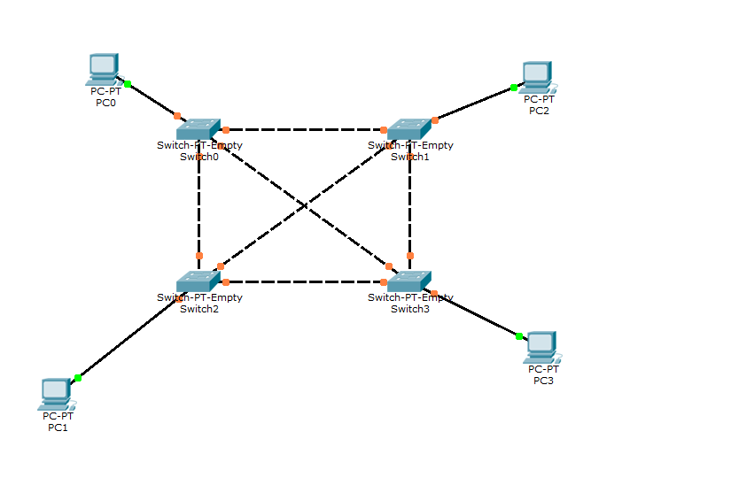
Program 2: Configure DHCP within a LAN and outside LAN.
Network diagram:
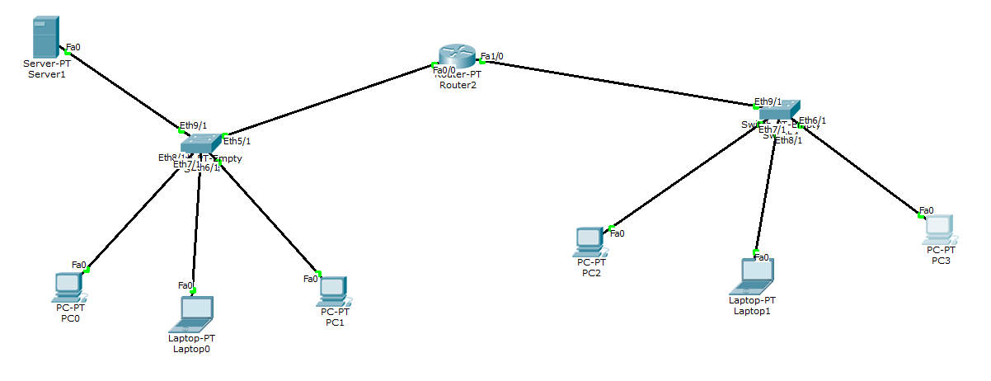
Configuration:
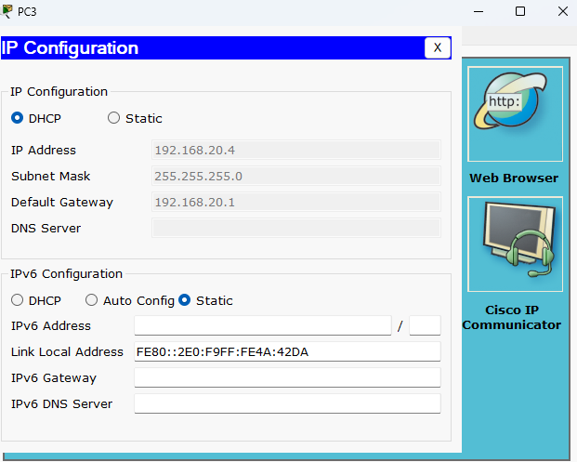
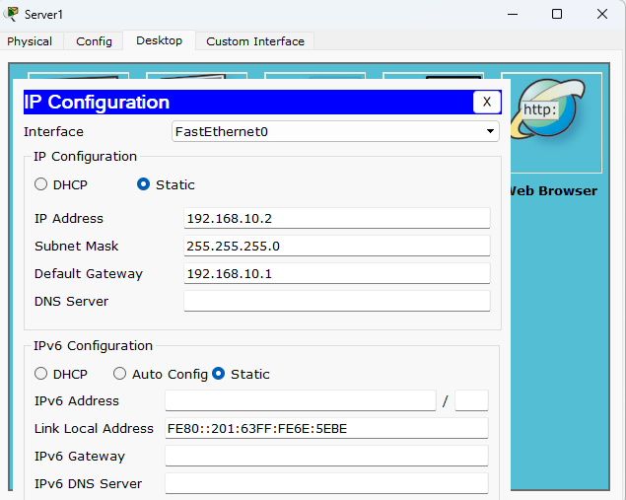
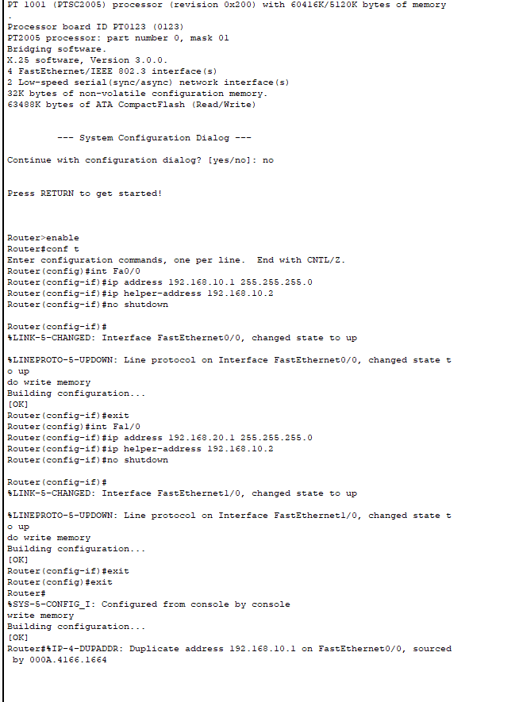

Program 3: Configure Web Server, DNS within a LAN.
Network diagram:
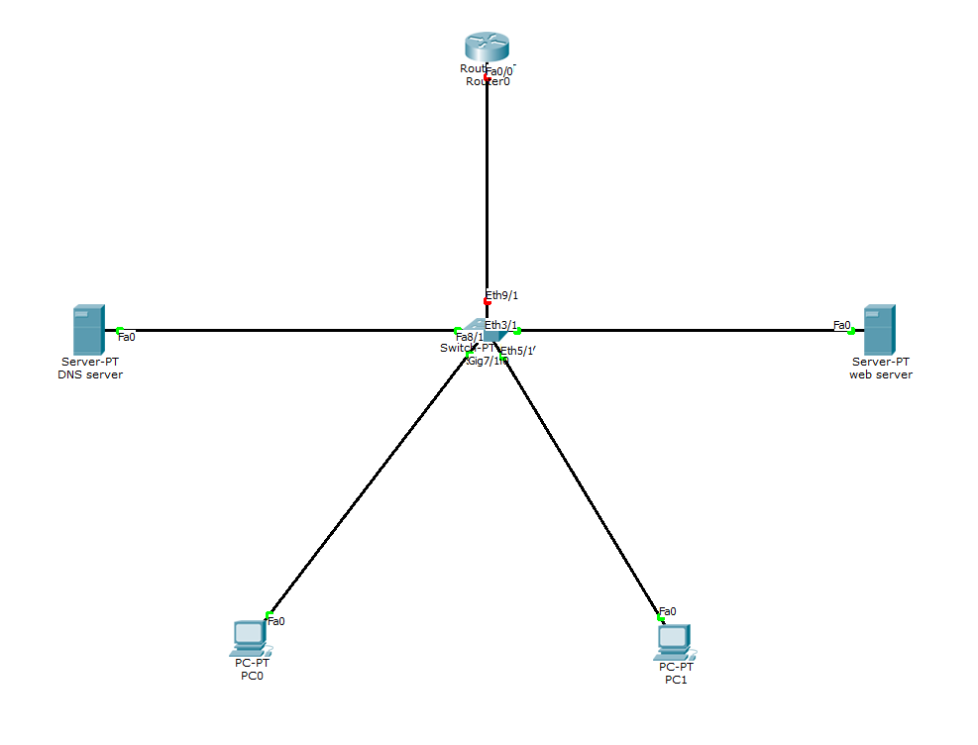

Configuration:
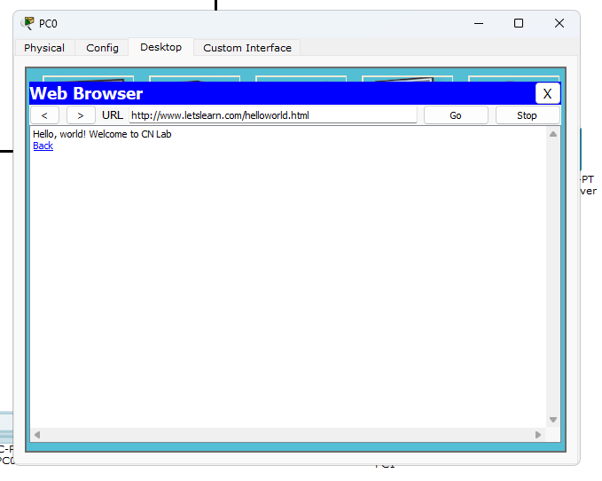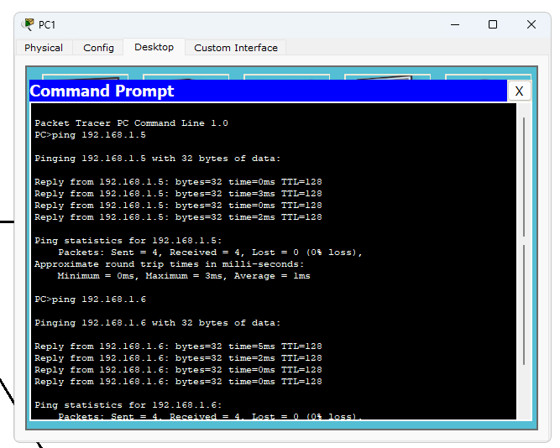

Program 4: Configure IP address to routers in packet tracer. Explore the following messages: ping responses, destination unreachable, request timed out, reply.
Network diagram:


Configuration:
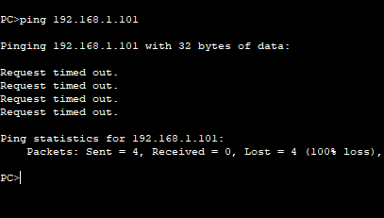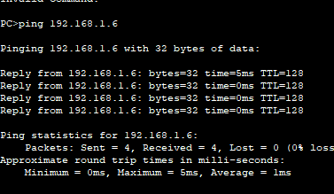

Program 5: Configure default route, static route to the Router.
Network diagram:
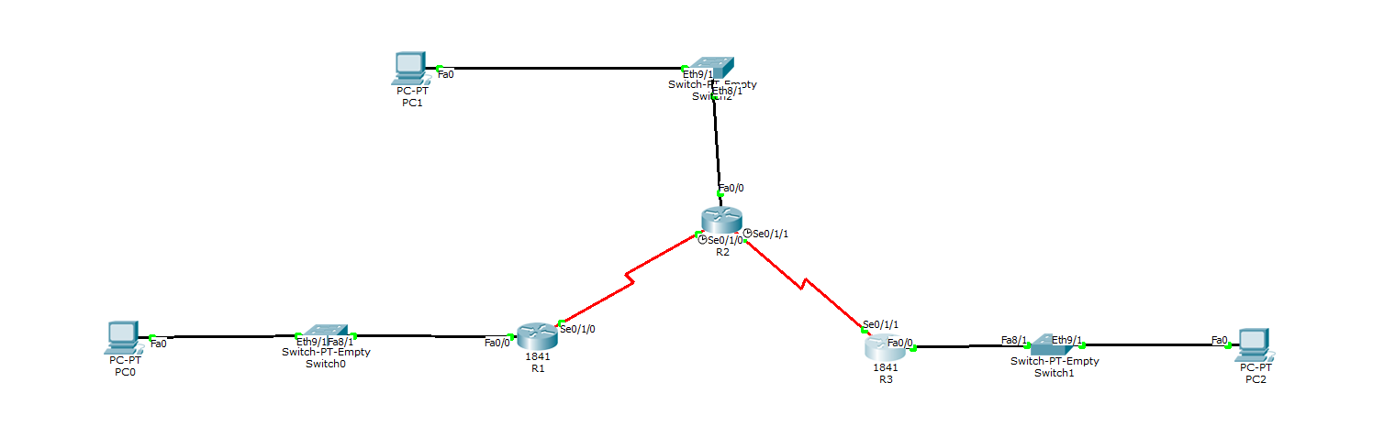

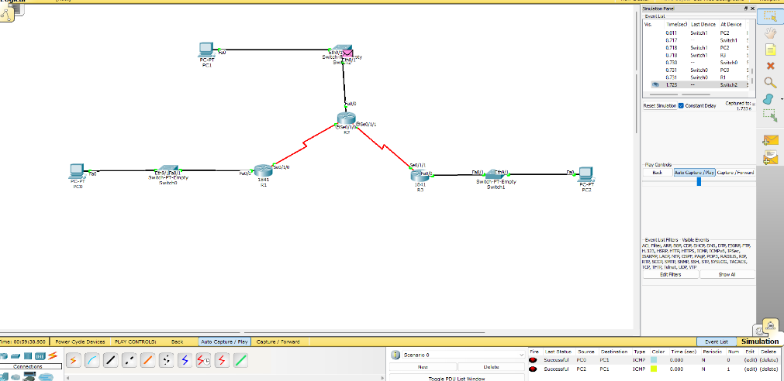

Configuration:
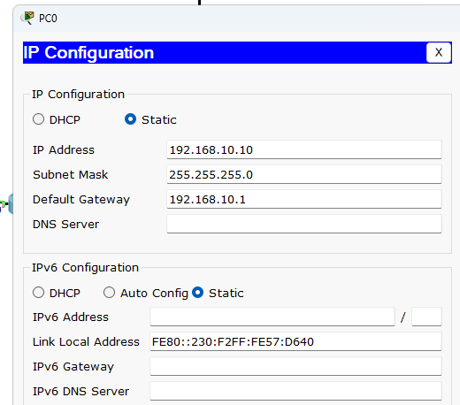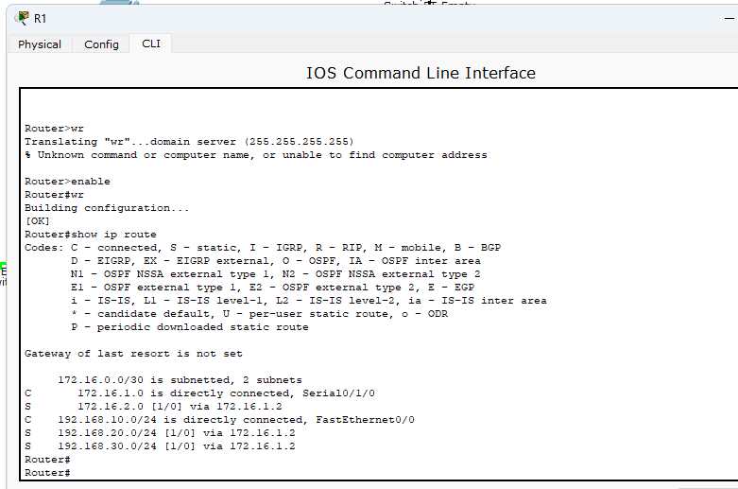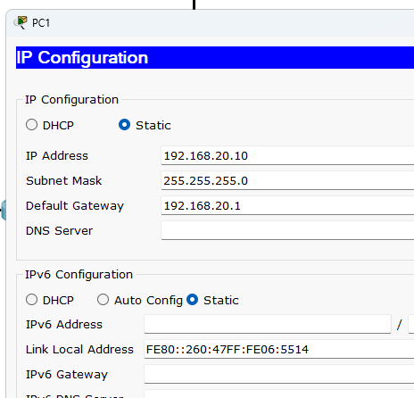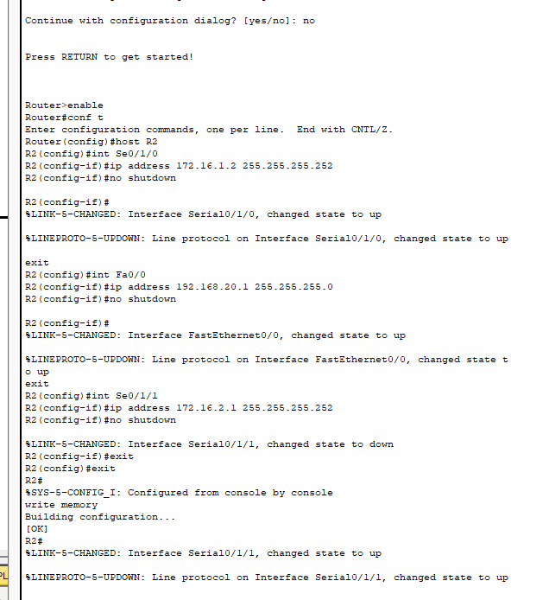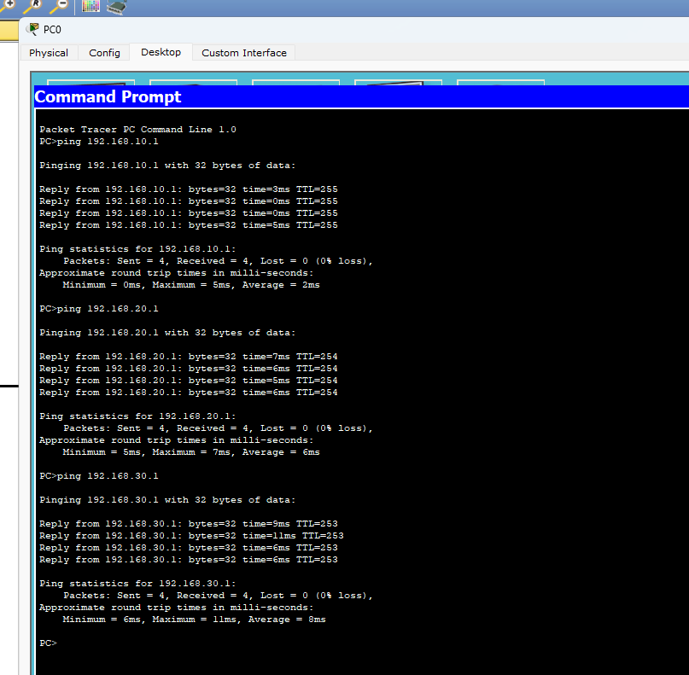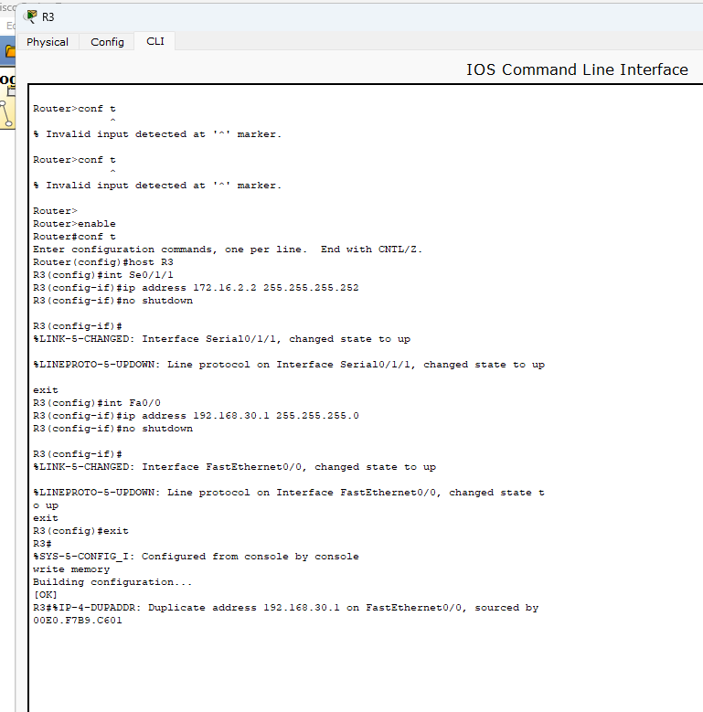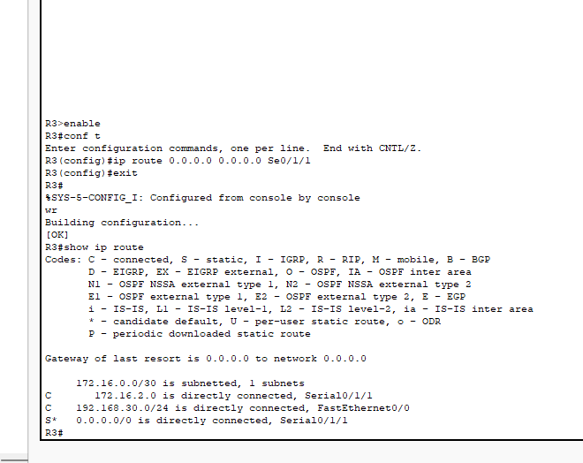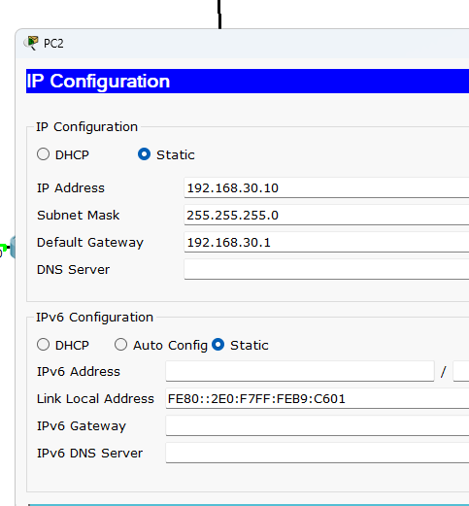

Program 6: Configure RIP routing Protocol in Routers.
Network diagram:
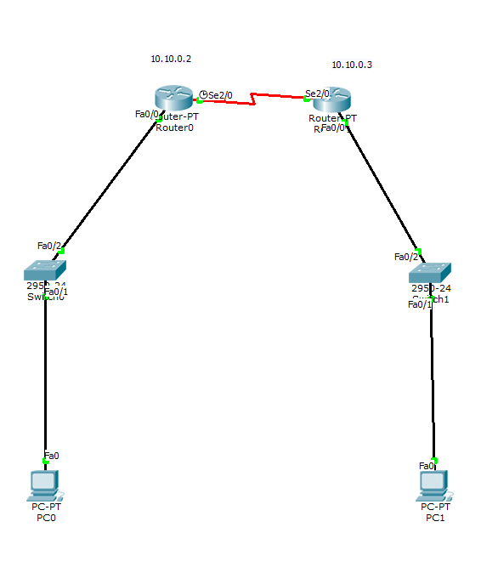
Configuration:
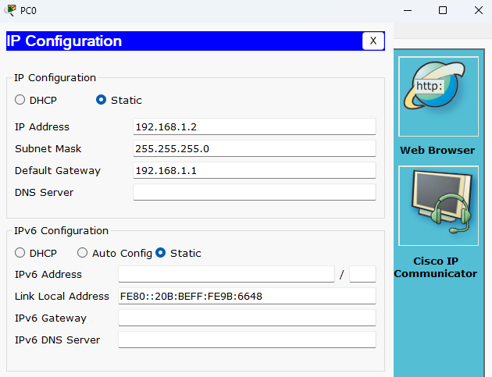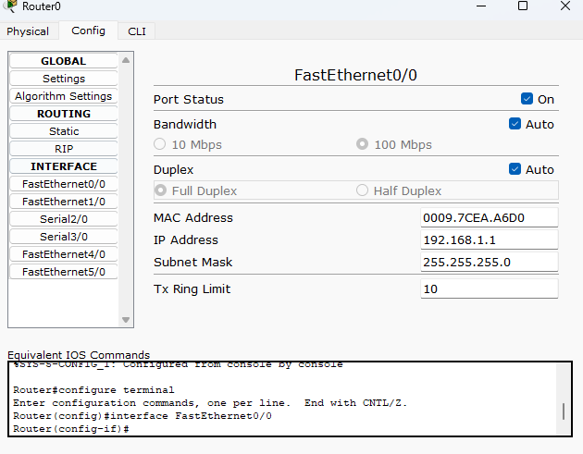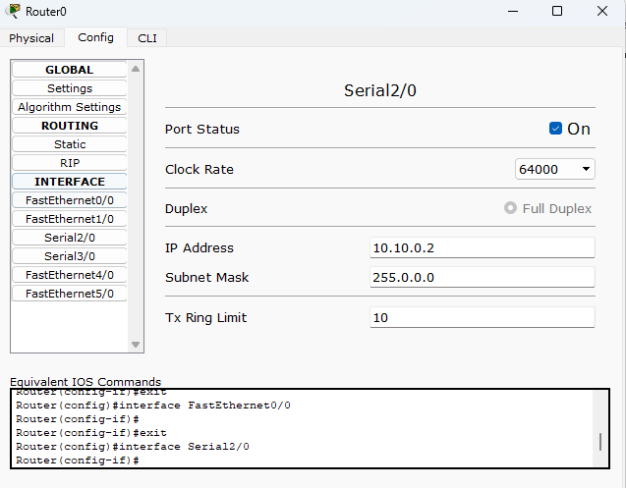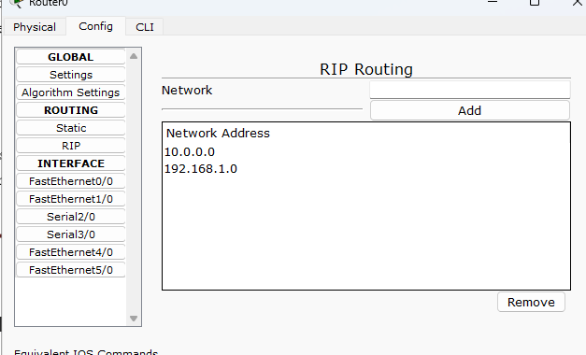
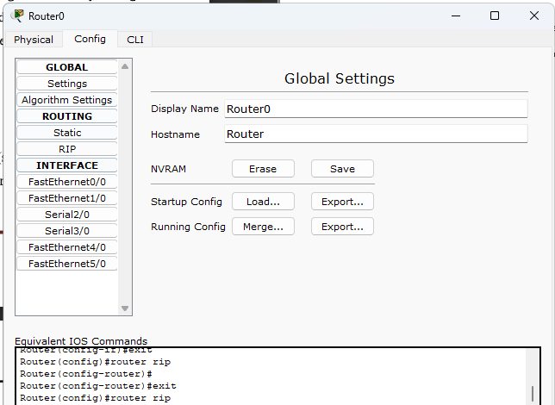

Program 7: Configure OSPF routing protocol.
Network diagram: 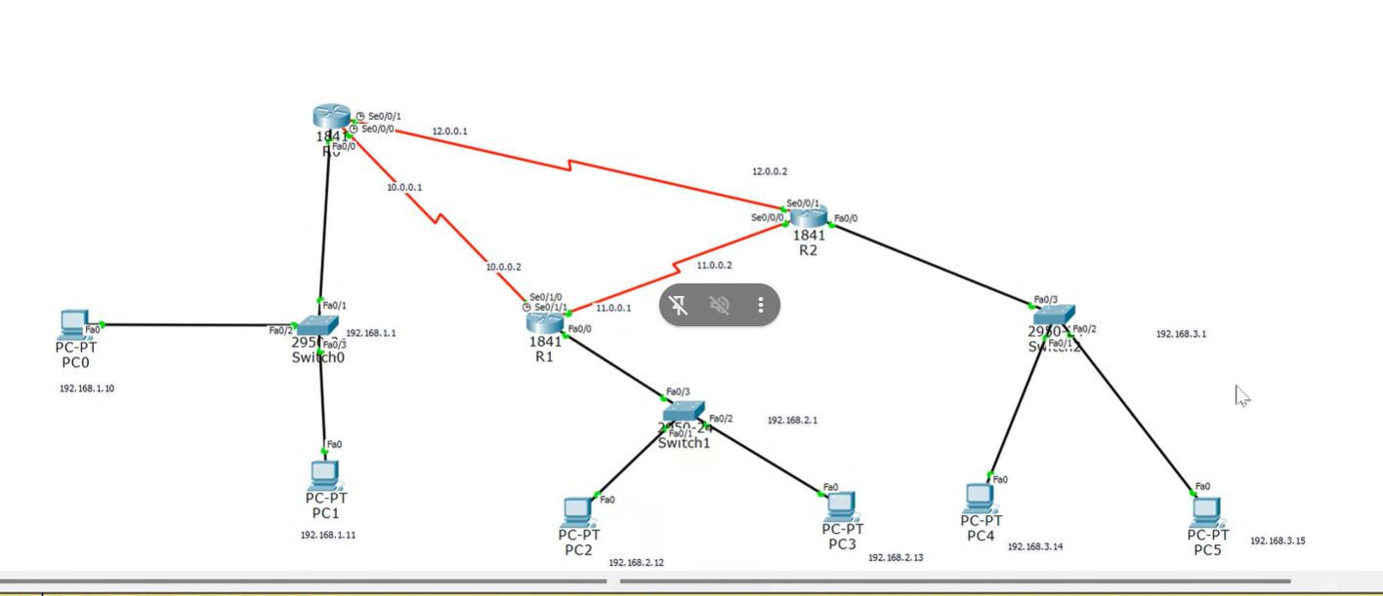
Configuration:
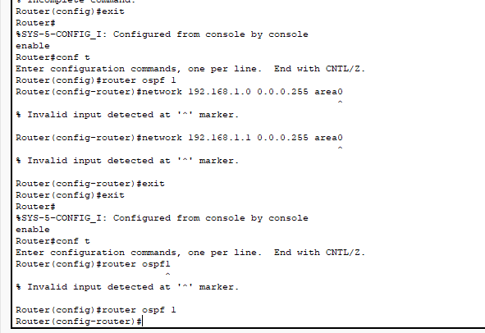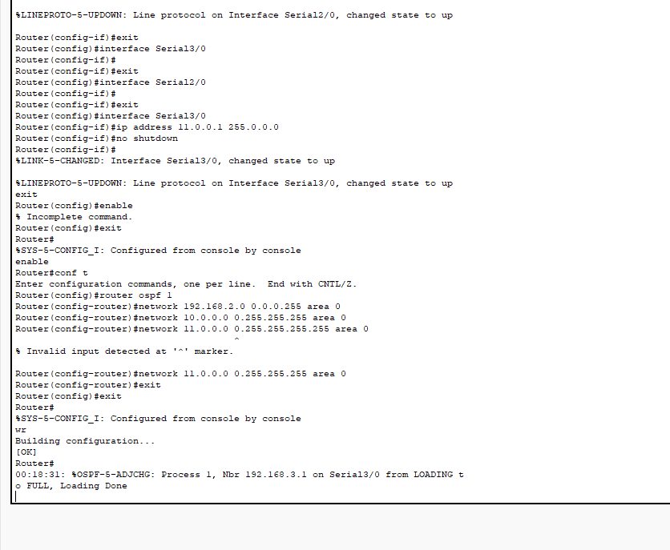

Program 8: To construct a VLAN and make the PC’s communicate among a VLAN.
Network diagram:
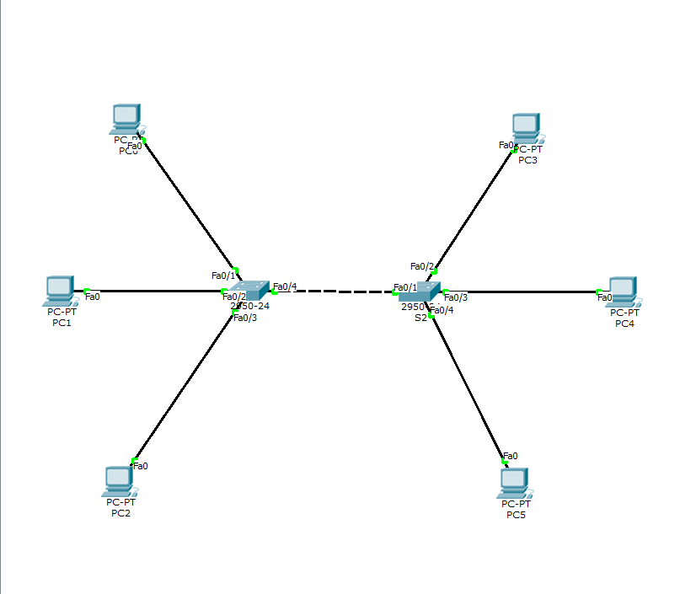

Configuration:
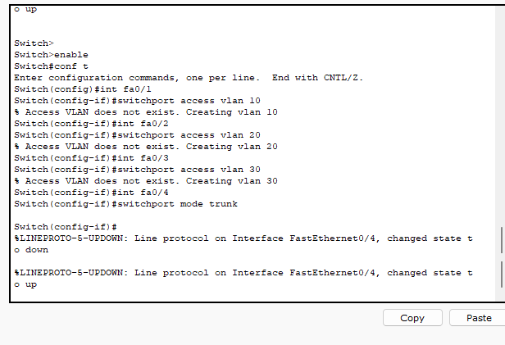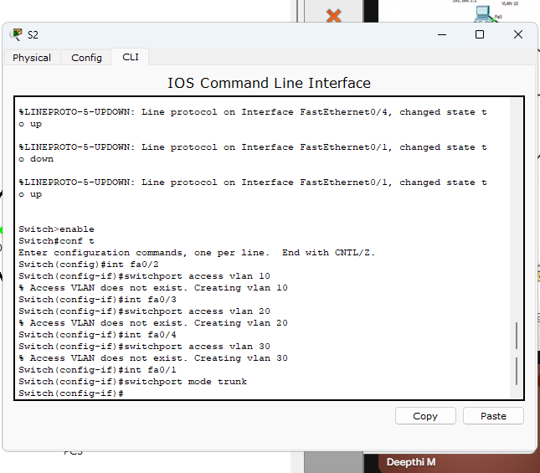
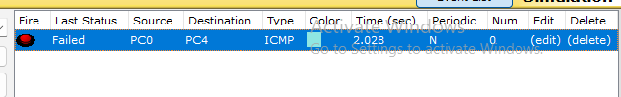

Program 9: To construct a WLAN and make the nodes communicate wirelessly.
Network diagram:
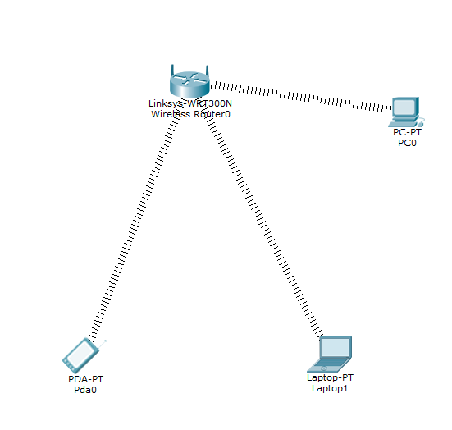

Configuration:
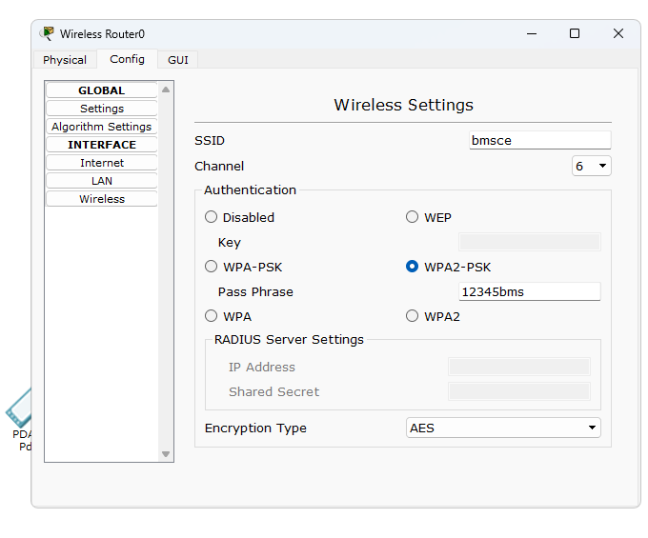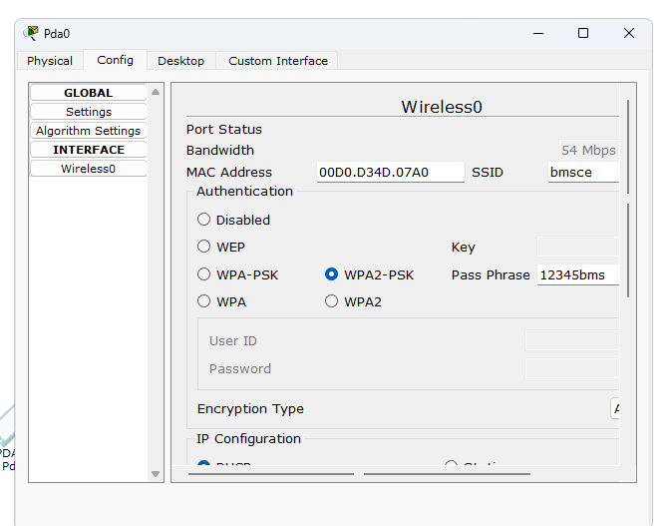

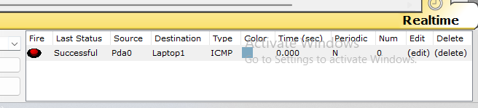

Program 10: Demonstrate the TTL/ Life of a Packet.
Network diagram:
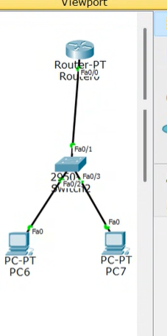
Configuration:
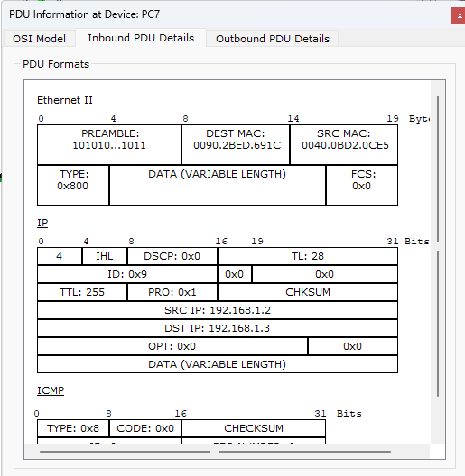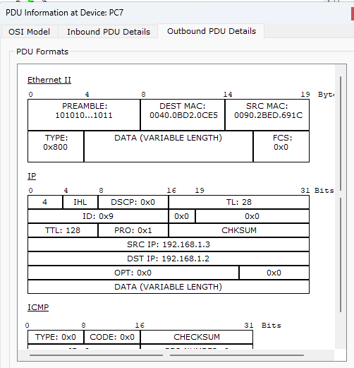

Program 11: To understand the operation of TELNET by accessing the router in server room from a PC in IT office.
Network diagram: 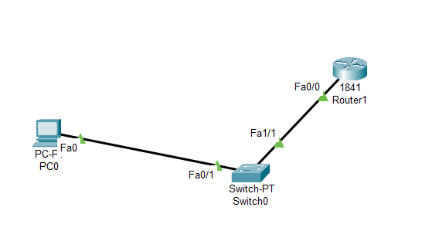
Configuration:
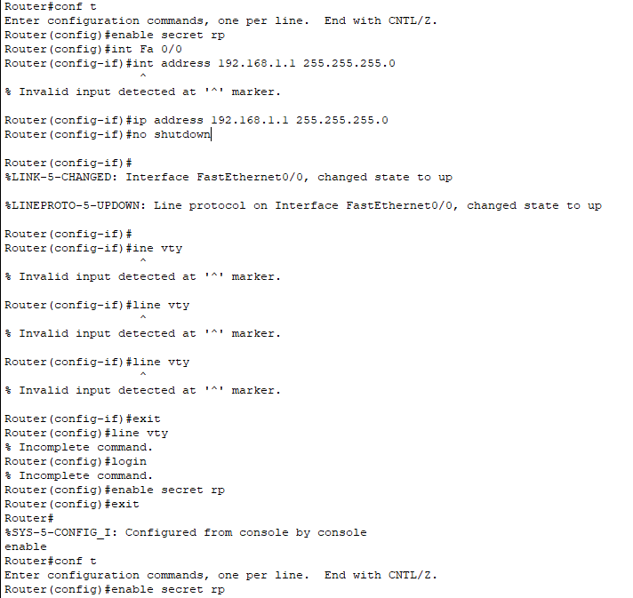

Program 12: To construct simple LAN and understand the concept and operation of Address Resolution Protocol (ARP).
Network diagram:
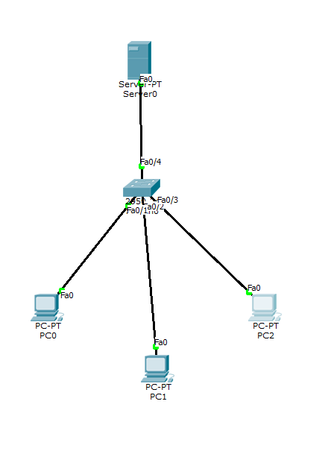
Configuration:
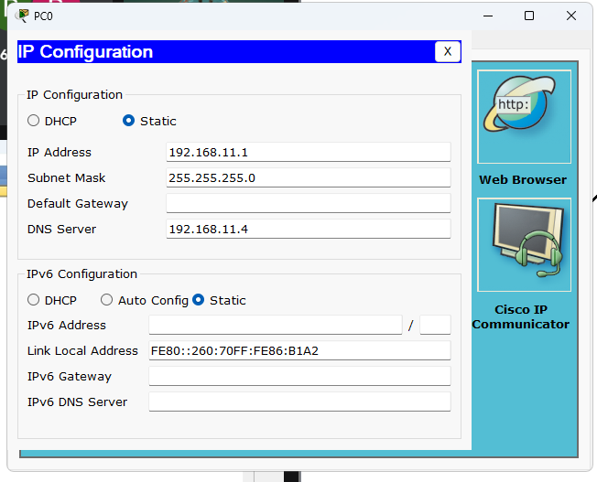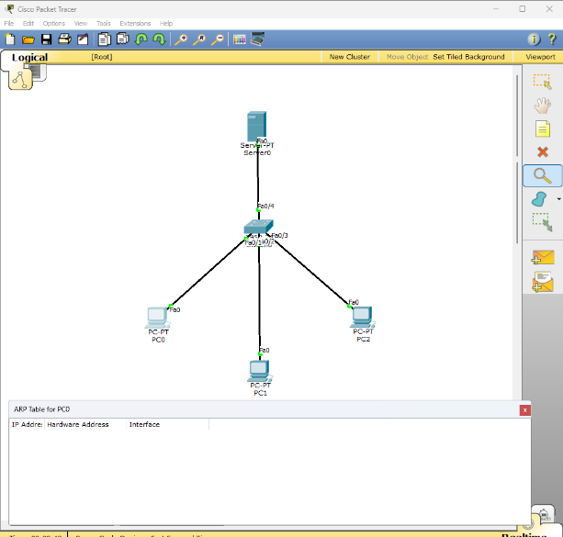
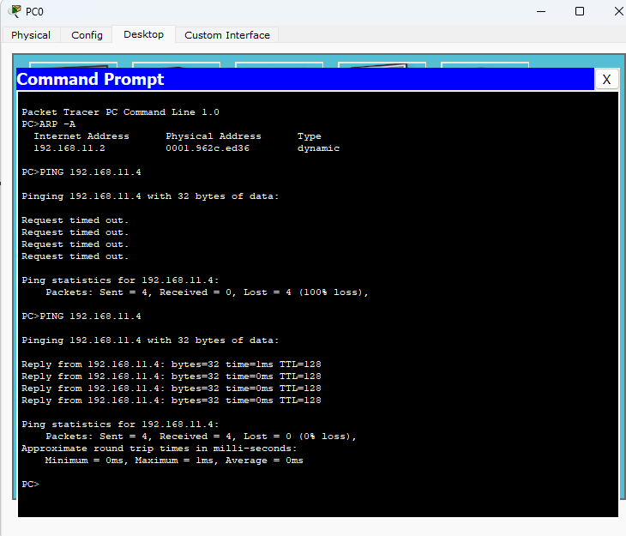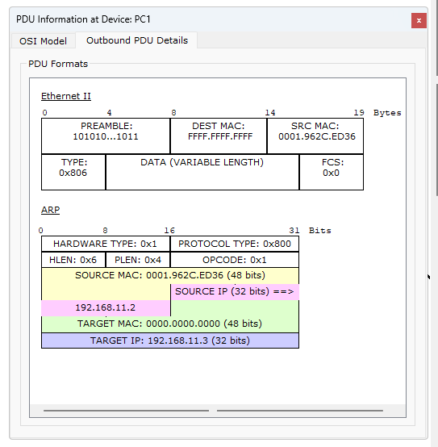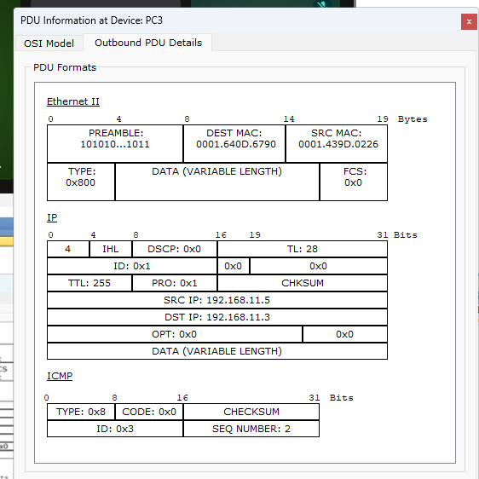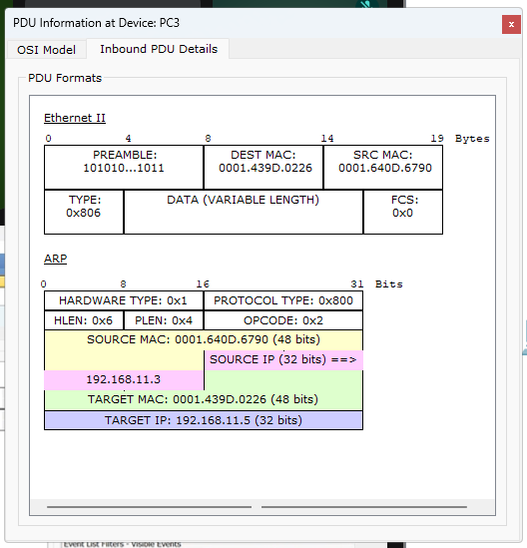

PART - B
Program 1: Write a program for congestion control using Leaky bucket algorithm.
Code: #include<stdio.h>
int min(int x, int y) {
return (x < y) ? x : y;
}
int main() {
int drop = 0, mini, nsec, cap, count = 0, i, inp[25], process;
printf("Enter the bucket size: ");
scanf("%d", &cap);
printf("Enter the processing rate: ");
scanf("%d", &process);
printf("Enter the number of seconds you want to simulate: ");
scanf("%d", &nsec);
for (i = 0; i < nsec; i++) {
printf("Enter the size of the packet entering at %d sec: ", i + 1);
scanf("%d", &inp[i]);
}
printf("\n Second | Packet Received | Packet Sent | Packet Left | Dropped \n");
printf("---------------------------------------------------------------------\n");
for (i = 0; i < nsec; i++) {
count += inp[i];
if (count > cap) {
drop = count - cap;
count = cap;
}
printf("%6d | %15d |", i + 1, inp[i]);
mini = min(count, process);
printf(" %11d |", mini);

count -= mini;
printf(" %11d | %7d\n", count, drop);

drop = 0;
}
while (count != 0) {
i++;
if (count > cap) {
drop = count - cap;
count = cap;
}
printf("%6d | %15d |", i, 0);
mini = min(count, process);
printf(" %11d |", mini);

count -= mini;
printf(" %11d | %7d\n", count, drop);
}
return 0;
}
OUTPUT:
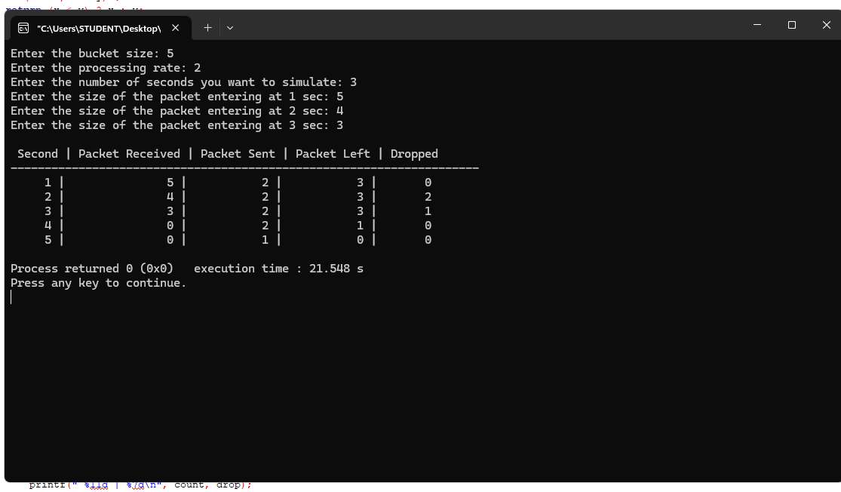

Program 2: Using TCP/IP sockets, write a client-server program to make client sending the file name and the server to send back the contents of the requested file if present.
Code:
Server:
#include <stdio.h>
#include <stdlib.h>
#include <string.h>
#include <unistd.h>
#include <sys/types.h>
#include <sys/socket.h>
#include <netinet/in.h>
int main(int argc, char *argv[])
{
int sockfd, newsockfd, portno, n;
char buffer[256], line[2000], filedata[20000];
struct sockaddr_in serv, cli;
socklen_t len;
FILE *fp;
if (argc < 2) {
printf("Error: No port number provided.\nUsage: ./server <port>\n");
exit(1);
}
sockfd = socket(AF_INET, SOCK_STREAM, 0);
if (sockfd < 0) {
perror("Socket creation failed");
exit(1);
}
memset(&serv, 0, sizeof(serv));
portno = atoi(argv[1]);
serv.sin_family = AF_INET;
serv.sin_addr.s_addr = INADDR_ANY;
serv.sin_port = htons(portno);
if (bind(sockfd, (struct sockaddr *)&serv, sizeof(serv)) < 0) {
perror("Bind failed");
exit(1);
}
listen(sockfd, 5);
printf("Server: Waiting for connection...\n");
len = sizeof(cli);
newsockfd = accept(sockfd, (struct sockaddr *)&cli, &len);
if (newsockfd < 0) {
perror("Accept failed");
exit(1);
}

memset(buffer, 0, sizeof(buffer));
n = read(newsockfd, buffer, sizeof(buffer) - 1);
if (n < 0) {
perror("Error reading file name");
exit(1);
}
printf("Server received file request: %s\n", buffer);
fp = fopen(buffer, "r");
if (fp == NULL) {
printf("Server: File not found.\n");
write(newsockfd, "File not found", 15);
close(newsockfd);
close(sockfd);
return 0;
}
printf("Server: File found. Reading...\n");
memset(filedata, 0, sizeof(filedata));
while (fgets(line, sizeof(line), fp) != NULL) {
strcat(filedata, line);
}
fclose(fp);
n = write(newsockfd, filedata, strlen(filedata));
if (n < 0)
perror("Error writing to socket");
printf("Transfer complete.\n");

close(newsockfd);
close(sockfd);
return 0;
}
Client:
#include <stdio.h>
#include <stdlib.h>
#include <string.h>
#include <unistd.h>
#include <sys/types.h>
#include <sys/socket.h>
#include <netinet/in.h>
int main(int argc, char *argv[])
{
int sockfd, portno, n;
char filename[256], filedata[20000];
struct sockaddr_in serv;
if (argc < 2) {
printf("Error: No port number provided.\nUsage: ./client <port>\n");
exit(1);
}
sockfd = socket(AF_INET, SOCK_STREAM, 0);
if (sockfd < 0) {
perror("Socket creation failed");
exit(1);
}
memset(&serv, 0, sizeof(serv));
portno = atoi(argv[1]);
serv.sin_family = AF_INET;
serv.sin_port = htons(portno);
serv.sin_addr.s_addr = INADDR_ANY; // connecting to same machine
if (connect(sockfd, (struct sockaddr *)&serv, sizeof(serv)) < 0) {
perror("Server not responding");
exit(1);
}
printf("Enter file path: ");
scanf("%s", filename);
n = write(sockfd, filename, strlen(filename));
if (n < 0)
perror("Error writing filename");
memset(filedata, 0, sizeof(filedata));
n = read(sockfd, filedata, sizeof(filedata) - 1);
if (n < 0)
perror("Error reading data from server");
printf("\n--- File Content ---\n%s\n", filedata);
close(sockfd);
return 0;
}
Output:
$ cc socketserver.c
$ ./a.out 1025
server:
waiting for connection
server received:/home/aps/cse.txt
server:/home/aps/cse.txt found
opening and reading..
reading..
..reading complete
transfer complete
$ cc socketclient.c
$ ./a.out 1025
Enter the file with complete path
/home/aps/cse.txt
Reading..
..
client: display content of /home/aps/cse.txt
..
Welcome to the CSE department..........
2)
$ cc fserver.c
$ ./a.out
error:no port no
usage:
/server port no
$ cc fclient.c
$./a.out
Err:no port no.
usage:
./client portno
ex:./client 7777

Program 3: Using UDP sockets, write a client-server program to make client sending the file name and the server to send back the contents of the requested file if present.
Code:
Server:
#include <stdio.h>
#include <stdlib.h>
#include <string.h>
#include <unistd.h>
#include <sys/types.h>
#include <sys/socket.h>
#include <netinet/in.h>

int main(int argc, char *argv[])
{
int sockfd, portno, n;
char buffer[1024];
struct sockaddr_in servaddr, cliaddr;
socklen_t len;

if (argc < 2) {
printf("Usage: ./server <port>\n");
exit(1);
}

portno = atoi(argv[1]);

sockfd = socket(AF_INET, SOCK_DGRAM, 0);
if (sockfd < 0) {
perror("Socket creation failed");
exit(1);
}

memset(&servaddr, 0, sizeof(servaddr));
memset(&cliaddr, 0, sizeof(cliaddr));

servaddr.sin_family = AF_INET;
servaddr.sin_addr.s_addr = INADDR_ANY;
servaddr.sin_port = htons(portno);

if (bind(sockfd, (struct sockaddr *)&servaddr, sizeof(servaddr)) < 0) {
perror("Bind failed");
exit(1);
}

printf("UDP Server: Waiting for data...\n");

len = sizeof(cliaddr);
memset(buffer, 0, sizeof(buffer));

n = recvfrom(sockfd, buffer, sizeof(buffer)-1, 0,
(struct sockaddr *)&cliaddr, &len);
if (n < 0) {
perror("Receive failed");
exit(1);
}

printf("Received from client: %s\n", buffer);

// Echo back the same data
n = sendto(sockfd, buffer, strlen(buffer), 0,
(struct sockaddr *)&cliaddr, len);
if (n < 0)
perror("Send failed");

close(sockfd);
return 0;
}
Client:
#include <stdio.h>
#include <stdlib.h>
#include <string.h>
#include <unistd.h>
#include <sys/types.h>
#include <sys/socket.h>
#include <netinet/in.h>

int main(int argc, char *argv[])
{
int sockfd, portno, n;
char buffer[1024];
struct sockaddr_in servaddr;
socklen_t len;

if (argc < 2) {
printf("Usage: ./client <port>\n");
exit(1);
}

portno = atoi(argv[1]);

sockfd = socket(AF_INET, SOCK_DGRAM, 0);
if (sockfd < 0) {
perror("Socket creation failed");
exit(1);
}

memset(&servaddr, 0, sizeof(servaddr));

servaddr.sin_family = AF_INET;
servaddr.sin_port = htons(portno);
servaddr.sin_addr.s_addr = INADDR_ANY; // local machine

printf("Enter message to send: ");
scanf("%[^\n]", buffer);

len = sizeof(servaddr);

n = sendto(sockfd, buffer, strlen(buffer), 0,
(struct sockaddr *)&servaddr, len);
if (n < 0) {
perror("Send failed");
exit(1);
}

memset(buffer, 0, sizeof(buffer));

n = recvfrom(sockfd, buffer, sizeof(buffer)-1, 0,
(struct sockaddr *)&servaddr, &len);
if (n < 0) {
perror("Receive failed");
exit(1);
}

printf("Server replied: %s\n", buffer);
close(sockfd);
return 0;
}
Output:
1)
UDP Server: Waiting for data...
Received from client: Hello UDP Server!
2)
Enter message to send: Hello UDP Server!
Server replied: Hello UDP Server!
Program 4: Write a program for error detecting code using CRC-CCITT (16-bits).
Code: #include <stdio.h>
#include <string.h>
#include <stdlib.h>

int main() {
char rem[50], a[50], s[50], c, msj[50], gen[30];
int i, genlen, t, j, flag = 0, k, n;

printf("Enter the generator polynomial: ");
fgets(gen, sizeof(gen), stdin);
gen[strcspn(gen, "\n")] = '\0';
printf("Generator polynomial is CRC: %s\n", gen);

genlen = strlen(gen);
k = genlen - 1;

printf("Enter the message: ");
n = 0;
while ((c = getchar()) != '\n') {
msj[n] = c;
n++;
}
msj[n] = '\0';

for (i = 0; i < n; i++) {
a[i] = msj[i];
}
for (i = 0; i < k; i++) {
a[n + i] = '0';
}
a[n + k] = '\0';

printf("\nMessage polynomial appended with zeros:\n");
puts(a);

for (i = 0; i < n; i++) {
if (a[i] == '1') {
t = i;
for (j = 0; j <= k; j++) {
a[t] = (a[t] == gen[j]) ? '0' : '1';
t++;
}
}
}

for (i = 0; i < k; i++) {
rem[i] = a[n + i];
}
rem[k] = '\0';

printf("The checksum appended:\n");
puts(rem);
printf("\nThe message with checksum appended:\n");
for (i = 0; i < n; i++) {
a[i] = msj[i];
}
for (i = 0; i < k; i++) {
a[n + i] = rem[i];
}
a[n + k] = '\0';
puts(a);

n = 0;
printf("Enter the received message: ");
while ((c = getchar()) != '\n') {
s[n] = c;
n++;
}
s[n] = '\0';
for (i = 0; i < n; i++) {
if (s[i] == '1') {
t = i;
for (j = 0; j <= k; j++, t++) {
s[t] = (s[t] == gen[j]) ? '0' : '1';
}
}
}

for (i = 0; i < k; i++) {
rem[i] = s[n + i];
}
rem[k] = '\0';
for (i = 0; i < k; i++) {
if (rem[i] == '1') {
flag = 1;
}
}

if (flag == 0) {
printf("Received polynomial is error-free.\n");
} else {
printf("Received polynomial has an error.\n");
}

return 0;
}
OUTPUT:
