**Web Technology**

**Bhoomika B V – 1JT18IS014**

**Program-1: Write a JavaScript to design a simple calculator to perform the following operations: Sum, Product, Difference and Quotient.**

HTML CODE:

<!DOCTYPE html>

<html>

    <head>

        <title>Program 1</title>

            <style type="text/css">

            table, td, th

            {

            border: 2px solid;

            text-align: center;

            background-color: skyblue;

                margin: auto;

            }

            input

            {

                text-align: center;

            }

            </style>

    <script type="text/javascript">

function calc(clicked_id)

{

    var v1=parseFloat(document.getElementById("value1").value);

    var v2=parseFloat(document.getElementById("value2").value);

    if(isNaN(v1) || isNaN(v2))

        alert("Please enter a valid number");

        else if(clicked_id=="add")

            document.getElementById("answer").value=v1+v2;

        else if(clicked_id=="sub")

            document.getElementById("answer").value=v1-v2;

        else if(clicked_id=="mul")

            document.getElementById("answer").value=v1*v2;

        else if(clicked_id=="div")

    {

        if(v2==0)

    {

        alert("Please Enter a Non Zero Denominator");

    location.reload();

    }

    else

        document.getElementById("answer").value=v1/v2;

    }

}

function cls()

    {

    value1.value="0";

    value2.value="0";

    answer.value="";

    }

    </script>

</head>

<body>

<table>

    <tr>

        <th colspan="4"> Simple Calculator </th>

    </tr>

    <tr>

        <td>Enter Operand-1</td>

        <td> <input type="text" id="value1" value="0"/></td>

        <td>Enter Operand-2</td>

        <td><input type="text" id="value2" value="0"/></td>

    </tr>

    <tr>

    <td><input type="button" value="Addition" id="add"

    onclick="calc(this.id)"/> </td>

    <td><input type="button" value="Subtraction" id="Sub"

    onclick="calc(this.id)"/> </td>

    <td><input type="button" value="Multiplication" id="mul"

    onclick="calc(this.id)"/> </td>

    <td colspan="2"><input type="button" value="Division" id="div"

    onclick="calc(this.id)"/> </td>

    </tr>

    <tr>

        <td> Result: </td>

        <td> <input type="text" id="answer" value="" disabled/></td>

        <td><input type="button" value="Clear All" id="cls"

        onclick="cls(this.id)"/> </td>

    </tr>

        </table>

    </body>

</html>

**Output - 1 (Sum):**

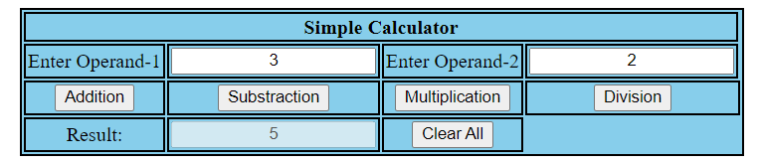

**Output - 2 (Difference):**

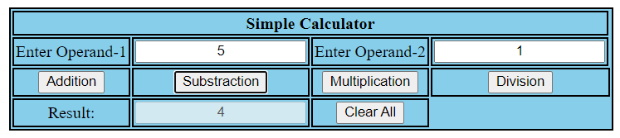

**Output - 3 (Product):**

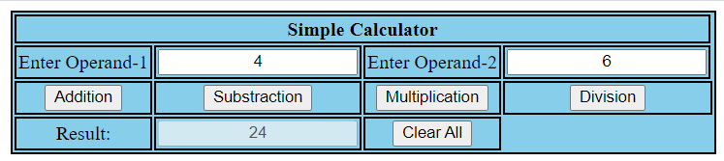

**Output - 4 (Quotient):**

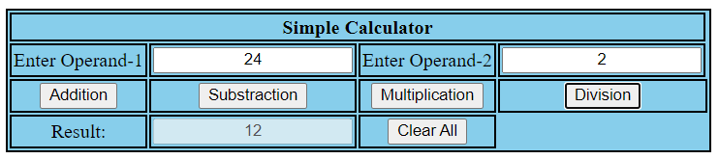

**Test Cases:**

|  |  |  |  |  |
| --- | --- | --- | --- | --- |
| **Test No.** | **Input Parameters** | **Expected O/P** | **Obtained O/P** | **Remarks** |
| **1.** | V1 = 8  V2 = 2 | Addition = 10 | Addition = 10 | **PASS** |
| Subtraction = 6 | Subtraction = 6 |
| Product = 16 | Product = 16 |
| Division = 4 | Division = 4 |
| **2.** | V1 = 8.0  V2 = 2.0 | Addition = 10 | Addition = 10 | **PASS** |
| Subtraction = 6 | Subtraction = 6 |
| Product = 16 | Product = 16 |
| Division = 4 | Division = 4 |
| **3.** | V1 = 2  V2 = 8 | Addition = 10 | Addition = 10 | **PASS** |
| Subtraction = -6 | Subtraction = -6 |
| Product = 16 | Product = 16 |
| Division = 0.25 | Division = 0.25 |
| **4.** | V1 = 0  V2 = 8 | Addition = 8 | Addition = 8 | **PASS** |
| Subtraction = -8 | Subtraction = -8 |
| Product = 0 | Product = 0 |
| Division = 0 | Division = 0 |
| **5.** | V1 = 8  V2 = 0 | Addition = 8 | Addition = 8 | **PASS** |
| Subtraction = 8 | Subtraction = 8 |
| Product = 0 | Product = 0 |
| Division = Infinity | Division = Infinity |
| **6.** | V1 = abc  V2 = 8 | Enter a number | Enter a number | **PASS** |

**Code:** [**https://github.com/bhoomikajitwta/1JT18IS014_WT**](https://github.com/bhoomikajitwta/1JT18IS014_WT)

**Challenge Assignment – 1**

**HTML Code:**

  <html>

   <head>

      <script>

         function dis(val)

         {

             document.getElementById("result").value+=val

         }

         function solve()

         {

             let x = document.getElementById("result").value

             let y = eval(x)

             document.getElementById("result").value = y

         }

         function clr()

         {

             document.getElementById("result").value = ""

         }

      </script>

      <style>

       h1 {text-align: center;}

        table

         {

            border: solid grey 3px;

            text-align: center;

            background-color: white;

            margin: auto;

            box-shadow: 3px 3px grey;

            padding: 2px;

            border-radius: 8px;

         }

         .title{

         margin-bottom: 10px;

         text-align:center;

         width: 210px;

         color:grey;

         border: solid white 2px;

         }

         input[type="button"]

         {

         background-color:grey;

         border: solid white 2px;

         height:50px;

         width:100%

         }

         input[type="text"]

         {

         background-color:grey;

         border: solid white 2px;

         height:50px;

         width:100%

         }

      </style>

   </head>

   <body>

      <h1 >Simple Calculator</h1>

      <table border="1">

         <tr>

            <td colspan="4"><input type="text" id="result"/></td>

         </tr>

         <tr>

            <td><input type="button" value="1" onclick="dis('1')"/> </td>

            <td><input type="button" value="2" onclick="dis('2')"/> </td>

            <td><input type="button" value="3" onclick="dis('3')"/> </td>

            <td><input type="button" value="/" onclick="dis('/')"/> </td>

         </tr>

         <tr>

            <td><input type="button" value="4" onclick="dis('4')"/> </td>

            <td><input type="button" value="5" onclick="dis('5')"/> </td>

            <td><input type="button" value="6" onclick="dis('6')"/> </td>

            <td><input type="button" value="*" onclick="dis('*')"/> </td>

         </tr>

         <tr>

            <td><input type="button" value="7" onclick="dis('7')"/> </td>

            <td><input type="button" value="8" onclick="dis('8')"/> </td>

            <td><input type="button" value="9" onclick="dis('9')"/> </td>

            <td><input type="button" value="-" onclick="dis('-')"/> </td>

         </tr>

         <tr>

            <td><input type="button" value="c" onclick="clr()"/> </td>

            <td><input type="button" value="0" onclick="dis('0')"/> </td>

            <td><input type="button" value="=" onclick="solve()"/> </td>

            <td><input type="button" value="+" onclick="dis('+')"/> </td>

         </tr>

      </table>

   </body>

</html>

**Screenshots:**

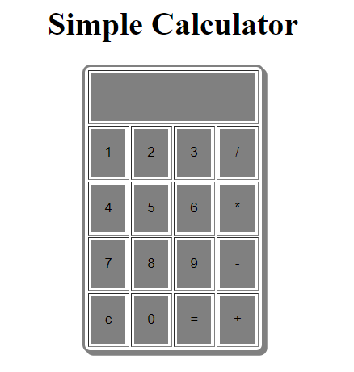

**Output – 1(Sum)**

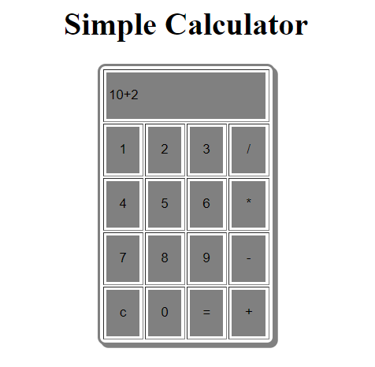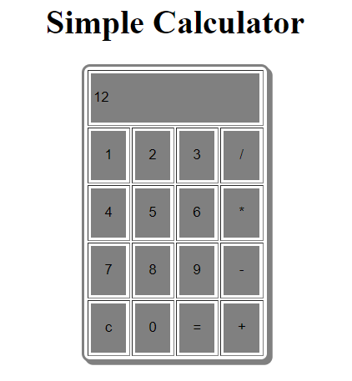

🡪

**Output – 2 (Difference)**

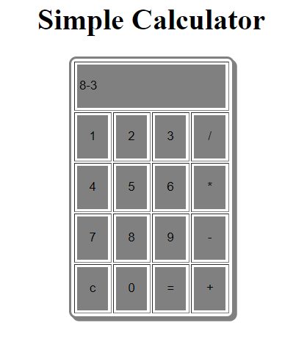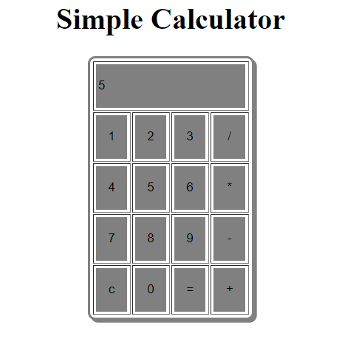

🡪

**Output – 3 (Product):**

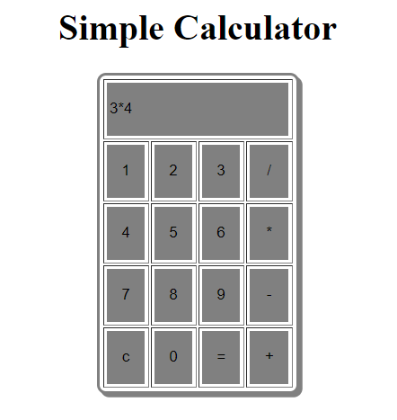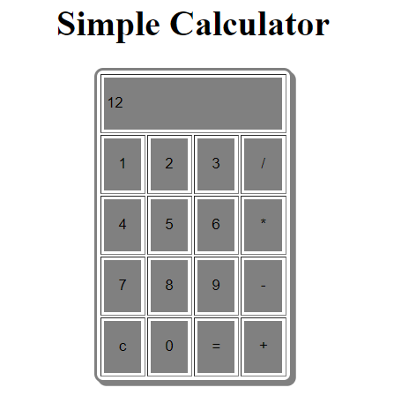

🡪

**Output - 4 (Quotient):**

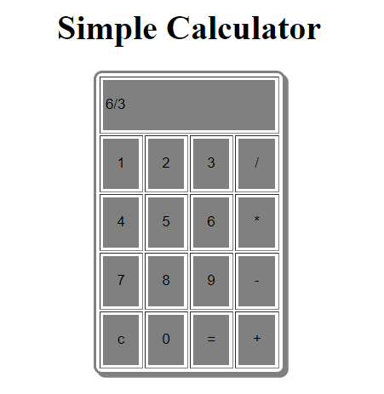 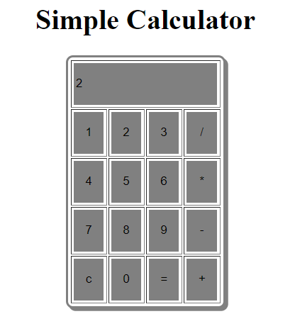

🡪

**Test Cases:**

|  |  |  |  |  |
| --- | --- | --- | --- | --- |
| **Test No.** | **Input Parameters** | **Expected O/P** | **Obtained O/P** | **Remarks** |
| **1.** | V1 = 8  V2 = 2 | Addition = 10 | Addition = 10 | **PASS** |
| Subtraction = 6 | Subtraction = 6 |
| Product = 16 | Product = 16 |
| Division = 4 | Division = 4 |
| **2.** | V1 = 8.0  V2 = 2.0 | Addition = 10 | Addition = 10 | **PASS** |
| Subtraction = 6 | Subtraction = 6 |
| Product = 16 | Product = 16 |
| Division = 4 | Division = 4 |
| **3.** | V1 = 2  V2 = 8 | Addition = 10 | Addition = 10 | **PASS** |
| Subtraction = -6 | Subtraction = -6 |
| Product = 16 | Product = 16 |
| Division = 0.25 | Division = 0.25 |
| **4.** | V1 = 0  V2 = 8 | Addition = 8 | Addition = 8 | **PASS** |
| Subtraction = -8 | Subtraction = -8 |
| Product = 0 | Product = 0 |
| Division = 0 | Division = 0 |
| **5.** | V1 = 8  V2 = 0 | Addition = 8 | Addition = 8 | **PASS** |
| Subtraction = 8 | Subtraction = 8 |
| Product = 0 | Product = 0 |
| Division = Infinity | Division = Infinity |
| **6.** | V1 = abc  V2 = 8 | Enter a number | Enter a number | **PASS** |

**Code:** [**https://github.com/bhoomikajitwta/1JT18IS014_WT**](https://github.com/bhoomikajitwta/1JT18IS014_WT)