Customer Shopping Behavior Analysis

End-to-End Data Analytics Project

Submitted By:
Bhoomika P
Tools Used:
Python
PostgreSQL
SQL
Power BI
Date:
July 2026

- Project Overview
This project analyzes customer shopping behavior using transactional data from 3,900 purchases across various product categories. The goal is to uncover insights into spending patterns, customer segments, product preferences, and subscription behavior to guide strategic business decisions.
2. Dataset Summary
Rows: 3,900
Columns: 18
Key Features:
- Customer demographics (Age, Gender, Location, Subscription Status)
- Purchase details (Item Purchased, Category, Purchase Amount, Season, Size, Color)
- Shopping behavior (Discount Applied, Promo Code Used, Previous Purchases, Frequency of Purchases, Review Rating, Shipping Type)
Missing Data:
- 37 values were missing in the Review Rating column.

3.Exploratory Data Analysis using Python
We began with data preparation and cleaning in Python.
Data Loading:
- Imported the dataset using the pandas library.
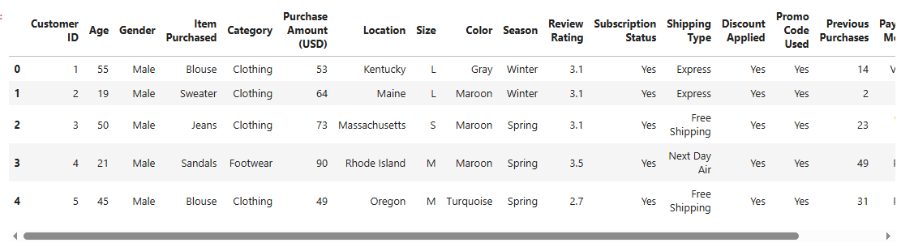
Figure 1: Preview of the Customer Shopping Behavior dataset loaded into Python using pandas.
Initial Exploration:
- Used df.info() to check the dataset structure.
- Used df.describe() to generate summary statistics.

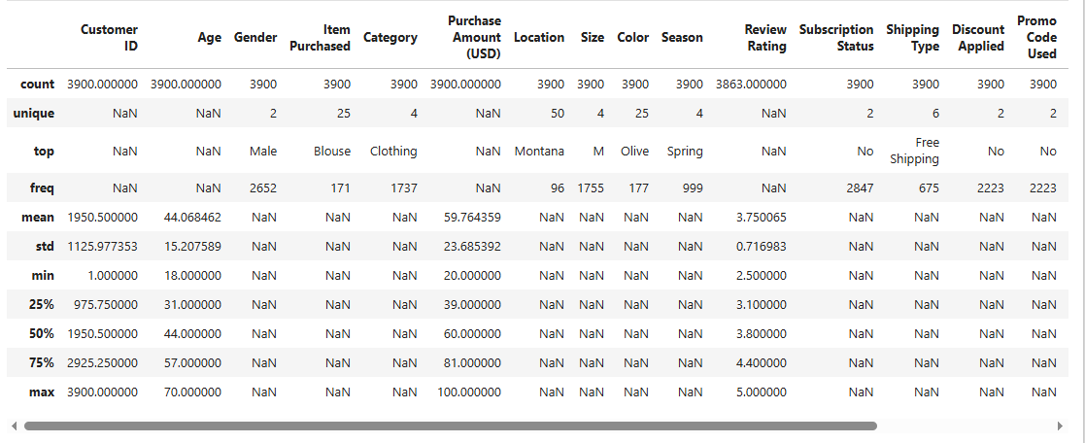
Figure 2: Summary statistics of the dataset generated using df.describe()
Missing Data Handling:
- Checked for missing values in the dataset.
- Filled missing values in the Review Rating column using the median rating of each product category.
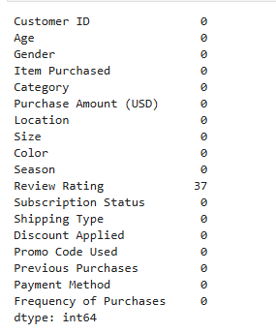
Figure 3: Missing value check before data cleaning (df.isnull().sum())
Column Standardization:
- Renamed column names to snake_case for better readability and consistency.
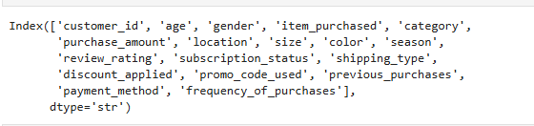
Figure 4: Column names after standardization to snake_case format
Feature Engineering:
- Created age_group column by grouping customers into different age categories.
- Created purchase_frequency_days column from the purchase frequency data.
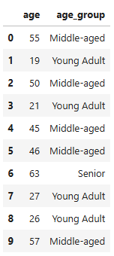
Figure 5: Feature engineering – Creation of the age_group column
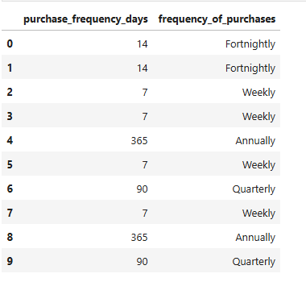
Figure 6: Feature engineering – Creation of the purchase_frequency_days column
Data Consistency Check:
- Verified whether discount_applied and promo_code_used contained duplicate information.
- Dropped the promo_code_used column because it was redundant.
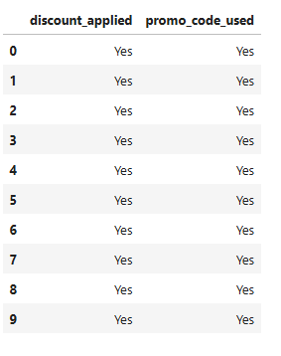
Figure 7: Data consistency check between discount_applied and promo_code_used
Database Integration:
- Connected the cleaned dataset from Python to PostgreSQL.
- Loaded the cleaned DataFrame into a PostgreSQL table for SQL analysis.
4. Data Analysis using SQL (Business Transactions)
We performed structured analysis in PostgreSQL to answer key business questions.
1. Revenue by Gender
Description:
Compared the total revenue generated by male and female customers using SQL aggregation functions.
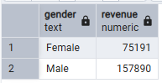
Figure 8: SQL query result – Revenue by Gender
2. High-Spending Discount Users
Description:
Identified customers who used discounts but still spent more than the average purchase amount.
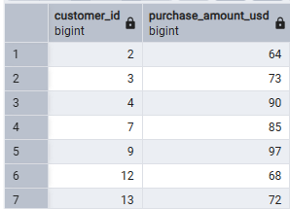
Figure 9: SQL query result – High-Spending Discount Users

3. Top 5 Products by Rating
Description:
Found the top five products with the highest average customer review ratings.
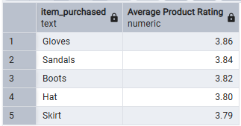
Figure 10: SQL query result – Top 5 Products by Rating
4. Shipping Type Comparison
Description:
Compared the average purchase amount between Standard Shipping and Express Shipping.
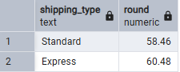
Figure 11: SQL query result – Shipping Type Comparison
5. Subscribers vs. Non-Subscribers
Description:
Compared the average purchase amount and total revenue of subscribers and non-subscribers.
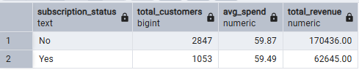
Figure 12: SQL query result – Subscribers vs. Non-Subscribers
6. Discount-Dependent Products
Description:
Identified the top five products with the highest percentage of discounted purchases.
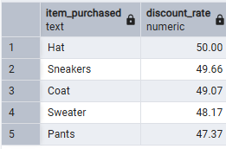
Figure 13: SQL query result – Discount-Dependent Products
7. Customer Segmentation
Description:
Classified customers into New, Returning, and Loyal segments based on their purchase history.
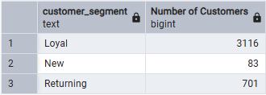
Figure 14: SQL query result – Customer Segmentation
8. Top 3 Products per Category
Description:
Listed the three most purchased products within each product category.
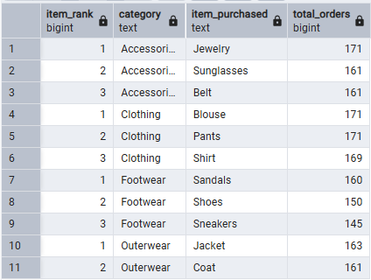
Figure 15: SQL query result – Top 3 Products per Category
9. Repeat Buyers & Subscriptions
Description:
Analyzed whether customers with more than five previous purchases were more likely to subscribe.
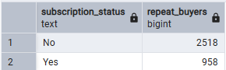
Figure 16: SQL query result – Repeat Buyers & Subscriptions
10. Revenue by Age Group
Description:
Calculated the total revenue generated by different age groups.
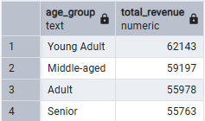
Figure 17: SQL query result – Revenue by Age Group
5. Dashboard in Power BI
An interactive dashboard was created in Power BI to visualize customer shopping behavior and present key business insights in a clear and user-friendly format. The dashboard enables users to analyze customer demographics, purchase patterns, product performance, subscription status, and revenue trends through interactive charts and filters.
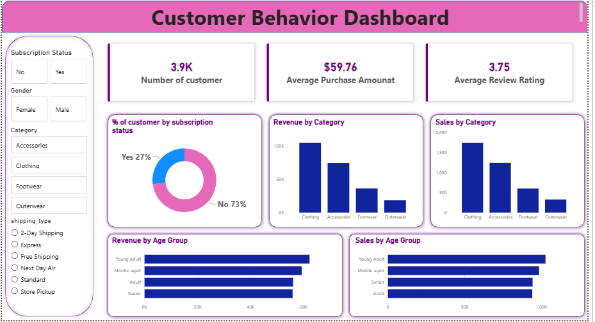
Figure 18: Customer Shopping Behavior Dashboard developed in Power BI

Dashboard Highlights
- Customer demographics analysis
- Revenue analysis
- Product category performance
- Subscription status analysis
- Shipping type comparison
- Purchase trends
- Interactive filters and slicers

6. Business Recommendations
- Boost Subscriptions: Promote exclusive benefits and rewards to encourage more customers to subscribe.
- Customer Loyalty Programs: Reward repeat customers with special offers to increase customer retention.
- Review Discount Policy: Optimize discount strategies to increase sales while maintaining profit margins.
- Product Positioning: Promote top-rated and best-selling products through targeted marketing campaigns.
- Targeted Marketing: Focus marketing efforts on high-revenue age groups and customers who prefer express shipping.
7. Conclusion
This project demonstrated the complete data analytics workflow, from data cleaning and preprocessing in Python to SQL-based business analysis and interactive dashboard development in Power BI. The analysis provided valuable insights into customer behavior, purchasing patterns, and business performance. The findings and recommendations can help organizations make data-driven decisions, improve customer satisfaction, and increase overall business growth.

