▲ Rippl App – Testing & Feedback Report
Tester: Bhoomi Sahu

OVERVIEW
I tested the Rippl app across onboarding, login, profile setup, Discover, Music, Collections, Rizz Coins, Settings, and Reels. Installation and login worked without issues. The app has a clean, modern dark-themed UI that's easy to navigate. However, testing surfaced one major reproducible crash, a general performance/speed issue, and a few smaller UX gaps — alongside things the app already does well.

What Worked Well
- Installation & Login — installed and logged in smoothly, no issues.
- UI Design — clean, modern interface; the dark theme looks premium and polished.
- Navigation — simple and beginner-friendly.
- Profile Picture Upload — once the Gallery opened, selecting and uploading an image as the profile picture was smooth with no errors.
- Spotify Integration — adding a music recommendation redirected correctly to Spotify, and the integration felt smooth.
- Rizz Coins (Gamification) — the reward system (earning coins for adding reels, creating collections, following curators, daily logins, milestones, etc.) is a genuinely interesting way to keep users engaged.
- Overall Concept — combining recommendations for movies, music, books, travel, and shopping into one platform is a unique idea with strong potential.

Bugs Found
01 · App Crashes in Reels Section
Priority: HIGH
Steps to Reproduce:
- Open the Rippl app.
- Log in.
- Go to the Reels section.
- Start scrolling through reels.
- On reaching the 2nd–3rd reel, the app crashes.
Expected Result: Reels should keep playing/scrolling without interruption.
Actual Result: The app crashes and Android shows "Rippl has stopped working." The app exits automatically. Reopening the app works initially, but the crash happens again on repeating the same steps.
Frequency: Reproduced consistently, multiple times, on repeated attempts.
Impact: Blocks access to one of the app's core features, and also makes it impossible to verify whether Rizz Coins are being credited correctly for reel-related actions.

02 · App Feels Slow / Occasional Lag
Priority: MEDIUM
Steps to Reproduce:
- Navigate between sections like Discover, Profile, Collections, and Settings.
- Keep switching between screens.
Expected Result: Smooth, quick transitions between screens.
Actual Result: The app feels a bit slow overall — some pages take longer to load and screen transitions occasionally feel delayed.
Frequency: Occurs occasionally, but noticeable enough to affect the experience.
Impact: Makes the app feel less polished than the UI suggests.
→ Evidence: (optional)

03 · Change Profile Picture Only Opens Gallery
Priority: LOW
Steps to Reproduce:
- Go to Profile.
- Tap "Change Profile Picture."
Expected Result: Users should be given a choice between Camera and Gallery.
Actual Result: Only the Gallery opens directly — no Camera option.
Impact: Minor inconvenience; upload itself worked fine once Gallery was open.
→ Evidence: (add profile picture screen here)

REPRODUCTION MAP
Bug | Steps | Priority
Reels Crash | Login → Open Reels → Scroll to 2nd/3rd reel | High
Lag/Slowness | Navigate between Discover, Profile, Collections, Settings | Medium
Profile Photo (Gallery only) | Profile → Change Photo | Low

EVIDENCE (Screenshots / Videos)
- Crash screen — "Rippl has stopped working"
- Profile picture selection screen (Gallery-only)
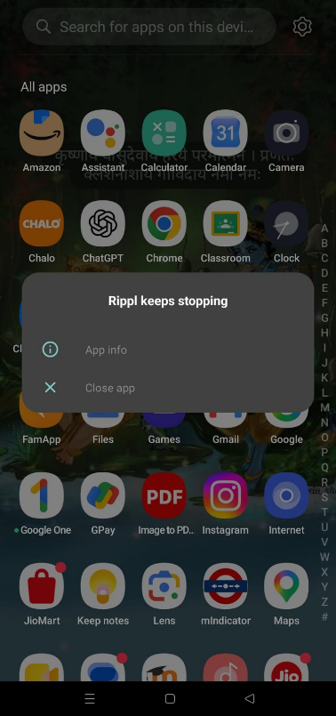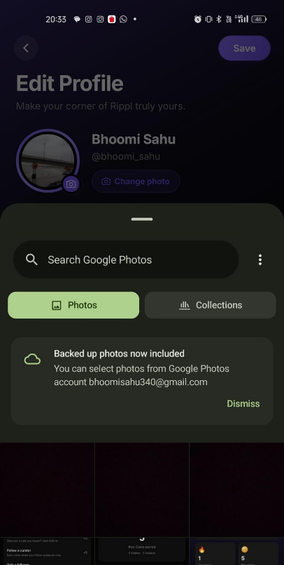

Feature Ideas
- Light Mode — add a Light Theme alongside the current Dark Theme.
- Coin History — a page showing coins earned/spent, with activity and timestamp.
- Milestone Progress Bars — e.g. Recommendations: 4/10, Followers: 12/25, Daily Login: 5-day streak.
- Reward Animation — a small pop-up (e.g. "+15 Rizz Coins Earned") whenever coins are earned.
- Profile Completion Meter — "Profile Completion: 80%" with suggestions for remaining steps.
- Better Error Handling — "Unable to load reels. Please try again." instead of crashing.
- Loading Indicators — skeleton screens or spinners while content loads.
- Retry Button — on failed loads, instead of forcing a restart.
- Search Improvements — Recent, Trending, and Suggested Searches.
- Notifications — on coin earnings, new followers, milestones, and engagement.
- Welcome Screen for New Users — friendly onboarding nudge instead of an empty profile.
- Camera + Gallery for Profile Photo — let users choose between the two.

UI/UX Improvements
- Add both Light Mode and Dark Mode.
- Improve overall app speed and reduce lag during screen transitions.
- Add loading indicators so slowness doesn't feel like the app is stuck.
- Improve empty-state screens for new users.
- Show progress bars for milestones instead of static labels.
- Add clearer success/error messages and confirmations after actions.
- Increase touch target sizes where needed for accessibility.
- Offer both Camera and Gallery when changing a profile picture.

Concept Prototypes
• AI Mood-Based Recommendations — understands a user's mood (e.g., happy, stressed, adventurous) and recommends movies, music, books, cafés, or travel destinations accordingly.
• AI Review Summarizer — generates a short summary of multiple user reviews, helping users quickly understand why an item is highly recommended.
• AI Smart Caption Generator — automatically suggests engaging captions and descriptions when users post a new recommendation.
• AI Friend Matcher — identifies users with similar interests and recommends people to follow based on shared preferences and recommendation history.
• AI Personalized Feed — continuously learns from user interactions and displays recommendations tailored to individual interests instead of a generic feed.
• AI Duplicate Recommendation Detector — detects if the same recommendation has already been posted and suggests contributing a personal review instead of creating duplicate content.
• AI Daily Challenges — generates personalized daily recommendation challenges (e.g., recommend a hidden café, share your favorite book) and rewards users with bonus Rizz Coins.
• AI Smart Notifications — sends personalized notifications such as new recommendations matching user interests, trending collections, or milestone achievements.
• AI Review Translator — automatically translates recommendations into the user's preferred language, making content accessible to a wider audience.
• AI Voice Assistant — allows users to search, discover, and create recommendations using natural voice commands instead of typing.
• AI Image Recognition — identifies books, movies, products, restaurants, or landmarks from uploaded images and instantly provides related recommendations.
• AI Travel Planner — creates personalized travel itineraries with recommended attractions, restaurants, hotels, and estimated budgets based on user preferences.
• AI Recommendation Trends — analyzes community activity to identify emerging trends and predicts recommendations that are likely to become popular.
• AI Accessibility Assistant — reads recommendations aloud, summarizes long reviews, and supports accessibility features for users with different needs.
• AI Collection Builder — automatically groups similar recommendations into smart collections such as "Weekend Watchlist," "Must-Read Books," "Best Cafés," or "Budget Travel."
• AI Conversation Starter — suggests discussion topics or questions between users who have similar interests, encouraging meaningful community interactions.
• AI Achievement Coach — analyzes user activity and provides personalized suggestions to help users unlock milestones, increase engagement, and earn more Rizz Coins.
SCORECARD
Category | Rating
UI & Design | 5.0 / 5
Ease of Navigation | 4.5 / 5
Features | 4.0 / 5
Performance | 3.0 / 5
Stability | 2.0 / 5 — due to the Reels crash
Overall Experience | 4.0 / 5

CLOSING NOTES
- Rippl has a genuinely fresh concept — bringing recommendations across movies, music, books, travel, and shopping into one gamified platform. Login, profile setup, image upload, and Spotify integration all worked smoothly, and the dark-themed UI feels premium.
- The most significant issue is the reproducible crash in the Reels section, which blocks access to a core feature and prevents full verification of the Rizz Coins reward system. The app also feels somewhat slow during navigation.
- Fixing the Reels crash, improving performance, and adding quality-of-life features like Light Mode, Camera support for profile photos, and better loading/error feedback would meaningfully elevate the app.

