SOFTWARE REQUIREMENTS SPECIFICATION
Student Research Collaboration Platform
with an Agentic Research Match & Progress Assistant
Version 1.2 (Expanded Edition)
Prepared for Software Engineering and Architecture Mini Project
Vivekanand Education Society's Institute of Technology
Department of Computer Engineering

Table of Contents
1. Introduction 3
1.1 Purpose 3
1.2 Document Conventions 3
1.3 Intended Audience and Reading Suggestions 3
1.4 Product Scope 3
1.5 References 4
2. Overall Description 5
2.1 Product Perspective 5
2.2 Product Functions 5
2.3 User Classes and Characteristics 5
2.4 Operating Environment 5
2.5 Design and Implementation Constraints 5
2.6 User Documentation 6
2.7 Assumptions and Dependencies 6
3. External Interface Requirements 7
3.1 User Interfaces 7
3.2 Hardware Interfaces 7
3.3 Software Interfaces 7
3.4 Communications Interfaces 7
4. System Features 9
4.1 User and Role Management 9
4.2 Research Opportunity Management 9
4.3 Student Applications and Collaboration 10
4.4 Research Resources and Documents 10
4.5 Project Progress and Milestones 11
4.6 Notifications 11
4.7 Agentic Research Match & Progress Assistant 12
4.8 Dashboards and Reports 13
4.9 Letters of Recommendation (LOR) 13
5. Other Nonfunctional Requirements 14
5.1 Performance Requirements 14
5.2 Safety Requirements 14
5.3 Security Requirements 14
5.4 Software Quality Attributes 14
5.5 Business Rules 14
6. Other Requirements 16
6.1 Database Requirements 16
6.2 Logging and Audit Requirements 16
6.3 Deployment Requirements 16
6.4 Maintenance and Support Requirements 16
Appendix A: Glossary 17
Appendix B: Analysis Models 18
Appendix C: To Be Determined List 28
Appendix D: Detailed Use Case Descriptions 29
Appendix E: Requirements Traceability Matrix 32
Appendix F: Project Risk Register 33
Appendix G: Acceptance Test Scenarios 34
Appendix H: Data Dictionary 36
Revision History
Version | Date | Description | Author
1.0 | 12 August 2026 | Initial SRS | Project Team
1.1 | 13 August 2026 | Expanded edition: added detailed rationale for every functional requirement, multiple stimulus/response flows per feature, an enlarged glossary, and four new appendices (Use Case Descriptions, Requirements Traceability Matrix, Project Risk Register, Acceptance Test Scenarios) to give reviewers a fuller, more traceable picture of the same requirement set defined in Version 1.0. No new features, functional requirements, or scope changes were introduced in this revision. | Project Team
1.2 | 13 August 2026 | Added faculty-issued/requested Letters of Recommendation (LOR) as a new feature (Section 4.9, FR-036 through FR-038); added agentic detection of inactive research opportunities with recommended actions (Section 4.7, FR-035); rendered the analysis models named in Appendix B as actual diagrams; extended the database model, glossary, use cases, traceability matrix, acceptance tests, and data dictionary to cover the new requirements. | Project Team
This revision does not change the product idea, the functional scope, or any individual requirement statement carried over from Version 1.0. It exists to document the same system in greater depth: additional rationale, additional analysis views (use cases, traceability, risk, acceptance tests), and clearer editorial structure to support review, design, and testing activities that follow this document in the course of the mini-project.

1. Introduction

1.1 Purpose
This Software Requirements Specification (SRS) defines the requirements for a Student Research Collaboration Platform designed for a college environment. The system provides a structured space for students to discover research opportunities, faculty to publish projects and requirements, and research teams to collaborate and track progress. It also includes a focused Agentic Research Match & Progress Assistant that recommends suitable opportunities and collaborators and monitors project progress.
In most college departments, research opportunities are currently discovered through informal and fragmented channels: notice-board postings, word of mouth between students, personal email threads with individual faculty members, or ad-hoc messages in departmental chat groups. This fragmentation makes it difficult for a student to see the full set of opportunities available to them at a given time, and difficult for faculty to reach a wide and appropriately qualified pool of applicants. Once a student does join a project, tracking progress, sharing resources, and keeping all collaborators aware of milestone status is often handled through a mixture of spreadsheets, shared drives, and informal messaging, with no single system of record. The platform described in this document is intended to replace that fragmented process with a single, structured, role-aware application.
The purpose of this document is to describe, in sufficient and testable detail, what the system shall do so that it can guide subsequent design, implementation, and testing activities carried out as part of the Software Engineering and Architecture mini-project. This document is the baseline against which use-case models, data-flow diagrams, class diagrams, sequence diagrams, and test cases produced in later experiments are expected to remain consistent. Where this document and a later artifact disagree, this SRS (as most recently revised) is treated as authoritative unless a change request is recorded.
The Agentic Research Match & Progress Assistant described throughout this document is intentionally scoped narrowly. Its purpose is to reduce the manual effort involved in two specific activities that do not require final academic judgement: (a) surfacing research opportunities, resources, and potential collaborators that are likely to be relevant to a given student or faculty member, and (b) drawing attention to project activity that appears to be falling behind schedule. In both cases the assistant produces a recommendation or alert for a human to consider; it never finalizes an academic or administrative decision on its own, a boundary that is restated as a nonfunctional safety requirement in Section 5.2 and as functional requirement FR-030.

1.2 Document Conventions
This document uses a small, consistent set of conventions so that individual requirements can be referenced unambiguously from design documents, test plans, and review comments.
Requirement identifiers. Each functional requirement is labelled FR-x, where x is a zero-padded sequential number assigned in the order the requirement first appears in Section 4 (FR-001 through FR-034). Each nonfunctional requirement is labeled NFR-x and numbered within its subsection of Section 5. Each business rule is labeled BR-x. Identifiers are stable once assigned: if a requirement is removed in a future revision, its identifier is retired rather than reused, so that historical references in test cases or review comments remain unambiguous.
Priority values. Every functional requirement and business rule carries a Priority of High, Medium, or Low. High indicates a requirement that is necessary for the system to be considered a working, gradable implementation of the platform's core idea; the mini-project is not considered complete without it. Medium indicates a requirement that materially improves the platform but around which a reduced implementation could still function acceptably if time is short. Low indicates a requirement that is desirable but may reasonably be deferred to a future iteration without compromising the evaluation of the core idea.
Verification methods. Each functional requirement lists a Verification method describing how the team intends to confirm the requirement has been met. “Functional test” denotes a direct test of the described behavior through the UI or API. “Security test” and “Access-control test” denote tests that specifically attempt to bypass authentication or authorization. “Negative test” denotes a test that confirms disallowed actions are correctly rejected. “UI test” denotes a test focused on what is rendered and how it responds to interaction. “Database/functional test” denotes a test that inspects persisted state directly, not only the response returned to the client. “Agent evaluation” denotes a qualitative or semi-automated review of agent output against a curated set of profiles and opportunities. “Scenario test” and “Safety/permission test” denote end-to-end tests that exercise a realistic multi-step sequence of actions, the latter specifically checking that the agent cannot exceed its advisory boundary.
Requirement writing style. Requirements are written in the form “The system shall…”, “Users/Students/Faculty shall be able to…”, or “The agent shall…” and are intended to be testable and independently identifiable: each requirement should be verifiable in isolation from the others, even though several requirements typically cooperate to deliver one user-visible feature.
Tables. Functional requirement tables in Section 4 include a Description/Rationale column in this revision. That column is explanatory: it clarifies intent, edge-case handling, and how the requirement relates to neighboring requirements. It does not itself introduce a new obligation on the system; the obligation is the Requirement column text, unchanged from Version 1.0.

1.3 Intended Audience and Reading Suggestions
The SRS is intended for five overlapping groups of readers, each of whom is expected to use the document somewhat differently.
- Student development team — uses the document as the primary reference while designing the database schema, APIs, and user interface, and while deciding how to sequence implementation work across the project timeline.
- Project guide / faculty coordinator — uses the document to assess whether the team's understanding of the problem is sound before implementation begins, and later to assess whether the delivered system matches what was specified.
- Testers — use the Functional Requirements tables in Section 4 and Appendix G (Acceptance Test Scenarios) directly as the source for test case derivation, and use Appendix E (Traceability Matrix) to check that every requirement has at least one associated test.
- Evaluators / examiners — use the document to judge completeness and internal consistency of the specification as a deliverable in its own right, independent of the eventual implementation.
- Future maintainers — use the document, together with Appendix A (Glossary) and Appendix B (Analysis Models), to understand the intended behavior of a module before modifying it, particularly for the agentic assistant, whose behavior is otherwise easy to under-specify.
Readers new to the project should begin with Sections 1 and 2 to understand the problem and the system's boundaries, then read Section 3 for the interfaces the system exposes, and Section 4 for the detailed behavior of each feature. Section 5 defines the quality, safety, and security expectations that apply across all features. Section 6 and the appendices provide supporting detail — database structure, glossary terms, diagram descriptions, use cases, traceability, risk, and acceptance scenarios — that is most useful once the reader already has the Section 4 picture in mind.

1.4 Product Scope
The platform aims to reduce the fragmented process of finding research opportunities, identifying suitable student collaborators, managing applications, sharing research resources, and tracking project progress. The proposed system centralizes these activities while keeping the agentic component limited to recommendation, prioritization, and progress-assistance workflows.
Within this scope, the system is expected to:
- Discover and publish faculty research opportunities.
- Maintain student profiles containing skills, interests, projects, and research experience.
- Apply to research opportunities and manage application status.
- Form research teams and assign project roles.
- Share datasets, papers, links, and project documents.
- Define milestones and monitor project progress.
- Use an agentic assistant for research matching, resource suggestions, and progress alerts.
- Provide dashboards for students, faculty, and administrators.

1.4.1 Out of Scope
To keep the mini-project feasible for a three-member team within a single academic term, the following are explicitly out of scope for this version of the platform, and are not implied by any requirement in this document:
- Payment processing, funding disbursement, or grant-management workflows.
- Federation or account interoperability with other institutions.
- Native mobile applications; the responsive web client described in Section 3.1 is the only client considered.
- Plagiarism or originality detection for shared research documents.
- Integration with a Learning Management System (LMS) or student information system beyond what is described in Section 3.3.
- Autonomous decision-making by the agentic assistant; every agent output remains advisory, per FR-030 and Section 5.2.

1.5 References
- 1. Software Requirements Specification template provided for the project, based on the Karl E. Wiegers SRS structure.
- 2. Software Engineering and Architecture laboratory experiment plan provided by the Department of Computer Engineering.
- 3. Project-specific design, UML, testing, and Agile artifacts to be developed during subsequent experiments.
- 4. General conventions for structuring a requirements specification, informed by the IEEE recommended-practice tradition for software requirements documents (used here only as a structural reference for section organization, not as a claim of formal certification).
- 5. General REST/HTTP conventions (status codes, resource-oriented URLs, JSON payloads) as commonly used to describe the client-server communication style referenced in Section 3.4.
- 6. OpenAPI-style API documentation conventions, referenced in Section 5.4 as the intended documentation format for the backend REST API.

2. Overall Description

2.1 Product Perspective
The platform is a new, self-contained web application for academic research collaboration. It can optionally integrate with external services such as GitHub for project activity and email services for notifications, but the core research workflow remains within the platform. The system follows a client-server architecture with a web frontend, REST backend, relational database, file storage, and an isolated agentic service.
Conceptually, the system is organized into four layers. The presentation layer is the responsive web client used by all four roles. The application layer is the REST backend that implements authentication, authorization, and the business logic for opportunities, applications, projects, milestones, resources, and notifications. The data layer is a relational database (PostgreSQL) together with object/file storage for uploaded documents. The agentic layer is a separately deployable service that reads a bounded, purpose-specific slice of platform data — profiles, opportunities, activity timestamps — and returns recommendations or alerts back through an internal API; it never writes directly to the primary database tables that represent academic decisions.
The system's actors are the four user classes described in Section 2.3, plus three optional external systems: a GitHub API (for surfacing repository/commit activity associated with a project, if enabled), an SMTP or transactional email provider (for outbound notifications), and an external LLM or recommendation service that backs the agentic layer (if the design chooses to use one rather than a fully in-house heuristic). All three external integrations are optional in the sense described in Section 2.7: the platform's core research-collaboration workflow must continue to function if any of them is temporarily unavailable.

2.2 Product Functions
At a high level the system performs the following functions; each is elaborated into detailed functional requirements in Section 4.
Authentication and role-based access control. Verifies user identity and restricts every protected operation to the roles permitted to perform it.
Student and faculty profile management. Captures the structured information (skills, interests, research experience, expertise) that both search/filter and the agentic assistant depend on.
Research opportunity creation, discovery, search, and filtering. Lets faculty publish openings and lets students find openings relevant to them.
Application submission, review, approval, and rejection. Manages the lifecycle of a student's interest in a specific opportunity, from submission through a final faculty decision.
Project/team creation and member management. Converts accepted applicants into a working research team with defined membership.
Milestone, task, and progress tracking. Gives teams a shared, dated record of what has been planned and what has been completed.
Research resource and document sharing. Provides controlled, project-scoped sharing of papers, datasets, links, and files.
Notifications and reminders. Keeps students and faculty informed of status changes and approaching deadlines without requiring them to poll the system.
Agentic research matching and progress assistance. Surfaces likely-relevant opportunities, collaborators, and resources, and flags project activity that appears to be falling behind.
Dashboards and basic analytics. Gives each role a role-appropriate summary view rather than requiring navigation into individual records to understand overall status.

2.3 User Classes and Characteristics
The table below summarizes the four user classes recognized by the system. “Frequency of Use” and “Access Level” are included in this revision to make the relative design priority of each class’s workflows clearer to the implementation team.
User Class | Characteristics | Major Functions | Frequency | Access Level
Student | Primary end user; basic technical proficiency; the largest user population. | Profile, discover opportunities, apply, collaborate, track milestones, receive agent recommendations. | Frequent (multiple sessions per week) | Own profile, own applications, projects they belong to
Faculty/Researcher | Research project owner or guide; comfortable with academic workflows, may have limited patience for complex UI. | Create opportunities, define requirements, review applicants, manage teams, monitor progress. | Regular (several sessions per week during active recruitment/monitoring periods) | Own opportunities and projects, applicants to those opportunities
Research Coordinator | Faculty/administrative coordinator with an oversight rather than day-to-day role. | Monitor projects, generate reports, manage categories and escalations. | Occasional (periodic review sessions) | Read/aggregate access across projects; limited write access to categories
Administrator | System-level privileged user, typically a course staff member or system owner. | Manage users, roles, configuration, moderation, and system data. | Infrequent (as-needed administrative tasks) | Full system access, including user and role management

2.4 Operating Environment
Client: modern web browser on Windows, Linux, macOS, Android, or iOS. Server: Linux-based environment or containerized deployment. Backend: Java/Spring Boot or equivalent REST service. Database: PostgreSQL. Agent service: Python-based service exposed through an internal API.
More specifically, the client is expected to be used through the current or immediately preceding major release of a mainstream evergreen browser (for example, Chrome, Firefox, Edge, or Safari); the interface should be responsive enough to remain usable on a tablet-sized viewport, since students may check dashboards and notifications outside of a desktop session. The server-side components are designed to be containerized so that the backend, database, and agent service can each be deployed and restarted independently; this containerization also supports the deployment requirements described in Section 6.3. The agent service is intentionally isolated as its own process/container so that a slow or failing call to an external LLM/recommendation provider cannot block or crash the core backend, which is a direct consequence of the reliability quality attribute in Section 5.4.

2.5 Design and Implementation Constraints
- Role-based access must restrict student, faculty, coordinator, and administrator operations.
- Research documents must not be publicly accessible unless explicitly shared.
- The system should use REST APIs and modular services to support testing and maintainability.
- The agent must not autonomously accept or reject research applications; final academic decisions remain with authorized users.
- Any external AI service must be accessed through a controlled backend service and must not receive unnecessary personal or confidential research data.
- The mini-project implementation must remain feasible for a three-member team.
- Implementation must fit within the academic term allotted to the Software Engineering and Architecture course, which constrains the depth of any single feature relative to covering the full breadth described in Section 4.
- Source code must be maintained under version control (Git) with a shared remote repository, consistent with the collaboration practices the platform itself is meant to encourage.
- Automated tests should be practical to run locally by any of the three team members without dependence on the live external LLM/agent provider, so agent-dependent code paths should be designed to be testable against a stub or mock.

2.6 User Documentation
The project will provide a short user guide for students and faculty, administrator instructions, an API/documentation page for developers, and a setup/readme document for deployment and testing.
The student/faculty user guide is expected to walk through the core workflows each role performs most often — for a student, discovering and applying to an opportunity and checking recommendations; for faculty, publishing an opportunity and reviewing applicants — rather than attempting to describe every screen exhaustively. The administrator instructions cover user and role management and any moderation actions available to that role. The API documentation, generated from the OpenAPI specification referenced in Section 5.4, is aimed at the development team itself and at evaluators who want to inspect the backend contract directly. The setup/readme document covers local development setup, environment configuration, and how to run the automated test suite, and is kept in the source repository rather than distributed separately.

2.7 Assumptions and Dependencies
- Users provide accurate skills, interests, and project information.
- Faculty members are responsible for final research opportunity and application decisions.
- Email/notification services may be unavailable temporarily; core system functions should continue.
- GitHub integration, if implemented, depends on GitHub API availability and permissions.
- The agentic module depends on the availability of the selected LLM/recommendation service, but core platform functions must not depend on it.
- It is assumed that institutional email addresses remain a reliable proxy for institutional affiliation for the duration of the mini-project; a more robust identity-verification mechanism is out of scope.
- It is assumed that the volume of opportunities, applications, and projects generated during evaluation will be small enough that the performance targets in Section 5.1 can be validated without specialized load-testing infrastructure.

3. External Interface Requirements

3.1 User Interfaces
The system exposes the following screens. Each is described below in terms of its primary purpose and the key elements it must present; detailed layout is a design-stage decision and is not fixed by this SRS beyond what is stated here.
Login and registration screens. Collect institutional email and password (or initiate the registration flow described under FR-001), display validation feedback inline, and clearly separate “new account” from “returning user” actions.
Student dashboard. The default landing view after a student logs in. Shows recommended opportunities, the student's current applications with status, active project milestones, and recent notifications, per FR-032, without requiring navigation into separate pages to see a summary of each.
Faculty dashboard. The default landing view after a faculty member logs in. Shows the faculty member's research projects, pending applicants awaiting review, team composition, and milestone progress across their projects, per FR-033.
Research opportunity listing. A searchable, filterable list of published opportunities (FR-008), showing enough summary information — title, domain, required skills, duration, remaining capacity — for a student to decide whether to open the full details without additional clicks.
Opportunity details and application screen. Shows the full opportunity description and requirements, the current application status if the viewing student has already applied, and, if eligible, an application form (FR-010).
Project workspace. The shared view for an approved research team: members and roles, milestones and their status, shared resources, and a chronological activity feed (FR-014, FR-021).
Agent recommendations panel. Shows ranked recommendations with a short, understandable reason for each (FR-026) and a visible action to dismiss a recommendation (FR-031); recommendations are visually distinguished from content the user or faculty produced directly, so the advisory nature of agent output described in Section 5.2 is clear from the interface itself.
Administrator/coordinator dashboard. Shows user and role management controls for administrators, and aggregate project/participation statistics for coordinators (FR-034), consistent with the access levels in Section 2.3.
Across all screens, the interface should follow basic accessibility practice (sufficient color contrast, keyboard-navigable forms, descriptive labels on interactive elements) and should degrade gracefully on a tablet-width viewport, since students may check the platform between classes on a device other than a laptop.

3.1.1 Common Screen States
The screens listed above share a small set of states that this revision makes explicit, since each was already implied by an exception flow in Section 4 but not previously called out as an interface requirement in its own right.
Loading state. Shown while a screen's primary data is being fetched — for example, while the agent service is generating recommendations under the exception flow described in Section 4.7. A loading state should not block the rest of an otherwise-ready page; the recommendations panel in particular should load independently of the rest of the student dashboard, consistent with NFR-002 and the reliability quality attribute in Section 5.4.
Empty state. Shown when a screen has no data to display for a reason that is not an error — for example, a new student with no applications yet, or a search whose filters match no opportunities (Section 4.2). An empty state should say plainly that there is nothing to show yet, rather than presenting a blank area that could be mistaken for a loading failure.
Error / unavailable state. Shown when a request fails or a dependency is unreachable — for example, the agent service timing out under the exception flow in Section 4.7, or the email service being unreachable under the alternate flow in Section 4.6. Consistent with the constraint in Section 2.5 that core platform functions must not depend on the agent or on email delivery, an error or unavailable state on one panel must never prevent the rest of the screen from rendering.
Access-denied state. Shown when an authenticated user requests a screen or record they are not authorized to view — for example, a non-member requesting a private project resource under FR-016. This state should be visually distinct from the empty state, since “nothing here” and “you may not see this” are different situations for a user trying to understand what happened.

3.2 Hardware Interfaces
No specialized hardware is required. The application runs on standard computers or mobile devices with network connectivity. Server hardware must provide sufficient CPU, memory, storage, and network capacity for the expected mini-project workload.
Because the expected concurrent user count for the mini-project (see NFR-003) is modest, the server hardware requirement is deliberately left as a qualitative statement rather than a fixed specification; the team is expected to size a single small virtual machine or equivalent container host, sufficient for the target load, rather than provisioning for production-scale traffic.

3.3 Software Interfaces
PostgreSQL database. Stores structured application data — users, profiles, opportunities, applications, projects, milestones, resources metadata, notifications, and activity/audit records — as enumerated in Section 6.1. Accessed only by the backend service, never directly by the client or the agent service.
Object/file storage. Stores the binary content of uploaded research documents and datasets; the database stores metadata and access-controlled references (not public URLs) to this storage, consistent with NFR-008.
REST API (frontend – backend). A JSON-over-HTTPS API exposed by the backend and consumed by the web client. Endpoints are organized around the primary resources described in Section 6.1 (users, opportunities, applications, projects, milestones, resources, notifications).
Internal API (backend – agent service). A separate, authenticated internal API through which the backend requests recommendations or alerts and receives structured results (a ranked list with reasons, per FR-025–FR-029). This boundary is what allows the agent service to be deployed, restarted, or replaced independently, per Section 2.1.
Optional GitHub API. If repository/activity integration is implemented, used to retrieve commit or activity information associated with a project, subject to the permissions granted by the connecting user or organization; this dependency is explicitly optional per Section 2.7 and TBD-003.
Optional SMTP or transactional email service. Used to deliver the outbound notifications described in Section 4.6 when email delivery is enabled; the specific provider is left open per TBD-004.

3.4 Communications Interfaces
Client-server communication shall use HTTPS and REST/JSON APIs. Authentication tokens shall be transmitted only over secure connections. Internal agent requests shall use authenticated service-to-service communication.
All externally reachable endpoints — the public API used by the web client and, if applicable, any webhook endpoint used by the optional GitHub integration — are expected to reject plain HTTP and to enforce HTTPS. The internal API between backend and agent service is not expected to be reachable from outside the deployment network; it is authenticated and, where the deployment environment allows it, further restricted at the network level so that only the backend service can call it.

4. System Features
This section describes each of the eight system features. For every feature this revision documents three things beyond what Version 1.0 contained: (1) a fuller description of why the feature exists and how it fits with the others, (2) more than one stimulus/response flow — a normal flow together with at least one alternate or exception flow — and (3) a Description/Rationale column added to each functional-requirement table, explaining validation rules, edge-case handling, or the relationship between that requirement and neighboring ones. The requirement text itself (the Requirement column) and every requirement identifier are unchanged from Version 1.0.

4.1 User and Role Management
This feature manages user registration, authentication, profiles, and permissions. It is the foundation every other feature depends on: opportunities are always associated with a faculty account, applications are always associated with a student account, and every access-control decision described elsewhere in this document ultimately rests on the role assigned here.
Priority: High.

Stimulus/Response Sequences
Normal flow: A prospective user submits the registration form with an institutional email address and password. The system validates the email format and domain, creates an inactive account, and sends a verification message. The user confirms the address; the account becomes active and the user can log in and complete their role-appropriate profile.
Alternate flow — profile update: An already-authenticated student or faculty member edits their profile (skills, interests, research experience, or expertise). The system validates the submitted fields and saves the update; because profile data feeds the agentic assistant (Section 4.7) and search/filter (Section 4.2), the updated values take effect the next time a recommendation or search is computed, without requiring any other action from the user.
Exception flow — duplicate or invalid registration: If the submitted email is already registered, or is not a recognized institutional domain, the system rejects the registration with a specific, non-account-revealing error message and does not create a new account, consistent with the account-enumeration guidance under NFR-006/FR-002.

Functional Requirements
ID | Requirement | Description / Rationale | Priority | Verification
FR-001 | The system shall allow a user to register using an institutional email address. | Registration requires email format validation and a domain check before an account is created. A verification link or one-time code is sent to confirm ownership of the address before the account is activated; the account remains inactive and cannot log in until verification succeeds. | High | Functional test
FR-002 | The system shall authenticate users before granting protected access. | All protected routes and APIs require a valid session or token. Authentication failures return a generic error message that does not reveal whether the email or password was incorrect, reducing account-enumeration risk. Session/token expiry and renewal behavior is finalized during design. | High | Functional/security test
FR-003 | The system shall assign and enforce role-based permissions. | Every account has exactly one primary role (Student, Faculty/Researcher, Research Coordinator, or Administrator) assigned at registration or by administrative action. Role checks are enforced on the server for every protected operation, not only hidden in the client interface, consistent with NFR-007. | High | Security test
FR-004 | Students shall be able to maintain skills, interests, projects, and research experience. | The student profile is the primary input to the matching logic used by the agentic assistant (Section 4.7). Skills and interests are structured (selected from, or tagged against, a controlled list) rather than free text alone, so matching and search/filtering (Section 4.2) can compare them directly. | High | Functional test
FR-005 | Faculty shall be able to maintain research expertise and profile information. | Faculty profile information supports both student discovery — understanding who leads a given opportunity — and the agent's ability to explain why an opportunity fits a student's stated interests. | Medium | Functional test

Section 5.3 (Security Requirements) and Section 6.1 (Database Requirements, User/StudentProfile/FacultyProfile entities) should be read together with this feature, since password storage (NFR-005) and role enforcement (NFR-007) are direct extensions of FR-002 and FR-003.

4.2 Research Opportunity Management
This feature allows faculty/researchers to publish and manage research opportunities, and allows students to discover them through search and filtering. It is the entry point of the platform's core workflow: an opportunity published here is what a student later applies to under Section 4.3, and what the agentic assistant ranks and explains under Section 4.7.
Priority: High.

Stimulus/Response Sequences
Normal flow: Faculty creates an opportunity with title, description, domain, required skills, duration, and capacity, saves it as a draft, reviews it, and publishes it. The opportunity becomes searchable; eligible students can view and apply per Section 4.3.
Alternate flow — editing a published opportunity: Faculty edits a field (for example, required skills) on an opportunity that already has applications against it. The system preserves the version of the requirements that was in force when each existing application was submitted, so faculty reviewing those applications still see the criteria the applicant actually responded to, while new applicants see the updated criteria.
Exception flow — closing or archiving: Faculty closes an opportunity once capacity is reached or the recruitment window ends. The system stops accepting new applications (FR-009) immediately, including any application already in flight when the close action is processed, but keeps the opportunity and its history visible to faculty and existing applicants; archiving later removes it from default search results without deleting the underlying record.

Functional Requirements
ID | Requirement | Description / Rationale | Priority | Verification
FR-006 | Faculty shall be able to create a research opportunity with title, description, domain, required skills, duration, capacity, and status. | Capacity is a numeric field representing the maximum number of students that may be accepted. Status follows a defined lifecycle (Draft, Published, Closed, Archived). Required skills reference the same controlled skill list used in student profiles (FR-004) so the agent and search/filter can compare them directly. | High | Functional test
FR-007 | Faculty shall be able to edit, publish, close, or archive an opportunity. | Editing a published opportunity does not silently invalidate applications already submitted against it; the system preserves a record of the requirements in force at the time each application was made. Closing an opportunity stops new applications (FR-009) but does not remove it from faculty view. | High | Functional test
FR-008 | Students shall be able to search and filter opportunities by domain, skills, duration, and availability. | Search and filtering operate without a full page reload (NFR-004) and support combining multiple filters at once. Results are ordered with a sensible default (most recently published first), with agent-ranked recommendations surfaced separately per FR-025 rather than reordering the general listing. | High | Functional test
FR-009 | The system shall prevent applications to closed or inactive opportunities. | This is enforced server-side regardless of what the client interface displays, preventing a race condition where a student submits an application after an opportunity is closed but before the client has refreshed its state. | High | Negative test

4.3 Student Applications and Collaboration
This feature manages applications submitted against opportunities and the approved research teams that result from them. It is the bridge between opportunity discovery (Section 4.2) and active project work (Sections 4.4 and 4.5): an application that a faculty member accepts here becomes project membership there.
Priority: High.

Stimulus/Response Sequences
Normal flow: Student submits an application to an active opportunity; the system validates eligibility and opportunity status, stores the application, and notifies the faculty owner. Faculty reviews, optionally shortlists, and makes a final accept or reject decision; the student is notified of the outcome (Section 4.6).
Alternate flow — team formation from multiple applicants: Once several applicants for the same opportunity have been accepted, faculty creates a research team from those accepted applications in a single action. The system creates a ResearchProject record and adds each accepted applicant as a ProjectMember, giving the team immediate access to the project workspace described in Section 4.4 and 4.5.
Exception flow — withdrawal: A student withdraws an application that has not yet been finally decided. The application status changes to Withdrawn, the faculty owner is notified, and the withdrawn application no longer counts against the opportunity's remaining capacity.

Functional Requirements
ID | Requirement | Description / Rationale | Priority | Verification
FR-010 | Students shall be able to submit an application to an active opportunity. | An application captures, at minimum, the student's motivation for applying and a reference to the state of their profile at the time of application, so faculty review consistent information even if the student's profile changes afterward. | High | Functional test
FR-011 | Faculty shall be able to view, shortlist, accept, or reject applications. | Shortlisting is an intermediate state distinct from acceptance, letting faculty narrow a large applicant pool before a final decision. Rejection may optionally include a short faculty comment, though this is not mandatory. | High | Functional test
FR-012 | The system shall maintain application status and timestamps. | Status transitions (Submitted, Shortlisted, Accepted, Rejected, Withdrawn) are each timestamped, supporting the notification requirements in Section 4.6 and the audit logging requirements in Section 6.2. | Medium | Database/functional test
FR-013 | Faculty shall be able to create a research team from approved applicants. | Team creation converts one or more accepted applications into ProjectMember records associated with a ResearchProject entity. A project may originate from a single opportunity or, where the design allows, aggregate accepted applicants from more than one related opportunity. | High | Functional test
FR-014 | Authorized project members shall be able to view project information and activity. | Access is restricted to members of the specific project (and to faculty/coordinator/admin roles per BR-004), distinguishing this view from the public-facing opportunity listing, which is visible more broadly. | High | Access-control test

4.4 Research Resources and Documents
This feature provides controlled sharing of papers, datasets, links, and project files among the members of a research project. It gives an approved team the shared reference material that the agentic assistant later draws from when suggesting relevant resources under Section 4.7.
Priority: Medium.

Stimulus/Response Sequences
Normal flow: A project member adds a resource with a title, type, description, and a link or uploaded file. The resource appears in the project workspace for all current members and becomes eligible for the agent's resource-suggestion logic (FR-028).
Alternate flow — update or removal: The uploader, or a faculty/lead member of the project, edits a resource's description or removes it entirely; the removal is recorded in the project's activity history (FR-021) so other members can see that it happened, even though the file itself is no longer accessible.
Exception flow — unauthorized access attempt: A user who is not a member of the project attempts to access a private resource directly (for example, by guessing or reusing a link). The system rejects the request based on project membership, independent of whether the link itself is difficult to guess, per NFR-008.

Functional Requirements
ID | Requirement | Description / Rationale | Priority | Verification
FR-015 | Project members shall be able to add research resources with title, type, description, and link/file. | Type distinguishes resources such as paper, dataset, code repository link, or general link, letting the interface render each appropriately — for example, an external link versus a downloadable file. | Medium | Functional test
FR-016 | The system shall restrict private project resources to authorized users. | This directly supports NFR-008, which requires that private resources not be reachable through guessable public URLs; access is checked against project membership on every request, including direct file downloads, not only when the resource list is rendered. | High | Security test
FR-017 | Users shall be able to remove or update resources when authorized. | Only the resource's original uploader or a faculty/lead member of the project is authorized to remove or update it, preventing accidental loss of shared research material by unrelated members. | Medium | Functional test

4.5 Project Progress and Milestones
This feature tracks project work using milestones and progress updates. It gives every project a shared, dated record of what has been planned and what has been completed, which is the data both the overdue-detection logic in this feature and the agent's progress-monitoring logic in Section 4.7 rely on.
Priority: High.

Stimulus/Response Sequences
Normal flow: A faculty member or project lead creates a milestone with a target date; project members update the status of the milestone (and any associated tasks) as work proceeds; the system records each update in the activity history.
Alternate flow — approaching-deadline visibility: As a milestone's target date approaches, the system surfaces it more prominently on relevant dashboards (Section 4.8) and queues a reminder notification (FR-024) ahead of the deadline, distinct from the overdue highlighting that occurs only after the date has passed.
Exception flow — overdue milestone: A milestone's target date passes while its status is not Completed. The system marks it overdue, highlights it for project members and faculty, and makes it visible to the agent's inactivity-detection logic (FR-029), which may in turn recommend a specific follow-up action to a human reviewer.

Functional Requirements
ID | Requirement | Description / Rationale | Priority | Verification
FR-018 | Faculty/project leads shall be able to create milestones with target dates. | A milestone is associated with a specific project and may optionally be broken down into tasks (see the Task entity in Section 6.1) for finer-grained tracking. | High | Functional test
FR-019 | Project members shall be able to update milestone/task status. | Status values distinguish at least Not Started, In Progress, Completed, and Blocked, so overdue detection (FR-020) and agent progress-monitoring (FR-029) can reason about project health rather than a simple done/not-done flag. | High | Functional test
FR-020 | The system shall display overdue and incomplete milestones. | A milestone is overdue when its target date has passed and its status is not Completed. This calculation runs consistently whether triggered by a user viewing a dashboard or by a scheduled background check feeding the agentic assistant. | High | Functional test
FR-021 | The system shall maintain a project activity history. | Activity history provides the underlying record for both the audit requirements in Section 6.2 and for faculty/coordinator dashboards that need to show recent project activity without reconstructing it from individual tables. | Medium | Functional test

4.6 Notifications
This feature notifies users about important workflow events — application decisions, pending faculty actions, and approaching or overdue milestones — so that users are not required to repeatedly check the platform to learn whether something they care about has changed.
Priority: Medium.

Stimulus/Response Sequences
Normal flow: A tracked event occurs (for example, an application status change). The system creates a notification record and, if email delivery is enabled, sends a corresponding email; the notification also appears in-app on the recipient's dashboard.
Alternate flow — email temporarily unavailable: The email/notification service is unreachable when a notification is generated. The in-app notification is still created and visible, consistent with the assumption in Section 2.7 that core system functions continue even if email delivery is temporarily degraded.
Exception flow — reminder for an already-completed milestone: A scheduled reminder job runs against a milestone that was marked Completed after the reminder was originally queued. The system checks current status before sending and suppresses the now-irrelevant reminder rather than notifying the user about work that is already finished.

Functional Requirements
ID | Requirement | Description / Rationale | Priority | Verification
FR-022 | The system shall notify students when application status changes. | Notification is triggered at each status transition described in FR-012 and is visible in-app at minimum, with the specific delivery channel (email vs. in-app only) left to design, consistent with TBD-004. | Medium | Functional test
FR-023 | The system shall notify faculty/project leads about important pending actions. | Pending actions include unreviewed applications, upcoming or overdue milestones for projects they lead, and any high-priority agent alerts (FR-029) associated with their projects. | Medium | Functional test
FR-024 | The system shall provide reminders for approaching or overdue milestones. | Reminder timing (for example, a fixed number of days before the target date) is configurable during design rather than hard-coded, allowing it to be tuned during evaluation. | Medium | Functional test

4.7 Agentic Research Match & Progress Assistant
This feature provides focused agentic assistance for research discovery, matching, and project progress. It is the platform's differentiating capability, but its scope is deliberately bounded: it reads structured data already captured elsewhere in the system (profiles, opportunities, activity timestamps) and produces recommendations or alerts, and it never finalizes an academic or administrative decision, a boundary restated in Section 5.2 and business rule BR-005.
Priority: High.

Stimulus/Response Sequences
Normal flow — opportunity recommendation: Student opens their dashboard; the system loads the student's profile and eligible opportunities; the agent evaluates matching factors and produces ranked recommendations with reasons; the student can inspect a recommendation, use it as a starting point for an application, or dismiss it.
Alternate flow — collaborator suggestion within a project: A faculty member or project lead, viewing a project with a skills gap, requests collaborator suggestions; the agent compares the current team's collective skills against the project's stated requirements and suggests students whose profiles fill the gap, with a reason for each suggestion (FR-027).
Exception flow — agent service unavailable: The agent service does not respond within the expected time. The dashboard loads normally without a recommendations panel (or shows a clearly labeled “not available right now” state) rather than blocking the rest of the page, consistent with the reliability quality attribute in Section 5.4 and the constraint in Section 2.5 that core functions must not depend on the agent.
Alternate flow — inactive opportunity alert: A published opportunity approaches or passes its intended application deadline (Section 4.2) with zero or very few applications against it. The agent detects this condition, generates an alert for the owning faculty member with recommended actions — for example, broaden the required skills, extend the deadline, or promote the opportunity — and the faculty member decides whether to act, consistent with the advisory-only boundary in FR-030.

Functional Requirements
ID | Requirement | Description / Rationale | Priority | Verification
FR-025 | The agent shall generate research opportunity recommendations using student skills, interests, and opportunity requirements. | The matching logic compares the structured skill/interest data captured under FR-004 against the required-skills data captured under FR-006. The exact scoring approach (for example, overlap count or weighted similarity) is a design decision but must be deterministic enough to explain per FR-026. | High | Agent evaluation
FR-026 | The agent shall provide an understandable reason for each recommendation. | A reason references concrete matching factors — shared skills, matching domain — rather than an opaque score alone, so students and faculty can judge whether to trust the suggestion. | High | Agent evaluation
FR-027 | The agent shall suggest potential student collaborators based on complementary skills and project requirements. | This applies within an existing project or opportunity context, helping a faculty member or project lead identify students whose profiles complement the current team's skill gaps. | Medium | Agent evaluation
FR-028 | The agent shall suggest relevant research resources from the platform's indexed resources. | Suggestions draw only from resources already present in the platform (FR-015), not from external search, keeping the agent's data access scoped to the platform's own indexed content. | Medium | Agent evaluation
FR-029 | The agent shall identify potentially overdue or inactive project activity and recommend an action. | This works from the same overdue detection described in FR-020 and the activity history in FR-021, adding a recommended next step — for example, suggesting the lead follow up with an inactive member — rather than simply flagging the condition. | High | Scenario test
FR-030 | The agent shall send a recommendation or alert without changing academic decisions or project membership autonomously. | This is a hard boundary reinforced by the safety requirement in Section 5.2 and business rule BR-005: the agent's output is always advisory text presented to an authorized human user, never a direct write to application status, acceptance, or project membership. | High | Safety/permission test
FR-031 | Users shall be able to dismiss or ignore agent recommendations. | Dismissal is recorded, at minimum locally, so a dismissed recommendation is not repeatedly re-shown in an identical form, avoiding notification fatigue. | Medium | Functional test
FR-035 | The agent shall detect research opportunities nearing or past their application deadline with no or insufficient applications and notify the owning faculty member with recommended actions. | This reuses the overdue/inactivity detection approach already described for FR-029, applied to ResearchOpportunity instead of Milestone. The notification names at least one concrete recommended action (for example, broaden required skills, extend the deadline, or promote the opportunity) rather than only flagging the condition, and remains advisory per FR-030. | Medium | Agent evaluation

Because this feature carries the platform's highest concentration of High-priority, safety-relevant requirements, Appendix F (Project Risk Register) and Appendix G (Acceptance Test Scenarios) both give it proportionally more attention than the other seven features.

4.8 Dashboards and Reports
This feature provides role-specific visibility into research activity. Rather than duplicating data already described elsewhere in Section 4, it defines how that data is summarized and surfaced for each of the four user classes described in Section 2.3.
Priority: Medium.

Stimulus/Response Sequences
Normal flow: A user performs an authorized action; the system validates input and permissions; the database is updated; the relevant dashboard or notification is refreshed so the change is visible the next time the affected user views it.
Alternate flow — coordinator aggregate view: A coordinator opens their dashboard and requests aggregate statistics (for example, active-project counts by domain). The system computes the aggregate from current project and application data without exposing individual student application details the coordinator is not otherwise authorized to see.

Functional Requirements
ID | Requirement | Description / Rationale | Priority | Verification
FR-032 | Students shall see applications, active projects, milestones, and recommendations. | This dashboard is the default landing view after student login and summarizes state across all the student's opportunities/projects rather than requiring navigation into each individually. | Medium | UI test
FR-033 | Faculty shall see project participation, applications, and milestone progress. | The faculty view aggregates across all opportunities and projects they own or lead, distinguishing pending-action items — for example, unreviewed applications — from purely informational summaries. | Medium | UI test
FR-034 | Coordinators shall be able to view aggregate project and participation statistics. | Aggregate statistics are read-only summaries — for example, counts of active projects per domain, or application volume trends — intended for oversight rather than case-by-case management, which remains with faculty per BR-003. | Low | Functional test

4.9 Letters of Recommendation (LOR)
This feature lets faculty issue Letters of Recommendation (LOR) to students they have supervised, either on their own initiative or in response to a student’s request. It draws on the same project and milestone history already captured under Sections 4.3 and 4.5, so a recommendation decision can be grounded in a student’s recorded performance rather than memory alone.
Priority: Medium.

Stimulus/Response Sequences
Normal flow — faculty-initiated LOR: Faculty reviews a student’s performance on a project they supervised (milestone completion, contributions) and chooses to issue an LOR directly from the student’s project or profile view. The system records the letter as Issued and notifies the student.
Alternate flow — student-requested LOR: A student requests an LOR from a faculty member they have worked with. The system presents the faculty member with a summary of the student’s recorded performance on the relevant project(s) to support the decision. Faculty may accept and issue the letter, or decline; either outcome updates the request status and notifies the student, consistent with FR-030’s advisory boundary — the system surfaces performance data but never issues or denies the letter itself.
Exception flow — insufficient shared history: A student requests an LOR from a faculty member with whom they have no recorded ProjectMember history. The system still allows the request but flags the absence of recorded shared history to the faculty member, leaving the accept/decline decision with them.

Functional Requirements
ID | Requirement | Description / Rationale | Priority | Verification
FR-036 | Faculty shall be able to issue a Letter of Recommendation to a student they have supervised, at their own discretion. | Issuance does not require a prior student request; faculty may act on their own assessment of a student's performance recorded under Sections 4.3 and 4.5. | Medium | Functional test
FR-037 | Students shall be able to request a Letter of Recommendation from faculty they have worked with, and the system shall present that faculty member with a summary of the student's recorded performance to support the decision. | The performance summary is drawn from existing Milestone and ProjectMember data (Sections 4.3, 4.5) rather than collected separately, so the request adds no new self-reported input a faculty member would need to independently verify. | Medium | Functional test
FR-038 | The system shall record Letter of Recommendation status (Requested, Issued, Declined) and notify the relevant party of status changes. | Status changes route through the notification mechanism already described in Section 4.6, so a student is told of a decision the same way they are told of an application outcome. | Medium | Functional test

5. Other Nonfunctional Requirements
This section states the quality, safety, security, and business-rule expectations that apply across the features described in Section 4, rather than to any single one of them. Each item is unchanged in substance from Version 1.0; this revision adds a short rationale to each so that the reason for the target — not only the target itself — is available to reviewers and testers.

5.1 Performance Requirements
NFR-001: Normal page/API requests should return within 2 seconds under expected mini-project load, excluding external AI/API latency. This target keeps ordinary browsing, searching, and form submission responsive; the exclusion for external AI/API latency exists because that latency is governed separately by NFR-002 and is outside the backend's direct control.
NFR-002: Agent recommendations should normally be produced within 10 seconds. A longer allowance than NFR-001 is reasonable because recommendation generation may involve a call to an external LLM/recommendation provider; the interface should show a loading state during this window rather than appearing frozen.
NFR-003: The system should support at least 100 concurrent active users in the initial deployment. This figure is sized to the mini-project's expected evaluation and demonstration audience, not to a production-scale user base, and is intended to be validated with lightweight load testing rather than specialized infrastructure, per Section 2.7.
NFR-004: Search/filter operations should return results without requiring a full page reload. This keeps the opportunity-discovery workflow in Section 4.2 fluid when a student adjusts filters repeatedly while narrowing down a search.

5.2 Safety Requirements
The system shall not allow the agent to make final academic decisions such as accepting applicants, rejecting students, or modifying project membership. Agent outputs shall be advisory and reviewable by authorized users.
This safety requirement is the single most important nonfunctional constraint on the agentic feature described in Section 4.7. It is implemented at three levels: functionally, through FR-030, which states the same boundary as a testable requirement; architecturally, through the internal-API separation described in Section 2.1 and Section 3.3, which means the agent service has no direct write path to application, acceptance, or membership tables; and procedurally, through the safety/permission test verification method attached to FR-030 and the acceptance scenarios in Appendix G, which specifically attempt to exercise this boundary rather than only exercising the feature's happy path.

5.3 Security Requirements
NFR-005: Passwords shall never be stored in plaintext. Passwords are stored using a salted, one-way hashing algorithm; the specific algorithm is a design decision but must not be reversible.
NFR-006: Protected APIs shall require authenticated access. Every endpoint other than registration, login, and public opportunity discovery requires a valid session or token, checked on the server for every request.
NFR-007: Role-based authorization shall be enforced server-side. Client-side role checks may improve the user experience by hiding controls a user cannot use, but they are never treated as the authoritative access-control mechanism, since a client can always be bypassed.
NFR-008: Private research documents shall not be accessible through guessable public URLs. Access to a private resource is checked against project membership on every request (FR-016), independent of how difficult the URL itself is to guess.
NFR-009: Sensitive data sent to an external agent/LLM service shall be minimized. Only the structured fields needed for matching or progress-assessment — skills, interests, domain, activity timestamps — are sent; free-text personal information not relevant to matching is not forwarded, consistent with the design constraint in Section 2.5.
NFR-010: Inputs shall be validated and sanitized to reduce common web vulnerabilities. This applies uniformly to every user-writable field described across Section 4, including opportunity descriptions, application text, resource metadata, and profile fields, to reduce risks such as injection and stored script content.

5.4 Software Quality Attributes
Maintainability: Modular frontend, backend, and agent service with clear interfaces. The internal API boundary described in Section 2.1 exists partly for this reason: the agent service can be reworked or replaced without changing the backend's contract with the frontend.
Testability: Business logic and APIs shall be independently testable. Requirements throughout Section 4 are written so that each has a defined verification method, and the agent-dependent code paths are designed to be testable against a stub or mock, per the constraint in Section 2.5.
Usability: Common workflows should require minimal navigation. The dashboard-first design described in Section 3.1 and Section 4.8 exists specifically to reduce the number of screens a student or faculty member must visit to understand their current status.
Reliability: Failed agent calls should not prevent normal platform operation. This is exercised directly by the exception flow described for Section 4.7 and is a restatement, from a reliability perspective, of the same isolation principle that underlies the safety requirement in Section 5.2.
Scalability: Services should be deployable in containers and allow database growth. This supports the deployment requirements in Section 6.3 and keeps the option open to scale the backend, database, or agent service independently if usage grows beyond the initial mini-project deployment.
Interoperability: REST/JSON APIs and OpenAPI documentation should be used. This keeps the backend contract inspectable by evaluators and usable by future maintainers without requiring access to the original implementation team.
Auditability: Important application, approval, and project status changes should be logged. This is elaborated in Section 6.2 and is what makes the activity-history requirement in FR-021 and the traceability view in Appendix E meaningful after the fact, not only at the moment an action occurs.

5.5 Business Rules
BR-001: Only faculty/researchers with appropriate permissions can publish research opportunities. This keeps opportunity creation aligned with the role boundaries established in Section 4.1 and prevents students or unaffiliated accounts from posting openings.
BR-002: A student cannot apply to a closed opportunity. This is the business rule that FR-009 exists to enforce technically.
BR-003: Faculty retain final authority over applicant selection. Coordinators and the agentic assistant may inform this decision — through aggregate statistics (FR-034) or recommendations (Section 4.7) — but neither can substitute for it.
BR-004: Only authorized project members can access private project resources. This is the business rule that FR-016 and NFR-008 exist to enforce technically.
BR-005: Agent recommendations are advisory and cannot directly alter academic decisions. This restates the safety requirement in Section 5.2 as a business rule, so it is visible both to engineers implementing FR-030 and to non-technical reviewers reading only Section 5.5.
BR-006: A student may participate in multiple projects subject to project capacity and institutional rules. The system does not impose an arbitrary hard limit on simultaneous project membership beyond what individual opportunity capacity and any institutional policy require.

6. Other Requirements

6.1 Database Requirements
The database shall maintain entities including User, StudentProfile, FacultyProfile, ResearchOpportunity, Skill, Application, ResearchProject, ProjectMember, Milestone, Task, Resource, Notification, AgentRecommendation, ActivityLog, and RecommendationLetter. Foreign keys and appropriate constraints shall preserve referential integrity.
The role each entity plays, and the requirements in Section 4 it primarily supports, are summarized below:
User — the account and credential record shared by all four roles; supports FR-001 through FR-003.
StudentProfile — skills, interests, projects, and research experience for a student account; supports FR-004, FR-025, and FR-027.
FacultyProfile — research expertise and profile information for a faculty account; supports FR-005.
ResearchOpportunity — a published opening with title, description, domain, required skills, duration, capacity, and status; supports FR-006 through FR-009, FR-025, and FR-035.
Skill — the controlled vocabulary referenced by both StudentProfile and ResearchOpportunity so matching and filtering compare like with like; supports FR-004, FR-006, FR-008, and FR-025.
Application — a student's submitted interest in a specific opportunity, with status and timestamps; supports FR-010 through FR-012.
ResearchProject — an approved research activity formed from accepted applications; supports FR-013 and FR-014.
ProjectMember — the membership and role of a specific user within a specific ResearchProject; supports FR-013, FR-014, and BR-006.
Milestone — a dated project target with a status; supports FR-018 through FR-020 and FR-029.
Task — an optional finer-grained breakdown of a Milestone; supports FR-019.
Resource — a shared paper, dataset, link, or file scoped to a ResearchProject; supports FR-015 through FR-017 and FR-028.
Notification — a record of a workflow event delivered to a specific user; supports FR-022 through FR-024.
AgentRecommendation — a stored recommendation or alert produced by the agentic service, including its reason text and dismissal state; supports FR-025 through FR-031 and FR-035.
ActivityLog — the chronological record of significant actions across projects and accounts; supports FR-021 and the audit requirements in Section 6.2.
RecommendationLetter — a Letter of Recommendation record linking a faculty author to a student recipient, with status (Requested, Issued, Declined) and an optional reference to the shared ResearchProject; supports FR-036 through FR-038.

6.2 Logging and Audit Requirements
The system should log authentication events, application status changes, project membership changes, milestone updates, and important agent recommendations for traceability.
These log categories are chosen to match the auditability quality attribute in Section 5.4: authentication events support security review; application-status and membership-change events support disputes or questions about how a given academic decision was reached; milestone updates support reconstructing a project's actual progress history independent of what the current dashboard shows; and logging of important agent recommendations — not only user actions — exists specifically so that reviewers can later confirm the agent stayed within its advisory boundary (FR-030, Section 5.2), rather than only trusting that it did.

6.3 Deployment Requirements
The application should be deployable using Docker and a CI/CD pipeline. Environment-specific configuration and secrets shall be stored outside source code.
Containerizing the backend, database, and agent service separately, as already noted in Section 2.4, allows each to be deployed, updated, or restarted independently; this is what makes the reliability property in Section 5.4 (failed agent calls should not prevent normal platform operation) achievable at the infrastructure level, not only at the application-code level. Keeping configuration and secrets outside source code (for example, through environment variables or a secrets manager appropriate to the chosen deployment target) is a standard precaution against accidentally exposing credentials in a shared academic repository.

6.4 Maintenance and Support Requirements
Although not present in Version 1.0, this subsection is added to document, in general terms, how the system is expected to be maintained after initial submission, consistent with the maintainability quality attribute already stated in Section 5.4.
- Source code and this SRS shall be kept under version control, with revisions to either recorded in a changelog or revision history, as demonstrated by the Revision History table at the start of this document.
- Defects identified during evaluation or subsequent use should be tracked as issues referencing the affected functional requirement identifier (FR-x) where applicable, so that a fix can be traced back to the requirement it restores compliance with.
- Any future change to the agentic assistant's matching or overdue-detection logic should be re-verified against the safety requirement in Section 5.2 and the relevant acceptance scenarios in Appendix G before being considered complete.

Appendix A: Glossary
This glossary is expanded from Version 1.0 to include every entity, identifier convention, and abbreviation used elsewhere in this document, so a reader can resolve an unfamiliar term without searching back through earlier sections.
Term | Definition
Agentic Assistant | A software component that observes relevant system information, reasons over it, and produces recommendations or actions within defined permissions.
Research Opportunity | A faculty/researcher-created opening for students to participate in a research project.
Research Project | An approved research activity with members, milestones, resources, and progress.
Milestone | A defined project target with a planned completion date.
Task | An optional, finer-grained unit of work associated with a Milestone.
Application | A student's submitted interest in a specific Research Opportunity, tracked through a defined status lifecycle.
Project Member | The record linking a specific user to a specific Research Project, including their role within it.
Resource | A shared paper, dataset, link, or file scoped to a Research Project.
Notification | A record of a workflow event delivered to a specific user, in-app and optionally by email.
Recommendation | A ranked suggestion, with an accompanying reason, produced by the Agentic Assistant.
Dismissal | A user action recording that a specific recommendation should not be repeatedly re-shown.
Overdue | The state of a Milestone whose target date has passed while its status is not Completed.
Shortlist | An intermediate application status faculty may use to narrow a pool of applicants before a final decision.
Domain | The subject-area classification of a Research Opportunity, used for search, filtering, and matching.
Capacity | The maximum number of students a Research Opportunity may accept.
Status (Opportunity) | The lifecycle stage of a Research Opportunity: Draft, Published, Closed, or Archived.
Institutional Email | An email address issued by the institution, used as the primary proxy for verifying institutional affiliation during registration.
Skill | An entry from a controlled vocabulary referenced by both student profiles and research opportunities to support matching and filtering.
Activity Log | The chronological record of significant actions across projects and accounts, used for audit and traceability.
FR | Functional Requirement, identified as FR-x.
NFR | Nonfunctional Requirement, identified as NFR-x.
BR | Business Rule, identified as BR-x.
Priority (High/Medium/Low) | The relative importance of a requirement to the mini-project, as defined in Section 1.2.
Verification Method | The intended means of confirming a requirement has been met, as defined in Section 1.2.
RBAC | Role-Based Access Control.
PR | Pull Request, if GitHub integration is enabled.
LLM | Large Language Model, if used by the agentic service.
API | Application Programming Interface.
REST | Representational State Transfer, the architectural style used for the platform's HTTP APIs.
JSON | JavaScript Object Notation, the data format used by the platform's REST APIs.
HTTPS | Hypertext Transfer Protocol Secure, the required transport for all client-server and externally reachable communication.
SMTP | Simple Mail Transfer Protocol, used by the optional transactional email service.
CI/CD | Continuous Integration / Continuous Deployment, referenced in the deployment requirements of Section 6.3.
Docker | The containerization technology referenced in Sections 2.4 and 6.3 for deploying backend, database, and agent-service components.
OpenAPI | A specification format for documenting REST APIs, referenced in Section 5.4 as the intended documentation approach for the backend.
LOR | Letter of Recommendation. A faculty-authored endorsement of a student, issued either at the faculty member's initiative or in response to a student's request, tracked through a Requested/Issued/Declined status.

Appendix B: Analysis Models
Version 1.0 named the analysis models planned for subsequent Software Engineering and Architecture experiments without describing their expected content. This revision keeps the same plan — no new diagram type is introduced — but describes, in text, what each planned model is expected to contain, so that the modeling experiments that follow this document have a concrete starting point drawn directly from Sections 4 and 6.

B.1 Use Case Diagram
Actors: Student, Faculty/Researcher, Research Coordinator, Administrator, and the Agentic Assistant (modeled as a secondary actor that the system consults, not a human actor). Primary use cases, one per major functional-requirement group in Section 4: Register and Verify Account, Manage Profile, Publish Opportunity, Search and Filter Opportunities, Apply to Opportunity, Review Applications, Form Research Team, Share Resource, Manage Milestones, Receive Notification, Receive Agent Recommendation, Dismiss Recommendation, View Dashboard, and Manage Users (Administrator only), Issue/Request LOR, and Receive Inactive Opportunity Alert. Twelve of these use cases are elaborated in full in Appendix D.
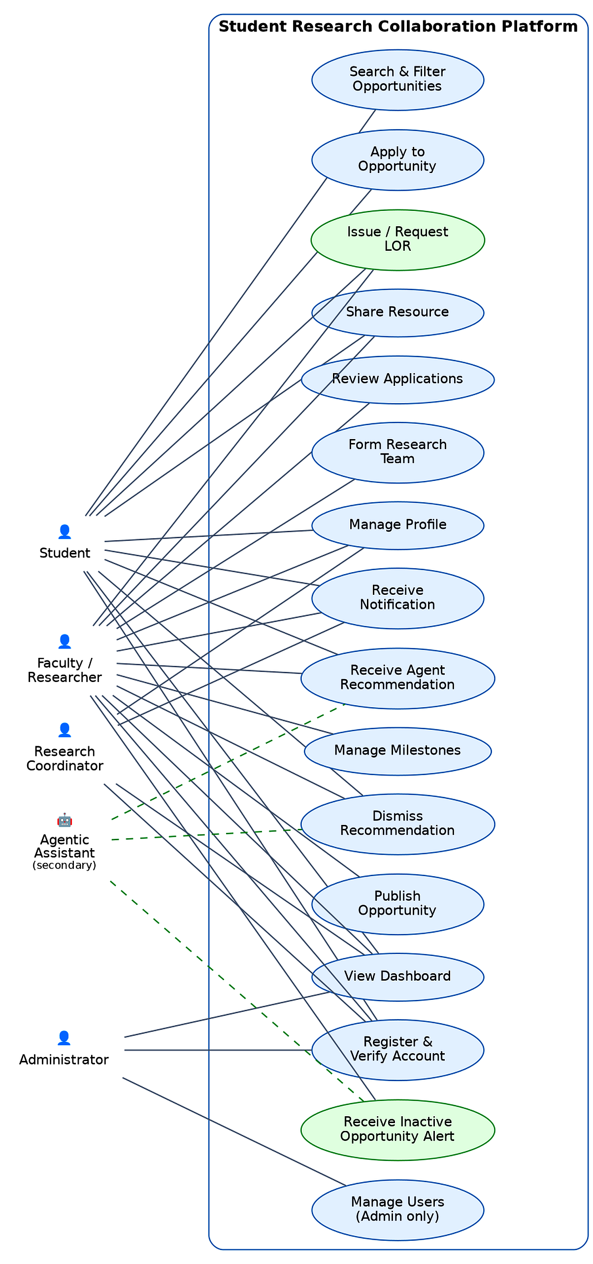
Figure B.1 — Use Case Diagram

B.2 Data Flow Diagrams
Level 0 (context diagram). A single process, “Student Research Collaboration Platform,” with data flows to and from four internal actors (Student, Faculty/Researcher, Research Coordinator, Administrator) and three optional external actors (GitHub API, Email Service, LLM/Agent Provider), matching the actors and interfaces already described in Section 2.1 and Section 3.3.
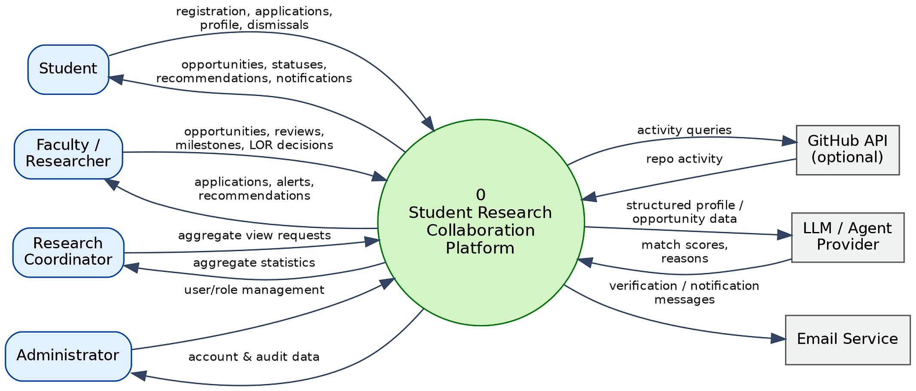
Figure B.2a — DFD Level 0 (Context Diagram)
Level 1 (major processes). The context process decomposes into eight processes that map directly onto the eight features in Section 4: (1) Manage Accounts & Roles, (2) Manage Opportunities, (3) Manage Applications & Teams, (4) Manage Resources, (5) Track Milestones, (6) Send Notifications, (7) Agent Matching & Monitoring, and (8) Generate Dashboards. Data stores at this level correspond to the entities in Section 6.1 (Users, Opportunities, Applications, Projects, Milestones, Resources, Notifications, Agent Recommendations, Activity Log).
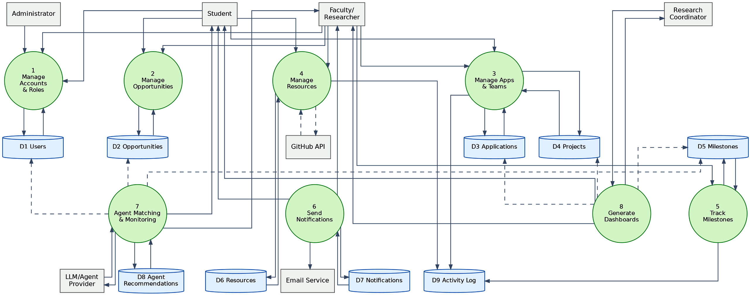
Figure B.2b — DFD Level 1
Level 2 (decomposition of Process 7). Process 7, Agent Matching & Monitoring, is the most internally complex of the eight and is decomposed further: 7.1 Collect Profile & Opportunity Data (reads StudentProfile, FacultyProfile, ResearchOpportunity, and Skill data), 7.2 Compute Match Score (applies the matching logic behind FR-025 and FR-027), 7.3 Generate Explanation (produces the human-readable reason required by FR-026), 7.4 Deliver Recommendation (writes an AgentRecommendation record and triggers the notification flow where applicable), and 7.5 Record Dismissal/Feedback (implements FR-031).
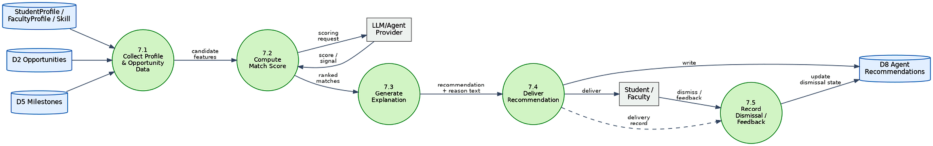
Figure B.2c — DFD Level 2 (Decomposition of Process 7)

B.3 Class Diagram
The class diagram is expected to model the fifteen entities listed in Section 6.1 as classes, with the relationships implied by the functional requirements: User is specialized (or associated, depending on the chosen modeling approach) by StudentProfile and FacultyProfile; ResearchOpportunity is authored by a FacultyProfile and has many Applications; Application references a StudentProfile and a ResearchOpportunity and has a status enumeration; ResearchProject has many ProjectMember, Milestone, and Resource records; Milestone has many Task records; and AgentRecommendation references the User it was generated for and, depending on type, a ResearchOpportunity, a candidate collaborator User, a Resource, or a Milestone; and RecommendationLetter references the authoring FacultyProfile, the recipient StudentProfile, and optionally the shared ResearchProject.
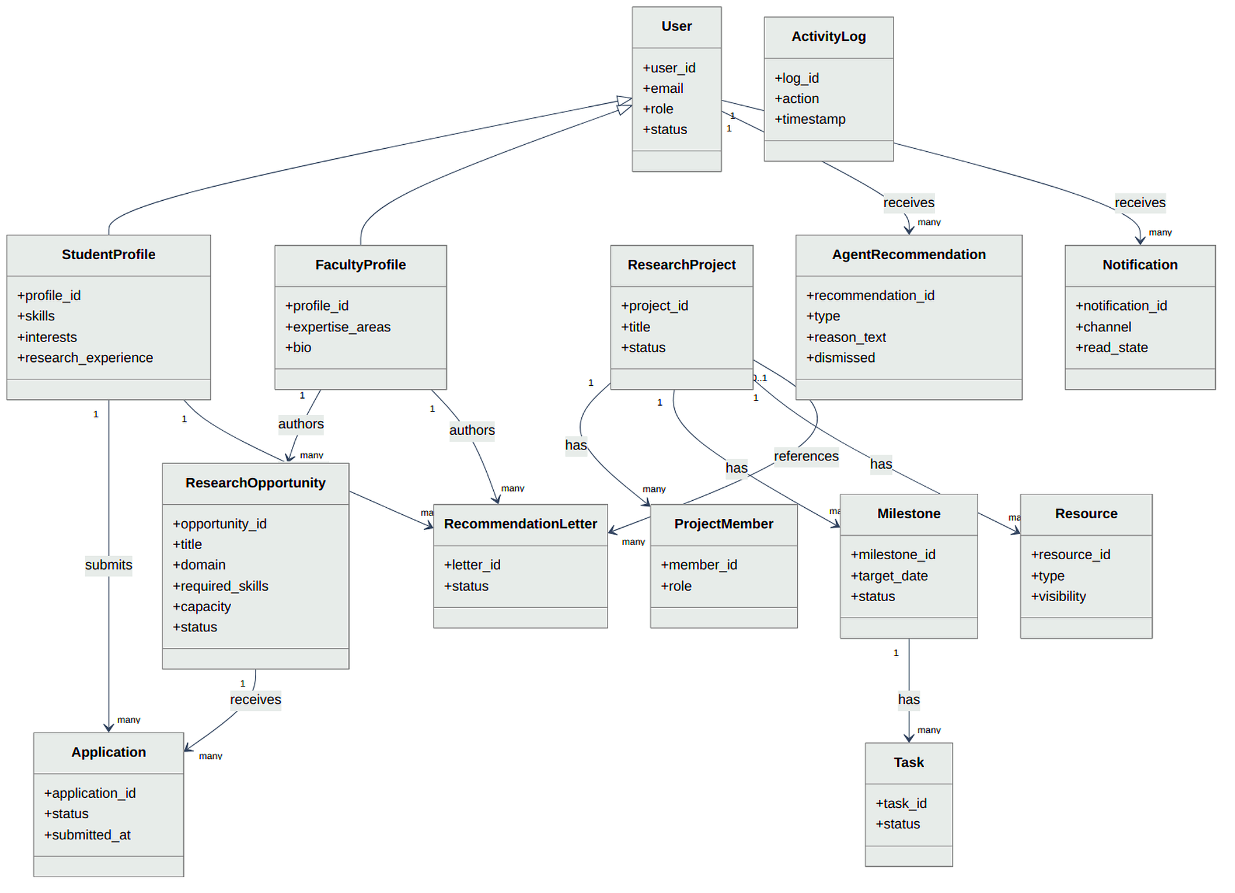
Figure B.3 — Class Diagram

B.4 Sequence Diagrams
Four sequence diagrams are expected to cover the interactions with the most participants or the most conditional branching: Registration & Verification (User, Backend, Email Service), Apply to Opportunity (Student, Backend, Faculty via Notification), Agent Recommendation Generation (Student, Backend, Agent Service, optionally an external LLM/recommendation provider), and Milestone Overdue Alert (Scheduled Job, Backend, Agent Service, Faculty via Notification). Each corresponds to one of the normal or exception flows already described in the relevant subsection of Section 4.
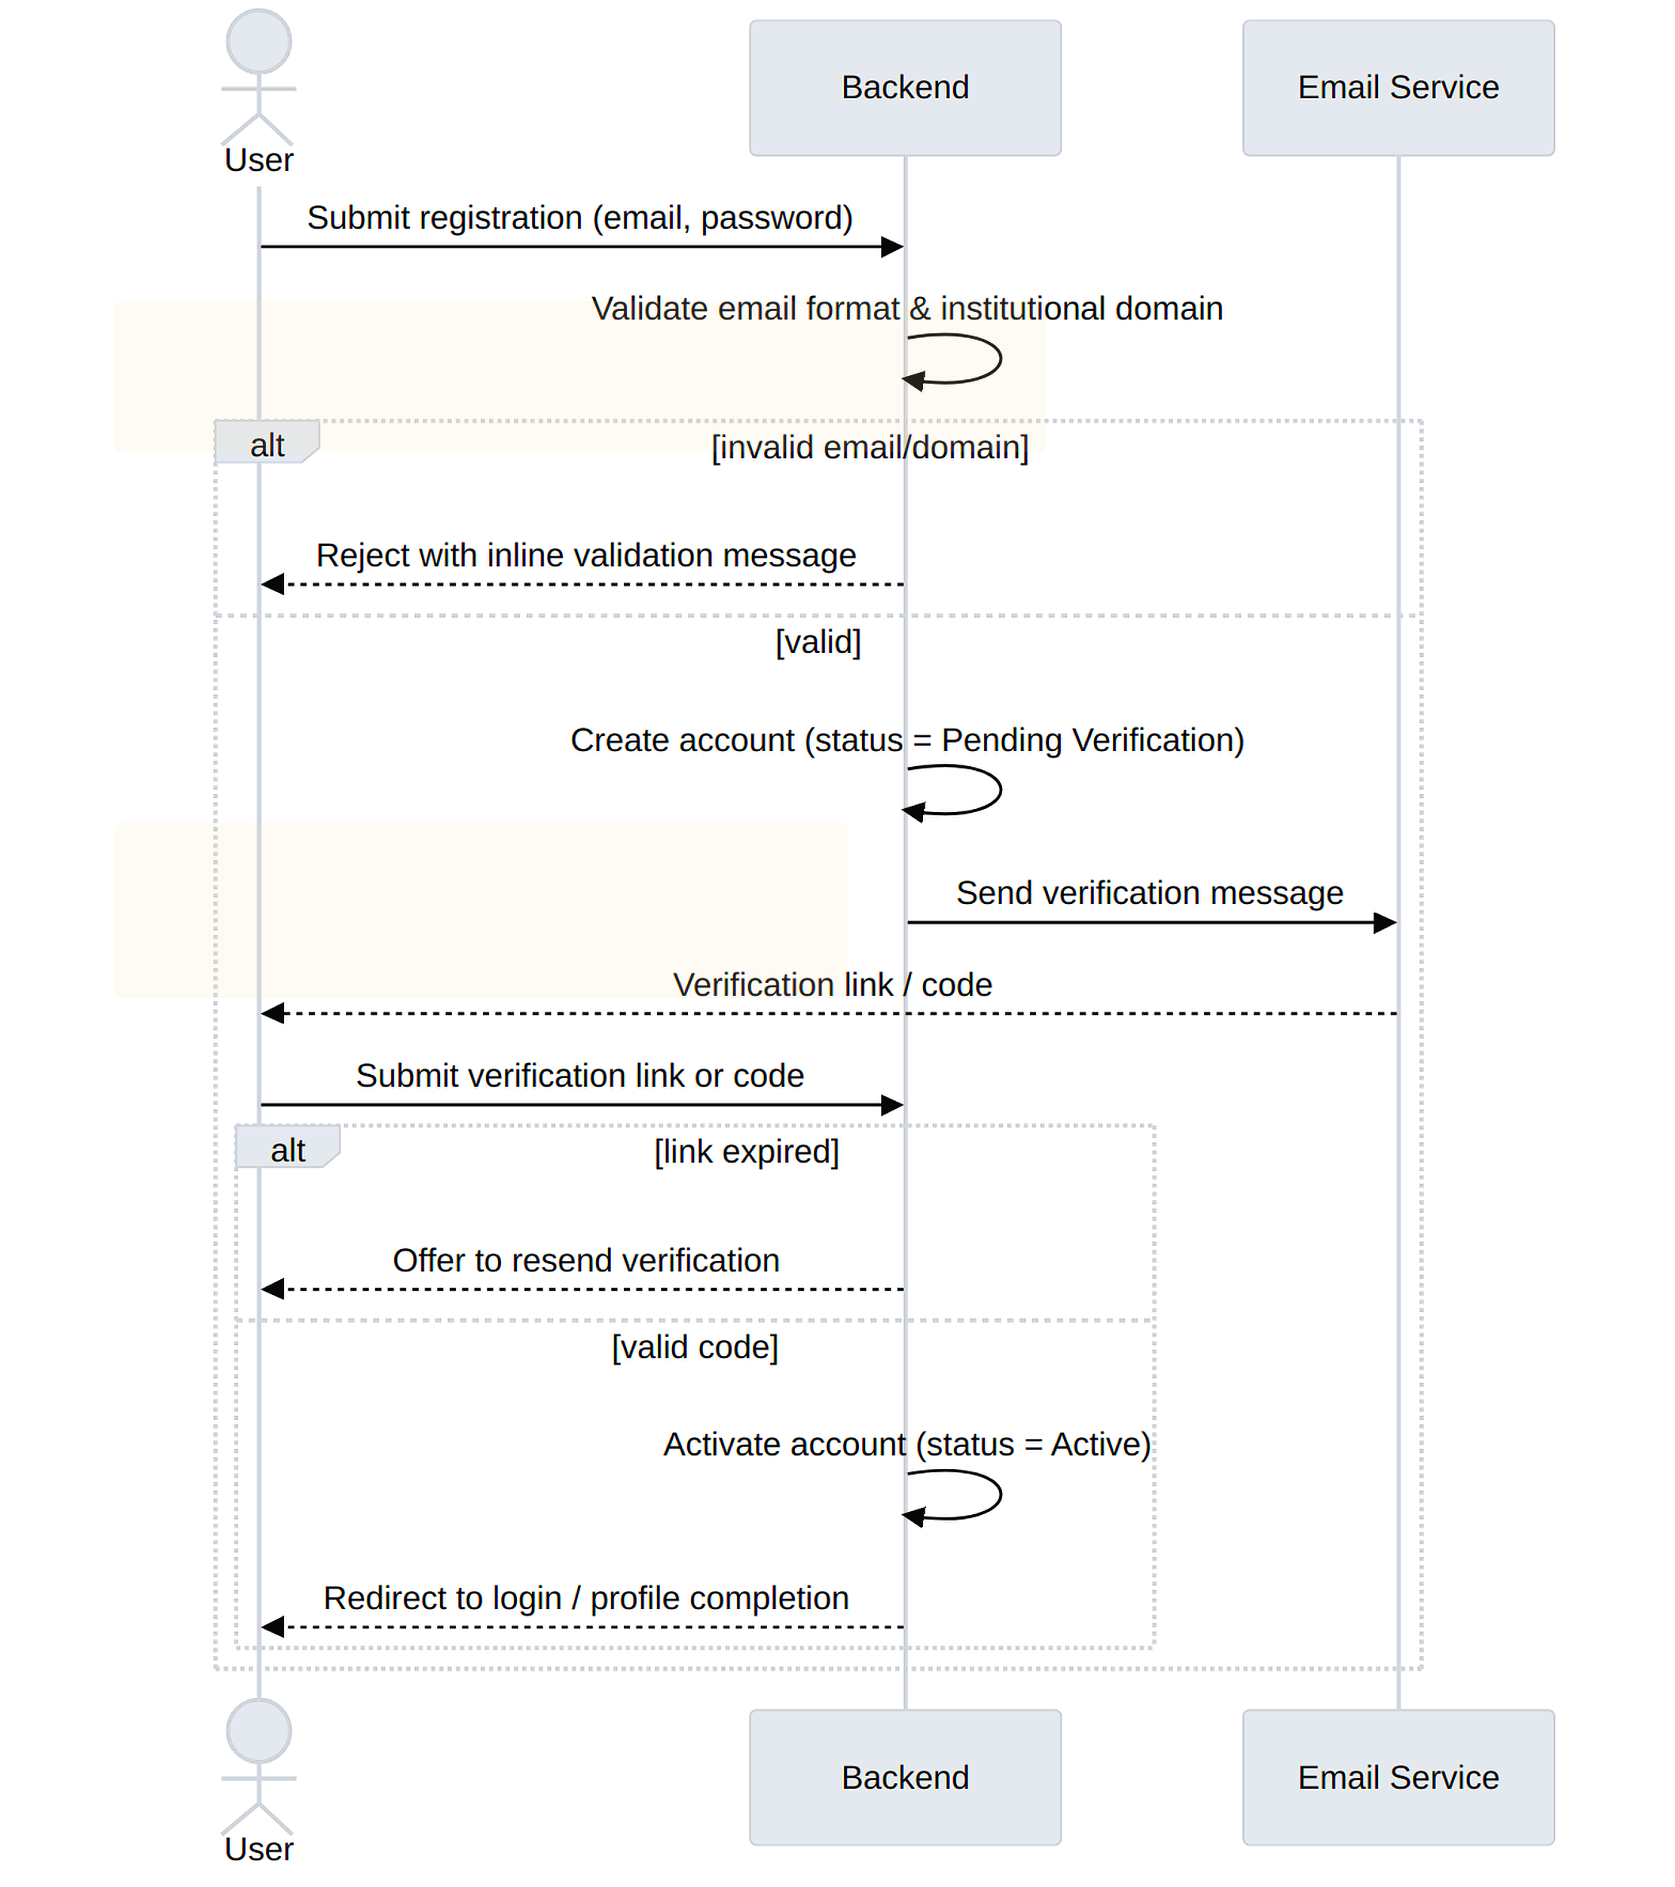
Figure B.4a — Registration & Verification
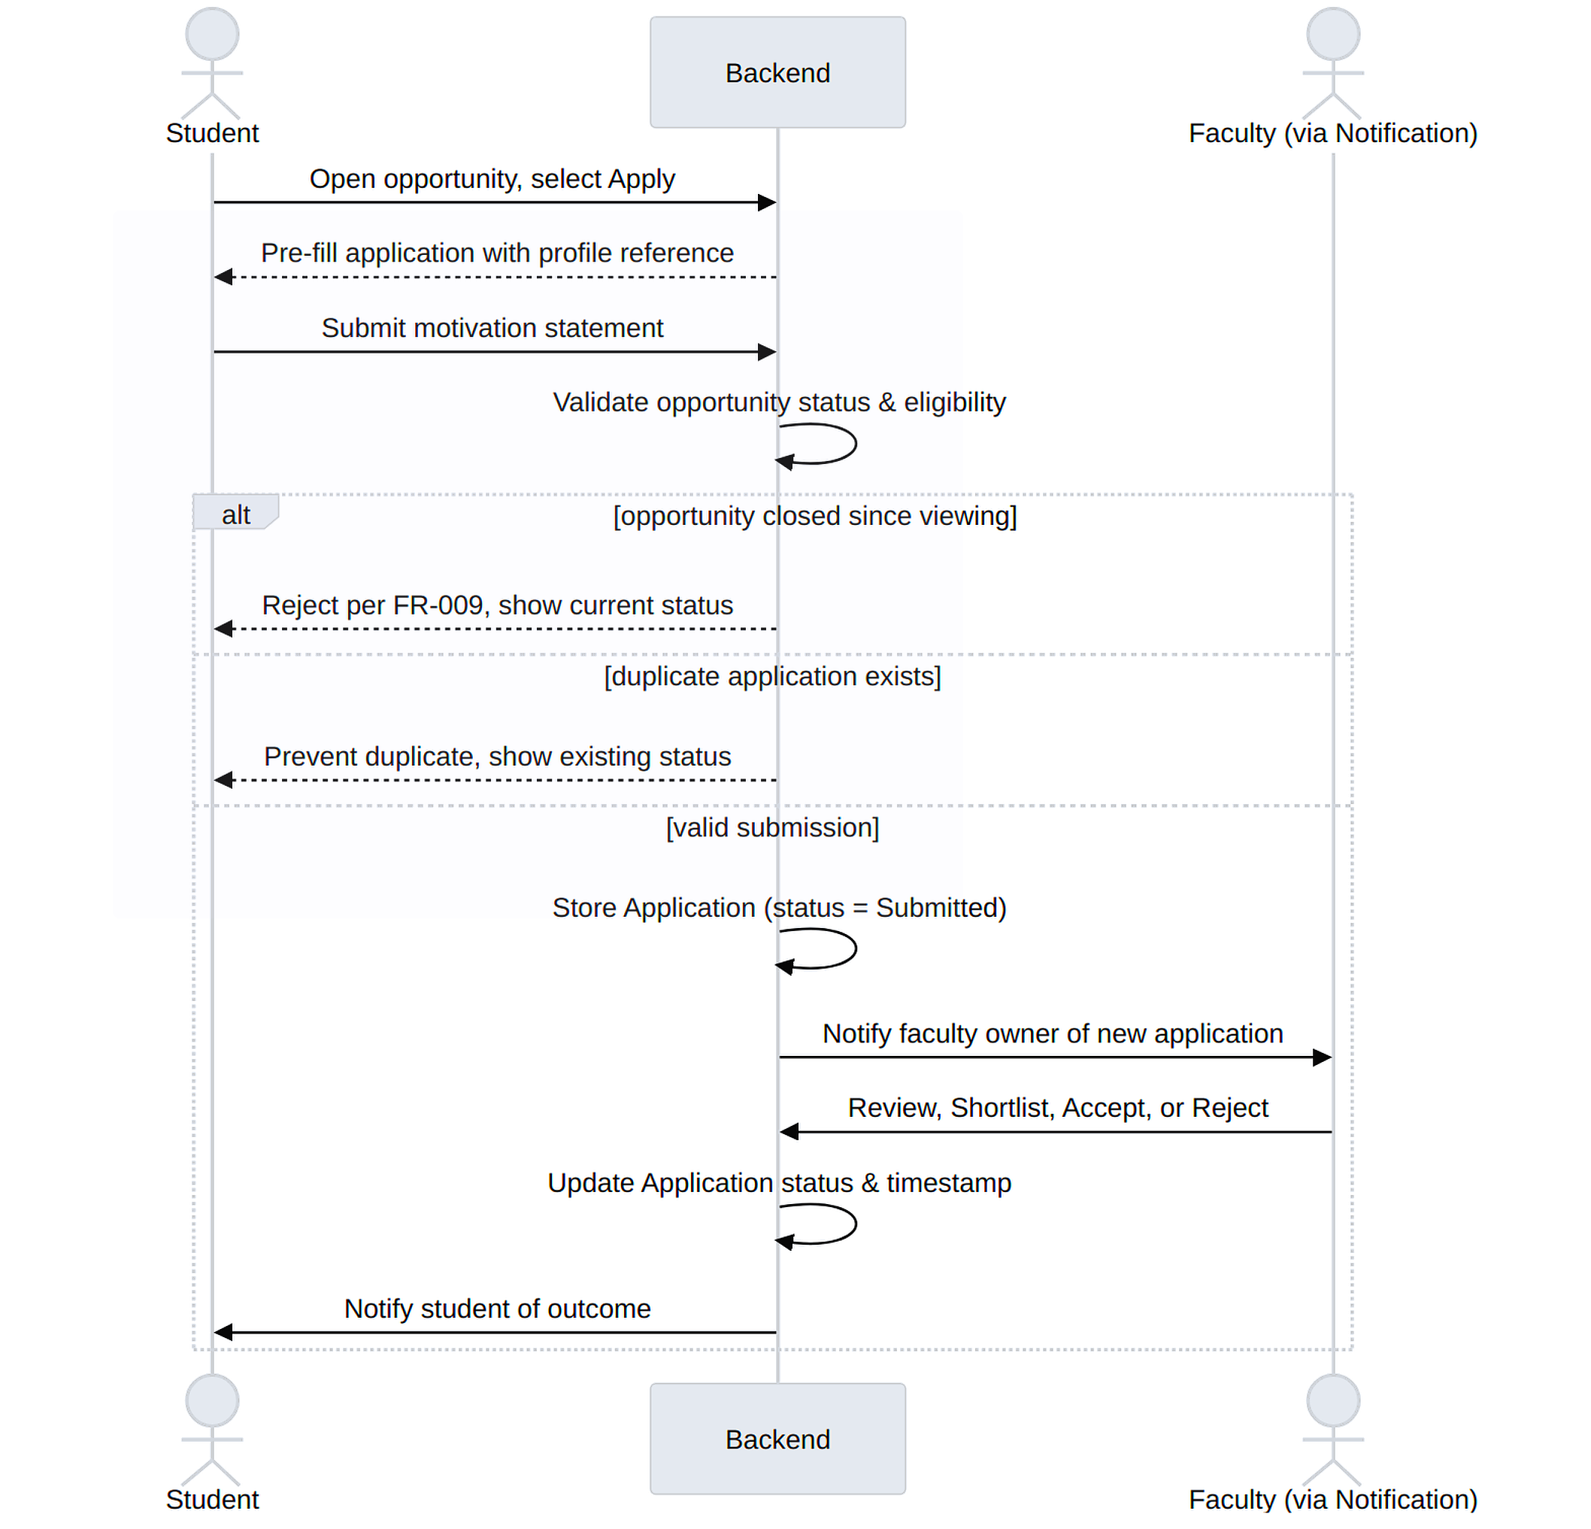
Figure B.4b — Apply to Opportunity
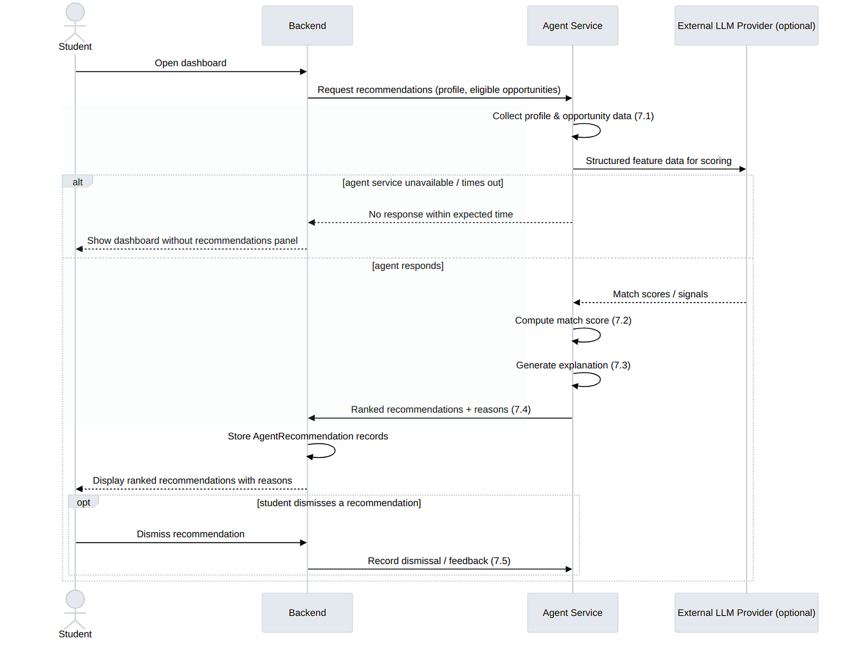
Figure B.4c — Agent Recommendation Generation
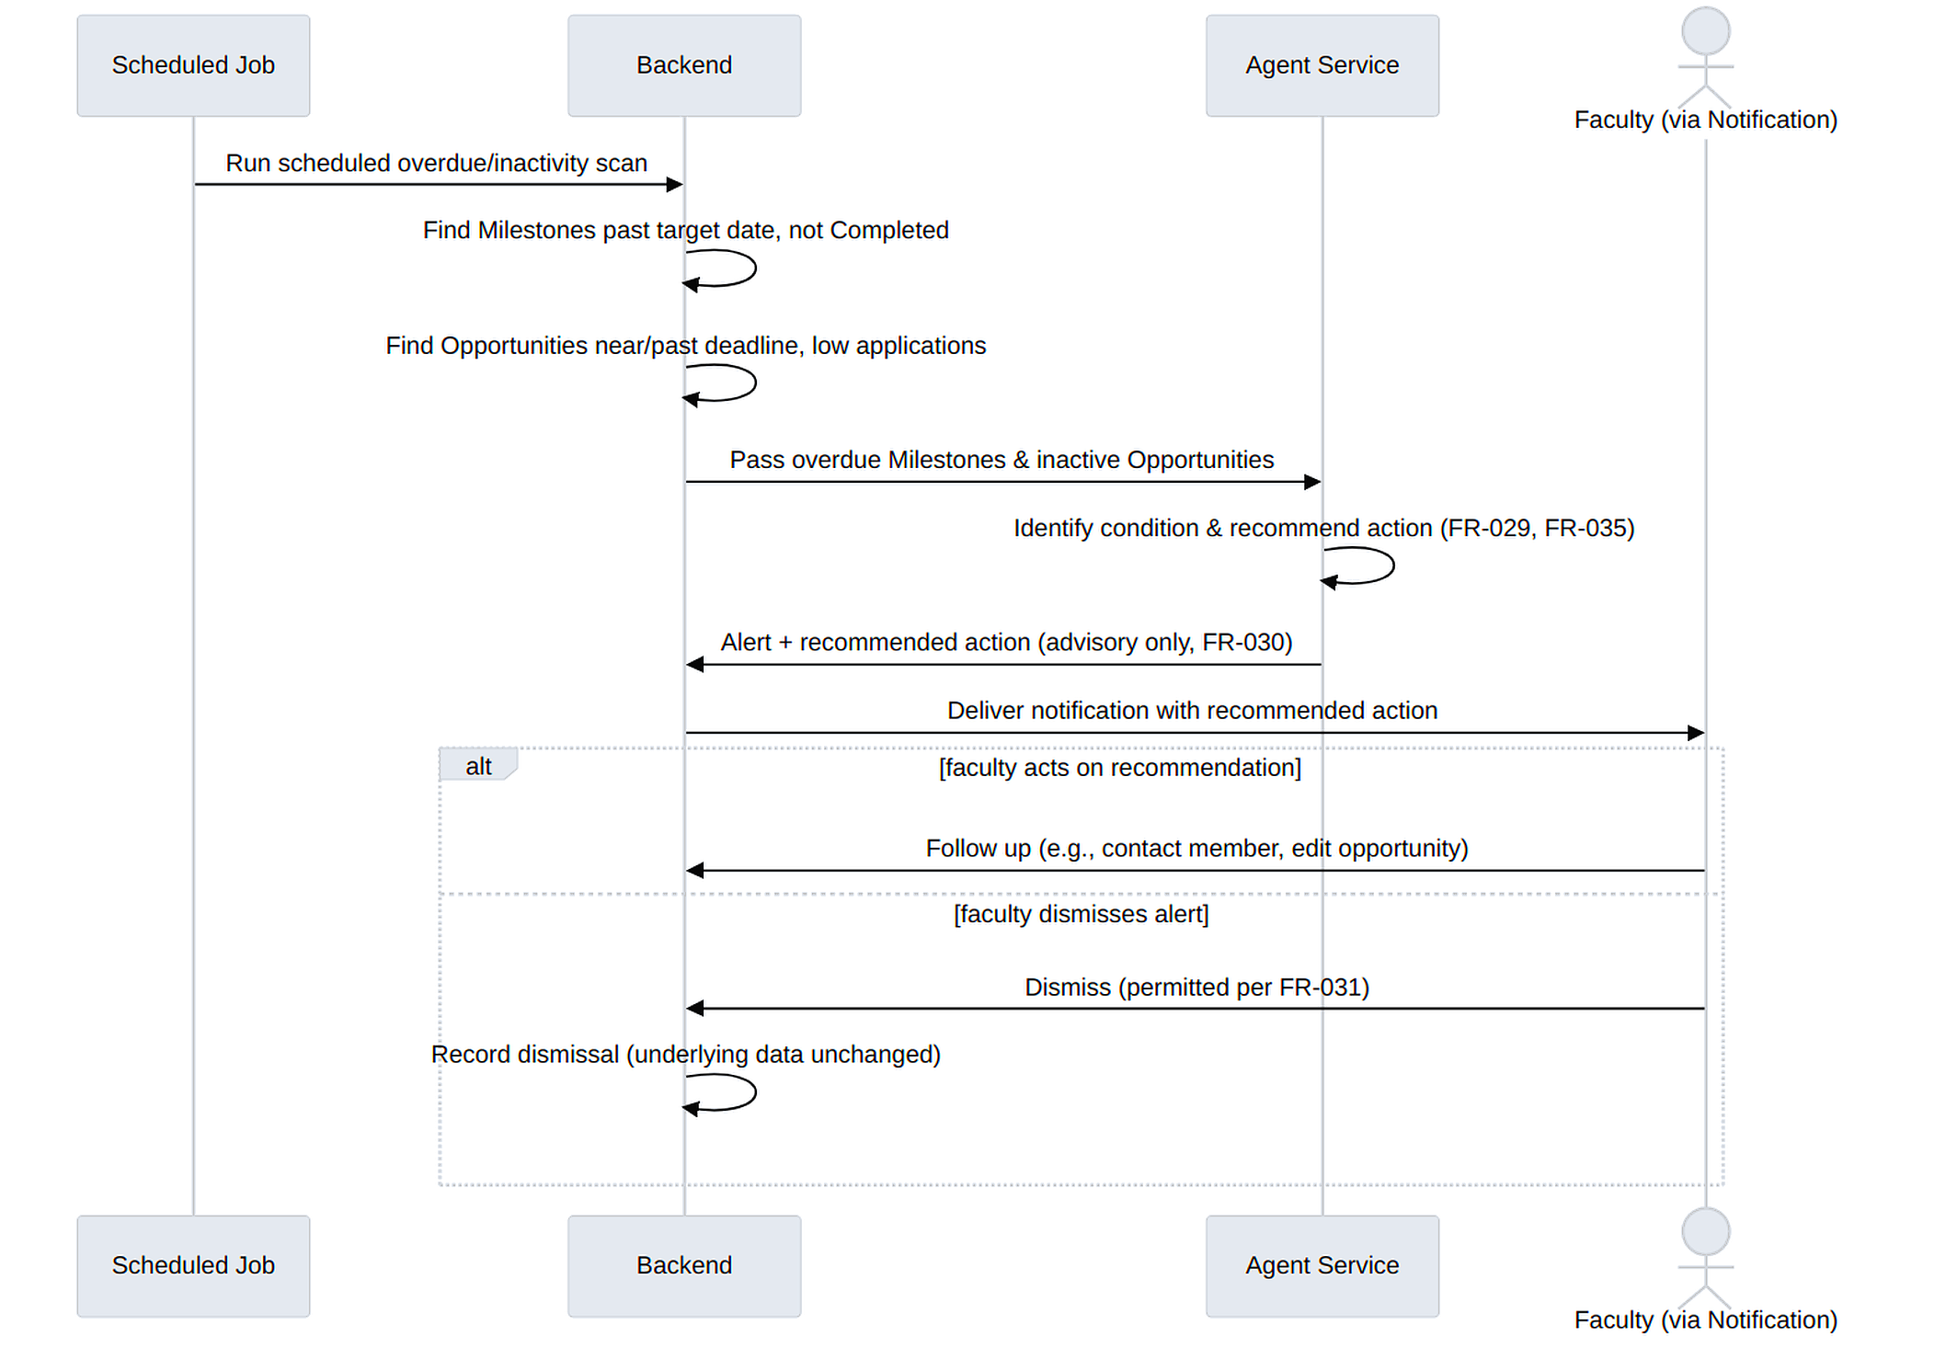
Figure B.4d — Milestone Overdue / Inactive Opportunity Alert

B.5 State / Workflow Models
Application status. Submitted → Shortlisted → Accepted, or Submitted/Shortlisted → Rejected, or Submitted/Shortlisted → Withdrawn (student-initiated), matching FR-011 and FR-012.
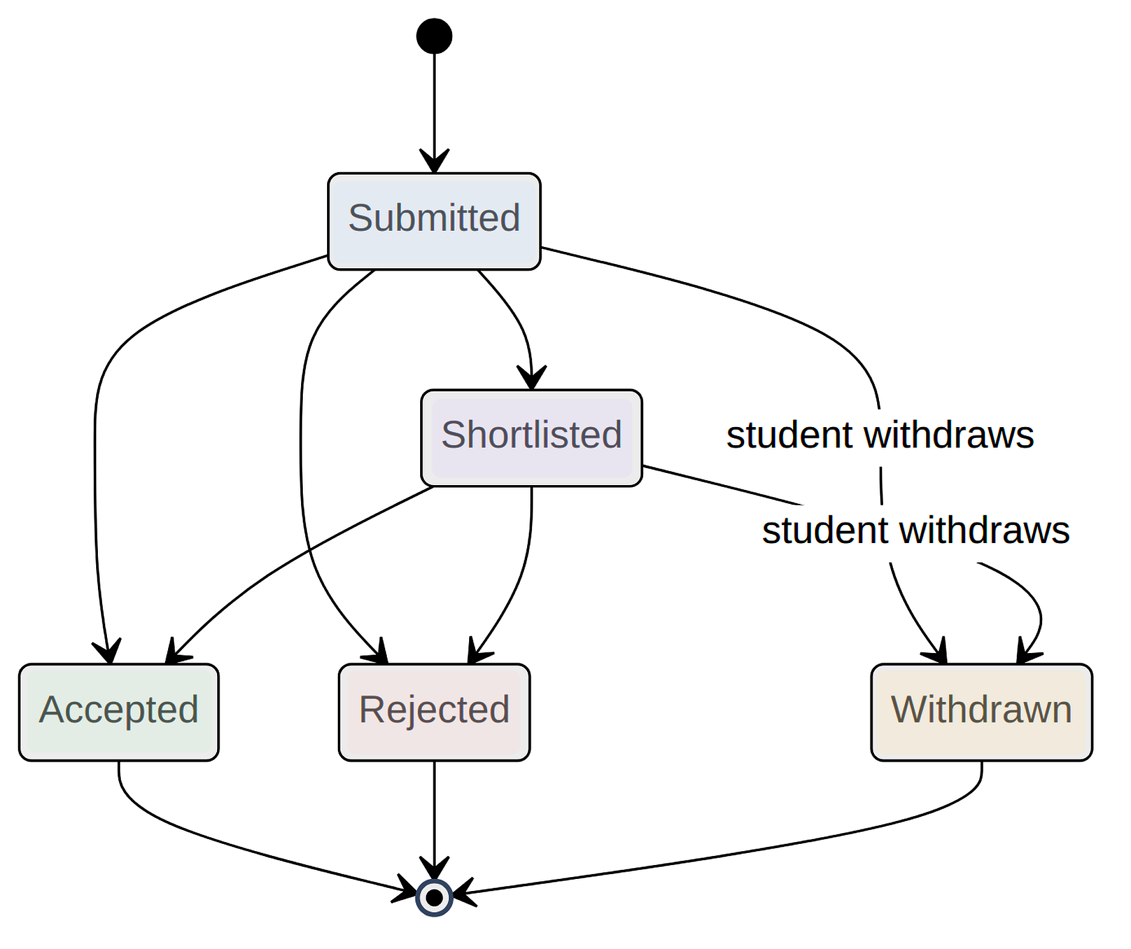
Figure B.5a — Application Status
Opportunity status. Draft → Published → Closed → Archived, matching FR-006 and FR-007.
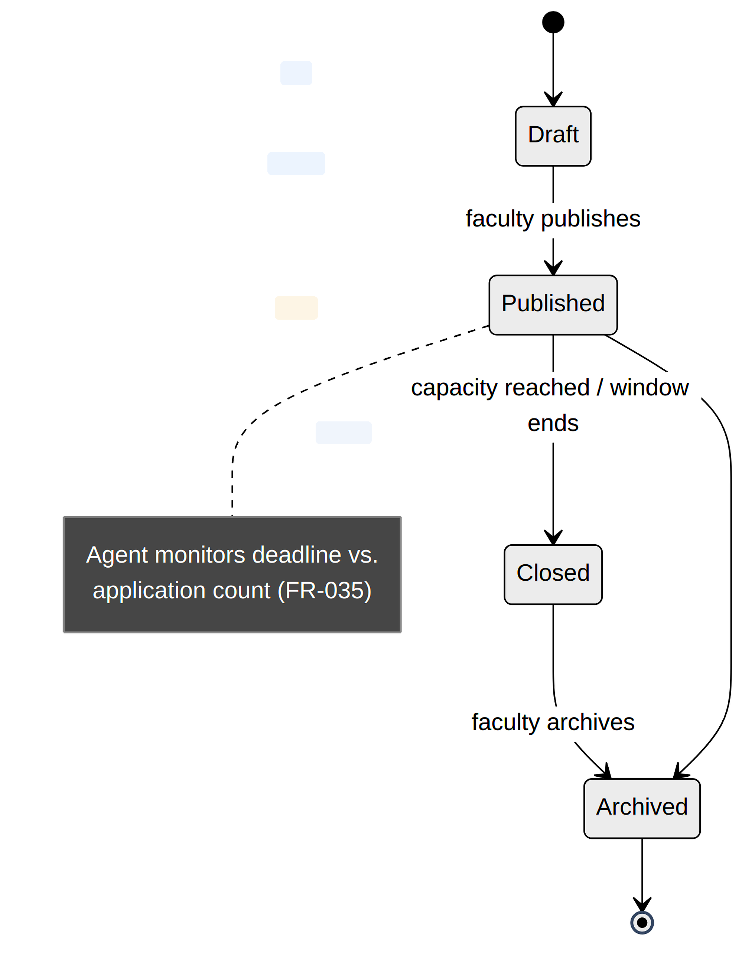
Figure B.5b — Opportunity Status
Milestone status. Not Started → In Progress → Completed, with a Blocked state reachable from In Progress, matching FR-019 and FR-020.
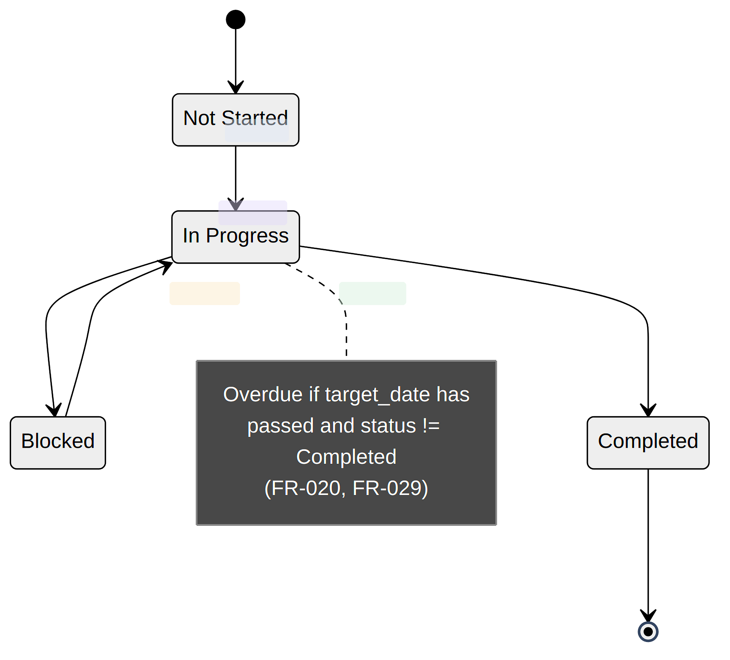
Figure B.5c — Milestone Status

Appendix C: To Be Determined List
The items below are unresolved design decisions carried over unchanged from Version 1.0. They are listed here, rather than resolved in this revision, because resolving them is a design-stage activity that follows this SRS rather than a clarification of the requirements themselves.
- TBD-001: Final external LLM/agent framework, if an external LLM is used.
- TBD-002: Final hosting provider and deployment configuration.
- TBD-003: Whether GitHub integration will be included in the mini-project scope.
- TBD-004: Final notification provider.
Each TBD item is referenced from the section of this document it most directly affects (Sections 2.1, 2.4, 3.3, 4.6, and 6.3) so that whichever team member resolves it during design can locate every place the decision has downstream consequences.

Appendix D: Detailed Use Case Descriptions
This appendix presents twelve of the use cases named in Appendix B.1 in full structured form. Each use case is derived directly from the functional requirements already stated in Section 4; no new behavior is introduced here. The purpose of presenting them this way is to give a step-by-step, actor-centered view of the same requirements that Section 4 presents as a flat table, which is typically more useful when deriving test scripts or walking a reviewer through a workflow end-to-end.

UC-01: Register and Verify Account
Primary Actor: Prospective Student or Faculty member
Related Requirements: FR-001, FR-002
Preconditions: The actor has a valid institutional email address and has not previously registered.
Main Success Scenario:
1. Actor opens the registration screen and enters their institutional email address and a password.
2. System validates the email format and institutional domain.
3. System creates an inactive account and sends a verification message to the supplied address.
4. Actor follows the verification link or enters the verification code.
5. System activates the account and redirects the actor to the login screen.
6. Actor logs in and is directed to the profile-completion step.
Extensions / Alternate Flows:
- 2a. Email format is invalid or the domain is not recognized — system rejects the submission with an inline validation message; no account is created.
- 3a. The email address already has an active account — system rejects registration with a generic, non-account-revealing message.
- 4a. Verification link has expired — system offers to resend a new verification message.
Postcondition: A verified, active account exists with a role assigned, ready for profile completion.

UC-02: Publish a Research Opportunity
Primary Actor: Faculty/Researcher
Related Requirements: FR-006, FR-007
Preconditions: Actor is authenticated with the Faculty/Researcher role.
Main Success Scenario:
1. Actor opens “Create Opportunity” and enters title, description, domain, required skills, duration, and capacity.
2. System validates required fields and saves the opportunity with status Draft.
3. Actor reviews the draft and selects Publish.
4. System changes status to Published and the opportunity becomes searchable.
Extensions / Alternate Flows:
- 2a. A required field is missing or invalid — system highlights the field and does not save until corrected.
- 3a. Actor chooses to keep the opportunity as a draft — use case ends without publishing; the draft can be resumed later.
Postcondition: The opportunity exists with status Published (or remains Draft) and is discoverable per UC-03 if published.

UC-03: Search and Filter Opportunities
Primary Actor: Student
Related Requirements: FR-008, FR-009
Preconditions: At least one opportunity has status Published.
Main Success Scenario:
1. Actor opens the opportunity listing.
2. Actor applies one or more filters (domain, skills, duration, availability).
3. System returns matching, currently open opportunities without a full page reload.
4. Actor opens an opportunity to view its full details.
Extensions / Alternate Flows:
- 3a. No opportunities match the current filters — system shows an explicit empty-results state rather than an error.
- 4a. The opportunity has since been closed — system shows its details but disables the Apply action, consistent with FR-009.
Postcondition: The actor has viewed opportunity details relevant to their filters and, if eligible, may proceed to UC-04.

UC-04: Apply to a Research Opportunity
Primary Actor: Student
Related Requirements: FR-010, FR-022
Preconditions: The opportunity has status Published and the student has not already applied to it.
Main Success Scenario:
1. Actor opens the opportunity details screen and selects Apply.
2. System pre-fills the application with a reference to the actor's current profile and prompts for a motivation statement.
3. Actor submits the application.
4. System validates opportunity status and eligibility, stores the application with status Submitted, and notifies the owning faculty member.
Extensions / Alternate Flows:
- 3a. The opportunity was closed between UC-03 step 4 and this submission — system rejects the submission per FR-009 and informs the actor.
- 3b. The actor has already applied — system prevents a duplicate application and shows the existing application's status instead.
Postcondition: An Application record exists with status Submitted, visible to both the student and the owning faculty member.

UC-05: Review Applications and Form a Research Team
Primary Actor: Faculty/Researcher
Related Requirements: FR-011, FR-012, FR-013
Preconditions: At least one Application with status Submitted exists for an opportunity the actor owns.
Main Success Scenario:
1. Actor opens the applicant list for an opportunity.
2. Actor shortlists one or more applicants for closer review.
3. Actor accepts the applicants who will join the project and rejects the remainder.
4. Actor selects “Form Team” for the accepted applicants.
5. System creates a ResearchProject and adds each accepted applicant as a ProjectMember.
Extensions / Alternate Flows:
- 3a. Actor rejects an applicant without shortlisting first — permitted; shortlisting is optional, not mandatory, per FR-011.
- 4a. Actor forms the team from a subset of accepted applicants, deferring the rest to a later team or a future opportunity — permitted.
Postcondition: Every reviewed Application has a final status, and, where UC step 5 completed, a ResearchProject with an initial membership exists.

UC-06: Share a Research Resource
Primary Actor: Project Member (Student or Faculty)
Related Requirements: FR-015, FR-016, FR-017
Preconditions: Actor is an authorized member of an existing ResearchProject.
Main Success Scenario:
1. Actor opens the project workspace and selects “Add Resource.”
2. Actor enters a title, selects a type, adds a description, and provides a link or uploads a file.
3. System stores the resource, scoped to the project, and records the addition in the project's activity history.
4. Other project members see the new resource in the workspace.
Extensions / Alternate Flows:
- 4a. A non-member attempts to access the resource directly — system denies access per FR-016 and NFR-008, regardless of whether the direct link was somehow obtained.
- 3a. Actor (or a faculty/lead member) later edits or removes the resource — handled per FR-017, with the change recorded in the activity history.
Postcondition: The resource is visible to current project members only, and its addition (and any later edit or removal) is recorded.

UC-07: Create and Track a Milestone
Primary Actor: Faculty/Project Lead, then Project Members
Related Requirements: FR-018, FR-019, FR-020, FR-021
Preconditions: Actor is a faculty member or lead of an existing ResearchProject.
Main Success Scenario:
1. Actor opens the project workspace and selects “Add Milestone,” entering a description and target date.
2. System creates the milestone with status Not Started and records the creation in the activity history.
3. Project members update the milestone's status as work proceeds (In Progress, Blocked, or Completed).
4. If the target date passes while status is not Completed, the system marks the milestone overdue and highlights it on relevant dashboards.
Extensions / Alternate Flows:
- 3a. A member marks the milestone Blocked — the reason, if provided, is visible to other members and is available to the agent's inactivity-detection logic (FR-029).
- 4a. The milestone is completed on time — no overdue marking occurs; the completion is recorded in the activity history.
Postcondition: The milestone's current status and full status history are available to project members and to the reporting features in Section 4.8.

UC-08: Receive an Agent Opportunity Recommendation
Primary Actor: Student
Related Requirements: FR-025, FR-026, FR-031
Preconditions: The student has a completed profile with at least one skill or interest recorded, and at least one eligible Published opportunity exists.
Main Success Scenario:
1. Actor opens their dashboard.
2. System requests recommendations from the agent service, passing the actor's structured profile data and the set of eligible opportunities.
3. Agent service computes a ranked list of matches and a short reason for each.
4. System displays the ranked recommendations in the recommendations panel.
5. Actor inspects a recommendation and either opens it to start an application (per UC-04) or dismisses it.
Extensions / Alternate Flows:
- 5a. Actor dismisses a recommendation — handled per UC-09; the dismissed item is not shown again in the same form.
- 2a. The agent service does not respond within the expected time — system loads the rest of the dashboard normally and shows a clearly labeled unavailable state for the panel, per the exception flow in Section 4.7.
Postcondition: The student has seen ranked, explained recommendations and has either acted on or dismissed each.

UC-09: Receive an Overdue Project Alert
Primary Actor: Faculty/Project Lead
Related Requirements: FR-020, FR-029, FR-030
Preconditions: A milestone within a project the actor leads has become overdue, or a project shows no recent activity.
Main Success Scenario:
1. A scheduled check evaluates project milestones and recent activity against the overdue and inactivity conditions defined in FR-020 and FR-029.
2. For a project that meets the condition, the agent service generates a recommended follow-up action and a short explanation.
3. System stores the recommendation and notifies the project's faculty lead.
4. Actor reviews the alert on their dashboard and decides what action, if any, to take.
Extensions / Alternate Flows:
- 2a. The agent recommends contacting a specific inactive member — the recommendation names the member and the reason (for example, no milestone updates in the observed window), but performs no action on the member's behalf, per FR-030.
- 4a. Actor dismisses the alert without acting — permitted per FR-031; the underlying overdue condition remains visible on the project dashboard regardless of the dismissal.
Postcondition: The faculty lead has been made aware of the overdue condition and any agent-suggested action; no project data was changed by the agent itself.

UC-10: View a Role-Specific Dashboard
Primary Actor: Student, Faculty/Researcher, or Research Coordinator
Related Requirements: FR-032, FR-033, FR-034
Preconditions: Actor is authenticated.
Main Success Scenario:
1. Actor logs in and is directed to their role's dashboard.
2. System loads the summary data appropriate to the actor's role: for a Student, applications, active projects, milestones, and recommendations (FR-032); for Faculty, project participation, applications, and milestone progress (FR-033); for a Coordinator, aggregate project and participation statistics (FR-034).
3. Actor reviews the summary and navigates into a specific item of interest if needed.
Extensions / Alternate Flows:
- 2a. The actor holds the Administrator role instead — system shows the administrator dashboard described in Section 3.1, outside the scope of FR-032–FR-034.
- 2b. No data yet exists for a given panel (for example, a new student with no applications) — system shows an explicit empty state rather than an error.
Postcondition: The actor has a current, role-appropriate summary of platform activity without needing to visit each underlying screen individually.

UC-11: Issue or Request a Letter of Recommendation
Primary Actor: Faculty/Researcher (issuing) or Student (requesting)
Related Requirements: FR-036, FR-037, FR-038
Preconditions: Actor is authenticated; for a student-initiated request, the target faculty member has authenticated an account.
Main Success Scenario:
1. Faculty issues an LOR directly from a student's project view, or a Student requests one from a faculty member they have worked with.
2. If the flow began with a request, system presents the faculty member with a summary of the student's recorded performance.
3. Faculty decides to issue or decline the letter.
4. System records the LOR status (Issued or Declined) and notifies the student.
Extensions / Alternate Flows:
- 2a. Faculty has no recorded ProjectMember history with the requesting student — system still allows the request but flags the absence of shared history.
- 3a. Faculty takes no action within a reasonable period — the request remains in Requested status, visible to the student.
Postcondition: The LOR record has a final or pending status consistent with FR-038, and the student has been notified of any decision.

UC-12: Receive an Inactive Opportunity Alert
Primary Actor: Faculty/Researcher
Related Requirements: FR-035
Preconditions: Faculty owns a Published opportunity that is nearing or past its application deadline with no or few applications.
Main Success Scenario:
1. A scheduled job identifies the opportunity's low-application condition.
2. The agent generates an alert naming at least one recommended action (broaden required skills, extend the deadline, or promote the opportunity).
3. Faculty receives the alert via the notification mechanism (Section 4.6).
4. Faculty follows a recommended action, takes a different action, or dismisses the alert.
Extensions / Alternate Flows:
- 4a. Faculty dismisses the alert without acting — permitted per FR-031; the underlying opportunity is unchanged.
Postcondition: Faculty has been made aware of the inactivity condition and any agent-recommended action, without the agent making a change on its own (FR-030).

Appendix E: Requirements Traceability Matrix
This matrix maps every functional requirement to the feature it belongs to, the nonfunctional requirement(s) or business rule(s) most directly relevant to it, and its verification method, so that a reviewer can confirm each requirement has at least one clear path to a test, and so a tester can see, in one place, which broader quality or rule concern a given test result speaks to.
FR ID | Feature (Section 4) | Related NFR / BR | Verification
FR-001 | 4.1 User & Role Mgmt | NFR-005, NFR-006 | Functional test
FR-002 | 4.1 User & Role Mgmt | NFR-006 | Functional/security test
FR-003 | 4.1 User & Role Mgmt | NFR-007 | Security test
FR-004 | 4.1 User & Role Mgmt | FR-025 (data source) | Functional test
FR-005 | 4.1 User & Role Mgmt | FR-026 (data source) | Functional test
FR-006 | 4.2 Opportunity Mgmt | BR-001 | Functional test
FR-007 | 4.2 Opportunity Mgmt | BR-001 | Functional test
FR-008 | 4.2 Opportunity Mgmt | NFR-004 | Functional test
FR-009 | 4.2 Opportunity Mgmt | BR-002 | Negative test
FR-010 | 4.3 Applications & Collab. | — | Functional test
FR-011 | 4.3 Applications & Collab. | BR-003 | Functional test
FR-012 | 4.3 Applications & Collab. | Section 6.2 (audit) | Database/functional test
FR-013 | 4.3 Applications & Collab. | BR-006 | Functional test
FR-014 | 4.3 Applications & Collab. | BR-004 | Access-control test
FR-015 | 4.4 Resources & Documents | — | Functional test
FR-016 | 4.4 Resources & Documents | NFR-008, BR-004 | Security test
FR-017 | 4.4 Resources & Documents | — | Functional test
FR-018 | 4.5 Progress & Milestones | — | Functional test
FR-019 | 4.5 Progress & Milestones | — | Functional test
FR-020 | 4.5 Progress & Milestones | FR-029 (data source) | Functional test
FR-021 | 4.5 Progress & Milestones | Section 6.2 (audit) | Functional test
FR-022 | 4.6 Notifications | — | Functional test
FR-023 | 4.6 Notifications | — | Functional test
FR-024 | 4.6 Notifications | — | Functional test
FR-025 | 4.7 Agentic Assistant | NFR-002, NFR-009 | Agent evaluation
FR-026 | 4.7 Agentic Assistant | — | Agent evaluation
FR-027 | 4.7 Agentic Assistant | — | Agent evaluation
FR-028 | 4.7 Agentic Assistant | — | Agent evaluation
FR-029 | 4.7 Agentic Assistant | FR-020 (data source) | Scenario test
FR-030 | 4.7 Agentic Assistant | Section 5.2 (safety), BR-005 | Safety/permission test
FR-031 | 4.7 Agentic Assistant | — | Functional test
FR-032 | 4.8 Dashboards & Reports | — | UI test
FR-033 | 4.8 Dashboards & Reports | — | UI test
FR-034 | 4.8 Dashboards & Reports | BR-003 | Functional test
FR-035 | 4.7 Agentic Assistant | BR-005 | Agent evaluation
FR-036 | 4.9 Letters of Recommendation | — | Functional test
FR-037 | 4.9 Letters of Recommendation | — | Functional test
FR-038 | 4.9 Letters of Recommendation | — | Functional test

Appendix F: Project Risk Register
This risk register identifies delivery and design risks specific to building the system described in this SRS within the constraints already stated in Section 2.5 (a three-member team, a single academic term). It is a project-management view of the same system, not a new set of requirements.
ID | Risk Description | Likelihood | Impact | Mitigation
R-01 | External LLM/agent provider is slow, rate-limited, or unavailable during a demonstration. | Medium | High | Design the agent service behind the internal API described in Section 3.3 with a timeout and a graceful unavailable state (Section 4.7 exception flow); rehearse the demonstration with the provider intentionally disabled.
R-02 | Three-member team cannot complete all High-priority requirements within the academic term. | Medium | High | Prioritize strictly by the Priority column in Section 4 FR tables; treat Medium/Low items as first to defer, consistent with Section 1.2's definition of priority.
R-03 | Sensitive profile data is sent to an external LLM provider beyond what NFR-009 permits. | Low | High | Restrict the internal API payload to the structured fields named in NFR-009 at the code level, and cover this with a dedicated test rather than relying on manual review alone.
R-04 | Client-side-only role checks are mistaken for real authorization during development. | Medium | High | Treat NFR-007 as a checklist item in code review: every protected endpoint must show a server-side role check, verified by an access-control test per FR-014's verification method.
R-05 | Optional GitHub integration absorbs disproportionate development time relative to its priority. | Medium | Medium | Confirm TBD-003 early; if included, scope it to read-only activity display only, consistent with Section 2.7's framing of it as an optional dependency.
R-06 | Email/notification provider outage is mistaken for a core-platform outage during testing. | Low | Medium | Explicitly test the alternate flow in Section 4.6 (email unavailable) so the team can distinguish a notification-channel issue from a core-functionality regression.
R-07 | Agent recommendation logic drifts toward influencing acceptance decisions as features are added. | Low | High | Re-run the safety/permission test attached to FR-030 whenever the matching or alert logic changes, per the maintenance requirement in Section 6.4.
R-08 | Database schema changes during development break existing Application or Milestone status history. | Medium | Medium | Apply schema changes through migrations rather than destructive edits, and add a regression check that existing status-history records remain readable after a migration.
R-09 | Search/filter performance degrades as sample data grows during testing, missing the NFR-004 target. | Low | Medium | Index the fields used by FR-008's filters (domain, skills, duration, availability) and measure response time under NFR-001/NFR-004 with a realistic sample dataset before evaluation.
R-10 | Course timeline compresses the time available for the modeling experiments referenced in Appendix B. | Medium | Medium | Use the process/entity breakdown already given in Appendix B as a starting draft for each diagram, rather than starting each modeling experiment from a blank page.
R-11 | Manual test coverage does not keep pace with the number of functional requirements as implementation proceeds. | Medium | Medium | Use Appendix E (Traceability Matrix) as a running checklist during development, and prioritize automated coverage for High-priority, safety-relevant requirements such as FR-030 first.
R-12 | Loading, empty, error, and access-denied states (Section 3.1.1) are implemented inconsistently across screens, confusing evaluators during a demonstration. | Low | Low | Treat the four common screen states as a single shared UI checklist applied to every screen listed in Section 3.1, rather than re-deciding the behavior separately for each one.

Appendix G: Acceptance Test Scenarios
The scenarios below are written in Given/When/Then form and are drawn directly from the functional requirements in Section 4 and the use cases in Appendix D. They are representative rather than exhaustive — a full test plan would enumerate additional edge cases — but each of the eight features has at least one scenario, and Section 4.7 (the agentic feature) has proportionally more, consistent with its concentration of High-priority, safety-relevant requirements noted at the end of Section 4.

AT-01: Successful registration with institutional email (FR-001)
Given a prospective user has a valid, previously unregistered institutional email address
When they submit the registration form with that address and a password
Then an inactive account is created and a verification message is sent; the account cannot log in until verified

AT-02: Registration rejected for non-institutional email (FR-001)
Given a prospective user submits an email address outside the recognized institutional domain
When they submit the registration form
Then the system rejects the submission with an inline validation message and creates no account

AT-03: Protected endpoint rejects unauthenticated requests (FR-002, NFR-006)
Given no valid session or token is presented
When a request is made to a protected API endpoint
Then the request is rejected and no protected data is returned

AT-04: Server-side role enforcement (FR-003, NFR-007)
Given an authenticated Student attempts to call an endpoint reserved for Faculty (for example, publishing an opportunity)
When the request is made directly to the API, bypassing the client interface
Then the server rejects the request based on role, independent of what the client interface would have shown or hidden

AT-05: Opportunity becomes searchable after publishing (FR-006, FR-007, FR-008)
Given a Faculty user has created and published an opportunity with a specific domain and required skills
When a Student searches the opportunity listing filtering by that domain
Then the opportunity appears in the filtered results without a full page reload

AT-06: Application blocked against a closed opportunity (FR-009)
Given an opportunity's status has been changed to Closed
When a Student attempts to submit an application to it, including by calling the API directly
Then the system rejects the application server-side, regardless of what the client interface displayed

AT-07: Application status visible to both parties with timestamps (FR-010, FR-011, FR-012)
Given a Student has submitted an application and a Faculty member shortlists then accepts it
When either party views the application
Then both see the same current status (Accepted) and the timestamp of each transition (Submitted, Shortlisted, Accepted)

AT-08: Team formation creates project membership (FR-013, FR-014)
Given one or more applications for an opportunity have status Accepted
When the Faculty owner selects Form Team for those applicants
Then a ResearchProject is created and each accepted applicant becomes a ProjectMember with access to the project workspace

AT-09: Private resource inaccessible to non-members (FR-016, NFR-008)
Given a Resource exists within a ResearchProject and a user is not a member of that project
When the user attempts to access the resource directly, including by reusing a previously valid link
Then access is denied based on project membership, not on whether the link itself was guessable

AT-10: Milestone marked overdue after target date passes (FR-020)
Given a Milestone has a target date in the past and a status other than Completed
When a user views the project dashboard or the scheduled overdue check runs
Then the milestone is flagged overdue consistently in both the dashboard view and the scheduled check

AT-11: In-app notification still created during email outage (FR-022, Section 4.6 alternate flow)
Given the email/notification service is unreachable
When an application status change occurs
Then an in-app notification is still created and visible to the affected Student, per the assumption in Section 2.7 that core functions continue during a notification-channel outage

AT-12: Recommendation includes an understandable reason (FR-025, FR-026)
Given a Student has a profile with recorded skills and interests, and at least one eligible Published opportunity exists
When the Student opens their dashboard
Then the returned recommendation includes a reason referencing a concrete matching factor (for example, a specific shared skill), not only a numeric score

AT-13: Dashboard remains usable when the agent service is unavailable (Section 4.7 exception flow, Section 5.4 (Reliability))
Given the agent service does not respond within the expected time window
When a Student opens their dashboard
Then the rest of the dashboard loads normally and the recommendations panel shows a clearly labeled unavailable state, rather than blocking the page

AT-14: Agent alert does not alter project data (FR-029, FR-030, Section 5.2)
Given a project meets the overdue/inactivity condition defined in FR-020 and FR-029
When the agent generates a recommended follow-up action
Then an AgentRecommendation record is created and the faculty lead is notified, but no Application, Milestone, or ProjectMember record is changed by the agent itself

AT-15: Dismissed recommendation is not repeatedly re-shown (FR-031)
Given a Student has dismissed a specific recommendation
When the Student's dashboard is refreshed or reloaded
Then the same recommendation, in the same form, is not shown again

AT-16: Coordinator sees aggregates without individual application detail beyond their access level (FR-034, Section 2.3 (Access Level))
Given a Research Coordinator opens their dashboard
When they view aggregate project and participation statistics
Then the figures shown are aggregate counts/trends consistent with the Coordinator's read/aggregate access level defined in Section 2.3, not a case-by-case listing of individual applications

AT-17: Duplicate application prevented (UC-04 extension 3b)
Given a Student already has a non-Withdrawn application against a specific opportunity
When the Student attempts to submit a second application to the same opportunity
Then the system prevents the duplicate submission and shows the existing application's current status instead

AT-18: Faculty edit preserves prior applicants' original criteria (FR-007)
Given an opportunity has at least one existing application and Faculty edits its required skills
When an existing applicant's application is later reviewed
Then the review view shows the requirements that were in force when that application was submitted, per the alternate flow described in Section 4.2, even though the opportunity's current requirements have changed

AT-19: Resource removal is recorded in project activity history (FR-017, FR-021)
Given a project member with authorization removes a shared resource
When another project member views the project's activity feed
Then the removal appears in the activity history, even though the resource itself is no longer accessible

AT-20: Milestone reminder suppressed once already completed (FR-024, Section 4.6 exception flow)
Given a milestone reminder was queued before the milestone's target date, and the milestone is marked Completed before the reminder job runs
When the scheduled reminder job executes
Then the system checks current status before sending and suppresses the now-irrelevant reminder

AT-21: Faculty can issue an LOR without a prior student request (FR-036)
Given a faculty member viewing a student they have supervised on a project
When the faculty member chooses to issue a Letter of Recommendation
Then the system records the letter as Issued and notifies the student, with no prior request required

AT-22: Agent alerts faculty to a low-application opportunity nearing its deadline (FR-035)
Given a Published opportunity with zero applications is within the configured window of its deadline
When the scheduled inactivity scan runs
Then the owning faculty member receives an alert naming at least one recommended action, and no property of the opportunity itself is changed automatically

Appendix H: Data Dictionary
Section 6.1 lists the fifteen entities the database must maintain and, for each, the requirements it supports. This appendix carries that same set of fifteen entities one level deeper, listing the attributes each entity is expected to hold. Attribute names and types are illustrative of the level of detail expected at design time; the authoritative source for an entity's existence and purpose remains Section 6.1, and for the behavior it supports, Section 4. No entity, attribute, or requirement introduced here is new: every attribute below exists to hold a value already implied by a functional requirement in Section 4 (for example, Application.status exists because FR-012 requires the system to maintain application status).

H.1 User
Supports FR-001 through FR-003.
Attribute | Type / Reference | Description
user_id | Primary key | Unique identifier for the account.
email | Unique, institutional domain | The institutional email address used for registration and login, per FR-001.
password_hash | Salted hash | Never stores the plaintext password, per NFR-005.
role | Enumeration | Student, Faculty/Researcher, Research Coordinator, or Administrator, per FR-003.
status | Enumeration | Pending Verification, Active, or Disabled, reflecting the registration flow in FR-001.
created_at | Timestamp | When the account was created.

H.2 StudentProfile
Supports FR-004, FR-025, and FR-027.
Attribute | Type / Reference | Description
profile_id | Primary key | Unique identifier for the profile record.
user_id | Foreign key → User | Owning student account.
skills | References Skill (many) | Structured skill list used for matching and search, per FR-004.
interests | References Skill/domain tags (many) | Structured interest list used for matching, per FR-004 and FR-025.
research_experience | Text | Free-text summary of prior projects and research experience, per FR-004.
updated_at | Timestamp | Last time the profile was edited; recommendations reflect the latest saved value.

H.3 FacultyProfile
Supports FR-005.
Attribute | Type / Reference | Description
profile_id | Primary key | Unique identifier for the profile record.
user_id | Foreign key → User | Owning faculty account.
expertise_areas | References Skill/domain tags (many) | Structured expertise list, per FR-005.
bio | Text | Free-text profile description shown to students, per FR-005.
updated_at | Timestamp | Last time the profile was edited.

H.4 ResearchOpportunity
Supports FR-006 through FR-009 and FR-025.
Attribute | Type / Reference | Description
opportunity_id | Primary key | Unique identifier for the opportunity.
faculty_id | Foreign key → User (Faculty) | Owning faculty member, per BR-001.
title, description, domain | Text | Core descriptive fields captured at creation, per FR-006.
required_skills | References Skill (many) | Skills compared against StudentProfile.skills for search (FR-008) and matching (FR-025).
duration, capacity | Text / Integer | Expected duration and maximum number of students accepted, per FR-006.
status | Enumeration | Draft, Published, Closed, or Archived, per FR-006/FR-007.
published_at | Timestamp, nullable | Set when status transitions to Published; used for default listing order, per FR-008.

H.5 Skill
Supports FR-004, FR-006, FR-008, and FR-025.
Attribute | Type / Reference | Description
skill_id | Primary key | Unique identifier for the controlled skill/interest term.
name | Text, unique | Display name of the skill or interest tag.
category | Text | Optional grouping (for example, technical, domain-area) used to organize search filters.

H.6 Application
Supports FR-010 through FR-012.
Attribute | Type / Reference | Description
application_id | Primary key | Unique identifier for the application.
student_id | Foreign key → User (Student) | Applicant, per FR-010.
opportunity_id | Foreign key → ResearchOpportunity | Opportunity applied to, per FR-010.
motivation_statement | Text | The applicant's stated interest, captured at submission, per FR-010.
status | Enumeration | Submitted, Shortlisted, Accepted, Rejected, or Withdrawn, per FR-011/FR-012.
submitted_at, decided_at | Timestamp, decided_at nullable | Timestamps for the status transitions required by FR-012.

H.7 ResearchProject
Supports FR-013 and FR-014.
Attribute | Type / Reference | Description
project_id | Primary key | Unique identifier for the project.
opportunity_id | Foreign key → ResearchOpportunity, nullable | Originating opportunity, where the project was formed from a single opportunity, per FR-013.
title, description | Text | Project-level descriptive fields, distinct from the originating opportunity's fields since a project may outlive or extend beyond it.
status | Enumeration | Active, Completed, or On Hold; supports the dashboard summaries in FR-032/FR-033.
created_at | Timestamp | When the project was formed.

H.8 ProjectMember
Supports FR-013, FR-014, and BR-006.
Attribute | Type / Reference | Description
member_id | Primary key | Unique identifier for the membership record.
project_id | Foreign key → ResearchProject | Project the membership belongs to.
user_id | Foreign key → User | The member (typically a Student, but may include a Faculty lead).
role_in_project | Enumeration | Lead or Member, distinguishing who may create milestones (FR-018) and manage resources (FR-017).
joined_at | Timestamp | When the member was added, per team formation in FR-013.

H.9 Milestone
Supports FR-018 through FR-020 and FR-029.
Attribute | Type / Reference | Description
milestone_id | Primary key | Unique identifier for the milestone.
project_id | Foreign key → ResearchProject | Project the milestone belongs to, per FR-018.
description, target_date | Text / Date | What is due and by when, per FR-018.
status | Enumeration | Not Started, In Progress, Completed, or Blocked, per FR-019.
completed_at | Timestamp, nullable | Set when status transitions to Completed; used with target_date to compute overdue state, per FR-020.

H.10 Task
Supports FR-019.
Attribute | Type / Reference | Description
task_id | Primary key | Unique identifier for the task.
milestone_id | Foreign key → Milestone | Parent milestone, per FR-018.
description | Text | What the task involves.
status | Enumeration | Mirrors Milestone status values, per FR-019.
assigned_to | Foreign key → User, nullable | Project member responsible for the task, where assigned at that level of detail.

H.11 Resource
Supports FR-015 through FR-017 and FR-028.
Attribute | Type / Reference | Description
resource_id | Primary key | Unique identifier for the resource.
project_id | Foreign key → ResearchProject | Scope of the resource, per FR-016.
title, description | Text | Descriptive fields captured at creation, per FR-015.
type | Enumeration | Paper, Dataset, Link, or File, per FR-015.
storage_reference | Access-controlled reference | Points to object/file storage (Section 3.3) or an external link; never a public URL, per NFR-008.
uploaded_by | Foreign key → User | Used to determine who may edit or remove the resource, per FR-017.

H.12 Notification
Supports FR-022 through FR-024.
Attribute | Type / Reference | Description
notification_id | Primary key | Unique identifier for the notification.
user_id | Foreign key → User | Recipient.
type | Enumeration | Application Status, Pending Action, or Milestone Reminder, corresponding to FR-022–FR-024.
message | Text | Human-readable notification content.
related_entity_reference | Reference | Links back to the Application, Project, or Milestone that triggered the notification.
read_status, created_at | Boolean / Timestamp | Supports the dashboard's unread-notification indicators.

H.13 AgentRecommendation
Supports FR-025 through FR-031.
Attribute | Type / Reference | Description
recommendation_id | Primary key | Unique identifier for the recommendation or alert.
user_id | Foreign key → User | Recipient of the recommendation.
type | Enumeration | Opportunity Match, Collaborator Suggestion, Resource Suggestion, Overdue Alert, or Inactive Opportunity Alert, corresponding to FR-025, FR-027, FR-028, FR-029, and FR-035.
reference_entity | Reference | The ResearchOpportunity, User, Resource, or Milestone the recommendation concerns.
reason_text | Text | The human-readable explanation required by FR-026.
status | Enumeration | Active or Dismissed, per FR-031.
created_at | Timestamp | When the recommendation was generated; used with NFR-002 to monitor generation latency.

H.14 ActivityLog
Supports FR-021 and Section 6.2.
Attribute | Type / Reference | Description
log_id | Primary key | Unique identifier for the log entry.
actor_user_id | Foreign key → User, nullable | Who performed the action; nullable for system-generated events such as an automated overdue check.
entity_type, entity_id | Reference | Which record the action concerns (Application, Project, Milestone, and so on).
action | Text | Short description of what happened, feeding the activity feed in FR-021 and the audit log in Section 6.2.
timestamp | Timestamp | When the action occurred.

H.15 RecommendationLetter
Supports FR-036 through FR-038.
Attribute | Type / Reference | Description
letter_id | Primary key | Unique identifier for the LOR record.
faculty_user_id | Foreign key → User (FacultyProfile) | The letter's author.
student_user_id | Foreign key → User (StudentProfile) | The letter's recipient.
project_id | Foreign key → ResearchProject (optional) | The shared project the letter references, if any.
status | Enumeration | Requested, Issued, or Declined, per FR-038.
requested_at | Timestamp (optional) | When a student-initiated request was made, if applicable.
decided_at | Timestamp (optional) | When faculty issued or declined the letter.

