

ATHARVA UNIVERSITY MUMBAI

PROJECT REPORT

Project Title:
NarrativeIQ – AI-Powered Narrative Intelligence & Persona-Based Writing Engine
Team Details:
Team Name | BYTEFORCE
Team Leader | Bhoomika Surve
Project Title | NarrativeIQ – AI-Powered Narrative Intelligence & Persona-Based Writing Engine
Institution | Atharva University, Mumbai

Project Link: https://narrative-iq-main.vercel.app/

1. Introduction
In today’s digital era, content creation has become an essential skill for students, professionals, businesses, and creators, yet most existing AI tools are limited to simple text rewriting without offering structured intelligence, contextual understanding, or personalization. NarrativeIQ is an AI-powered Narrative Intelligence Platform designed to go beyond basic rewriting by enhancing content through persona-based transformation, structural analysis, and intelligent visualization. It analyzes document structure, extracts entities and relationships, and tracks character progression to provide deeper insights into the narrative. By integrating Natural Language Processing (NLP), Named Entity Recognition (NER), and Large Language Models (LLMs), the system delivers intelligent enhancements along with visual narrative memory graphs (mind maps). Combining AI capabilities with structured processing pipelines, NarrativeIQ functions as a powerful and explainable writing assistant

2. Problem Statement
Develop an intelligent writing assistant that enhances content by maintaining narrative consistency, improving structure, and applying controlled style transformation.
Existing challenges in this domain include:
• Most AI tools only rewrite text without deep contextual or structural understanding.
• They lack proper personalization beyond basic tone changes.
• They do not provide visual representation of narrative structure.
• Many solutions are costly and lack transparency in outputs.
Therefore, there is a pressing need for a solution that provides structured narrative analysis, persona-driven writing enhancement, visual memory graph generation, explainable AI transformations, and an accessible, scalable usage model.

3. Working
The overall working of NarrativeIQ begins when the user uploads or enters text through the frontend interface. The backend then processes the content using NLP techniques and persona-based routing to analyze structure and context. AI models enhance the text while extracting key entities and relationships. Finally, the system returns the improved content along with a visual narrative memory graph to the user.

3.1 System Architecture/Flow
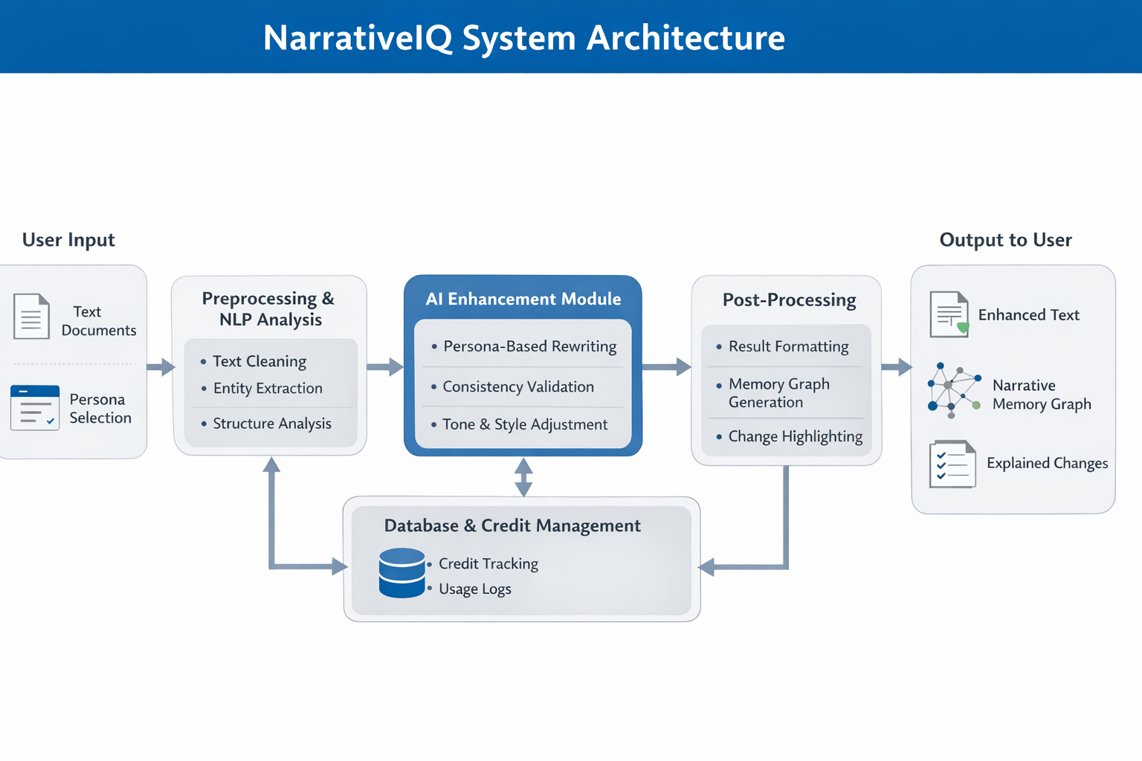
Fig. 3.1. System architecture

3.2 Technology Stack
Component | Technology / Tool Used
Frontend | React 18, TypeScript, Vite, Tailwind CSS, shadcn/ui, Framer Motion
Backend | Python 3.10, Flask, Flask-CORS
Database | MongoDB (PyMongo) — users, documents, enhancement history
Authentication | Custom JWT (PyJWT) + bcrypt password hashing
AI / LLM | LLM API (cloud-hosted, provider-agnostic via config)
NLP & Graph | spaCy (NER), NetworkX (graph layout), Matplotlib (PNG export)
File Processing | PyPDF2 (PDF extraction), plain text & Markdown parsing

3.3 Step-by-Step Working
Step 1: The user inputs or uploads text such as a script, article, notes, or document through the frontend interface and selects the desired writing persona or feature.
Step 2: The system sends the input to the backend, where NLP preprocessing is performed to clean the text, segment it, and extract key entities like characters, locations, and themes.
Step 3: The processed text is analyzed using the persona routing engine and enhanced through AI models, while relationships between entities are inferred to generate a narrative memory graph.
Step 4: The enhanced text and visual memory graph are returned to the frontend for display, and relevant usage details such as credits and logs are stored in the database.
4. Features
Below is an overview of the key features of the project:
Feature | Description
Feature 1: Persona-Based Writing Enhancement | Allows users to transform their content using predefined personas such as "Technical," "Business," "Simplified," "Poet," or "Comedian." This helps users tailor their writing to different audiences and purposes effectively.
Feature 2: NLP-Based Structural Analysis | Performs text segmentation, entity extraction, and structural analysis using NLP techniques. This improves clarity, organization, and overall document quality.
Feature 3: Narrative Memory Graph (Mindmap Generation) | Automatically extracts characters, locations, themes, and relationships to generate a visual memory graph. This helps users understand narrative structure and connections in long documents.
Feature 4: Character Evolution Tracking | Tracks changes in character traits or emotions throughout a story, helping maintain narrative consistency and improving storytelling quality.
Feature 5:Credit-Based Usage System | Implements a scalable credit system where users consume credits per feature usage. This ensures controlled access, fair usage, and commercial viability of the platform.

5. Unique Selling Proposition (USP)
What makes this project stand out from existing solutions is highlighted below:
• USP 1 : Persona-Constrained AI Enhancement: Instead of simple tone changes, the system applies structured persona-based transformations (Technical, Business, Poet, etc.), delivering targeted and audience-specific writing improvements.
• USP 2 : Narrative Memory Graph Generation: Automatically extracts entities and relationships to generate a visual mindmap, enabling users to understand story structure and document hierarchy clearly.
• USP 3 : Character Evolution Tracking: Tracks emotional and behavioral progression of characters in long-form content, ensuring narrative consistency.
• USP 4 : Explainable AI Output: Provides transparency by highlighting modifications between original and enhanced text, increasing user trust.
• USP 5 : Credit-Based Scalable Model: Implements a practical monetization strategy with controlled feature usage, making the platform commercially viable.
Unlike existing solutions that only provide basic rewriting without structural intelligence or visualization, our project offers deep narrative analysis, persona-driven transformation, and intelligent visual mapping. This makes it uniquely suited for students, content creators, script writers, and professionals who require structured, explainable, and high-quality content enhancement.

6. Project Photos
The following images illustrate the project. hardware setup, UI screenshots, demo, and team working on the project.

6.1 Project Demo / UI Screenshots

