Task 2

UART
Important Terms
1.Baud Rate: Communication speed (bits/sec)
2.TX: Transmit pin
3.RX: Receive pin
4.Start Bit: Signals data frame start
5.Stop Bit: Signals data frame end
6. Data Frame: Start + Data (5-9 bits) + Parity + Stop
I2C
Important Terms
1.SDA: Serial Data (bidirectional)
2.SCL: Serial Clock (from master)
3.Master: Initiates communication
4.Slave: Responds to master
5.Address: 7-bit device identifier
6.ACK/NACK: Acknowledge signal
SPI
Important Terms
1.SDA: Serial Data (bidirectional)
- SCL: Serial Clock (from master)
3.Master: Initiates communication
4.Slave: Responds to master
5. Address: 7-bit device identifier
6.ACK/NACK: Acknowledge signal

Theoretical Difference between UART,I2C,SPI
UART
- It is asynchronous serial communication
- We do not require any clock.
- Uses 2 wires transmit and receive.
- It is used for point to point data transfer.
- Used in Serial monitor, Bluetooth, GPS modules.
I2C
- It is synchronous serial protocol.
- It requires Serial Clock Line(SCL).
- Wires used are Serial Data Line (SDA) and Serial Clock Line(SCL).
- It allows multiple devices to communicate.
- Used in Sensors , Real time clock(RTC),Electrical Erasable Programmable Read Only Memory (EEPROM) .
SPI
- It is high speed synchronous serial protocol.
- It requires serial clock line (SCL).
- Wires used are Master out slave in (MOSI), Master in slave out(MISO) , Serial clock (SCL) , SS / CS – Slave Select / Chip Select.
- Used for short distance communication.
- Used in SD cards, Displays ,ADCs.
Practical Difference between UART,I2C,SPI
UART
- Data transfer depends on baud rate matching.
- Communication fails if TX/RX are not crossed.
- No clock signal observed.
- Simple and easy to debug using Serial Monitor.
I2C
1. Only two wires used for multiple devices.
2. Devices respond based on address.
3. ACK/NACK bits observed during communication.
4. Pull-up resistors are necessary for SDA and SCL.
SPI
1. Fastest data transfer among the three.
2. Chip Select (CS) controls active slave.
3. Separate data lines allow full-duplex transfer.
4. More wiring compared to UART and I²C.

Simulation Screenshots
UART
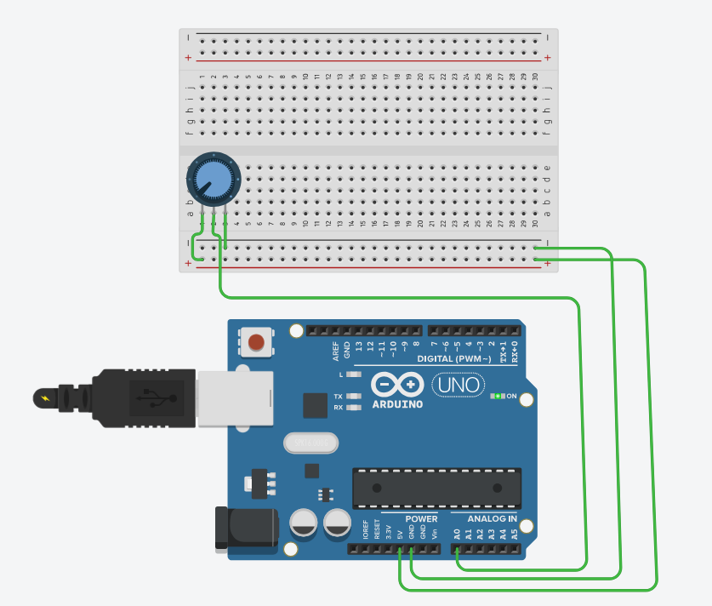

I2C
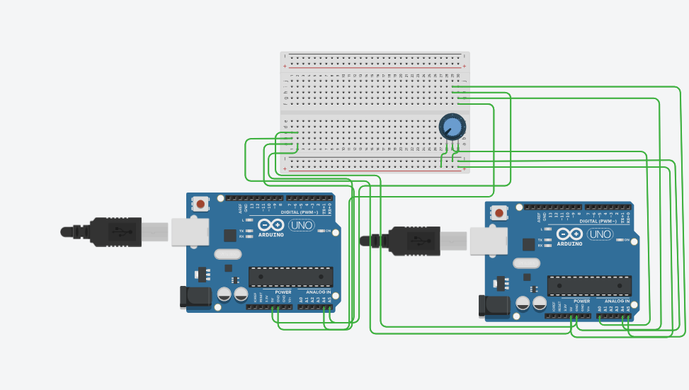
SPI
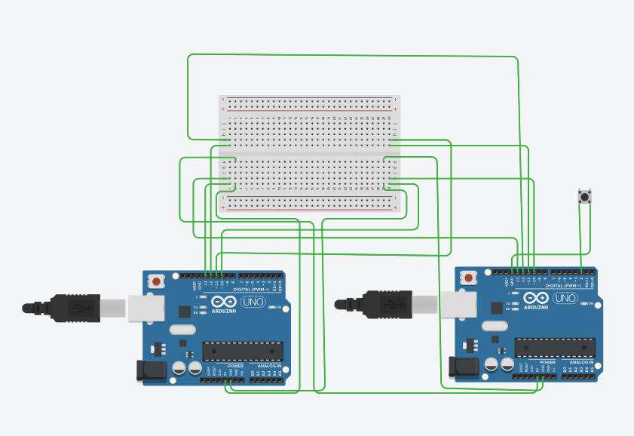
Working Codes
UART
// Pin definitions
const int POT_PIN = A0; // Potentiometer connected to analog pin A0

// Variables for sensor reading
int potValue = 0;
float voltage = 0.0;
int percentage = 0;

void setup() {
// Initialize UART communication at 9600 baud rate
Serial.begin(9600);

while (!Serial) {
;
}

Serial.println("====================================");
Serial.println(" UART Serial Communication Demo");
Serial.println(" Potentiometer Analog Reading");
Serial.println("====================================");
Serial.println();
Serial.println("Reading potentiometer values...");
Serial.println();

analogReference(DEFAULT);

delay(1000);
}

void loop() {

potValue = analogRead(POT_PIN);

voltage = potValue * (5.0 / 1023.0);

percentage = map(potValue, 0, 1023, 0, 100);

Serial.println("--- New Reading ---");

Serial.print("Raw ADC Value: ");
Serial.println(potValue);

Serial.print("Voltage: ");
Serial.print(voltage, 2);
Serial.println(" V");

Serial.print("Percentage: ");
Serial.print(percentage);
Serial.println(" %");

Serial.println();

delay(1000);

Serial.print(millis()); // Timestamp
Serial.print(",");
Serial.print(potValue); // Raw value
Serial.print(",");
Serial.print(voltage, 2); // Voltage
Serial.print(",");
Serial.println(percentage); // Percentage

I2C
Arduino(Master)

#include <Wire.h>

#define SLAVE_ADDRESS 0x08

int receivedValue = 0;
float voltage = 0.0;
int percentage = 0;

void setup() {

Wire.begin();

Serial.begin(9600);

Serial.println("======================================");
Serial.println(" I²C Master-Slave Communication");
Serial.println(" Master Arduino - Requesting Data");
Serial.println("======================================");
Serial.println();
Serial.println("Master initialized. Requesting data from Slave...");
Serial.println();

delay(1000);
}

void loop() {
// Request 2 bytes of data from slave at address 0x08
Wire.requestFrom(SLAVE_ADDRESS, 2);

delay(10);

if (Wire.available() >= 2) {

byte highByte = Wire.read();
byte lowByte = Wire.read();

receivedValue = (highByte << 8) | lowByte;

voltage = receivedValue * (5.0 / 1023.0);

percentage = map(receivedValue, 0, 1023, 0, 100);

Serial.println("--- I²C Data Received ---");
Serial.print("Raw ADC Value: ");
Serial.println(receivedValue);

Serial.print("Voltage: ");
Serial.print(voltage, 2);
Serial.println(" V");

Serial.print("Percentage: ");
Serial.print(percentage);
Serial.println(" %");

Serial.println();

} else {

Serial.println("ERROR: No data received from Slave!");
Serial.println("Check I²C connections (SDA, SCL, GND)");
Serial.println();
}

// Request data every 1 second
delay(1000);
}

Arduino(Slave)

#include <Wire.h>

#define SLAVE_ADDRESS 0x08

const int POT_PIN = A0;

int potValue = 0;

void setup() {

Wire.begin(SLAVE_ADDRESS);

Wire.onRequest(requestEvent);

Serial.begin(9600);
Serial.println("======================================");
Serial.println(" I²C Slave Arduino Ready");
Serial.println(" Address: 0x08");
Serial.println("======================================");
Serial.println();
Serial.println("Waiting for Master requests...");
Serial.println("Reading potentiometer on A0");
Serial.println();
}

void loop() {

potValue = analogRead(POT_PIN);

Serial.print("Current Pot Value: ");
Serial.println(potValue);
delay(500);
delay(50);
}

void requestEvent() {
potValue = analogRead(POT_PIN);

byte highByte = (potValue >> 8);

byte lowByte = (potValue & 0xFF);

Wire.write(highByte);
Wire.write(lowByte);

Serial.print("Master requested data. Sent: ");
Serial.print(potValue);
Serial.print(" (Voltage: ");
Serial.print(potValue * (5.0 / 1023.0), 2);
Serial.println(" V)");
}

SPI
Arduino(Master)

#include <SPI.h>

const int SS_PIN = 10;

byte receivedData = 0;
int buttonState = 0;
int buttonPressCount = 0;
unsigned long lastPressTime = 0;

void setup() {

Serial.begin(9600);

pinMode(SS_PIN, OUTPUT);
digitalWrite(SS_PIN, HIGH); // Deselect slave initially

SPI.begin();
SPI.setClockDivider(SPI_CLOCK_DIV16); // 1 MHz SPI clock

Serial.println("==========================================");
Serial.println(" SPI Master-Slave Communication");
Serial.println(" Master Arduino - Receiving Button Data");
Serial.println("==========================================");
Serial.println();
Serial.println("Master SPI initialized");
Serial.println("Waiting for button presses on Slave...");
Serial.println();

delay(1000);
}

void loop() {

digitalWrite(SS_PIN, LOW);
delayMicroseconds(10);

receivedData = SPI.transfer(0x00);

delayMicroseconds(10);
digitalWrite(SS_PIN, HIGH);

buttonState = receivedData;

Serial.print("SPI Data Received: 0x");
if (receivedData < 16) Serial.print("0");
Serial.print(receivedData, HEX);
Serial.print(" | Button State: ");

if (buttonState == 1) {

Serial.println("PRESSED ✓");

if (millis() - lastPressTime > 300) {
buttonPressCount++;
lastPressTime = millis();

Serial.print(">>> Button Press Count: ");
Serial.println(buttonPressCount);
}
Serial.println();

} else if (buttonState == 0) {
// Button is released
Serial.println("RELEASED");

} else {
Serial.println("UNKNOWN");
}

delay(200);
}

Arduino(Slave)

#include <SPI.h>

const int BUTTON_PIN = 2;

volatile byte buttonState = 0;
volatile boolean dataRequested = false;
int lastButtonState = 0;

void setup() {
pinMode(BUTTON_PIN, INPUT_PULLUP);

pinMode(MISO, OUTPUT);

Serial.begin(9600);
Serial.println("==========================================");
Serial.println(" SPI Slave Arduino Ready");
Serial.println(" Reading Button on Pin 2");
Serial.println("==========================================");
Serial.println();
Serial.println("Waiting for SPI communication...");
Serial.println("Press the button to send data!");
Serial.println();

SPCR |= _BV(SPE); // Enable SPI

SPI.attachInterrupt();

delay(1000);
}

ISR (SPI_STC_vect) {

byte received = SPDR;

SPDR = buttonState;

dataRequested = true;
}

void loop() {

int currentButtonState = digitalRead(BUTTON_PIN);

if (currentButtonState == LOW) {
buttonState = 1; // Button pressed
} else {
buttonState = 0; // Button released
}

if (currentButtonState != lastButtonState) {
lastButtonState = currentButtonState;

Serial.print("Button State Changed: ");
if (buttonState == 1) {
Serial.println("PRESSED");
} else {
Serial.println("RELEASED");
}
}

if (dataRequested) {
dataRequested = false;
Serial.print("Data sent to Master via SPI: ");
Serial.println(buttonState);
}

delay(50);
}

