

**CS516 - Computer Vision**

**Prof. Russell Butler**

Students

|  |  |
| --- | --- |
| Bhoopalsinh Musale | 002269332 |
| Sara Eskandarirad | 002279327 |

**Part 1: Denoising**

* Implemented Bilateral filtering.
* Signal to Noise ratio is shown respective output images.

**Bilateral Filter Code**

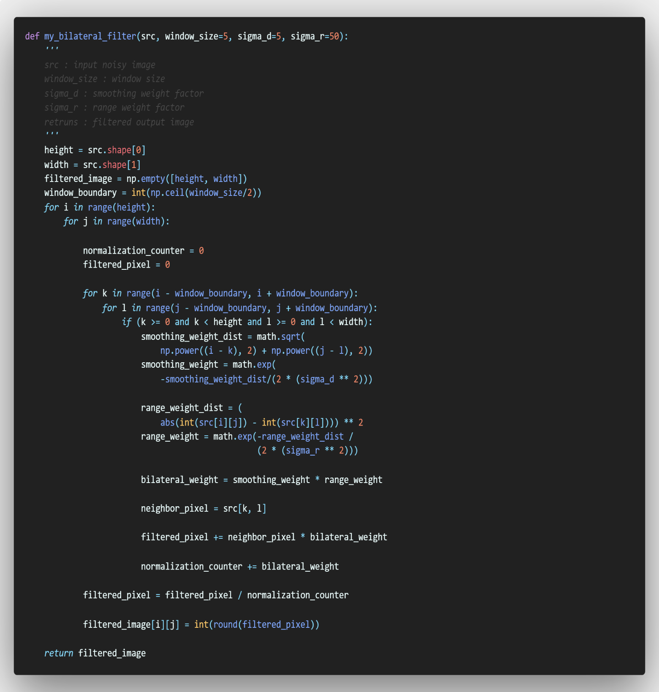

**Output of t1.png**

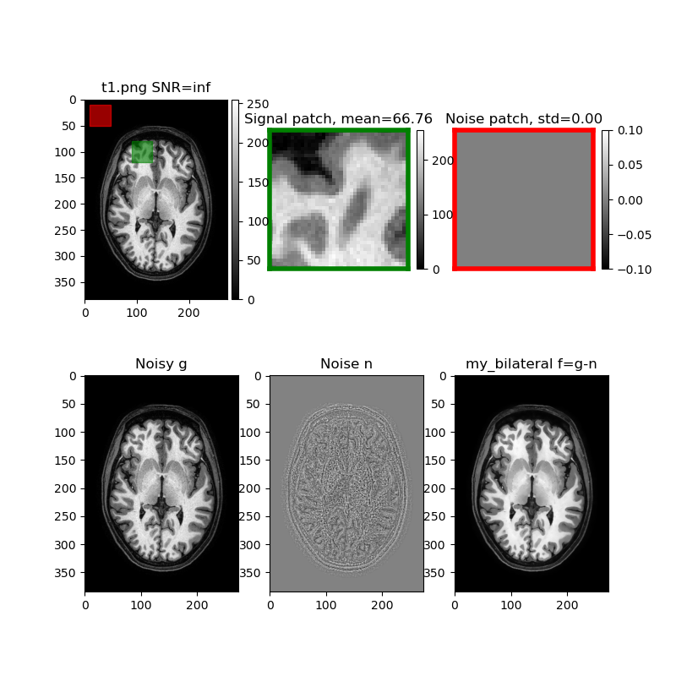

**Output of t1_v2.png**

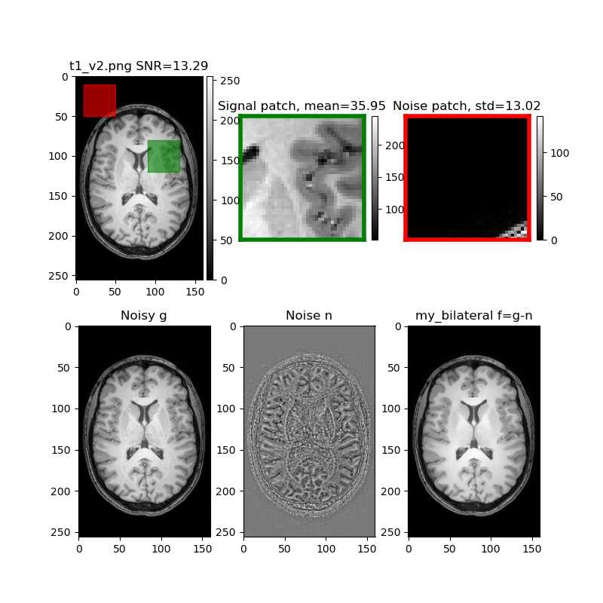

**Output of t1_v3.png**

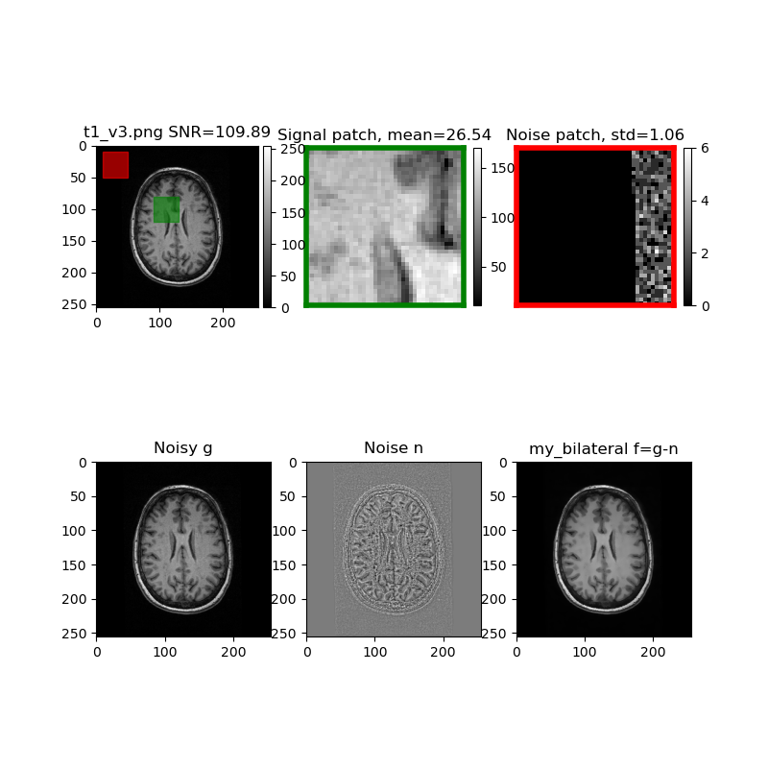

**Output of t2.png**

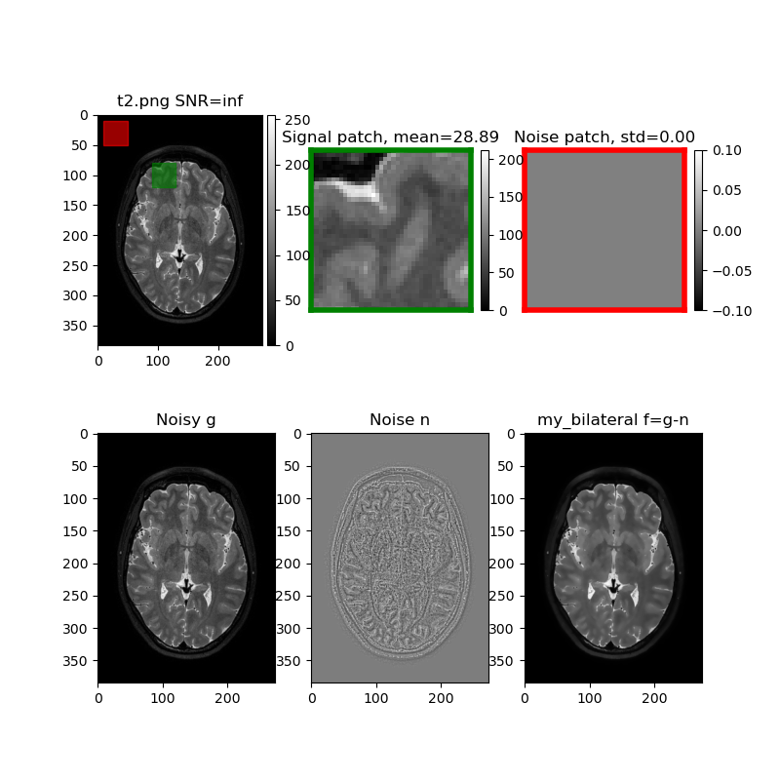

**Output of flair.png**

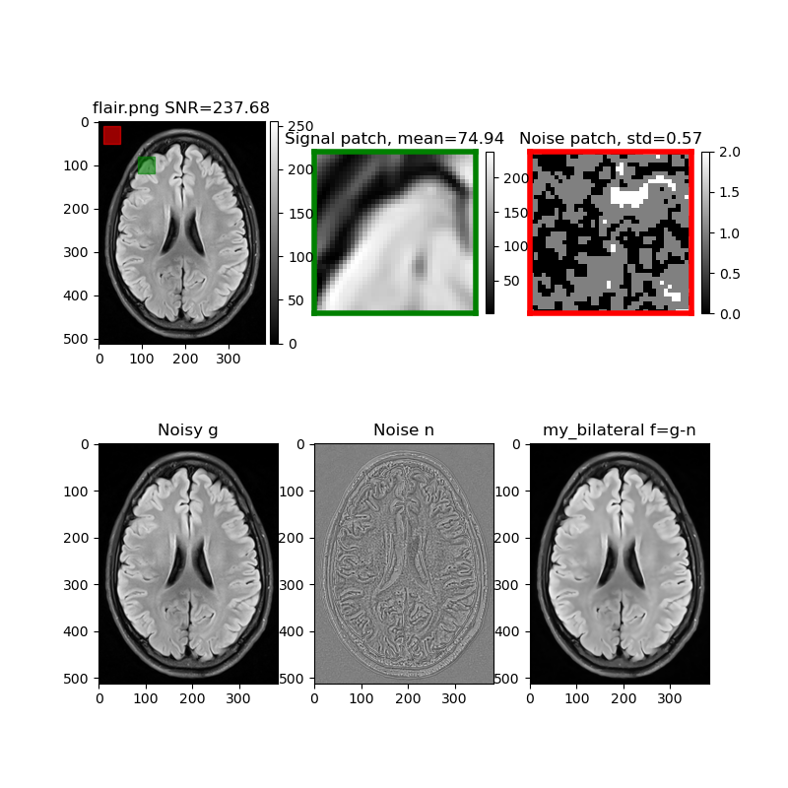

**Part 2: Segmentation**

* Implemented Otsu’s method.

**Otsu’s Method Code** 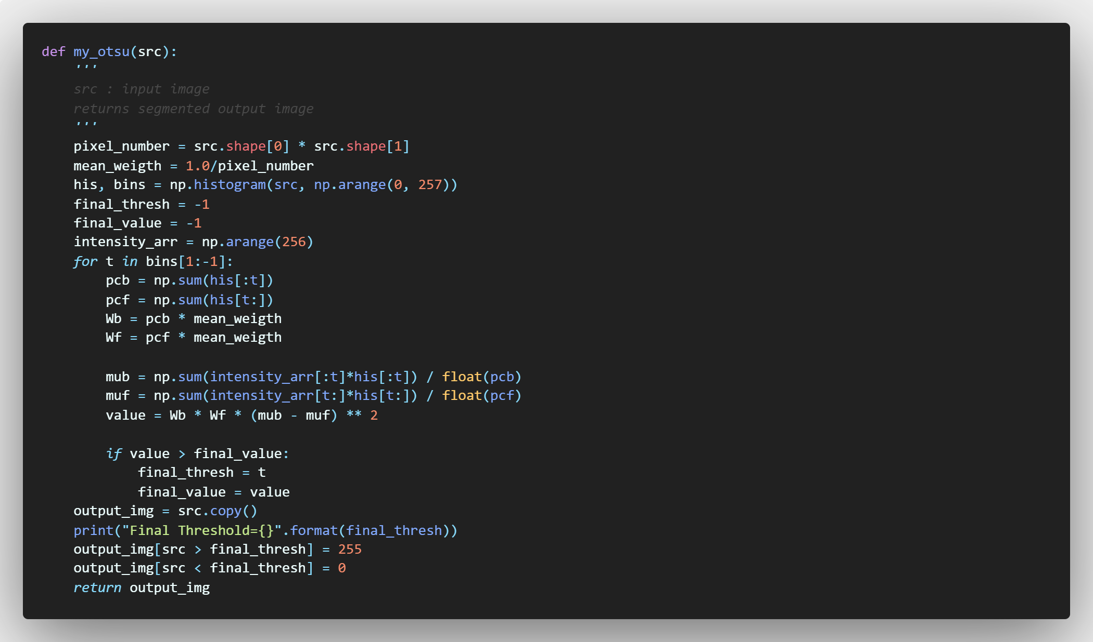

**Output of t1.png**

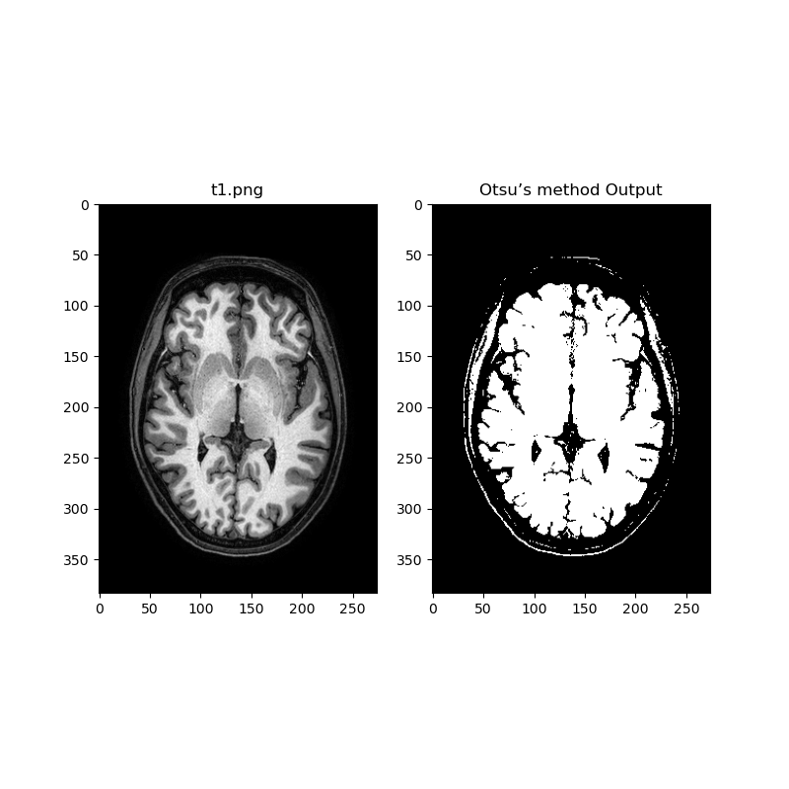

**Output of t1_v2.png**

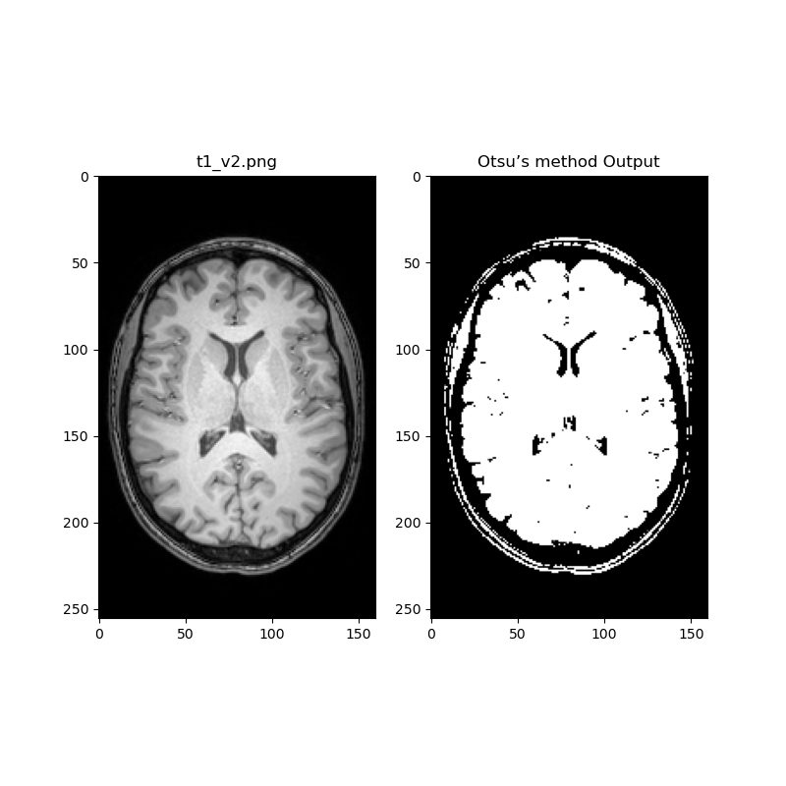

**Output of t1_v3.png**

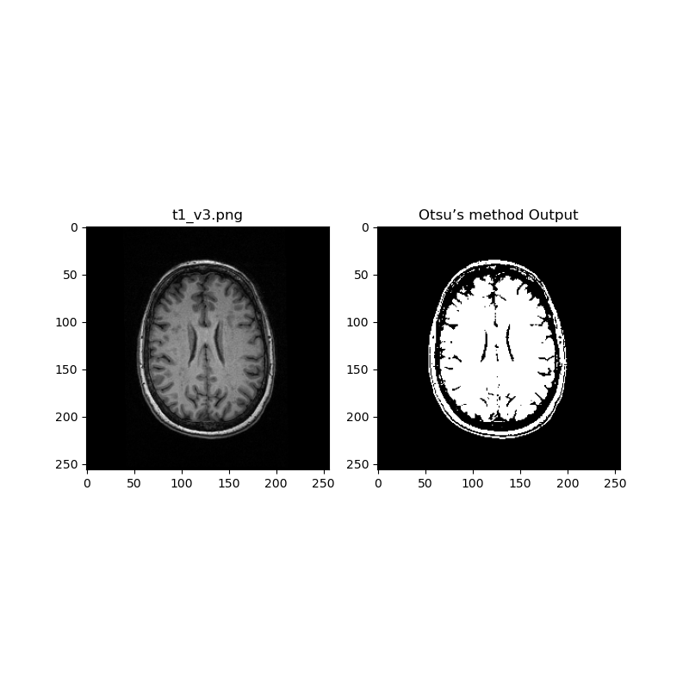

**Output of t2.png**

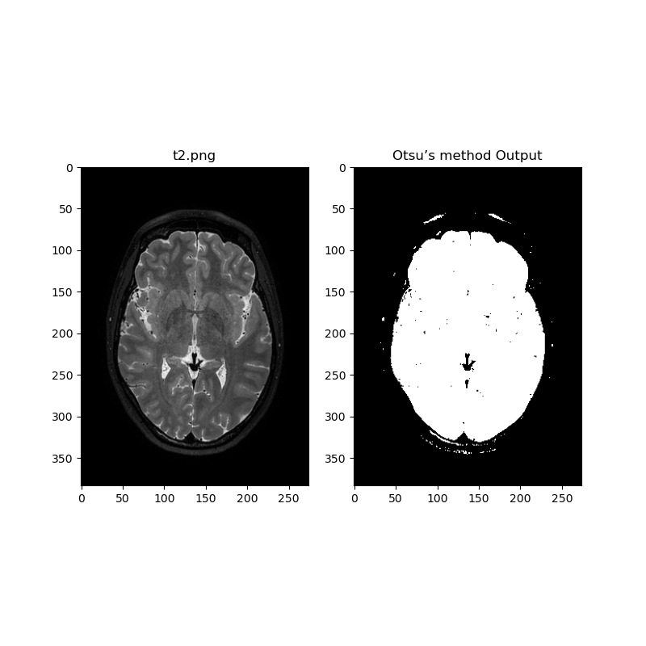

**Output of flair.png**

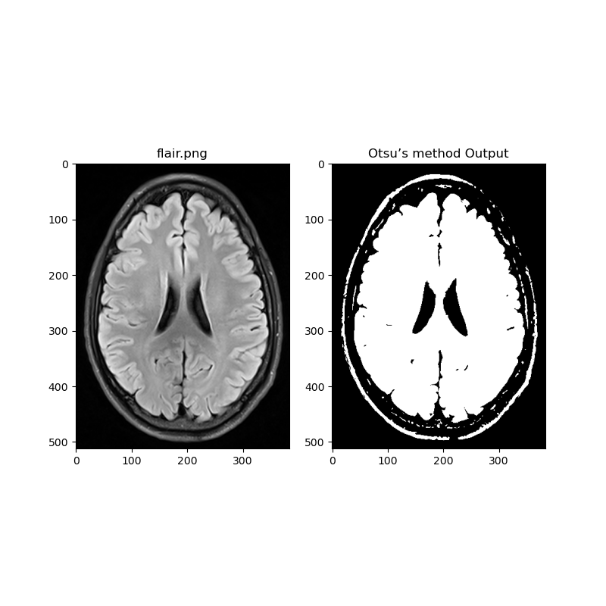

**Comment:**

Otsu’s method finds the threshold such that variants in class are minimum. The total variance is sum of within class and between class variables.

This method has limitations when image has a non-uniform background. The resulting image may have binary distribution but due to bias this is not the basic binary bimodal distribution. Hence, we can see some errors in output images.

**Part 3: Practical Challenge (Vascular Segmentation):**

**Skull Stripping Code**

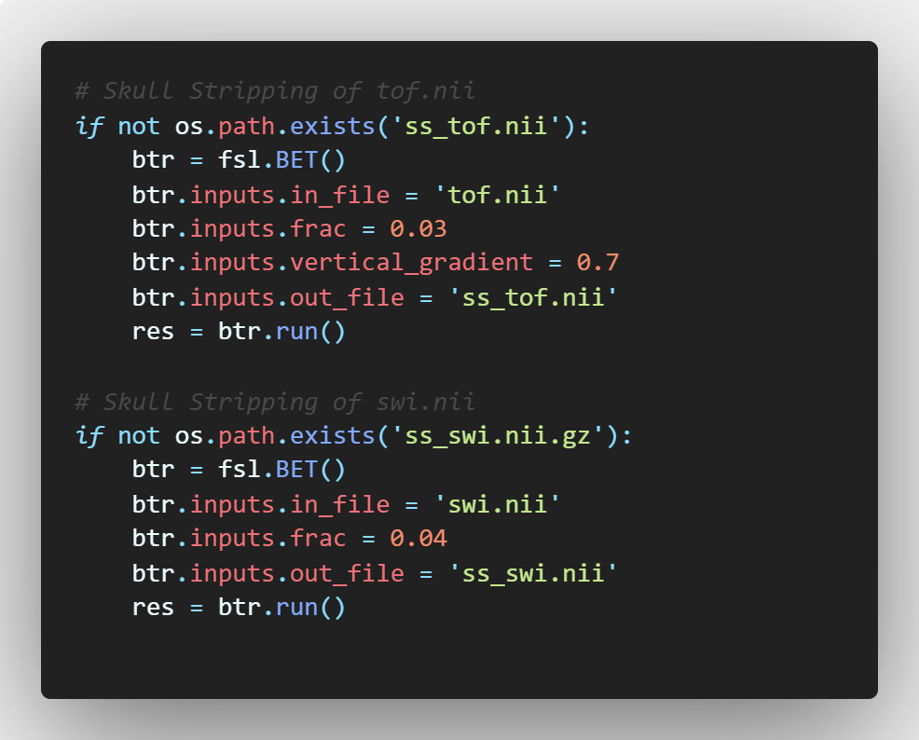

**Output of Skull Stripping**

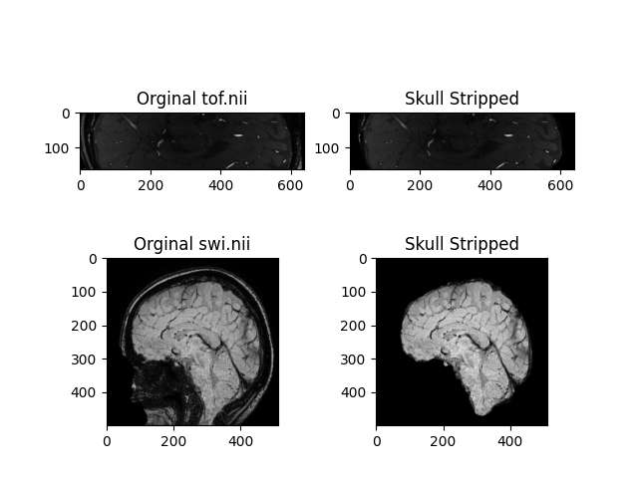

**NLMeans Denoising Code**

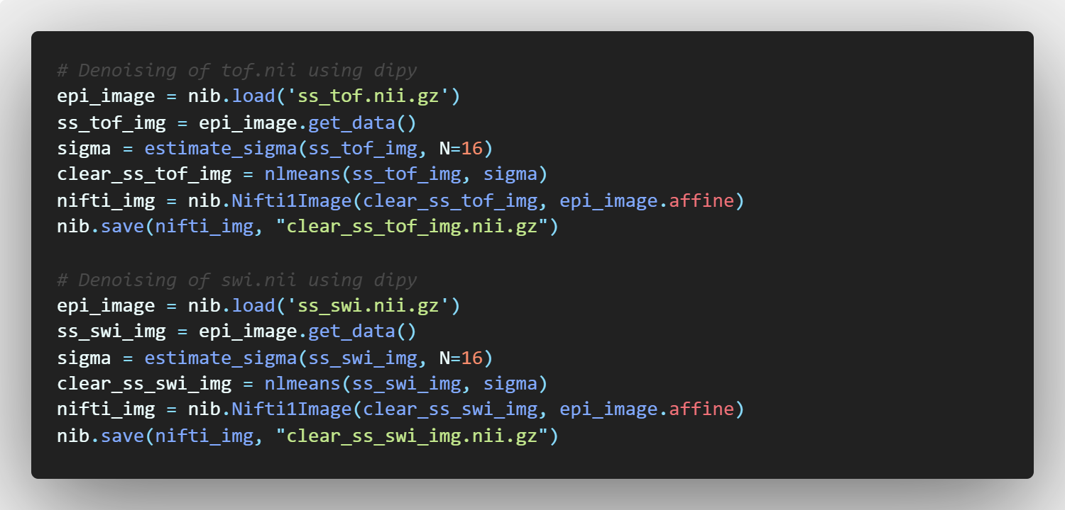

**Vessel Segmentation Code**

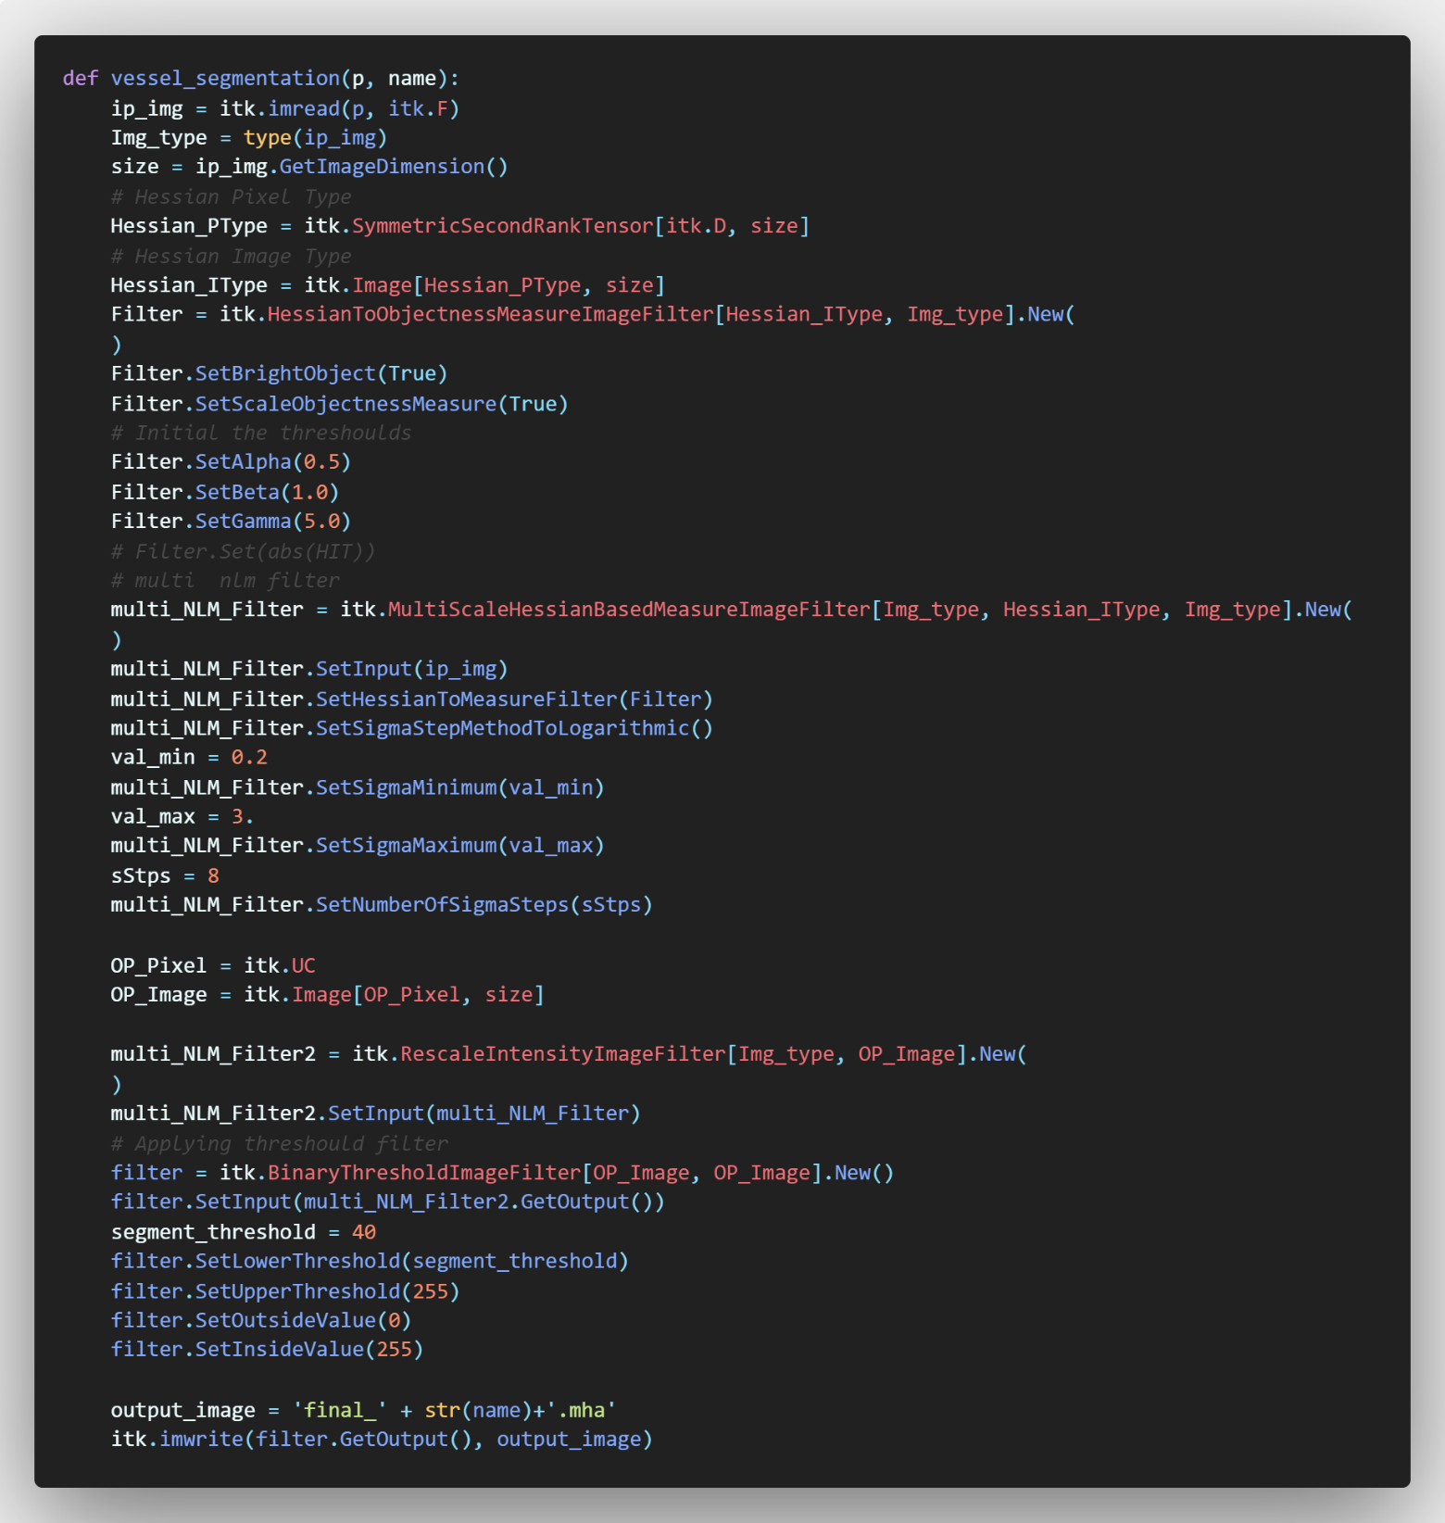

**Tof.nii Final Output**

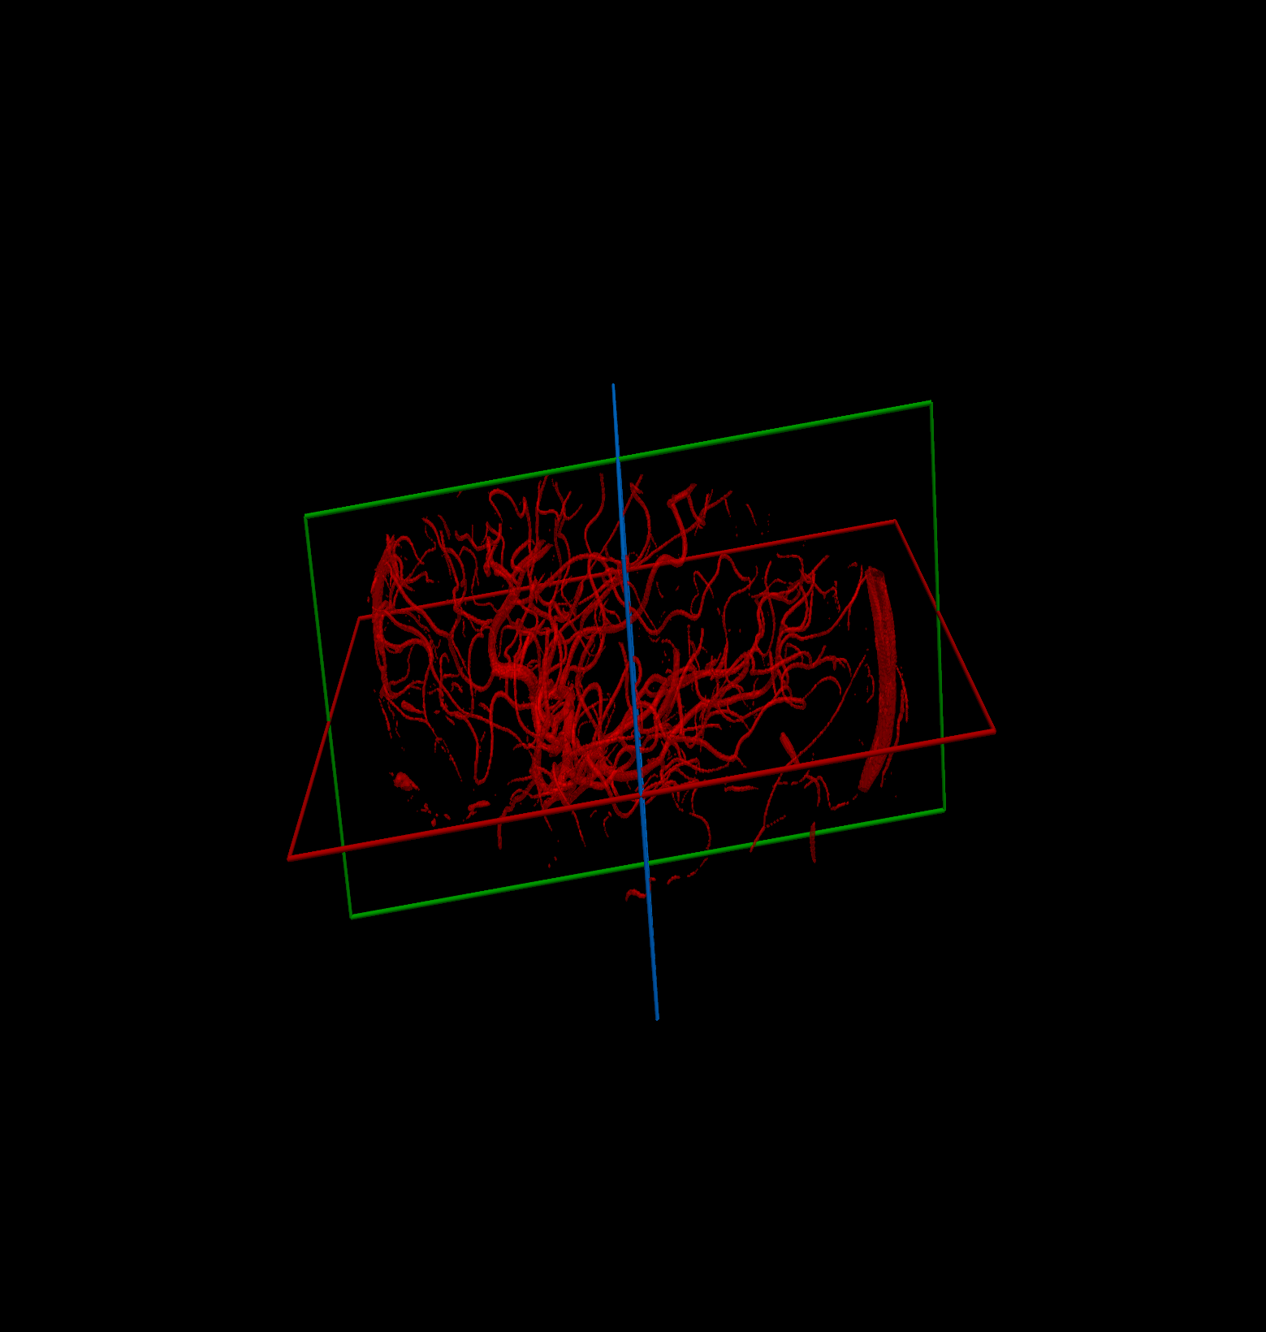

**Swi.nii Final Output**

