**Create an MVC project using Spring Boot & Thymeleaf (Employee Management System) and perform the following operations using appropriate mappings**

1. **View** all records from the database table.
2. **Insert** new records into the table.
3. **Update an** existing record in the table.
4. **Delete** existing records from the table.

**PFB: UI screenshots**

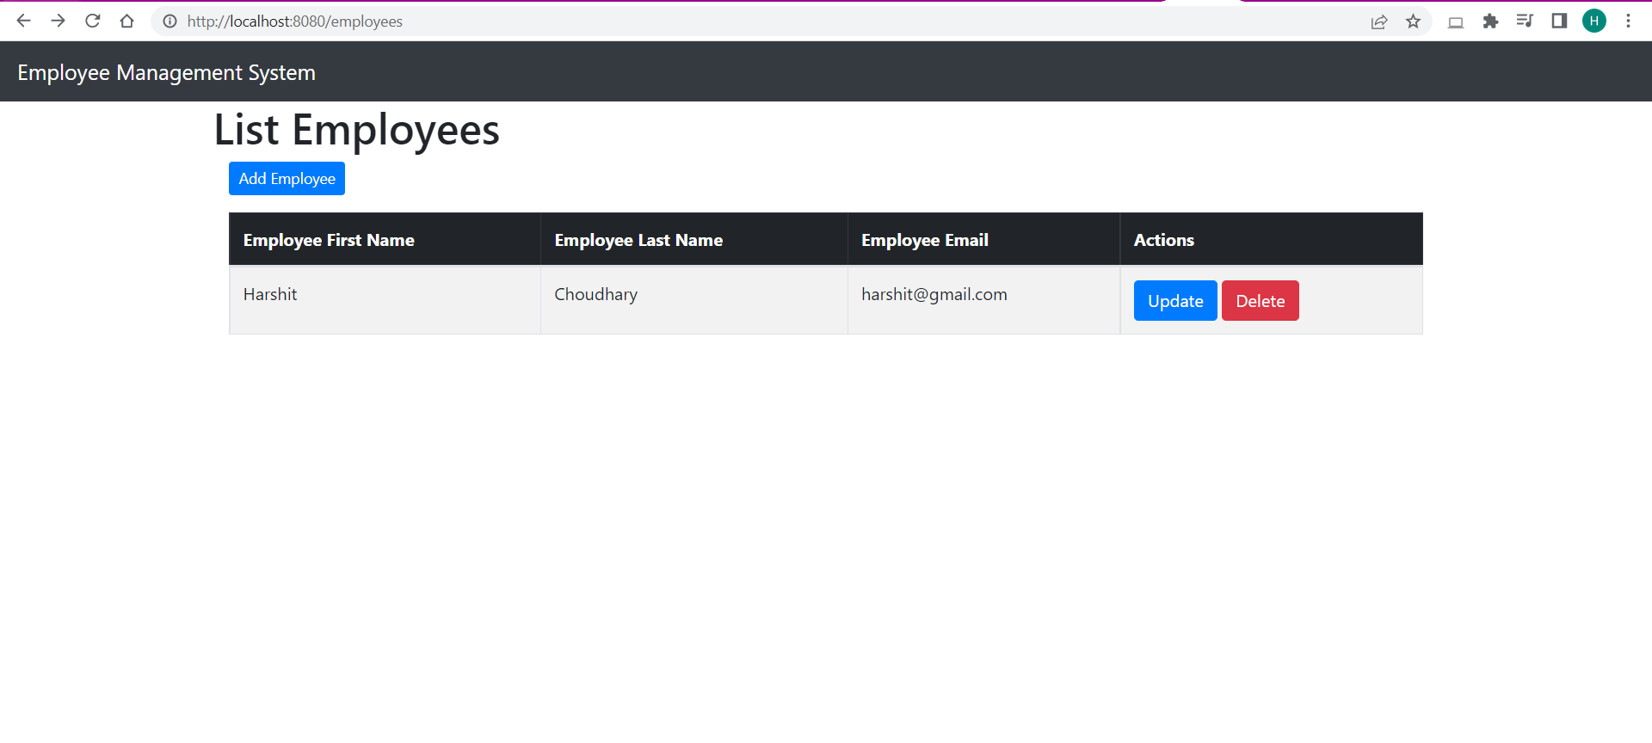

1. **Home Page**

**—-----------------------------------------------------------------------------------------------------------------**

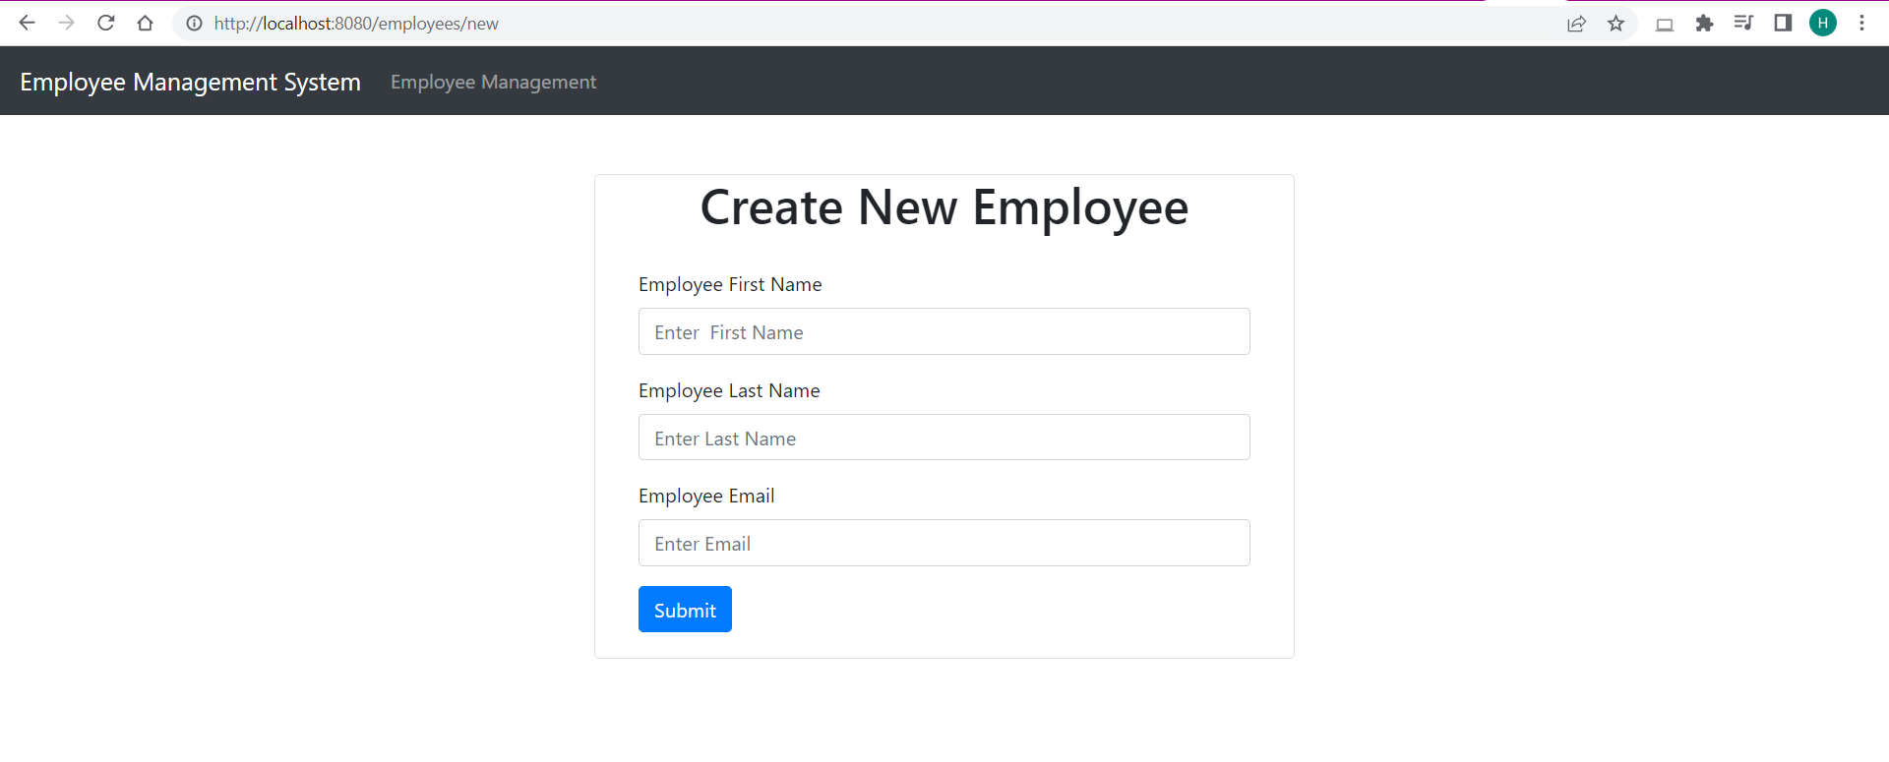

1. **Create Employee**

**__________________________________________________________________________**

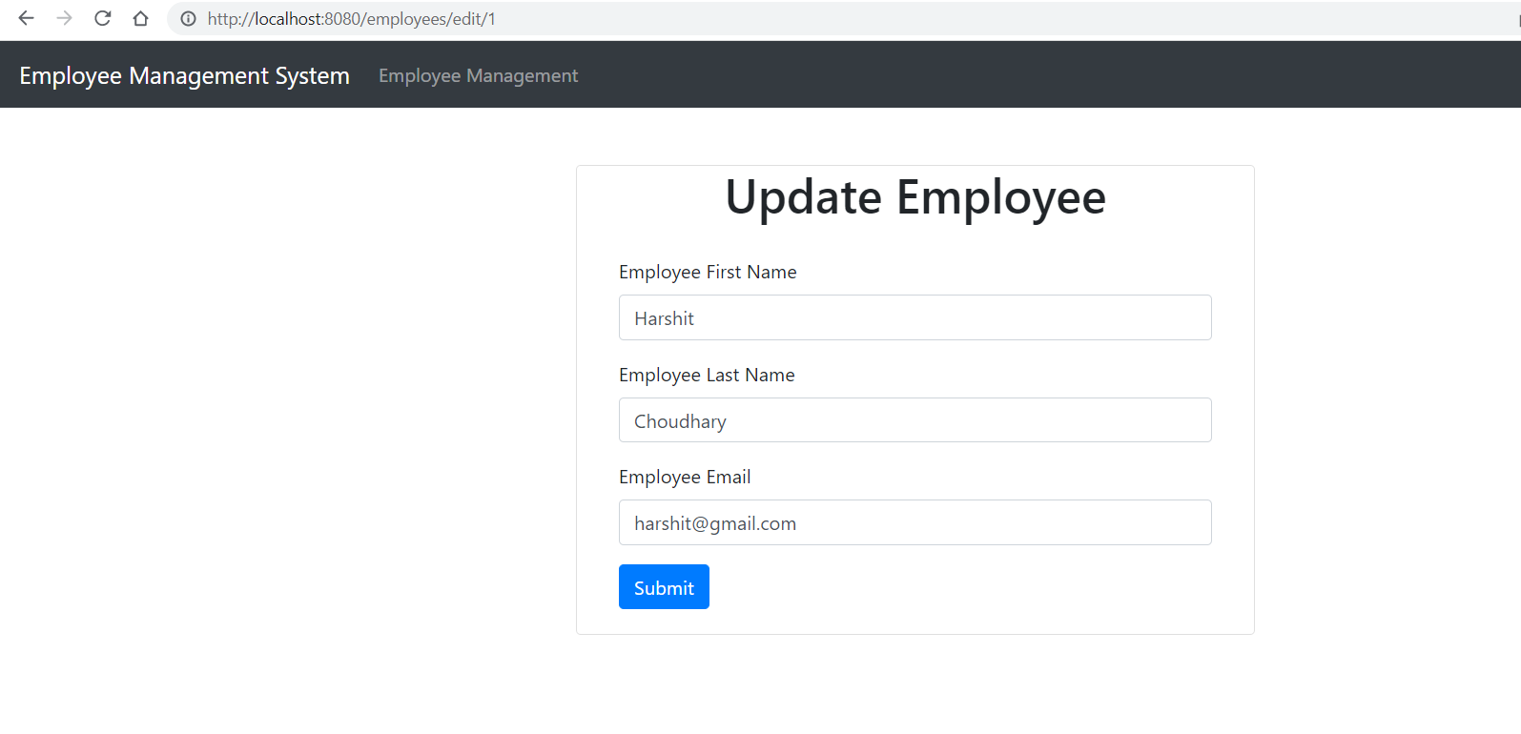

1. **Update Employee**