**Problem Statement:**

You are an IT Support Administrator and are charged with the task of creating credentials for new hires

You are working in a Service Provider company as IT Support Administrator. Your responsibility is to automate the manual login credentials generation for new employees. To achieve this, your application should perform the following tasks:

Your application should do the following:

1. Determine the department of the new employee (Technical, Admin, Human Resource, Legal)
2. Generate an email with the following syntax

firstNamelastName@department.company.com

1. Generate a random password which will contain (number, capital letter, small letter & special character)
2. Display the generated credentials
3. Use parameterized constructor of class Employee, to pass firstName, lastName.
4. Create a separate CredentialService which will have generatePassword, generateEmailAddress, & showCredentials method.

**Sample output**

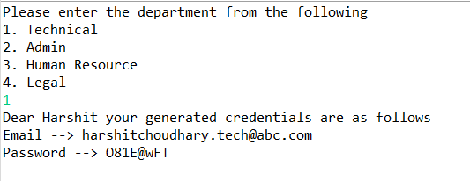

Dear Harshit your generated credentials are as follows

Email ---> harshitchoudary@tech.abc.com

Password ---> 181E@wFT

**Learning Objective:**

The objective of this problem is to

1. Test the candidate's ability to design and implement a functional system that meets the specified requirements. This includes proficiency in programming concepts such as object-oriented programming, string manipulation, and random number generation.
2. Implement an automated system for generating login credentials for new employees. This system should be able to generate an email address and password for each new employee, based on their department and name.