Season, temperature, humidity, and lunar phase influence bat activity in the Sierra Nevada
Alan T. Hitch
Lauren Dusek
Christine Champe

Title options for co-author review
Option 1 — Current working title
Directed acyclic graph reveals frequency-dependent humidity sensitivity and thermal niche differentiation in a Sierra Nevada bat community
Option 2
Atmospheric call attenuation, thermal niches, and migratory phenology jointly shape bat activity: a causal-inference analysis of a Sierra Nevada community
Option 3
Seasonal occupancy patterns reveal migratory structure and species-level heterogeneity in a temperate bird community
Option 4
Atmospheric attenuation predicts frequency-dependent humidity sensitivity in a temperate bat community: a causal-inference analysis[
Option 5
Untangling seasonal, weather, and lunar drivers of bat activity in the Sierra Nevada using causal models

Introduction
Seasonal variation in insectivorous bat activity is well documented across temperate and Mediterranean ecosystems with activity generally increasing during warmer periods when insect prey is more available. Across latitudes and habitat types, bat activity commonly peaks during warmer months and declines during cooler periods, a pattern observed in grasslands of southern Brazil (Barros et al., 2014), sclerophyllous forests of Chile (Escobar & Villaseñor, 2024), Mediterranean forests of North Africa (Boukhari et al., 2025), and urban landscapes of southern Italy (Meola et al., 2025). Within this broader seasonal pattern, nightly bat activity may also respond to temperature, relative humidity, and lunar phase. Because these environmental conditions vary seasonally and may covary with one another, their associations with bat activity cannot be readily separated. Distinguishing these relationships requires accounting explicitly for shared seasonal structure and evaluating environmental responses over the conditions represented during the sampling period.
Atmospheric humidity provides a particularly strong mechanistic prediction because water vapor attenuates ultrasonic sound, and the magnitude of attenuation varies nonlinearly with both call frequency and humidity (griffin1971?; lawrence1982?). The atmosphere therefore acts as a frequency-dependent filter. At relatively low ultrasonic frequencies (<25 kHz), humidity-induced changes in attenuation are expected to be comparatively small across biologically relevant conditions; at intermediate frequencies (25–40 kHz), attenuation may increase sharply once water-vapor concentration crosses a threshold; and at higher frequencies (>40 kHz), attenuation is expected to be humidity-sensitive across a broader range. Recent experimental work further suggests that bats may not fully compensate for increased atmospheric attenuation by modifying call structure, such that effective detection distance declines as attenuation increases (deframond2023?).
This frequency dependence generates a directional community-level prediction: observed acoustic activity should be relatively insensitive to increasing humidity among low-frequency callers, show stronger responses under humid conditions among intermediate-frequency callers, and decline across a broader humidity range among high frequency callers. Testing this prediction with field data requires separating humidity responses from correlated variation in temperature and seasonal activity while retaining differences among echolocation-frequency groups.
Temperature is among the most consistently documented drivers of insectivorous bat activity across geographic regions, seasons, and habitat types. In temperate systems, warmer nights are generally associated with greater foraging activity, and temperature can determine whether hibernating or semi-active bats arouse and forage during colder periods (andreozzi2024?; bender2015?; mas2022?). Reported temperature thresholds vary markedly among species and regions, from very low temperatures in Mediterranean systems to substantially warmer thresholds in other temperate and tropical environments (salvarina2023?; andreozzi2024?; milne2005?). Foraging strategy may further modify temperature responses (ciechanowski2007?), and activity can decline at extreme temperatures, producing nonlinear relationships rather than simple monotonic increases (escobar2024?). At high latitudes, interactions between temperature and night length can also constrain seasonal and nocturnal foraging opportunities (lilley2026?). Together, these studies suggest that nonlinear responses and thermal niche differences among components of a bat community may be obscured when temperature is treated as a single linear community-level driver.
The lunar cycle provides a predictable source of variation in nocturnal illumination (lang2006?). Reduced bat activity during brighter nights, often termed lunar phobia, has generally been attributed to increased exposure to visually oriented predators (morrison1978?; prugh2014?; saldanavazquez2013?). However, responses to lunar illumination vary among species and ecological settings, with negative, negligible, and positive relationships with bat activity reported (appleAerialInsectivorousBat2017?; saldanavasquez2013?). Several studies of temperate insectivorous bats have found weak or absent lunar responses (hecker1999?; karlsson2002?; milne2005?; negraeff1995?). Some of this inconsistency may reflect analytical structure: lunar phase overlaps with seasonal timing and may covary with nightly weather, so models that do not explicitly represent these relationships can conflate lunar effects with other environmental signals.
Distinguishing the contributions of seasonal phenology, temperature, humidity, and lunar phase therefore requires more than including all variables in a single additive model. Directed acyclic graphs (DAGs) provide a transparent framework for representing hypothesized causal relationships, identifying adjustment sets appropriate to particular estimands, and avoiding inappropriate conditioning on mediators or colliders (pearl2009?). Although DAGs are well established in epidemiology and increasingly used in evolutionary and ecological research, they remain less common in field-based community ecology, where model specification is often driven by convention rather than explicit causal assumptions. Pairing a DAG-based framework with frequency-stratified analysis provides a way to test mechanistic predictions from acoustic-attenuation theory while accounting for the covariance among seasonal and nightly environmental drivers.
We investigated seasonal phenology and nightly environmental associations with bat activity at eight sites in the northern Sierra Nevada of California. Our objectives were to (1) estimate the total seasonal pattern in bat activity and compare it with seasonal structure remaining after nightly environmental conditions were held constant; (2) estimate conditional associations of nightly humidity, temperature, and lunar phase with bat activity among characteristic echolocation-frequency groups under the causal structure represented by our DAG; and (3) test whether humidity sensitivity varies systematically with characteristic echolocation frequency, as predicted by acoustic-attenuation theory.
We predicted that (1) accounting for nightly environmental conditions would alter the estimated seasonal pattern of bat activity; (2) temperature would be strongly associated with nightly activity, with response shape potentially varying among frequency groups occupying different thermal niches; (3) humidity sensitivity would differ among characteristic-frequency groups, with low-frequency species showing little response, mid-frequency species showing stronger declines under humid conditions, and high-frequency species showing declines across a broader humidity gradient; and (4) lunar phase would have a comparatively small association with activity once seasonal and weather covariates were accounted for.

Methods

Study area and acoustic surveys
Acoustic surveys were conducted at eight sites in Plumas County, California, in the northern Sierra Nevada, spanning an elevational gradient of 581–1,846 m. Most sites were near perennial water sources, including reservoirs (Bucks Lake, Lower Bucks Lake, Grizzly Forebay, and Three Lakes), tributary streams, and the North Fork Feather River; one site was situated in an upland meadow adjacent to forest (Figure 1). Surveys were conducted from April through October 2015, with detectors programmed to record from one hour before sunset to one hour after sunrise.
Each site was equipped with an Anabat II ultrasonic detector and CF-ZCAIM data storage unit (Titley Electronics, Ballina, NSW, Australia) housed in a weatherproof enclosure mounted at least 1 m above the ground. Detectors were fitted with a microphone extension cable, weather shroud, and flat acoustic reflector. Units were powered by batteries recharged with 5-W solar panels and miniature charge controllers (EME Systems, Berkeley, California, USA). Detectors recorded nightly temperature and relative humidity. Lunar phase was obtained from the U.S. Naval Observatory and expressed from 0 (new moon) to 1 (full moon).

Acoustic classification and activity index
Echolocation calls were classified using Kaleidoscope Pro (Wildlife Acoustics Inc., version 5.1.8) with the Bats of North America 5.1.0 classifier at the “More Accurate (Conservative)” setting. Ten percent of classified calls were manually vetted.
Bat activity was quantified using a modified Acoustic Activity Index (miller2001?) based on 5-min sampling intervals. Acoustic detections were divided into 5-min intervals, and nightly activity for each site was calculated as the number of intervals containing at least one bat call. Thus, the response represented the number of 5-min intervals per site-night in which bats were acoustically active rather than the total number of individual calls. Site-nights without usable acoustic data were excluded from analysis rather than treated as zero activity.
For environmental analyses, nightly mean temperature and relative humidity were standardized to a mean of zero and standard deviation of one. Day of year and lunar phase were retained on their original scales for model fitting.

Causal structure and seasonal activity
The causal structure used to distinguish seasonal and nightly environmental associations is shown in Figure 1. Day of year was represented as a common cause of temperature, relative humidity, and bat activity, while temperature was additionally allowed to influence relative humidity. Temperature, relative humidity, and lunar phase were each represented as having direct effects on bat activity. This structure distinguishes the total seasonal pattern in activity from seasonal structure remaining after conditioning on nightly environmental conditions and provides the basis for estimating conditional environmental responses.
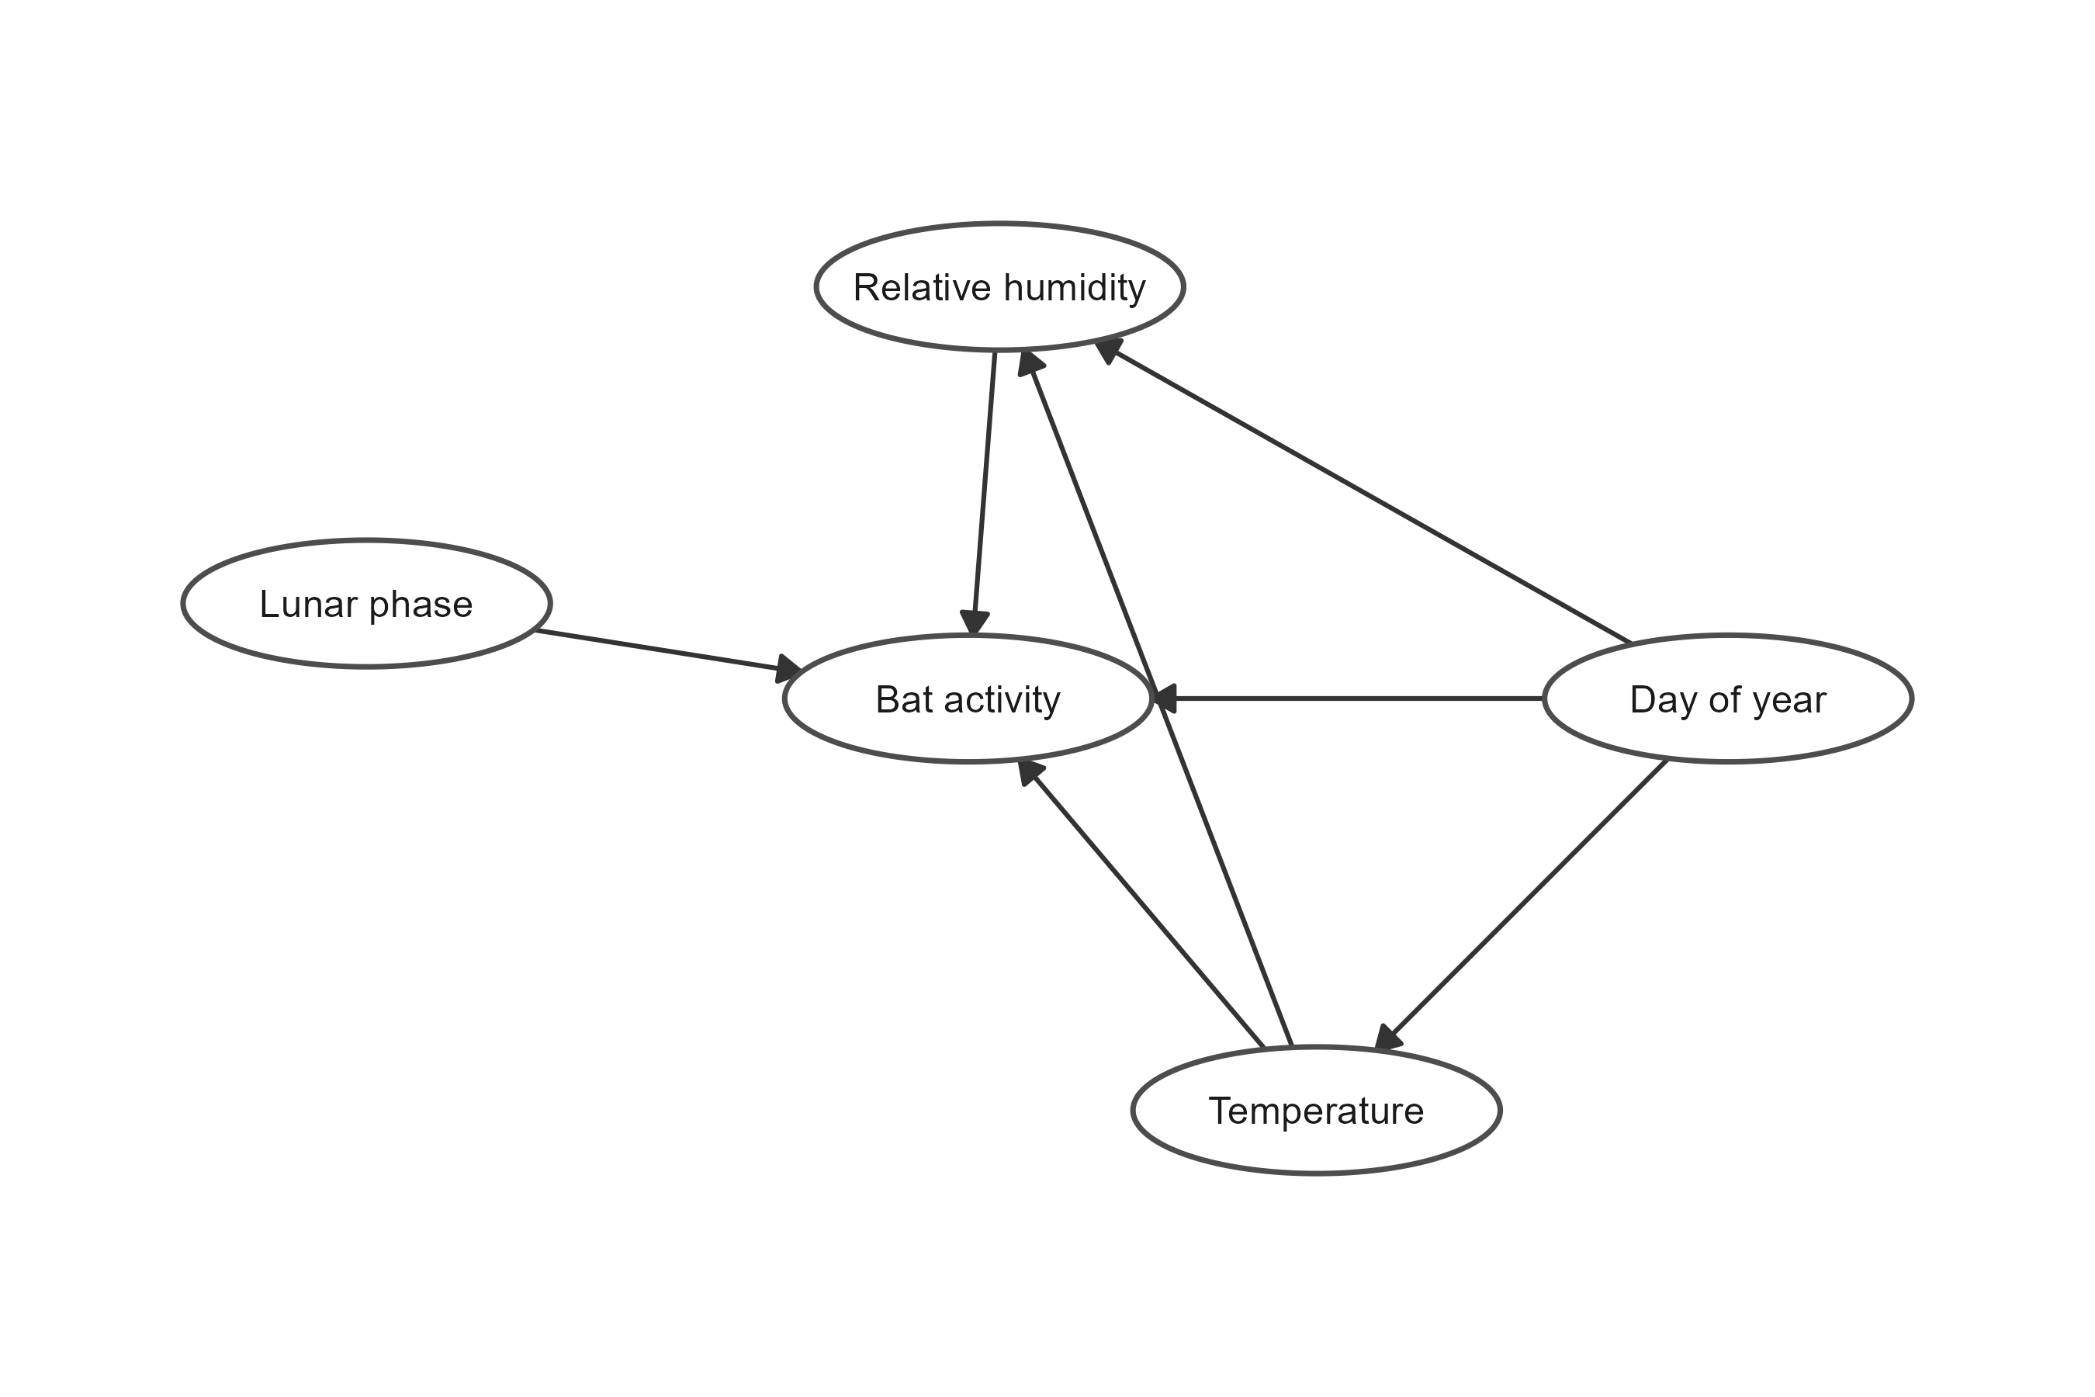
Figure 1: Directed acyclic graph representing the hypothesized causal relationships among day of year, nightly temperature, relative humidity, lunar phase, and bat acoustic activity. Arrows indicate the assumed direction of causal influence. Day of year represents seasonal structure in bat activity and environmental conditions not otherwise represented by the measured nightly covariates. Temperature was assumed to influence relative humidity in addition to having a direct effect on bat activity. Relative humidity and lunar phase were also hypothesized to directly influence bat activity. The graph was used to guide model specification and interpretation of total seasonal and conditional environmental associations.
Two aggregate-community models represented the primary seasonal and environmental estimands. The total seasonal model estimated variation in bat activity across day of year without conditioning on nightly temperature, relative humidity, or lunar phase. Because nightly weather is itself seasonally structured, this model describes the overall seasonal pattern expressed under the environmental conditions occurring through the study period.
The conditional environmental model included day of year, nightly temperature, relative humidity, and lunar phase simultaneously. Environmental response curves from this model therefore describe the association with each focal environmental variable after conditioning on the remaining modeled predictors. The day-of-year smooth from this model represents residual seasonal phenology after accounting for nightly environmental conditions. Comparison of the total seasonal and conditional seasonal patterns was used to distinguish the observed seasonal activity pattern from seasonal structure remaining after nightly weather and lunar phase were held constant.

Characteristic echolocation-frequency groups
To test whether environmental responses varied with characteristic echolocation frequency, we classified each species into one of three frequency groups: low (<25 kHz), mid (25–40 kHz), and high (>40 kHz). Characteristic frequency ($F_{c}$) was defined as the frequency at the lowest, flattest portion of the descending frequency-modulated sweep of an echolocation call, where call bandwidth is narrowest and the call typically provides its diagnostic signal for species identification (fenton1981?; ofarrell1999?). Group boundaries were based on species accounts in the Western Bat Working Group reference and the Kaleidoscope Pro classifier reference-call library and correspond to frequency ranges over which atmospheric absorption of ultrasound is expected to differ in sensitivity to humidity (griffin1971?; lawrence1982?).
The low-frequency group contained Lasiurus cinereus, Eumops perotis, and Euderma maculatum. The mid-frequency group contained Eptesicus fuscus, Lasionycteris noctivagans, Tadarida brasiliensis, Antrozous pallidus, Myotis evotis, Myotis thysanodes, and Corynorhinus townsendii. The high-frequency group contained Myotis yumanensis, M. lucifugus, M. californicus, M. ciliolabrum, M. volans, Parastrellus hesperus, and Lasiurus frantzii. Full species-level information, characteristic frequencies, and detection totals are provided in Table S4.
For each frequency group, nightly activity at each site was calculated as the number of 5-min intervals containing at least one detection from any species assigned to that group. The same model-development and diagnostic framework used for aggregate activity was then evaluated for the frequency-group datasets.

Bayesian generalized additive models
We modeled nightly acoustic activity using Bayesian generalized additive models (GAMs) fit in brms (burkner2017?) with Stan (carpenter2017?). Nightly activity was represented as the number of 5-min intervals containing at least one bat call and was modeled using a negative-binomial distribution with a log link to accommodate the substantial variation among nights.
Seasonal activity was allowed to vary among sites. Although the eight sites occurred within the same geographic region, local differences in habitat, elevation, species composition, resource availability, and roost use could produce differences in the timing and magnitude of seasonal bat activity. We therefore represented seasonality using a population-level smooth of day of year together with a factor-smooth interaction between day of year and site. The factor smooth estimates penalized site-specific departures from the overall seasonal trajectory, allowing local phenology to differ while sharing information among sites.
We fit two complementary models to distinguish overall seasonal variation from conditional environmental relationships. The total seasonal model was
$$n_{it}∼NegBinomial(μ_{it},ϕ),$$
$$log(μ_{it})=β_{0}+f({DOY}_{it})+f_{site}({DOY}_{it}),$$
where $n_{it}$ is the number of occupied 5-min intervals at site $i$ on night $t$, $f(DOY)$ represents the overall seasonal trajectory, and $f_{site}(DOY)$ represents penalized site-specific departures from that trajectory. Because this model does not condition on nightly environmental covariates, it describes the total seasonal pattern in acoustic activity, including seasonal variation associated with changing environmental conditions.
The conditional environmental model was
$$log(μ_{it})=β_{0}+f({DOY}_{it})+f_{site}({DOY}_{it})+f(T_{it})+f(RH_{it})+f(L_{it}),$$
where $T$ is standardized nightly mean temperature, $RH$ is standardized nightly mean relative humidity, and $L$ is lunar phase. This model estimates the relationship between each environmental predictor and acoustic activity conditional on the other predictors and seasonal structure in the model. Thus, the seasonal and environmental models address different questions: the former describes the overall seasonal pattern in activity, whereas the latter evaluates environmental relationships after accounting for seasonality and site-specific phenology.
Smooth terms were estimated using the default thin-plate regression spline basis in brms/mgcv, and site-specific seasonal trajectories were represented using a factor-smooth basis (bs = "fs"). Because the factor smooth is fully penalized and represents site-level differences in the seasonal trajectory, we did not include an additional site random intercept.

Priors, computation, and model assessment
We used a weakly informative Normal(0, 10) prior for the intercept; smoothing parameters and the negative-binomial shape parameter used the regularizing defaults implemented by brms. Models were estimated using Hamiltonian Monte Carlo through the cmdstanr backend, with four chains of 4,000 iterations, including 1,000 warmup iterations per chain, yielding 12,000 post-warmup draws. Sampling used adapt_delta = 0.99 and a maximum tree depth of 12.
We assessed convergence and sampling quality using $\hat{R}$, bulk and tail effective sample sizes, divergent transitions, maximum-tree-depth warnings, and energy diagnostics. Model adequacy was evaluated using posterior predictive checks of the response distribution and site-level variation, including the mean, standard deviation, and frequency of zero-activity nights. Because sampling was interrupted at some sites by detector failures, residual temporal dependence was evaluated using calendar-day lags rather than row-order lags, ensuring that missing sampling nights were not treated as consecutive observations. We examined these residual correlations to determine whether important temporal structure remained after accounting for the shared and site-specific seasonal trajectories.
Posterior summaries are reported as medians with 89% credible intervals. Environmental response curves were generated from the conditional environmental model by varying the focal predictor across its observed range while holding other continuous environmental predictors at their reference values. Seasonal predictions were obtained from the seasonal model and therefore represent the total fitted seasonal pattern rather than seasonality conditional on nightly temperature, relative humidity, or lunar phase.
All analyses were conducted in R. Models were fit with brms (burkner2017?) using Stan (carpenter2017?) through cmdstanr; posterior summaries and predictions were generated using posterior and tidybayes (kay2023?).

Results

Sampling and acoustic activity
After excluding nights without usable acoustic recordings, the final analysis comprised 1,056 site-nights across eight sites and 179 sampling nights from late April through mid-October 2015 (Table 1). Sampling effort varied among sites because of detector failures and other periods without usable acoustic data, ranging from 47 retained nights at BUL18 to 174 nights at the most intensively sampled sites.
Across the retained site-nights, aggregate bat activity totaled 103,681 5-min detection intervals representing 17 species. Of these detections, 7,078 were assigned to the low-frequency group, 27,602 to the mid-frequency group, and 69,001 to the high-frequency group. Environmental conditions represented in the analysis spanned substantial variation in nightly temperature, relative humidity, and lunar illumination (Table 1).
Table 1: Summary of the acoustic sampling design and environmental conditions represented in the analysis. Environmental ranges are based on the site-night observations retained for modeling.
Characteristic | Value
Sites | 8
Sampling nights | 179
Site-nights | 1,056
Bat species | 17
Sampling period | April 22–October 17
Day of year | 112–290
Nightly mean temperature (°C) | -0.1–24.2
Nightly mean relative humidity (%) | 33.4–94.4
Lunar illumination | 0.00–1.00

Model adequacy and diagnostics
The final models incorporated site-specific seasonal phenology using penalized factor-smooth interactions between day of year and site. This structure substantially accounted for temporal dependence in nightly activity. In the aggregate conditional model, residual autocorrelation declined from 0.379 at lag 1 to 0.208 at lag 2 and 0.168 at lag 3, approached zero by lag 4, and remained weak at longer lags. Thus, the remaining temporal dependence was limited primarily to the shortest time lags.
MCMC diagnostics indicated satisfactory posterior sampling. All reported $\hat{R}$ values were 1.00, with large bulk and tail effective sample sizes. Seven of 12,000 post-warmup transitions in the aggregate conditional model reached the maximum tree depth of 12. Posterior predictive checks showed that the model reproduced the overall distribution of nightly activity and site-specific mean activity well, although predictive variation differed somewhat among sites. In particular, variability was overpredicted at BUC3, BUL11, and LBL5 and modestly underpredicted at several other sites. Overall, the final model captured the principal seasonal, among-site, and distributional structure relevant to inference while retaining a parsimonious representation of the data.

Seasonal activity
Seasonal activity varied nonlinearly across the sampling period, and the inferred seasonal pattern changed substantially after accounting for nightly environmental conditions (Figure 2). In the total seasonal model, equal-site averaged activity declined through May, increased to a first summer maximum in June, declined in July, and increased again in early August before falling through September and October (Figure 2a). After conditioning on nightly temperature, relative humidity, and lunar phase, the seasonal trajectory was markedly different: activity was highest early in the sampling season, declined sharply from May into June, and remained comparatively low through most of the summer and autumn, with only modest increases in August and September (Figure 2b). Thus, much of the pronounced mid-summer structure in the total seasonal pattern was associated with seasonal variation in the measured environmental conditions, while the conditional day-of-year effect was dominated by elevated activity early in the sampling season. Seasonal phenology also differed substantially among sites in both the magnitude and timing of activity (Figure 2c), supporting the use of site-specific seasonal smooths rather than a single common seasonal trajectory.
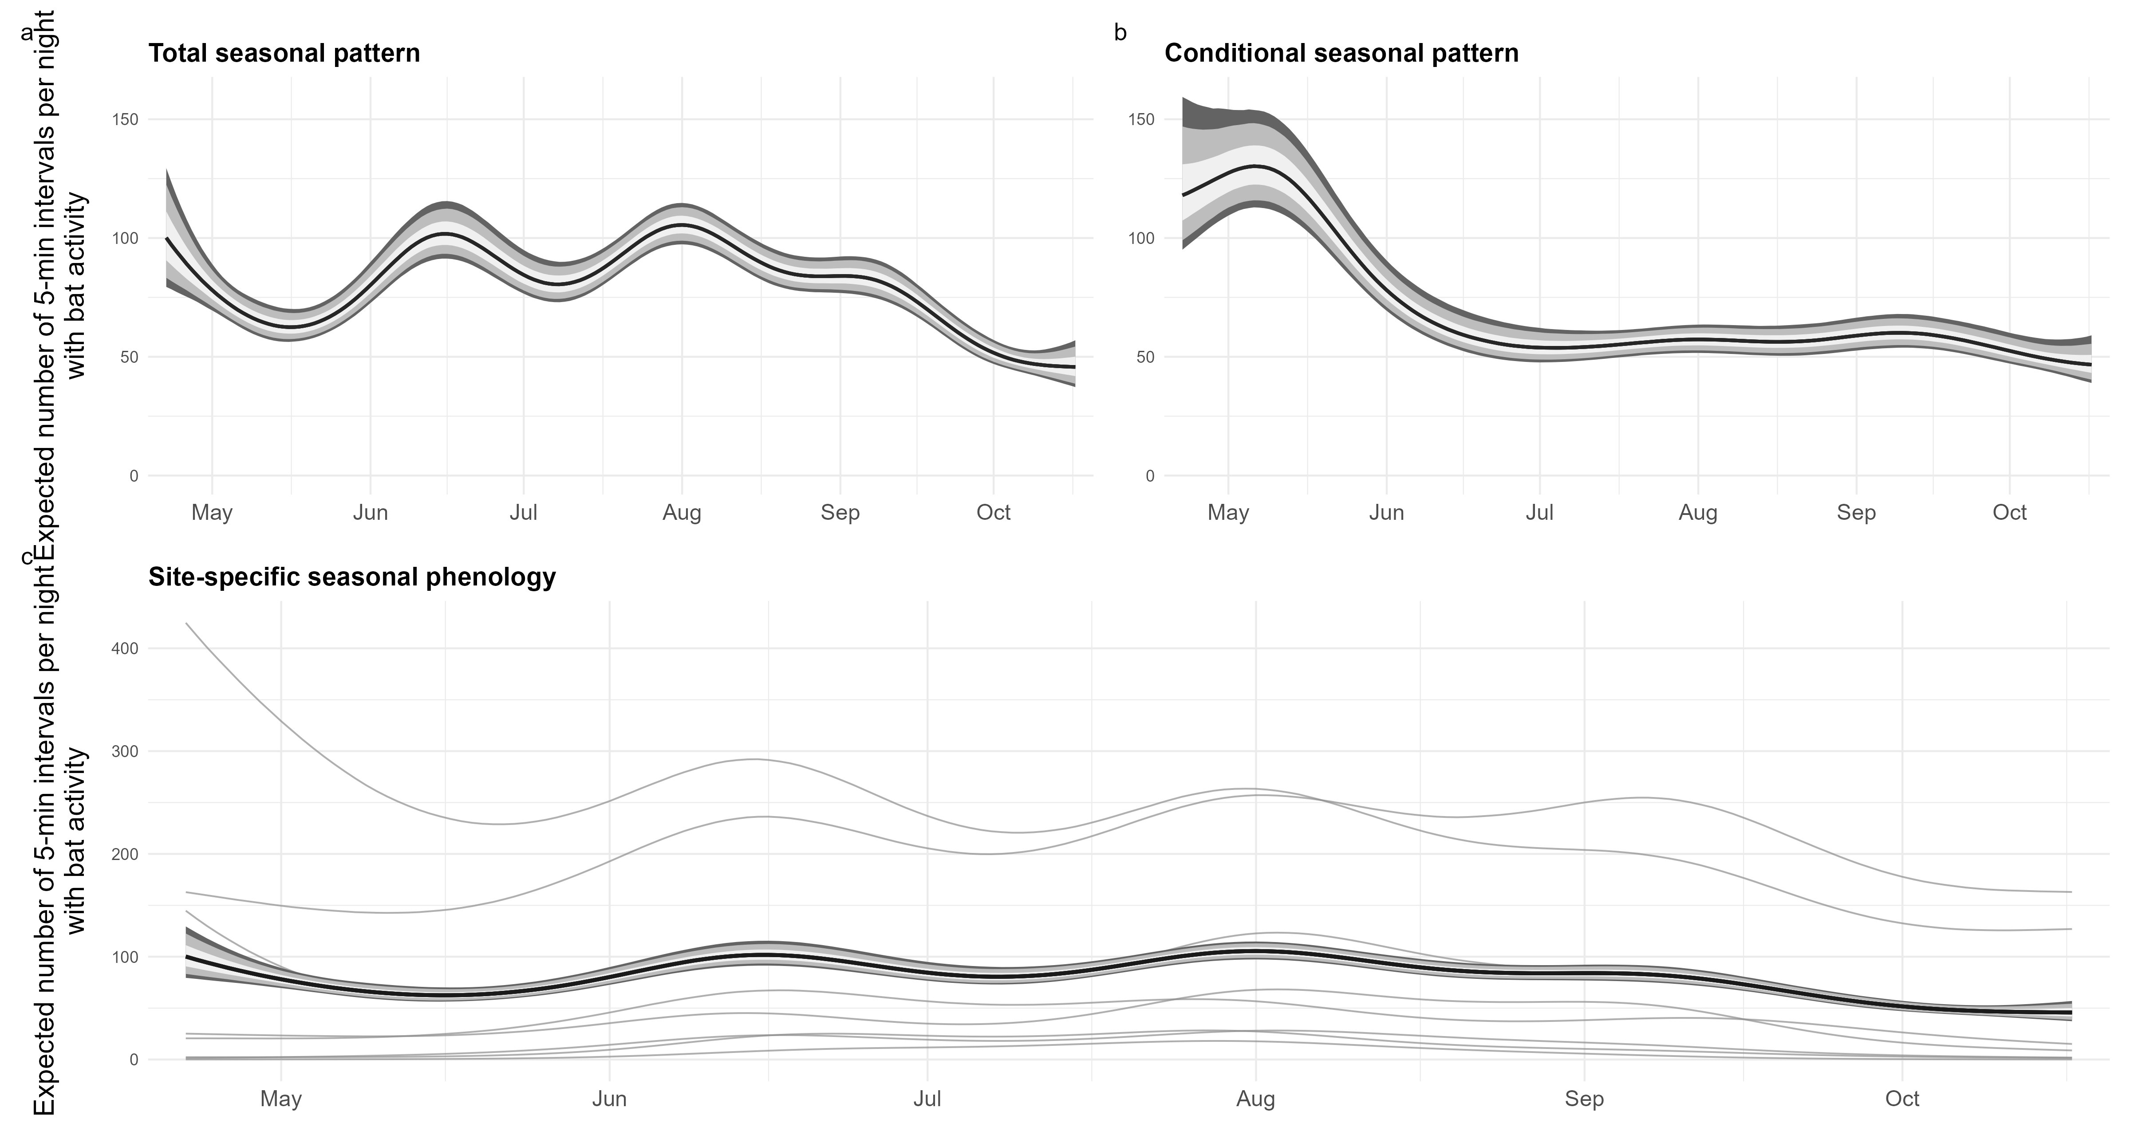
Figure 2: Seasonal variation in community-level bat acoustic activity across eight sites in the northern Sierra Nevada, California, April–October 2015. (a) Total seasonal pattern from the day-of-year model, shown as the posterior distribution of the equal-site averaged expected number of 5-min intervals per night in which a bat call occurred. (b) Conditional seasonal pattern from the environmental model after accounting for nightly mean temperature, relative humidity, and lunar phase; the curve is likewise averaged equally across sites. (c) Site-specific seasonal phenology from the total seasonal model. Thin gray lines show posterior median trajectories for individual sites; the black line and shaded bands show the equal-site averaged seasonal trajectory. In panels a and b, and for the average in panel c, lines indicate posterior medians and shaded bands indicate 50%, 80%, and 89% credible intervals from darkest to lightest.

Echolocation-frequency groups
Characteristic-frequency groups contributed very different amounts of total recorded activity. High-frequency species accounted for 69,001 detection intervals, compared with 27,602 for the mid-frequency group and 7,078 for the low-frequency group. Consequently, the aggregate community response was numerically dominated by high-frequency detections, although the frequency-stratified models allow the environmental responses of the three groups to be evaluated separately.

Temperature responses among frequency groups
Temperature was positively associated with bat activity across all three frequency groups over the well-sampled portion of the observed temperature gradient, although response shape differed among groups (Figure 3). Across the central 80% of observed nightly temperatures (6.07–17.3 $​^{∘}$C), predicted activity increased from 1.52 to 13.7 intervals per night for the low-frequency group, from 3.48 to 69.9 intervals per night for the mid-frequency group, and from 33.9 to 68.3 intervals per night for the high-frequency group. The corresponding median increases were 12.2 (89% CrI: 9.50–15.5), 66.4 (54.4–81.0), and 34.3 (26.7–42.4) intervals per night, respectively, with posterior probability of an increase equal to 1.00 for each group. Low- and mid-frequency activity continued to increase toward the warm end of the observed gradient, whereas high-frequency activity increased through most of the well-sampled temperature range before leveling off and declining at warmer temperatures. Across posterior draws, the median temperature associated with maximum high-frequency activity was 18.8 $​^{∘}$C (89% CrI: 17.3–24.2 $​^{∘}$C); 16.9% of posterior curves placed the maximum at the upper boundary of the observed temperature range, indicating greater uncertainty in the shape of the response at the warmest temperatures.
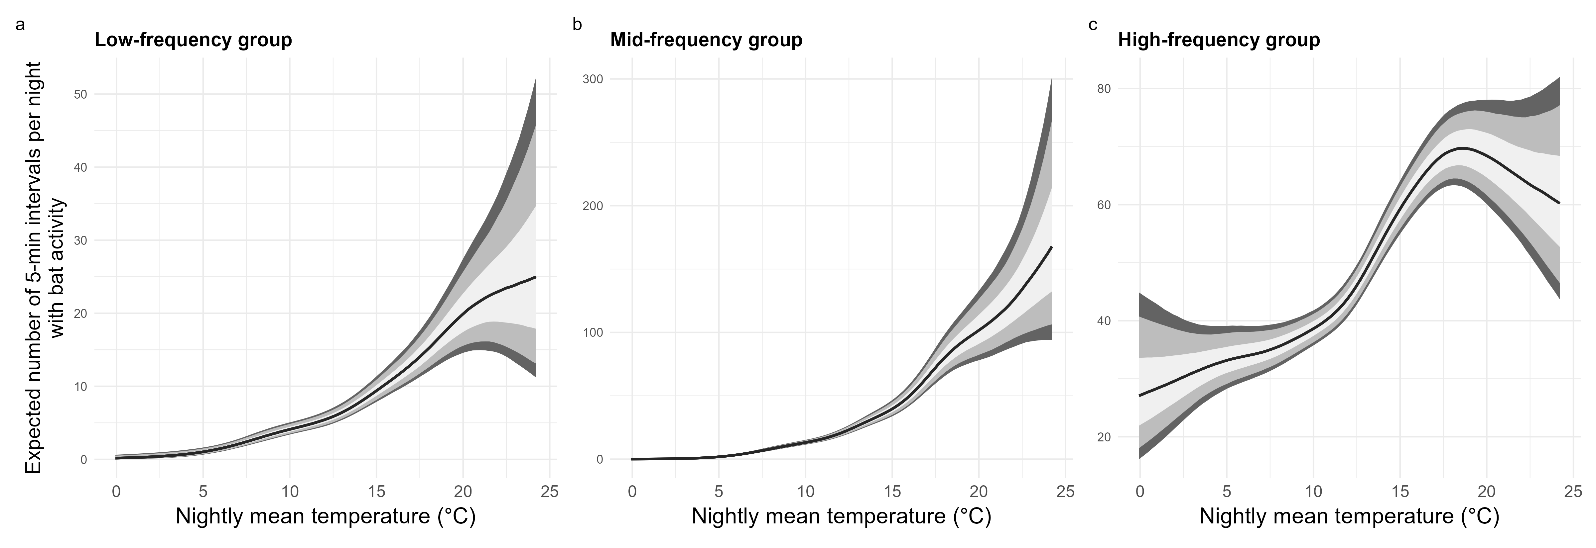
Figure 3: Conditional relationships between nightly mean temperature and bat acoustic activity for (a) low-frequency, (b) mid-frequency, and (c) high-frequency echolocation groups at eight sites in the northern Sierra Nevada, California. Predictions were generated across the observed temperature range and averaged over the observed distribution of sampled days of year, with each site weighted equally; relative humidity and lunar phase were held at their reference values. Lines show posterior medians and shaded ribbons show 50%, 80%, and 89% credible intervals (darkest to lightest). Y-axis scales differ among panels to emphasize differences in response shape among frequency groups.

Frequency-dependent humidity responses
Relative humidity was associated with markedly different patterns of activity among frequency groups (Figure 4). Across the central 80% of observed nightly relative humidity conditions (49.4–84.6%), expected activity declined substantially for both the mid- and high-frequency groups. For high-frequency bats, expected activity decreased from 52.4 to 29.0 5-min detection intervals per night, corresponding to a median ratio of 0.55 (89% CrI: 0.50–0.62) and a posterior probability of a decrease of 1.00. Mid-frequency activity declined from 19.8 to 13.7 intervals per night over the same humidity range (median ratio = 0.69, 89% CrI: 0.58–0.83; posterior probability of decrease > 0.999). In contrast, low-frequency activity showed little evidence of an overall decline, increasing slightly from 4.32 to 5.32 intervals per night (median ratio = 1.23, 89% CrI: 0.97–1.56; posterior probability of decrease = 0.083). Response curves were nonlinear, particularly for the mid-frequency group, but declines became pronounced at high relative humidity for both the mid- and high-frequency groups, whereas activity of the low-frequency group remained comparatively insensitive across the observed humidity gradient.
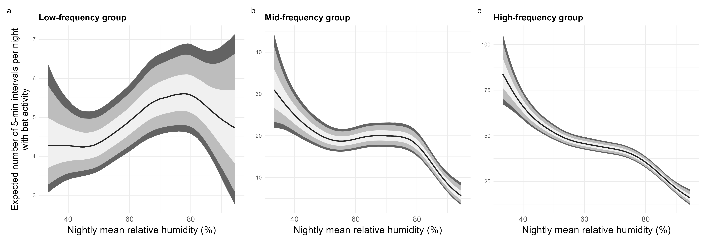
Figure 4: Conditional relationships between nightly mean relative humidity and bat activity for (a) low-, (b) mid-, and (c) high-frequency echolocation groups. Lines show posterior median expected numbers of 5-min detection intervals per night, with inner and outer ribbons representing 50% and 89% credible intervals, respectively. Predictions were generated from the frequency-group-specific Bayesian generalized additive models while holding the other environmental predictors at their reference values and averaging over the seasonal effect. Note that y-axis scales differ among panels to emphasize the shape and uncertainty of the response within each frequency group.

Frequency-specific seasonal phenology
[PENDING FINAL FREQUENCY-GROUP FITS.]

Lunar responses among frequency groups
Associations between lunar illumination and bat activity also differed among frequency groups (Figure 5). High-frequency activity increased with lunar illumination, with expected activity increasing by 10.4 5-min detection intervals per night from new moon to full moon (89% CrI: 7.02–14.4). This corresponded to a 1.28-fold increase in expected activity (89% CrI: 1.18–1.39), with essentially all posterior draws supporting an increase. Low-frequency activity showed weaker evidence of a response in the opposite direction, declining by a median of 0.92 intervals per night from new moon to full moon (89% CrI: −2.06–0.25; posterior probability of a decrease = 0.898). Mid-frequency activity exhibited a nonlinear relationship with lunar illumination, but the overall new- to full-moon contrast was comparatively small and uncertain (median difference = 1.81 intervals per night, 89% CrI: −1.00–4.80; posterior probability of an increase = 0.850). Thus, the clearest lunar response occurred among high-frequency bats, for which activity increased across the lunar illumination gradient.
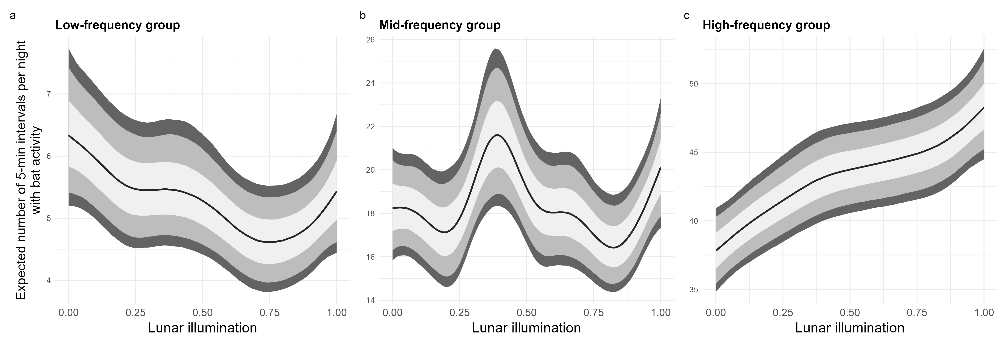
Figure 5: Conditional relationships between lunar illumination and bat activity for (a) low-, (b) mid-, and (c) high-frequency groups. Lunar illumination ranges from 0 (new moon) to 1 (full moon). Lines show posterior median expected numbers of 5-min detection intervals per night, with inner and outer ribbons representing 50% and 89% credible intervals, respectively. Predictions were generated from the frequency-group-specific Bayesian generalized additive models while holding temperature and relative humidity at their reference values and averaging over the seasonal effect. Note that y-axis scales differ among panels to emphasize the shape and uncertainty of the response within each frequency group.

Environmental contrasts
Posterior contrasts summarized the differing environmental responses among frequency groups (Table 2). Increasing temperature from the 10th to the 90th percentile of observed nightly conditions was associated with higher predicted activity in all three groups, although the proportional increase was substantially larger for the low- and mid-frequency groups than for the high-frequency group. In contrast, increasing relative humidity over the same portion of its observed distribution was associated with pronounced declines in mid- and high-frequency activity, whereas the low-frequency response was comparatively weak. Lunar illumination produced a smaller and less consistent response across groups, except for the high-frequency group, for which predicted activity was higher under full than new moon conditions. Together, these contrasts reinforce the distinct environmental response profiles evident in the posterior response curves.
Table 2: Posterior contrasts in expected nightly bat activity across environmental gradients for low-, mid-, and high-frequency echolocation groups. Temperature and relative-humidity contrasts compare predictions at the 10th and 90th percentiles of the observed covariate distributions; lunar contrasts compare new moon (0) with full moon (1). Differences and ratios are posterior medians with 89% credible intervals. P(Δ > 0) is the posterior probability that predicted activity at the upper endpoint exceeds predicted activity at the lower endpoint. Predictions are conditional on the remaining covariates in the full environmental model.
Predictor | Frequency group | Contrast | Predicted low | Predicted high | Difference (89% CrI) | Ratio (89% CrI) | P(Δ > 0)
Temperature | Low | 10th–90th percentile | 1.5 | 13.7 | 12.2 (9.5, 15.5) | 9.04 (6.21, 13.39) | 1.000
Temperature | Mid | 10th–90th percentile | 3.5 | 69.9 | 66.4 (54.4, 81.0) | 20.09 (15.37, 26.34) | 1.000
Temperature | High | 10th–90th percentile | 33.9 | 68.3 | 34.3 (26.7, 42.4) | 2.01 (1.70, 2.38) | 1.000
Relative humidity | Low | 10th–90th percentile | 4.3 | 5.3 | 1.0 (-0.1, 2.3) | 1.23 (0.97, 1.56) | 0.917
Relative humidity | Mid | 10th–90th percentile | 19.8 | 13.7 | -6.1 (-9.2, -3.1) | 0.69 (0.58, 0.83) | 0.000
Relative humidity | High | 10th–90th percentile | 52.4 | 29.0 | -23.3 (-28.0, -18.9) | 0.55 (0.50, 0.62) | 0.000
Lunar illumination | Low | New–full moon | 6.3 | 5.4 | -0.9 (-2.1, 0.2) | 0.85 (0.71, 1.04) | 0.102
Lunar illumination | Mid | New–full moon | 18.2 | 20.1 | 1.8 (-1.0, 4.8) | 1.10 (0.95, 1.28) | 0.850
Lunar illumination | High | New–full moon | 37.8 | 48.3 | 10.4 (7.0, 14.4) | 1.28 (1.18, 1.39) | 1.000

Summary of principal findings

Tables and figures to generate

Acknowledgements
We are grateful to Pacific Gas & Electric Company (PG&E), who sponsored this data collection as part of the Bucks Creek Project, FERC Project No. 619, relicensing studies for the Federal Energy Relicensing Commission (FERC); Laura Burkholder (former PG&E biologist) who was the main contact person for biology at PG&E and supported the development of the study plan; Paul Heady (Central Coast Bat Research Group) who advised the bat surveys; and Matt Franz (PG&E biologist) who handled the administrative processes.

References
Barros, M. A. S., Pessoa, D. M. A., & Rui, A. M. (2014). Habitat use and seasonal activity of insectivorous bats (Mammalia: Chiroptera) in the grasslands of southern Brazil. Zoologia, 31(2), 153–161.
Boukhari, A., Ait-Abdesselam, M., Bissaad, F. Z., Bounaceur, F., Khazar, I., Bouhani, M., & Aulagnier, S. (2025). Bat Activity in South Mediterranean Forests: A Seasonal Acoustic Survey. Diversity, 17(11), 750. https://doi.org/10.3390/d17110750
Escobar, M. A. H., & Villaseñor, N. R. (2024). Seasonal variation of bat activity in an endangered temperate forest in the Chilean biodiversity hotspot. Neotropical Biology and Conservation, 19(4), 475–494. https://doi.org/10.3897/neotropical.19.e131710
Meola, V., Ekklisiarchos, I., Cistrone, L., Migliozzi, A., & Russo, D. (2025). Landscape and Season Influence Bat Activity and Richness in a Mediterranean Metropolitan Area. Ecology and Evolution, 15(8), e71978. https://doi.org/10.1002/ece3.71978

Supplementary material
This supplementary material provides model specifications, sampling and species summaries, model diagnostics, posterior predictive checks, and residual temporal diagnostics supporting the main-text analysis of bat activity in the northern Sierra Nevada. Intermediate model-development objects that do not contribute directly to interpretation are retained in the analysis repository rather than reproduced here.

Supplementary tables

Table S1. Final model specifications
Table 3: Final Bayesian generalized additive models used to estimate aggregate and frequency-group bat activity. All models used a negative-binomial response distribution with a log link and site-specific seasonal phenology represented by penalized factor-smooth interactions where applicable.
Model | Response | Formula | Likelihood | Site-nights
Aggregate seasonal | Aggregate activity | n ~ s(doy) + s(doy, Site, bs = “fs”) | negbinomial (log link) | 1056
Aggregate environmental | Aggregate activity | n ~ s(doy) + s(doy, Site, bs = “fs”) + s(scale_avetemp) + s(scale_averh) + s(Lunar) | negbinomial (log link) | 1056
Low-frequency environmental | Low-frequency activity | n ~ s(doy) + s(doy, Site, bs = “fs”) + s(scale_avetemp) + s(scale_averh) + s(Lunar) | negbinomial (log link) | 1056
Mid-frequency environmental | Mid-frequency activity | n ~ s(doy) + s(doy, Site, bs = “fs”) + s(scale_avetemp) + s(scale_averh) + s(Lunar) | negbinomial (log link) | 1056
High-frequency environmental | High-frequency activity | n ~ s(doy) + s(doy, Site, bs = “fs”) + s(scale_avetemp) + s(scale_averh) + s(Lunar) | negbinomial (log link) | 1056

Table S2. Aggregate-model sampling diagnostics
Table 4: MCMC sampling diagnostics for the final aggregate seasonal and conditional environmental models. Negative-binomial shape is summarized by the posterior median and 89% credible interval.
Model | Site-nights | Post-warmup draws | Maximum R-hat | Minimum bulk ESS | Minimum tail ESS | Divergences | Max-treedepth transitions | NB shape median | NB shape lower 89% | NB shape upper 89%
Aggregate seasonal | 1056 | 12000 | 1 | 2175 | 4238 | 0 | 0 | 4.28 | 3.92 | 4.67
Aggregate environmental | 1056 | 12000 | 1 | 1865 | 2712 | 0 | 7 | 8.52 | 7.66 | 9.46

Table S3. Frequency-group model sampling diagnostics
Table 5: MCMC sampling diagnostics for the final low-, mid-, and high-frequency conditional environmental models. Negative-binomial shape is summarized by the posterior median and 89% credible interval.
Model | Site-nights | Post-warmup draws | Maximum R-hat | Minimum bulk ESS | Minimum tail ESS | Divergences | Max-treedepth transitions | NB shape median | NB shape lower 89% | NB shape upper 89%
Low-frequency group | 1056 | 12000 | 1 | 2984 | 4306 | 0 | 0 | 2.02 | 1.78 | 2.28
Mid-frequency group | 1056 | 12000 | 1 | 1799 | 2165 | 0 | 0 | 3.22 | 2.90 | 3.58
High-frequency group | 1056 | 12000 | 1 | 1696 | 2437 | 0 | 3012 | 10.01 | 8.82 | 11.38

Table S4. Species composition and characteristic echolocation-frequency groups
Table 6: Bat species included in the analysis, characteristic echolocation frequency, assigned frequency group, total number of 5-min detection intervals, and number of retained site-nights on which each species was detected.
Species code | Scientific name | Common name | Characteristic frequency (kHz) | Frequency group | Total intervals | Site-nights detected
EUDMAC | Euderma maculatum | Spotted bat | 11 | Low | 122 | 49
EUMPER | Eumops perotis | Western mastiff bat | 12 | Low | 1209 | 251
LASCIN | Lasiurus cinereus | Hoary bat | 20 | Low | 5834 | 727
TADBRA | Tadarida brasiliensis | Mexican free-tailed bat | 25 | Mid | 11474 | 779
LASNOC | Lasionycteris noctivagans | Silver-haired bat | 26 | Mid | 9441 | 841
EPTFUS | Eptesicus fuscus | Big brown bat | 27 | Mid | 6211 | 654
CORTOW | Corynorhinus townsendii | Townsend’s big-eared bat | 28 | Mid | 67 | 57
ANTPAL | Antrozous pallidus | Pallid bat | 30 | Mid | 526 | 214
MYOTHY | Myotis thysanodes | Fringed myotis | 32 | Mid | 69 | 59
MYOEVO | Myotis evotis | Long-eared myotis | 35 | Mid | 220 | 171
MYOVOL | Myotis volans | Long-legged myotis | 40 | High | 1128 | 330
MYOLUC | Myotis lucifugus | Little brown myotis | 42 | High | 19013 | 838
LASBLO | Lasiurus blossevillii | Western red bat | 42 | High | 1519 | 484
PARHES | Parastrellus hesperus | Canyon bat | 45 | High | 4413 | 640
MYOCIL | Myotis ciliolabrum | Western small-footed myotis | 45 | High | 3428 | 382
MYOYUM | Myotis yumanensis | Yuma myotis | 48 | High | 35004 | 859
MYOCAL | Myotis californicus | California myotis | 50 | High | 5943 | 769

Table S5. Retained sampling effort by site
Table 7: Retained acoustic sampling effort and activity summaries by site after nights without usable acoustic recordings were excluded. Zero-activity nights are sampled nights with usable recordings but no accepted bat detections.
Site | Retained site-nights | Zero-activity nights | Total activity intervals | Mean intervals per night | Median intervals per night | First retained night | Last retained night
BUC3 | 172 | 1 | 35057 | 203.8 | 210.0 | 2015-04-22 | 2015-10-17
BUL11 | 174 | 0 | 40054 | 230.2 | 232.5 | 2015-04-24 | 2015-10-14
BUL18 | 47 | 6 | 620 | 13.2 | 8.0 | 2015-04-25 | 2015-07-31
BUL4 | 64 | 17 | 666 | 10.4 | 7.0 | 2015-04-24 | 2015-09-17
GRP1 | 174 | 0 | 6904 | 39.7 | 30.5 | 2015-04-24 | 2015-10-14
GRP5 | 168 | 14 | 2293 | 13.6 | 8.0 | 2015-04-24 | 2015-10-14
LBL5 | 174 | 0 | 14871 | 85.5 | 82.0 | 2015-04-24 | 2015-10-14
THL1 | 83 | 2 | 3216 | 38.7 | 32.0 | 2015-07-24 | 2015-10-14

Table S6. Software and computational environment
Table 8: Software and package versions used in the final analysis.
Software | Version
R | 4.6.1
brms | 2.23.0
cmdstanr | 0.9.0
posterior | 1.7.0
tidybayes | 3.0.7
mgcv | 1.9.4
tidyverse | 2.0.0
ggplot2 | 4.0.3
patchwork | 1.3.2
flextable | 0.10.0

Supplementary figures

Figure S1. Site-specific seasonal phenology
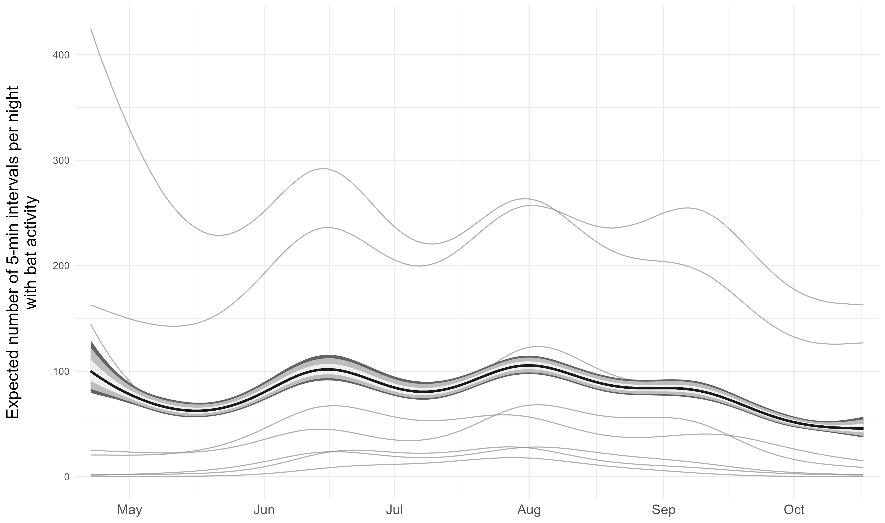
Figure 6: Site-specific seasonal phenology in bat activity from the final aggregate seasonal model. Gray curves show posterior median activity trajectories for individual sites, and the black curve and shaded intervals show the equal-site posterior average and associated credible intervals.

Figure S2. Residual temporal dependence
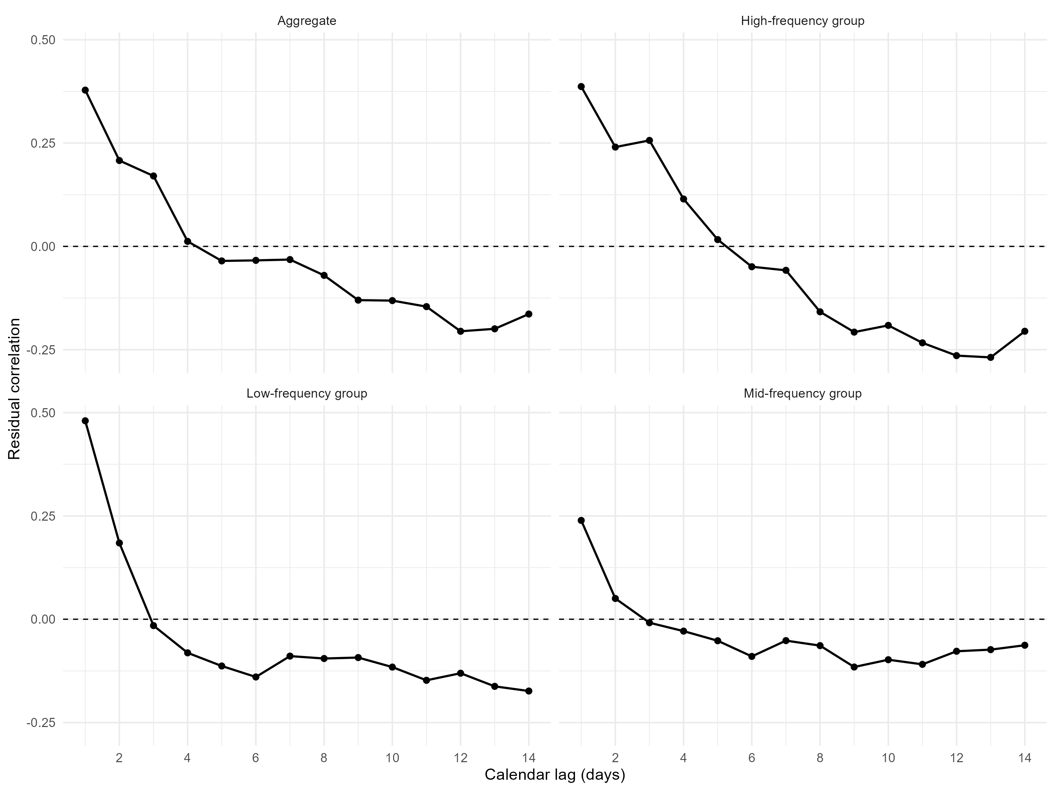
Figure 7: Calendar-aware residual correlation for the final aggregate conditional environmental model and the final low-, mid-, and high-frequency conditional environmental models. Correlations are calculated using actual calendar-day lags so that gaps in sampling are not treated as consecutive observations.

Figure S3. Aggregate posterior predictive checks
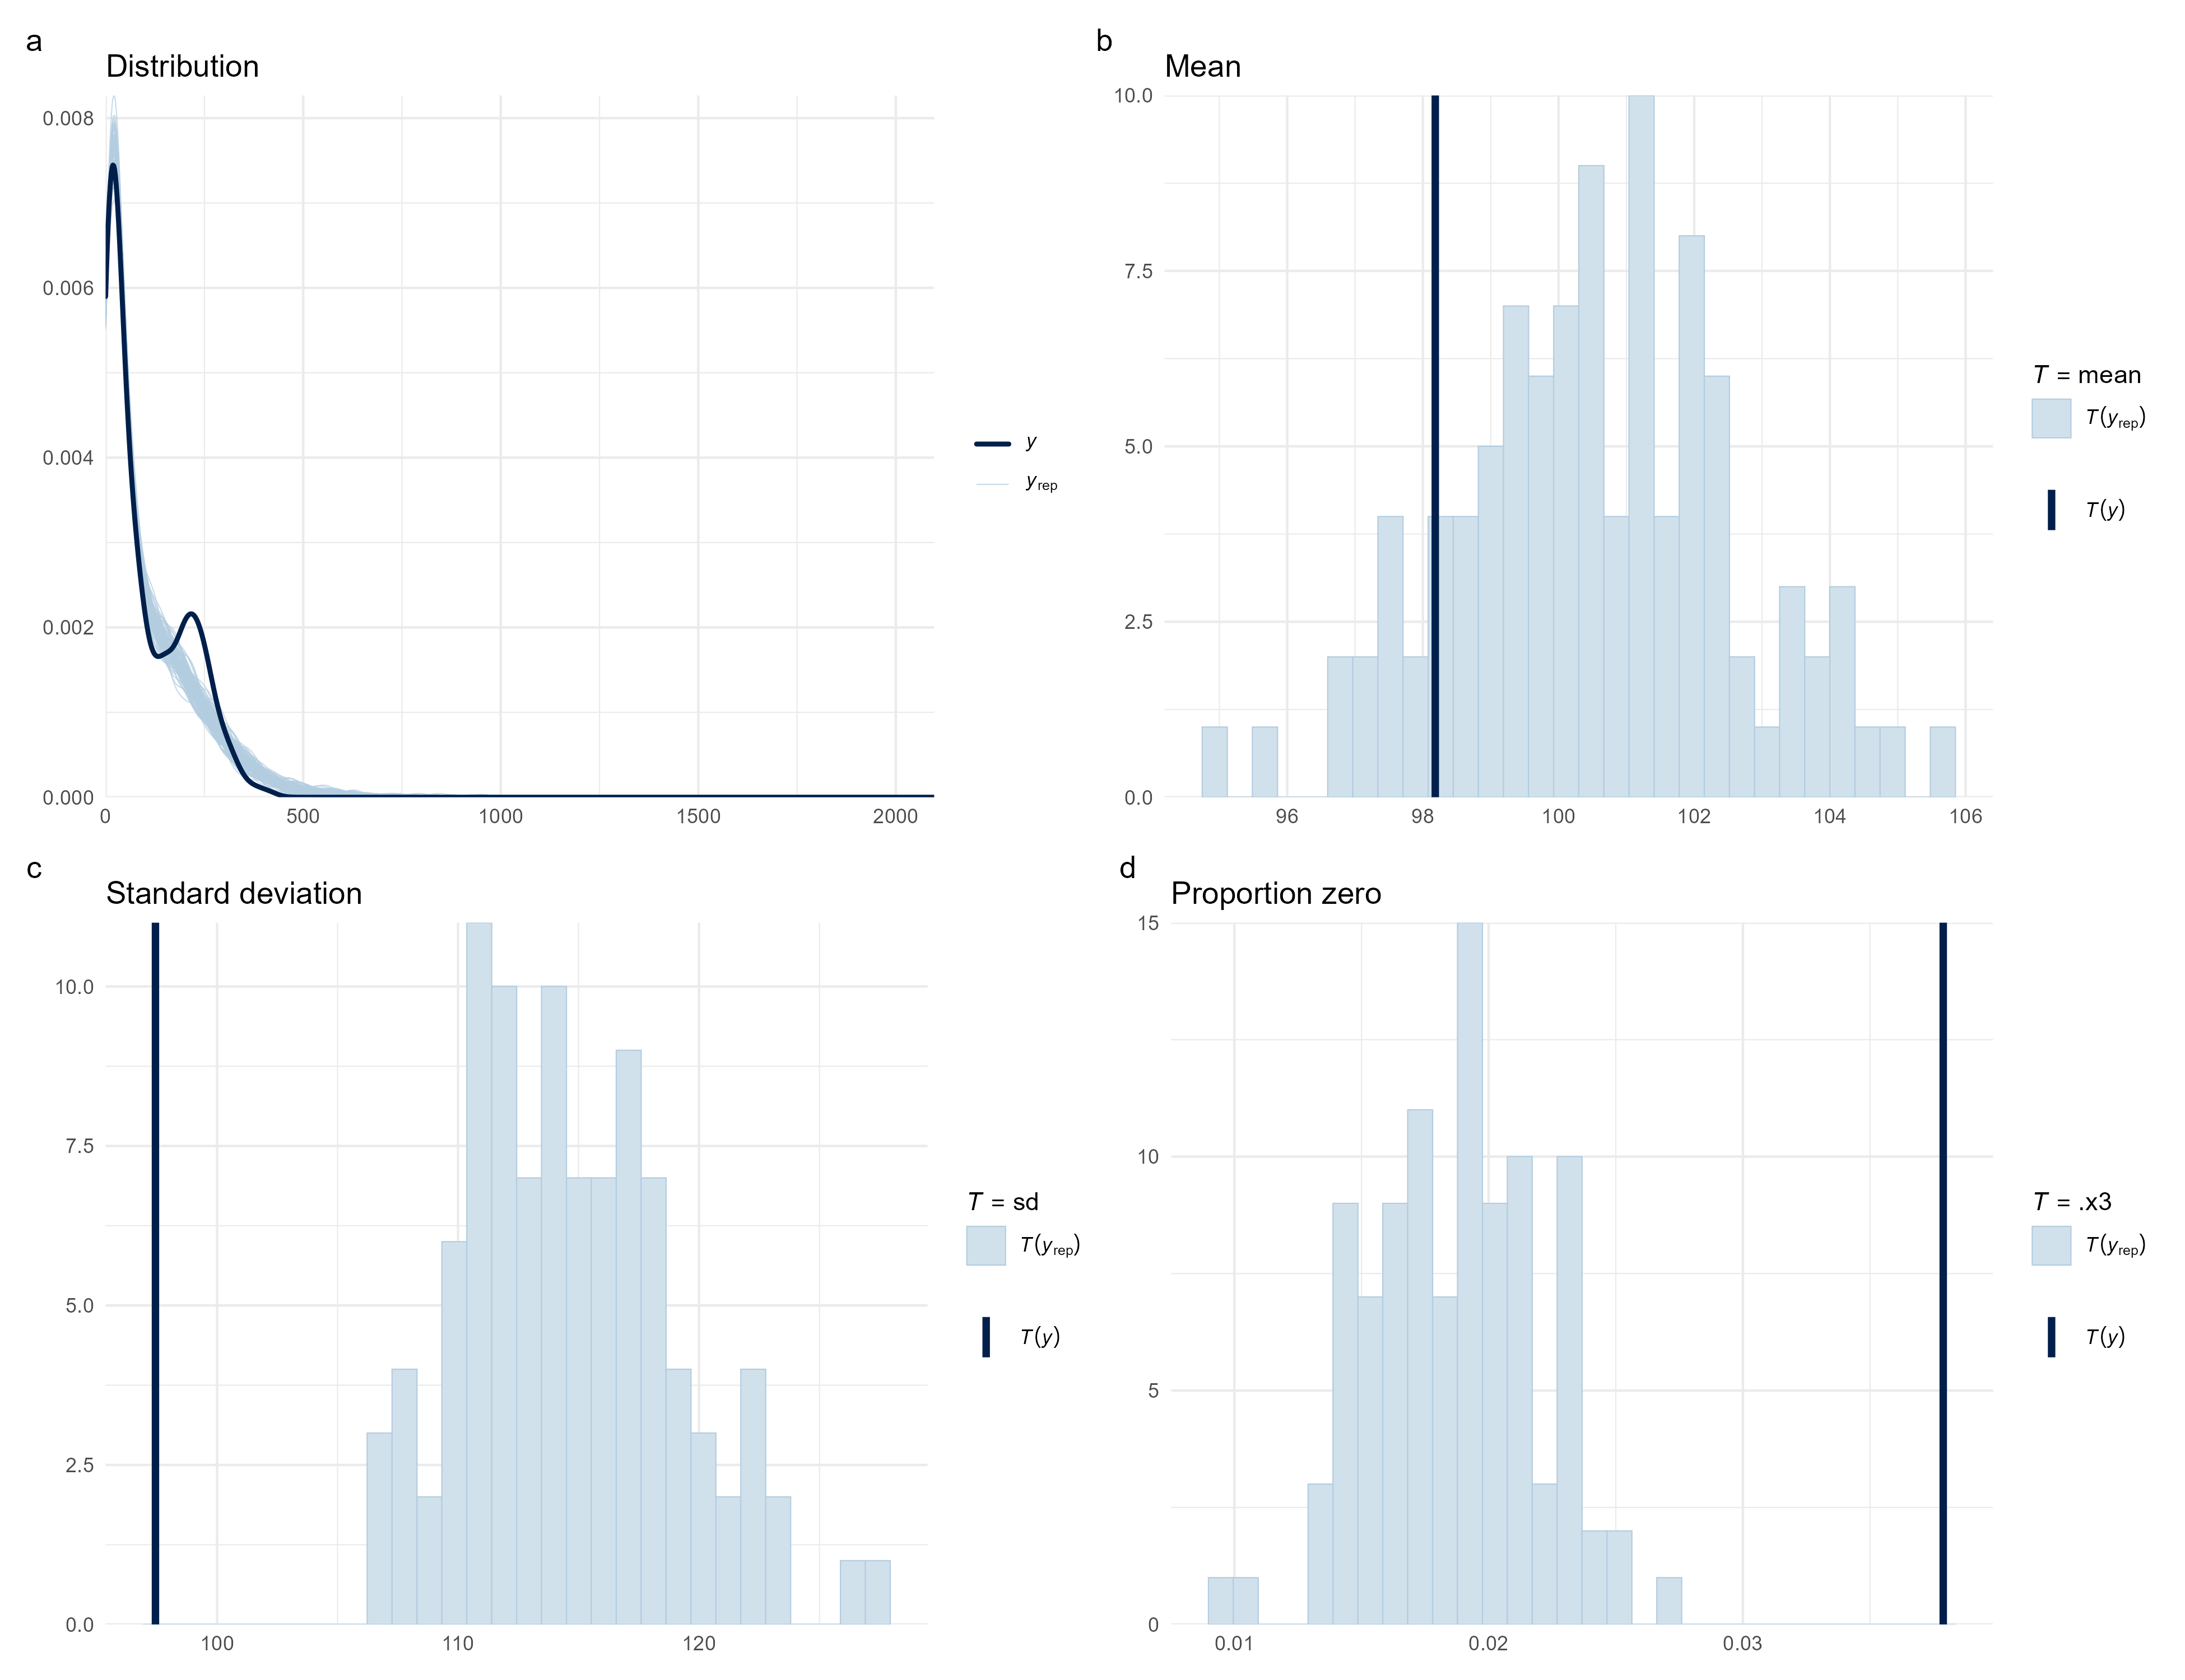
Figure 8: Posterior predictive checks for the final aggregate conditional environmental model. Checks compare the observed nightly activity distribution with replicated datasets generated from the posterior predictive distribution and evaluate key features of the response distribution.

Figure S4. Site-specific posterior predictive checks
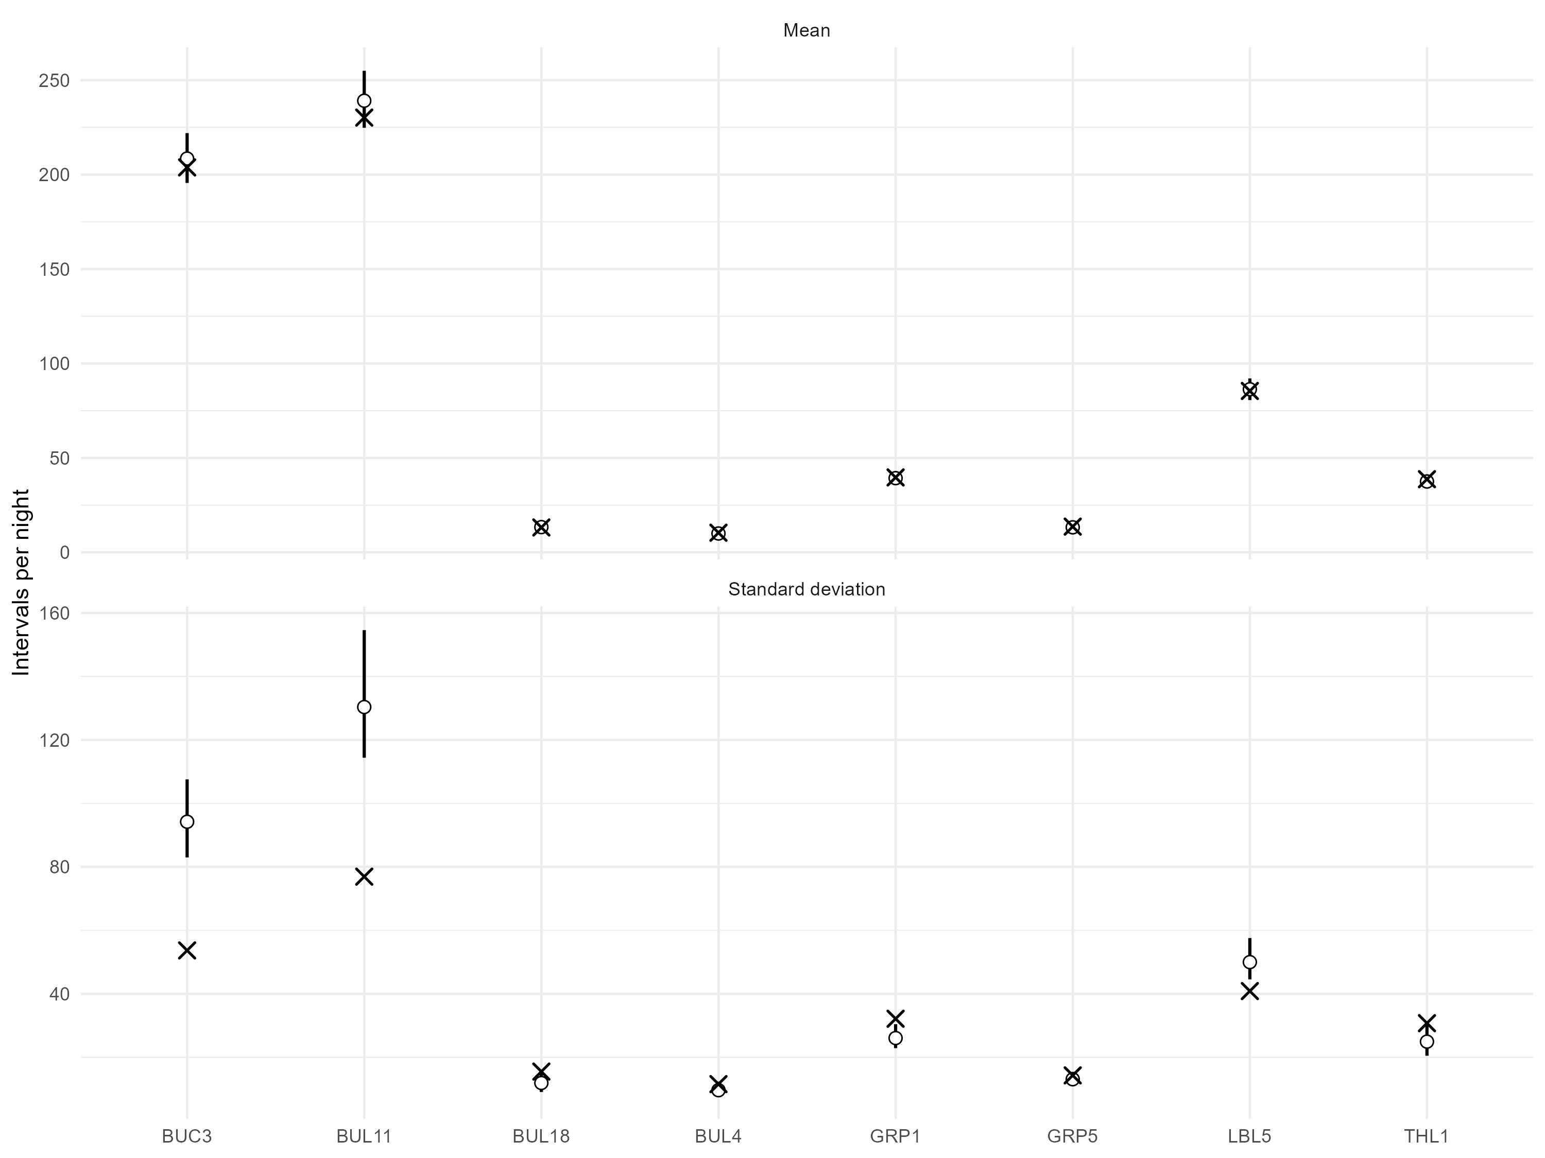
Figure 9: Site-specific posterior predictive checks for the final aggregate conditional environmental model. Crosses show observed site-level means and standard deviations of nightly activity; circles show posterior predictive medians and vertical intervals show 89% posterior predictive intervals.

Figure S5. Frequency-group posterior predictive checks
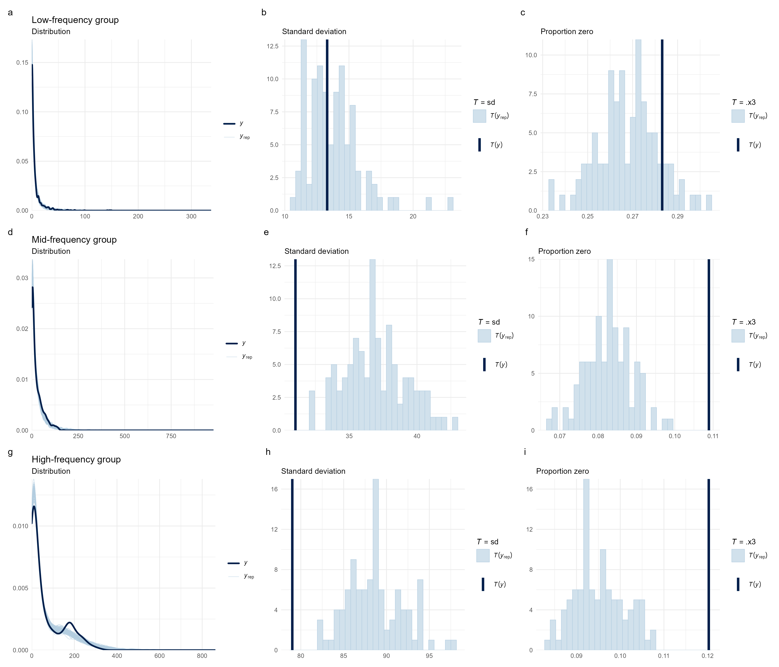
Figure 10: Posterior predictive checks for the final low-, mid-, and high-frequency conditional environmental models. For each frequency group, checks compare the observed response distribution with posterior predictive replicates and evaluate the standard deviation and proportion of zero-activity nights.

Additional model assessment
Routine trace plots are not reproduced because the tabulated sampling diagnostics document convergence and effective sample sizes for the final models. The graphical diagnostics above focus on model adequacy relevant to the biological estimands: posterior predictive fit, among-site predictive performance, and remaining short-lag temporal dependence.

