Results

Sampling and acoustic activity
After excluding nights without usable acoustic recordings, the final analysis comprised 1,056 site-nights across eight sites and 179 sampling nights from late April through mid-October 2015 (Table 1). Sampling effort varied among sites because of detector failures and other periods without usable acoustic data, ranging from 47 retained nights at BUL18 to 174 nights at the most intensively sampled sites.
Across the retained site-nights, aggregate bat activity totaled 103,681 5-min detection intervals representing 17 species. Of these detections, 7,078 were assigned to the low-frequency group, 27,602 to the mid-frequency group, and 69,001 to the high-frequency group. Environmental conditions represented in the analysis spanned substantial variation in nightly temperature, relative humidity, and lunar illumination (Table 1).
Table 1: Summary of the acoustic sampling design and environmental conditions represented in the analysis. Environmental ranges are based on the site-night observations retained for modeling.
Characteristic | Value
Sites | 8
Sampling nights | 179
Site-nights | 1,056
Bat species | 17
Sampling period | April 22–October 17
Day of year | 112–290
Nightly mean temperature (°C) | -0.1–24.2
Nightly mean relative humidity (%) | 33.4–94.4
Lunar illumination | 0.00–1.00

Model adequacy and diagnostics
The final models incorporated site-specific seasonal phenology using penalized factor-smooth interactions between day of year and site. This structure substantially accounted for temporal dependence in nightly activity. In the aggregate conditional model, residual autocorrelation declined from 0.379 at lag 1 to 0.208 at lag 2 and 0.168 at lag 3, approached zero by lag 4, and remained weak at longer lags. Thus, the remaining temporal dependence was limited primarily to the shortest time lags.
MCMC diagnostics indicated satisfactory posterior sampling. All reported $\hat{R}$ values were 1.00, with large bulk and tail effective sample sizes. Seven of 12,000 post-warmup transitions in the aggregate conditional model reached the maximum tree depth of 12. Posterior predictive checks showed that the model reproduced the overall distribution of nightly activity and site-specific mean activity well, although predictive variation differed somewhat among sites. In particular, variability was overpredicted at BUC3, BUL11, and LBL5 and modestly underpredicted at several other sites. Overall, the final model captured the principal seasonal, among-site, and distributional structure relevant to inference while retaining a parsimonious representation of the data.

Seasonal activity
Seasonal activity varied nonlinearly across the sampling period, and the inferred seasonal pattern changed substantially after accounting for nightly environmental conditions (Figure 1). In the total seasonal model, equal-site averaged activity declined through May, increased to a first summer maximum in June, declined in July, and increased again in early August before falling through September and October (Figure 1a). After conditioning on nightly temperature, relative humidity, and lunar phase, the seasonal trajectory was markedly different: activity was highest early in the sampling season, declined sharply from May into June, and remained comparatively low through most of the summer and autumn, with only modest increases in August and September (Figure 1b). Thus, much of the pronounced mid-summer structure in the total seasonal pattern was associated with seasonal variation in the measured environmental conditions, while the conditional day-of-year effect was dominated by elevated activity early in the sampling season. Seasonal phenology also differed substantially among sites in both the magnitude and timing of activity (Figure 1c), supporting the use of site-specific seasonal smooths rather than a single common seasonal trajectory.
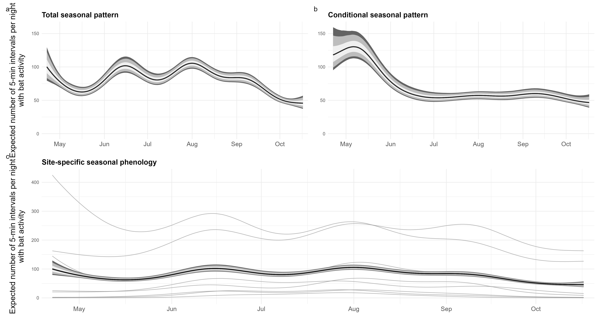
Figure 1: Seasonal variation in community-level bat acoustic activity across eight sites in the northern Sierra Nevada, California, April–October 2015. (a) Total seasonal pattern from the day-of-year model, shown as the posterior distribution of the equal-site averaged expected number of 5-min intervals per night in which a bat call occurred. (b) Conditional seasonal pattern from the environmental model after accounting for nightly mean temperature, relative humidity, and lunar phase; the curve is likewise averaged equally across sites. (c) Site-specific seasonal phenology from the total seasonal model. Thin gray lines show posterior median trajectories for individual sites; the black line and shaded bands show the equal-site averaged seasonal trajectory. In panels a and b, and for the average in panel c, lines indicate posterior medians and shaded bands indicate 50%, 80%, and 89% credible intervals from darkest to lightest.

Echolocation-frequency groups
Characteristic-frequency groups contributed very different amounts of total recorded activity. High-frequency species accounted for 69,001 detection intervals, compared with 27,602 for the mid-frequency group and 7,078 for the low-frequency group. Consequently, the aggregate community response was numerically dominated by high-frequency detections, although the frequency-stratified models allow the environmental responses of the three groups to be evaluated separately.

Temperature responses among frequency groups
Temperature was positively associated with bat activity across all three frequency groups over the well-sampled portion of the observed temperature gradient, although response shape differed among groups (Figure 2). Across the central 80% of observed nightly temperatures (6.07–17.3 $​^{∘}$C), predicted activity increased from 1.52 to 13.7 intervals per night for the low-frequency group, from 3.48 to 69.9 intervals per night for the mid-frequency group, and from 33.9 to 68.3 intervals per night for the high-frequency group. The corresponding median increases were 12.2 (89% CrI: 9.50–15.5), 66.4 (54.4–81.0), and 34.3 (26.7–42.4) intervals per night, respectively, with posterior probability of an increase equal to 1.00 for each group. Low- and mid-frequency activity continued to increase toward the warm end of the observed gradient, whereas high-frequency activity increased through most of the well-sampled temperature range before leveling off and declining at warmer temperatures. Across posterior draws, the median temperature associated with maximum high-frequency activity was 18.8 $​^{∘}$C (89% CrI: 17.3–24.2 $​^{∘}$C); 16.9% of posterior curves placed the maximum at the upper boundary of the observed temperature range, indicating greater uncertainty in the shape of the response at the warmest temperatures.
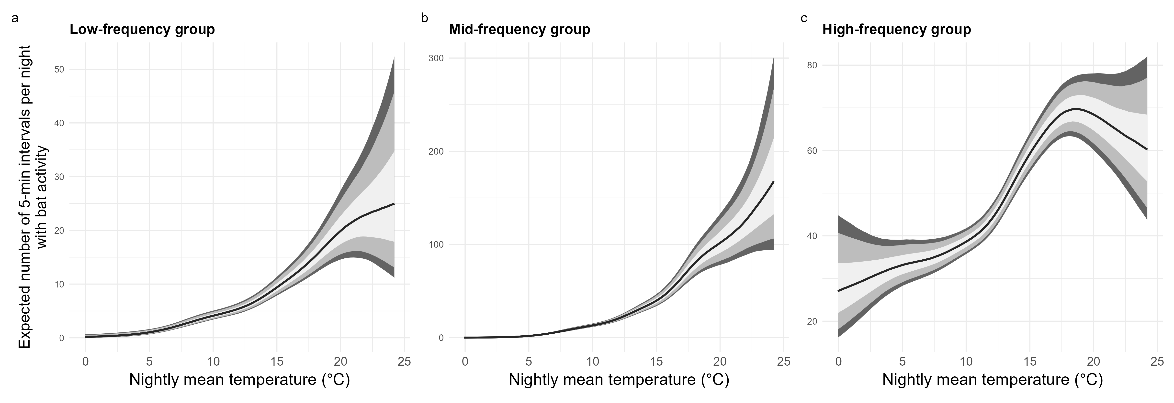
Figure 2: Conditional relationships between nightly mean temperature and bat acoustic activity for (a) low-frequency, (b) mid-frequency, and (c) high-frequency echolocation groups at eight sites in the northern Sierra Nevada, California. Predictions were generated across the observed temperature range and averaged over the observed distribution of sampled days of year, with each site weighted equally; relative humidity and lunar phase were held at their reference values. Lines show posterior medians and shaded ribbons show 50%, 80%, and 89% credible intervals (darkest to lightest). Y-axis scales differ among panels to emphasize differences in response shape among frequency groups.

Frequency-dependent humidity responses
Relative humidity was associated with markedly different patterns of activity among frequency groups (Figure 3). Across the central 80% of observed nightly relative humidity conditions (49.4–84.6%), expected activity declined substantially for both the mid- and high-frequency groups. For high-frequency bats, expected activity decreased from 52.4 to 29.0 5-min detection intervals per night, corresponding to a median ratio of 0.55 (89% CrI: 0.50–0.62) and a posterior probability of a decrease of 1.00. Mid-frequency activity declined from 19.8 to 13.7 intervals per night over the same humidity range (median ratio = 0.69, 89% CrI: 0.58–0.83; posterior probability of decrease > 0.999). In contrast, low-frequency activity showed little evidence of an overall decline, increasing slightly from 4.32 to 5.32 intervals per night (median ratio = 1.23, 89% CrI: 0.97–1.56; posterior probability of decrease = 0.083). Response curves were nonlinear, particularly for the mid-frequency group, but declines became pronounced at high relative humidity for both the mid- and high-frequency groups, whereas activity of the low-frequency group remained comparatively insensitive across the observed humidity gradient.
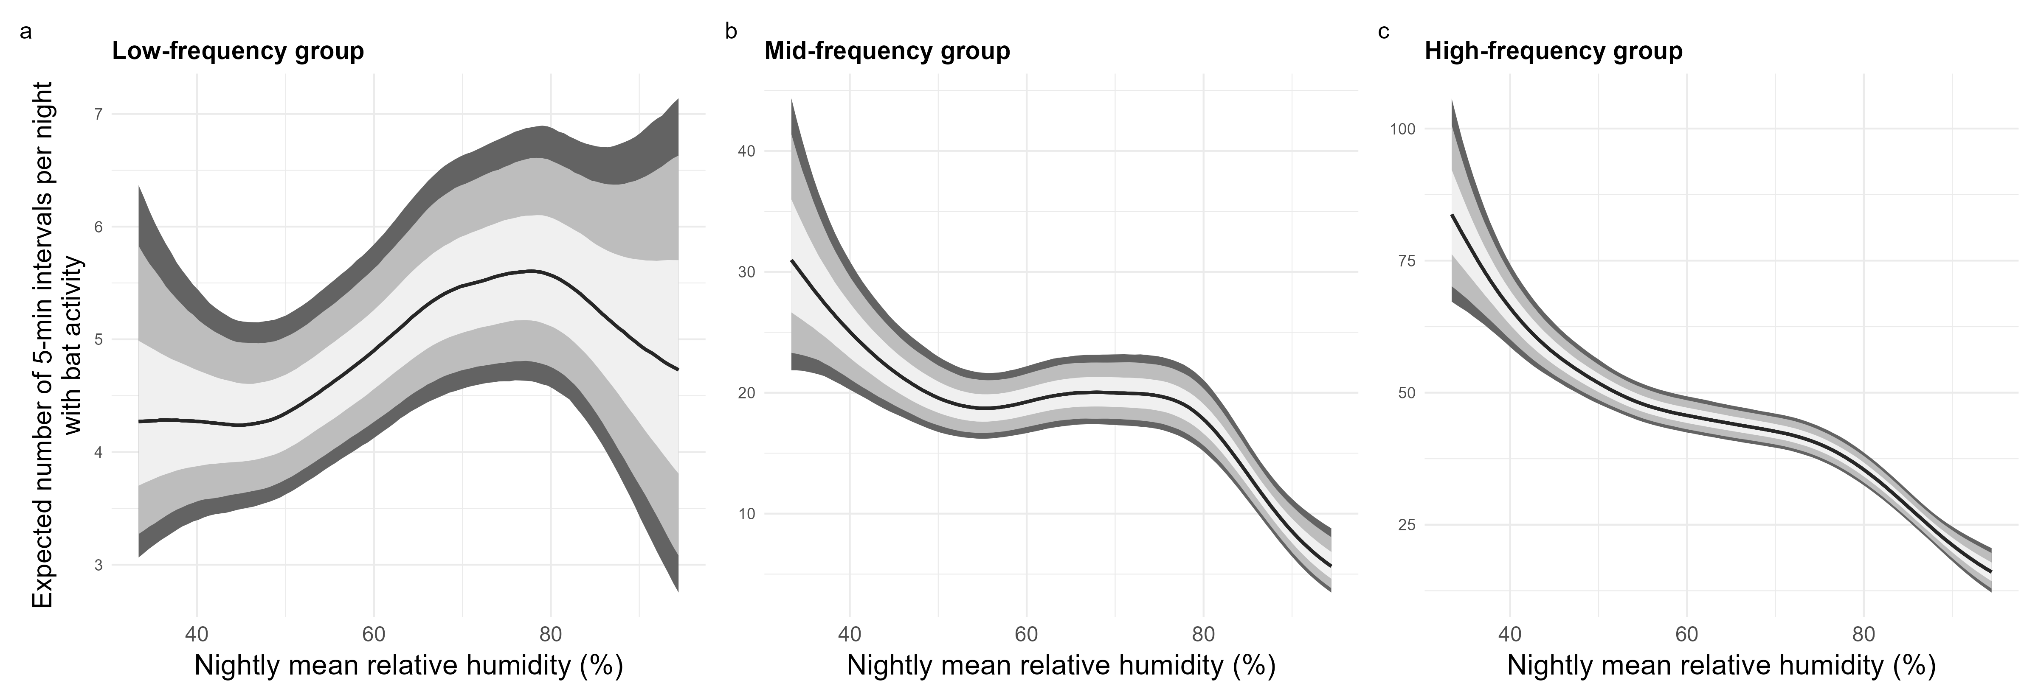
Figure 3: Conditional relationships between nightly mean relative humidity and bat activity for (a) low-, (b) mid-, and (c) high-frequency echolocation groups. Lines show posterior median expected numbers of 5-min detection intervals per night, with inner and outer ribbons representing 50% and 89% credible intervals, respectively. Predictions were generated from the frequency-group-specific Bayesian generalized additive models while holding the other environmental predictors at their reference values and averaging over the seasonal effect. Note that y-axis scales differ among panels to emphasize the shape and uncertainty of the response within each frequency group.

Frequency-specific seasonal phenology
[PENDING FINAL FREQUENCY-GROUP FITS.]

Lunar responses among frequency groups
Associations between lunar illumination and bat activity also differed among frequency groups (Figure 4). High-frequency activity increased with lunar illumination, with expected activity increasing by 10.4 5-min detection intervals per night from new moon to full moon (89% CrI: 7.02–14.4). This corresponded to a 1.28-fold increase in expected activity (89% CrI: 1.18–1.39), with essentially all posterior draws supporting an increase. Low-frequency activity showed weaker evidence of a response in the opposite direction, declining by a median of 0.92 intervals per night from new moon to full moon (89% CrI: −2.06–0.25; posterior probability of a decrease = 0.898). Mid-frequency activity exhibited a nonlinear relationship with lunar illumination, but the overall new- to full-moon contrast was comparatively small and uncertain (median difference = 1.81 intervals per night, 89% CrI: −1.00–4.80; posterior probability of an increase = 0.850). Thus, the clearest lunar response occurred among high-frequency bats, for which activity increased across the lunar illumination gradient.
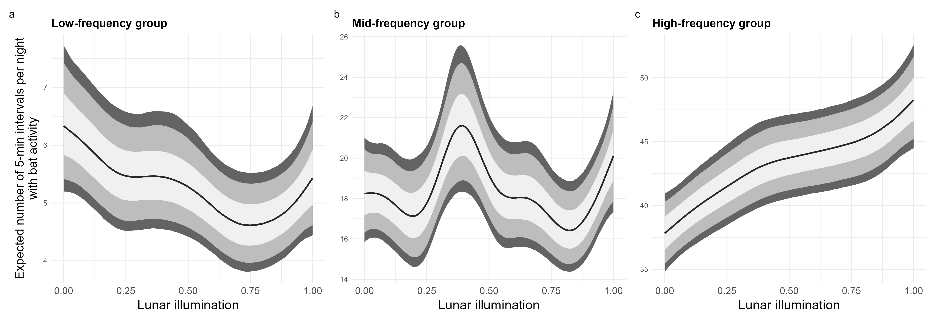
Figure 4: Conditional relationships between lunar illumination and bat activity for (a) low-, (b) mid-, and (c) high-frequency groups. Lunar illumination ranges from 0 (new moon) to 1 (full moon). Lines show posterior median expected numbers of 5-min detection intervals per night, with inner and outer ribbons representing 50% and 89% credible intervals, respectively. Predictions were generated from the frequency-group-specific Bayesian generalized additive models while holding temperature and relative humidity at their reference values and averaging over the seasonal effect. Note that y-axis scales differ among panels to emphasize the shape and uncertainty of the response within each frequency group.

Environmental contrasts
Posterior contrasts summarized the differing environmental responses among frequency groups (Table 2). Increasing temperature from the 10th to the 90th percentile of observed nightly conditions was associated with higher predicted activity in all three groups, although the proportional increase was substantially larger for the low- and mid-frequency groups than for the high-frequency group. In contrast, increasing relative humidity over the same portion of its observed distribution was associated with pronounced declines in mid- and high-frequency activity, whereas the low-frequency response was comparatively weak. Lunar illumination produced a smaller and less consistent response across groups, except for the high-frequency group, for which predicted activity was higher under full than new moon conditions. Together, these contrasts reinforce the distinct environmental response profiles evident in the posterior response curves.
Table 2: Posterior contrasts in expected nightly bat activity across environmental gradients for low-, mid-, and high-frequency echolocation groups. Temperature and relative-humidity contrasts compare predictions at the 10th and 90th percentiles of the observed covariate distributions; lunar contrasts compare new moon (0) with full moon (1). Differences and ratios are posterior medians with 89% credible intervals. P(Δ > 0) is the posterior probability that predicted activity at the upper endpoint exceeds predicted activity at the lower endpoint. Predictions are conditional on the remaining covariates in the full environmental model.
Predictor | Frequency group | Contrast | Predicted low | Predicted high | Difference (89% CrI) | Ratio (89% CrI) | P(Δ > 0)
Temperature | Low | 10th–90th percentile | 1.5 | 13.7 | 12.2 (9.5, 15.5) | 9.04 (6.21, 13.39) | 1.000
Temperature | Mid | 10th–90th percentile | 3.5 | 69.9 | 66.4 (54.4, 81.0) | 20.09 (15.37, 26.34) | 1.000
Temperature | High | 10th–90th percentile | 33.9 | 68.3 | 34.3 (26.7, 42.4) | 2.01 (1.70, 2.38) | 1.000
Relative humidity | Low | 10th–90th percentile | 4.3 | 5.3 | 1.0 (-0.1, 2.3) | 1.23 (0.97, 1.56) | 0.917
Relative humidity | Mid | 10th–90th percentile | 19.8 | 13.7 | -6.1 (-9.2, -3.1) | 0.69 (0.58, 0.83) | 0.000
Relative humidity | High | 10th–90th percentile | 52.4 | 29.0 | -23.3 (-28.0, -18.9) | 0.55 (0.50, 0.62) | 0.000
Lunar illumination | Low | New–full moon | 6.3 | 5.4 | -0.9 (-2.1, 0.2) | 0.85 (0.71, 1.04) | 0.102
Lunar illumination | Mid | New–full moon | 18.2 | 20.1 | 1.8 (-1.0, 4.8) | 1.10 (0.95, 1.28) | 0.850
Lunar illumination | High | New–full moon | 37.8 | 48.3 | 10.4 (7.0, 14.4) | 1.28 (1.18, 1.39) | 1.000

Summary of principal findings

Tables and figures to generate

