Supplementary material
This supplementary material provides model specifications, sampling and species summaries, model diagnostics, posterior predictive checks, and residual temporal diagnostics supporting the main-text analysis of bat activity in the northern Sierra Nevada. Intermediate model-development objects that do not contribute directly to interpretation are retained in the analysis repository rather than reproduced here.

Supplementary tables

Table S1. Final model specifications
Table 1: Final Bayesian generalized additive models used to estimate aggregate and frequency-group bat activity. All models used a negative-binomial response distribution with a log link and site-specific seasonal phenology represented by penalized factor-smooth interactions where applicable.
Model | Response | Formula | Likelihood | Site-nights
Aggregate seasonal | Aggregate activity | n ~ s(doy) + s(doy, Site, bs = “fs”) | negbinomial (log link) | 1056
Aggregate environmental | Aggregate activity | n ~ s(doy) + s(doy, Site, bs = “fs”) + s(scale_avetemp) + s(scale_averh) + s(Lunar) | negbinomial (log link) | 1056
Low-frequency environmental | Low-frequency activity | n ~ s(doy) + s(doy, Site, bs = “fs”) + s(scale_avetemp) + s(scale_averh) + s(Lunar) | negbinomial (log link) | 1056
Mid-frequency environmental | Mid-frequency activity | n ~ s(doy) + s(doy, Site, bs = “fs”) + s(scale_avetemp) + s(scale_averh) + s(Lunar) | negbinomial (log link) | 1056
High-frequency environmental | High-frequency activity | n ~ s(doy) + s(doy, Site, bs = “fs”) + s(scale_avetemp) + s(scale_averh) + s(Lunar) | negbinomial (log link) | 1056

Table S2. Aggregate-model sampling diagnostics
Table 2: MCMC sampling diagnostics for the final aggregate seasonal and conditional environmental models. Negative-binomial shape is summarized by the posterior median and 89% credible interval.
Model | Site-nights | Post-warmup draws | Maximum R-hat | Minimum bulk ESS | Minimum tail ESS | Divergences | Max-treedepth transitions | NB shape median | NB shape lower 89% | NB shape upper 89%
Aggregate seasonal | 1056 | 12000 | 1 | 2175 | 4238 | 0 | 0 | 4.28 | 3.92 | 4.67
Aggregate environmental | 1056 | 12000 | 1 | 1865 | 2712 | 0 | 7 | 8.52 | 7.66 | 9.46

Table S3. Frequency-group model sampling diagnostics
Table 3: MCMC sampling diagnostics for the final low-, mid-, and high-frequency conditional environmental models. Negative-binomial shape is summarized by the posterior median and 89% credible interval.
Model | Site-nights | Post-warmup draws | Maximum R-hat | Minimum bulk ESS | Minimum tail ESS | Divergences | Max-treedepth transitions | NB shape median | NB shape lower 89% | NB shape upper 89%
Low-frequency group | 1056 | 12000 | 1 | 2984 | 4306 | 0 | 0 | 2.02 | 1.78 | 2.28
Mid-frequency group | 1056 | 12000 | 1 | 1799 | 2165 | 0 | 0 | 3.22 | 2.90 | 3.58
High-frequency group | 1056 | 12000 | 1 | 1696 | 2437 | 0 | 3012 | 10.01 | 8.82 | 11.38

Table S4. Species composition and characteristic echolocation-frequency groups
Table 4: Bat species included in the analysis, characteristic echolocation frequency, assigned frequency group, total number of 5-min detection intervals, and number of retained site-nights on which each species was detected.
Species code | Scientific name | Common name | Characteristic frequency (kHz) | Frequency group | Total intervals | Site-nights detected
EUDMAC | Euderma maculatum | Spotted bat | 11 | Low | 122 | 49
EUMPER | Eumops perotis | Western mastiff bat | 12 | Low | 1209 | 251
LASCIN | Lasiurus cinereus | Hoary bat | 20 | Low | 5834 | 727
TADBRA | Tadarida brasiliensis | Mexican free-tailed bat | 25 | Mid | 11474 | 779
LASNOC | Lasionycteris noctivagans | Silver-haired bat | 26 | Mid | 9441 | 841
EPTFUS | Eptesicus fuscus | Big brown bat | 27 | Mid | 6211 | 654
CORTOW | Corynorhinus townsendii | Townsend’s big-eared bat | 28 | Mid | 67 | 57
ANTPAL | Antrozous pallidus | Pallid bat | 30 | Mid | 526 | 214
MYOTHY | Myotis thysanodes | Fringed myotis | 32 | Mid | 69 | 59
MYOEVO | Myotis evotis | Long-eared myotis | 35 | Mid | 220 | 171
MYOVOL | Myotis volans | Long-legged myotis | 40 | High | 1128 | 330
MYOLUC | Myotis lucifugus | Little brown myotis | 42 | High | 19013 | 838
LASBLO | Lasiurus blossevillii | Western red bat | 42 | High | 1519 | 484
PARHES | Parastrellus hesperus | Canyon bat | 45 | High | 4413 | 640
MYOCIL | Myotis ciliolabrum | Western small-footed myotis | 45 | High | 3428 | 382
MYOYUM | Myotis yumanensis | Yuma myotis | 48 | High | 35004 | 859
MYOCAL | Myotis californicus | California myotis | 50 | High | 5943 | 769

Table S5. Retained sampling effort by site
Table 5: Retained acoustic sampling effort and activity summaries by site after nights without usable acoustic recordings were excluded. Zero-activity nights are sampled nights with usable recordings but no accepted bat detections.
Site | Retained site-nights | Zero-activity nights | Total activity intervals | Mean intervals per night | Median intervals per night | First retained night | Last retained night
BUC3 | 172 | 1 | 35057 | 203.8 | 210.0 | 2015-04-22 | 2015-10-17
BUL11 | 174 | 0 | 40054 | 230.2 | 232.5 | 2015-04-24 | 2015-10-14
BUL18 | 47 | 6 | 620 | 13.2 | 8.0 | 2015-04-25 | 2015-07-31
BUL4 | 64 | 17 | 666 | 10.4 | 7.0 | 2015-04-24 | 2015-09-17
GRP1 | 174 | 0 | 6904 | 39.7 | 30.5 | 2015-04-24 | 2015-10-14
GRP5 | 168 | 14 | 2293 | 13.6 | 8.0 | 2015-04-24 | 2015-10-14
LBL5 | 174 | 0 | 14871 | 85.5 | 82.0 | 2015-04-24 | 2015-10-14
THL1 | 83 | 2 | 3216 | 38.7 | 32.0 | 2015-07-24 | 2015-10-14

Table S6. Software and computational environment
Table 6: Software and package versions used in the final analysis.
Software | Version
R | 4.6.1
brms | 2.23.0
cmdstanr | 0.9.0
posterior | 1.7.0
tidybayes | 3.0.7
mgcv | 1.9.4
tidyverse | 2.0.0
ggplot2 | 4.0.3
patchwork | 1.3.2
flextable | 0.10.0

Supplementary figures

Figure S1. Site-specific seasonal phenology
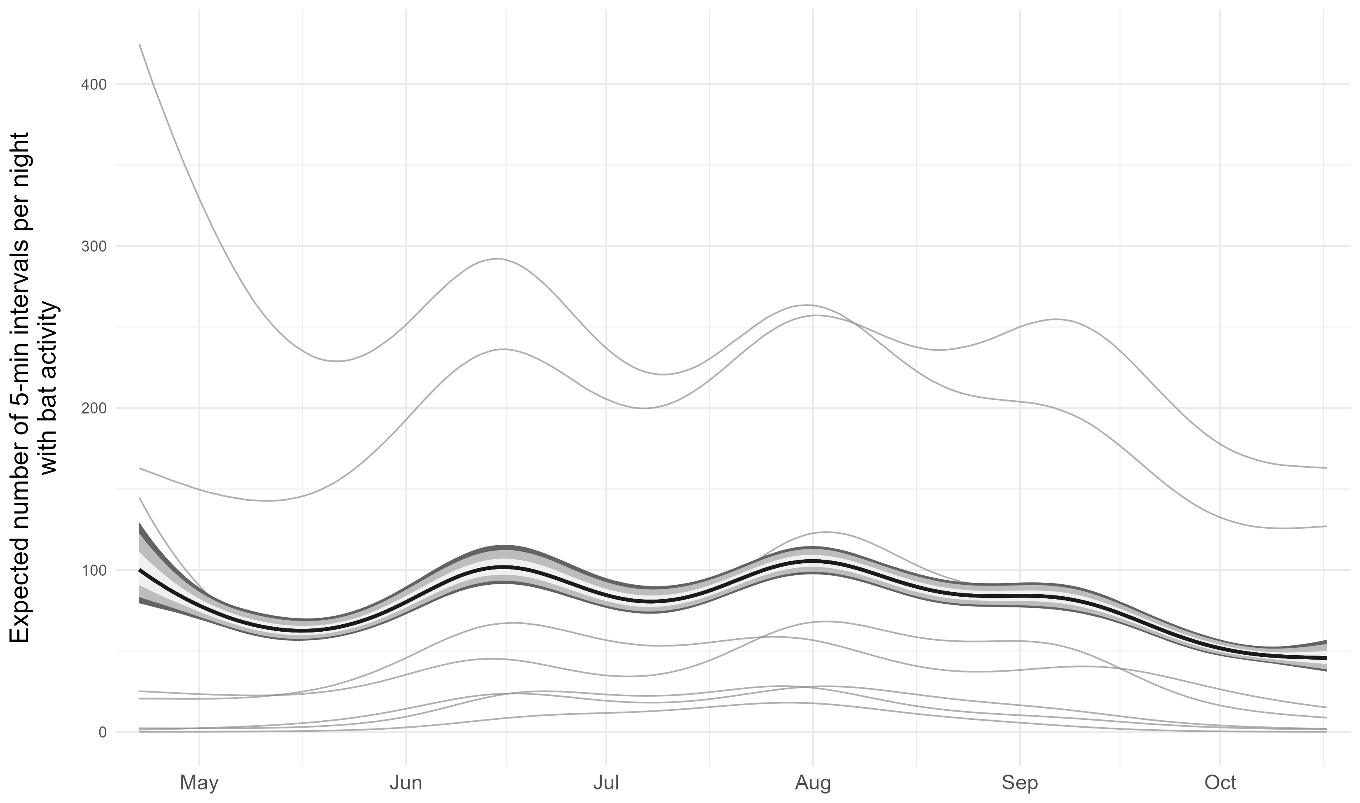
Figure 1: Site-specific seasonal phenology in bat activity from the final aggregate seasonal model. Gray curves show posterior median activity trajectories for individual sites, and the black curve and shaded intervals show the equal-site posterior average and associated credible intervals.

Figure S2. Residual temporal dependence
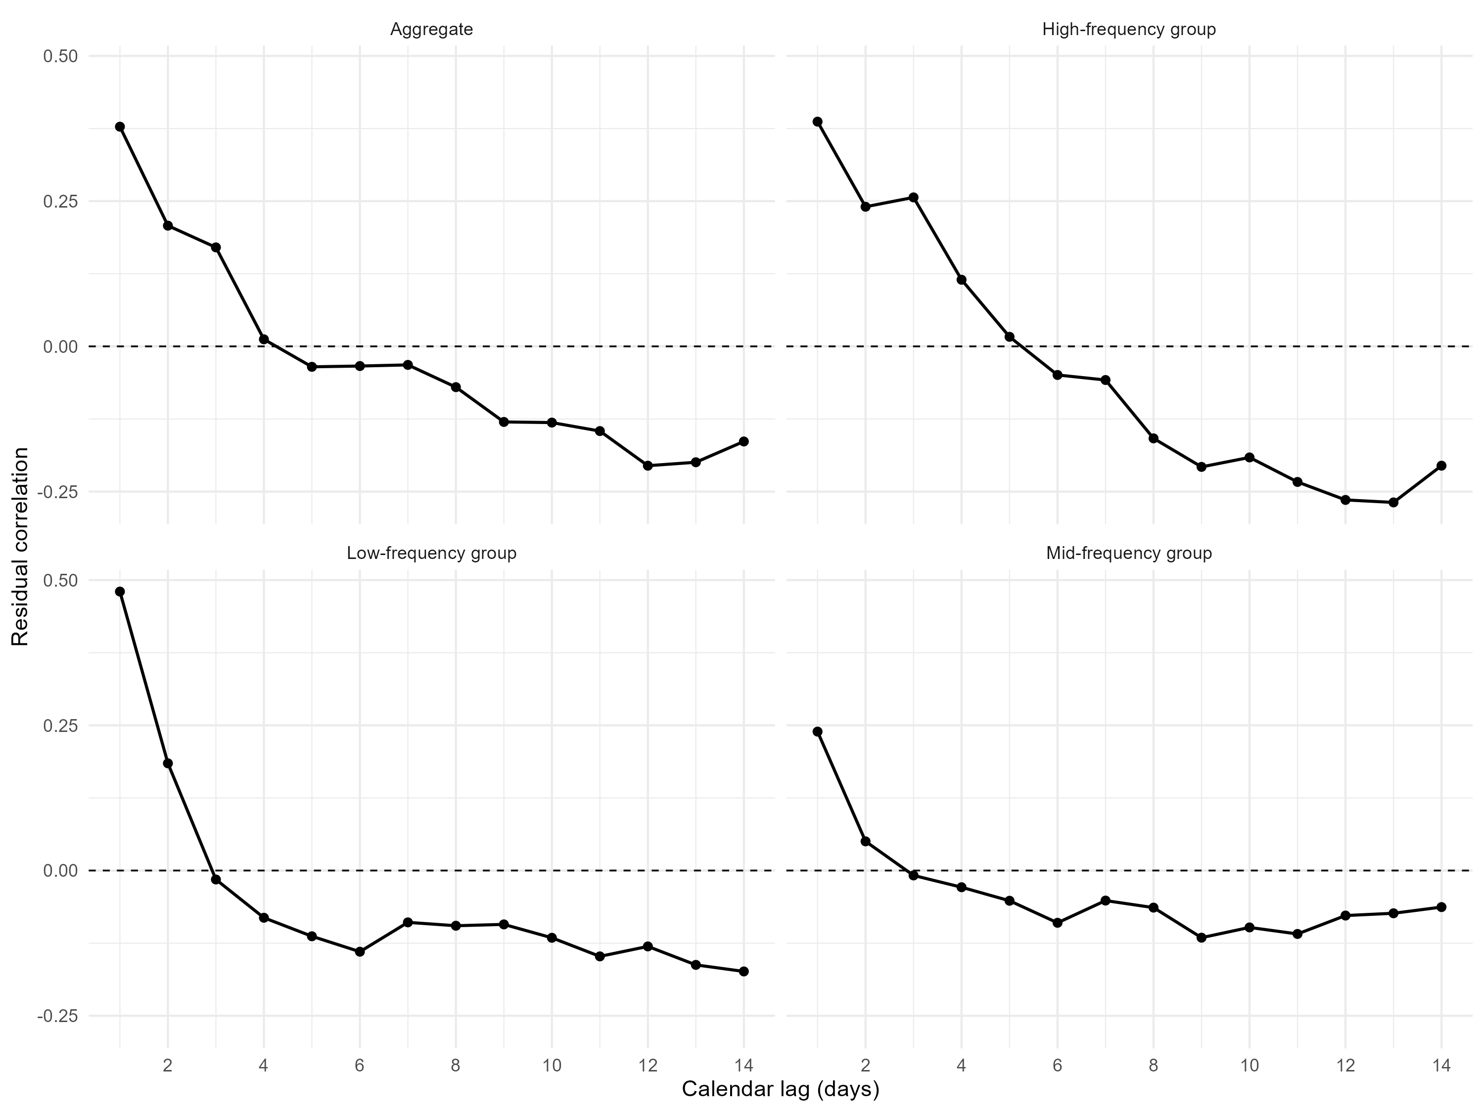
Figure 2: Calendar-aware residual correlation for the final aggregate conditional environmental model and the final low-, mid-, and high-frequency conditional environmental models. Correlations are calculated using actual calendar-day lags so that gaps in sampling are not treated as consecutive observations.

Figure S3. Aggregate posterior predictive checks
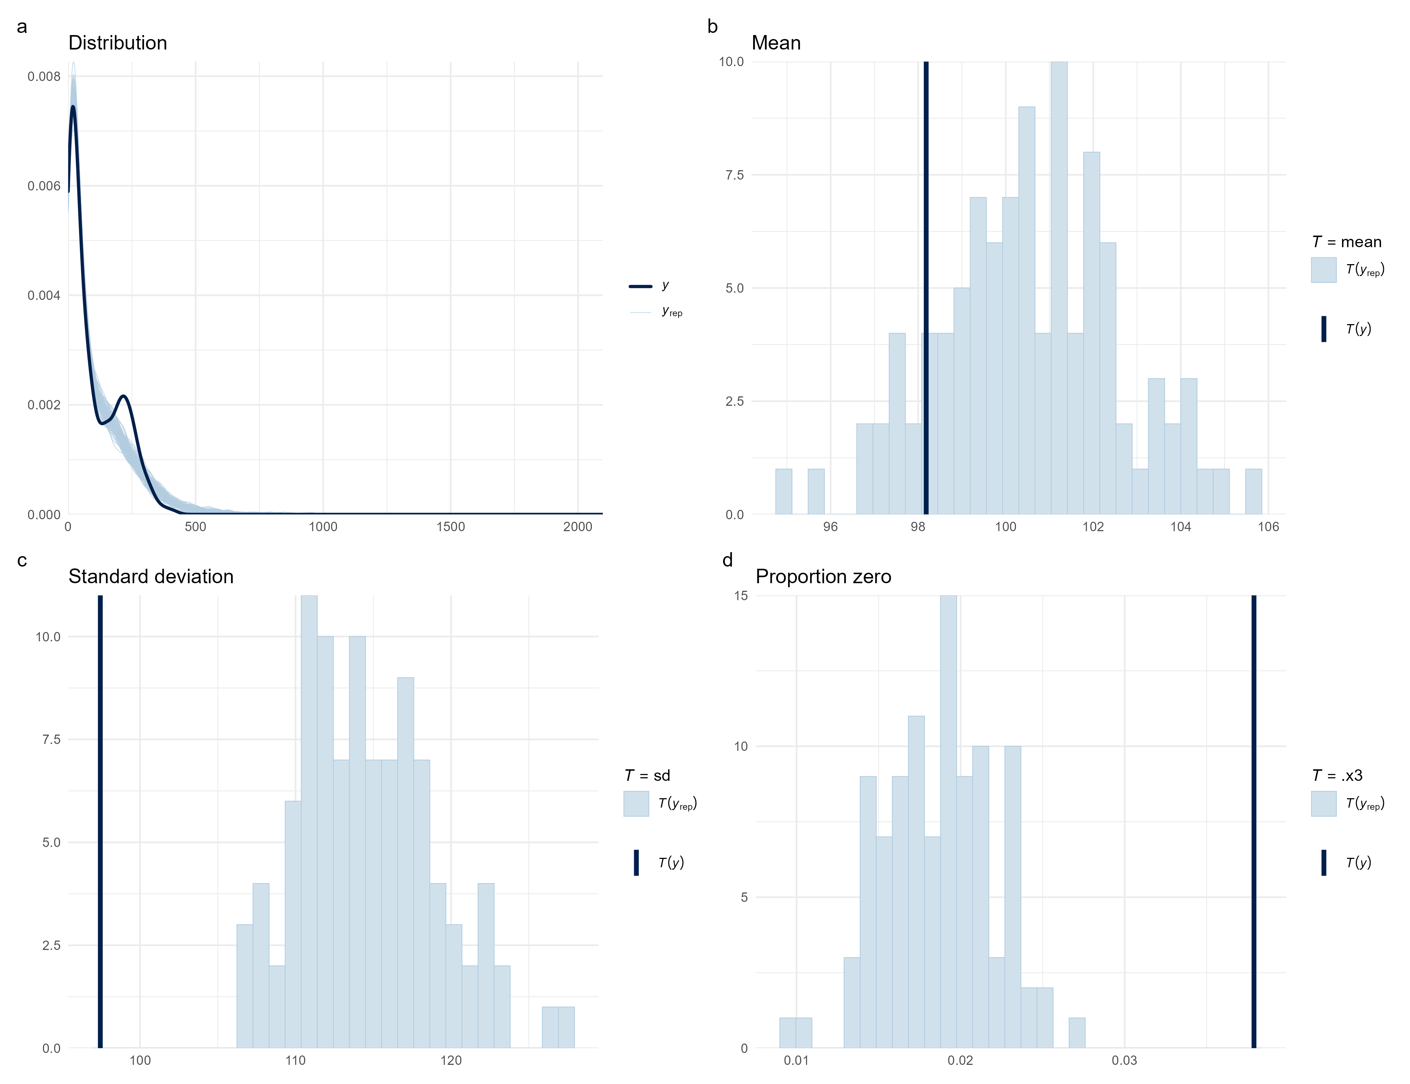
Figure 3: Posterior predictive checks for the final aggregate conditional environmental model. Checks compare the observed nightly activity distribution with replicated datasets generated from the posterior predictive distribution and evaluate key features of the response distribution.

Figure S4. Site-specific posterior predictive checks
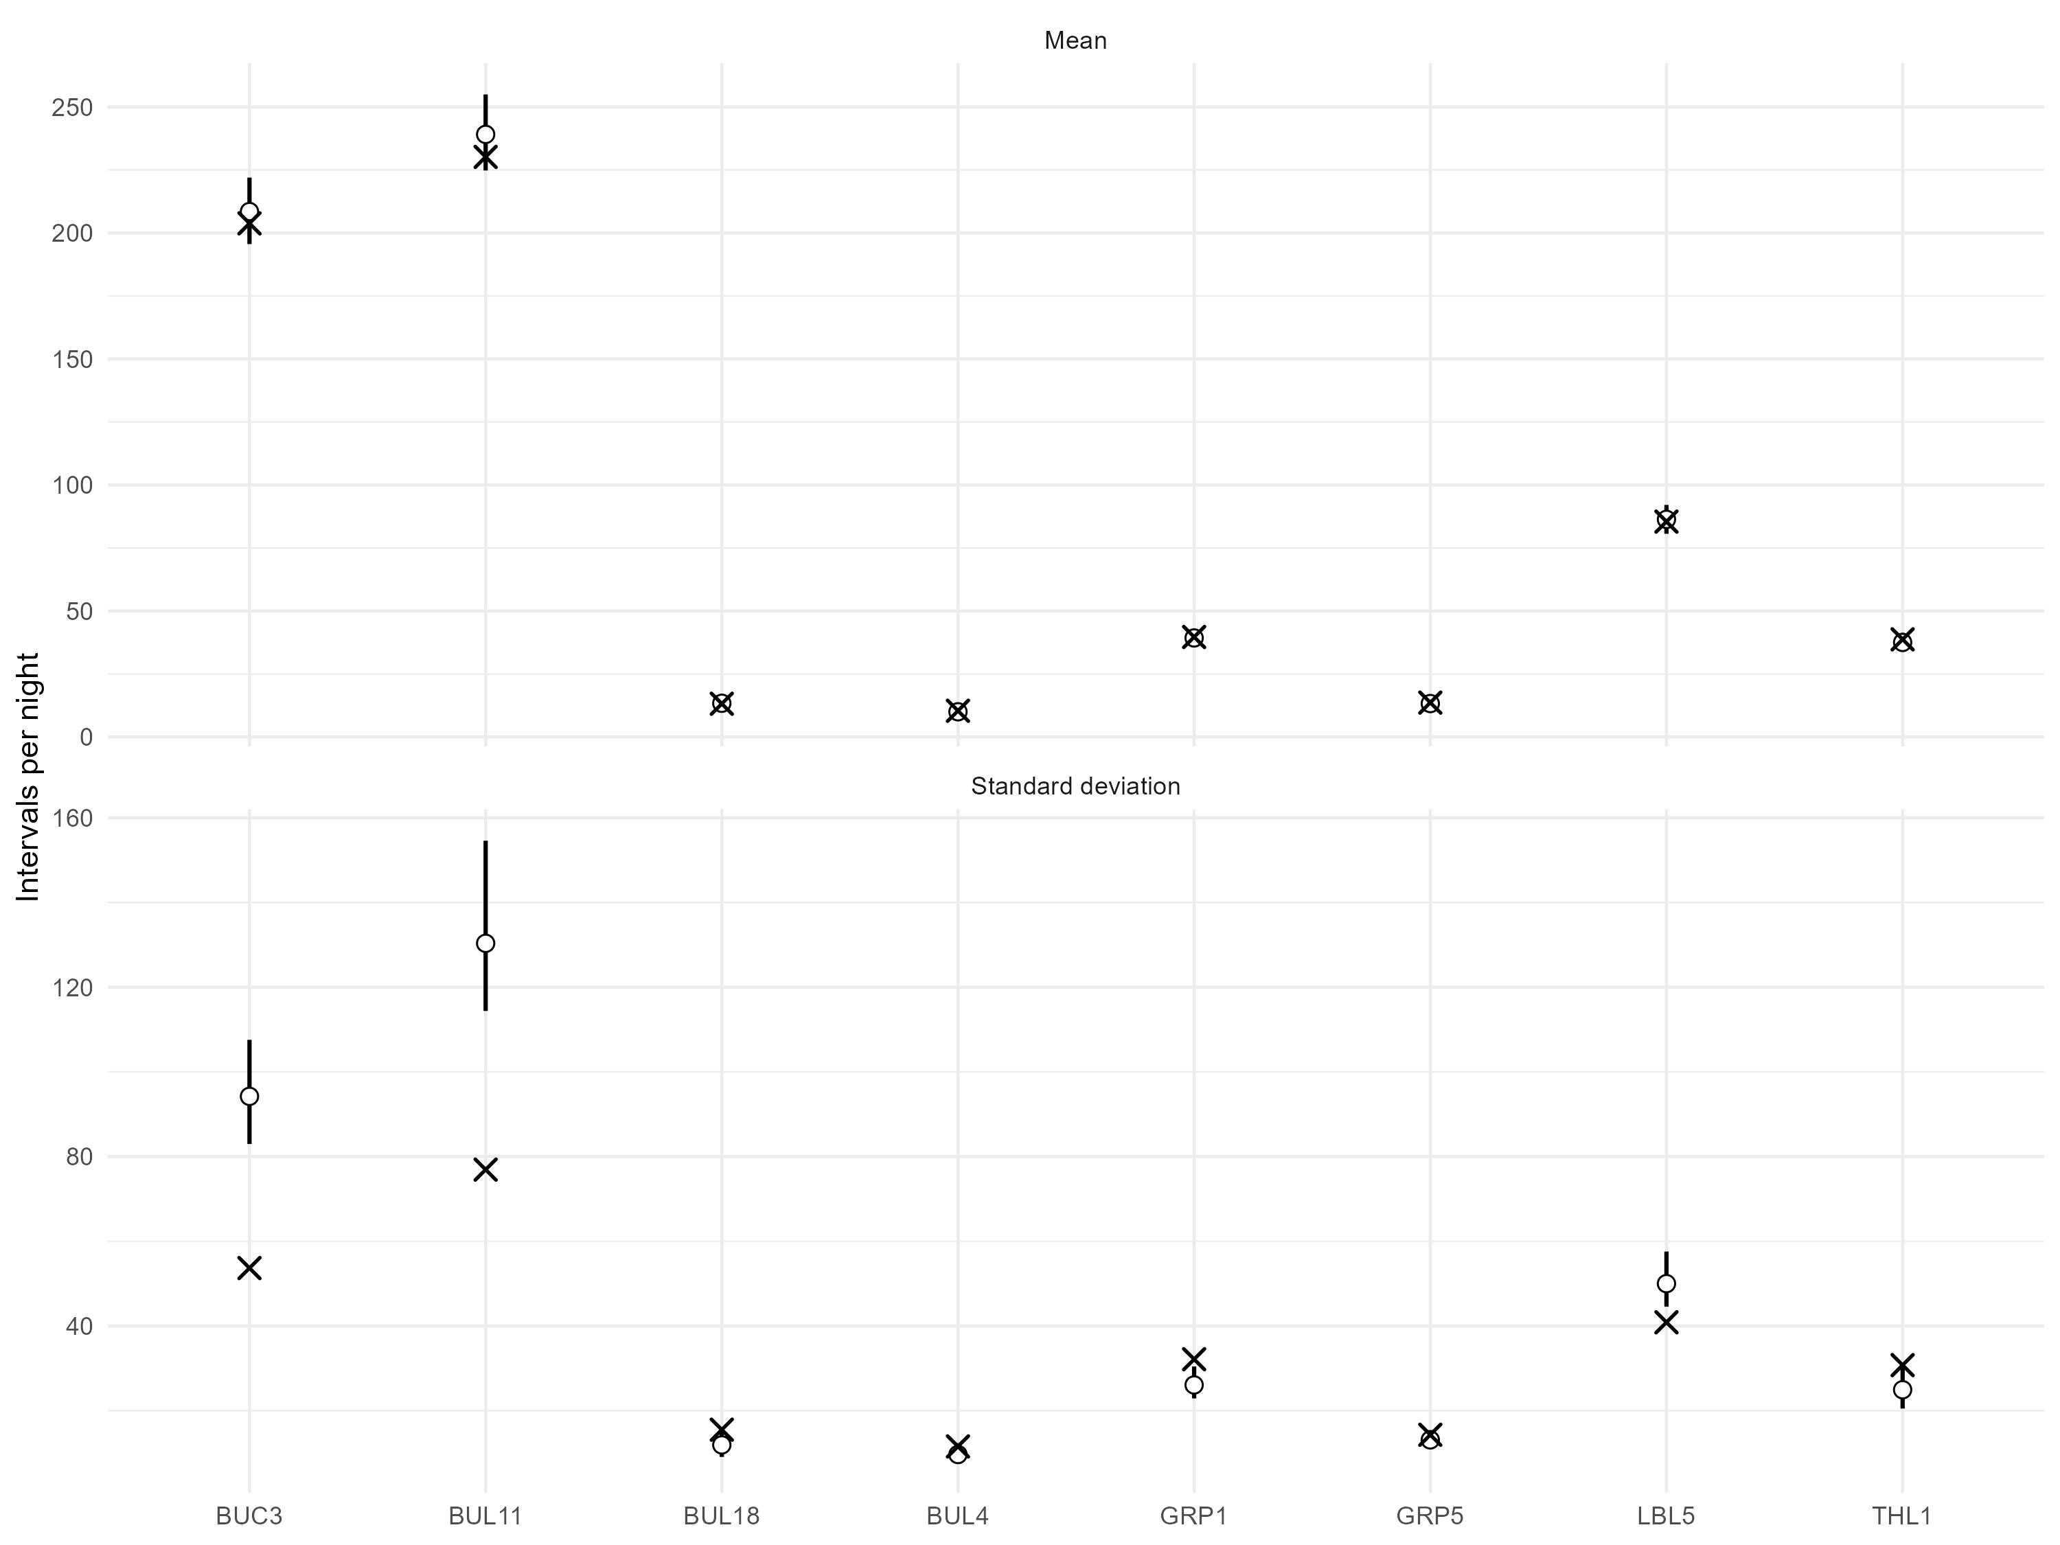
Figure 4: Site-specific posterior predictive checks for the final aggregate conditional environmental model. Crosses show observed site-level means and standard deviations of nightly activity; circles show posterior predictive medians and vertical intervals show 89% posterior predictive intervals.

Figure S5. Frequency-group posterior predictive checks
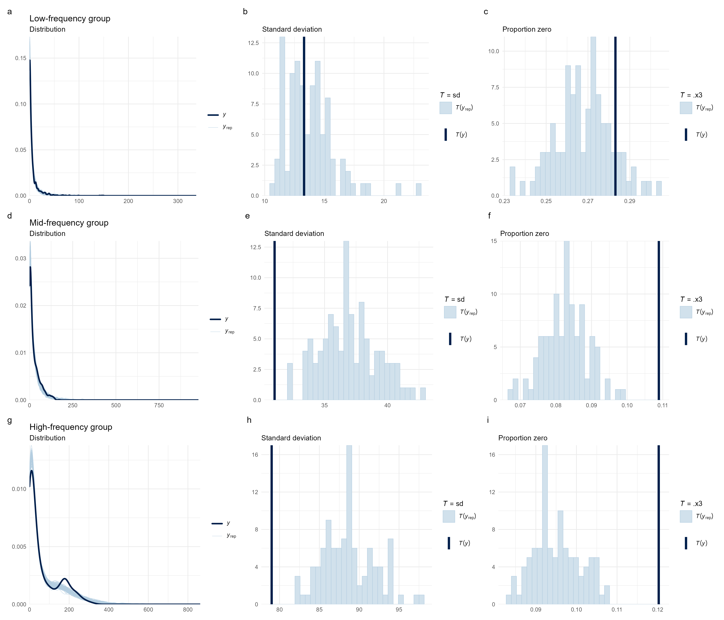
Figure 5: Posterior predictive checks for the final low-, mid-, and high-frequency conditional environmental models. For each frequency group, checks compare the observed response distribution with posterior predictive replicates and evaluate the standard deviation and proportion of zero-activity nights.

Additional model assessment
Routine trace plots are not reproduced because the tabulated sampling diagnostics document convergence and effective sample sizes for the final models. The graphical diagnostics above focus on model adequacy relevant to the biological estimands: posterior predictive fit, among-site predictive performance, and remaining short-lag temporal dependence.

