Methods

Study area and acoustic surveys
Acoustic surveys were conducted at eight sites in Plumas County, California, in the northern Sierra Nevada, spanning an elevational gradient of 581–1,846 m. Most sites were near perennial water sources, including reservoirs (Bucks Lake, Lower Bucks Lake, Grizzly Forebay, and Three Lakes), tributary streams, and the North Fork Feather River; one site was situated in an upland meadow adjacent to forest (Figure 1). Surveys were conducted from April through October 2015, with detectors programmed to record from one hour before sunset to one hour after sunrise.
Each site was equipped with an Anabat II ultrasonic detector and CF-ZCAIM data storage unit (Titley Electronics, Ballina, NSW, Australia) housed in a weatherproof enclosure mounted at least 1 m above the ground. Detectors were fitted with a microphone extension cable, weather shroud, and flat acoustic reflector. Units were powered by batteries recharged with 5-W solar panels and miniature charge controllers (EME Systems, Berkeley, California, USA). Detectors recorded nightly temperature and relative humidity. Lunar phase was obtained from the U.S. Naval Observatory and expressed from 0 (new moon) to 1 (full moon).

Acoustic classification and activity index
Echolocation calls were classified using Kaleidoscope Pro (Wildlife Acoustics Inc., version 5.1.8) with the Bats of North America 5.1.0 classifier at the “More Accurate (Conservative)” setting. Ten percent of classified calls were manually vetted.
Bat activity was quantified using a modified Acoustic Activity Index [@miller2001] based on 5-min sampling intervals. Acoustic detections were divided into 5-min intervals, and nightly activity for each site was calculated as the number of intervals containing at least one bat call. Thus, the response represented the number of 5-min intervals per site-night in which bats were acoustically active rather than the total number of individual calls. Site-nights without usable acoustic data were excluded from analysis rather than treated as zero activity.
For environmental analyses, nightly mean temperature and relative humidity were standardized to a mean of zero and standard deviation of one. Day of year and lunar phase were retained on their original scales for model fitting.

Causal structure and seasonal activity
The causal structure used to distinguish seasonal and nightly environmental associations is shown in Figure 1. Day of year was represented as a common cause of temperature, relative humidity, and bat activity, while temperature was additionally allowed to influence relative humidity. Temperature, relative humidity, and lunar phase were each represented as having direct effects on bat activity. This structure distinguishes the total seasonal pattern in activity from seasonal structure remaining after conditioning on nightly environmental conditions and provides the basis for estimating conditional environmental responses.
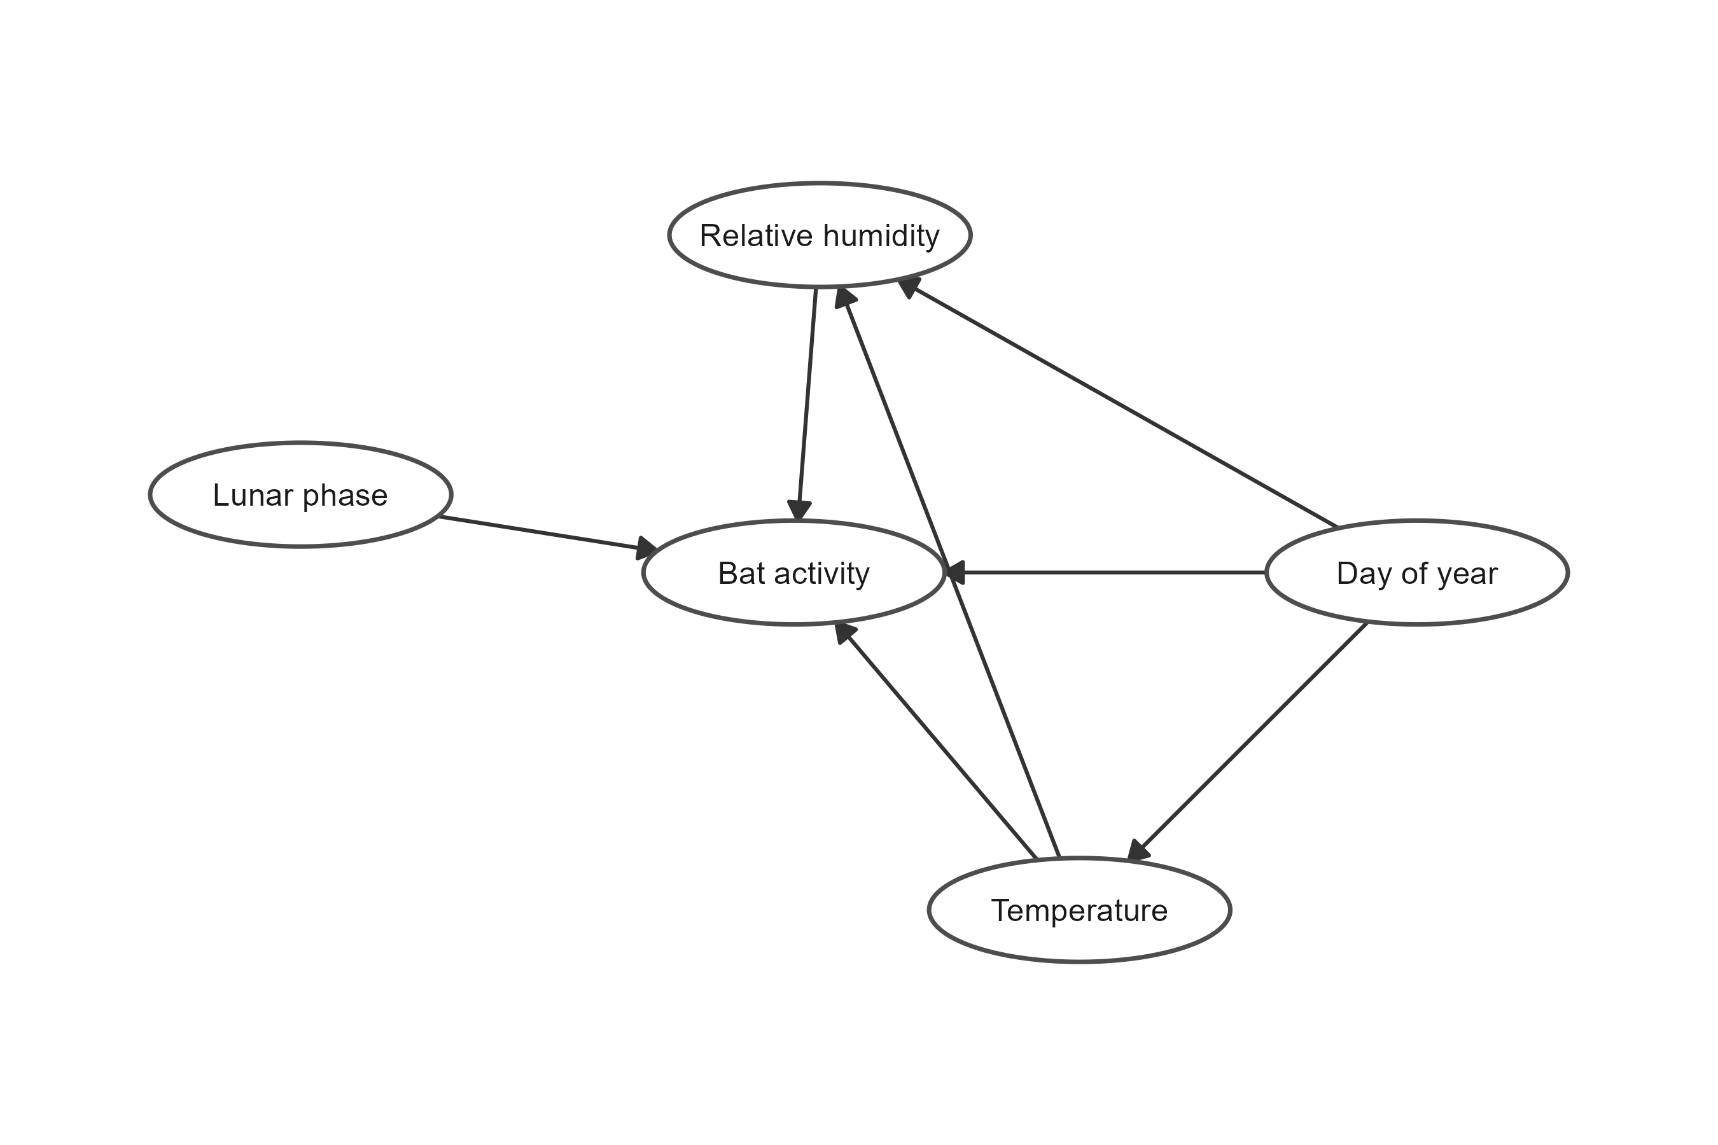
Figure 1: Directed acyclic graph representing the hypothesized causal relationships among day of year, nightly temperature, relative humidity, lunar phase, and bat acoustic activity. Arrows indicate the assumed direction of causal influence. Day of year represents seasonal structure in bat activity and environmental conditions not otherwise represented by the measured nightly covariates. Temperature was assumed to influence relative humidity in addition to having a direct effect on bat activity. Relative humidity and lunar phase were also hypothesized to directly influence bat activity. The graph was used to guide model specification and interpretation of total seasonal and conditional environmental associations.
Two aggregate-community models represented the primary seasonal and environmental estimands. The total seasonal model estimated variation in bat activity across day of year without conditioning on nightly temperature, relative humidity, or lunar phase. Because nightly weather is itself seasonally structured, this model describes the overall seasonal pattern expressed under the environmental conditions occurring through the study period.
The conditional environmental model included day of year, nightly temperature, relative humidity, and lunar phase simultaneously. Environmental response curves from this model therefore describe the association with each focal environmental variable after conditioning on the remaining modeled predictors. The day-of-year smooth from this model represents residual seasonal phenology after accounting for nightly environmental conditions. Comparison of the total seasonal and conditional seasonal patterns was used to distinguish the observed seasonal activity pattern from seasonal structure remaining after nightly weather and lunar phase were held constant.

Characteristic echolocation-frequency groups
To test whether environmental responses varied with characteristic echolocation frequency, we classified each species into one of three frequency groups: low (<25 kHz), mid (25–40 kHz), and high (>40 kHz). Characteristic frequency ($F_{c}$) was defined as the frequency at the lowest, flattest portion of the descending frequency-modulated sweep of an echolocation call, where call bandwidth is narrowest and the call typically provides its diagnostic signal for species identification [@fenton1981; @ofarrell1999]. Group boundaries were based on species accounts in the Western Bat Working Group reference and the Kaleidoscope Pro classifier reference-call library and correspond to frequency ranges over which atmospheric absorption of ultrasound is expected to differ in sensitivity to humidity [@griffin1971; @lawrence1982].
The low-frequency group contained Lasiurus cinereus, Eumops perotis, and Euderma maculatum. The mid-frequency group contained Eptesicus fuscus, Lasionycteris noctivagans, Tadarida brasiliensis, Antrozous pallidus, Myotis evotis, Myotis thysanodes, and Corynorhinus townsendii. The high-frequency group contained Myotis yumanensis, M. lucifugus, M. californicus, M. ciliolabrum, M. volans, Parastrellus hesperus, and Lasiurus frantzii. Full species-level information, characteristic frequencies, and detection totals are provided in Table S4.
For each frequency group, nightly activity at each site was calculated as the number of 5-min intervals containing at least one detection from any species assigned to that group. The same model-development and diagnostic framework used for aggregate activity was then evaluated for the frequency-group datasets.

Bayesian generalized additive models
We modeled nightly acoustic activity using Bayesian generalized additive models (GAMs) fit in brms [@burkner2017] with Stan [@carpenter2017]. Nightly activity was represented as the number of 5-min intervals containing at least one bat call and was modeled using a negative-binomial distribution with a log link to accommodate the substantial variation among nights.
Seasonal activity was allowed to vary among sites. Although the eight sites occurred within the same geographic region, local differences in habitat, elevation, species composition, resource availability, and roost use could produce differences in the timing and magnitude of seasonal bat activity. We therefore represented seasonality using a population-level smooth of day of year together with a factor-smooth interaction between day of year and site. The factor smooth estimates penalized site-specific departures from the overall seasonal trajectory, allowing local phenology to differ while sharing information among sites.
We fit two complementary models to distinguish overall seasonal variation from conditional environmental relationships. The total seasonal model was
$$n_{it}∼NegBinomial(μ_{it},ϕ),$$
$$log(μ_{it})=β_{0}+f({DOY}_{it})+f_{site}({DOY}_{it}),$$
where $n_{it}$ is the number of occupied 5-min intervals at site $i$ on night $t$, $f(DOY)$ represents the overall seasonal trajectory, and $f_{site}(DOY)$ represents penalized site-specific departures from that trajectory. Because this model does not condition on nightly environmental covariates, it describes the total seasonal pattern in acoustic activity, including seasonal variation associated with changing environmental conditions.
The conditional environmental model was
$$log(μ_{it})=β_{0}+f({DOY}_{it})+f_{site}({DOY}_{it})+f(T_{it})+f(RH_{it})+f(L_{it}),$$
where $T$ is standardized nightly mean temperature, $RH$ is standardized nightly mean relative humidity, and $L$ is lunar phase. This model estimates the relationship between each environmental predictor and acoustic activity conditional on the other predictors and seasonal structure in the model. Thus, the seasonal and environmental models address different questions: the former describes the overall seasonal pattern in activity, whereas the latter evaluates environmental relationships after accounting for seasonality and site-specific phenology.
Smooth terms were estimated using the default thin-plate regression spline basis in brms/mgcv, and site-specific seasonal trajectories were represented using a factor-smooth basis (bs = "fs"). Because the factor smooth is fully penalized and represents site-level differences in the seasonal trajectory, we did not include an additional site random intercept.

Priors, computation, and model assessment
We used a weakly informative Normal(0, 10) prior for the intercept; smoothing parameters and the negative-binomial shape parameter used the regularizing defaults implemented by brms. Models were estimated using Hamiltonian Monte Carlo through the cmdstanr backend, with four chains of 4,000 iterations, including 1,000 warmup iterations per chain, yielding 12,000 post-warmup draws. Sampling used adapt_delta = 0.99 and a maximum tree depth of 12.
We assessed convergence and sampling quality using $\hat{R}$, bulk and tail effective sample sizes, divergent transitions, maximum-tree-depth warnings, and energy diagnostics. Model adequacy was evaluated using posterior predictive checks of the response distribution and site-level variation, including the mean, standard deviation, and frequency of zero-activity nights. Because sampling was interrupted at some sites by detector failures, residual temporal dependence was evaluated using calendar-day lags rather than row-order lags, ensuring that missing sampling nights were not treated as consecutive observations. We examined these residual correlations to determine whether important temporal structure remained after accounting for the shared and site-specific seasonal trajectories.
Posterior summaries are reported as medians with 89% credible intervals. Environmental response curves were generated from the conditional environmental model by varying the focal predictor across its observed range while holding other continuous environmental predictors at their reference values. Seasonal predictions were obtained from the seasonal model and therefore represent the total fitted seasonal pattern rather than seasonality conditional on nightly temperature, relative humidity, or lunar phase.
All analyses were conducted in R. Models were fit with brms [@burkner2017] using Stan [@carpenter2017] through cmdstanr; posterior summaries and predictions were generated using posterior and tidybayes [@kay2023].

