House Price Prediction using Linear Regression
Artificial Intelligence & Machine Learning Internship
Submitted To:
Sumerix Global

Submitted By:
Aniket Bhosale

B.Tech Computer Science Engineering
MIT Art, Design & Technology University Pune

1. Project Overview
The objective of this project was to improve house price prediction performance using feature scaling and model comparison techniques. Multiple machine learning algorithms were trained and evaluated to identify the most suitable model for predicting house prices.
Tools Used:
- Python
- Pandas
- NumPy
- Matplotlib
- Scikit-learn
Dataset:
California Housing Dataset containing 20,640 records and 8 input features

2. Methodology
- Loaded the California Housing Dataset
- Separated features and target variable
- Applied Standard Scaler for feature scaling
- Split data into training and testing sets
- Trained multiple regression models
- Compared model performance using RMSE and R² Score
- Selected the best-performing model
- Visualized prediction results

3. Models Used
- Linear Regression
- Ridge Regression
- Decision Tree Regressor

Results
Model | RMSE | R² Score
Linear Regression | 0.745581 | 0.575788
Ridge Regression | 0.745554 | 0.575819
Decision Tree | 0.724234 | 0.599732

4. Visualizations
The project included the following visualizations:
Actual vs Predicted House Prices
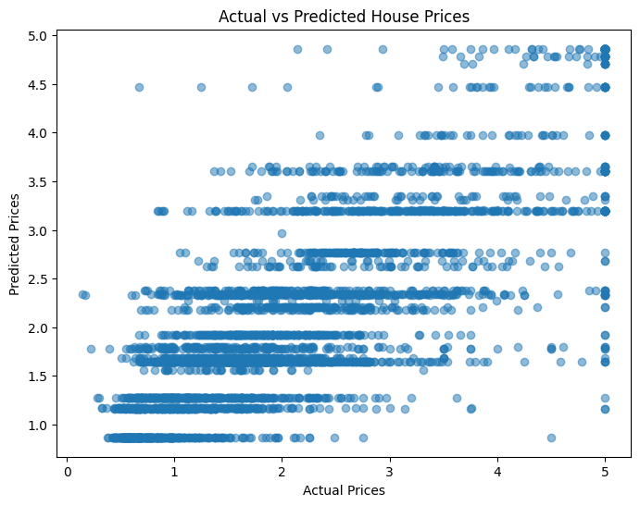
Interpretation:
The scatter plot compares the actual house prices with the predicted house prices generated by the Decision Tree Regressor model. Points closer to the diagonal trend indicate better prediction accuracy. The visualization demonstrates that the model is able to capture the relationship between input features and house prices with reasonable accuracy
5. Conclusion
6. Conclusion
In this project, feature scaling and model comparison techniques were applied to improve the performance of house price prediction. Three machine learning models—Linear Regression, Ridge Regression, and Decision Tree Regressor—were trained and evaluated using RMSE and R² Score metrics.
The Decision Tree Regressor achieved the best performance with the lowest RMSE (0.724234) and the highest R² Score (0.599732). This demonstrated that model selection plays an important role in improving prediction accuracy.
Through this project, practical experience was gained in data preprocessing, feature scaling, model training, performance evaluation, and selecting the most suitable machine learning model for a real-world prediction problem.

.

