Feedback and suggested improvements for GNH application

1. Incorect validations get run, on click of update button, see fig, -1.00 should not be there, instead normal text would be there,

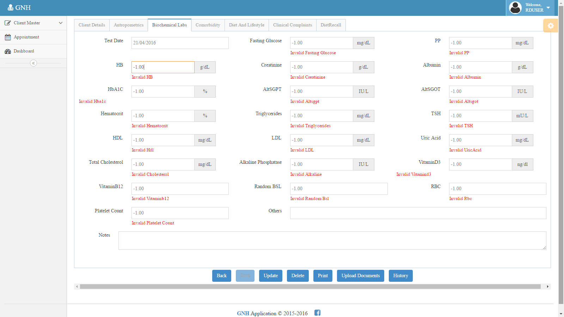

1. Increase width of notes section in DietAndLifeStyle section – done but recheck
2. Remove DietRecall Tab in patient details section
3. Dashboard shows all appointments confirm whether todays appointment need to show
4. Receptionist page for in office marking with list of today’s patient should be designed
5. Client History functionality should be done
6. Followup questions functionality need to be coded with database save
7. Weight change graph doesn’t show up when no record is found in trail tables
8. Report should be generated correctly as per suggestion last time, All
9. Recommended Diet, Upload documents, Recall Diet, weight change graph should go under patient’s menu after visit start and in left side (Need to design this panel)
10. No provision for mark as visit graph
11. Appointment autocomplete feature should be implemented with existing patient list
12. Keyboard listener to move between Tabs should be taken care while entering in input fields since user may use next and previous keyboard buttons at that time
13. Remove test test test client from live database since not populating data at that time
14. Use my latest solution to continue further
15. If possible try to prevent country, state and city dropdown postback, with ajax request since it is annoying and clearing on page javascript
16. Recheck following bugs that fixed

ViewAppointment.aspx must be set instead of Edit.aspx to Appointments Menu (../ViewAppointments.aspx)

Followup Questions should be linked correctly to page Followup Questions (../Screens/FollowupQuestions.aspx)

Comment alert in IBW() Javascript function

Change Menu name Recommended Diet to Recall Diet in DB

Correction –

document.getElementById('<%=txtIdealBodyWeight.ClientID %>').disabled = true;

//make it ""false" before changing value of Ideal body weight textbox in IBW function

Add this in update panel register script too - since postback removing this,Hide DietRecall Tab in Patient Master –

$("a[href$='tabs-7']").parent().replaceWith("</ul><ul>");