 |  | 

INSTITUTE FOR ADVANCED COMPUTING AND

SOFTWARE DEVELOPMENT AKURDI, PUNE

Documentation On
“Online Vegetables Shopping System”
PG-DAC FEB 2020

Submitted By:
Group No: 87
Sudhir Bhosale 1124
Mayur Kadam 1162

Prashant Karhale  Centre Coordinator |  | Mr. Akshay Parab  Project Guide

Table of Content
1. Introduction .................................................................................................................................... 4
Document Purpose .........................................................................................................................4
Problem Statement .........................................................................................................................4
Product Scope ...............................................................................................................................4
Aim & Objectives .........................................................................................................................4
2. Overall Description .........................................................................................................................5
Product Perspective.........................................................................................................................5
Benefits of Society Management System ......................................................................................5
User and Characteristics ................................................................................................................6
Operating Environment .................................................................................................................6
Design and Implementation Constraints .......................................................................................7
3. Requirements Specification ...........................................................................................................7
External Interface Requirements ...................................................................................................7
4. System Diagram ..............................................................................................................................8
Activity Diagram ............................................................................................................................8
Data Flow Diagram ........................................................................................................................9
Class Diagram ...............................................................................................................................12
Use Case Diagram .........................................................................................................................13
ER Diagram ...................................................................................................................................14
SDLC .............................................................................................................................................14
5. Table Structure ............................................................................................................................. 15
Role ................................................................................................................................................15
Users .............................................................................................................................................15
Vegetables .....................................................................................................................................16
Orders ............................................................................................................................................16
Shipment .......................................................................................................................................16
6. Conclusion ....................................................................................................................................17
Future Scope .................................................................................................................................17
7. References .....................................................................................................................................17

List of Figures
Figure 1 Activity Diagram ....................................................................................................................8

Figure 2 Level 0 Data Flow Diagram .................................................................................................. 9

Figure 3 Level 1 Data Flow Diagram .................................................................................................. 9

Figure 4 Level 2 Data Flow Diagram for Shopper ..............................................................................10

Figure 5 Level 2 Data Flow Diagram for Customer ...........................................................................10
Figure 6 Level 2 Data Flow Diagram for Admin ................................................................................11
Figure 7 Class Diagram .......................................................................................................................12
Figure 8 Use Case Diagram .................................................................................................................13
Figure 9 ER Diagram ..........................................................................................................................14
Figure 10 SDLC……............................................................................................................................14

- Introduction
Now these days people buy vegetables manually from market , shops and malls. In manual system , customers have to face many problems like bargaining , quality ,quantity, and its very time-consuming process , customers have to travel for buying vegetables. The Online Vegetable Shopping System allows customers to buy vegetables with reasonable rates and discounts, customers get the products at their doorstep. This system is for all who don’t have time to purchase vegetables and farmers who has to sell their product to customers directly
  - Document Purpose
The advancement in Information Technology and internet penetration has greatly enhanced various business processes to go online This Online Vegetable Shopping System is developed to provide the following services:

Enhance Business Processes:
This system allows farmers to sell their product to customers directly without any third-party commission.

Online Vegetable Shopping System:
A tool through which Shopper can add products and customer can buy the products .The admin also receives some set of functionalities which help in managing the website effectively.

  - Problem Statement

Now these day people buy vegetables manually from market , shops and malls. In manual system , customers have to face many problems like bargaining , quality ,quantity, and its very time-consuming process , customers have to travel for buying vegetables .
  - Product Scope
This system allows farmers to sell their product to customers directly connecting with customers by adding it to cart ,so there is no 3rd party person involve in it and customers those don’t have time to go market they can select ,add product to cart , and receive the product through local delivery boy.

  - Aims & Objectives

Specific goals are: -

- To produce a web-based system that allow the shopper to add vegetables and with their details.
- To ease customers by providing them different functionalities like searching , selecting, adding to shopping cart and place the order.
- Admin will have access to all the activities on the Website.

- Overall Description
  - Product Perspective:

    - Existing system function:
People buy vegetables manually from market, shops and malls. In manual system , customers have to face many problems like bargaining , quality ,quantity, and its very time-consuming process , customers have to travel for buying vegetables. This system provides customers to buy vegetables with reasonable rates and discounts, customers get the products at their doorstep. This system is for all who don’t have time to purchase vegetables and farmers who has to sell their product to customers directly.

    - PROPOSED SYSTEM

      - Product functionality:
Online Vegetables Shopping System provides the feature for shopper, customer and admin. . It includes several functionalities describes as below:

      - Shopper :
Shopper can add vegetables with their details like title, description , category, unit price, quantity using their credentials.

      - Customer:
Customer can search, select product also add to shopping cart and place order.

      - Admin:
Admin will have access to all the activities on the Website to work it efficiently.

  - Benefits of Online Vegetable Shopping System

- This online vegetable shopping system is fully functional and flexible.
- It is very easy to use.
- This online vegetable shopping system helps shoppers to sell products and customers get easy solution to buy their daily needs.
- It saves a lot of time and gives quick delivery.
- Best way to buy daily needs in this pandemic situation .
- The application acts as a shop that is open 24/7.
- It increases the quality of product and offers best service to the customers.

  - Users and Characteristics:
    - Shopper:
• Shopper can login to the system.
- View the list of all vegetables which he had added already.
- Add new vegetables .
- Delete vegetables.
- Update vegetables details.

    - Customer:
- Customer can login to the system.
- View the list of all vegetables which are available.
- Can add to shopping cart.
- View the list of all products add in cart.
- Also can remove product from cart.
- Can place the order.

    - Admin:
- Admin can login to the system.
- View the list of all users .
- Can view the list by account type of users.
- Admin can remove particular user.
- Can update the users active or inactive status.

  - Operating Environment:
    - Server Side:
Processor: Intel® Xeon® processor 3500 series
HDD: Minimum 1Tb Disk Space
RAM: Minimum 4GB
OS: Windows 8.1, Linux 6
Database: MySQL

    - Client Side (minimum requirement):
Processor: Intel Dual Core
HDD: Minimum 50GB Disk Space
RAM: Minimum 4GB
OS: Windows 10, Linux

  - Design and Implementation Constraints:
- The application will use HTML 5, CSS, Bootstrap as main web technologies.
- HTTP and FTP protocols are used as communication protocols. FTP is used to upload the web application in live domain and the client can access it via HTTP protocol.
- Several types of validations make this web application a secured one and SQL Injections can also be prevented.
- Since Online Vegetable Shopping System is a web-based application, internet connection must be established.
- The Online Vegetable Shopping System will be used on PCs and will function via internet or intranet in any web browser.

- Specific Requirement:
  - External Interface Requirements:
    - User Interfaces:
- All the users will see the same page when they enter in this website. This page asks
the users a username and a password.
- After being authenticated by correct username and password, user will be redirect to their corresponding profile where they can do various activities.
- The user interface will be simple and consistence, using terminology commonly understood by intended users of the system. The system will have simple interface, consistence with standard interface, to eliminate need for user training of infrequent users.

    - Hardware Interfaces:
- No extra hardware interfaces are needed.
- The system will use the standard hardware and data communication resources.
- This includes, but not limited to, general network connection at the server/hosting site, network server and network management tools.

  - Application Interfaces:

OS: Windows 10, Linux
Web Browser:
The system is a web-based application; clients need a modern web browser such as Mozilla Firebox, Internet Explorer, Opera, and Chrome. The computer must have an Internet connection in order to be able to access the system.

Communications Interfaces:
- This system uses communication resources which includes but not limited to, HTTP protocol for communication with the web browser and web server and TCP/IP network protocol with HTTP protocol.
- This application will communicate with the database that holds all the booking information. Users can contact with server side through HTTP protocol by means of a function that is called HTTP Service. This function allows the application to use the data retrieved by server to fulfill the request fired by the user.

- System Design:
  - Activity Diagram:
Figure 1:Activity Diagram

  - Data Flow Diagram:
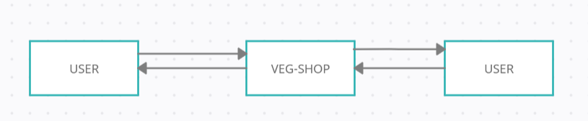
Figure 2: Level 0 Data Flow Diagram

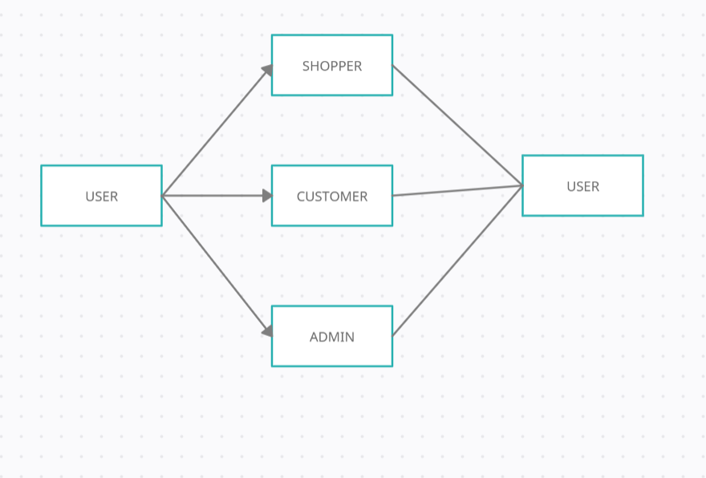
Figure 3: Level 1 Data Flow Diagram

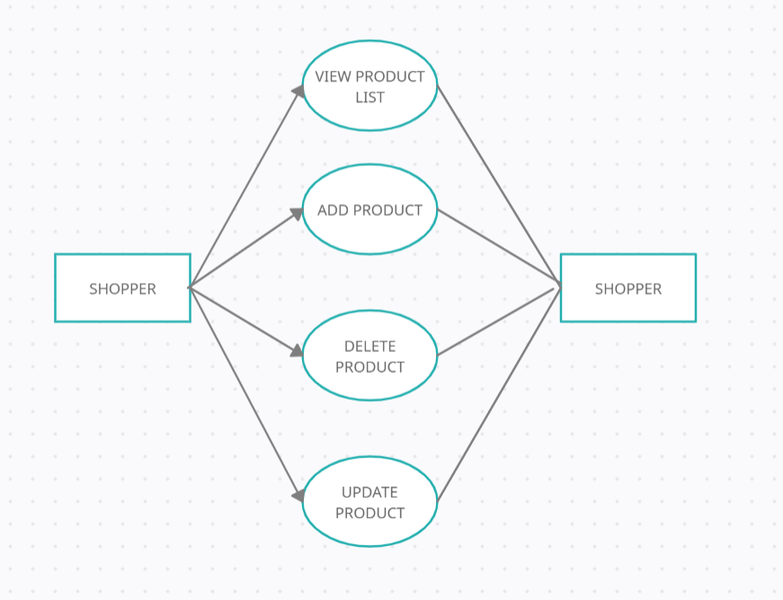
Figure 4:Level 2 Data Flow Diagram for Shopper

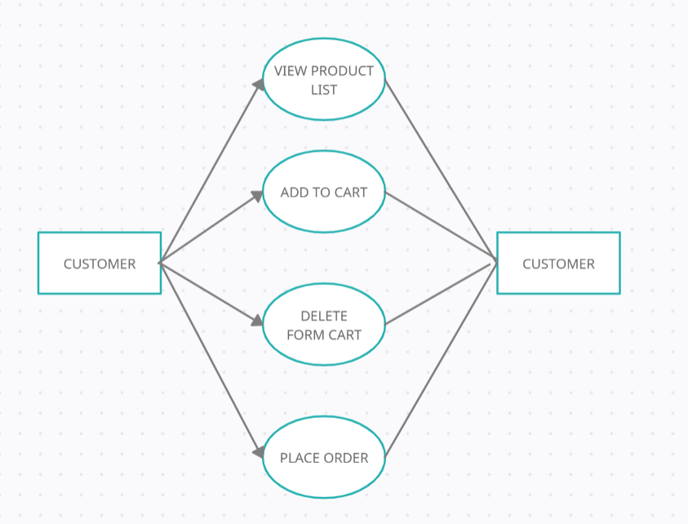
Figure 5:Level 2 Data Flow Diagram for Customer
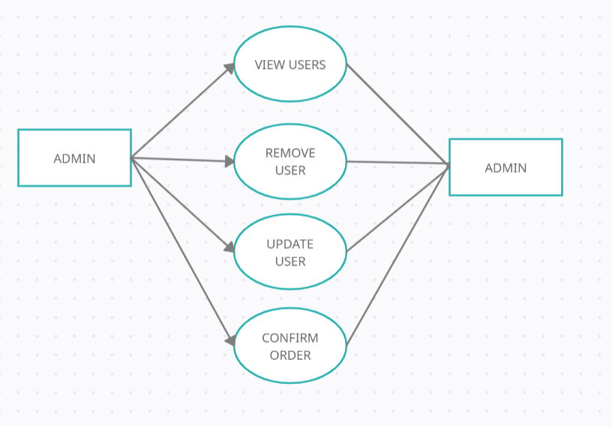
Figure 6:Level 2 Data Flow Diagram for Admin

  - Class Diagram:

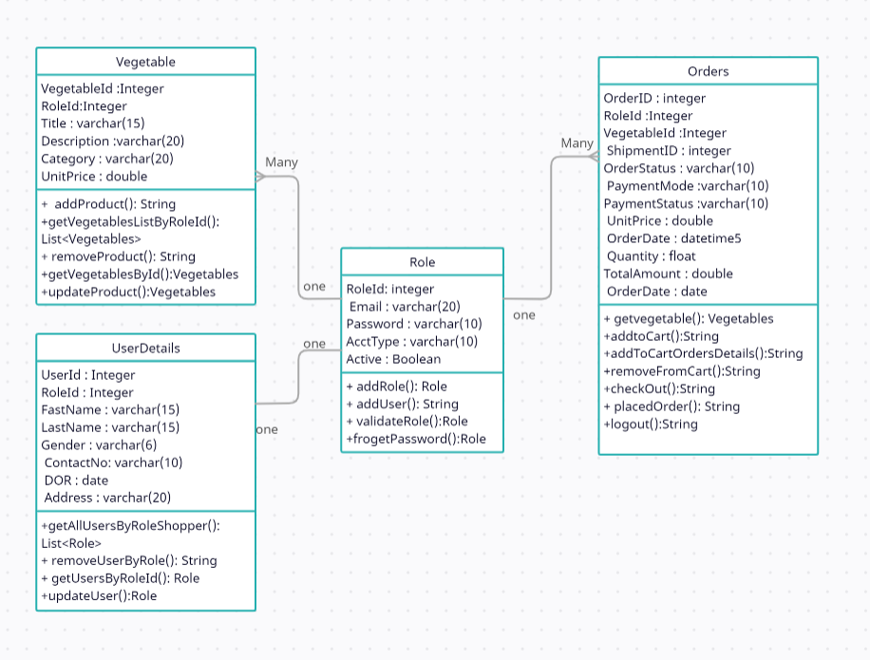

Figure 7: Class Diagram

  - Use Case Diagram:

Figure 8:Use Case Diagram

  - ER Diagram:

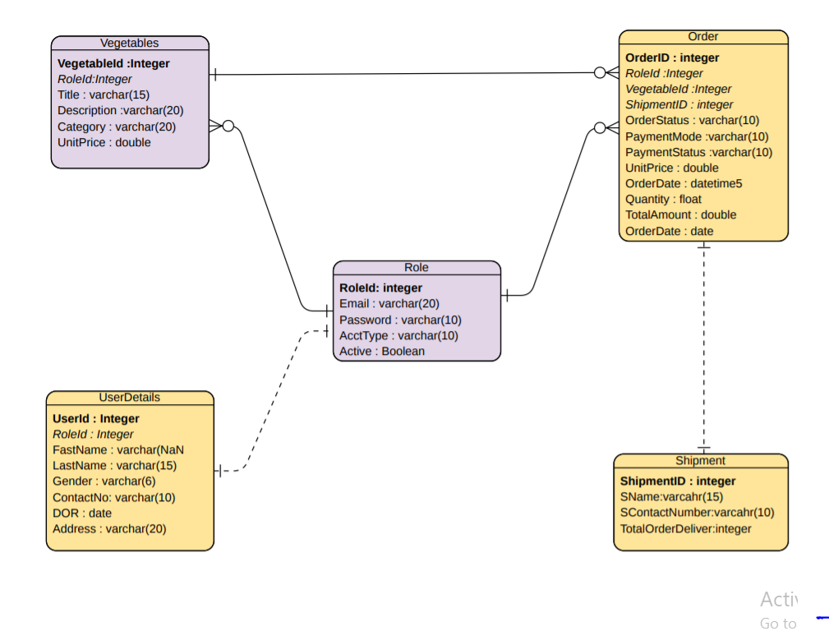

Figure 9:ER Diagram

  - SDLC

Figure 10: SDLC

- Table Structure:

  - Role:

Field | Type | Null | Key | Default | Extra
roleId | number(11) | NO | PK | NULL | Auto_increment
email | varchar2(30) | NO |  | NULL
password | varchar2(30) | NO |  | NULL
accType | varchar2(30) | NO |  | NULL

  - Users:

Field | Type | Null | Key | Default | Extra
userId | number(11) | NO | PRI | NULL | Auto_increment
firstName | varchar2(30) | NO |  | NULL
lastName | varchar2(30) | NO | UNI | NULL
gender | varchar2(30) | NO |  | NULL
address | varchar2(30) | NO |  | NULL
contactNo | varchar2(30) | NO |  | NULL
DOR | date | NO |  | NULL
active | boolean | NO |  | true
roleId | number(11) | NO | FK

  - Vegetables:

Field | Type | Null | Key | Default | Extra
vegetableId | number(11) | NO | PK | NULL | Auto_increment
title | varchar2(30) | NO |  | NULL
description | varchar2(30) | NO |  | NULL
category | varchar2(30) | NO |  | NULL
unitPrice | number(11) | NO |  | NULL
quantity | number(11) | NO |  | NULL
roleId | number(11) | NO | FK

  - Orders:

Field | Type | Null | Key | Default | Extra
orderId | number(11) | NO | PK | NULL | Auto_increment
roleId | number(11) | NO | FK
vegetableId | number(11) | NO | FK
ShipmentId | number(11) | NO | FK
orderStatus | varchar2(30) | NO |  | NULL
paymentMode | varchar2(30) | NO |  | NULL
paymentStatus | varchar2(30) | NO |  | unpaid
unitPrice | number(11) | NO |  | NULL
Quantity | number(11) | NO |  | NULL
orderDate | varchar2(30) | NO |  | NULL
totalAmount | number(11) | NO |  | NULL

  - Shipment:

Field | Type | Null | Key | Default | Extra
shipmentId | number(11) | NO | PK | NULL | Auto_increment
sName | varchar2(30) | NO |  | NULL
sContactNumber | varchar2(30) | NO |  | NULL
totalOrderDeliver | number(11) | NO |  | NULL

- Conclusion

Online Vegetable shopping system give an easy solution to small shoppers to sell their vegetables without any third-party commission. Customer will get best option to buy his daily needs and a quality product. Admin will have access to all the activities on the Website to work it efficiently.

Future Scope
This project can be enhanced further by giving discount on best buy, feedback given by customer, online payment facility . The software is flexible enough to be modified and implemented as per future requirements. We have tried our best to present this free and user–friendly website to Shoppers and Customer. Message and Email alerts for various happenings in the Application can be added to the system so that users do not miss the update.

- References
Online References
- www.bigbasket.com/
[2]https://docs.oracle.com/javase/tutorial/

