0.5 x 0.5

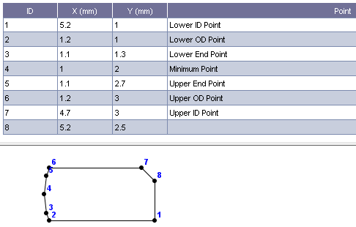

auo=1.91047e-3; %upper OD width

aui=1.58953e-3; %upper ID width

alo=1.91047e-3; %lower OD width

ali=2.08953e-3; %lower ID width

huo=1.01284e-3; %upper OD height

hui=1.01284e-3; %upper ID height

hlo=0.987164e-3; %lower OD height

hli=0.987164e-3; %lower ID height

thrt=0; %ring upper flank angle

thrb=0; %ring lower flank angle

rb1=0.7e-3; %the lower edge width 0.2e-3

rb2=0.7e-3; %the upper edge width

rbn=0.0128363e-3; %running face minimum point axial location

a10=0;

a11=0;

a12=50; %the lower edge shape factor 53 2.040816326530635e+02

a20=0;

a21=0;

a22=50; %the upper edge shape factor 148 2.040816326530635e+02

arm=2.11047e-3; %minimum point width

gap=0e-3; %gap size 0.3314e-3

Ac=8.115e-6; %area of cross-section 4e-6

Izz=11.2155e-12; %principal moment of inertial in plane Izp 10.6667e-12

Iyy=2.62009e-12; %principal moment of inertial out of plane Iyp 2.6667e-12

Izr=11.2109e-12; %moment of inertial in plane Iz 10.6667e-12

Ip=Izz+Iyy; %polar moment of inertial

Jt=7.30359e-12; %torsional factor 7.328e-12

alp=1.32985/180*pi; %principal angle, rad

isi=0*(alp<=0)+1*(alp>0);

0.2 x 0.2

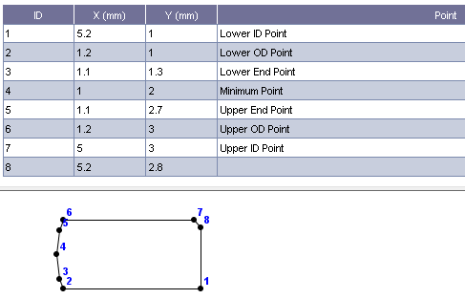

auo=1.93479e-3; %upper OD width

aui=1.86521e-3; %upper ID width

alo=1.93479e-3; %lower OD width

ali=2.06521e-3; %lower ID width

huo=1.00227e-3; %upper OD height

hui=1.00227e-3; %upper ID height

hlo=0.997729e-3; %lower OD height

hli=0.997729e-3; %lower ID height

thrt=0; %ring upper flank angle

thrb=0; %ring lower flank angle

rb1=0.7e-3; %the lower edge width 0.2e-3

rb2=0.7e-3; %the upper edge width

rbn=0.00227088e-3; %running face minimum point axial location

a10=0;

a11=0;

a12=50; %the lower edge shape factor 53 2.040816326530635e+02

a20=0;

a21=0;

a22=50; %the upper edge shape factor 148 2.040816326530635e+02

arm=2.13479e-3; %minimum point width

gap=0e-3; %gap size 0.3314e-3

Ac=8.22e-6; %area of cross-section 4e-6

Izz=11.5882e-12; %principal moment of inertial in plane Izp 10.6667e-12

Iyy=2.69693e-12; %principal moment of inertial out of plane Iyp 2.6667e-12

Izr=11.588e-12; %moment of inertial in plane Iz 10.6667e-12

Ip=Izz+Iyy; %polar moment of inertial

Jt=7.52386e-12; %torsional factor 7.328e-12

alp=0.240262/180*pi; %principal angle, rad

isi=0*(alp<=0)+1*(alp>0);

0.1 x 0.1

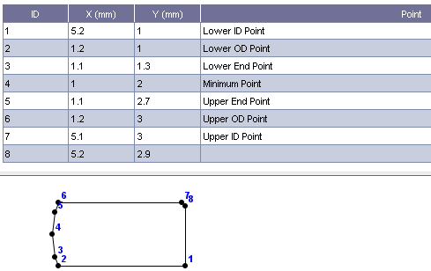

auo=1.93841e-3; %upper OD width

aui=1.96159e-3; %upper ID width

alo=1.93841e-3; %lower OD width

ali=2.06159e-3; %lower ID width

huo=1.00059e-3; %upper OD height

hui=1.00059e-3; %upper ID height

hlo=0.999413e-3; %lower OD height

hli=0.999413e-3; %lower ID height

thrt=0; %ring upper flank angle

thrb=0; %ring lower flank angle

rb1=0.7e-3; %the lower edge width 0.2e-3

rb2=0.7e-3; %the upper edge width

rbn=0.000586926e-3; %running face minimum point axial location

a10=0;

a11=0;

a12=50; %the lower edge shape factor 53 2.040816326530635e+02

a20=0;

a21=0;

a22=50; %the upper edge shape factor 148 2.040816326530635e+02

arm=2.13841e-3; %minimum point width

gap=0e-3; %gap size 0.3314e-3

Ac=8.235e-6; %area of cross-section 4e-6

Izz=11.6472e-12; %principal moment of inertial in plane Izp 10.6667e-12

Iyy=2.70991e-12; %principal moment of inertial out of plane Iyp 2.6667e-12

Izr=11.6472e-12; %moment of inertial in plane Iz 10.6667e-12

Ip=Izz+Iyy; %polar moment of inertial

Jt=7.56052e-12; %torsional factor 7.328e-12

alp=0.0628381/180*pi; %principal angle, rad

isi=0*(alp<=0)+1*(alp>0);

0.5 x 0.5

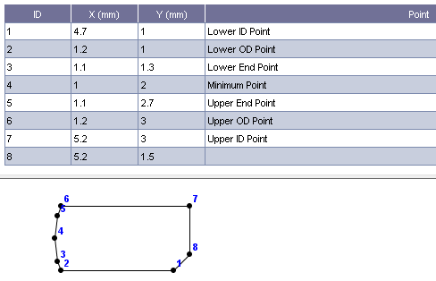

auo=1.91047e-3; %upper OD width

aui=2.08953e-3; %upper ID width

alo=1.91047e-3; %lower OD width

ali=1.58953e-3; %lower ID width

huo=0.987164e-3; %upper OD height

hui=0.987164e-3; %upper ID height

hlo=1.01284e-3; %lower OD height

hli=1.01284e-3; %lower ID height

thrt=0; %ring upper flank angle

thrb=0; %ring lower flank angle

rb1=0.7e-3; %the lower edge width 0.2e-3

rb2=0.7e-3; %the upper edge width

rbn=-0.0128363e-3; %running face minimum point axial location

a10=0;

a11=0;

a12=50; %the lower edge shape factor 53 2.040816326530635e+02

a20=0;

a21=0;

a22=50; %the upper edge shape factor 148 2.040816326530635e+02

arm=2.11047e-3; %minimum point width

gap=0e-3; %gap size 0.3314e-3

Ac=8.115e-6; %area of cross-section 4e-6

Izz=11.2155e-12; %principal moment of inertial in plane Izp 10.6667e-12

Iyy=2.62009e-12; %principal moment of inertial out of plane Iyp 2.6667e-12

Izr=11.2109e-12; %moment of inertial in plane Iz 10.6667e-12

Ip=Izz+Iyy; %polar moment of inertial

Jt=7.30359e-12; %torsional factor 7.328e-12

alp=-1.32985/180*pi; %principal angle, rad

isi=0*(alp<=0)+1*(alp>0);

0.2 x 0.2

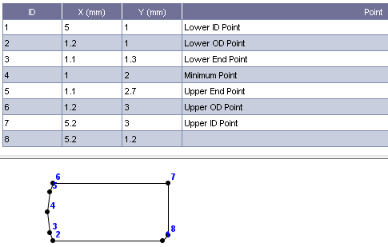

auo=1.93479e-3; %upper OD width

aui=2.06521e-3; %upper ID width

alo=1.93479e-3; %lower OD width

ali=1.86521e-3; %lower ID width

huo=0.997729e-3; %upper OD height

hui=0.997729e-3; %upper ID height

hlo=1.00227e-3; %lower OD height

hli=1.00227e-3; %lower ID height

thrt=0; %ring upper flank angle

thrb=0; %ring lower flank angle

rb1=0.7e-3; %the lower edge width 0.2e-3

rb2=0.7e-3; %the upper edge width

rbn=-0.00227088e-3; %running face minimum point axial location

a10=0;

a11=0;

a12=50; %the lower edge shape factor 53 2.040816326530635e+02

a20=0;

a21=0;

a22=50; %the upper edge shape factor 148 2.040816326530635e+02

arm=2.13479e-3; %minimum point width

gap=0e-3; %gap size 0.3314e-3

Ac=8.22e-6; %area of cross-section 4e-6

Izz=11.5882e-12; %principal moment of inertial in plane Izp 10.6667e-12

Iyy=2.69693e-12; %principal moment of inertial out of plane Iyp 2.6667e-12

Izr=11.588e-12; %moment of inertial in plane Iz 10.6667e-12

Ip=Izz+Iyy; %polar moment of inertial

Jt=7.52386e-12; %torsional factor 7.328e-12

alp=-0.240262/180*pi; %principal angle, rad

isi=0*(alp<=0)+1*(alp>0);

0.1 x 0.1

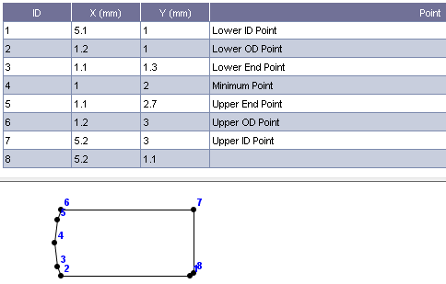

auo=1.93841e-3; %upper OD width

aui=2.06159e-3; %upper ID width

alo=1.93841e-3; %lower OD width

ali=1.96159e-3; %lower ID width

huo=0.999413e-3; %upper OD height

hui=0.999413e-3; %upper ID height

hlo=1.00059e-3; %lower OD height

hli=1.00059e-3; %lower ID height

thrt=0; %ring upper flank angle

thrb=0; %ring lower flank angle

rb1=0.7e-3; %the lower edge width 0.2e-3

rb2=0.7e-3; %the upper edge width

rbn=-0.000586926e-3; %running face minimum point axial location

a10=0;

a11=0;

a12=50; %the lower edge shape factor 53 2.040816326530635e+02

a20=0;

a21=0;

a22=50; %the upper edge shape factor 148 2.040816326530635e+02

arm=2.13841e-3; %minimum point width

gap=0e-3; %gap size 0.3314e-3

Ac=8.235e-6; %area of cross-section 4e-6

Izz=11.6472e-12; %principal moment of inertial in plane Izp 10.6667e-12

Iyy=2.70991e-12; %principal moment of inertial out of plane Iyp 2.6667e-12

Izr=11.6472e-12; %moment of inertial in plane Iz 10.6667e-12

Ip=Izz+Iyy; %polar moment of inertial

Jt=7.56052e-12; %torsional factor 7.328e-12

alp=-0.0628381/180*pi; %principal angle, rad

isi=0*(alp<=0)+1*(alp>0);

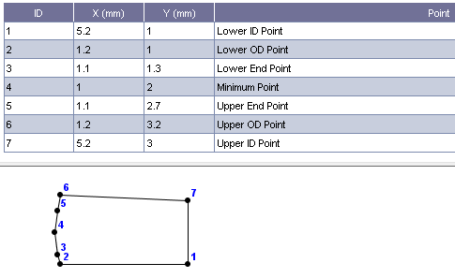

auo= 1.909325626204240e-3; %upper OD width

aui= 2.090674373795760e-3; %upper ID width

alo= 1.909325626204240e-3; %lower OD width

ali= 2.090674373795760e-3; %lower ID width

huo= 1.149556840077072e-3; %upper OD height

hui= 0.949556840077072e-3; %upper ID height

hlo= 1.050443159922929e-3; %lower OD height

hli= 1.050443159922929e-3; %lower ID height

thrt= 2.862405226111749*pi/180; %ring upper flank angle

thrb=0; %ring lower flank angle

rb1=0.7e-3; %the lower edge width 0.2e-3

rb2=0.7e-3; %the upper edge width

rbn= -0.050443159922928e-3; %running face minimum point axial location

a10=0;

a11=0;

a12=50; %the lower edge shape factor 53 2.040816326530635e+02

a20=0;

a21=0;

a22=50; %the upper edge shape factor 148 2.040816326530635e+02

arm= 2.109325626204241e-3; %minimum point width

gap=0e-3; %gap size 0.3314e-3

Ac= 8.65-6; %area of cross-section 4e-6

Izz= 12.209622500233360e-12; %principal moment of inertial in plane Izp 10.6667e-12

Iyy= 3.149781867139798e-12; %principal moment of inertial out of plane Iyp 2.6667e-12

Izr= 12.201364399486193e-12; %moment of inertial in plane Iz 10.6667e-12

Ip=Izz+Iyy; %polar moment of inertial

Jt= 8.589953839799971e-12; %torsional factor 7.328e-12

alp= 1.730088983692877/180*pi; %principal angle, rad

isi=0*(alp<=0)+1*(alp>0);

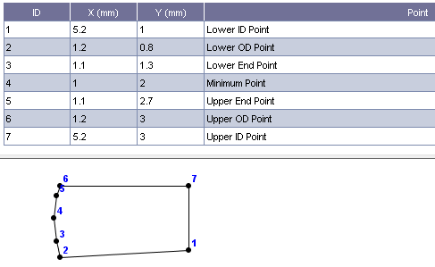

auo= 1.909325626204240e-3; %upper OD width

aui= 2.090674373795760e-3; %upper ID width

alo= 1.909325626204240e-3; %lower OD width

ali= 2.090674373795760e-3; %lower ID width

huo= 1.050443159922929e-3; %upper OD height

hui= 1.050443159922929e-3; %upper ID height

hlo= 1.149556840077072e-3; %lower OD height

hli= 0.949556840077072e-3; %lower ID height

thrt= 0*pi/180; %ring upper flank angle

thrb= 2.862405226111749*pi/180; %ring lower flank angle

rb1=0.7e-3; %the lower edge width 0.2e-3

rb2=0.7e-3; %the upper edge width

rbn= 0.050443159922928e-3; %running face minimum point axial location

a10=0;

a11=0;

a12=50; %the lower edge shape factor 53 2.040816326530635e+02

a20=0;

a21=0;

a22=50; %the upper edge shape factor 148 2.040816326530635e+02

arm= 2.109325626204241e-3; %minimum point width

gap=0e-3; %gap size 0.3314e-3

Ac= 8.65e-6; %area of cross-section 4e-6

Izz= 12.209622500233360e-12; %principal moment of inertial in plane Izp 10.6667e-12

Iyy= 3.149781867139798e-12; %principal moment of inertial out of plane Iyp 2.6667e-12

Izr= 12.201364399486193e-12; %moment of inertial in plane Iz 10.6667e-12

Ip=Izz+Iyy; %polar moment of inertial

Jt= 8.589953839799971e-12; %torsional factor 7.328e-12

alp= -1.730088983692877/180*pi; %principal angle, rad

isi=0*(alp<=0)+1*(alp>0);

**Working example**

auo=1.939644012944984e-3; %upper OD width

aui=2.060355987055016e-3; %upper ID width

alo=1.939644012944984e-3; %lower OD width

ali=2.060355987055016e-3; %lower ID width

huo=1e-3; %upper OD height

hui=1e-3; %upper ID height

hlo=1e-3; %lower OD height

hli=1e-3; %lower ID height

thrt=0; %ring upper flank angle

thrb=0; %ring lower flank angle

rb1=0.7e-3; %the lower edge width 0.2e-3

rb2=0.7e-3; %the upper edge width

rbn=-0; %running face minimum point axial location

a10=0;

a11=0;

a12=50; %the lower edge shape factor 53 2.040816326530635e+02

a20=0;

a21=0;

a22=50; %the upper edge shape factor 148 2.040816326530635e+02

arm=2.139644012944984e-3; %minimum point width

gap=0e-3; %gap size 0.3314e-3

Ac=8.24e-6; %area of cross-section 4e-6

Izz=11.667782955771303e-12; %principal moment of inertial in plane Izp 10.6667e-12

Iyy=2.714600000000000e-12; %principal moment of inertial out of plane Iyp 2.6667e-12

Izr=11.667782955771303e-12; %moment of inertial in plane Iz 10.6667e-12

Ip=Izz+Iyy; %polar moment of inertial

Jt=7.573654782911500e-12; %torsional factor 7.328e-12

alp=-2/180*pi; %principal angle, rad

**Classic symmetric example**

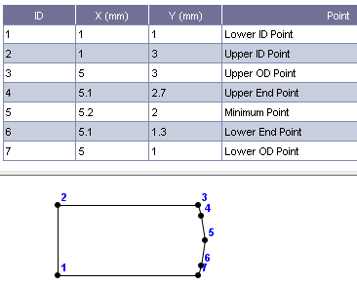

auo=1.939644012944984e-3; %upper OD width

aui=2.060355987055016e-3; %upper ID width

alo=1.939644012944984e-3; %lower OD width

ali=2.060355987055016e-3; %lower ID width

huo=1e-3; %upper OD height

hui=1e-3; %upper ID height

hlo=1e-3; %lower OD height

hli=1e-3; %lower ID height

thrt=0; %ring upper flank angle

thrb=0; %ring lower flank angle

rb1=0.7e-3; %the lower edge width 0.2e-3

rb2=0.7e-3; %the upper edge width

rbn=-0; %running face minimum point axial location

a10=0;

a11=0;

a12=50; %the lower edge shape factor 53 2.040816326530635e+02

a20=0;

a21=0;

a22=50; %the upper edge shape factor 148 2.040816326530635e+02

arm=2.139644012944984e-3; %minimum point width

gap=0e-3; %gap size 0.3314e-3

Ac=8.24e-6; %area of cross-section 4e-6

Izz=11.667782955771303e-12; %principal moment of inertial in plane Izp 10.6667e-12

Iyy=2.714600000000000e-12; %principal moment of inertial out of plane Iyp 2.6667e-12

Izr=11.667782955771303e-12; %moment of inertial in plane Iz 10.6667e-12

Ip=Izz+Iyy; %polar moment of inertial

Jt=7.573654782911500e-12; %torsional factor 7.328e-12

alp=0/180*pi; %principal angle, rad

auo= 1.909325626204240e-3; %upper OD width, m

aui= 2.090674373795760e-3; %upper ID width, m

alo= 1.909325626204240e-3; %lower OD width, m

ali= 2.090674373795760e-3; %lower ID width, m

huo= 1.050443159922929e-3; %upper OD height, m

hui= 1.050443159922929e-3; %upper ID height, m

hlo= 1.149556840077072e-3; %lower OD height, m

hli= 0.949556840077072e-3; %lower ID height, m

thrt= 0*pi/180; %ring upper flank angle, rad

thrb= 2.862405226111749*pi/180; %ring lower flank angle, rad

rb1=0.7e-3; %the lower edge width, m

rb2=0.7e-3; %the upper edge width, m

rbn= 0.050443159922928e-3; %running face minimum point axial location, m

a10=0;

a11=0; %Linear cofficient for lower edge shape factor:

a12=50; %the lower edge shape factor, 1/m

a20=0;

a21=0; %Linear cofficient for upper edge shape factor:

a22=50; %the upper edge shape factor, 1/m

arm= 2.109325626204241e-3; %running face minimum point width, m

gap=0e-3; %ring gap size when closed, m

Ac= 8.65e-6; %area of cross-section, m^2

Izz= 12.209622500233360e-12; %principal moment of inertial in plane, m^4

Iyy= 3.149781867139798e-12; %principal moment of inertial out of plane, m^4

Izr= 12.201364399486193e-12; %moment of inertial in plane Iz, m^4

Ip=Izz+Iyy;

Jt= 8.589953839799971e-12; %torsional factor, m^4

alp= -1.730088983692877/180*pi; %principal angle, rad

isi=0*(alp<=0)+1*(alp>0);