M-List
Mechanics
Lagrange’s Equations of Motion:
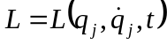
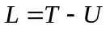
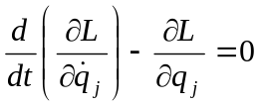
Lagrange’s Equations with Undetermined Multipliers:
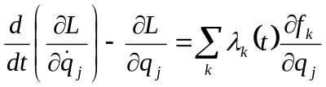
Hamilton’s Equations of Motion:
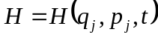, 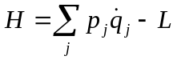, 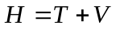
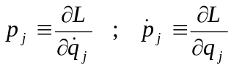
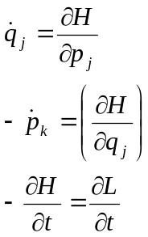
Orbit equation for a known orbit 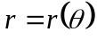:

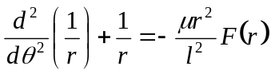
where 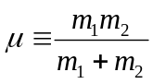, and 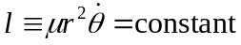
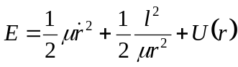

Electrodynamics

Coulomb’s Law:
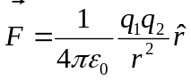 where 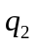 is the test charge
Electric field of a system of point charges:
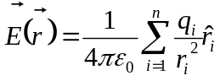
Electric field for charge distributions:

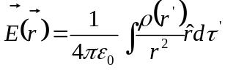
Gauss’s Law:

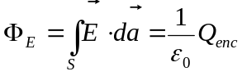

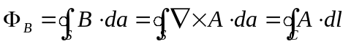
Solution to Laplace’s Equation in spherical coordinates with no 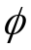 dependence:
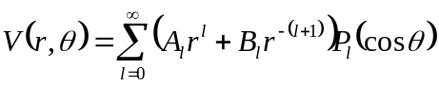
Solution to Laplace’s Equation in cylindrical coordinates:
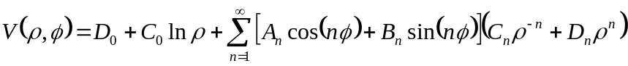
Maxwell’s Equations:
In general:
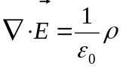
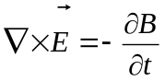
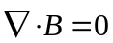
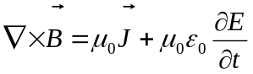
In matter:
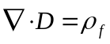
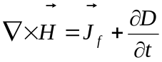

Potentials:
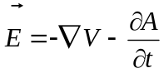, 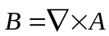
Lorentz force law:
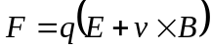

Quantum Mechanics
Classical Hamiltonian:
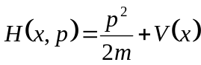
for QM:
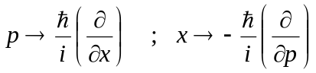
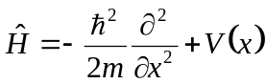
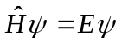
Particle in a box of length L, 0<x<L:

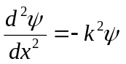, 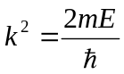
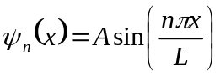, 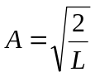
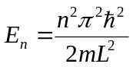
Particle in a box of length a, 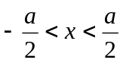:
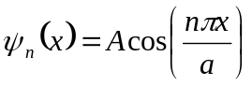 for odd n
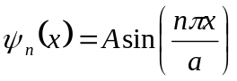 for even n
QM harmonic oscillator:
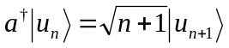
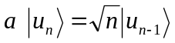
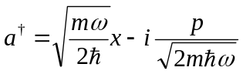
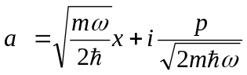
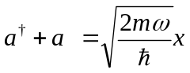, let 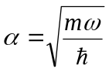
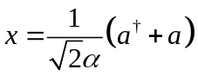
Time-independent perturbation theory:

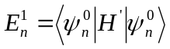 (first order correction to energy)
Commutators:
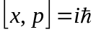
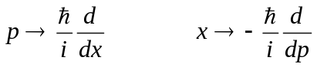
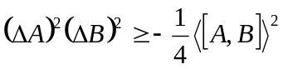

Harmonic oscillator: 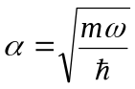
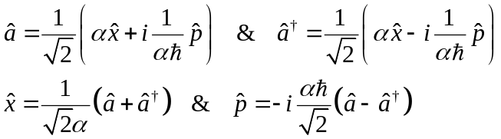

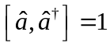
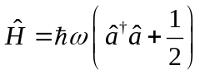
Let 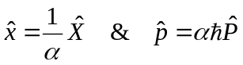
Which leads to
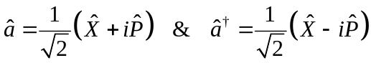
Also
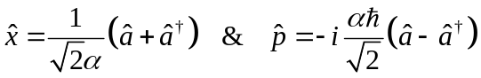
and
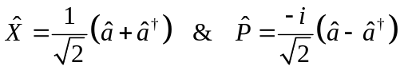

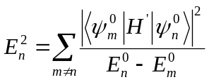 (second order correction to energy)
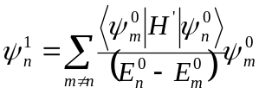 (first order correction to the wave function

Modern Physics
Relativity:
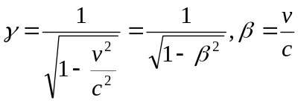
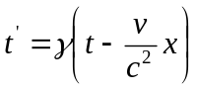
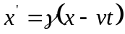
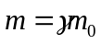
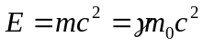
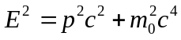
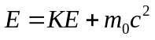
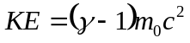
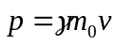
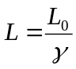
Hydrogen Atom:

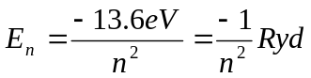
Treat excited one-electron atoms like Hydrogen, but include the effective charge, Z:
