Fine structure constant:
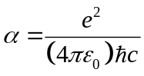

Length:
Bohr radius:
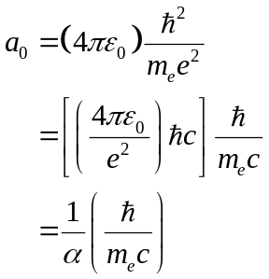

Compton wavelength:
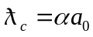

Classical radius of the electron:
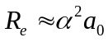

Bohr energy:
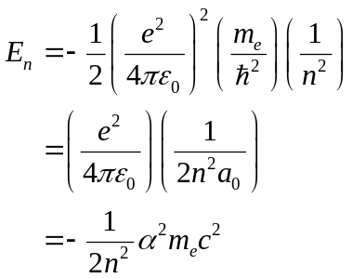

Bohr magneton:
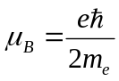

Commutators:
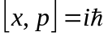
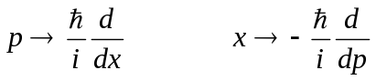
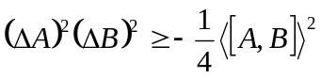

Harmonic oscillator:
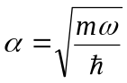
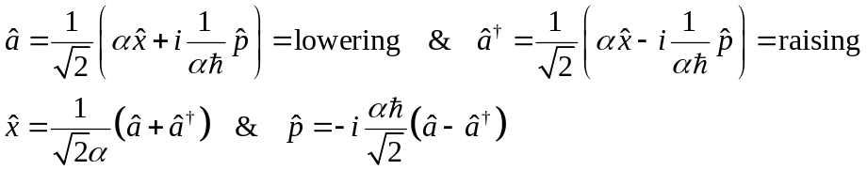
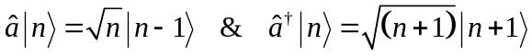

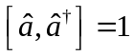
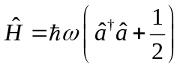
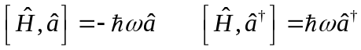
Let 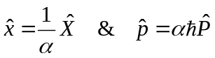
Which leads to
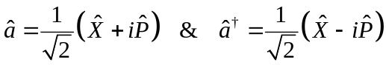
Also
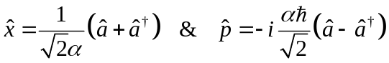
and
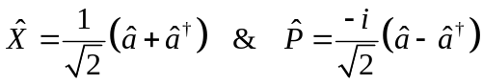

Heisenberg picture – harmonic oscillator:
