THE TITLE OF DISSERTATION

GOES HERE – DOUBLE

SPACED

by

YOUR FULL NAME HERE

A DISSERTATION

Presented to the Faculty of the Graduate School of the

MISSOURI UNIVERSITY OF SCIENCE & TECHNOLOGY

In Partial Fulfillment of the Requirements for the Degree

DOCTOR OF PHILOSOPHY
in
MECHANICAL ENGINEERING

2008

Approved by

Robert Smith, Advisor
James B. Brown
Charles R. Jones
D. F. Ling
Hardy Davidson

Students do not own the copyrights of research which is sponsored by grants or by stipend from UMR. Check with your advisor if you are unsure. You need to leave this page blank in that case.

© 2008
Your Full Name
All Rights Reserved
ABSTRACT
First page with visible page number.
Abstract is supposed to be a short description of your work. No references, equations, or Figures go here. It should be one page maximum (250 to 350 words). It must be double spaced since the library puts it on microfilm.
ACKNOWLEDGMENTS
This is where you should thank your Advisor for teaching you how to walk on water. Further, you should acknowledge any and all funding sources.
Should not exceed one page.
For professional courtesy and for brownie points with your committee, you should thank the members of your committee.
Finally, thanking family members or someone important to you is okay as well.

TABLE OF CONTENTS
Page
Refer to the thesis/dissertation specifications for illustration of “Table of Contents”.
ABSTRACT i
ACKNOWLEDGMENTS i
LIST OF ILLUSTRATIONS i
LIST OF TABLES i
NOMENCLATURE i
SECTION
1. INTRODUCTION 1
1.1. THIS IS A SUBSECTION 1
1.1.1. How to Use the STYLE Formats 1
1.1.2. How to Use the Table of Contents 1
1.1.3. Formatting Figures 1
1.1.4. Formatting Tables 1
1.2. MORE EQUATIONS AND FIGURES 1
2. MISCELLANEOUS INFORMATION 1
2.1. THIS IS SUBSECTION LEVEL ONE 1
2.2. THIS IS SUBSECTION LEVEL TWO 1
2.2.1. Second Subsection 1
2.2.2. Second Subsection 1
2.2.2.1 Third subsection 1
2.2.2.2 Third subsection 1
2.2.2.2.1 Fourth subsection 1
2.2.2.2.2 Fourth subsection will illustrate the case with very
long title… 1
3. THIS IS SECTION THREE 1
3.1. THIS IS SUBSECTION LEVEL ONE 1
3.1.1. Second Subsection 1
3.1.2. Second Subsection 1
3.1.2.1 Third subsection 1
3.1.2.2 Third subsection 1
3.1.2.2.1 Fourth subsection 1
3.1.2.2.2 Fourth subsection 1
APPENDICES 9
A. THIS IS AN APPENDIX 9
B. THIS IS AN APPENDIX 11
BIBLIOGRAPHY 1
VITA 1
Refer to the thesis specifications for examples.

LIST OF ILLUSTRATIONS
Figure Page
1.1. Example Four-Bar Linkage 1
1.2. Four-Bar Linkage – Crossed Configuration 1
1.3. Example Mechanism 1
2.1. Vector Loop Decomposition of Loop 1 1

LIST OF TABLES
Table Page
1.1. Original STATUS Array for Example Mechanism 1

NOMENCLATURE
Symbol Description
This section is optional.
β Angle of Attack
α Change in Coupler Angle

INTRODUCTION
It is a good idea to retain Body Text as unjustified (Align Left). You’ll have fewer problems while printing this way.

THIS IS A SUBSECTION
This is where the dissertation really begins. The most important thing to remember is that first person (I, We, our, my, etc.) should not to be used in formal writings. This is a sentence to take up space and look like text. In fact, this text and ALL text within the body of the T/D uses the STYLE Body Text, usually found on the toolbar next to the font type or, alternatively, in the Format menu under Style…. All headings, text, Figure titles, and table titles have been mapped to the STYLE formats and should be used throughout your T/D in order for the Table of Contents, Figures, …etc to function correctly.

How to Use the STYLE Formats. Note that this is a second level
subsection heading and is indented ½” over from the left hand margin, and it’s text is NOT all capital letters while the paragraph text begins immediately after the heading. Also note that because of the way Word handles styles, this subsection heading has to be doctored a little. The entire first line is Heading 3 style, but only the title is bold. How do you do that? Go ahead and put 2 spaces after the period, and begin typing the first line of your body. Then, once you get to the second line, highlight from the first space following the period to the end of the first line (level above), and turn off the bold and underline properties. Once those are off, you then have to give a carriage return, and you should then be automatically placed into the Body Text style. Note that you must be careful when using these carriage returns and be prepared to doctor it up. “But wait a minute, the next line becomes tabbed over!” To get rid of this, just backspace it out. The STYLE to use for headings and titles are as follows:
all headings in the pre-text pages (i – x) that you want in the Table of Contents
should be Heading 0
the only heading you wouldn’t want in the table of contents, the TABLE OF
CONTENTS, should be the style TOC HEADING
all major Section headings, such as INTRODUCTION above, are Heading 1
all subsection headings follow in a like manner, Heading 2 (see 1.1 THIS IS A
SUBSECTION above), Heading 3, …etc.
all body text, except for the Abstract, should be style Body Text
the abstract body text should be the style Abstract Body. It makes the paragraph
double spaced automatically.
all Figure captions should be the style Figure Title
all table titles should be Table Title

How to Use the Table of Contents. The TABLE OF CONTENTS, LIST
OF FIGURES, LIST OF TABLES, and NOMENCLATURE all work in a similar manner. The table of contents (TOC) is automatically generated and uses the styles mentioned above. They are already linked together, so once you get your T/D up and running, all you have to do is right click in the TOC and click Update Fields (and Update Entire Table if prompted) and Word then searches out the styles Heading 0, 1, 2, …etc. However, note that for Sections that use Heading 3 and beyond, you may have to modify the entry in the TOC to exclude the rest of the first line.
The LIST OF FIGURES (LOF) and LIST OF TABLES (LOT) work in a similar manner, except they use the styles Figure Title and Table Title, respectively. Again, to update these, you will have to right click the table and click Update Field. Also, because the title of Figures and tables usually begin with Figure and Table, you will again have to update the entry in the table to remove these words to avoid the repetition. If you leave the word Figure or Table for each one, your T/D will come back from the Dean’s office with a note for you to remove these!!
All other tables, such as for the NOMENCLATURE (NOM) are updated the same way. However, to get a symbol to be added to the NOM, you must add a Field before the symbol. For example, suppose you wanted the symbol β to be added to the NOM. You would have to move your cursor immediately before the symbol (between the l and the beta for this example), go to the Insert menu, and click Field. Then, in the Field Names box, scroll down to TC and select TC, select Options, type in the text window in quotes the description for your symbol, and follow that with a /f NOM. Thus, β will be defined as follows:
TC “Angle of Attack” /f NOM.
Now, you should add the symbol to this TC entry. To accomplish this, you need to have a Show/Hide Paragraph Code button (refer to your documentation) so you can click it to show all codes. Then, once the codes are shown, you will see the text description you added, and you should place your cursor just inside your opening quotes. Next, just add your symbol followed by a tab to get the spacing half right. To get the spacing fully correct, go to the table, click between your symbol and the description, and press the tab button again to insert another tab. Now you’ll see that it lines up correctly.
To show another example, show the codes on this α.

Formatting Figures. Figures should be formatted as one below with
plenty of space above and below the actual Figure (three 1.5 space carriage returns, or, to be more accurate, four single spaces). The title should be below the Figure and be designated with Figure x.y. where x is the main Section number it is in and y is the number of the Figure in that Section. For example, first Section could have Figures 1.1, 1.2, and 1.3. Then, Section 2 could have 2.1, 2.2, 2.3, and 2.4. Refer to Figures like this: Figure 1.1 illustrates a classic four-bar linkage where R₁ is the ground link.

All figures and tables must be mentioned before they appear.
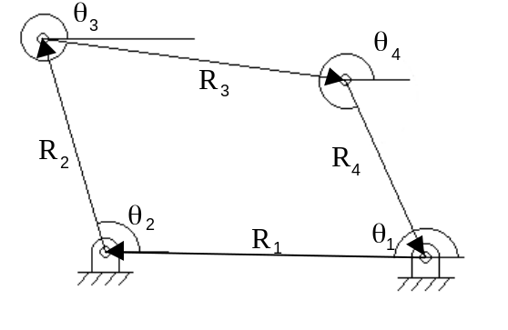Figure 1.1. Example Four-Bar Linkage

(1)
(2)

Equations should be numbered as above throughout the T/D and should have one blank line before and after.

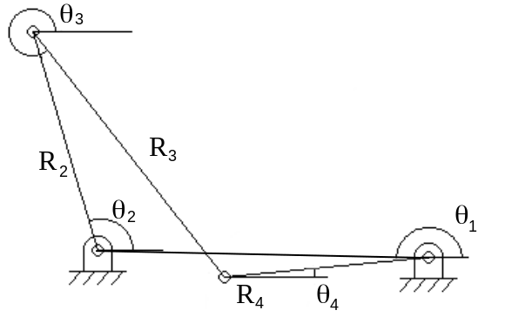
Figure 1.2. Four-Bar Linkage – Crossed Configuration

Formatting Tables. Tables are formatted in much the same way as
Figures. The title is placed at the top, and 4 blank lines (or 3 1.5 space lines) are used above and below. And, unlike Figures, tables should NOT be used in the middle of a paragraph. They should be placed at the end of the paragraph where they are discussed. Table 1.1 is one such example.

Table 1.1. Original STATUS Array for Example Mechanism
 | Loop # | Vector numbers
 | Loop # | 1 | 2 | 3 | 4 | 5 | 6 | 7 | 8 | 9 | 10 | 11 | 12
Mag | 1 | 0 | 0 | 0 | 0 | 9 | 9 | 9 | 9 | 9 | 9 | 9 | 9
Dir | 1 | 1 | 1 | 1 | 0 | 9 | 9 | 9 | 9 | 9 | 9 | 9 | 9
Mag | 2 | 9 | 9 | 9 | 9 | 0 | 0 | 1 | 0 | 9 | 9 | 9 | 9
Dir | 2 | 9 | 9 | 9 | 9 | 1 | 1 | 0 | 0 | 9 | 9 | 9 | 9
Mag | 3 | 0 | 9 | 9 | 9 | 9 | 9 | 9 | 9 | 0 | 0 | 1 | 0

MORE EQUATIONS AND FIGURES
Here are some more equations and Figures for illustration. Notice how the Figure number includes Section 1 again and increments from that already given above.
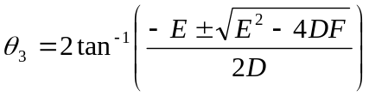 (3)
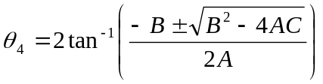 (4)

These are new example equations. Note that they are numbers 3 and 4. In Section 2 you will see some more that are 5 and 6.
Shown below is the third figure.

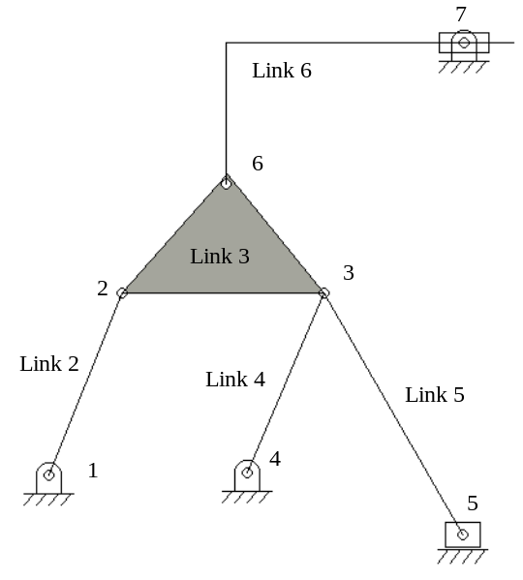Figure 1.3. Example Mechanism

MISCELLANEOUS INFORMATION

THIS IS SUBSECTION LEVEL ONE
You’re one Section closer to being finished. All that needs to be covered now is that this is the way to reference material from outside sources [1].
This sentence is used to take up space, but touches on something noted in a footnote. The footnote is at the bottom of the page.

THIS IS SUBSECTION LEVEL TWO
This is a sentence to take up space. Below is another Figure for a different Section. Notice that it is Figure 2.1 reflecting the first Figure in Section 2.

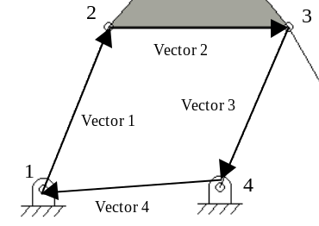
Figure 2.1. Vector Loop Decomposition of Loop 1

This is the next line after Figure 2.1.

Second Subsection. This is the second subsection of Section 2. Note the
difference between this and the others.

Second Subsection. This is the second subsection of Section 2. Note the
difference between this and the others.

Third subsection. This is the third subsection of Section 2. Note the
diference between this and the others. And further subsections would continue as these do, but there are not styles beyond the next level.

Third subsection. This is the third subsection of Section 2. Note the
diference between this and the others. And further subSections would continue as these do, but there are not styles beyond the next level.

Fourth subsection. This is the last subsection that has a style sheet
applied. The heading is underlined in this case. This level of subsection should be avoided at all cost. One can instead use bullets. To add more subSection heading formats, use the Style option under the Format Menu. Note that the subsection title is in sentence style.

Fourth subsection will illustrate the case with very long title. This is
the last subsection that has a style sheet applied. To add more subsection heading formats, use the Style option under the Format Menu.

THIS IS SECTION THREE

THIS IS SUBSECTION LEVEL ONE
This is a sentence to take up space. This is a sentence to take up space. This is a sentence to take up space. This is a sentence to take up space. This is a sentence to take up space. This is a sentence to take up space. This is a sentence to take up space.

Second Subsection. Note the first line continues on the same
line as the the Section title. This is a sentence to take up space. This is a sentence to take up space. This is a sentence to take up space. This is a sentence to take up space.

Second Subsection. Note the first line continues on the same
line as the Section title. This is a sentence to take up space. This is a sentence to take up space. This is a sentence to take up space. This is a sentence to take up space.

Third subsection. Note the first line continues on the
sme as the Section title. This is a sentence to take up space. This is a sentence to takesup space. This is a sentence to take up space. This is a sentence to take up space.

Third subsection. Note the first line continues on the
sme as the Section title. This is a sentence to take up space. This is a sentence to takesup space. This is a sentence to take up space. This is a sentence to take up space.

Fourth subsection. This is the last subsection that has a style sheet
applied. To add more subSection heading formats, use the Style option under the Format Menu.

Fourth subsection. This is the last subsection that has a style sheet
applied. To add more subSection heading formats, use the Style option under the Format Menu.

Double click on the rectangle placed over the page number and change the Line color to “No Line”. Now you can place the rectangle such that it hides the page number.

APPENDIX A.
THIS IS AN APPENDIX

Put your appendix information here. Note that the format used here is for a T/D that has more than one appendix. The format for this is each appendix must have its own title sheet with the word APPENDIX, in uppercase letters, followed by an uppercase letter and centered on the page. You should then have two blank lines (or one 1.5 space line) and then the TITLE of the appendix in uppercase letters. And, you do NOT include a page number on your hardcopy, however it is counted in the overall page count. Finally, it should be listed in the TOC.
For a T/D with a single appendix, the word APPENDIX must be centered at the top of the page and the material should start on the same page. Note that there is NOT a letter distinction for this type.
Also note that these will have to be doctored in the TOC to match what it looks like there.

PAGE NUMBER SHOULD NOT BE PRESENT ON APPENDIX COVER PAGES. ONE SOLUTION IS TO HAVE THE APPENDICES IN A DIFFERENT FILE. ANOTHER EASY WAY TO DO IT IS TO DRAW A RECTANGLE WITHOUT BORDER OVER THE PAGE NUMBER AS SHOWN IN THE PREVIOUS PAGE.

APPENDIX B.
THIS IS ANOTHER APPENDIX
This is where you put the info for the second appendix. This is a sentence to take up space. This is a sentence to take up space. This is a sentence to take up space. This is a sentence to take up space. This is a sentence to take up space. This is a sentence to take up space. This is a sentence to take up space. This is a sentence to take up space. This is a sentence to take up space. This is a sentence to take up space. This is a sentence to take up space.

READ THIS

You can shrink text to print programs (i.e., condense print) or long explanations. The margins must be maintained as in the rest of the document and figures and tables should stand out clearly.

BIBLIOGRAPHY
[1] J. McCardle and D. Chester, “Measuring an Asynchronous Processor’s Power
NOTE: For references, comma comes before closing quotation mark.
and Noise,” Synopsys User Group Conference (SNUG), Boston, 2001.

[2] C. L. Seitz, “System Timing,” in Introduction to VLSI Systems, Addison-Wesley, pp. 218-262, 1980.

[3] http://www.sce.carleton.ca/faculty/chinneck/thesis.html. Organizing Your Thesis, June 2004 (date mentioned here is the date on which the website was last visited).

One can follow the numbered listing shown above OR use the alphabetical listing shown below. Refer to a writing handbook for the correct formats of references.

ACI Committee 440, Guide for the Design and Construction of Concrete Reinforced with
FRP Bars (440.1R-01), American Concrete Institute, Farmington Hills, Michigan,
2001, 41 pp.

Canny J, A Computational Approach to Edge Detection. IEEE Transactions PAMI 1986,
Vol 10, pp. 679-698.

VITA
Provide information about yourself here. You must include your full name, Joseph Edward Miner, and your date of birth January 32, 1891. All degrees earned and year earned need to be included in the Vita. Also include the degree and date of the current degree earned. This is a sentence to take up space. This is a sentence to take up space. This is a sentence to take up space.
This is a sentence to take up space. This is a sentence to take up space. This is a sentence to take up space. This is a sentence to take up space. This is a sentence to take up space. This is a sentence to take up space. This is a sentence to take up space. This is a sentence to take up space.
This is a sentence to take up space. This is a sentence to take up space. This is a sentence to take up space. This is a sentence to take up space. This is a sentence to take up space.
Finally, don’t forget to include a blank unnumbered page at the end for your hardcopy.

Here’s the text of the footnote.

