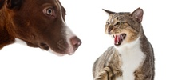
Dogs vs. Cats
Data set from Kaggle competition. In order to use this example, the following requirements must be met:
- Download Cat&Dog data set from https://www.kaggle.com/c/dogs-vs-cats
- Extract data set to C:\sc\Datasets\cat-dog\ path.
- The following image shows how extracted dataset should looks like:

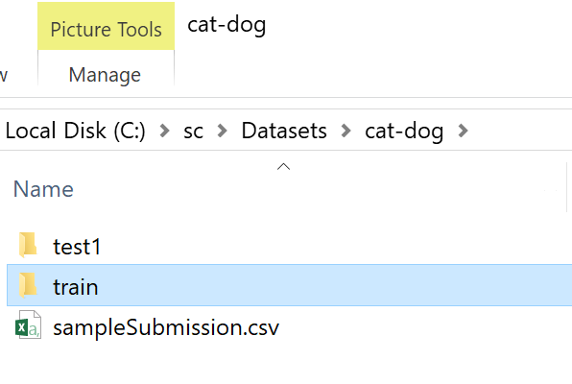
- Once you have dataset you can click on covnNet machine learning configuration in the project explorer.

