https://www.kaggle.com/c/dogs-vs-cats
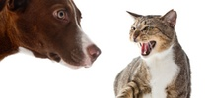
Dogs vs. Cats
Create an algorithm to distinguish dogs from cats
- 215 teams
- 5 years ago
In this competition, you'll write an algorithm to classify whether images contain either a dog or a cat. This is easy for humans, dogs, and cats. Your computer will find it a bit more difficult.
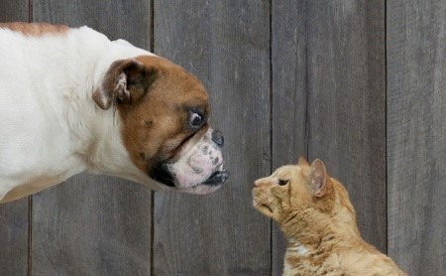
Deep Blue beat Kasparov at chess in 1997.
Watson beat the brightest trivia minds at Jeopardy in 2011.
Can you tell Fido from Mittens in 2013?
The Asirra data set
Web services are often protected with a challenge that's supposed to be easy for people to solve, but difficult for computers. Such a challenge is often called a CAPTCHA (Completely Automated Public Turing test to tell Computers and Humans Apart) or HIP (Human Interactive Proof). HIPs are used for many purposes, such as to reduce email and blog spam and prevent brute-force attacks on web site passwords.
Asirra (Animal Species Image Recognition for Restricting Access) is a HIP that works by asking users to identify photographs of cats and dogs. This task is difficult for computers, but studies have shown that people can accomplish it quickly and accurately. Many even think it's fun! Here is an example of the Asirra interface:
Asirra is unique because of its partnership with Petfinder.com, the world's largest site devoted to finding homes for homeless pets. They've provided Microsoft Research with over three million images of cats and dogs, manually classified by people at thousands of animal shelters across the United States. Kaggle is fortunate to offer a subset of this data for fun and research.
Image recognition attacks
While random guessing is the easiest form of attack, various forms of image recognition can allow an attacker to make guesses that are better than random. There is enormous diversity in the photo database (a wide variety of backgrounds, angles, poses, lighting, etc.), making accurate automatic classification difficult. In an informal poll conducted many years ago, computer vision experts posited that a classifier with better than 60% accuracy would be difficult without a major advance in the state of the art. For reference, a 60% classifier improves the guessing probability of a 12-image HIP from 1/4096 to 1/459.
State of the art
The current literature suggests machine classifiers can score above 80% accuracy on this task [1]. Therfore, Asirra is no longer considered safe from attack. We have created this contest to benchmark the latest computer vision and deep learning approaches to this problem. Can you crack the CAPTCHA? Can you improve the state of the art? Can you create lasting peace between cats and dogs?
Okay, we'll settle for the former.
Acknowledgements
We extend our thanks to Microsoft Research for providing the data for this competition.
- Jeremy Elson, John R. Douceur, Jon Howell, Jared Saul, Asirra: A CAPTCHA that Exploits Interest-Aligned Manual Image Categorization, in Proceedings of 14th ACM Conference on Computer and Communications Security (CCS), Association for Computing Machinery, Inc., Oct. 2007

