|  |  |  |  |  |  |
| --- | --- | --- | --- | --- | --- |
|  |  | |  | |  |
| **Last Name:** | Ved | **First Name:** | | Bhrushank | |
| **Student ID:** | 1440239 | **Lecturer:** | | Nilufar Baghaei | |
| **Class:** | ISCG6420 | **Deadline:** | | 08-09-2014 8:30am | |
| Subject: | Internet & Website Development | |  |  | |
| **Login Name:** vedb01 | | **Sub Directories:** assignment1 | | | |
|  | |  | | | |
|  |  | **File Names:** contact.html, contact.js, essentials.html, gallery.html, gallery.js, index.html, main.css, main.js, main2.css, system.html, ubuntu0.jpg, ubuntu1.jpg, ubuntu2.jpg, ubuntu3.jpg, ubuntu4.jpg, ubuntu5.jpg  **This submission is my own work, except where clearly referenced.** | | | |

Contents

1. Purpose 3s

2. URL 3

3. Site Map 3

4. Page Design 4

5. JavaScript 9

6. Cascading Style Sheets 9

7. Web Design Practices 10

8. References 10

**Ubuntu Geeks**

**1. Purpose**

Ubuntu Geeks is aimed at helping first time users who are willing to migrate to Ubuntu from other operating systems. It is a useful resource for anyone who is keen on the prospect of using a Linux based operating system which is not too complicated. It provides them with software’s and resources they might need once they’ve installed Ubuntu. The user does not have to be an expert to understand the content of the website.

**2. URL**

http://hyperdisc.unitec.ac.nz/iwd14s2/VEDB01IWD/assignment1/index.html

**3. Site Map**

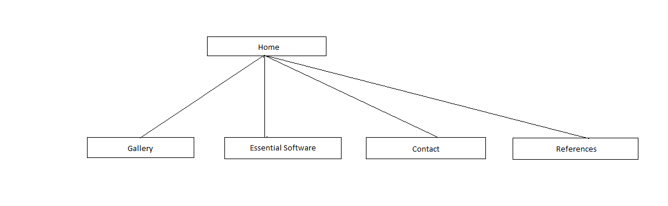

**4. Page Design**

**4.1. Home (index.html)**

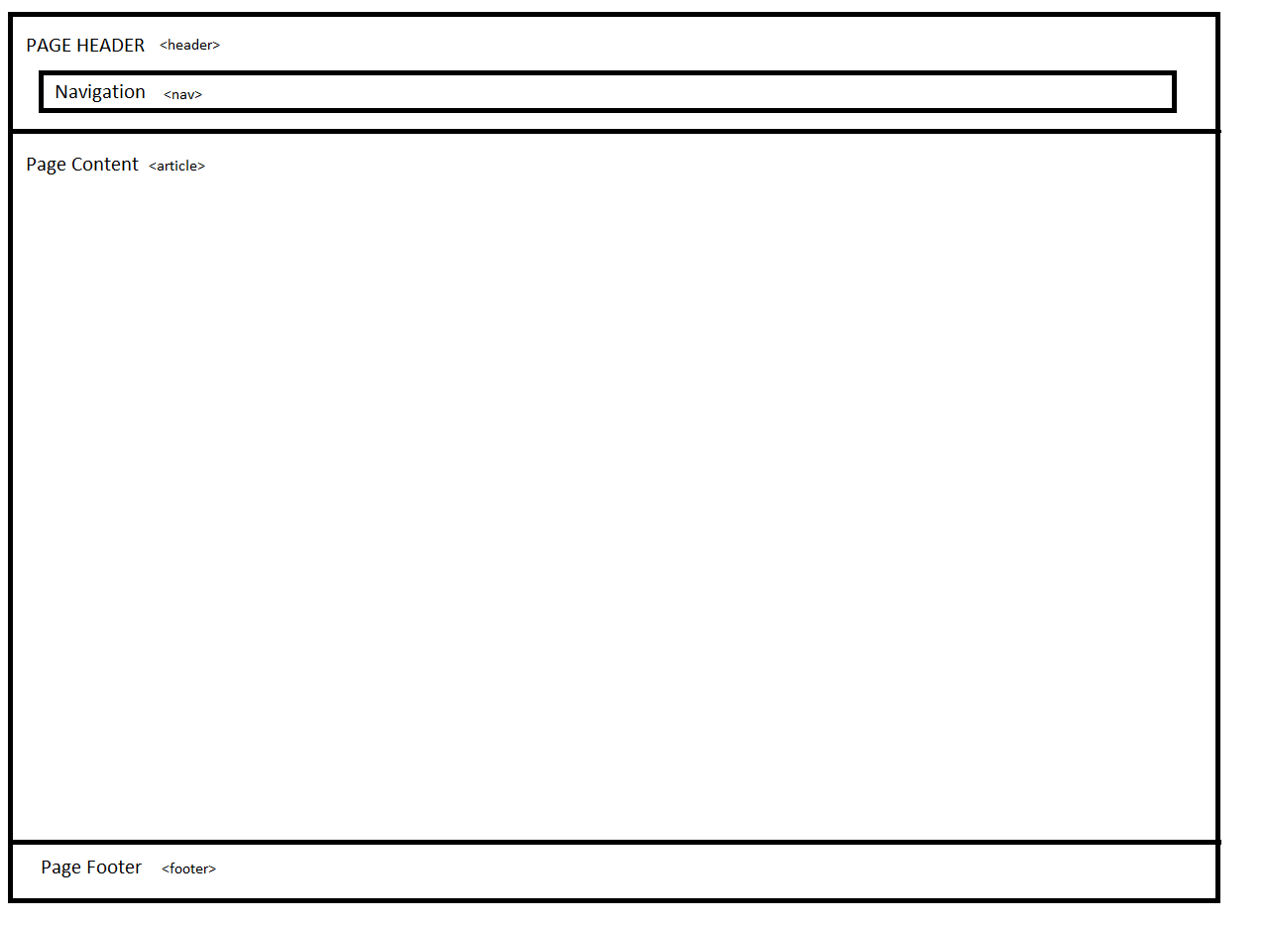

**4.2. Gallery (gallery.html)**

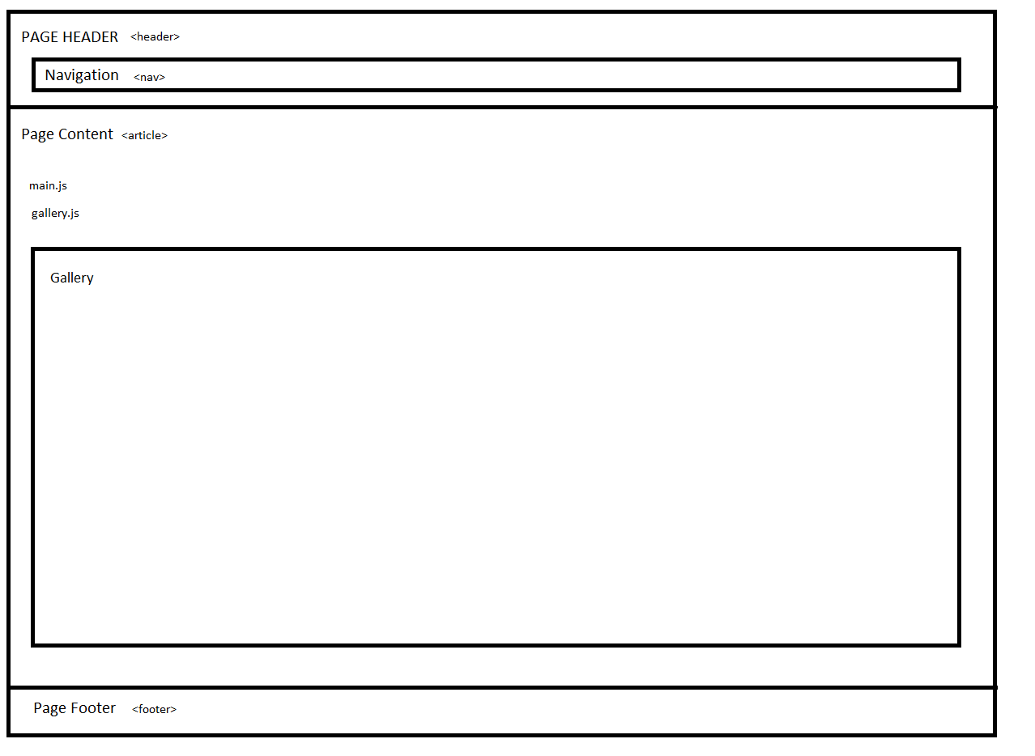

**4.3. Essential Software (essentials.html)**



**4.4. System Requirements (system.html)**



**4.5. Contact (contact.html)**

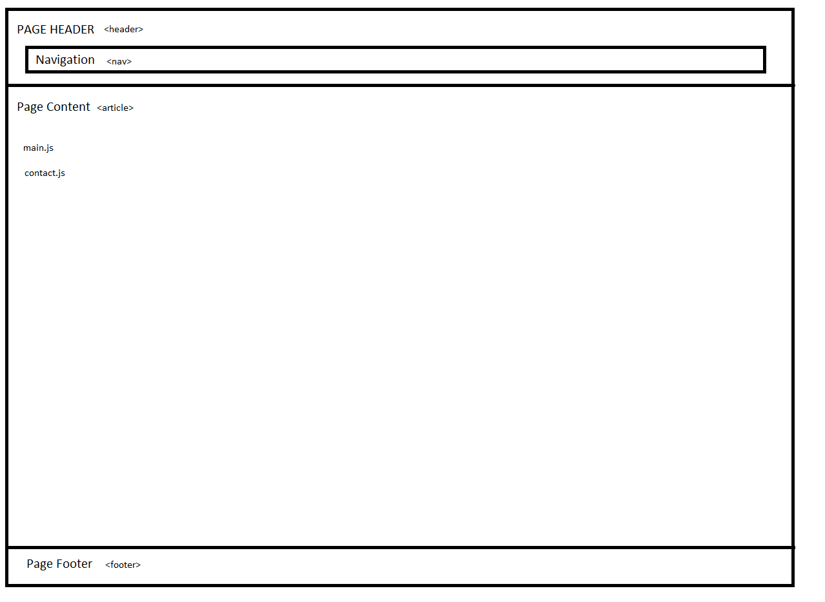

**5. JavaScript**

There are three JavaScript files used for the website and their usage is as follow:

**5.1. contact.js**

The contact.js file is used to validate form using JavaScript. The contact.html form calls the ‘validate_form(thisform)’ function to check if the fields such as name, email and message have been entered by the user before submitting the form.

**5.2. main.js**

The main.js file is used to enable users to switch between two versions of the websites. All of the html file can call the ‘theme(cssFile)’ function to enable the user to choose the desired layout for the website.

**5.3. gallery.js**

The gallery.js file is used to enable image slideshow of the screenshots of Ubuntu desktop. The gallery.html file calls ‘load_slide(place, file)’, ‘goforward()’ and ‘gobackward()’ functions to enable viewing slideshows of the Ubuntu desktop. It increments the counter using a for loop to load images in a sequential manner.

**6. Cascading Style Sheets**

There are two cascading style sheets used for the website and the user is given an option to switch between those style sheets.

**6.1. main.css**

The main.css file is the main style sheets or in other words, the default style sheet of the website. The main.css is imported by all the webpages. The theme uses the Ubuntu orange color when the mouse hovers over the title. Also, the webpage is flexible in terms of width upto a certain extent. Each heading is linked to a relevant webpage.

**6.2. main2.css**

The main2.css is the alternate style sheet provided to enable user to use a different theme other than the default. This theme uses the Aubergine color, also closely associated to the Ubuntu design.

**7. Web design practices**

* The website follows certain acceptable web design practices such as proper indentation to improve readability.
* Separate external style sheets have been used to define make the code easier to follow and adhere to the standards preferred by the web development industry.
* External JavaScript files are used to perform specialized and specific tasks.
* Navigational links have been provided on each webpage to enable easier navigation.
* Each sub heading is linked to the relevant source website and redirects the user to that page.

**8. References**

# Ubuntu images, Canonical Ltd. (2014)

* 1. JavaScript form, Making the switch (2012)